**VISVESVARAYA TECHNOLOGICAL UNIVERSITY**

**“JnanaSangama”, Belgaum -590014, Karnataka.**



**LAB REPORT**

**on**

**Analysis and Design of Algorithms**

***Submitted by***

**SUSHANTH (1BM21CS227)**

***in partial fulfillment for the award of the degree of***

**BACHELOR OF ENGINEERING**

***in***

**COMPUTER SCIENCE AND ENGINEERING**



**B.M.S. COLLEGE OF ENGINEERING**

**(Autonomous Institution under VTU)**

**BENGALURU-560019**

**June-2023 to Sep-2023**

**B. M. S. College of Engineering,**

**Bull Temple Road, Bangalore 560019**

(Affiliated To Visvesvaraya Technological University, Belgaum)

**Department of Computer Science and Engineering**



**CERTIFICATE**

This is to certify that the Lab work entitled “**Analysis and Design of Algorithms**” carried out by **SUSHANTH (1BM21CS227),** who is bonafide student of **B.M.S. College of Engineering.** It is in partial fulfillment for the award of **Bachelor of Engineering in Computer Science and Engineering** of the Visvesvaraya Technological University, Belgaum during the academic semester June-2023 to Sep-2023. The Lab report has been approved as it satisfies the academic requirements in respect of a **Analysis and Design of Algorithms (22CS4PCADA)** work prescribed for the said degree.

**Radhika A D** **Dr. Jyothi S Nayak**

Assistant Professor Professor and Head

Department of CSE Department of CSE

BMSCE, Bengaluru BMSCE, Bengaluru

**Index Sheet**

|  |  |  |
| --- | --- | --- |
| **Lab Program No.** | **Program Details** | **Page No.** |
| 1 | Write program to do the following:  a. Print all the nodes reachable from a given starting node in a digraph using BFS method.  b. Check whether a given graph is connected or not using DFS method. | 1-6 |
| 2 | Write program to obtain the Topological ordering of vertices in a given digraph. | 7-9 |
| 3 | Implement Johnson Trotter algorithm to generate permutations. | 10-14 |
| 4 | Sort a given set of N integer elements using Merge Sort technique and compute its time taken. Run the program for different values of N and record the time taken to sort. | 15-21 |
| 5 | Sort a given set of N integer elements using Quick Sort technique and compute its time taken. | 22-27 |
| 6 | Sort a given set of N integer elements using Heap Sort technique and compute its time taken. | 28-33 |
| 7 | Implement 0/1 Knapsack problem using dynamic programming. | 34-37 |
| 8 | Implement All Pair Shortest paths problem using Floyd’s algorithm. | 38-41 |
| 9 | Find Minimum Cost Spanning Tree of a given undirected graph using Prim’s and Kruskal’s algorithm. | 42-50 |
| 10 | From a given vertex in a weighted connected graph, find shortest paths to other vertices using Dijkstra’s algorithm. | 51-54 |
| 11 | Implement “N-Queens Problem” using Backtracking. | 55-58 |

**Course Outcome**

|  |  |
| --- | --- |
| CO1 | Analyze time complexity of Recursive and Non-recursive algorithms using asymptotic notations. |
| CO2 | Apply various design techniques for the given problem. |
| CO3 | Apply the knowledge of complexity classes P, NP, and NP-Complete and prove certain  problems are NP-Complete |
| CO4 | Design efficient algorithms and conduct practical experiments to solve problems. |

**PROGRAM-1**

**Write program to do the following:**

**a. Print all the nodes reachable from a given starting node in a digraph using BFS method.**

**b. Check whether a given graph is connected or not using DFS method.**

***DFS***

#include <stdio.h>

void DFS(int);

int isConnected();

int A[10][10], vis[10], n;

int main()

{

printf("Enter the number of vertices: ");

scanf("%d", &n);

printf("Enter Adjacency Matrix\n");

for (int i = 1; i <= n; i++)

{

for (int j = 1; j <= n; j++)

{

scanf("%d", &A[i][j]);

}

}

printf("DFS Traversal\n");

for (int i = 1; i <= n; i++)

{

vis[i] = 0;

}

DFS(1);

if(isConnected()==1){

printf("\nGraph is Conncetd.");

}

else{

printf("\nGraph is not Conncetd.");

}

return 0;

}

void DFS(int v)

{

vis[v] = 1;

printf("%d ", v);

for (int i = 1; i <= n; i++)

{

if (A[v][i] == 1 && vis[i] == 0)

{

DFS(i);

}

}

}

int isConnected()

{

for (int i = 1; i <= n; i++)

{

if (vis[i] == 0)

return 0;

}

return 1;

}

**GRAPH:**

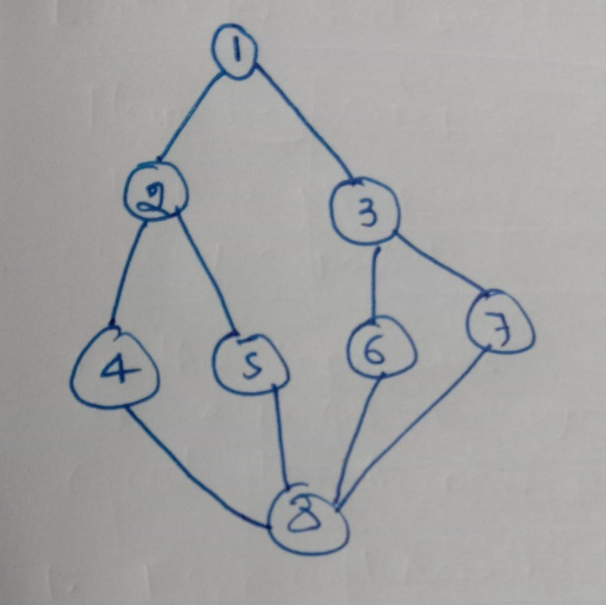

**OUTPUT:**

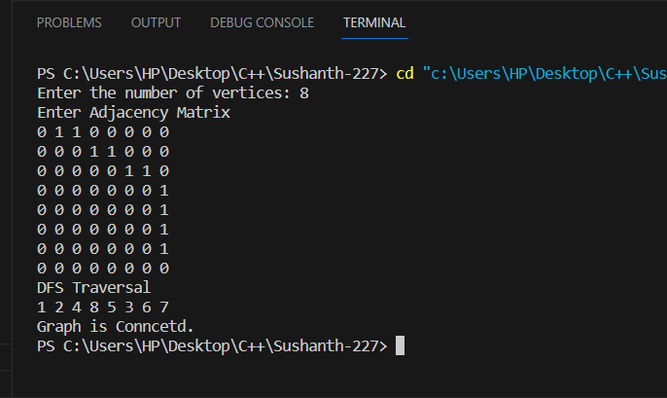

***BFS***

#include<stdio.h>

void BFS(int);

int Q[10],F=-1,R=-1;

int A[10][10],vis[10];

int n,m;

int main(){

int v,u,st;

printf("Enter the number of vertices\n");

scanf("%d",&n);

for(int i=1;i<=n;i++){

for(int j=1;j<=n;j++){

A[i][j]=0;

}

}

printf("Enter the number of edges\n");

scanf("%d",&m);

printf("Enter the edges\n");

for(int i=1;i<=m;i++){

scanf("%d %d",&u,&v);

A[u][v]=1;

}

for(int i=1;i<=n;i++){

vis[i]=0;

}

printf("Enter the starting Node\n");

scanf("%d",&st);

printf("Nodes rechable from %d\n",st);

BFS(st);

return 0;

}

void BFS(int v){

int u;

vis[v]=1;

Q[++R]=v;

while(F<=R){

u=Q[++F];

printf("%d ",u);

for(int i=1;i<=n;i++){

if(A[u][i]==1 && vis[i]==0){

Q[++R]=i;

vis[i]=1;

}

}

}

}

**GRAPH:**

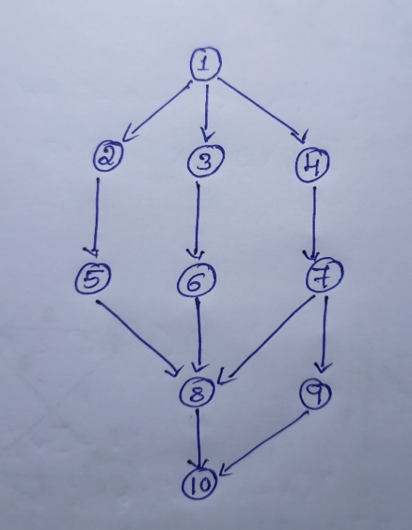

**OUTPUT:**

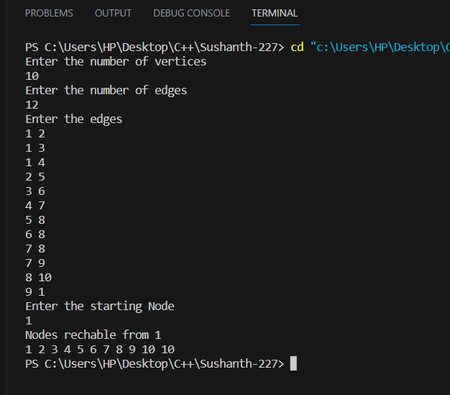

**PROGRAM-2**

**Write program to obtain the Topological ordering of vertices in a given digraph.**

#include <stdio.h>

void DFS(int);

int A[10][10], vis[10], EXP[10], J = 0;

int n, m;

int main()

{

int v, u;

printf("Enter the number of vertices\n");

scanf("%d", &n);

for (int i = 1; i <= n; i++)

{

for (int j = 1; j <= n; j++)

{

A[i][j] = 0;

}

}

printf("Enter the number of edges\n");

scanf("%d", &m);

printf("Enter the edges\n");

for (int i = 1; i <= m; i++)

{

scanf("%d %d", &u, &v);

A[u][v] = 1;

}

for (int i = 1; i <= n; i++)

vis[i] = 0;

for (int i = 1; i <= n; i++)

{

if (vis[i] == 0)

{

DFS(i);

}

}

printf("Topological traversal\n");

for (int i = n - 1; i >= 0; i--)

{

printf("%d ", EXP[i]);

}

}

void DFS(int v)

{

int i;

vis[v] = 1;

for (int i = 1; i <= n; i++)

{

if (A[v][i] == 1 && vis[i] == 0)

{

DFS(i);

}

}

EXP[J++] = v;

}

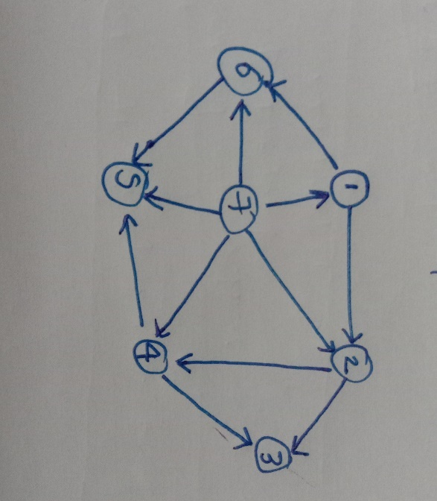**GRAPH:**

**OUTPUT:**

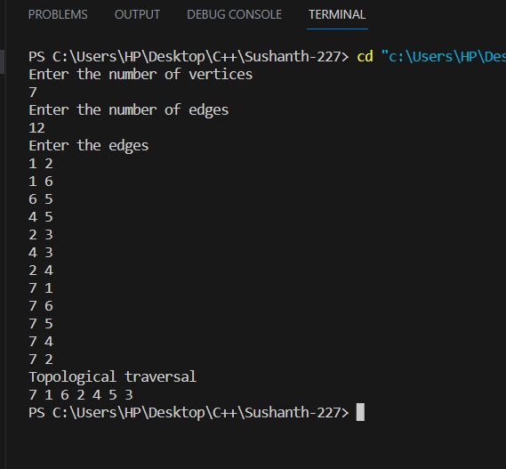

**PROGRAM-3**

**Implement Johnson Trotter algorithm to generate permutations.**

#include <stdio.h>

#include <conio.h>

int LEFT_TO_RIGHT = 1;

int RIGHT_TO_LEFT = 0;

int searchArr(int a[], int n, int mobile)

{

for (int i = 0; i < n; i++)

if (a[i] == mobile)

return i + 1;

}

int getMobile(int a[], int dir[], int n)

{

int mobile_prev = 0, mobile = 0;

for (int i = 0; i < n; i++)

{

if (dir[a[i] - 1] == RIGHT_TO_LEFT && i != 0)

{

if (a[i] > a[i - 1] && a[i] > mobile_prev)

{

mobile = a[i];

mobile_prev = mobile;

}

}

if (dir[a[i] - 1] == LEFT_TO_RIGHT && i != n - 1)

{

if (a[i] > a[i + 1] && a[i] > mobile_prev)

{

mobile = a[i];

mobile_prev = mobile;

}

}

}

if (mobile == 0 && mobile_prev == 0)

return 0;

else

return mobile;

}

int printOnePerm(int a[], int dir[], int n)

{

int mobile = getMobile(a, dir, n);

int pos = searchArr(a, n, mobile);

if (dir[a[pos - 1] - 1] == RIGHT_TO_LEFT)

{

printf("\n");

int temp;

temp = a[pos - 1];

a[pos - 1] = a[pos - 2];

a[pos - 2] = temp;

}

else if (dir[a[pos - 1] - 1] == LEFT_TO_RIGHT)

{

printf("\n");

int temp;

temp = a[pos];

a[pos] = a[pos - 1];

a[pos - 1] = temp;

}

for (int i = 0; i < n; i++)

{

if (a[i] > mobile)

{

if (dir[a[i] - 1] == LEFT_TO_RIGHT)

dir[a[i] - 1] = RIGHT_TO_LEFT;

else if (dir[a[i] - 1] == RIGHT_TO_LEFT)

dir[a[i] - 1] = LEFT_TO_RIGHT;

}

}

for (int i = 0; i < n; i++)

printf(" %d", a[i]);

}

int fact(int n)

{

int res = 1;

int i;

for (i = 1; i <= n; i++)

res = res * i;

return res;

}

void printPermutation(int n)

{

int a[n];

int dir[n];

for (int i = 0; i < n; i++)

{

a[i] = i + 1;

printf(" %d", a[i]);

}

for (int i = 0; i < n; i++)

dir[i] = RIGHT_TO_LEFT;

for (int i = 1; i < fact(n); i++)

printOnePerm(a, dir, n);

printf("\n");

}

int main()

{

int n;

printf("\nEnter the value of n: ");

scanf("%d", &n);

printf("\n");

printPermutation(n);

printf("\n");

return 0;

}

**OUTPUT:**

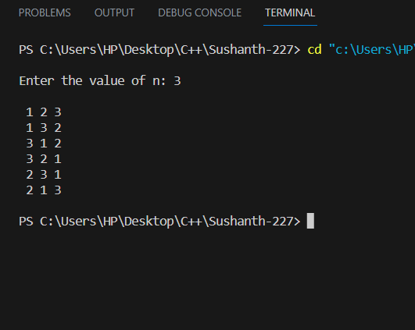

**PROGRAM-4**

**Sort a given set of N integer elements using the Merge Sort technique and compute its time taken. Run the program for different values of N and record the time taken to sort.**

#include <stdio.h>

#include <stdlib.h>

#include <time.h>

void merge(int arr[], int l, int m, int r)

{

int i, j, k;

int n1 = m - l + 1;

int n2 = r - m;

int L[n1], R[n2];

for (i = 0; i < n1; i++)

L[i] = arr[l + i];

for (j = 0; j < n2; j++)

R[j] = arr[m + 1 + j];

i = 0;

j = 0;

k = l;

while (i < n1 && j < n2)

{

if (L[i] <= R[j])

{

arr[k] = L[i];

i++;

}

else

{

arr[k] = R[j];

j++;

}

k++;

}

while (i < n1)

{

arr[k] = L[i];

i++;

k++;

}

while (j < n2)

{

arr[k] = R[j];

j++;

k++;

}

}

void mergeSort(int arr[], int l, int r)

{

if (l < r)

{

int m = l + (r - l) / 2;

mergeSort(arr, l, m);

mergeSort(arr, m + 1, r);

merge(arr, l, m, r);

}

}

int main()

{

int ch;

int n;

int A[100];

clock_t start_time, end_time;

printf("\n1.For manual entry of N value and array elements\n2.For Random Values of N\n3.Exit");

while (1)

{

printf("\nEnter your choice: ");

scanf("%d", &ch);

switch (ch)

{

case 1:

printf("\nEnter the number of elements: ");

scanf("%d", &n);

printf("Enter array elements\n");

for (int i = 0; i < n; i++)

{

scanf("%d", &A[i]);

}

printf("Array Elements: \n");

for (int i = 0; i < n; i++)

{

printf("%d ", A[i]);

}

start_time = clock();

mergeSort(A, 0, n - 1);

end_time = clock();

double taken_time = (double)(end_time - start_time) / CLOCKS_PER_SEC;

printf("\nSorted Array: \n");

for (int i = 0; i < n; i++)

{

printf("%d ", A[i]);

}

printf("\nTime taken: %f seconds\n", taken_time);

break;

case 2:

srand(time(NULL));

int sizes[] = {10, 50, 100, 200, 500, 1000, 2000, 5000, 10000, 20000, 50000, 100000};

int num_sizes = sizeof(sizes) / sizeof(sizes[0]);

for (int i = 0; i < num_sizes; i++)

{

int N = sizes[i];

int arr[N];

for (int j = 0; j < N; j++)

{

arr[j] = rand() % 1000;

}

clock_t start = clock();

mergeSort(arr, 0, N - 1);

clock_t end = clock();

double time_taken = ((double)(end - start)) / CLOCKS_PER_SEC;

printf("Time taken to sort array of size %d: %lf seconds\n", N, time_taken);

}

break;

case 3:

printf("Exiting the program.\n");

exit(0);

default:

printf("Invalid choice");

break;

}

}

return 0;

}

**OUTPUT:**

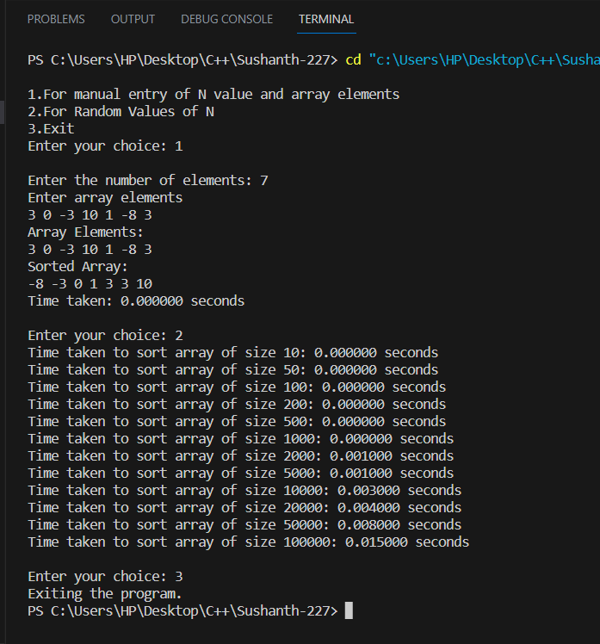

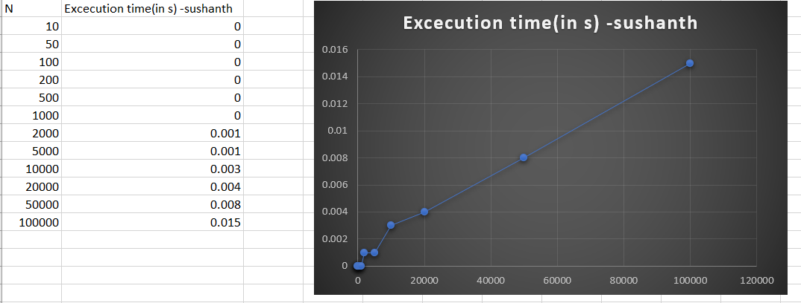

**PROGRAM-5**

**Sort a given set of N integer elements using the Quick Sort technique and compute its time taken.**

#include <stdio.h>

#include <stdlib.h>

#include <time.h>

int partition(int arr[], int low, int high)

{

int pivot = arr[high];

int i = (low - 1);

for (int j = low; j <= high - 1; j++)

{

if (arr[j] < pivot)

{

i++;

int temp = arr[i];

arr[i] = arr[j];

arr[j] = temp;

}

}

int temp = arr[i + 1];

arr[i + 1] = arr[high];

arr[high] = temp;

return (i + 1);

}

void quickSort(int arr[], int low, int high)

{

if (low < high)

{

int pi = partition(arr, low, high);

quickSort(arr, low, pi - 1);

quickSort(arr, pi + 1, high);

}

}

int main()

{

int ch;

int n;

int A[100];

clock_t start_time, end_time;

printf("\n1.For manual entry of N value and array elements\n2.For Random Values of N\n3.Exit");

while (1)

{

printf("\nEnter your choice: ");

scanf("%d", &ch);

switch (ch)

{

case 1:

printf("\nEnter the number of elements: ");

scanf("%d", &n);

printf("Enter array elements\n");

for (int i = 0; i < n; i++)

{

scanf("%d", &A[i]);

}

printf("Array Elements: \n");

for (int i = 0; i < n; i++)

{

printf("%d ", A[i]);

}

start_time = clock();

quickSort(A, 0, n - 1);

end_time = clock();

printf("\nSorted Array: \n");

for (int i = 0; i < n; i++)

{

printf("%d ", A[i]);

}

double taken_time = (double)(end_time - start_time) / CLOCKS_PER_SEC;

printf("\nTime taken: %f seconds\n", taken_time);

break;

case 2:

srand(time(NULL));

int sizes[] = {10, 50, 100, 200, 500, 1000, 2000, 5000, 10000, 20000, 50000, 100000};

int num_sizes = sizeof(sizes) / sizeof(sizes[0]);

for (int i = 0; i < num_sizes; i++)

{

int N = sizes[i];

int arr[N];

for (int j = 0; j < N; j++)

{

arr[j] = rand() % 1000;

}

clock_t start = clock();

quickSort(arr, 0, N - 1);

clock_t end = clock();

printf("Time taken to sort array of size %d: %lf seconds\n", N, ((double)(end - start)) / CLOCKS_PER_SEC);

}

break;

case 3:

printf("Exiting the program.\n");

exit(0);

default:

printf("Invalid choice\n");

break;

}

}

return 0;

}

**OUTPUT:**

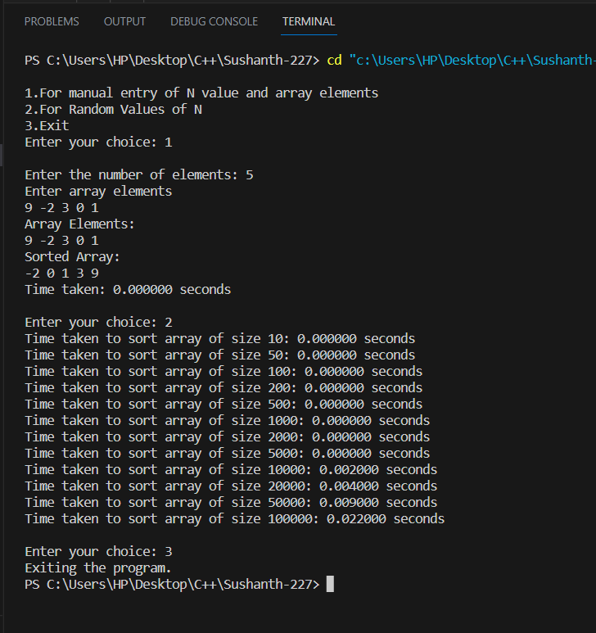

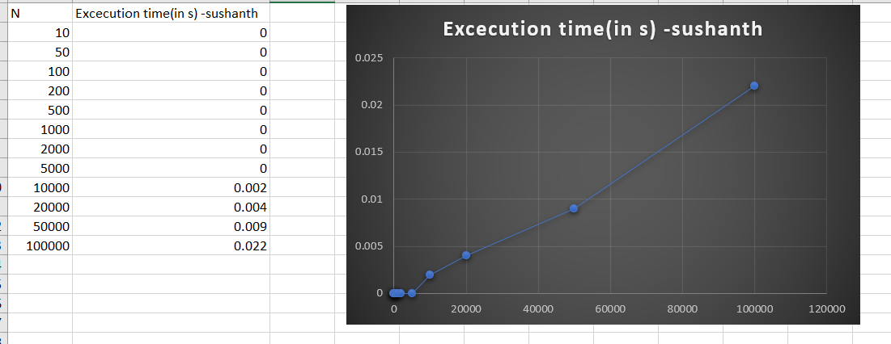

**PROGRAM-6**

**Sort a given set of N integer elements using Heap Sort technique and compute its time taken.**

#include <stdio.h>

#include <stdlib.h>

#include <time.h>

void heapify(int arr[], int n, int i)

{

int largest = i;

int left = 2 * i + 1;

int right = 2 * i + 2;

if (left < n && arr[left] > arr[largest])

{

largest = left;

}

if (right < n && arr[right] > arr[largest])

{

largest = right;

}

if (largest != i)

{

// Swap arr[i] and arr[largest]

int temp = arr[i];

arr[i] = arr[largest];

arr[largest] = temp;

heapify(arr, n, largest);

}

}

void heapSort(int arr[], int n)

{

for (int i = n / 2 - 1; i >= 0; i--)

{

heapify(arr, n, i);

}

for (int i = n - 1; i >= 0; i--)

{

// Swap arr[0] and arr[i]

int temp = arr[0];

arr[0] = arr[i];

arr[i] = temp;

heapify(arr, i, 0);

}

}

int main()

{

int ch;

int n;

int arr[100];

clock_t start_time, end_time;

printf("\n1.For manual entry of N value and array elements\n2.For Random Values of N\n3.Exit");

while (1)

{

printf("\nEnter your choice: ");

scanf("%d", &ch);

switch (ch)

{

case 1:

printf("\nEnter the number of elements: ");

scanf("%d", &n);

printf("Enter array elements: ");

for (int i = 0; i < n; i++)

{

scanf("%d", &arr[i]);

}

start_time = clock();

heapSort(arr, n);

end_time = clock();

printf("\nSorted Array: \n");

for (int i = 0; i < n; i++)

{

printf("%d ", arr[i]);

}

double taken_time = (double)(end_time - start_time) / CLOCKS_PER_SEC;

printf("\nTime taken: %f seconds\n", taken_time);

break;

case 2:

srand(time(NULL));

int sizes[] = {10, 50, 100, 200, 500, 1000, 2000, 5000, 10000, 20000, 50000, 100000};

int num_sizes = sizeof(sizes) / sizeof(sizes[0]);

for (int i = 0; i < num_sizes; i++)

{

int N = sizes[i];

int arr[N];

for (int j = 0; j < N; j++)

{

arr[j] = rand() % 1000;

}

clock_t start = clock();

heapSort(arr, N);

clock_t end = clock();

printf("Time taken to sort array of size %d: %lf seconds\n", N, ((double)(end - start)) / CLOCKS_PER_SEC);

}

break;

case 3:

printf("Exiting the program.\n");

exit(0);

default:

printf("Invalid choice\n");

break;

}

}

return 0;

}

**OUTPUT:**

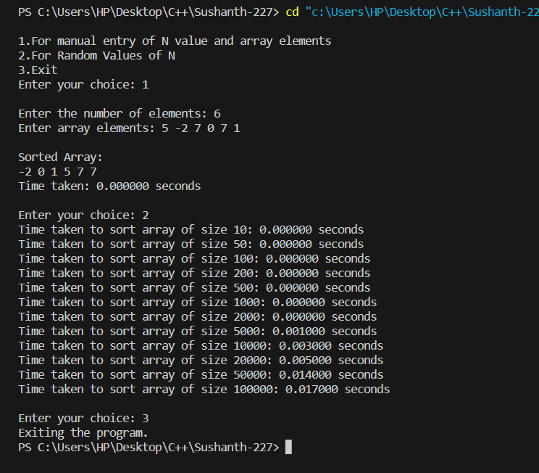

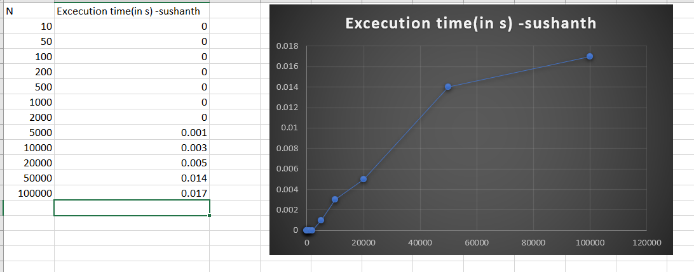

**PROGRAM-7**

**Implement 0/1 Knapsack problem using dynamic programming.**

#include <stdio.h>

#include <stdlib.h>

int V[100][100];

int max(int a, int b)

{

return a > b ? a : b;

}

int knapscak(int W, int N, int val[], int wt[])

{

for (int i = 0; i <= N; i++)

{

for (int j = 0; j <= W; j++)

{

if (i == 0 || j == 0)

{

V[i][j] = 0;

}

else if (wt[i - 1] > j)

{

V[i][j] = V[i - 1][j];

}

else

{

V[i][j] = max(V[i - 1][j], V[i - 1][j - wt[i - 1]] + val[i - 1]);

}

}

}

return V[N][W];

}

void object_selecetd(int N, int W, int wt[])

{

int X[N + 1];

for (int i = 1; i <= N; i++)

{

X[i] = 0;

}

int i = N;

int j = W;

while (i != 0 && j != 0)

{

if (V[i][j] != V[i - 1][j])

{

X[i] = 1;

j = j - wt[i - 1];

}

i--;

}

printf("\n");

for (int i = 1; i <= N; i++)

{

if (X[i] == 1)

{

printf("Object %d Selected\n", i);

}

}

}

int main()

{

int W, N;

printf("\nEnter number of items: ");

scanf("%d", &N);

printf("Enter the Capcity of bag: ");

scanf("%d", &W);

int val[W], wt[N];

for (int i = 0; i < N; i++)

{

printf("Enter profit and weight of item %d: ", i + 1);

scanf("%d%d", &val[i], &wt[i]);

}

int result = knapscak(W, N, val, wt);

object_selecetd(N, W, wt);

printf("\nMaxmimum profit is: %d", result);

}

**OUTPUT:**

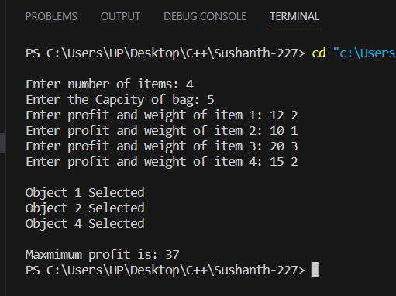

**PROGRAM-8**

**Implement All Pair Shortest paths problem using Floyd’s algorithm.**

#include <stdio.h>

int min(int, int);

void floyds(int p[10][10], int n)

{

int i, j, k;

for (k = 1; k <= n; k++)

for (i = 1; i <= n; i++)

for (j = 1; j <= n; j++)

if (i == j)

p[i][j] = 0;

else

p[i][j] = min(p[i][j], p[i][k] + p[k][j]);

}

int min(int a, int b)

{

if (a < b)

return (a);

else

return (b);

}

void main()

{

int p[10][10], w, n, e, u, v, i, j;

printf("\nEnter the number of vertices: ");

scanf("%d", &n);

printf("Enter the number of edges: ");

scanf("%d", &e);

for (i = 1; i <= n; i++)

{

for (j = 1; j <= n; j++)

p[i][j] = 999;

}

for (i = 1; i <= e; i++)

{

printf("\nEnter the end vertices of edge %d: ", i);

scanf("%d%d", &u, &v);

printf("Enter Weight: ");

scanf("%d",&w);

p[u][v] = w;

}

printf("\nAdjacency Matrix: \n");

for (i = 1; i <= n; i++)

{

for (j = 1; j <= n; j++)

printf("%d \t", p[i][j]);

printf("\n");

}

floyds(p, n);

printf("\nPath Matrix: \n");

for (i = 1; i <= n; i++)

{

for (j = 1; j <= n; j++)

printf("%d \t", p[i][j]);

printf("\n");

}

}

**GRAPH:**

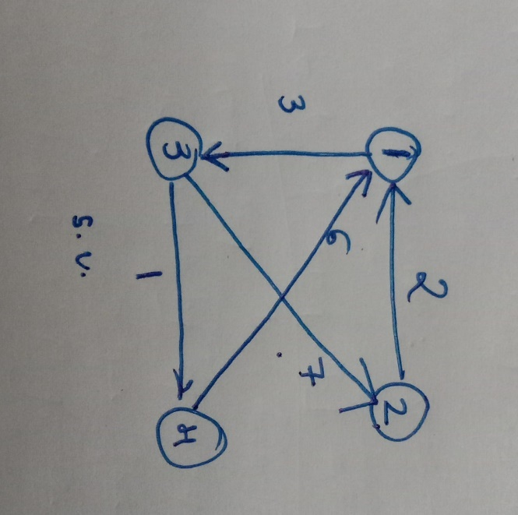

**OUTPUT:**

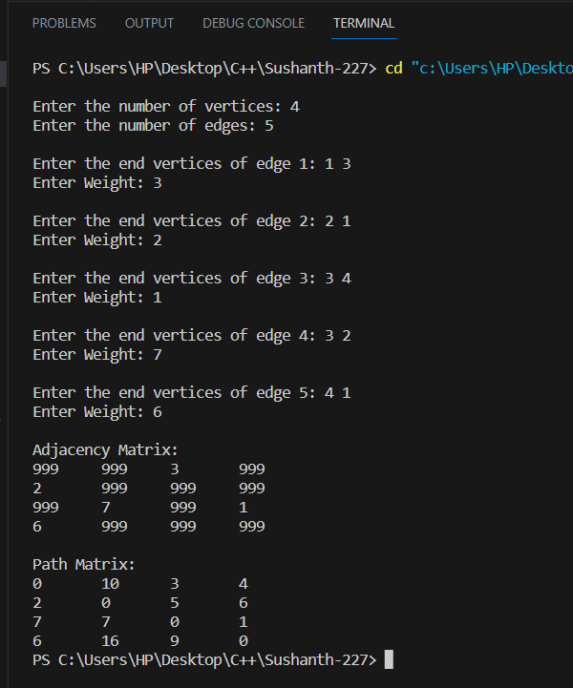

**PROGRAM-9**

**Find Minimum Cost Spanning Tree of a given undirected graph using Prim’s and Kruskal’s algorithm.**

***Prim’s algorithm***

#include <stdio.h>

int n, m, e = 0;

float sum = 0;

float costs[100][100];

int VT[100], ET[100][2], vis[20];

void prims()

{

int u, v;

int x = 1, j, K, min;

VT[x] = 1;

vis[x] = 1;

for (int i = 1; i < n; i++)

{

j = x;

min = 999;

while (j > 0)

{

K = VT[j];

for (int m = 2; m <= n; m++)

{

if (costs[K][m] < min && vis[m] == 0)

{

min = costs[K][m];

u = K;

v = m;

}

}

j--;

}

VT[++x] = v;

ET[i][0] = u;

ET[i][1] = v;

e++;

vis[v] = 1;

sum += costs[u][v];

}

}

void main()

{

printf("\n Prim's Algorithm\n");

printf(" ----------------------");

int u, v;

float w;

printf("\nEnter the number of vertices: ");

scanf("%d", &n);

for (int i = 1; i <= n; i++)

{

for (int j = 1; j <= n; j++)

{

if (i == j)

costs[i][j] = 0;

else

costs[i][j] = 999;

}

}

printf("Enter the number of egdes: ");

scanf("%d", &m);

printf("Enter vertices of edge with its weight: \n");

for (int i = 1; i <= m; i++)

{

scanf("%d%d%f", &u, &v, &w);

costs[u][v] = costs[v][u] = w;

}

for (int i = 1; i <= n; i++)

{

vis[i] = 0;

}

prims();

printf("\nMinimum Cost: %.2f\n", sum);

printf("\nEdges of Minimum spanning tree\n");

for (int i = 1; i <= e; i++)

{

printf("%d-->%d\n", ET[i][0], ET[i][1]);

}

}

**GRAPH:**

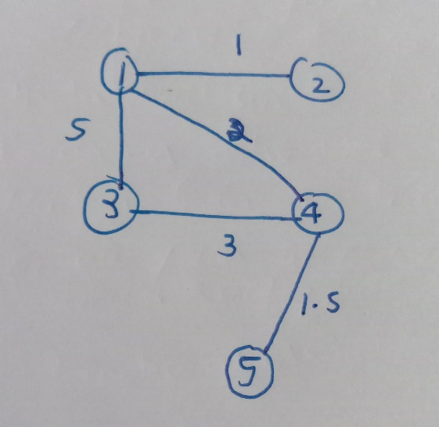

**OUTPUT:**

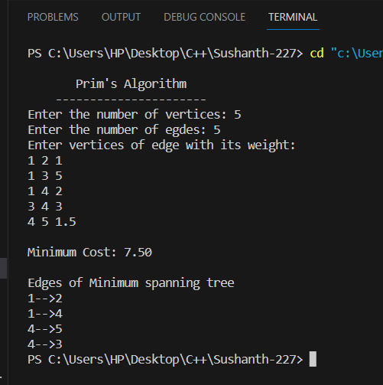

***Kruskal’s algorithm***

#include <stdio.h>

#include <stdbool.h>

int n, m, parent[100];

int count = 0;

int ET[100][2];

int cost[100][100];

int sum = 0;

void unionn(int a, int b)

{

if (a < b)

parent[b] = a;

else

parent[a] = b;

}

int find(int a)

{

while (parent[a] != a)

{

a = parent[a];

}

return a;

}

void kruskal()

{

int k = 0;

for (int i = 1; i <= n; i++)

{

parent[i] = i;

}

while (count != n - 1)

{

int min = 999;

int u, v;

for (int i = 1; i <= n; i++)

{

for (int j = 1; j <= n; j++)

{

if (cost[i][j] < min && cost[i][j] != 0)

{

min = cost[i][j];

u = i;

v = j;

}

}

}

int x = find(u);

int y = find(v);

if (x != y)

{

ET[k][0] = u;

ET[k][1] = v;

k++;

count++;

sum += cost[u][v];

unionn(x, y);

}

cost[u][v] = cost[v][u] = 999;

}

}

int main()

{

printf("\n Kruskal's algorithm\n");

printf(" -----------------------");

int u, v, w;

printf("\nEnter the number of vertices: ");

scanf("%d", &n);

for (int i = 1; i <= n; i++)

{

for (int j = 1; j <= n; j++)

{

if (i == j)

cost[i][j] = 0;

else

cost[i][j] = 999;

}

}

printf("Enter the number of edges: ");

scanf("%d", &m);

printf("Enter the egde with its weight: \n");

for (int i = 1; i <= m; i++)

{

scanf("%d%d%d", &u, &v, &w);

cost[u][v] = cost[v][u] = w;

}

kruskal();

printf("\nMinimum cost = %d\n", sum);

printf("Minimum spanning tree:\n");

for (int i = 1; i < count; i++)

{

printf("%d -> %d\n", ET[i][0], ET[i][1]);

}

return 0;

}

**GRAPH:**



**OUTPUT:**

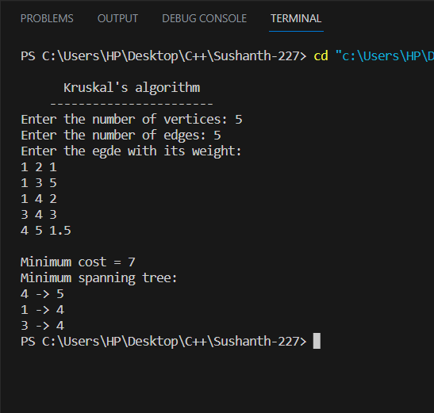

**PROGRAM-10**

**From a given vertex in a weighted connected graph, find shortest paths to other vertices using Dijkstra’s algorithm.**

#include <stdio.h>

int dist[10], cost[100][100], n, vis[10], src;

void dijkstra()

{

int count, min, u;

for (int i = 1; i <= n; i++)

{

dist[i] = cost[src][i];

vis[src] = 1;

}

count = 1;

while (count < n)

{

min = 9999;

for (int i = 1; i <= n; i++)

{

if (dist[i] < min && vis[i] == 0)

{

min = dist[i];

u = i;

}

}

vis[u] = 1;

for (int i = 1; i <= n; i++)

{

if (dist[u] + cost[u][i] < dist[i] && vis[i] == 0)

{

dist[i] = dist[u] + cost[u][i];

}

}

count++;

}

}

void main()

{

int m, u, v, w;

printf("\n Dijkstra's Algorithm\n");

printf(" ------------------------");

printf("\nEnter the number of vertices: ");

scanf("%d", &n);

for (int i = 1; i <= n; i++)

{

for (int j = 1; j <= n; j++)

{

if (i == j)

{

cost[i][j] = 0;

}

else

{

cost[i][j] = 9999;

}

}

}

printf("Enter the number of edges: ");

scanf("%d", &m);

printf("Enter the edge with its weight\n");

for (int i = 1; i <= m; i++)

{

scanf("%d%d%d", &u, &v, &w);

cost[v][u] = cost[u][v] = w;

}

printf("Enter the source\n");

scanf("%d", &src);

dijkstra();

printf("\n");

for (int i = 2; i <= n; i++)

printf("The distance from %d --> %d is %d\n", src, i, dist[i]);

}

**GRAPH:**

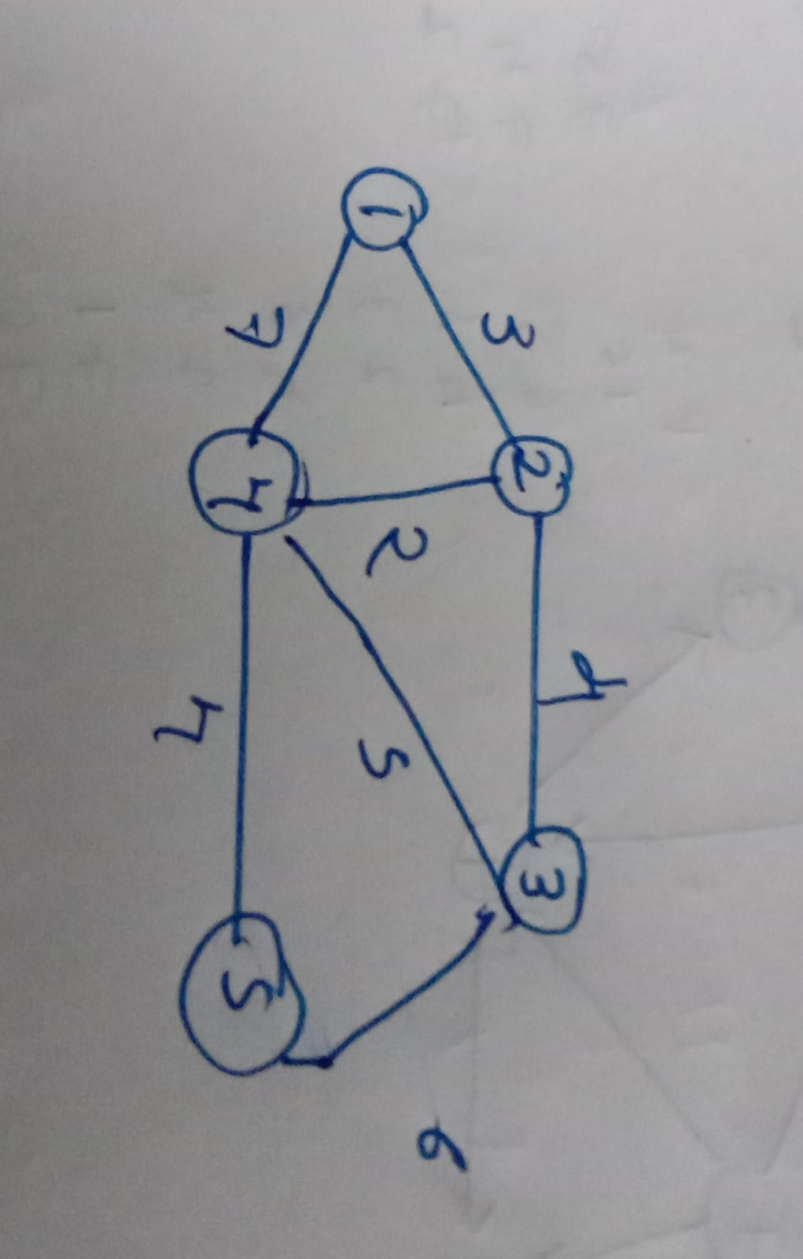

**OUTPUT:**

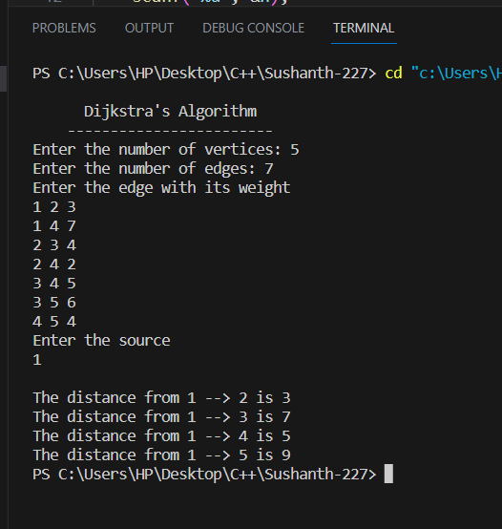

**PROGRAM-11**

**Implement “N-Queens Problem” using Backtracking.**

#include <stdio.h>

int n, count=0;

int isSafe(char board[n][n], int row, int col)

{

for (int i = row - 1; i >= 0; i--)

{

if (board[i][col] == 'Q')

{

return 0;

}

}

for (int i = row - 1, j = col - 1; i >= 0 && j >= 0; i--, j--)

{

if (board[i][j] == 'Q')

{

return 0;

}

}

for (int i = row - 1, j = col + 1; i >= 0 && j < n; i--, j++)

{

if (board[i][j] == 'Q')

{

return 0;

}

}

return 1;

}

void printBoard(char board[][n])

{

printf("\n---Chess Board---\n");

for (int i = 0; i < n; i++)

{

for (int j = 0; j < n; j++)

{

printf("%c ", board[i][j]);

}

printf("\n");

}

}

void nQueens(char board[n][n], int row)

{

if (row == n)

{

printBoard(board);

count++;

return;

}

for (int j = 0; j < n; j++)

{

if (isSafe(board, row, j) == 1)

{

board[row][j] = 'Q';

nQueens(board, row + 1);

board[row][j] = 'X';

}

}

}

int main()

{

printf("Enter the size of the board: ");

scanf("%d", &n);

char board[n][n];

for (int i = 0; i < n; i++)

{

for (int j = 0; j < n; j++)

{

board[i][j] = 'X';

}

}

nQueens(board, 0);

printf("\nTotal Possible Solution: %d ",count);

}

**OUTPUT:**

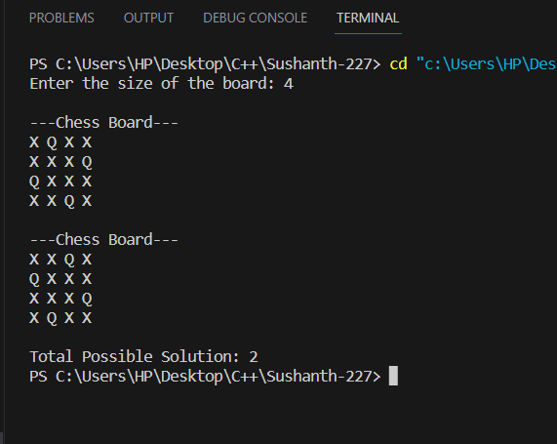

**LeetCode Problems**



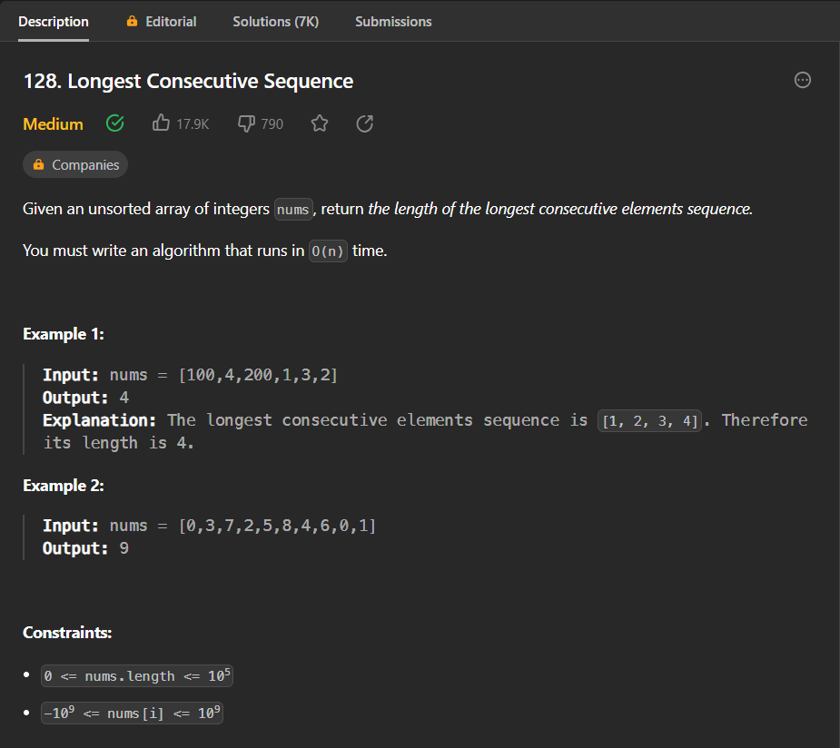

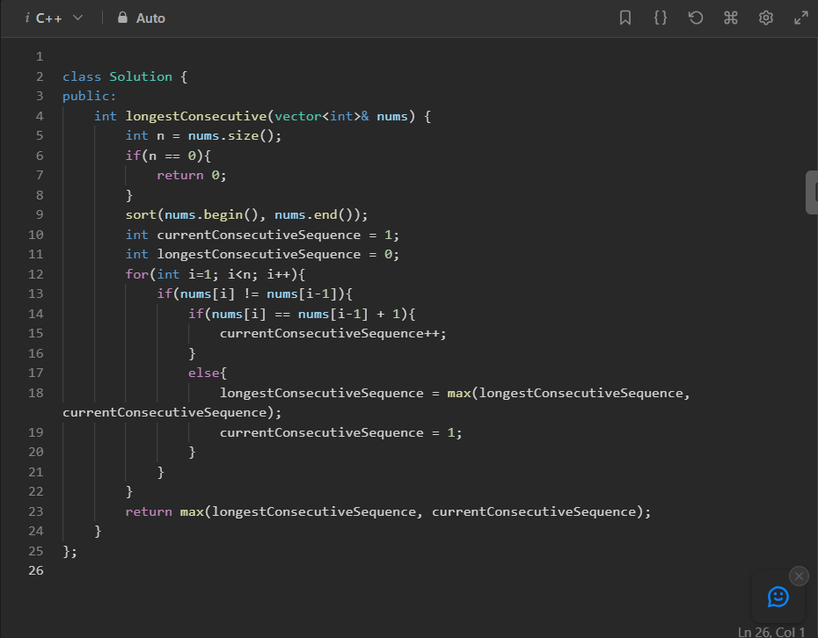

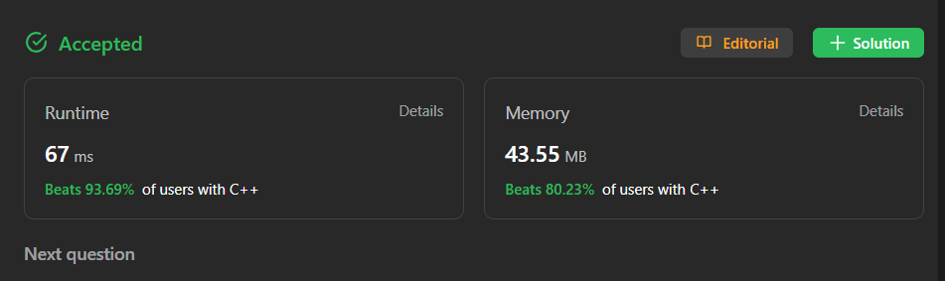



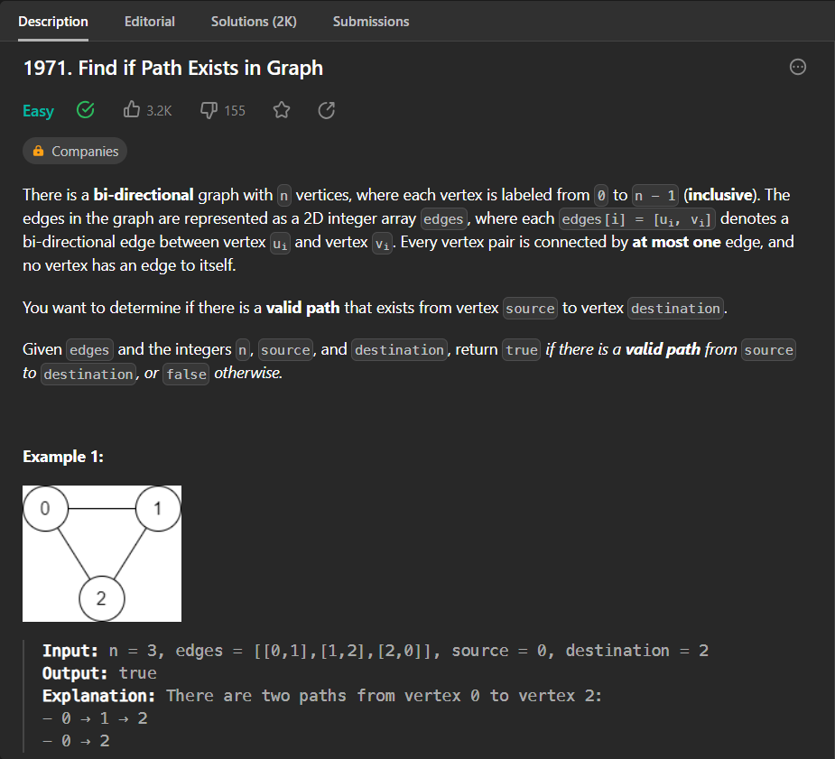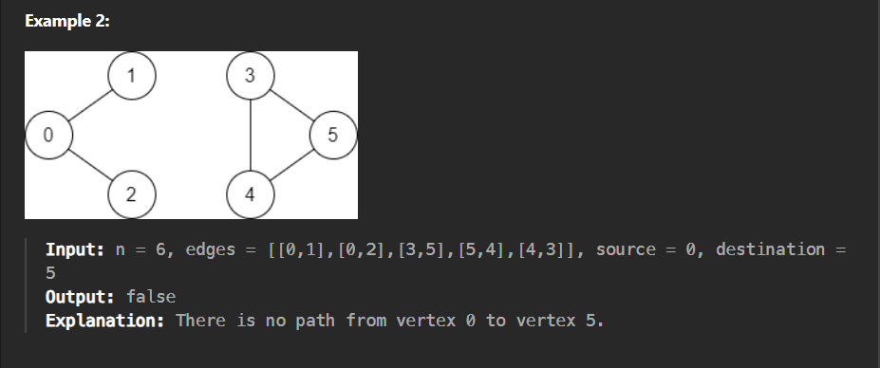

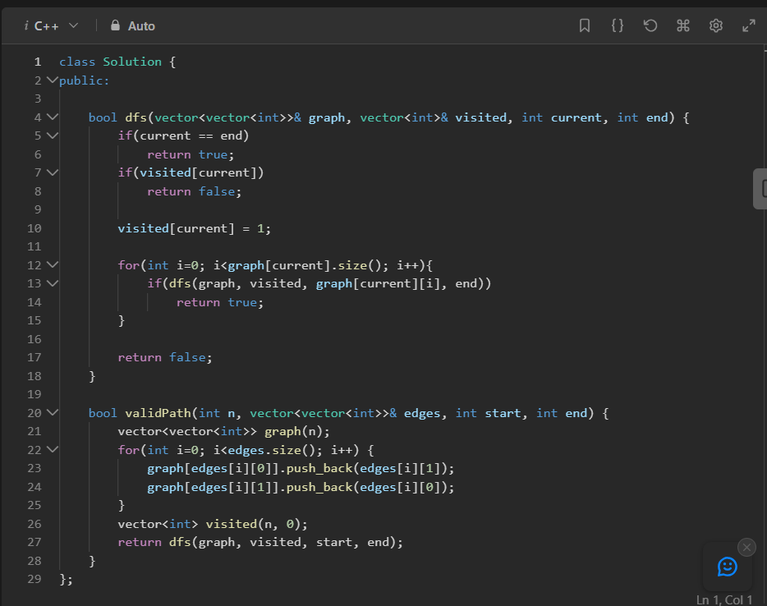

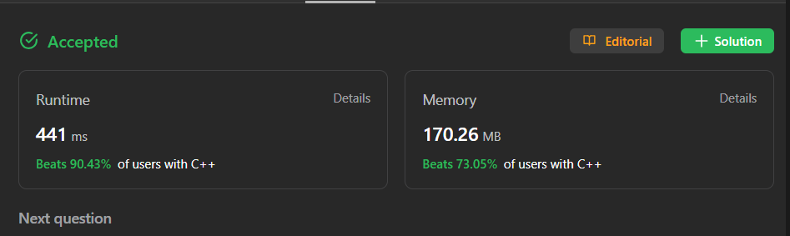



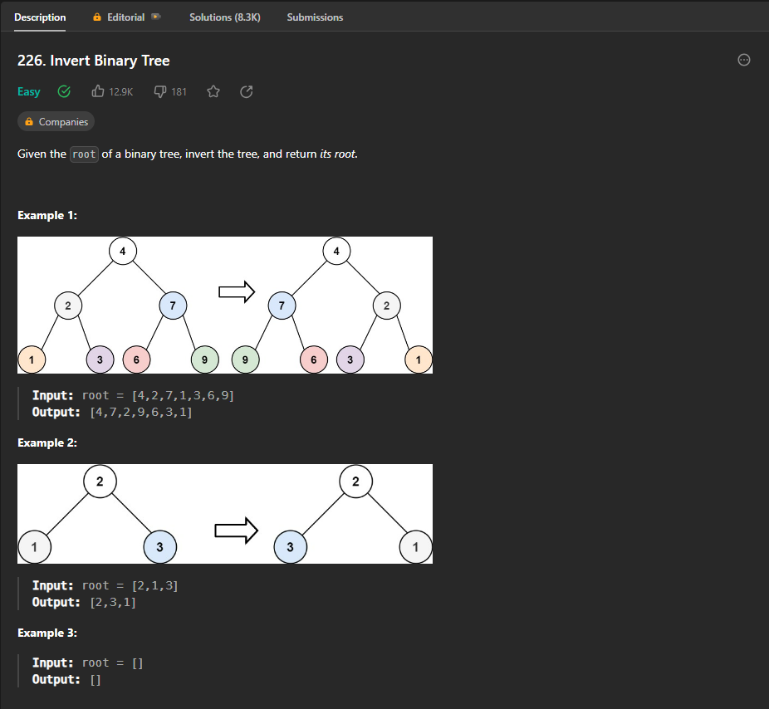

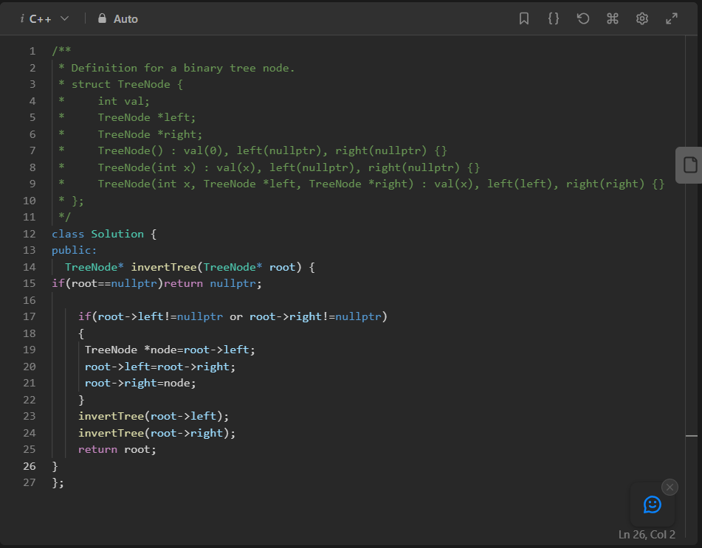

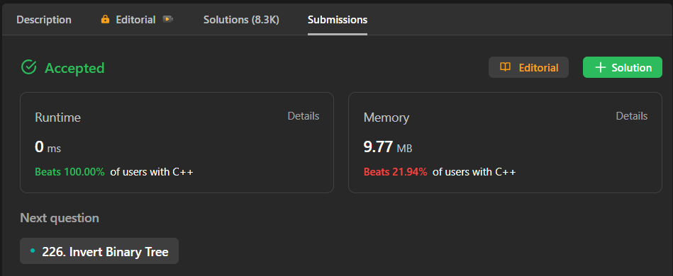

1. 