**19/07/23** **LAB-5**

**RIP configuration**

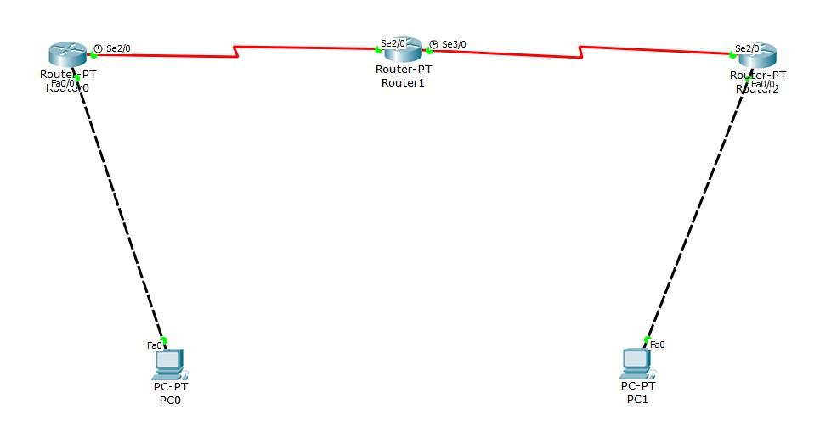**To overcome the drawback of default routing-we have Routing Information Protocol**

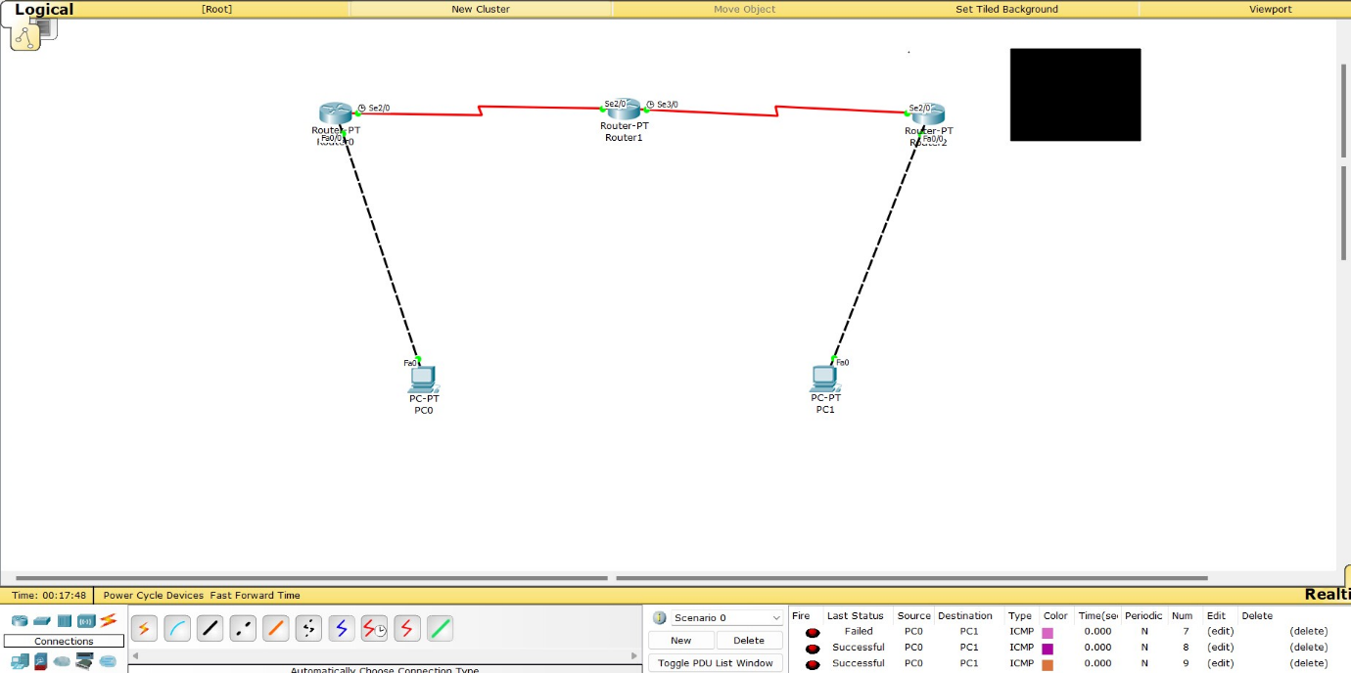

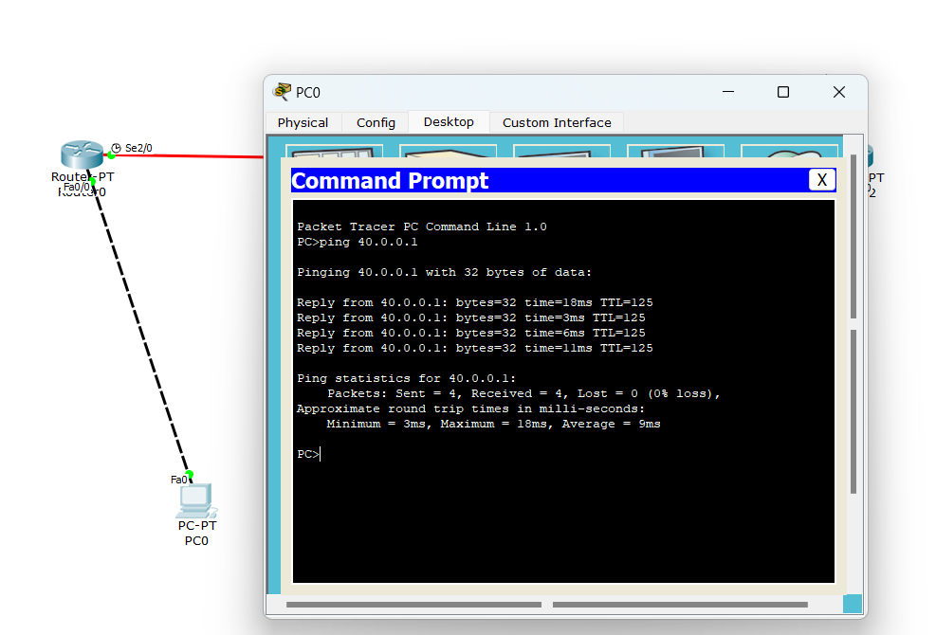PING from pc0 to pc1