**Week-3 bank database**

create database bank1;

use bank1;

create table branch

(branch_name varchar(20),

branch_city varchar(20),

assets float(20),

primary key(branch_name)

);

create table bankaccount

(accno int(20),

branch_name varchar(20),

balance float(20),

primary key(accno),

foreign key(branch_name) references branch(branch_name));

select * from branch,bankaccount;

create table bankcustomer

(

customer_name varchar(20),

customer_street varchar(20),

customer_city varchar(20),

primary key(customer_name)

);

create table depositer

(customer_name varchar(20),

accno int(20),

primary key(customer_name,accno),

foreign key(customer_name) references bankcustomer(customer_name) on delete cascade,

foreign key(accno) references bankaccount(accno) on delete cascade);

create table loan

(loan_num int,

branch_name varchar(20),

amount float(20),

primary key(loan_num),

foreign key(branch_name) references branch(branch_name) on delete cascade);

insert into branch values('SBI_Chamrajpet','Bangalore','50000'),('SBI Residency blre','Bangalore','10000'),('SBI Shivaji Road','Bombay','20000'),('SBI _ParlimentDelhi','Dehli','10000'),('SBI_jtmmtr_Delhi','Delhi','20000');

insert into bankaccount values('1','SBI_Chamrajpet','2000'),('2','SBI Residency blre','5000'),('3','SBI Shivaji Road','6000'),('4','SBI _ParlimentDelhi','9000'),('5','SBI_jtmmtr_Delhi',8000);

insert into bankaccount values('6','SBI Shivaji Road','4000');

insert into bankcustomer values('Avinash','Bull_Temple_Road','Bangalore'),('Dinesh','Bannergatta_Road','Bangalore'),('Mohan','NationalCollege_Road','Bangalore'),('Nikil','Akbar_Road','Delhi'),('Ravi','Prithviraj Road','Delhi');

set foreign_key_checks=0;

set global foreign_key_checks=0;

insert into depositer values('Avinash',1),('Dinesh',2),('Nikil',4),('Ravi',5),

('Avinash',8),('Nikil',9),('Dinesh',10),('Nikil',11);

insert into loan values(1,'SBI_Chamarajpet',1000),(2,'SBI_ResidencyRoad',2000),(3,'SBI_ShivajiRoad',3000),

(4,'SBI_ParlimentRoad',4000),(5,'SBI_Jantarmantar',5000);

select * from branch;

select * from bankaccount;

select * from bankcustomer;

select * from depositer;

select * from loan;

select branch_name,assets/100000 as assets_in_lakh

from branch;

select distinct customer_name

from depositer d, bankaccount b

where b.accno=d.accno and branch_name='SBI_ResidencyRoad'

having count(customer_name)>=2;

insert into bankaccount values(12,'SBI_ResidencyRoad','6000');

select customer_name

from depositer

where accno=10;

create view loansum as

select branch_name,sum(amount)

from loan

group by branch_name;

1. Display the branch name and assets from all branches in lakhs of rupees and rename  
   the assets column to 'assets in lakhs'.

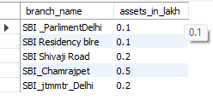  
select branch_name,assets/100000 as assets_in_lakh

from branch;

1. 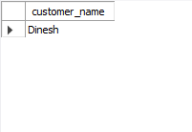Find all the customers who have at least two accounts at the same branch (ex.  
   SBI_ResidencyRoad).branch_name,assets/100000 as assets_in_lakh from branch;

select distinct customer_name

from depositer d, bankaccount b

where b.accno=d.accno and branch_name='SBI_ResidencyRoad'

having count(customer_name)>=2;

1. CREATE A VIEW WHICH GIVES EACH BRANCH THE SUM OF THE  
   AMOUNT OF ALL THE LOANS AT THE BRANCH

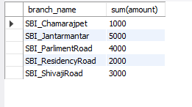create view loansum as

select branch_name,sum(amount)

from loan

group by branch_name;select * from branch;

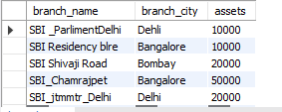

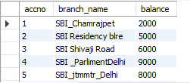select * from bankaccount;

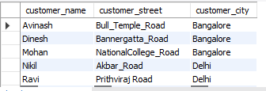select * from bankcustomer;

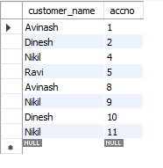

select * from depositer;

select * from loan;

