**VISVESVARAYA TECHNOLOGICAL UNIVERSITY**

**“JnanaSangama”, Belgaum -590014, Karnataka.**



**LAB REPORT on**

# Object Oriented Java Programming

***Submitted by***

## SUSHANTH(1BM21CS227)

***in partial fulfillment for the award of the degree of***

**BACHELOR OF ENGINEERING**

***in***

## COMPUTER SCIENCE AND ENGINEERING



**B.M.S. COLLEGE OF ENGINEERING**

**(Autonomous Institution under VTU)**

## BENGALURU-560019 Oct 2022-Feb 2023

**B. M. S. College of Engineering,**

**Bull Temple Road, Bangalore 560019**

(Affiliated To Visvesvaraya Technological University, Belgaum)

### Department of Computer Science and Engineering



#### CERTIFICATE

This is to certify that the Lab work entitled “**Object Oriented Java Programming**” carried out by **SUSHANTH(1BM21CS227),** who is bonafide student of **B. M. S. College of Engineering.** It is in partial fulfillment for the award of **Bachelor of Engineering in Computer Science and Engineering** of the Visvesvaraya Technological University, Belgaum during the year 2022-23. The Lab report has been approved as it satisfies the academic requirements in respect of Object Oriented Java Lab **- (21CS3PCOOJ)** work prescribed for the said degree.

|  |  |
| --- | --- |
| **Dr.Nandini Vineeth** | **Dr. Jyothi S Nayak** |
| Assistant professor | Professor and Head |
| Department of CSE | Department of CSE |
| BMSCE, Bengaluru | BMSCE, Bengaluru |

`

# Index Sheet

|  |  |  |
| --- | --- | --- |
| **Sl.**  **No.** | **Experiment Title** | **Page No.** |
| 1 | **Develop a Java program that prints all real solutions to the quadratic equation ax2+bx+c = 0. Read in a, b, c and use the quadratic formula. If the discriminate b2 -4ac is negative, display a message stating that there are no real solutions.** | 5 |
| 2 | **Develop a Java program to create a class Student with members usn, name, an array credits and an array marks. Include methods to accept and display details and a method to calculate SGPA of a student.** | 8 |
| 3 | **Develop a Java program to create a class Student with members usn, name, an array credits and an array marks. Include methods to accept and display details and a method to calculate SGPA of a student.** | 12 |
| 4 | **Develop a Java program to create an abstract class named Shape that contains two integers and an empty method named printArea( ). Provide three classes named Rectangle, Triangle and Circle such that each one of the classes extends the class Shape. Each one of the classes contain only the method printArea( ) that prints the area of the given shape** | 18 |
| 5 | **Develop a Java program to create a class Bank that maintains two kinds of account for its customers, one called savings account and the other current account. The savings account provides compound interest and withdrawal facilities but no cheque book facility. The current account provides cheque book facility but no interest. Current account holders should also maintain a minimum balance and if the balance falls below this level, a service charge is imposed. Create a class Account that stores customer name, account number and type of account. From this derive the classes Cur-acct and Sav-acct to make them more specific to their requirements. Include the necessary methods in order to achieve the following tasks:**  **a) Accept deposit from customer and update the balance.**  **b) Display the balance.**  **c) Compute and deposit interest**  **d) Permit withdrawal and update the balance**  **Check for the minimum balance, impose penalty if necessary and update the balance.** | 20 |
| 6 | **Write a program that demonstrates handling of exceptions in inheritance tree. Create a base class called “Father” and derived class called “Son” which extends the base class. In Father class, implement a constructor which takes the age and throws the exception WrongAge( ) when the input age=father’s age.** | 29 |
| 7 | **Write a program which creates two threads, one thread displaying “BMS College of Engineering” once every ten seconds and another displaying “CSE” once every two seconds.** | 33 |
| 8 | **Create a package CIE which has two classes- Student and Internals. The class Personal has members like usn, name, sem. The class internals has an array that stores the internal marks scored in five courses of the current semester of the student. Create another package SEE which has the class External which is a derived class of Student. This class has an array that stores the SEE marks scored in five courses of the current semester of the student. Import the two packages in a file that declares the final marks of n students in all five courses** | 37 |
| 9 |  |  |
| 10 |  |  |

**Course Outcome**

|  |  |
| --- | --- |
| **CO1** | **Apply the knowledge of Java concepts to find the solution for a given problem.** |
| **CO2** | **Analyse the given Java application for correctness/functionalities..** |
| **CO3** | **Develop Java programs / applications for a given requirement.** |
| **CO4** | **Conduct practical experiments for demonstrating features of Java** |

**LAB PROGRAM 1:**

**Develop a Java program that prints all real solutions to the quadratic equation ax2+bx+c = 0. Read in a, b, c and use the quadratic formula. If the discriminate b2 -4ac is negative, display a message stating that there are no real solutions.**

import java.util.Scanner;

import java.lang.Math;

class quadratic

{

double d,val;

void find(double a,double b,double c)

{

if(a==0)

{

System.out.println("a cannot be zero");

return;

}

else

{

d=(b*b)-(4*a*c);

}

if(d>0)

{

System.out.println("The roots are real and unique");

System.out.println((-b+Math.sqrt(d))/(2*a)+"\n"+(-b-Math.sqrt(d))/(2*a));

}

else if(d==0)

{

System.out.println("the roots are real and equal");

System.out.println(-b/(2*a));

}

else

{

System.out.println("there is no real root");

double img=Math.sqrt(-d)/(2*a);

double realpart=-b/(2*a);

System.out.println("real part is "+realpart+" imaginary part is "+img);

}

}

}

class Main

{

public static void main(String args[])

{

quadratic ob1=new quadratic();

System.out.println("enter the value of a,b and c");

Scanner sc=new Scanner(System.in);

double a1=sc.nextDouble();

double b1=sc.nextDouble();

double c1=sc.nextDouble();

ob1.find(a1,b1,c1);

}

}

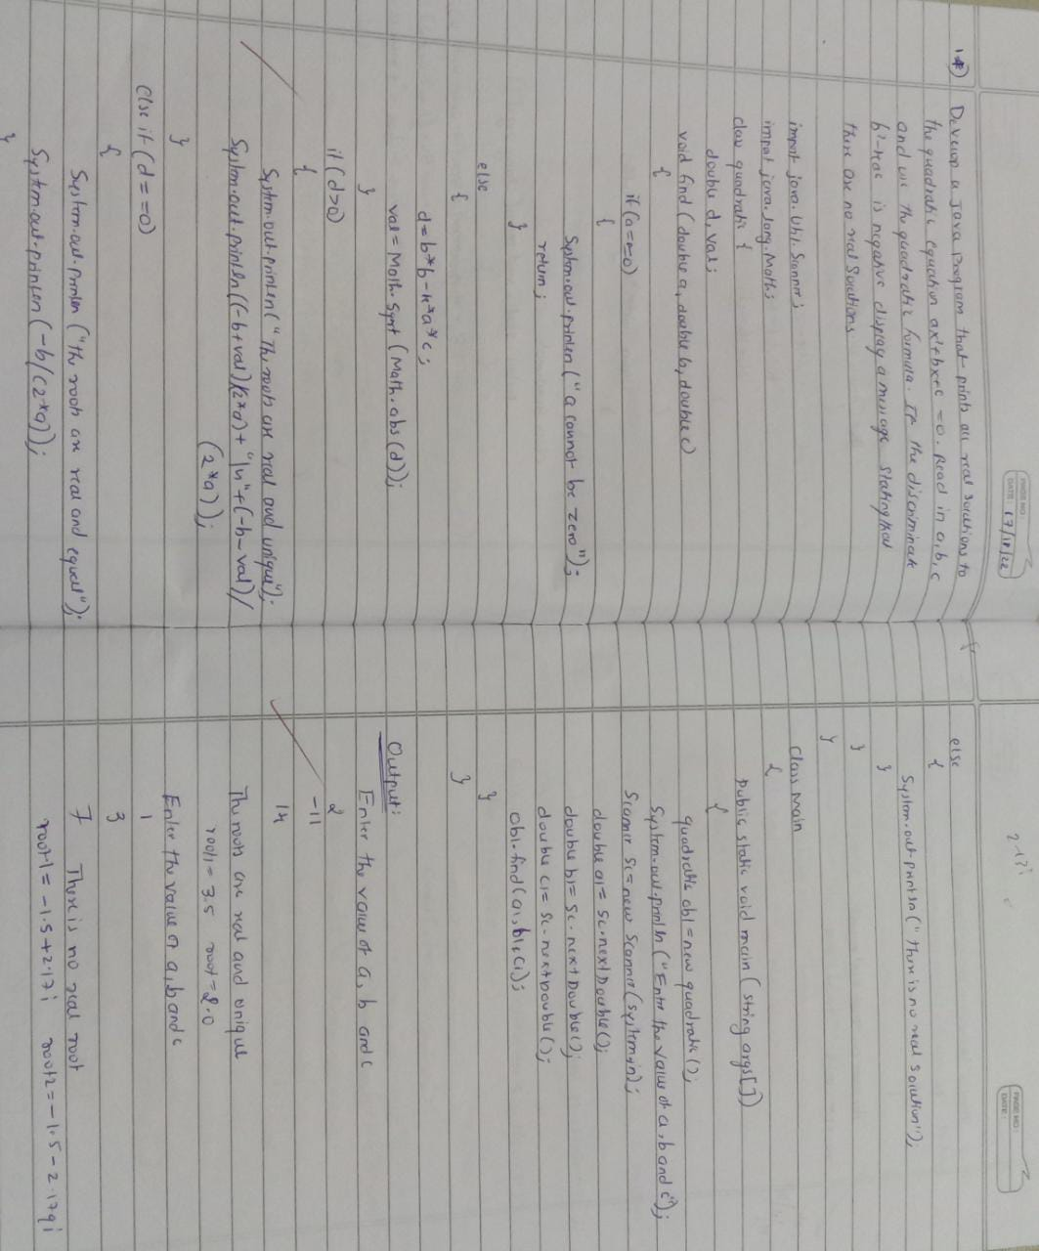**Observation:**

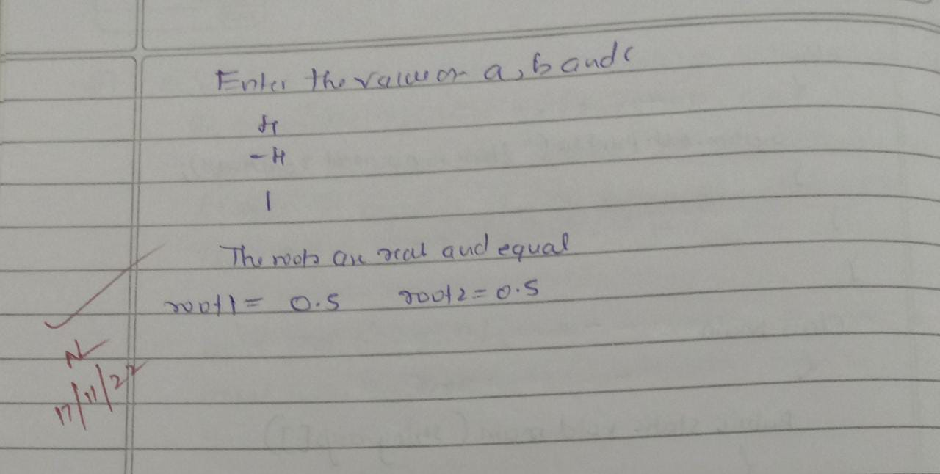

**Output:**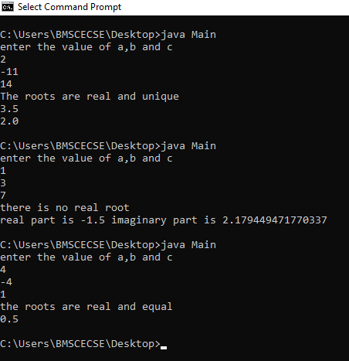

**LAB PROGRAM 2:**

**Develop a Java program to create a class Student with members usn, name, an array credits and an array marks. Include methods to accept and display details and a method to calculate SGPA of a student.**

import java.util.Scanner; class student

{float total;

Scanner sc=new Scanner(System.in); int marks[]=new int[10]; int credit[]=new int[10]; void display()

{ int i;

float sumofcredit=0;

System.out.println("Enter the name of the student:");

String name= sc.nextLine();

System.out.println("Enter the usn of the student:");

String usn=sc.nextLine();

System.out.println("Enter the credits for 5 subjects sequentially:");

for(i=0;i<5;i++)

{

credit[i]=sc.nextInt();

}

System.out.println("Enter the marks for 5 subjects sequentially:");

for(i=0;i<5;i++)

{

marks[i]=sc.nextInt();

}

for(i=0;i<5;i++)

{

total=total+credit[i];

}

for(i=0;i<5;i++)

{

if(marks[i]==100)

{

sumofcredit+=(10*credit[i]);

}

else sumofcredit+=((marks[i]/10)+1)*credit[i];

}

System.out.println("name="+name);

System.out.println("usn="+usn);

System.out.println("the sgpa of student is "+(sumofcredit/total));

}

}

class Main

{

public static void main(String args[])

{

student st=new student();

st.display();

}

}

**Observation:**

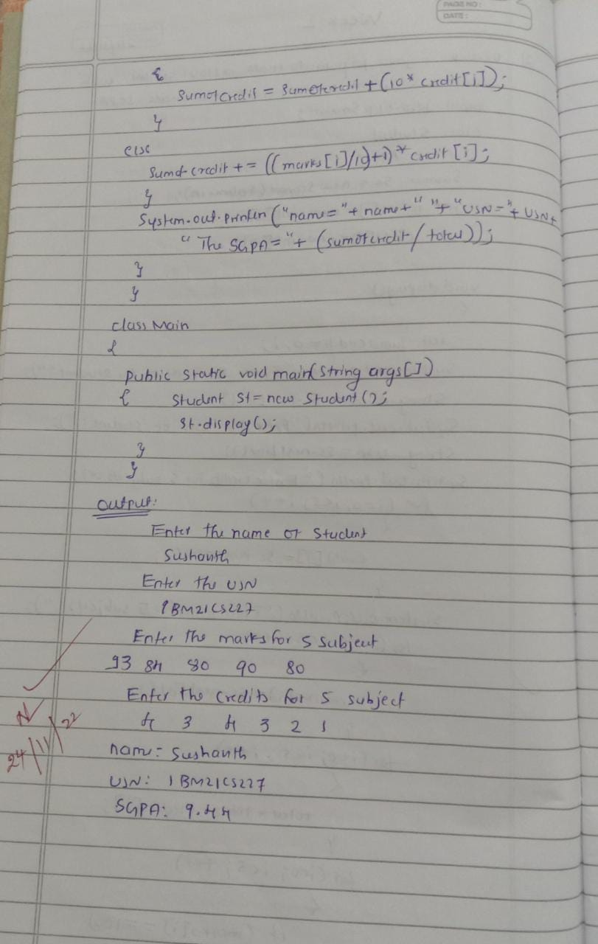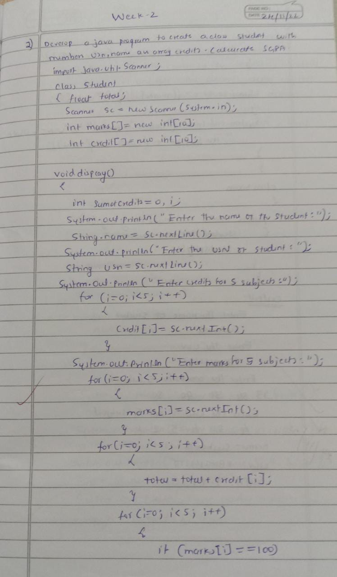

**Output:**

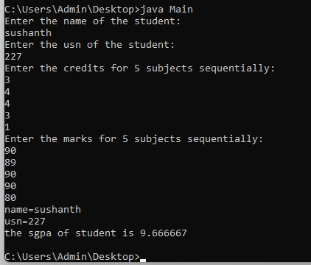

**LAB PRGRAM-3:**

**Create a class Book which contains four members: name, author, price, num_pages. Include a constructor to set the values for the members. Include methods to set and get the details of the objects. Include a toString( ) method that could display the complete details of the book. Develop a Java program to create n book objects.**

import java.util.Scanner;

class books {

int k,l;

String name,author;

Scanner sc=new Scanner(System.in);

int price;

int numpages;

books()

{

price=0;

numpages=0;

}

void get()

{

System.out.println("Enter the name of the book:");

name=sc.nextLine();

System.out.println("Enter the name of the author:");

author=sc.nextLine();

System.out.println("Enter the price of the book:");

price=sc.nextInt();

System.out.println("Enter the no of pages of the book:");

numpages=sc.nextInt();

}

public String toString()

{

return name+"\n"+author + "\n"+price+"\n"+numpages+"\n";

/*System.out.println(" name of the boook:");

System.out.println(name);

System.out.println(" name of the author:");

System.out.println(author);

System.out.println("price of book:");

System.out.println(price);

System.out.println("pages of book");

System.out.println(numpages);*/

}

}

class book

{

public static void main(String args[])

{

Scanner sc = new Scanner(System.in);

int i,n;

System.out.println(" enter number of books:");

n=sc.nextInt();

books[] arr=new books[n];

books ident=new books();

for(i=0;i<n;i++) {

arr[i]=new books();

arr[i].get();

}

for(i=0;i<n;i++)

{

System.out.println("\nThe details of book "+(i+1));

System.out.println(arr[i]);

System.out.println();

}

}

}

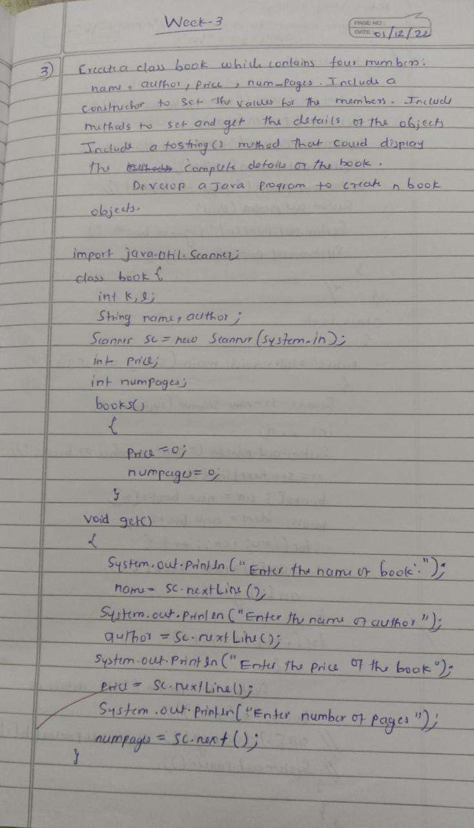**Observation:**

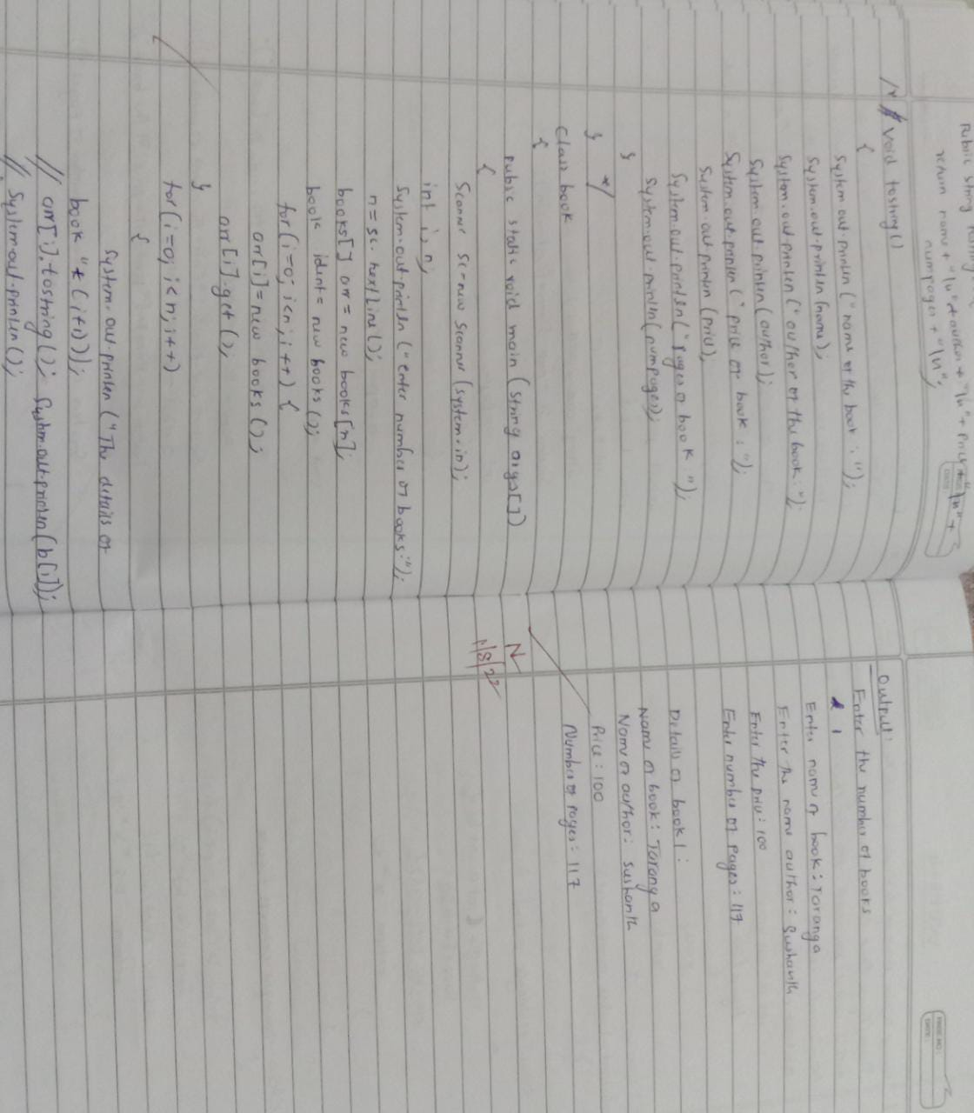

**Output:**

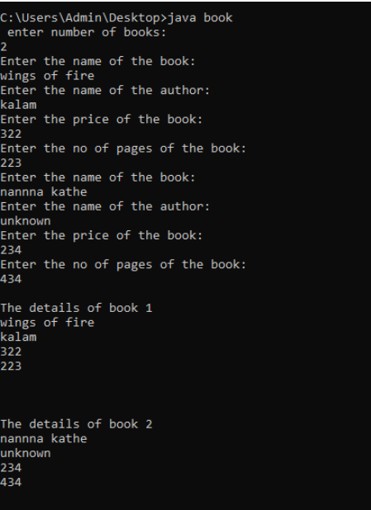

**LAB PROGRAM -4:**

**Develop a Java program to create an abstract class named Shape that contains two integers and an empty method named printArea( ). Provide three classes named Rectangle, Triangle and Circle such that each one of the classes extends the class Shape. Each one of the classes contain only the method printArea( ) that prints the area of the given shape**

abstract class figure

{

int x,y;

figure(int a,int b){

x=a;

y=b;

}

abstract double area();

}

class rectangle extends figure{

rectangle(int a,int b){

super(a,b);}

double area(){

return x*y;

}

}

class triangle extends figure{

triangle(int a, int b){

super(a,b);}

double area(){

return 0.5*x*y;

}

}

class circle extends figure{

circle(int a){

super(a,a);}

double area(){

return 3.14*x*x;

}

}

class abst{

public static void main(String args[]){

rectangle r=new rectangle(10,20);

triangle t=new triangle(4,5);

circle c=new circle(3);

figure f;

f=r;

double a1=f.area();

System.out.println("area of rectangle:"+a1);

f=t;

double a2=f.area();

System.out.println("area of triangle:"+a2);

f=c;

double a3=f.area();

System.out.println("area of circle:"+a3);

}

}

**Observation:**

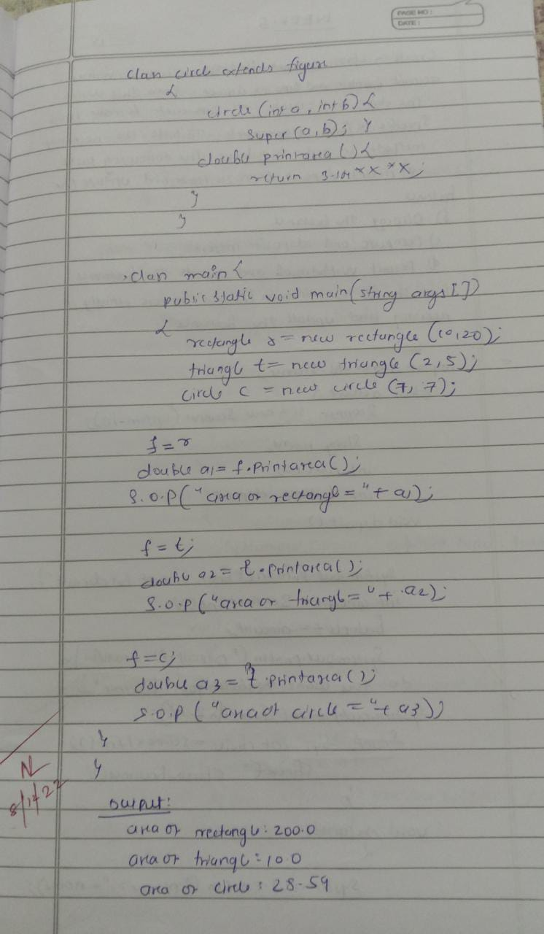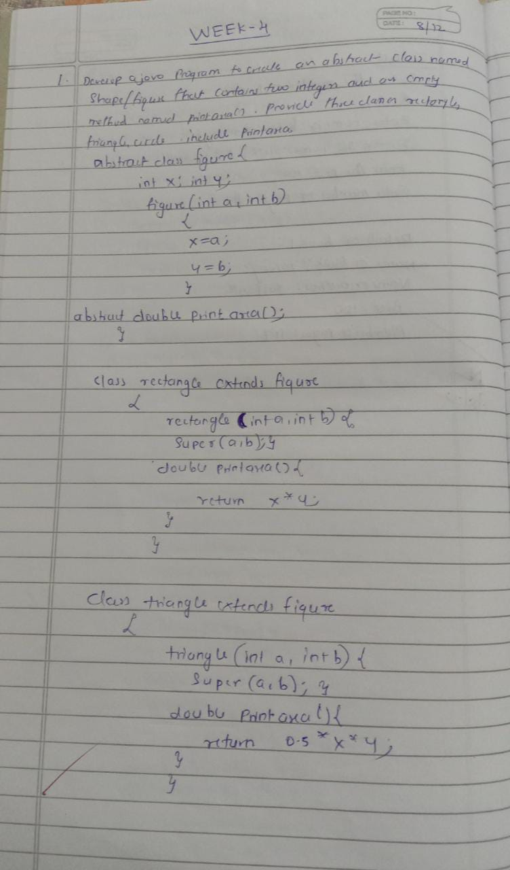

**Output:**

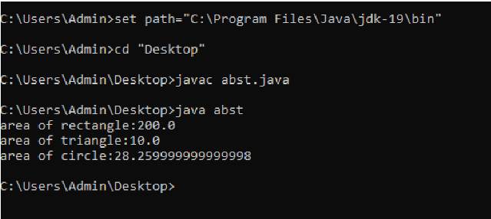

**LAB PROGRAM -5:**

**Develop a Java program to create a class Bank that maintains two kinds of account for its customers, one called savings account and the other current account. The savings account provides compound interest and withdrawal facilities but no cheque book facility. The current account provides cheque book facility but no interest. Current account holders should also maintain a minimum balance and if the balance falls below this level, a service charge is imposed. Create a class Account that stores customer name, account number and type of account. From this derive the classes Cur-acct and Sav-acct to make them more specific to their requirements. Include the necessary methods in order to achieve the following tasks:**

**a) Accept deposit from customer and update the balance.**

**b) Display the balance.**

**c) Compute and deposit interest**

**d) Permit withdrawal and update the balance**

**Check for the minimum balance, impose penalty if necessary and update the balance.**

import java.util.Scanner; class account{

Scanner sc=new Scanner(System.in); String name; int acct_no; int balance,deposit; // String type;

void deposit()

{

System.out.println("Enter amount for deposit\n"); int amount=sc.nextInt(); balance+=amount;

System.out.println("deposite is successfull\n do you want to check your balance"); System.out.println("1.YES\n2.NO"); int choice=sc.nextInt(); check_balance();

}

void details()

{

System.out.println("Name: "+name);

System.out.println("account_no: "+acct_no);

System.out.println("balance :"+balance);

}

void check_balance()

{

System.out.println("Balance is "+balance);

}

}

class savings extends account

{

double intrest=0; double rate=0.3;

savings(String n,int a,int d)

{

name=n; acct_no=a; deposit=d; balance=deposit;

}

void details()

{

System.out.println("Account_type: Savings"); super.details();

}

void withdrawal()

{

System.out.println("Enter amount for withdrawal\n"); int amount=sc.nextInt(); if(balance<amount)

System.out.println("You can withdraw the amount less than "+balance); else

{

balance=balance-amount;

System.out.println("withdrawal is successfull..!!!!!!! \nparty leda "+name);

System.out.println("\nDo you want check your balance\n"); System.out.println("1.YES\n2.NO"); int choice=sc.nextInt(); if(choice==1) check_balance(); return;

}

}

void get_intrest(int month)

{

month/=3;

intrest=(balance*rate*month/4);

System.out.println("Previous balance: "+balance+"\nIntrest: "+intrest+"\nCurrent balance:

"+(balance+intrest)); balance+=intrest;

}

}

class current extends account

{

int cheque_no;

current(String n,int a,int d)

{

name=n; acct_no=a; deposit=d; balance=deposit;

}

void details()

{

System.out.println("Account_type: Current"); super.details();

}

void withdrawal()

{

System.out.println("Do you have cheque"); System.out.println("1.YES\n2.NO"); int choice1=sc.nextInt(); if(choice1==1)

{

System.out.println("enter check number"); cheque_no=sc.nextInt();

}

System.out.println("Enter amount for withdrawal\n"); int amount=sc.nextInt(); if(balance<amount)

System.out.println("You can withdraw the amount less than "+balance); else

{

balance=balance-amount;

System.out.println("withdrawal is successfull..!!!!!!! \nparty leda "+name);

System.out.println("Do you want check your balance\n");

System.out.println("1.YES\n2.NO"); int choice=sc.nextInt(); if(choice==1) check_balance();

return;

}

}

}

class Main

{ public static void main(String[] args)

{

Scanner sc=new Scanner(System.in); String name; int acct_no; int deposit; int choice;

System.out.println("Enter your name\n"); name=sc.nextLine();

System.out.println("Type of account\n"); System.out.println("1.current\n2.Savings"); choice=sc.nextInt(); if(choice==2)

{

System.out.println("Enter amount for deposition and minimum amount 1000 rupees\n"); int x=sc.nextInt(); if(x<1000){

System.out.println("cant deposit less tahn 1000");

} else { deposit=x;

}

System.out.println("Create account number \n"); acct_no=sc.nextInt(); savings s=new savings(name,acct_no,deposit); while(true)

{

System.out.println("\nEnter your choice\n1.depost\n2.withdrawal\n3.Details of

account\n4.Intrest Calculate\n5.exit\n");

int ch=sc.nextInt(); if(ch==1)

s.deposit(); else if(ch==2)

{

s.withdrawal();

}else if(ch==3)

{

s.details(); }

else if(ch==4)

{ int m;

System.out.println("Enter duration for intrest calculate\n"); m=sc.nextInt();

s.get_intrest(m);

}

else if(ch==5)

break;

else

{

System.out.println("Invalid Choice..!!!!!\n"); }

}

}

else

{

System.out.println("Enter amount for deposition\n"); deposit=sc.nextInt();

System.out.println("Create account number \n"); acct_no=sc.nextInt(); current c=new current(name,acct_no,deposit); while(true)

{

System.out.println("\nEnter your choice\n1.depost\n2.withdrawal\n3.Details of account\n4.exit"); int ch=sc.nextInt(); if(ch==1)

c.deposit(); else if(ch==2)

{

c.withdrawal();

}else if(ch==3)

{

c.details(); }

else if(ch==4)

break;

else

{

System.out.println("Invalid Choice..!!!!!\n"); }

}

}

}

}

**Observation:**

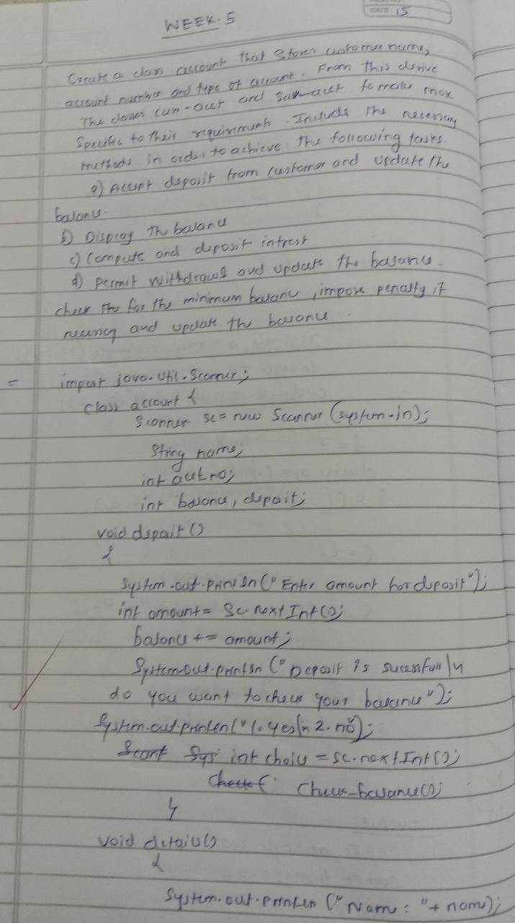

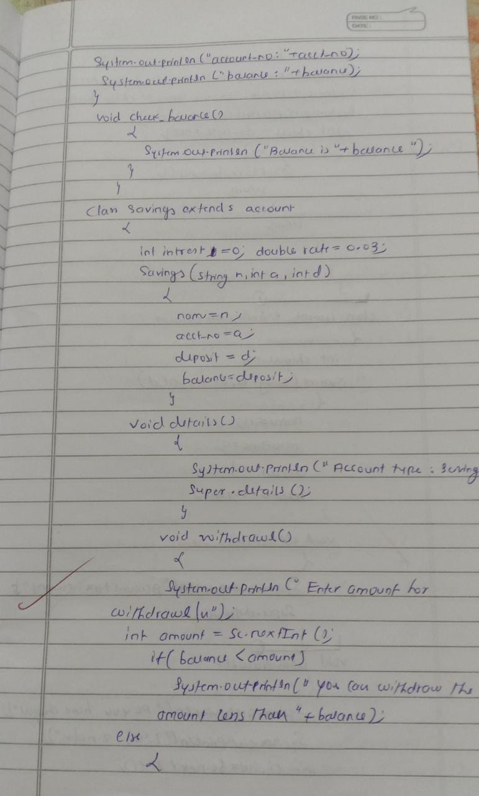

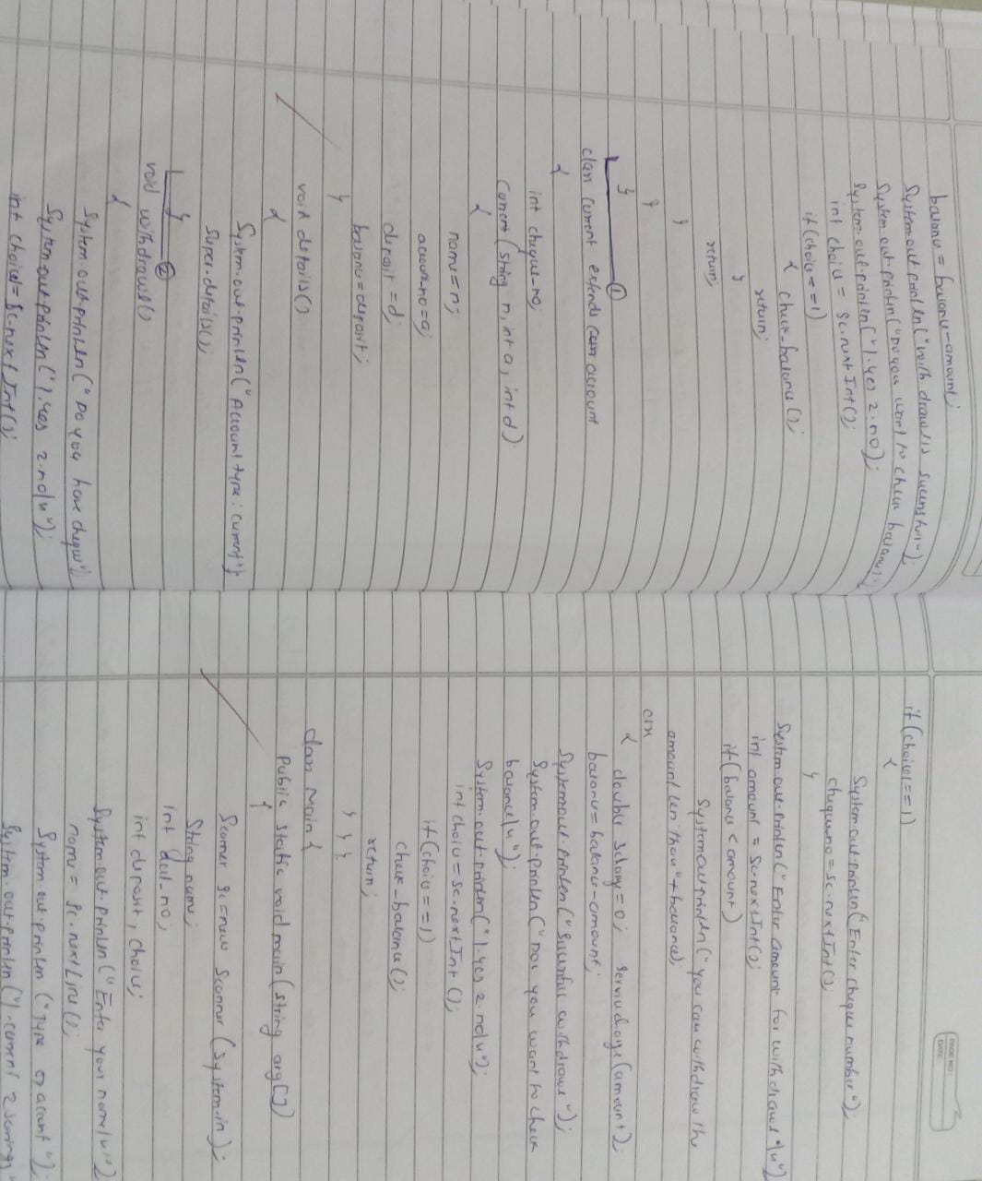

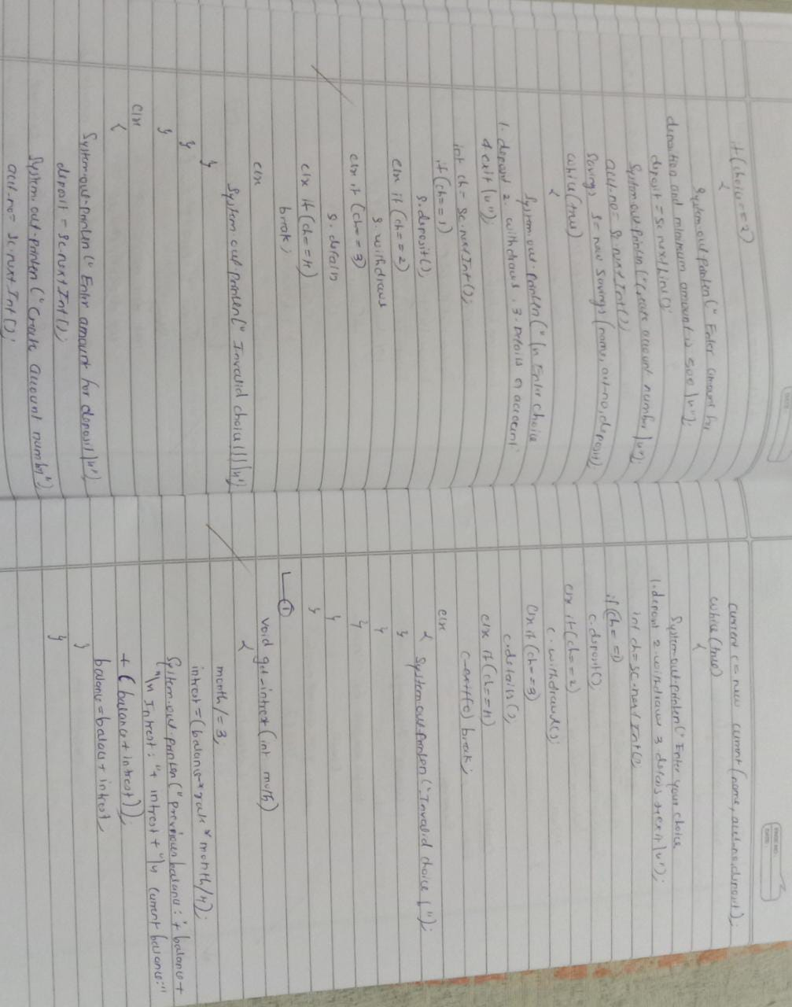

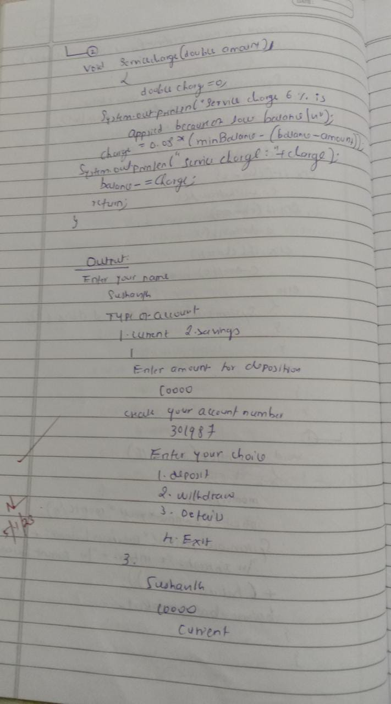

**Output:**

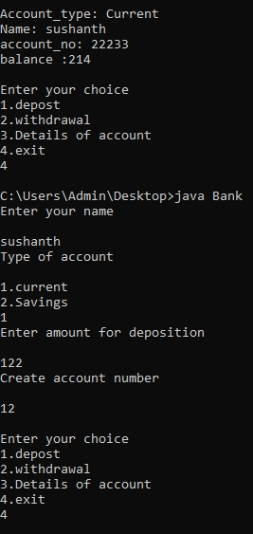

**LAB PROGRAM-6:**

**Write a program that demonstrates handling of exceptions in inheritance tree. Create a base class called “Father” and derived class called “Son” which extends the base class. In Father class, implement a constructor which takes the age and throws the exception WrongAge( ) when the input age=father’s age.**

import java.util.*; class father extends Exception{

int f_age; father(int a)

{

f_age=a;

}

public String toString()

{

return "Age : "+f_age+"\n Wrong age Input\nage should be greater than 0";

}

}

class son extends father{ int s_age; son(int f,int s)

{

super(f); s_age=s;

}

public String toString()

{

return "\nson age:"+s_age+"\n"+"father age:"+f_age+"\n"+"Son age should be less than father age";

}

}

class MyException

{

static void WrongAge(int f_age,int s_age) throws son,father

{

if(f_age<=0 || s_age<=0) throw new father(f_age); else if(s_age>=f_age) throw new son(f_age,s_age);

}

static void WrongAge(int age) throws father{

if(age<=0)

throw new father(age);

}

public static void main(String []args)

{

int f_age,s_age;

Scanner sc=new Scanner(System.in);

try{

System.out.println("Enter father age\n");

f_age=sc.nextInt();

WrongAge(f_age);

System.out.println("Enter son age\n");

s_age=sc.nextInt();

WrongAge(s_age);

WrongAge(f_age,s_age);

System.out.println("No error occured\n"+"son age:"+s_age+"\n"+"father age:"+f_age);

}

catch(son s)

{

System.out.println("\nError caught\n"+s);

}

catch(father f)

{

System.out.println("\nError caught\n"+f);

}

}

}

**Observation:**

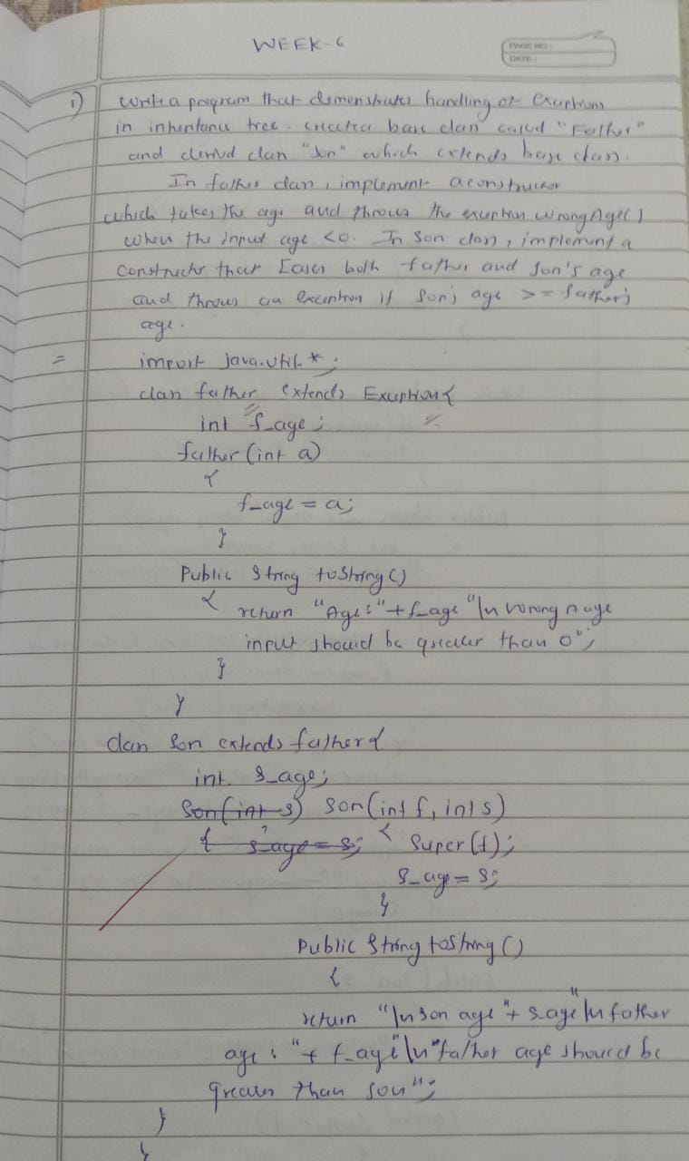

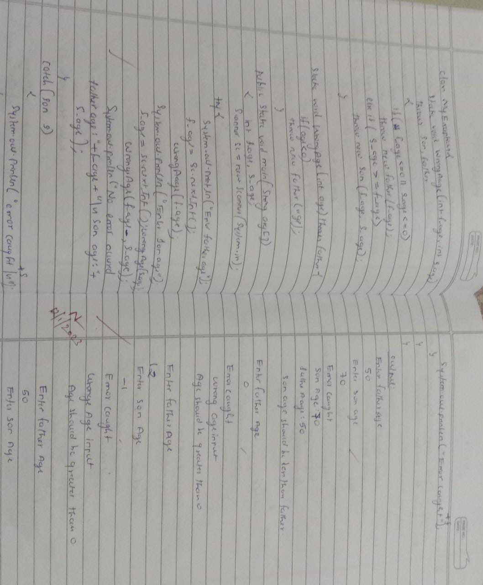

**Output:**

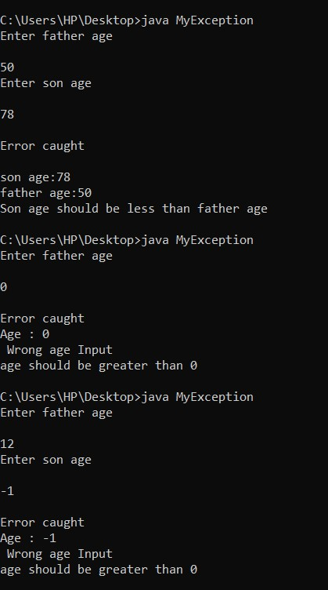

**LAB PROGRAM -7:**

**Write a program which creates two threads, one thread displaying “BMS College of Engineering” once every ten seconds and another displaying “CSE” once every two seconds.**

class one extends Thread{

public void run(){

try{

for(int i=0;i<5;i++){

System.out.println("\nBMS College of Engineering\n");

Thread.sleep(10000);

}

}

catch(InterruptedException e){

System.out.println("sleep exception\n");

}

}

}

class two extends Thread{ public void run(){ try{

for(int i=0;i<5;i++){

System.out.println("\nCSE\n");

Thread.sleep(2000);

}

}

catch(InterruptedException e){

System.out.println("sleep exception\n");

}

}

}

class Main{ public static void main(String args[]){

System.out.println("\nin main class\n");

new one().start();

new two().start();

}

}

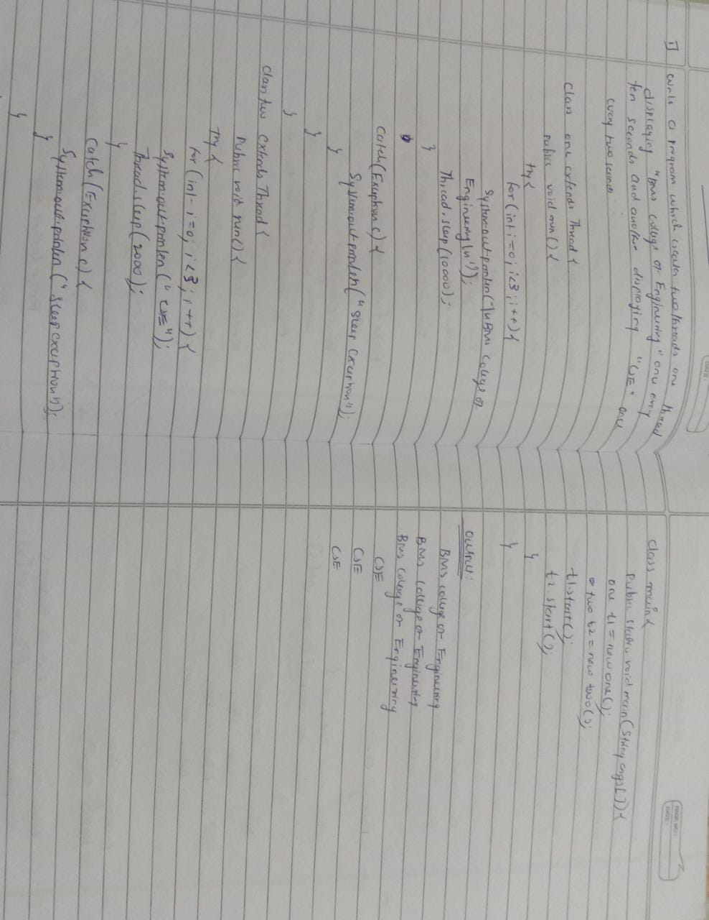**Observation:**

**Output:**

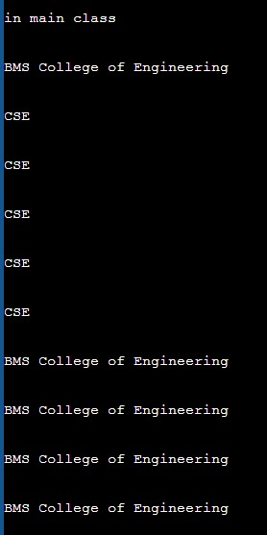

**OPEN ENDED PROGRAM -8:**

**Create a package CIE which has two classes- Student and Internals. The class Personal has members like usn, name, sem. The class internals has an array that stores the internal marks scored in five courses of the current semester of the student. Create another package SEE which has the class External which is a derived class of Student. This class has an array that stores the SEE marks scored in five courses of the current semester of the student. Import the two packages in a file that declares the final marks of n students in all five courses.**

package cie;

public class Internals {

public int internal[]=new int[5];

}

package cie;

public class Student {

public String name;

public int usn;

public int sem;

}

package see;

import cie.Internals;

public class External extends Student {

public int external[]=new int[5];

}

import java.util.Scanner;

import cie.Internals;

import see.External;

public class Marks {

public static void main(String[] args) {

int n;

Scanner sc=new Scanner(System.in);

System.out.println("enter number of students");

n=sc.nextInt();

External student[]=new External[n];

Internals internal[]=new Internals[n];

int final_marks[][]=new int[n][5];

for(int i=0;i<n;i++)

{

student[i]=new External();

internal[i]=new Internals();

System.out.println("Enter Student "+(i+1)+" name and usn and sem respectively");

student[i].name=sc.next();

student[i].usn=sc.next();

student[i].sem=sc.nextInt();

System.out.println("Enter Internal marks of 5 subject in respective order");

for(int j=0;j<5;j++)

{

internal[i].internal_marks[j]=sc.nextInt();

}

System.out.println("Enter external marks of 5 subject in respective order");

for(int k=0;k<5;k++)

{

student[i].external[k]=sc.nextInt();

}

}

for(int i=0;i<n;i++)

{

for(int j=0;j<5;j++)

final_marks[i][j]=internal[i].internal_marks[j]+(int)(student[i].external[j]/2);

}

for(int i=0;i<n;i++)

{

System.out.println("Name: "+student[i].name);

System.out.println("USN: "+student[i].usn);

System.out.println("Sem: "+student[i].sem);

System.out.println("Marks of the student "+(i+1)+" is");

for(int j=0;j<5;j++)

{

System.out.println(final_marks[i][j]);

}

}

}}

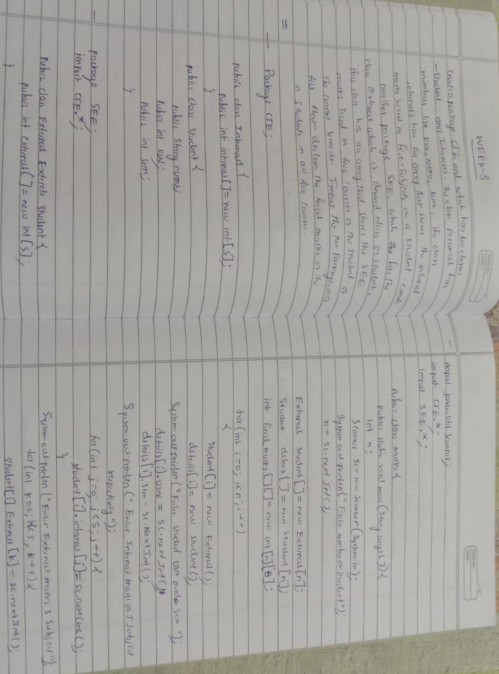**Observation:**

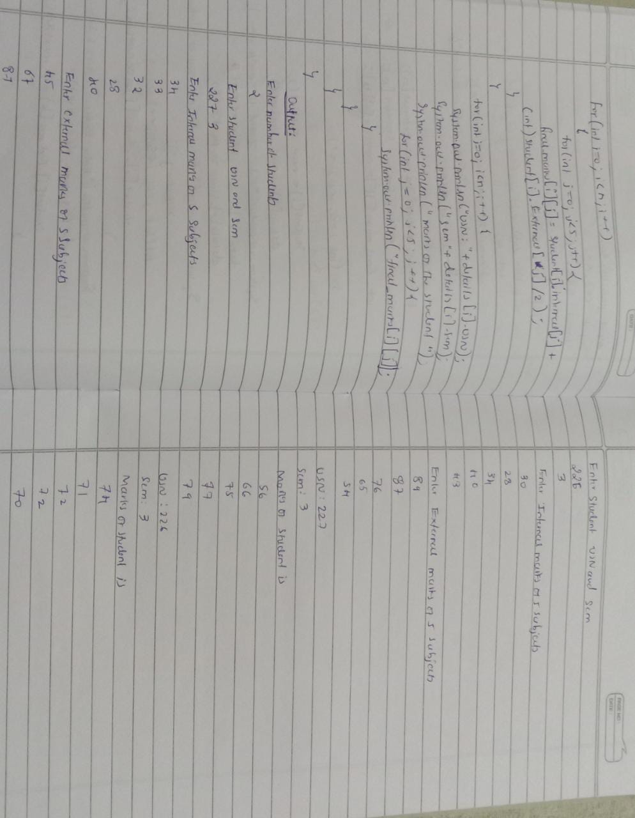

**Output:**

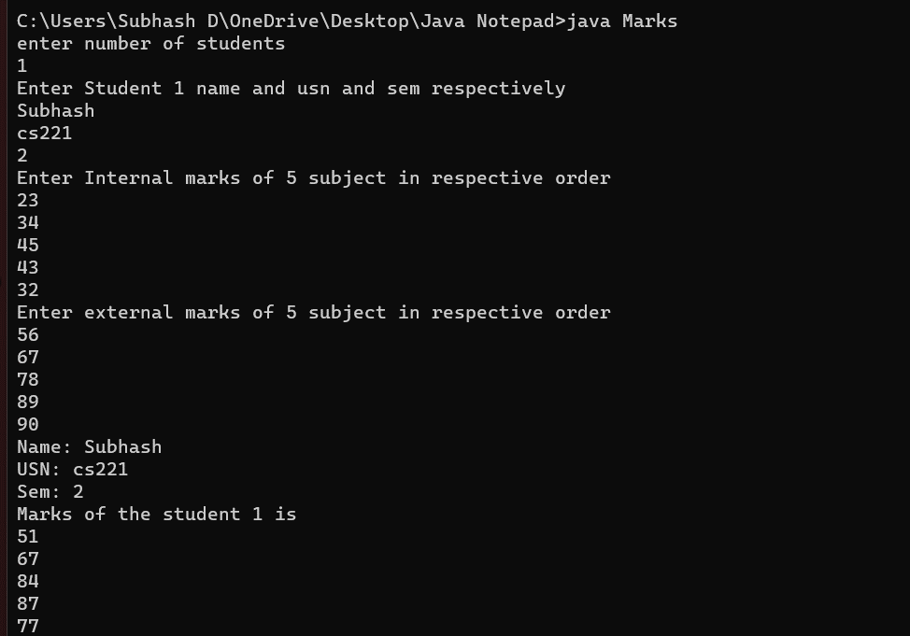

sushanthnnn