Detection of Crop Disease Using CNN and RAG-Enabled Decision Support
Sushanth Karkera
Department of Master of Computer Applications
A. J. Institute of Engineering and Technology Mangaluru, India
Email: sushanthpoojary8205@gmail.com

Abstract—Crop diseases can significantly reduce agricultural productivity when diagnosis is delayed or based only on manual visual inspection. This paper presents a web-based crop dis-ease detection and decision-support system that combines im-age validation, HSV-based region-of-interest (ROI) extraction, a VGG-16-based convolutional neural network (CNN) with spatial attention, confidence-aware prediction, and retrieval-augmented generation (RAG). The system uses the PlantVillage dataset and the project configuration covers 38 crop and disease classes. A crop-leaf image is uploaded through a responsive interface, preprocessed using OpenCV and TorchVision, and passed to the CNN for classification. Spatial attention is used to emphasize informative leaf regions, while a confidence threshold prevents uncertain predictions from being presented as definite diagnoses. For sufficiently confident disease predictions, a curated agri-cultural knowledge base supplies contextual information to a generative model so that the application can present symptoms, precautions, prevention, and management guidance. The appli-cation also provides scan history, downloadable PDF reports, and an optional agricultural-advisor consultation pathway. The supplied project materials do not contain a verified final test-set score; therefore, this paper does not fabricate aggregate accuracy, precision, recall, or F1-score values. Instead, it defines the evaluation protocol and reports the available diagnostic example. The system is intended as decision support and not as a replacement for qualified agricultural professionals.
Index Terms—crop disease detection, convolutional neural net-work, VGG-16, spatial attention, region of interest, PlantVillage, retrieval-augmented generation, decision support.

INTRODUCTION
Agriculture is closely connected with food security, rural livelihoods, and economic activity. Plant diseases are a per-sistent constraint on crop production because infections can reduce plant vigor, damage leaves and fruits, and ultimately re-duce yield. Disease symptoms often become visible on leaves before severe whole-plant damage occurs, making leaf-image analysis a useful starting point for early screening. The project synopsis identifies common disease manifestations such as leaf spot, blight, rust, powdery mildew, bacterial infection, mosaic, and leaf-curl symptoms as practical examples of problems that can affect crop health.
Conventional disease identification frequently depends on visual observation and access to experienced agricultural personnel. Such diagnosis can be effective, but it may be slow when an expert is unavailable, and visually similar symptoms can make early identification difficult. The software
requirements therefore frame the proposed application as a decision-support tool that accepts a crop-leaf image, performs preprocessing and ROI extraction, predicts a supported disease class, and provides grounded information to assist the user.
Deep learning, particularly convolutional neural networks, has become a common approach for image-based plant-disease classification because CNNs can learn hierarchical represen-tations of edges, textures, shapes, and more complex visual patterns. However, benchmark datasets can contain relatively clean images, whereas user-captured images may include soil, hands, pots, shadows, and other irrelevant regions. The proposed system addresses this issue through deterministic HSV-based green-region masking and ROI extraction before CNN inference. The model is based on VGG-16 with a custom spatial-attention mechanism so that informative spatial regions can receive greater emphasis.
A second limitation of a conventional classifier is that a disease label alone does not explain what the user should do next. The proposed workflow therefore adds a RAG-enabled decision-support layer. The predicted disease is used as retrieval context, relevant information is obtained from a curated agricultural knowledge base, and the retrieved context is supplied to a generative model. The resulting response can contain symptoms, precautions, preventive measures, man-agement guidance, and location-related information where available.
The major contributions of this work are: (1) an integrated image-to-decision-support workflow rather than classification alone; (2) HSV-based ROI preprocessing to reduce background influence; (3) VGG-16 feature extraction combined with spa-tial attention; (4) confidence-aware handling of uncertain pre-dictions; (5) RAG-based disease-specific guidance; and (6) a web application that connects prediction, reports, scan history, and optional agricultural-advisor consultation.

RELATED WORK
Plant disease recognition has been investigated using classi-cal machine learning, CNNs, transfer learning, attention mech-anisms, hybrid architectures, and multimodal systems. Albat-tah et al. presented a deep-learning framework for plant disease detection and classification and demonstrated the effectiveness of learned visual representations on PlantVillage [1]. The project synopsis further reports work using ROI localization

with DenseNet-77 and CenterNet, where 38 disease classes were considered and very high benchmark performance was obtained [1]. Such results illustrate the potential of deep learn-ing while also highlighting the difference between controlled datasets and practical field conditions.
Kochhar et al. proposed a three-tier crop-disease diagnosis framework with a deep-learning backend, API middleware, and mobile frontend [2]. Their study covered five crops and 19 leaf-based diseases and reported substantially different testing accuracies across crops. This variation is important because aggregate performance can hide class-specific weaknesses and because field images may differ from curated datasets.
Recent work has also focused on ROI extraction and hybrid models. The LDDHybridNet framework combines ROI extrac-tion, CNN feature extraction, Bi-LSTM sequence learning, attention, and Grad-CAM explainability [4]. The synopsis reports 98.91% accuracy on PlantVillage and 95.37% on FieldPlant, suggesting that evaluation on field images can provide a more realistic view of robustness. CNNAttLSTM similarly combines CNN, LSTM, and attention for jackfruit leaf disease classification [5]. Other studies have explored optimized LSTM-CNN models [6], CBAM attention with several CNN backbones [8], transfer-learning pipelines [9], weather-aware attention networks [10], and multimodal visual-textual disease analysis [11].
Although these approaches provide strong results, many in-troduce additional segmentation networks, optimization stages, sequence models, multimodal modules, or external sensor inputs. The present work instead uses deterministic HSV thresholding for ROI extraction and a VGG-16 plus spatial-attention classifier, with RAG placed after classification. This design separates visual diagnosis from knowledge retrieval and keeps the decision-support layer dependent on a curated knowledge source rather than treating generated text as the disease classifier itself.
The literature also motivates the use of attention. Attention mechanisms can emphasize informative disease regions while adding relatively small computational overhead compared with replacing the complete backbone. In this project, spatial at-tention is intended to make the classifier focus more strongly on relevant spatial locations in the extracted leaf region. The approach is therefore positioned as a practical combination of conventional CNN transfer learning, lightweight deterministic preprocessing, and knowledge-grounded generative support rather than as a new large-scale deep-learning architecture.

PROPOSED SYSTEM AND METHODOLOGY
- A. System Architecture and Workflow
The proposed system is implemented as a web-based ap-plication using Flask as the application backend, PyTorch and TorchVision for deep-learning operations, OpenCV for image processing, MongoDB for application and scan-history data, ReportLab for PDF generation, and a configured Gemini service for the generative recommendation layer. The end-to-end workflow contains image acquisition, validation, pre-processing, ROI extraction, CNN feature extraction, spatial

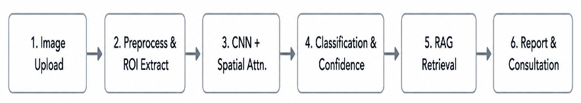

Fig. 1. High-level workflow of the proposed image-to-decision-support system.
attention, classification, confidence handling, RAG retrieval, decision support, reporting, and optional consultation.
- B. Image Validation and ROI-Based Preprocessing
Uploaded files are first validated for supported image type and readability. The image-processing pipeline then converts the OpenCV BGR representation to HSV color space. A configured green-region mask is used to emphasize the leaf region and reduce the influence of soil, hands, pots, and other background content. The extracted region is resized to the model input dimensions and normalized according to the model preprocessing requirements. During training, suitable augmentation can be applied to improve variation handling. The project materials explicitly identify ROI-oriented prepro-cessing as a mechanism for reducing background interference. Fig. 2 illustrates the feature-analysis pipeline available in the project material. It shows an RGB input, HSV leaf seg-mentation, contour-based ROI extraction, color-channel dis-tributions, early convolutional feature maps, deeper feature activations, an attention heatmap, and a condensed feature representation. These visualizations are used as explanatory evidence of the processing stages; they should not be in-terpreted as an independent quantitative evaluation of the
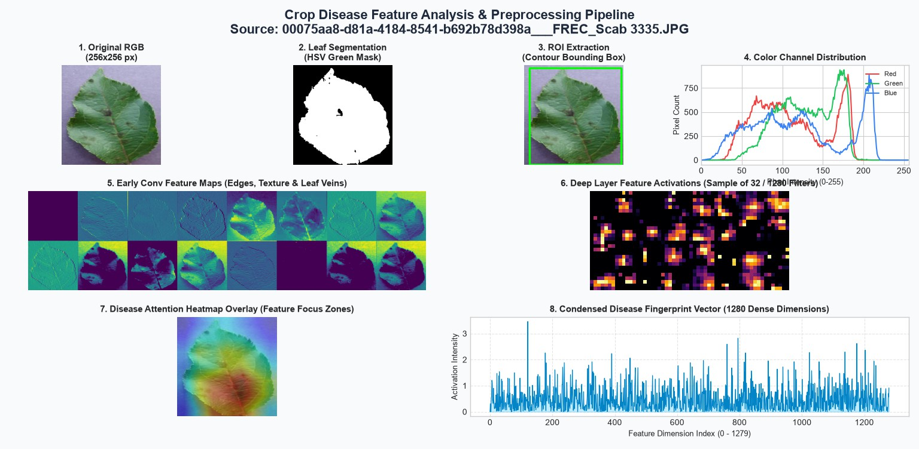
classifier.

Fig. 2. Crop-leaf preprocessing and feature-analysis pipeline from the project implementation
- C. VGG-16 CNN and Spatial Attention
The classification component uses a VGG-16 convolutional backbone. The convolutional layers learn hierarchical visual features, progressing from low-level edges and textures to-ward higher-level disease-related patterns. A custom spatial-attention block is positioned after feature extraction so that

spatial locations contributing to disease discrimination receive greater importance. The classifier head maps the attended representation to the defined crop/disease classes. The project configuration contains 38 PlantVillage classes.
The spatial attention mechanism is conceptually useful because disease symptoms are often localized rather than uni-formly distributed over an entire leaf. Lesions, discoloration, necrotic areas, spots, and texture changes may occupy only portions of the image. Attention can therefore complement ROI preprocessing: ROI reduces gross background interfer-ence, while spatial attention selects informative regions within the retained leaf content.
- D. Confidence-Aware Decision Handling
After classification, the system produces a predicted class and a confidence score. A predefined threshold is used to distinguish sufficiently confident predictions from uncertain outputs. Low-confidence predictions are not treated as definite diagnoses. This design is important for agricultural decision support because a visually ambiguous image can otherwise lead users to act on a weak prediction. The SRS specifies that the confidence threshold should be validated and that the system should communicate the decision-support nature of the result.
- E. RAG-Enabled Decision Support
Once a disease is detected with sufficient confidence, the predicted disease becomes the retrieval context for the knowledge layer. The retrieval component obtains relevant information from a curated agricultural knowledge base. The retrieved material is then provided as contextual information to the configured generative model. The generated response is intended to remain grounded in the retrieved context and can include symptoms, precautions, prevention, management measures, and location-related guidance where the knowledge source provides it.
This separation is important: the CNN performs image clas-sification, while RAG supports the interpretation and action stage. The generative model is not used as a substitute for the trained classifier. The SRS also states that the quality of generated guidance depends on the availability and quality of the curated knowledge base and that an active Gemini API configuration and internet connection are required where the external service is used.
- F. Application Modules and Data Management
The web application contains registration and login, image upload and validation, disease prediction, confidence display, scan history, PDF report generation, RAG-based recommen-dations, and agricultural-advisor support. MongoDB is used for user information, detection history, advisor information, and appointment data. A detection record can include a user identifier, crop, disease, confidence value, image path, and timestamp. Appointment records connect a farmer/user with an advisor, selected date and time slot, generated report path, and booking status.
The consultation module complements rather than replaces automated diagnosis. Users can view available advisor exper-tise and appointment slots and request professional assistance. This human-in-the-loop pathway is especially relevant when an image is uncertain or when management decisions require local agricultural knowledge.

EXPERIMENTAL SETUP AND EVALUATION
- A. Dataset and Data Preparation
The primary dataset is PlantVillage, consisting of labeled healthy and diseased plant-leaf images. The project uses the selected crop/disease labels corresponding to the 38 classes configured for the application. The data pipeline includes image validation, resizing, normalization, ROI extraction, and training-time augmentation. The class-label mapping must remain identical between training and inference so that the output index is interpreted correctly by the web application.
The dataset provides a controlled starting point for model development, but the project documentation recognizes the need for additional evaluation on field-acquired images. Real-world images can differ in lighting, camera quality, back-ground clutter, leaf orientation, occlusion, and disease severity. Consequently, strong performance on PlantVillage should not automatically be interpreted as equivalent performance under field conditions.
- B. Software and Hardware Environment
The implementation uses Python with Flask, PyTorch, TorchVision, OpenCV, ReportLab, MongoDB, HTML/CSS/JavaScript, and a configured Gemini API. Development can be performed on Windows, macOS, or Linux. The SRS specifies an Intel Core i5/i7-equivalent processor or better, at least 8 GB RAM, 256 GB or greater SSD storage, and a GPU for deep-learning training when available. Internet connectivity is required for external API integration and MongoDB Atlas deployments.
- C. Evaluation Metrics
Classification should be evaluated using accuracy, precision, recall, and F1-score on an independent test split. Class-wise results and a confusion matrix are important because visually similar diseases can produce errors that are hidden by an aggregate score. The SRS also lists RMSE as an additional evaluation metric; however, RMSE is not a standard primary metric for multiclass classification, so it should be reported only if the project evaluation framework requires it and its definition is stated clearly. The final paper should replace the placeholders below with measurements calculated from the exact checkpoint and fixed test set used by the deployed application.
- D. Inference Performance Requirement
The SRS specifies a target inference latency below 200 ms per image, measured after image preprocessing and excluding image upload, RAG response generation, database operations,

TABLE I
Evaluation metrics to be reported for the fixed experiment.

Metric | Validation | Independent Test
Accuracy | [insert %] | [insert %]
Precision | [insert %] | [insert %]
Recall | [insert %] | [insert %]
F1-score | [insert %] | [insert %]
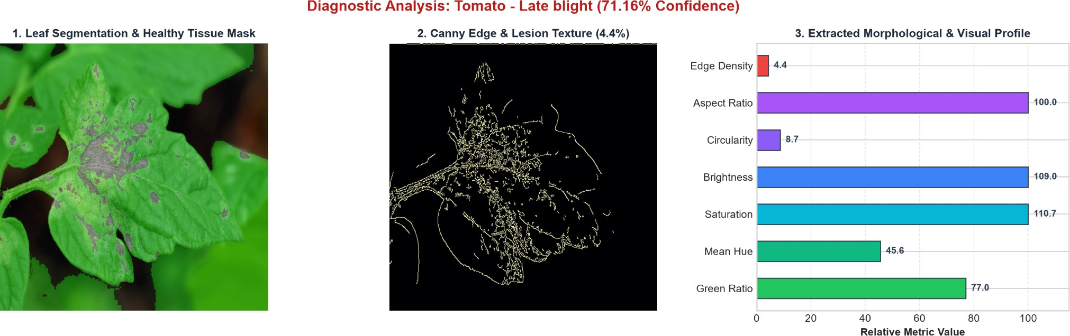

Fig. 3. Example diagnostic analysis for tomato late blight with 71.16% reported confidence.

and PDF generation. This separation is useful because end-to-end response time includes several non-ML operations. The deployed system should record the model inference time during testing so that the requirement can be checked inde-pendently of network and report-generation latency.

RESULTS AND DISCUSSION
- A. Available Diagnostic Evidence
The supplied project materials do not contain a verified final test-set confusion matrix or final accuracy, precision, recall, and F1-score for the exact deployed checkpoint. Accordingly, numerical aggregate results are not invented in this paper. The implementation material does, however, contain an example diagnostic analysis for a tomato late-blight sample with a reported model confidence of 71.16%. The example includes leaf segmentation, a Canny edge and lesion-texture view, and an extracted morphological/visual profile.
The 71.16% value should be interpreted as the confidence associated with the shown example, not as overall model accuracy. The example demonstrates how the application can expose intermediate visual information while producing a disease prediction. A complete research evaluation should additionally report class-wise precision and recall, a confusion matrix, and comparisons with appropriate baselines using the same train/test split.
- B. Discussion of the Proposed Design
ROI preprocessing and spatial attention address different sources of visual variation. HSV-based masking is intended to remove large portions of irrelevant background before infer-ence, while attention emphasizes informative spatial locations inside the processed image. Their combined effect should therefore be tested with an ablation experiment: baseline CNN without ROI or attention, CNN with ROI, CNN with attention, and the complete ROI-plus-attention configuration. The supplied materials identify this controlled comparison as future validation rather than reporting measured values.
Confidence-aware handling is another practical safeguard. A high-confidence prediction can trigger retrieval and report generation, whereas an uncertain result can be presented as inconclusive and directed toward additional image capture or advisor consultation. The exact threshold should be calibrated on a validation set rather than selected only from intuition.
The RAG layer adds a second form of value beyond classification. A farmer or agricultural worker generally needs actionable information rather than only a disease name. Re-trieval provides a controlled knowledge source, while gener-ation formats that information into a readable response. The architecture also allows the knowledge base to be improved independently of CNN retraining. Nevertheless, generated rec-ommendations should be reviewed against the curated source and should retain the application’s warning that the system is decision support rather than professional diagnosis.
The overall system is therefore best evaluated at three levels: visual classification quality, decision-support grounding and usefulness, and application-level usability. Classification metrics measure whether the disease label is correct; retrieval and expert review can assess whether the advice is relevant and grounded; and application testing can assess whether image upload, history, reports, and appointment booking behave correctly.
The SRS defines a modular separation between the web interface, Flask backend, preprocessing and ROI layer, VGG-
16 plus spatial attention classifier, RAG knowledge layer, Gemini API, MongoDB storage, and ReportLab reporting module. This modular organization is useful because each component has a clear responsibility. The interface handles user interaction, the backend coordinates requests, the ML layer produces a disease class and confidence, the RAG layer retrieves and formats supporting knowledge, and the database preserves application records.

- D. End-to-End Implementation Considerations
The inference path begins when an authenticated user selects a crop-leaf image. The application validates the file before any model operation is performed. The preprocessing stage then performs resizing, color-space processing, normal-ization, and ROI extraction. The processed tensor is passed to the VGG-16-based network and spatial-attention block. The resulting class probabilities are converted into a predicted class and confidence value. If the confidence is below the configured threshold, the system should return an uncertainty message rather than automatically generating strong management in-structions. If the result is sufficiently confident, the disease label becomes the retrieval context for the RAG layer.
The application then stores the relevant detection infor-mation in MongoDB and can create a PDF report using ReportLab. The report is intended to contain the detected dis-ease, confidence information, and retrieved decision-support content. Scan history allows a user to revisit previous results, while the consultation module provides a human-assistance pathway. This sequence keeps the diagnosis record, generated

report, and optional appointment information associated with the user’s application data.
- E. Security, Safety, and Reliability
The SRS specifies authentication, password hashing, protec-tion of API and database credentials, validation of uploaded files, and access control for scan history and appointment information. These requirements are important because the application stores user information and potentially sensitive location or consultation data. API keys should remain server-side and should never be embedded in browser code or committed to a public repository. Model weights and class-label mappings should also be protected against unauthorized modification because changes can affect prediction behavior.
Safety is addressed through confidence-aware handling and explicit communication that the system is a decision-support tool. The system should not represent a low-confidence pre-diction as a confirmed diagnosis. The RAG component should use a curated knowledge base and should preserve the distinc-tion between retrieved agricultural information and generated natural-language presentation. For difficult or uncertain cases, the advisor module provides a route to professional review.
- F. Recommended Experimental Protocol
A reproducible evaluation should begin with a fixed train, validation, and independent test split, with the same class-label mapping used by training and deployment. The complete model should then be evaluated on the untouched test set. In addition to overall accuracy, precision, recall, and F1-score, per-class results should be reported so that visually similar diseases can be identified as error-prone categories. A normalized confusion matrix can show which classes are most frequently confused.
An ablation study should separately test the effect of ROI extraction and spatial attention. A suitable comparison is: (1) baseline CNN without ROI or attention, (2) CNN with ROI preprocessing only, (3) CNN with spatial attention only, and
(4) the complete ROI-plus-attention system. The same data split and training protocol should be used for all variants. This experiment would provide evidence for the claimed contribu-tion of preprocessing and attention instead of assuming that the complete pipeline is superior.
The decision-support layer should also be evaluated inde-pendently of classification accuracy. A set of disease queries can be reviewed by an agricultural expert for factual relevance, completeness, grounding in the retrieved source, and clarity of recommendations. Retrieval quality and generation quality should not be conflated with CNN classification accuracy. Fi-nally, application-level tests should measure inference latency, report generation time, database reliability, error handling, and the success of advisor appointment operations.

LIMITATIONS
The principal limitation is the absence of a verified final numerical evaluation in the supplied materials. Therefore, the present manuscript describes the evaluation protocol but does
TABLE II
Model comparison template for the final experiment.

Model Accuracy Precision F1-score

not claim a final accuracy. A second limitation is dataset-domain mismatch: PlantVillage is useful for development but does not fully represent the diversity of field photographs. Third, HSV-based ROI extraction depends on color assump-tions and may be affected by unusual lighting, background colors, shadows, or leaves with atypical appearance. Fourth, the quality of RAG output depends on the completeness and reliability of the curated knowledge base and on the availability of the external generative API. Finally, advisor availability, internet connectivity, and database access affect the complete decision-support workflow.

CONCLUSION AND FUTURE WORK
This paper presented a web-based crop disease detection and decision-support system integrating HSV-based ROI pre-processing, a VGG-16 CNN with spatial attention, confidence-aware prediction, RAG-enabled agricultural guidance, PDF reporting, scan history, and optional advisor consultation. The design moves beyond a disease label by connecting visual classification with retrieved, disease-specific information. The architecture also separates the responsibilities of the CNN and the knowledge-generation layer, making the system easier to reason about and extend.
Future work should first validate the exact deployed check-point on an independent test set and report accuracy, precision, recall, F1-score, class-wise confusion, and inference latency. The project documentation also identifies field-image evalua-tion under varied lighting and backgrounds, expansion to addi-tional crop and disease classes, broader cross-dataset testing, improved and more systematically curated RAG knowledge bases, multilingual guidance in regional Indian languages, and additional explainability and model-monitoring features. An expert-reviewed evaluation of the generated recommenda-tions would be particularly valuable because decision-support quality cannot be inferred from image-classification accuracy alone.

ACKNOWLEDGMENT
The author would like to thank the Department of Master of Computer Applications, A. J. Institute of Engineering and Technology, Mangaluru, for academic guidance and support during the development of this project.
References
- W. Albattah, M. Nawaz, A. Javed, M. Masood, and S. Albahli, “A novel deep learning method for detection and classification of plant diseases,” Complex & Intelligent Systems, vol. 8, pp. 507–524, 2022, doi: 10.1007/s40747-021-00536-1.

- A. Kochhar, G. Narang, S. Patel, H. Kaur, C. Singla, B. Pateriya, and A. Galdelli, “A three-tier deep learning framework with mobile application integration for multi-crop disease diagnosis,” Discover Artificial Intelli-gence, vol. 6, art. no. 358, 2026, doi: 10.1007/s44163-026-01062-0.
- H. N. Ngugi, A. E. Ezugwu, A. A. Akinyelu, and L. Abualigah, “Rev-olutionizing crop disease detection with computational deep learning: A comprehensive review,” Environmental Monitoring and Assessment, vol. 196, art. no. 302, 2024, doi: 10.1007/s10661-024-12454-z.
- C. Santoshi, S. K. Mandala, and L. R. Raju, “LDDHybridNet: An ROI-aware CNN–LSTM hybrid framework for accurate and early leaf disease detection in precision agriculture,” Scientific Reports, vol. 16, art. no. 20284, 2026, doi: 10.1038/s41598-026-50398-1.
- G. Tuteja et al., “CNNAttLSTM: An attention-enhanced CNN–LSTM architecture for high-precision jackfruit leaf disease classification,” Frontiers in Plant Science, vol. 16, art. no. 1720471, 2026, doi: 10.3389/fpls.2025.1720471.
- M. A. Patil and M. Manohar, “Plant leaf disease classification using optimal tuned hybrid LSTM-CNN model,” SN Computer Science, vol. 4, art. no. 710, 2023, doi: 10.1007/s42979-023-02245-7.
- “AgroVisionNet,” Scientific Reports, vol. 16, art. no. 2479, 2026, doi: 10.1038/s41598-025-32384-1.
- P. Alirezazadeh, M. Schirrmann, and F. Stolzenburg, “Improving deep learning-based plant disease classification with attention mechanism,” Gesunde Pflanzen, vol. 75, pp. 49–59, 2023, doi: 10.1007/s10343-022-00796-y.
- B. Muthu and C. Cherubini, “A novel approach for crop disease detec-tion using transfer-learning-based deep convolutional neural networks,” Neural Computing and Applications, vol. 38, art. no. 500, 2026, doi: 10.1007/s00521-026-12216-7.
- G. Dai, J. Fan, Z. Tian, C. Wang, et al., “PPLC-Net: Neural network-based plant disease identification model supported by weather data augmentation and multi-level attention mechanism,” Journal of King Saud University–Computer and Information Sciences, vol. 35, art. no. 101555, 2023, doi: 10.1016/j.jksuci.2023.101555.
- X. Wang and J. Liu, “Enhancing plant disease detection through multi-modal integration of visual and textual data,” Plant Methods, vol. 22, art. no. 30, 2026, doi: 10.1186/s13007-026-01521-w.

