PID-BASED THERMAL CONTROL FOR HEAVY-DUTY TRUCK ENGINES: MODELLING AND SIMULATION
Sushanth Bibi (24BME0501) • Ganishk Mohanraj (24BME0500) • Aromal Kannan (24BMV0048) • Gayatri Korambil (24BME0545)
Department of Mechanical Engineering, Vellore Institute of Technology, Vellore, India
Project Guide:Dr. Geetha M. | Contact: sushanth.bibi2024@vitstudent.ac.in, ganishk.mohanraj2024@vitstudent.ac.in, aromal.kannan2024@vitstudent.ac.in, gayatri.korambil2024@vitstudent.ac.in.

Abstract
Engine coolant temperature affects engine durability, frictional losses and operating efficiency, yet conventional cooling systems rely on passive thermostats, on/off fan clutches and belt-driven pumps. This project develops a simplified feedback-control model for holding heavy-duty truck engine coolant at a reference temperature of 90 °C. Every number in the plant is calculated from published data: engine data from the Volvo D13C460 fact sheet, heat-rejection, coolant-flow and fan data from a truck and bus radiator study, the energy balance of an electronically controlled cooling system, and standard material properties. The linearised plant is represented by two transfer functions: a fan-air-flow path with engine and coolant-loop lags, G(s) = 38.1/[(851s + 1)(11.3s + 1)], and a disturbance path relating engine load to coolant temperature, G_d(s) = 2.0/(851s + 1). A PID controller tuned with the SIMC rule (K_p = 2.48, K_i = 0.044, K_d = 22.4) is implemented in a single MATLAB script. In the test, the engine load rises linearly from 30% to 70% over 60 s. Without control, the coolant passes the 105 °C limit after about 4 minutes and reaches 159.8 °C after 30 minutes; with the PID, the coolant peaks at 90.60 °C and returns to 90 °C with zero steady-state offset, staying within 0.1 K after 159 s. The model is illustrative and has not been validated against measured engine data.

Keywords
Engine thermal management; PID control; SIMC tuning; coolant temperature; disturbance rejection; MATLAB

I. Introduction
Heavy-duty truck engines operate under changing loads and ambient conditions. The cooling system must remove heat while allowing the engine to reach and remain near its intended operating temperature. In this project, approximately 90 °C is selected as the reference coolant temperature. The project identifies temperatures above about 105 °C as an overheating concern and temperatures below about 80 °C as undesirable because cold oil can increase friction.
A conventional cooling arrangement uses a wax thermostat, a fan clutch and a belt-driven coolant pump. For the purpose of this project, the thermostat is compared approximately with proportional-only control, the fan clutch with on/off control, and the belt-driven pump with cooling effort tied to engine speed rather than directly to cooling demand. This is a simplified analogy, not a claim that a real thermostat is an exact P controller or that all conventional systems behave identically. These mechanisms motivate investigation of feedback control that adjusts cooling effort according to measured coolant temperature. Reviews of automotive engine thermal management likewise discuss limitations of conventional mechanical components and the potential role of electrically actuated components and advanced control strategies [1], [2].
The objective of this project is to model a simplified engine-cooling process from published data and to compare the coolant temperature with and without PID feedback control when the engine load increases. The comparison focuses on peak temperature rise, settling behaviour and steady-state offset. The work is simulation-based; it does not claim experimental validation or measured fuel-economy improvement.
The remainder of this paper reviews related work in Section II, describes the plant and controller in Section III, presents simulation results in Section IV, and concludes with limitations and future work in Section V.

II. Related Work
Pang and Brace reviewed engine-cooling technologies and highlighted the trade-off between providing sufficient heat rejection at high power and avoiding unnecessary cooling-system losses during part-load operation [1]. Their discussion supports the motivation for controlling cooling effort according to operating conditions rather than relying only on passive mechanical behaviour.
Liu et al. reviewed thermal-management components and control strategies for automotive engines, including PID and model-predictive control, and discussed the potential benefits of electric fans, pumps and thermostats [2]. The present project follows the introductory PID approach and uses a reduced-order model rather than a detailed multi-dimensional engine model.
Zhang et al. studied a hydraulic-driven cooling system for a heavy-duty truck and compared PID control with an anti-integral-saturation strategy [3]. Their work is directly related in its use of a truck cooling model and PID control. The present project is smaller in scope: it uses a linearised model built from published data and compares the response with and without PID control rather than validating a specific truck model.

Visioli presents practical PID design techniques, including derivative filtering and anti-windup methods [4]. In this project, a short derivative filter keeps the derivative term realisable, and the PID gains are calculated with Skogestad's SIMC tuning rule [10], which gives the gains directly from the plant gain and time constants. The engine data come from the Volvo D13C460 fact sheet [5], the heat-rejection, coolant-flow and fan data from Rosa et al. [6], the energy-balance model from Mohamed et al. [7], the lumped-mass approach from Haury and Volkering [8], and the material properties from Engineering ToolBox [9]. Unlike the cited studies, this project is an educational simulation and has not been calibrated using actual vehicle test data.

III. System Model and Methodology

A. System description
The controlled output is engine coolant temperature, denoted by T_c, and the reference temperature is T_ref = 90 °C. The manipulated input is the radiator fan air flow y, between 0 and 4.5 kg/s; more air increases cooling and therefore reduces coolant temperature. The coolant pump runs at a fixed 3.25 kg/s [6]. Engine load is treated as an external disturbance. The model is linearised around 90 °C, 30% engine load and 30 °C air, where the fan air flow is y₀ = 1.58 kg/s.
Following Haury and Volkering [8], the engine block, coolant and oil are lumped into one thermal mass with one temperature, T_c. Using the Volvo D13 mass, coolant and oil volumes [5] and textbook specific heats and densities [9], its heat capacity is C = 1121 × 0.46 + 38 × 0.96531 × 4.2053 + 33 × 0.900 × 1.67 = 720 kJ/K. The radiator is not a separate state: the coolant takes 38 × 0.96531 / 3.25 = 11.3 s to go round the loop, which is represented as a short lag. Oil temperature and the individual dynamics of the valve, pump and fan are omitted.

B. Transfer-function model
The energy balance of Mohamed et al. [7], C·dT/dt = Q_engine − ε·ṁ_f·c_p,air·(T − T_air), is linearised about the operating point. Half of the engine power goes into the coolant (β = 0.5, the middle of the 0.45–0.55 range in Eq. 6 of [6]); the fan delivers at most 4.50 kg/s of air (the intersection of the fan and system curves in Fig. 6 of [6]); and the radiator effectiveness follows from rejecting the rated 169 kW at the radiator rating of 100 °C water and 30 °C air, ε = 0.533. This gives the following transfer functions for the fan path and the engine-load disturbance path:
G(s) = 38.1 / [(851s + 1)(11.3s + 1)] (1)
G_d(s) = 2.0 / (851s + 1) (2)
In (1), an increase of 1 kg/s in fan air flow produces an eventual 38.1 K reduction in coolant temperature, shaped by the 851 s engine lag (C divided by the 0.845 kW/K removed at the operating point) and the 11.3 s coolant-loop lag. In (2), a 1 percentage-point increase in engine load adds 1.69 kW of heat and produces an eventual 2.0 K increase in coolant temperature through the engine lag. The linearised temperature relation is written as:
T_c = 90 − G(s)Δy + G_d(s)ΔL (3)
Here, Δy is the change in fan air flow from its nominal value and ΔL is the change in engine load in percentage points. All transfer-function numbers are calculated in the MATLAB script from the published values above, so each one can be traced to a reference.

C. PID controller
The controller combines proportional, integral and filtered derivative actions. The error convention used in the project is e = T_c − T_ref: a temperature above the reference produces a positive error and should request additional cooling. The controller law is:
u(s) = [K_p + K_i/s + K_d s/(T_f s + 1)] e(s) (4)
The gains are calculated with the SIMC tuning rule [10]. For a plant K/[(τ₁s + 1)(τ₂s + 1)], SIMC gives K_c = τ₁/(K·τ_cl), τ_I = min(τ₁, 4τ_cl) and τ_D = τ₂. Choosing the closed-loop time constant τ_cl equal to the 11.3 s loop delay, as SIMC recommends for tight control, gives K_c = 1.98, τ_I = 45 s and τ_D = 11.3 s. Converted to the parallel form of (4), K_p = 2.48, K_i = 0.044 and K_d = 22.4, with a derivative-filter time constant T_f = 0.01 s. Proportional action responds to current error; integral action accumulates error to remove steady-state offset; derivative action responds to the rate of change and reduces the peak response.
Parameter | Value | Purpose
K_p | 2.48 | Proportional response
K_i | 0.044 | Eliminates steady-state offset
K_d | 22.4 | Damps transient peak
T_f | 0.01 s | Derivative low-pass filter
Nominal fan air flow, y₀ | 1.58 kg/s | Operating point at 90 °C and 30% load
Fan air flow range | 0–4.5 kg/s | Fan limit from Fig. 6 of [6]

In a full system, a split range would share one controller output between the valve, pump and fan. In this simplified model, the pump runs at a fixed 3.25 kg/s and the PID drives the fan only. The total fan air flow is y = y₀ + u, where y₀ = 1.58 kg/s and u is the controller output (the change from the nominal flow); y must stay within 0–4.5 kg/s. In the load test the fan air flow peaks at 3.96 kg/s, so the limit is never reached and the linear analysis remains valid.

D. Software and test conditions

The transfer functions and controller were implemented in one MATLAB script using Control System Toolbox functions, including tf, feedback, lsim and pole. No external dataset was used; all responses were generated directly from the model, whose numbers are calculated in the script from the cited sources. The full script is listed in the Appendix.

One simulation experiment was conducted, run with and without the controller:

Engine load input: the load stays at 30% for 20 s, then rises linearly to 70% over 60 s and is held for the rest of the 30-minute run, like a truck starting up a hill.

Cases compared: without PID (load to temperature through G_d(s)) and with PID (load to temperature through G_d(s)/[1 + C(s)G(s)]), with the reference temperature held at 90 °C.

Settling time is the time after which the coolant temperature stays within ±0.1 K of 90 °C. All values are read from the lsim output at 0.5 s resolution.

IV. Results and Discussion

A. Without PID: load 30% to 70%
Fig. 1 shows the coolant temperature over 30 minutes, with the engine load on the right-hand axis. Without PID, nothing removes the extra 68 kW of engine heat, so the temperature keeps rising: it passes the 105 °C limit after about 227 s (about 4 minutes) and reaches 159.8 °C after 30 minutes. Because of the 851 s engine lag it would only level off at 90 + 40 × 2.0 = 170 °C. With the PID, the temperature stays at 90 °C for the whole run.
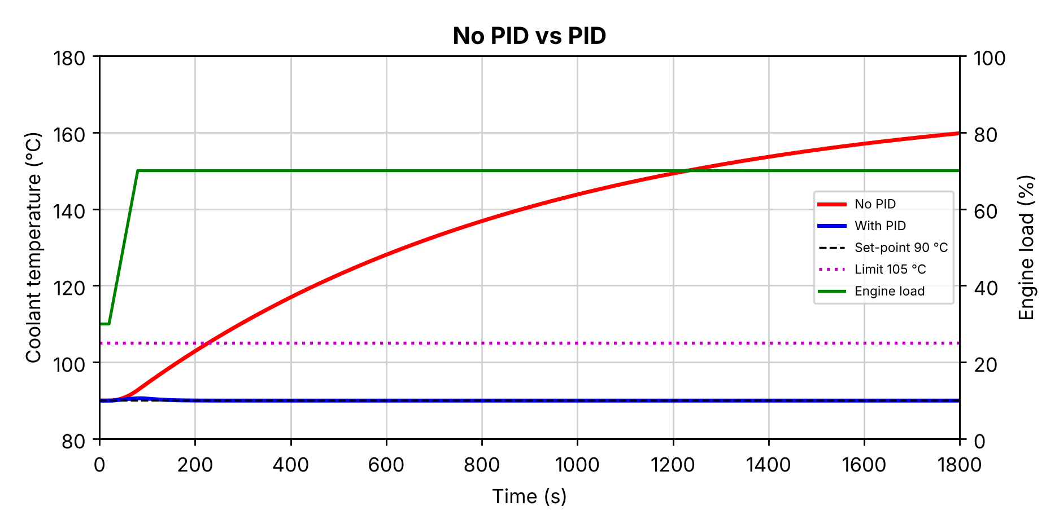
Fig. 1. Coolant temperature with no PID and with PID over 30 minutes; engine load on the right axis
Case | Behaviour after 30 min | Transient result
No PID | 159.8 °C and still rising towards 170 °C | Passes 105 °C after about 227 s
PID | 90.00 °C; zero steady-state offset | Peak 90.60 °C; within 0.1 K at 159 s

The comparison shows why feedback is needed: without a controller the engine overheats within minutes of the load increase, while the PID increases the fan air flow as soon as the temperature starts to rise and holds the coolant at the reference temperature.

B. With PID: zoom on the load rise
Fig. 2 zooms in on the first 200 s. Both cases sit at 90 °C until the load starts to rise at 20 s. Without PID, the temperature climbs faster and faster and leaves the plotted range (above 93 °C) at about 85 s. With the PID, the temperature rises only 0.60 K, peaking at 90.60 °C at about 85 s, just after the load stops rising; integral action then returns it to exactly 90 °C. The results are summarised in Table II.
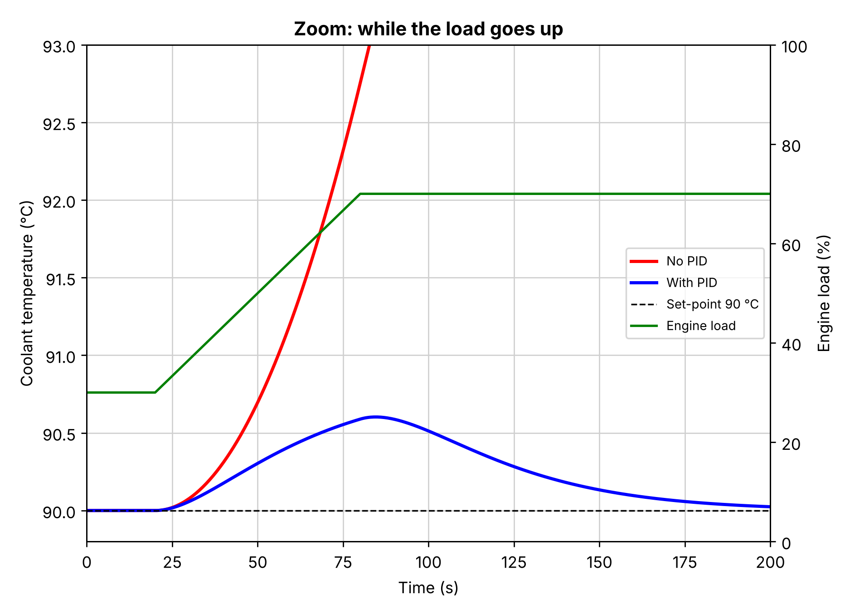
Fig. 2. Zoom on the first 200 s, while the engine load rises from 30% to 70%
Case | Peak rise (K) | Settling time (s) | Steady-state offset (K)
No PID | 69.8 (after 30 min) | never | 69.8
PID | 0.60 | 159 | 0

As shown in Table II, without PID the coolant ends 69.8 K above the reference after 30 minutes and is still rising. With the PID, the peak rise is 0.60 K, the temperature is back within 0.1 K at 159 s (about 80 s after the load stops rising), and the steady-state offset is zero. During the test the fan air flow rises from 1.58 kg/s to about 3.7 kg/s, peaking at 3.96 kg/s, below the 4.5 kg/s limit.

C. Stability, implementation and interpretation
The MATLAB script checks the closed-loop poles using pole(). All poles lie in the left half of the s-plane (−99.9, −0.089, −0.052 and −0.038 s⁻¹), so the linear closed loop is stable. The fast pole near −100 s⁻¹ comes from the 0.01 s derivative filter. The SIMC gains therefore give a stable loop without trial-and-error tuning.
The results should not be interpreted as proof that a PID retrofit would achieve the same performance on a real truck. The plant is linearised about one operating point, its data come from different published sources (a truck engine and a bus radiator study), the 60 s load ramp is a chosen test condition, and the individual valve, pump and fan dynamics are not represented. The plots and performance values are simulation outputs, not road-test measurements.

V. Conclusion
A simplified thermal-control model for a heavy-duty truck engine was built from published data and implemented in a single MATLAB script, with the PID gains calculated by the SIMC tuning rule. When the engine load rises from 30% to 70% over 60 s, the uncontrolled engine passes the 105 °C limit after about 4 minutes and reaches 159.8 °C after 30 minutes. With the PID, the coolant temperature peaks at 90.60 °C and returns to 90 °C with zero steady-state offset, staying within 0.1 K after 159 s, while the fan air flow stays below its 4.5 kg/s limit. Future work should add separate radiator and oil temperature states, model the valve, pump and fan dynamics and the split range, and validate the parameters and responses against measured engine or road-test data before making claims about real-world performance or energy savings.

Acknowledgment
The authors acknowledge the guidance provided by Dr. Geetha M.

Data and Code Availability
No external dataset was used. All numbers in the model are calculated in the MATLAB script from the cited published sources [5]–[10]. The full script (pid_truck_cooling.m) is listed in the Appendix.

References
[1] H. H. Pang and C. J. Brace, “Review of engine cooling technologies for modern engines,” Proceedings of the Institution of Mechanical Engineers, Part D: Journal of Automobile Engineering, vol. 218, no. 11, 2004, doi: 10.1243/0954407042580110.
[2] H. Liu, M. Wen, H. Yang, Z. Yue, and M. Yao, “A Review of Thermal Management System and Control Strategy for Automotive Engines,” Journal of Energy Engineering, vol. 147, no. 2, 2021, doi: 10.1061/(ASCE)EY.1943-7897.0000743.
[3] X. Zhang et al., “Modeling and Analyzing for Hydraulic-Driven Cooling System of Heavy Duty Truck,” SAE Technical Paper 2016-01-0222, 2016, doi: 10.4271/2016-01-0222.
[4] A. Visioli, Practical PID Control. Springer, 2006. doi: 10.1007/1-84628-586-0.
[5] Volvo Trucks, “Fact sheet D13C460, EU5SCR-M,” Version 02, 2010.
[6] G. S. Rosa, D. Lusa, C. R. Altafini and P. R. Wander, “Dimensioning procedure of coolant radiators for trucks and buses,” in Proc. 20th Int. Congress of Mechanical Engineering (COBEM 2009), Gramado, Brazil, 2009.
[7] M. Mohamed, M. H. Shedid, S. El-Demerdash and M. Fatouh, “Performance of electronically controlled automotive engine cooling system using PID and LQR control techniques,” IOSR Journal of Engineering, vol. 8, no. 6, pp. 16–25, 2018.
[8] A. Haury and J. Volkering, “Modelisation of the engine coolant warming-up behavior,” MSc thesis 2011:13, Chalmers University of Technology, Göteborg, 2011.
[9] Engineering ToolBox, property tables: specific heat of metals, specific heat capacity of water, water density, air specific heat, specific heat of liquids, and liquid densities (online).
[10] S. Skogestad, “Simple analytic rules for model reduction and PID controller tuning,” Journal of Process Control, vol. 13, no. 4, pp. 291–309, 2003, doi: 10.1016/S0959-1524(02)00062-8.

Appendix: MATLAB Program (pid_truck_cooling.m)
%% PID Temperature Control of a Truck Engine
% How the coolant temperature changes when the engine load goes up,
% first with no controller, then with a PID controller.
% Sushanth Bibi (24BME0501), Ganishk Mohanraj (24BME0500)
%
% Sources
% [1] Volvo Trucks, Fact sheet D13C460 EU5SCR-M, 2010
% [2] G. S. Rosa et al., "Dimensioning procedure of coolant radiators for
% trucks and buses", COBEM 2009
% [3] M. Mohamed et al., "Performance of electronically controlled
% automotive engine cooling system using PID and LQR control
% techniques", IOSR J. Engineering 8(6), 2018, pp. 16-25
% [4] A. Haury, J. Volkering, "Modelisation of the engine coolant
% warming-up behavior", MSc thesis 2011:13, Chalmers
% [5] Engineering ToolBox, specific heat and density tables
% [6] S. Skogestad, "Simple analytic rules for model reduction and PID
% controller tuning", J. Process Control 13 (2003) 291-309

clc;
clear;
close all;

%% Data from the sources
P = 338; % engine power [kW] [1]
m_eng = 1121; % engine dry weight [kg] [1]
V_c = 38; % coolant volume [L] [1]
V_o = 33; % oil volume [L] [1]
cp_fe = 0.46; % cast iron [kJ/kg K] [5]
rho_w = 0.96531; % water at 90 °C [kg/L] [5]
cp_w = 4.2053; % water at 90 °C [kJ/kg K] [5]
rho_o = 0.900; % lubricating oil [kg/L] [5]
cp_o = 1.67; % mineral oil [kJ/kg K] [5]
cp_a = 1.006; % air [kJ/kg K] [5]
beta = 0.5; % heat to coolant / engine power (0.45-0.55) [2]
m_w = 3.25; % coolant flow [kg/s] [2]
T_w = 100; % radiator rating: water in [°C] [2]
T_a = 30; % radiator rating: air in [°C] [2]
% Fan air flow = where system curve meets fan curve, Fig. 6 of [2]:
% system: 25.105x^2 + 76.084x - 3.7131, fan: -1.9147x^2 - 457.51x + 2945
mf_max = max(roots([25.105+1.9147, 76.084+457.51, -3.7131-2945])); % = 4.50 kg/s

%% Transfer function numbers from the energy balance [3]
% Block + coolant + oil as one mass [4]:
% C_th*dT/dt = Q_engine - eff*m_fan*cp_a*(T - T_a)
C_th = m_eng*cp_fe + V_c*rho_w*cp_w + V_o*rho_o*cp_o; % heat capacity [kJ/K]
eff = beta*P/(mf_max*cp_a*(T_w - T_a)); % radiator effectiveness
H = beta*P*0.30/(90 - T_a); % heat removed per K at 90 °C, 30 % load [kW/K]
tau_c = C_th/H; % engine time constant [s]
tau_r = V_c*rho_w/m_w; % coolant loop time [s]
K_fan = eff*cp_a*(90 - T_a)/H; % K per kg/s of fan air
K_load = beta*P/100/H; % K per % load

%% Plant
% Fan path: fan air flow [kg/s] -> coolant temperature [K]
num = K_fan; % = 38.1
den = conv([tau_c 1],[tau_r 1]); % (851s+1)(11.3s+1)
G = tf(num, den)

% Load path: engine load [%] -> coolant temperature [K]
numd = K_load; % = 2.0
dend = [tau_c 1]; % (851s+1)
Gd = tf(numd, dend)

%% PID controller (SIMC tuning rule [6])
Kc = tau_c/(K_fan*tau_r);
tauI = min(tau_c, 4*tau_r);
tauD = tau_r;
Kp = Kc*(1 + tauD/tauI) % = 2.48
Ki = Kp/(tauI + tauD) % = 0.044
Kd = Kp*tauI*tauD/(tauI + tauD) % = 22.4
C = tf(Kp, 1) + tf(Ki, [1 0]) + tf([Kd 0], [0.01 1]); % Kp + Ki/s + Kd*s

%% Engine load: 30 % for 20 s, then rises linearly to 70 % over 60 s
t = (0:0.5:1800)'; % 30 minutes
t_ramp = 60; % time for the load to rise [s]
dL = 40*min(max(t - 20, 0)/t_ramp, 1); % change in load from 30 % [%]
load_pct = 30 + dL; % engine load [%]

% Without PID: load -> temperature = Gd
T_noPID = lsim(Gd, dL, t);

% With PID: load -> temperature = Gd / (1 + C*G)
D = Gd * feedback(1, C*G);
T_PID = lsim(D, dL, t);

%% Figure 1: 30 minutes
figure;
yyaxis left;
plot(t, 90 + T_noPID, 'r-', t, 90 + T_PID, 'b-', 'LineWidth', 2);
hold on;
plot(t, 90*ones(size(t)), 'k--', t, 105*ones(size(t)), 'm:');
ylabel('Coolant temperature (°C)');
ylim([80 180]);
yyaxis right;
plot(t, load_pct, 'g-', 'LineWidth', 1.5);
ylabel('Engine load (%)');
ylim([0 100]);
grid on;
xlim([0 1800]);
title('No PID vs PID');
xlabel('Time (s)');
legend('No PID', 'With PID', 'Set-point 90 °C', 'Limit 105 °C', 'Engine load', 'Location', 'east');

%% Figure 2: zoom on the load increase
figure;
yyaxis left;
plot(t, 90 + T_noPID, 'r-', t, 90 + T_PID, 'b-', 'LineWidth', 2.5);
hold on;
plot(t, 90*ones(size(t)), 'k--');
ylabel('Coolant temperature (°C)');
ylim([89.8 93]);
yyaxis right;
plot(t, load_pct, 'g-', 'LineWidth', 1.5);
ylabel('Engine load (%)');
ylim([0 100]);
grid on;
xlim([0 200]);
title('Zoom: while the load goes up');
xlabel('Time (s)');
legend('No PID', 'With PID', 'Set-point 90 °C', 'Engine load', 'Location', 'east');

%% Results
disp(['No PID: temperature after 30 min = ', num2str(90 + T_noPID(end), '%5.1f'), ' °C']);
disp(['With PID: highest temperature = ', num2str(90 + max(T_PID), '%5.2f'), ' °C']);
disp(['With PID: temperature after 30 min = ', num2str(90 + T_PID(end), '%5.2f'), ' °C']);
poles = pole(feedback(C*G, 1)) % all negative real parts -> stable

% Inference:
% Without a PID, the extra load keeps heating the engine: it passes the
% 105 °C limit after about 4 minutes and keeps rising. With the PID, the
% temperature rises by only 0.6 °C while the load goes up, and is back at
% exactly 90 °C about 80 s after the load stops rising.

