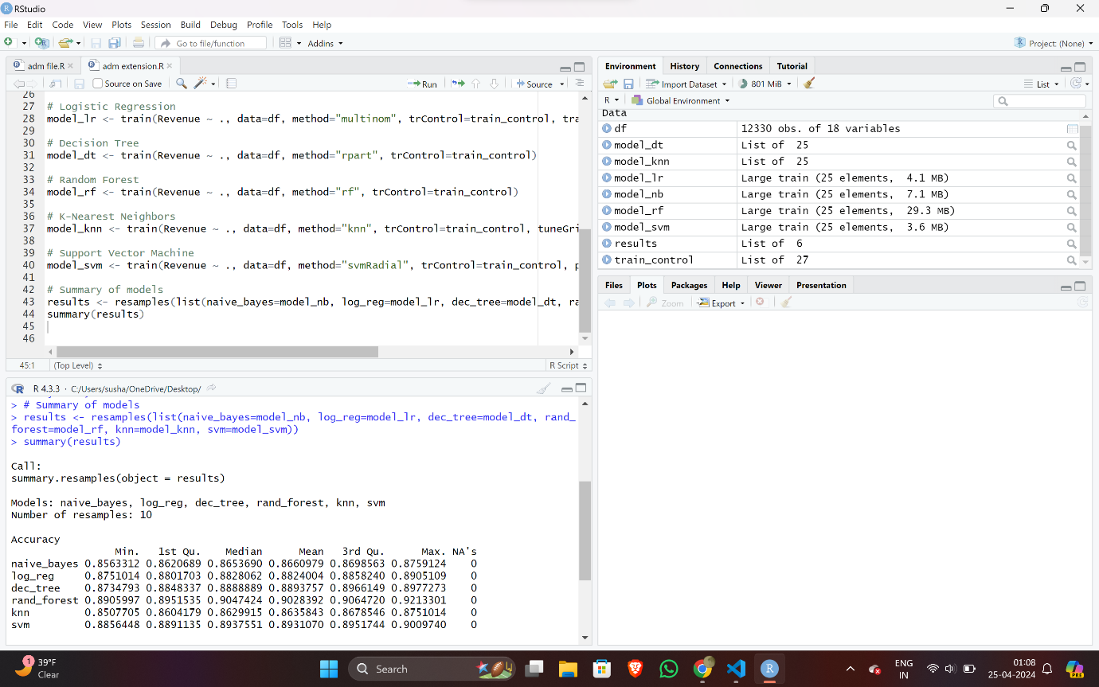

Fig – results of accuracies with k fold validation

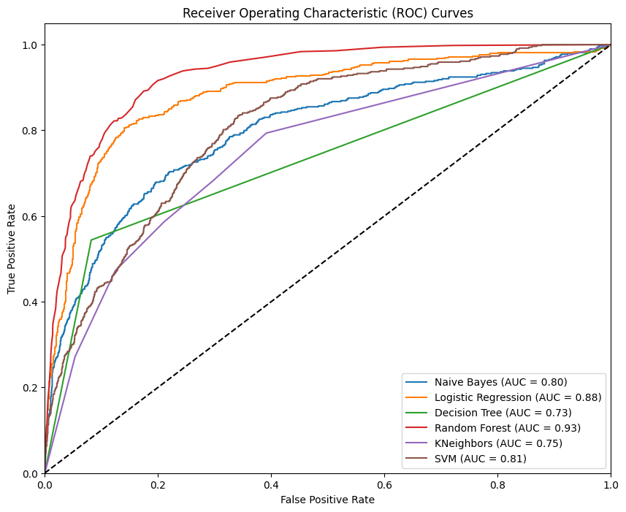

Fig – roc curves of all the models on the same plot

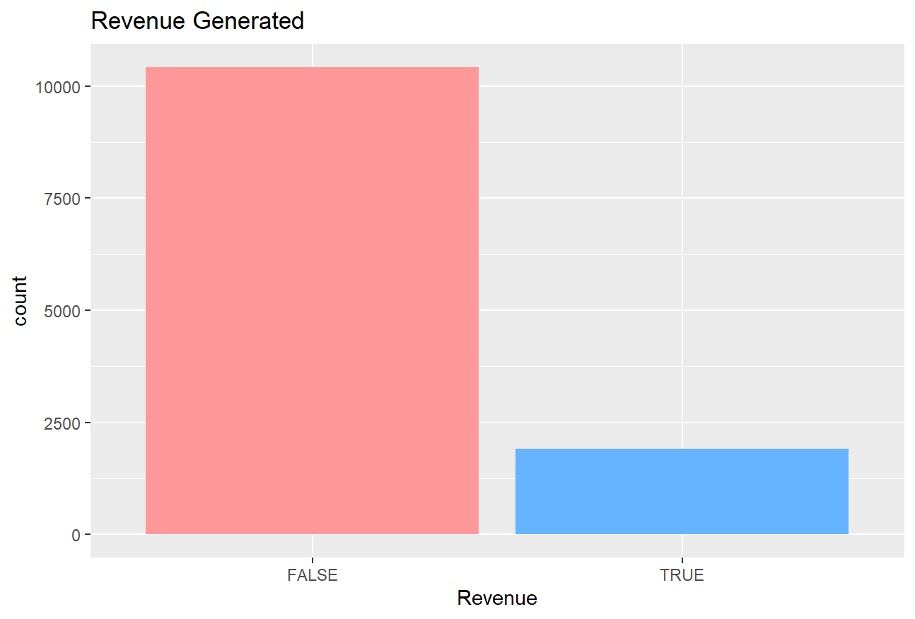

Fig – bar plot showing imbalance in dataset

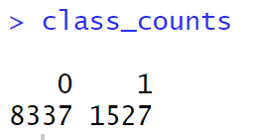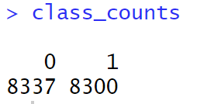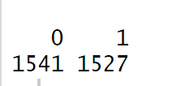

Fig – training datasets before and after smote and near miss algorithms

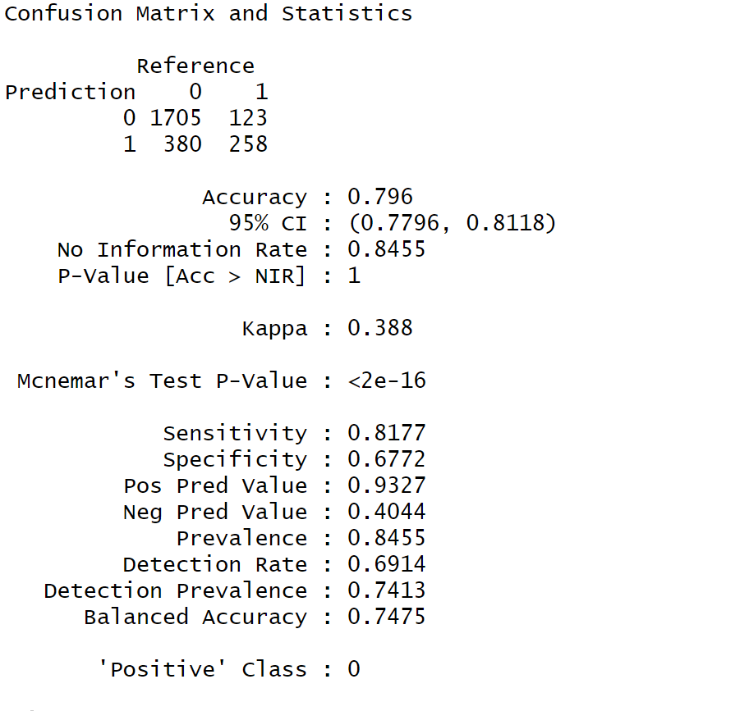

Fig – naïve bayes summary report

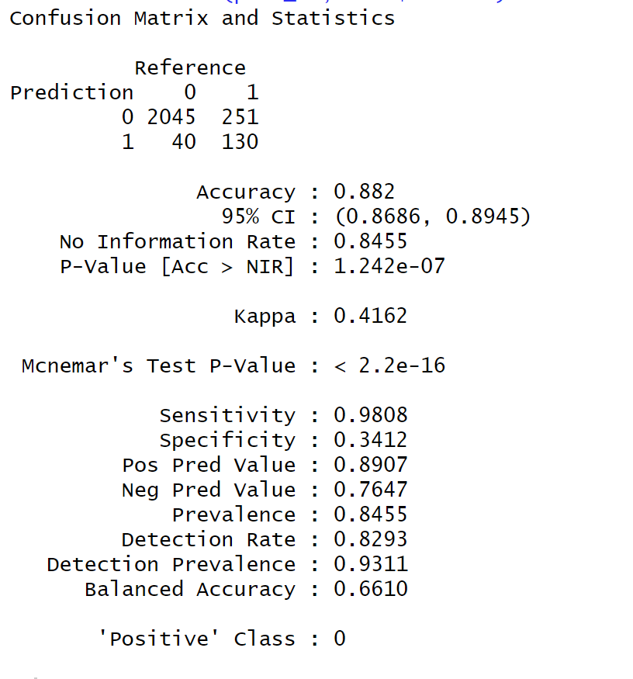

Fig – shows the summary report of the logistic model

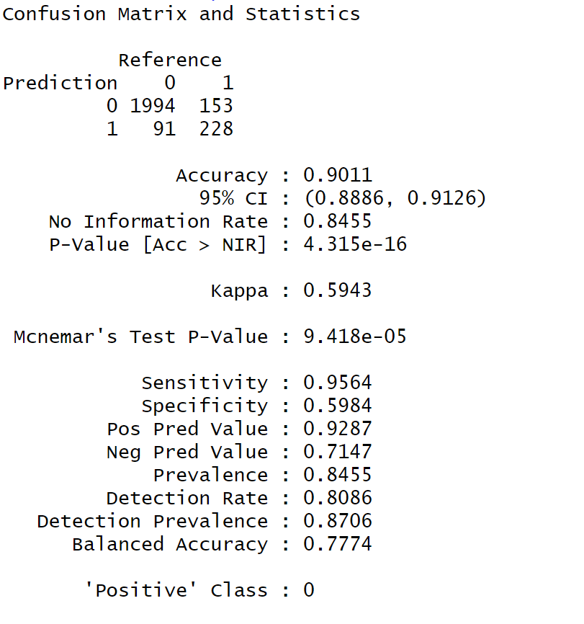

Fig – shows the summary report of decision tree model

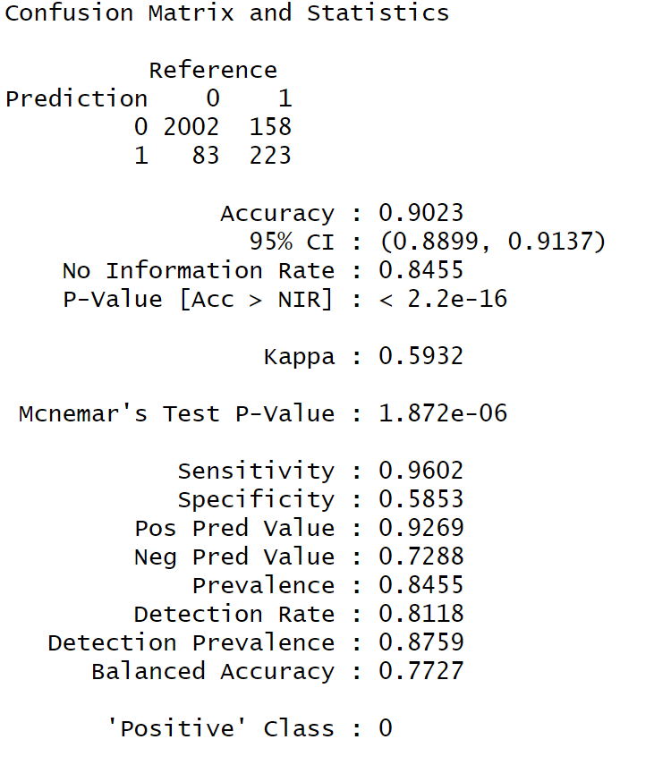

Fig – summary report of random forest

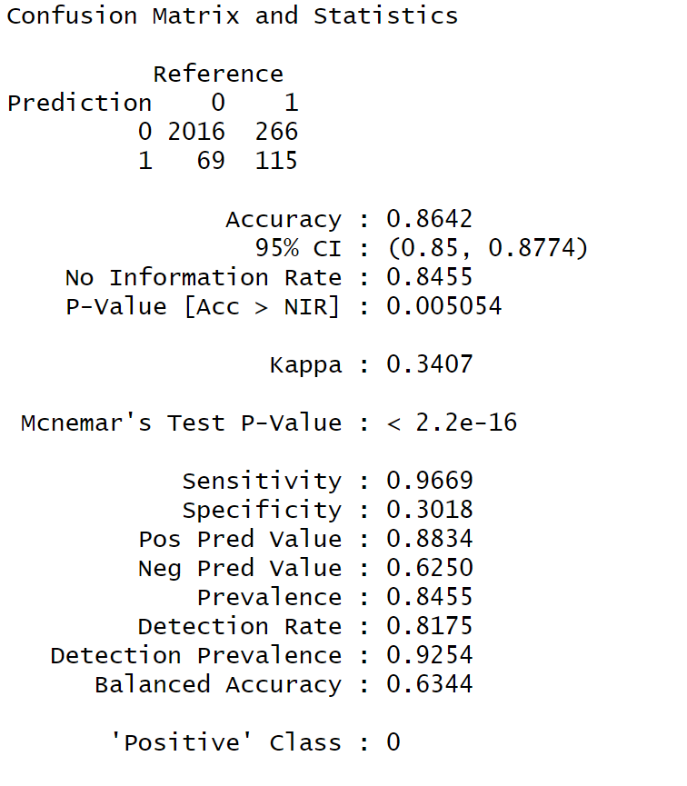

Fig – shows the summary report of KNN

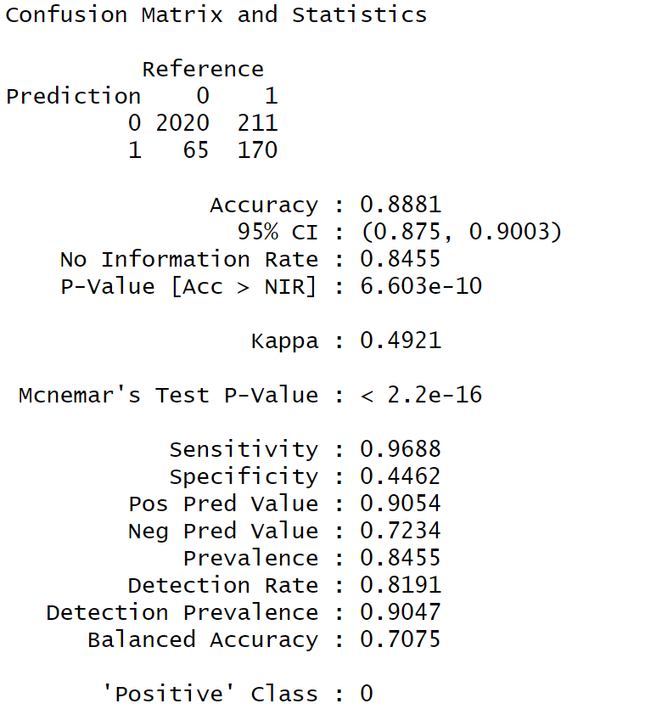

Fig – summary report of SVM

Similarly all the models shown above can be performed With an oversampled or an under sampled dataset.

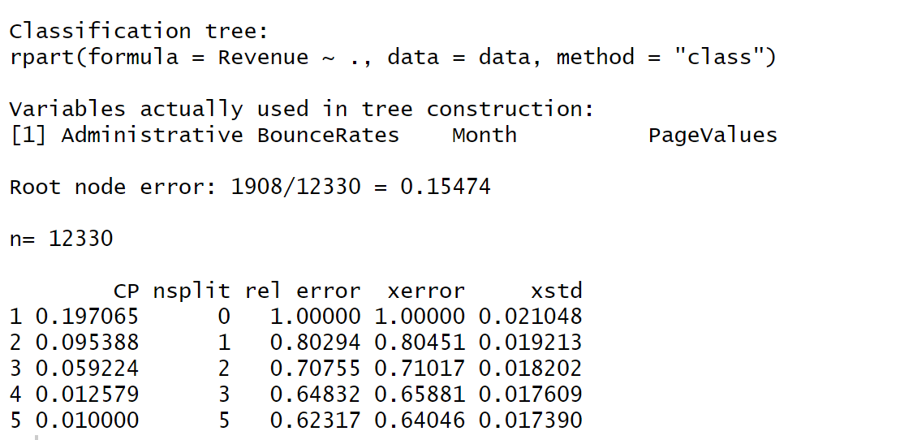

Fig – CP table for pruning in decision trees

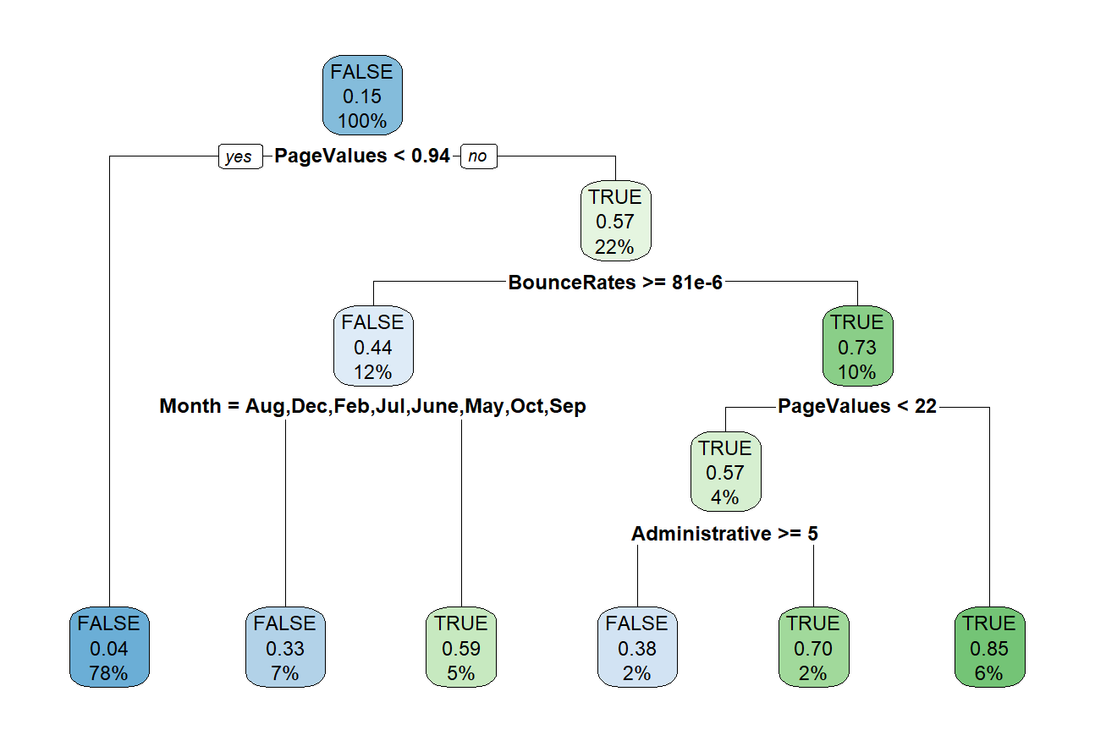

Fig – plotting what we have in had after the previous step

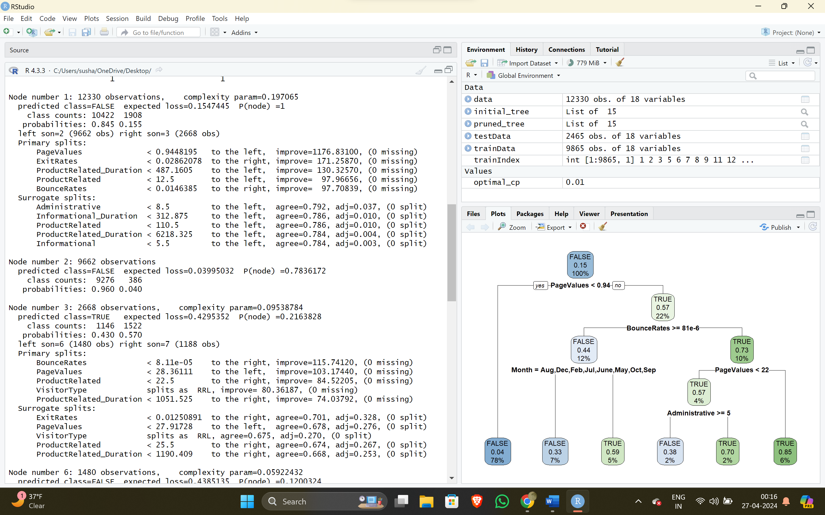

Fig – summary of pruned tree

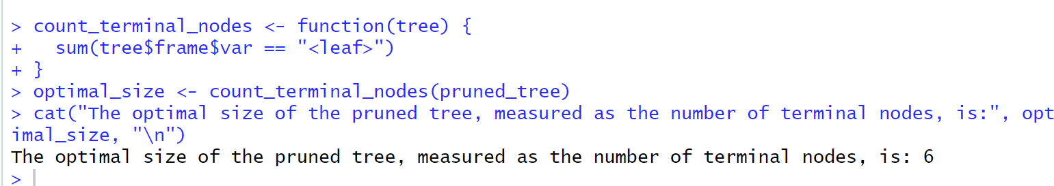

Fig – the size of the tree was found to be best at 6

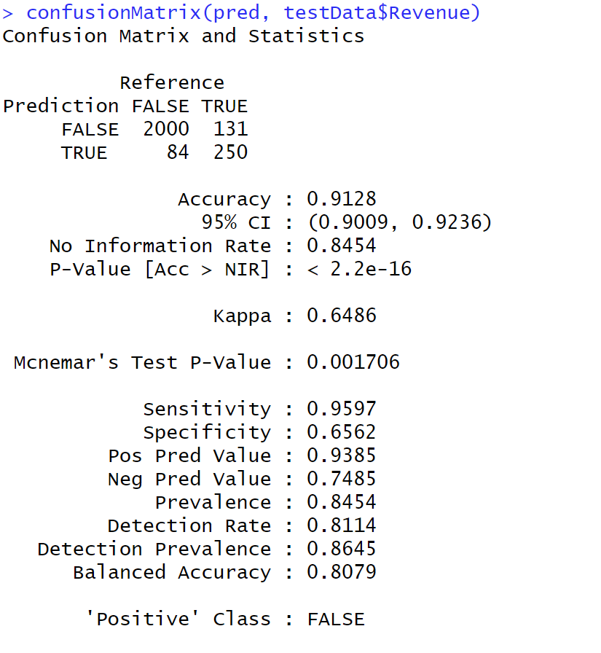

Fig - Decision tree prediction after pruning