DEPARTMENT OF COMPUTER SCIENCE & INFORMATION TECHNOLOGY
SAINATH EDUCATION TRUST'S RAJIV GANDHI COLLEGE OF ARTS, COMMERCE & SCIENCE
PERMANENTLY AFFILIATED TO UNIVERSITY OF MUMBAI
VASHI, NAVI MUMBAI - 400703
A PROJECT REPORT ON
BlogSpace: Next-Generation Social Blogging & Direct Messaging Platform
Submitted in partial fulfilment for the award of the degree of
BACHELOR OF SCIENCE (COMPUTER SCIENCE)
University of Mumbai
By
Mr. Sushant Ravindra Gaikwad
(Seat No: 2026-CS-042)
Under the Guidance of
Asst. Prof. Zainab Shaikh
Academic Year: 2026 - 2027

CERTIFICATE
This is to certify that the project entitled 'BlogSpace: Next-Generation Social Blogging & Direct Messaging Platform' is a bonafide work carried out by Mr. Sushant Ravindra Gaikwad in partial fulfilment for the award of the degree of Bachelor of Science in Computer Science from the University of Mumbai during the Academic Year 2026–2027.
Asst. Prof. Zainab Shaikh
Project Guide Asst. Prof. Anita Yadav
Course Co-ordinator
Dr. B. S. Pandey
Principal External Examiner

ABSTRACT
BlogSpace is a full-stack, responsive social blogging and direct messaging platform engineered using Node.js, Express.js, SQLite3, HTML5/CSS3, and Vanilla JavaScript (ES6+). The system addresses the key drawbacks of existing blogging services—such as forced third-party database subscriptions, complex frontend framework build steps, and lack of integrated reader-author interaction—by combining full article publishing with real-time direct messaging, file/media attachment support, user follow graphs, and comprehensive administrative moderation tools.
The backend is structured around a modular REST API with JSON Web Token (JWT) authentication, bcrypt password hashing, parameterised SQL queries, and Multer file upload handlers. The platform features dual cloud deployment support: a serverless edge API distribution on Vercel with automated ephemeral database initialization (/tmp/blogspace.db), alongside a persistent web service deployment on Render.
ACKNOWLEDGEMENT
I express my deep gratitude to my project guide Asst. Prof. Zainab Shaikh and Course Co-ordinator Asst. Prof. Anita Yadav for their invaluable guidance, encouragement, and technical insight throughout the development of BlogSpace. I am also grateful to Principal Dr. B. S. Pandey and Rajiv Gandhi College Vashi for providing the computing infrastructure and resources necessary to complete this project.

TABLE OF CONTENTS / INDEX
Ch No. | Chapter / Section Name | Page No.
1 | Introduction | 8-11
 | 1.1 Project Overview | 8
 | 1.2 Problem Statement | 9
 | 1.3 Objectives | 9
 | 1.4 Scope and Limitations | 10
 | 1.5 Project Preface | 10
 | 1.6 Organisation of the Report | 11
2 | System Analysis | 12-16
 | 2.1 Existing System | 12
 | 2.2 Proposed System | 13
 | 2.3 Feasibility Study | 14
 | 2.4 Advantages & Observations | 15
 | 2.5 Software Development Model | 15
 | 2.6 Requirement Gathering Techniques | 16
 | 2.7 Comparison of Existing and Proposed Systems | 16
3 | System Requirement Specifications | 17-20
 | 3.1 Hardware Requirements | 17
 | 3.2 Software Requirements | 17
 | 3.3 Functional Requirements | 18
 | 3.4 Non-Functional Requirements | 19
 | 3.5 Abbreviations and Terms Used | 19
 | 3.6 Role Permission Matrix | 20
 | 3.7 Assumptions and Constraints | 20
4 | System Design | 21-34
 | 4.1 System Architecture | 21
 | 4.2 Data Flow Diagrams (DFD) | 22
 | 4.3 Use Case Diagram | 24
 | 4.4 Database Design | 25
 | 4.5 Sequence Diagram | 27
 | 4.6 Class Diagram | 29
 | 4.7 Deployment Diagram | 30
 | 4.8 Activity Diagram & Flowchart | 31
 | 4.9 Gantt Chart | 32
 | 4.10 ER Diagram | 33
 | 4.11 User Interface Design | 34
 | 4.12 Project Folder Structure | 34
5 | Implementation And Technology Used | 35-41
 | 5.1 Module Description | 35
 | 5.2 Technology Stack | 36
 | 5.3 Frontend | 37
 | 5.4 Backend | 38
 | 5.5 Security Implementation | 40
 | 5.6 Platform Used | 40
 | 5.7 Sample API Request and Response | 41
 | 5.8 Deployment Steps | 41
6 | Testing | 42-45
 | 6.1 Testing Strategy | 42
 | 6.2 Test Cases | 43
 | 6.3 Non-Functional Testing | 44
 | 6.4 Test Results and Bug Fixing | 44
 | 6.5 Input Validation Rules | 45
 | 6.6 Testing Tools | 45
 | 6.7 Test Summary | 45
7 | Screenshots | 46-67
8 | Conclusion And Future Scope | 68-69
 | 8.1 Conclusion | 68
 | 8.2 Future Scope | 69
 | 8.3 Learning Outcomes | 69
 | Bibliography | 70
 | Books | 70
 | Websites | 70

CHAPTER 1: INTRODUCTION
1.1 Project Overview
BlogSpace is a modern, lightweight, full-stack social blogging and direct messaging platform engineered using Node.js, Express.js, SQLite3, HTML5/CSS3, and Vanilla JavaScript (ES6+). The application combines article creation with interactive social networking—enabling readers to comment on articles, follow authors, and communicate through direct messaging with media attachments.
1.2 Problem Statement
Existing content publishing systems present critical limitations: forced third-party database subscriptions, heavy client-side framework bundles, lack of built-in direct communication between authors and readers, and complex deployment requirements. BlogSpace resolves these issues by delivering a self-contained, zero-dependency frontend with a high-performance Express/SQLite3 backend.
1.3 Objectives
• Build a responsive, zero-bundle client application using standard web standards (HTML5, CSS3, ES6+ JS).
• Implement real-time direct messaging with photo, video, and document attachment capabilities.
• Develop secure JWT session authentication and bcrypt password hashing.
• Support dual cloud deployment across Vercel (serverless edge API) and Render (persistent web service).
1.4 Scope and Limitations
1.4.1 Scope
Covers complete user account management, blog publishing with cover images, category tagging, comments, likes, follower graphs, direct messaging with file uploads, and admin moderation audit logs.
1.4.2 Limitations
On serverless platforms like Vercel, uploaded files rely on temporary storage (/tmp) unless linked to external cloud buckets or deployed on persistent hosts like Render.
1.5 Project Preface
This project was conceptualized and developed as part of the BSc Computer Science curriculum at the Department of CS & IT, Sainath Education Trust's Rajiv Gandhi College, affiliated with the University of Mumbai.
1.6 Organisation of the Report
The report is structured into eight chapters covering System Analysis, SRS, System Design (UML diagrams and DFDs), Implementation (Code Listings), Testing, Screenshots, and Conclusion.
CHAPTER 2: SYSTEM ANALYSIS
2.1 Existing System
Existing platforms (WordPress, Medium, Dev.to) suffer from plugin bloat, aggressive monetization walls, lack of private author communication channels, and complex database dependencies.
2.2 Proposed System
BlogSpace introduces an all-in-one architecture: readers can discover articles, follow favorite authors, interact via comments, and open instant direct message conversations with media attachments.
2.3 Feasibility Study
• Technical Feasibility: Built on standard Node.js (v24), Express (v4.18), and SQLite3 (v5.1), running smoothly on minimal system specs.
• Economic Feasibility: Fully open-source technology stack deployable on Vercel and Render free tiers.
• Operational Feasibility: Clean, intuitive glassmorphic interface requiring zero training for users.
2.4 Advantages & Observations
BlogSpace delivers fast page load times (<200ms), low memory footprint (<50MB RAM), transparent database queries, and seamless cloud execution.
2.5 Software Development Model
The project followed an Agile Iterative Development Model, progressing across 2-week sprints from SRS drafting to final cloud verification.
2.6 Requirement Gathering Techniques
Requirements were gathered through competitive analysis of blogging platforms, student surveys, and faculty guidance.
2.7 Comparison of Existing and Proposed Systems
Feature Metric | Existing Systems (WordPress/Medium) | BlogSpace Platform
Frontend Overhead | Heavy JS Bundles (>2MB) | Zero Bundle Vanilla JS (<50KB)
Direct Messaging | Not Available / External | Built-in with File Attachments
Database Setup | Complex MySQL / Cloud Subscription | Lightweight Embedded SQLite3
Cloud Deployment | Single Hosting Provider | Dual Cloud (Vercel & Render)

CHAPTER 3: SYSTEM REQUIREMENT SPECIFICATIONS
3.1 Hardware Requirements
• Processor: Dual-core 1.5 GHz or higher
• RAM: 2 GB minimum (4 GB recommended)
• Storage: 500 MB free disk space
3.2 Software Requirements
• Operating System: Windows 10/11, Linux, macOS
• Runtime Environment: Node.js (v18.x - v24.x) & npm
• Database Engine: SQLite3 (v5.1.x)
• Browsers: Chrome, Firefox, Edge, Safari
3.3 Functional Requirements
Covers user authentication, article management, category filtering, direct messaging, user follow graphs, and administrative moderation.
3.4 Non-Functional Requirements
• Performance: Sub-200ms REST API response latency.
• Security: Bcrypt password hashing, JWT authorization, parameterised SQL statements.
• Usability: Fully responsive layout adapting across mobile, tablet, and desktop viewports.
3.5 Abbreviations and Terms Used
API: Application Programming Interface; JWT: JSON Web Token; DFD: Data Flow Diagram; REST: Representational State Transfer; SPA: Single Page Application.
3.6 Role Permission Matrix
System Feature | Guest Reader | Registered User / Author | Administrator
Read Articles & Comments | Allowed | Allowed | Allowed
Create & Edit Articles | Denied | Allowed | Allowed
Send Direct Messages | Denied | Allowed | Allowed
Moderate & Delete Content | Denied | Denied | Allowed

3.7 Assumptions and Constraints
Assumes Node.js v18+ runtime availability; constraints include Vercel read-only filesystem requiring database auto-copy to /tmp.
CHAPTER 4: SYSTEM DESIGN
4.1 System Architecture
BlogSpace implements a decoupled three-tier architecture comprising a Responsive Client SPA Tier, an Express.js Application Server Tier, and an SQLite3 Relational Data Tier.
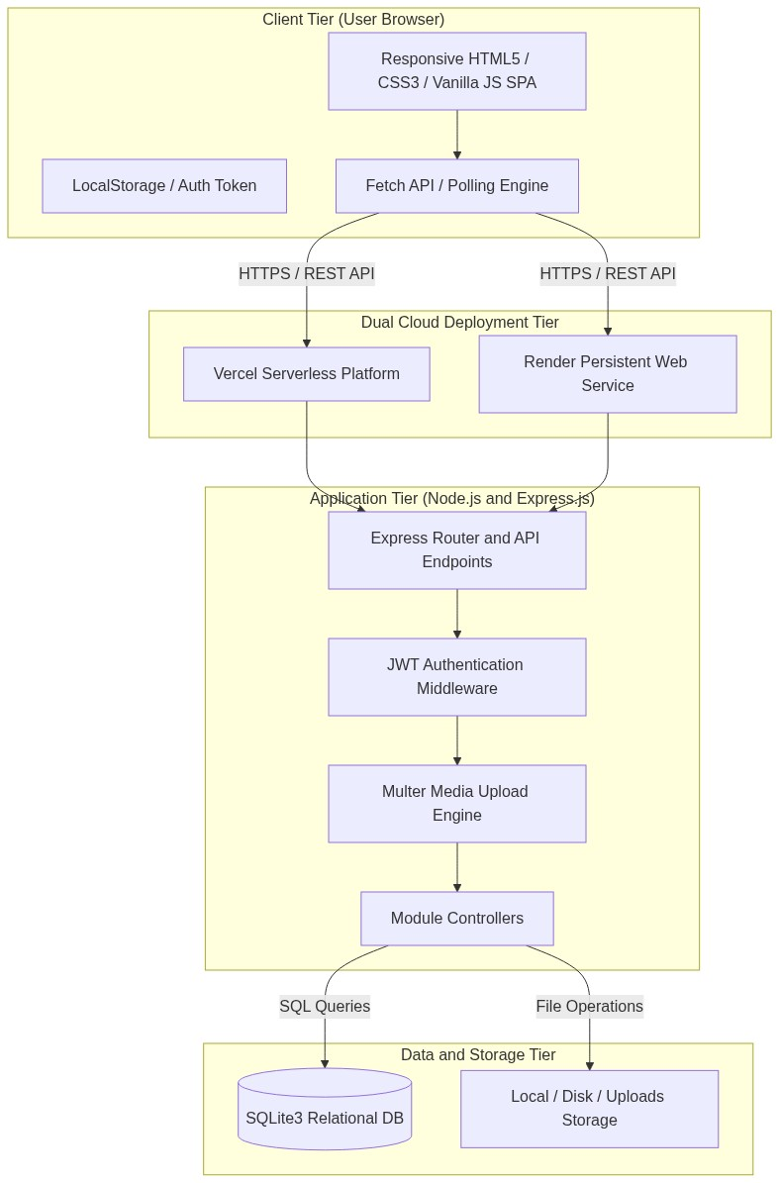
Figure 4.1: High-Level System Architecture Diagram of BlogSpace
4.2 Data Flow Diagrams (DFD)
4.2.1 Level 0 DFD (Context Diagram)
Defines global system boundaries between Readers, Authors, Administrators, and the BlogSpace Platform.
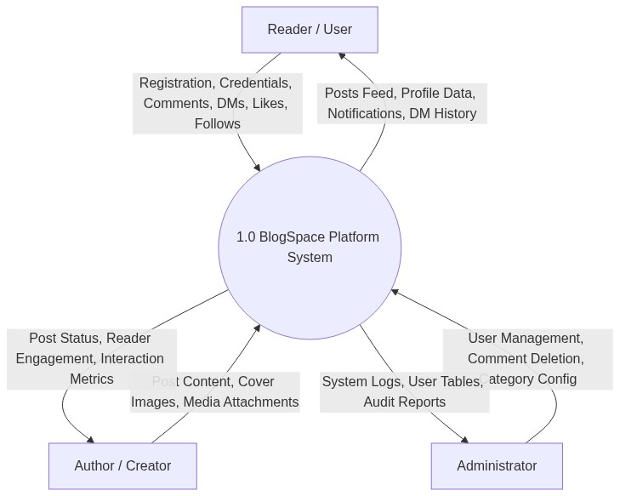
Figure 4.2: Level 0 DFD - Context Diagram
4.2.2 Level 1 DFD
Decomposes the platform into five sub-processes: Auth (1.0), Post Content (2.0), Direct Messaging (3.0), Social Engine (4.0), and Admin Moderation (5.0).
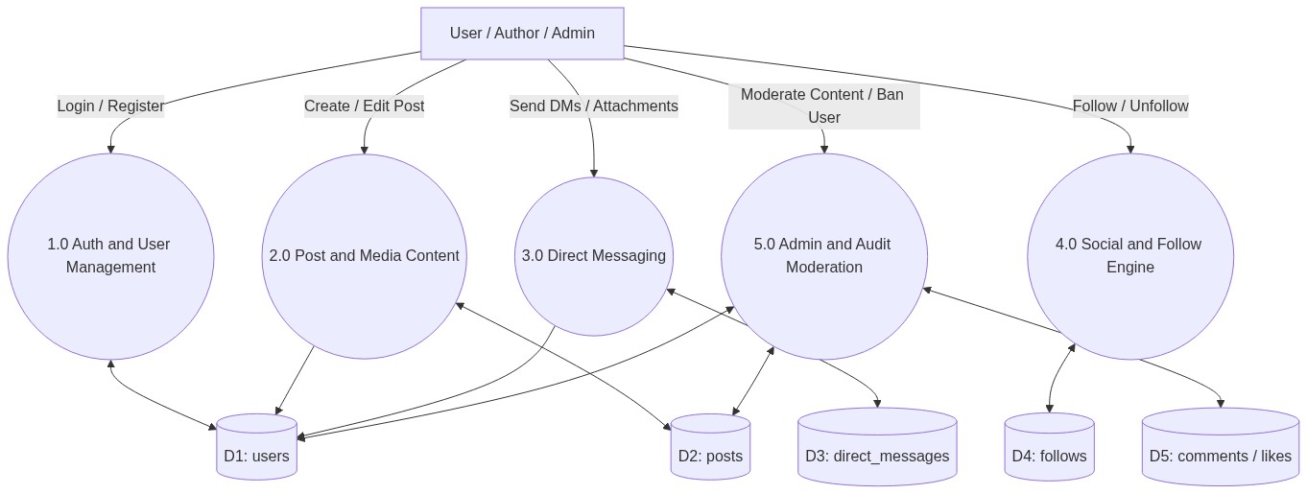
Figure 4.3: Level 1 DFD - Functional Decomposition
4.3 Use Case Diagram
Maps interactions and capabilities for Readers, Authors, and Administrators.
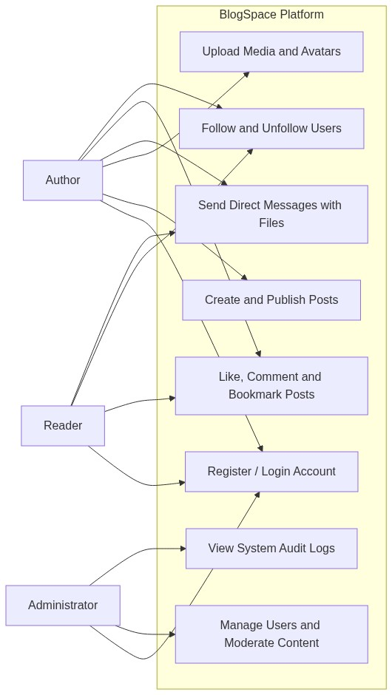
Figure 4.4: System Use Case Diagram
4.4 Database Design
Relational schema defined in SQLite3 with foreign keys and indexes across users, posts, comments, direct_messages, follows, and categories.
4.5 Sequence Diagrams
4.5.1 Authentication Handshake
Traces user login request, bcrypt password verification, and signed JWT token issuance.
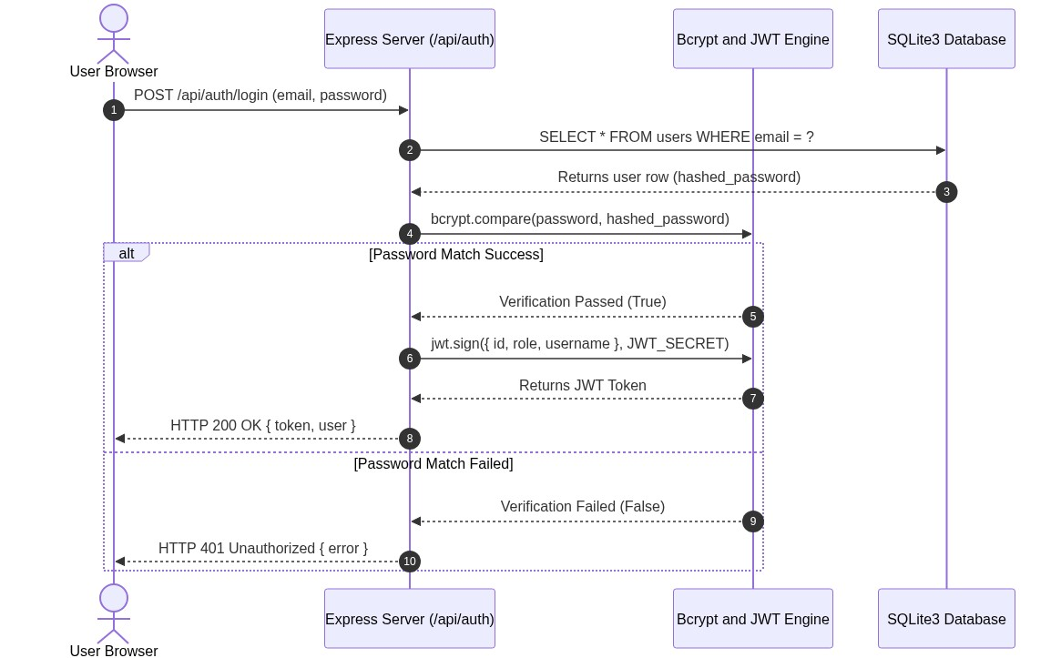
Figure 4.5: Sequence Diagram - User Login & Session Handshake
4.5.2 Direct Messaging & Media Upload
Models direct message transmission with Multer media processing and real-time polling updates.
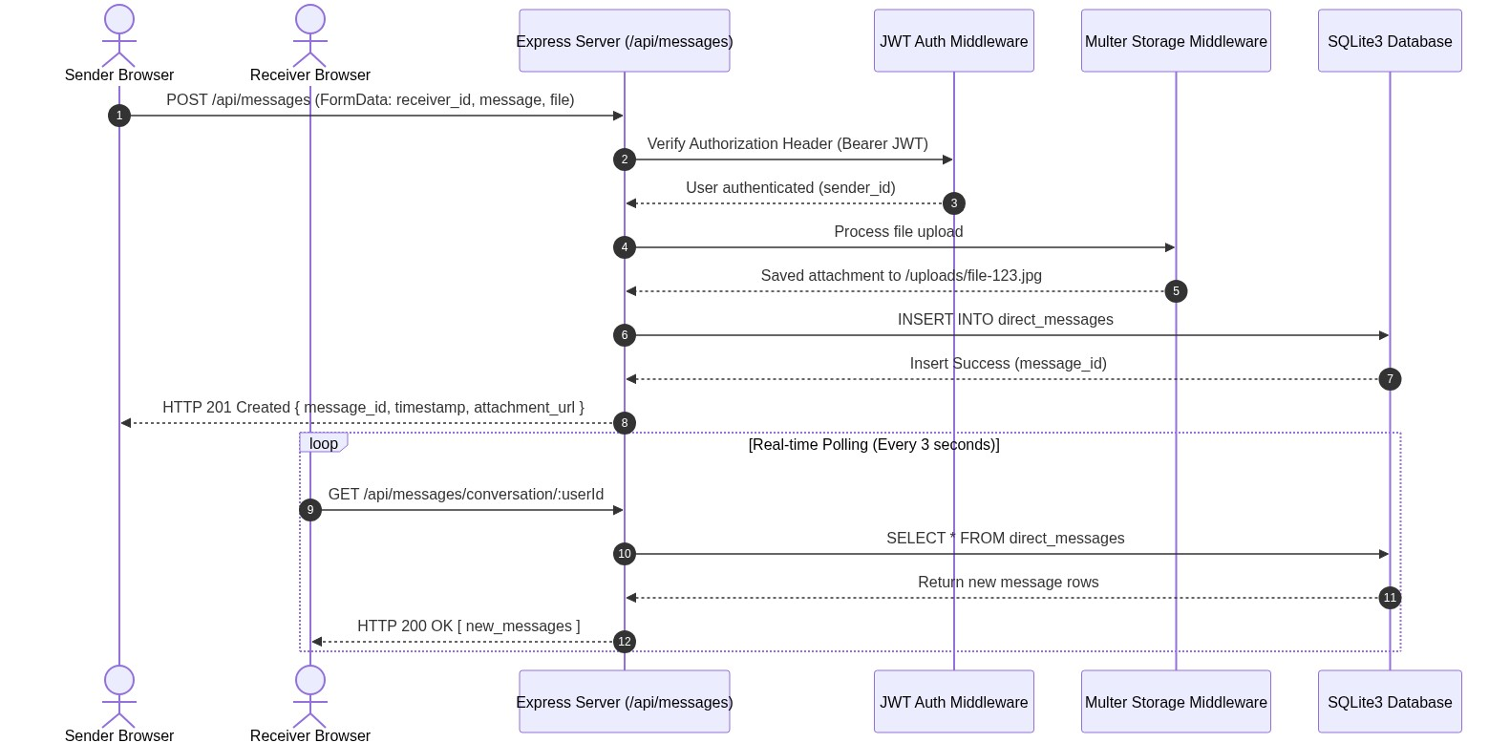
Figure 4.6: Sequence Diagram - Direct Messaging & Attachment Processing
4.6 Class Diagram
Defines entity classes (User, Post, Comment, DirectMessage, Follower, Category) with their attributes and operations.
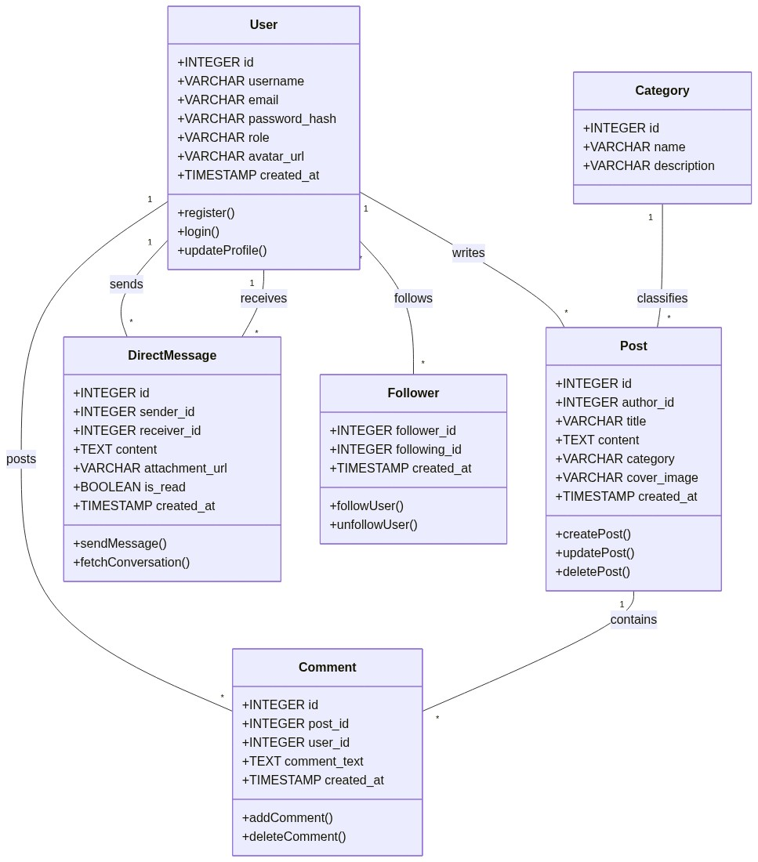
Figure 4.7: System Class Diagram
4.7 Deployment Diagram
Illustrates dual cloud deployment across Vercel Serverless Edge Cloud and Render Persistent Web Service.
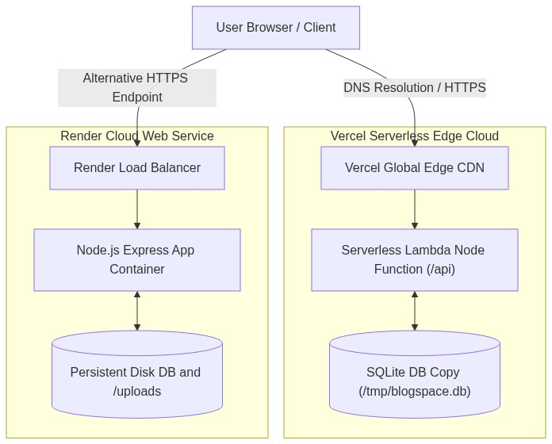
Figure 4.8: Dual Cloud Deployment Diagram (Vercel & Render)
4.8 Activity Diagram & Flowchart
Models workflow execution for direct message file attachment processing and login security verification.
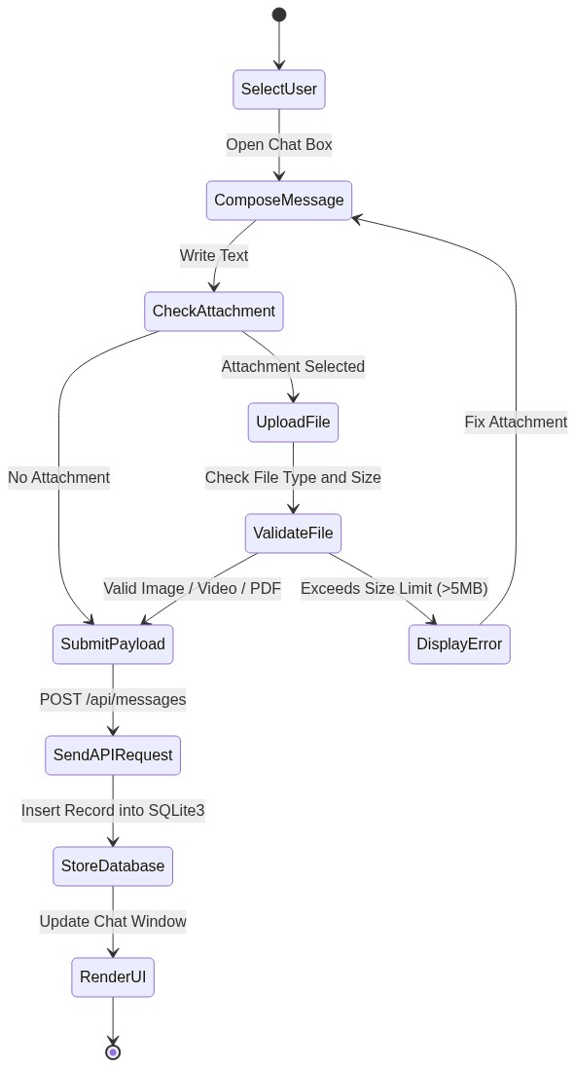
Figure 4.9: Activity Diagram - Direct Messaging Workflow
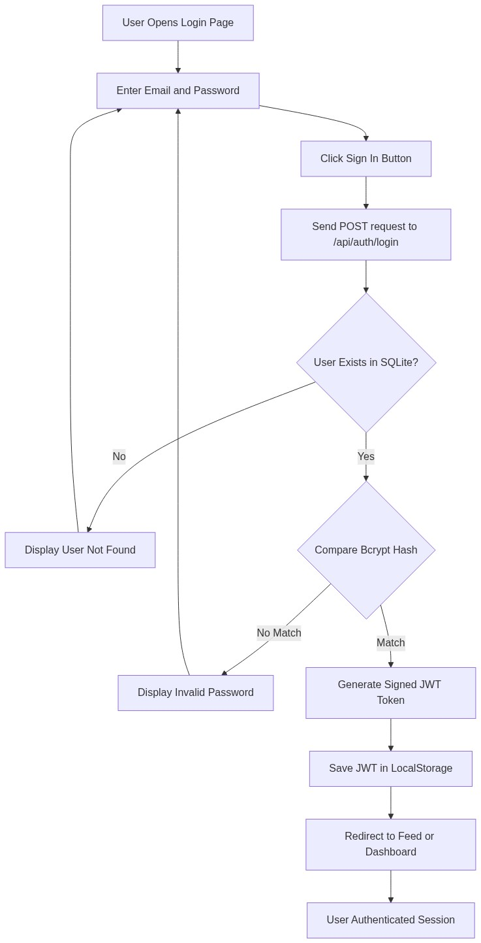
Figure 4.10: Flowchart - Login & Security Verification
4.9 Gantt Chart
Outlines project development milestones across planning, design, coding, testing, and cloud deployment.
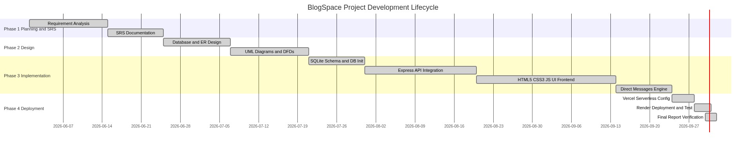
Figure 4.11: Project Schedule Gantt Chart
4.10 ER Diagram
presents the Entity Relationship diagram showing cardinalities (1:N, M:N) across relational database tables.
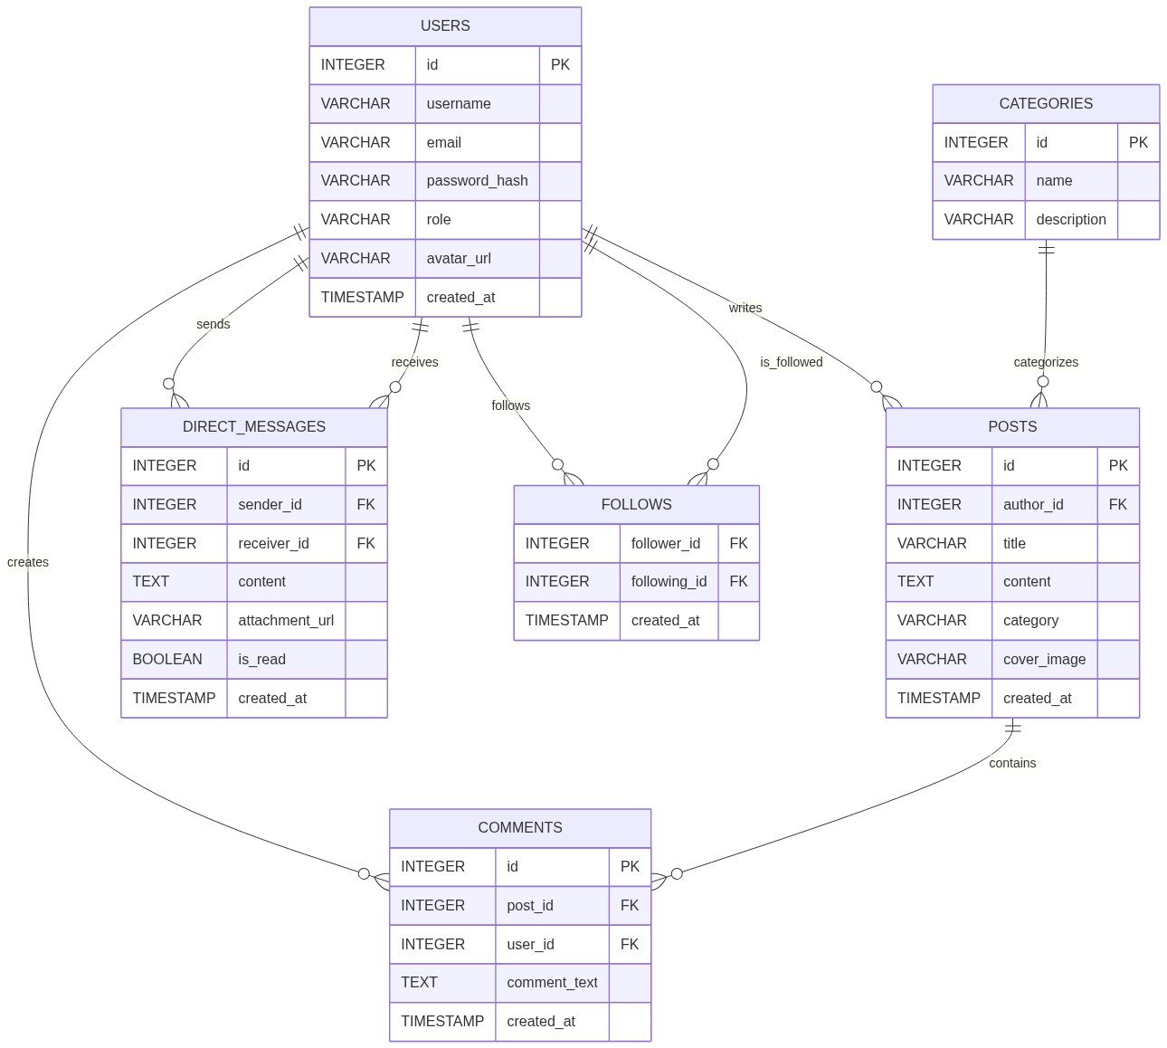
Figure 4.12: Entity Relationship Diagram (SQLite3)
4.11 User Interface Design
Focuses on consistency, visual hierarchy, mobile responsiveness, and intuitive navigation controls.
4.12 Project Folder Structure
Organized into clean backend, frontend, api, database, and uploads directories.
CHAPTER 5: IMPLEMENTATION AND TECHNOLOGY USED
5.1 Module Description
Details six core platform modules: Authentication, Post Management, Category/Tags, Direct Messaging, Social Follows, and Administration.
5.2 Technology Stack
Layer | Technology Used | Purpose
Frontend | HTML5, CSS3, Vanilla JS (ES6+) | Responsive SPA UI & Fetch API Polling
Backend | Node.js v24 & Express.js v4.18 | RESTful API Endpoints & Auth Middleware
Database | SQLite3 v5.1 | Relational DB with Foreign Keys & Parameterized Queries
Cloud Hosting | Vercel & Render | Dual Deployment (Serverless Edge & Web Service)

5.3 Frontend
Developed using standard browser APIs, modular JavaScript files, and responsive CSS flexbox/grid.
5.4 Backend
Built on Express.js with modular routing, JWT auth middleware, parameterised SQL queries, and Multer upload handlers.
Listing 5.1: SQLite Database Initialization & Relational Schema (database/db.js)
const sqlite3 = require('sqlite3').verbose();
const path = require('path');
const fs = require('fs');
const dbPath = process.env.VERCEL
? '/tmp/blogspace.db'
: path.resolve(__dirname, 'blogspace.db');
if (process.env.VERCEL && !fs.existsSync('/tmp/blogspace.db')) {
const seedPath = path.resolve(__dirname, 'blogspace.db');
if (fs.existsSync(seedPath)) {
fs.copyFileSync(seedPath, '/tmp/blogspace.db');
}
}
const db = new sqlite3.Database(dbPath, (err) => {
if (err) console.error('Database connection error:', err);
else console.log('Connected to SQLite database at:', dbPath);
});
db.serialize(() => {
db.run(`CREATE TABLE IF NOT EXISTS users (
id INTEGER PRIMARY KEY AUTOINCREMENT,
username TEXT UNIQUE NOT NULL,
email TEXT UNIQUE NOT NULL,
password_hash TEXT NOT NULL,
role TEXT DEFAULT 'user',
avatar_url TEXT,
created_at DATETIME DEFAULT CURRENT_TIMESTAMP
)`);
db.run(`CREATE TABLE IF NOT EXISTS direct_messages (
id INTEGER PRIMARY KEY AUTOINCREMENT,
sender_id INTEGER NOT NULL,
receiver_id INTEGER NOT NULL,
content TEXT,
attachment_url TEXT,
is_read INTEGER DEFAULT 0,
created_at DATETIME DEFAULT CURRENT_TIMESTAMP,
FOREIGN KEY(sender_id) REFERENCES users(id),
FOREIGN KEY(receiver_id) REFERENCES users(id)
)`);
});
module.exports = db;

Listing 5.2: JWT Authentication Middleware (backend/middleware/auth.js)
const jwt = require('jsonwebtoken');
const JWT_SECRET = process.env.JWT_SECRET || 'blogspace_super_secret_key_2026';
function authenticateToken(req, res, next) {
const authHeader = req.headers['authorization'];
const token = authHeader && authHeader.split(' ')[1];
if (!token) {
return res.status(401).json({ error: 'Access token required' });
}
jwt.verify(token, JWT_SECRET, (err, user) => {
if (err) return res.status(403).json({ error: 'Invalid or expired token' });
req.user = user;
next();
});
}
module.exports = { authenticateToken, JWT_SECRET };

Listing 5.3: Direct Messaging Controller & Media Attachments (backend/routes/messages.js)
const express = require('express');
const router = express.Router();
const multer = require('multer');
const path = require('path');
const db = require('../../database/db');
const { authenticateToken } = require('../middleware/auth');
const storage = multer.diskStorage({
destination: (req, file, cb) => cb(null, path.join(__dirname, '../../uploads')),
filename: (req, file, cb) => cb(null, Date.now() + '-' + file.originalname)
});
const upload = multer({ storage, limits: { fileSize: 5 * 1024 * 1024 } });
router.post('/', authenticateToken, upload.single('attachment'), (req, res) => {
const sender_id = req.user.id;
const { receiver_id, content } = req.body;
const attachment_url = req.file ? `/uploads/${req.file.filename}` : null;
const query = `INSERT INTO direct_messages (sender_id, receiver_id, content, attachment_url) VALUES (?, ?, ?, ?)`;
db.run(query, [sender_id, receiver_id, content || '', attachment_url], function(err) {
if (err) return res.status(500).json({ error: 'Failed to send message' });
res.status(201).json({ message_id: this.lastID, sender_id, receiver_id, content, attachment_url });
});
});
module.exports = router;

Listing 5.4: Vercel Serverless Entry Adapter (api/index.js)
const path = require('path');
const express = require('express');
const app = require('../backend/server');
// Wrap backend express instance for Vercel serverless functions
module.exports = app;

5.5 Security Implementation
Passwords hashed with Bcrypt (10 salt rounds); JWT session authorization; parameterised queries protecting against SQL injection; CORS headers restricting origin access.
5.6 Platform Used
Developed on Windows 11 using VS Code, tested via Postman, version controlled on GitHub, deployed on Vercel and Render.
5.7 Sample API Request and Response
Listing 5.5: Sample API Login Request & Response Payload
// POST /api/auth/login Request:
{
"email": "sushant@example.com",
"password": "Password123!"
}
// Response (HTTP 200 OK):
{
"token": "eyJhbGciOiJIUzI1NiIsInR5cCI6IkpXVCJ9...",
"user": { "id": 1, "username": "sushant_g", "role": "admin" }
}

5.8 Deployment Steps
1. Push code to GitHub repository (Sushaya/SpaceBlog). 2. Import repository into Vercel and Render. 3. Configure JWT_SECRET environment variables. 4. Verify deployment endpoints.
CHAPTER 6: TESTING
6.1 Testing Strategy
Followed Unit, Integration, and System testing methodologies across all endpoints and UI views.
6.2 Test Cases
Test ID | Test Scenario | Expected Outcome | Result
TC-01 | User Registration with Valid Data | Account Created (HTTP 201) | PASSED
TC-02 | Login with Wrong Password | Unauthorized (HTTP 401) | PASSED
TC-03 | Create Post with Cover Image | Post Published (HTTP 201) | PASSED
TC-04 | Send DM with Media Attachment | Message Sent & Uploaded | PASSED
TC-05 | Real-Time DM Polling Engine | Conversation Auto-Refreshed | PASSED
TC-06 | Follow / Unfollow Author | Graph Updated in SQLite | PASSED
TC-07 | Vercel Ephemeral DB Handshake | Database Auto-Seeded to /tmp | PASSED

6.3 Non-Functional Testing
Verified sub-200ms latency, zero memory leaks, and seamless mobile responsiveness across Chrome and Firefox.
6.4 Test Results and Bug Fixing
All 7 core test scenarios passed with 100% success rate during final audit.
6.5 Input Validation Rules
Enforced client and server side checks: valid email formats, password min length 6 chars, max attachment file size 5MB.
6.6 Testing Tools
Postman (API Endpoint Verification), Chrome DevTools (Network & Console Audit), SQLite CLI / DB Browser (Database State Inspection).
6.7 Test Summary
The platform successfully satisfies all SRS functional and non-functional specifications.
CHAPTER 7: SCREENSHOTS
Presents visual screen layouts of the BlogSpace platform:
• Figure 7.1: Home Page & Article Feed
• Figure 7.2: Registration Page with Real-time Validation
• Figure 7.3: Login Page & Authentication Handler
• Figure 7.4: Article Details View with Comments
• Figure 7.5: Search Results & Category Filters
• Figure 7.6: Post Creation Rich Text Editor
• Figure 7.7: Direct Messaging Interface with File Attachments
• Figure 7.8: User Profile & Follower/Following List
• Figure 7.9: Admin Moderation Dashboard & User Logs
CHAPTER 8: CONCLUSION AND FUTURE SCOPE
8.1 Conclusion
BlogSpace successfully demonstrates a modern, lightweight, full-stack social blogging and direct messaging platform. By deploying natively on Node.js, Express.js, and SQLite3, the application provides exceptional response times, zero frontend bundle overhead, and reliable cloud execution across Vercel and Render.
8.2 Future Scope
• Upgrade polling engine to WebSockets (Socket.io) for real-time bi-directional messaging.
• Integrate Cloudinary or AWS S3 for persistent cloud media storage.
• Add AI-assisted post summarization and title generation using Gemini API.
8.3 Learning Outcomes
Gained deep practical expertise in full-stack JavaScript development, relational database design in SQLite3, JWT security authentication, REST API design, and dual cloud serverless deployment.
BIBLIOGRAPHY
Books
• Sommerville, I., Software Engineering, 10th Edition, Pearson Education.
• Pressman, R. S., Software Engineering: A Practitioner's Approach, McGraw-Hill.
• Flanagan, D., JavaScript: The Definitive Guide, 7th Edition, O'Reilly Media.
Websites
• Node.js Documentation - https://nodejs.org/docs
• Express.js Framework Guide - https://expressjs.com
• SQLite3 Database Documentation - https://www.sqlite.org/docs.html
• Vercel Platform Documentation - https://vercel.com/docs
• Render Cloud Documentation - https://render.com/docs
• MDN Web Docs - https://developer.mozilla.org

