**Web Programming**

Lab - 1

HTML – Text, Image, Links

Name: Sushen Grover

Reg No: 23BCE1728

Slot: L11+L12+L31+L32

Class No: CH2024250502774

Course Code: BCSE203E

Faculty: Dr. L.M. Jenila Livingston

Ouestion 1:

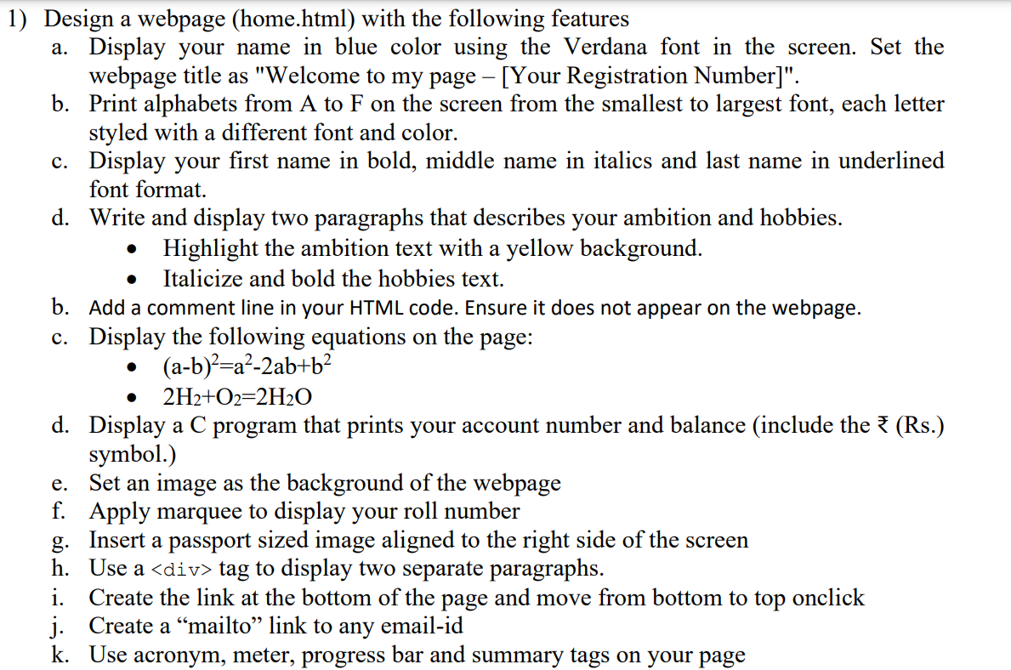

Code:

<!DOCTYPE html>

<html lang="en">

<head>

    <meta charset="UTF-8">

    <meta name="viewport" content="width=device-width, initial-scale=1.0">

    <title>Welcome to my page - [23BCE1728]</title>

</head>

<body background="skybue.jpeg">

    <p style="color: blue;font-family:verdana;">Sushen Grover</p>

    <h6 style="color: red;font-family:sans-serif;">A</h6>

    <h5 style="color: brown;font-family:'Segoe UI', Tahoma, Geneva, Verdana, sans-serif;">B</h5>

    <h4 style="color: purple;font-family:'Times New Roman', Times, serif;">C</h4>

    <h3 style="color: orange;font-family:Arial, Helvetica, sans-serif;">D</h3>

    <h2 style="color: green;font-family:Georgia, 'Times New Roman', Times, serif;">E</h2>

    <h1 style="color: yellow;font-family:system-ui, -apple-system, BlinkMacSystemFont, 'Segoe UI', Roboto, Oxygen, Ubuntu, Cantarell, 'Open Sans', 'Helvetica Neue', sans-serif;">F</h1>

    <p>

        <b>Sushen</b>

        <i>Grover</i>

        <u>SG</u>

    </p>

    <p>

        My ambition is to excel as a <mark>problem solver and innovator in the field of technology</mark>. I aspire to contribute to cutting-edge advancements by developing solutions that address real-world challenges, from efficient algorithms to impactful software systems. My long-term goal is to lead projects that blend creativity and engineering, whether it's through building sustainable energy systems, advancing artificial intelligence, or improving digital accessibility. By constantly honing my skills and learning new tools, I aim to leave a meaningful mark in the tech world.

    </p>

    <p>

        In my free time, I enjoy a variety of hobbies that keep me both inspired and grounded. <i><b>Coding</b></i> is not just a profession for me; it's also a passion, and I often challenge myself with competitive programming problems or personal projects. Outside the digital realm, I have a love for <i><b>art and design</b></i>, which lets me explore creativity through sketches and digital illustrations. Additionally, I enjoy <i><b>reading books</b></i>—especially those that blend science and philosophy—as they offer me fresh perspectives. Whenever I get the chance, I also indulge in <i><b>outdoor activities like hiking or playing badminton</b></i> to stay active and refresh my mind.

    </p>

    <!-- This is a comment line and it will not appear in the code. -->

    <p>

        (a-b)<sup>2</sup>=a<sup>2</sup>-2ab+b<sup>2</sup>

    </p>

    <p>

        2H<sub>2</sub>+O<sub>2</sub>=2H<sub>2</sub>O

    </p>

    <p>

        <h3>C Program to display Acount number and balance</h3>

        #include &ltstdio.h&gt<br>

            int main() {<br>

                long accountNumber = 1234567890;<br>

                double balance = 10543.75;<br>

                printf("Account Details:\n");<br>

                printf("Account Number: %ld\n", accountNumber);<br>

                printf("Balance: %.2f\n", balance);<br>

                return 0;<br>

            }<br>

    </p>

    <br>

    <marquee>Roll No: 23BCE1728</marquee>

    <img width="150" src="pp.jpg" alt="Passport Size img" *align*="right">

    <div><h4>Paragraph 1</h4>Lorem ipsum, dolor sit amet consectetur adipisicing elit. Doloribus ullam non incidunt ducimus, nesciunt quod laborum debitis tempora aut quaerat voluptas atque cupiditate nihil repellendus nam, maxime veritatis. Reiciendis, laborum.</div>

    <div><h4>Paragraph 2</h4>Lorem ipsum, dolor sit amet consectetur adipisicing elit. Doloribus ullam non incidunt ducimus, nesciunt quod laborum debitis tempora aut quaerat voluptas atque cupiditate nihil repellendus nam, maxime veritatis. Reiciendis, laborum.</div>

    <br>

    <a href="" target="_top">Link to top of the webpage</a>

    <br>

    <a href="mailto:groversushen@gmail.com">Mail Us</a>

    <br>

    <br>

    <p>

        <h3>Acronym</h3>

        <*acronym* title="Vellore Institute of Technology">VIT</*acronym*>

        <br>

    </p>

    <p>

        <h3>Meter</h3>

        Life goals achieved (30%)

        <meter min="0" max="100" value="30"></meter>

        <br>

    </p>

    <p>

        <h3>Progress Bar</h3>

        Progress in life goals (70%)

        <progress max=100 value=70></progress>

        <br>

    </p>

    <p>

        <h3>Summary</h3>

        <details>

            <summary>VIT</summary>

            <p>VIT provides a platform for students and faculty to connect with international experts and collaborate on projects involving cutting-edge technologies.</p>

        </details>

        <br>

    </p>

    <p>

        <a href="greetings.html" target="_blank">Link to Greetings Page</a>

    </p>

</body>

</html>

Output:

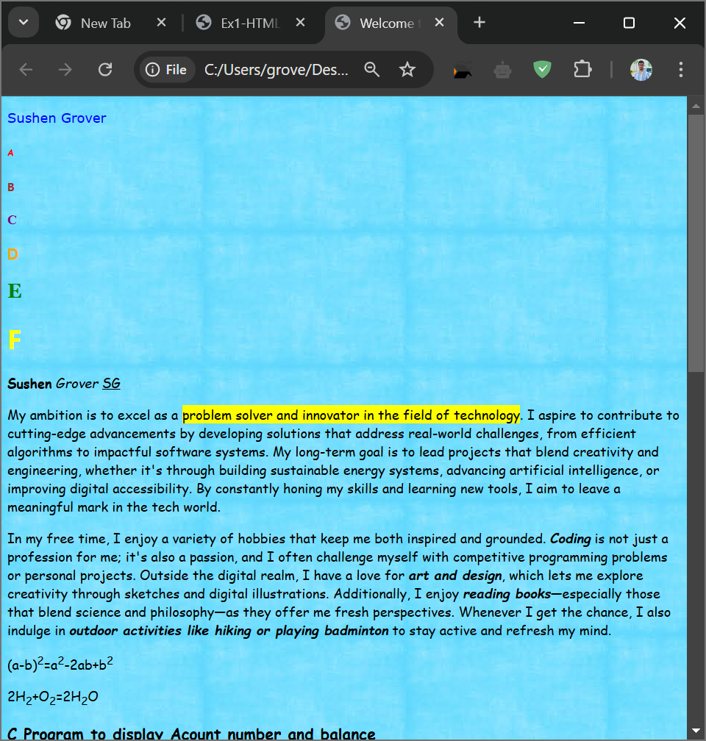

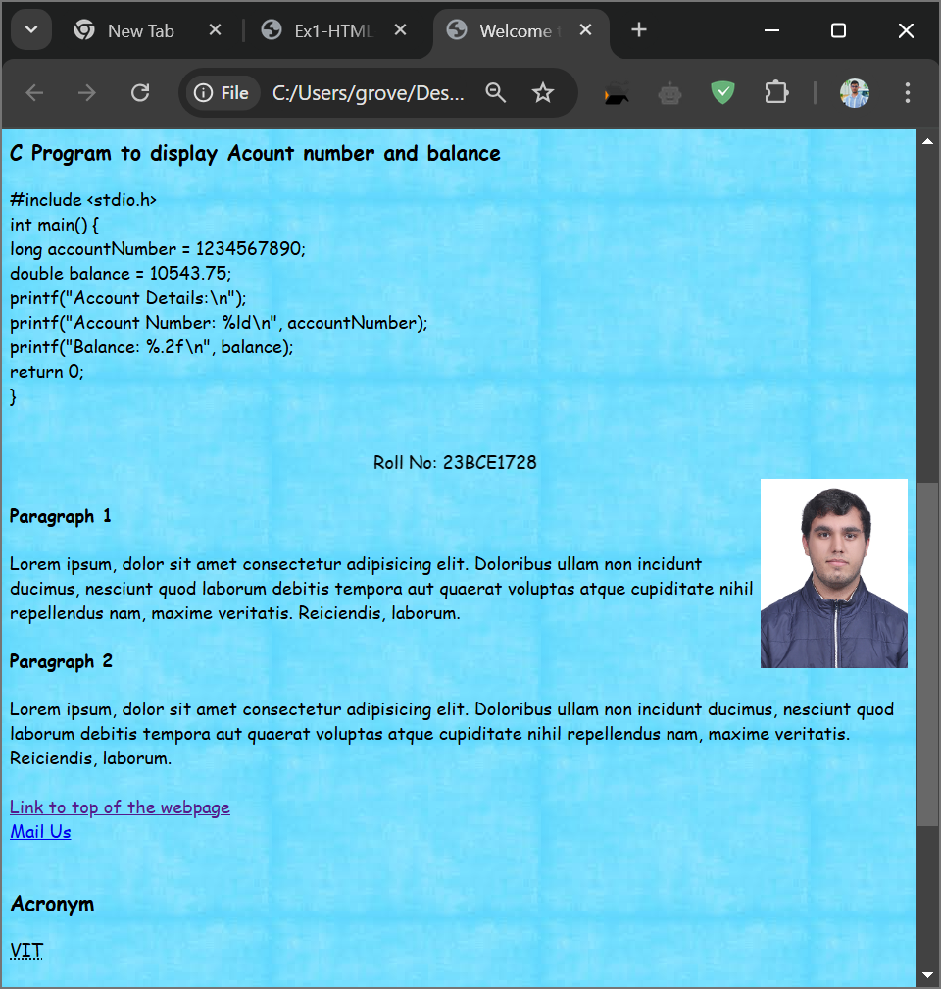

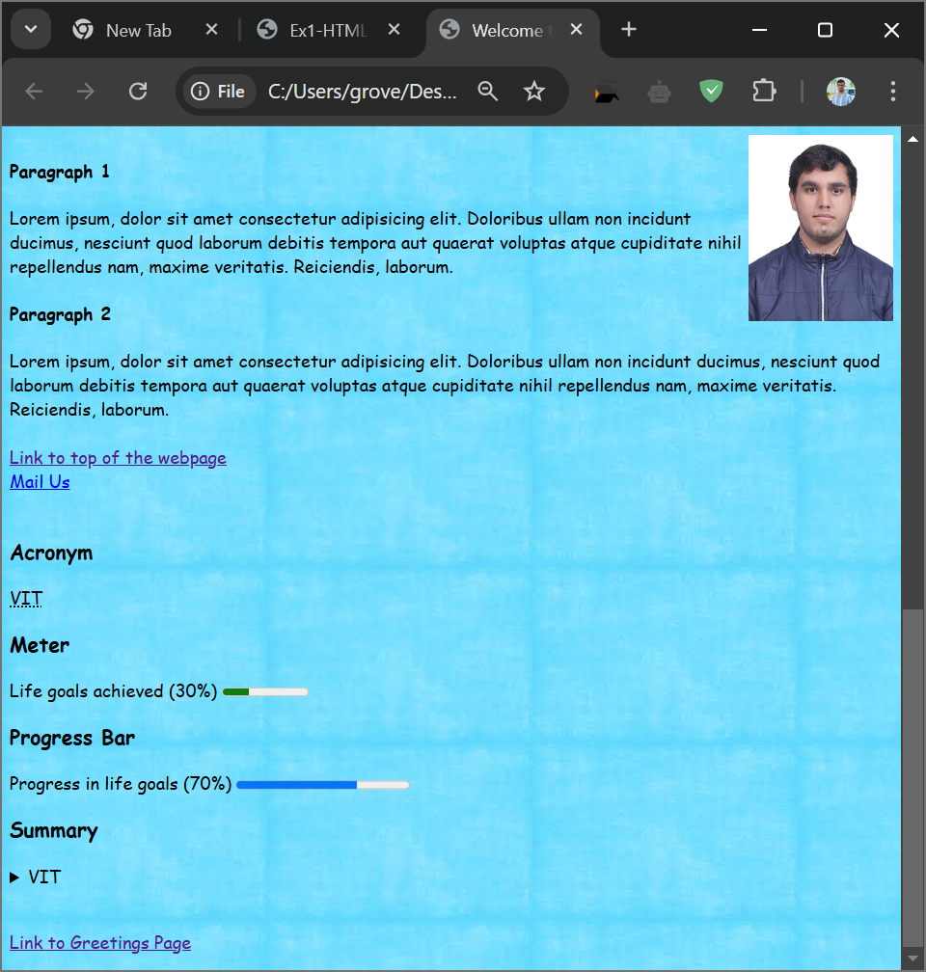

Ouestion 2:

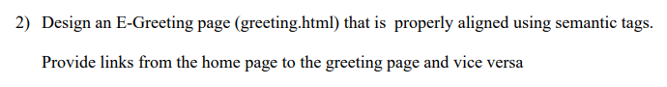

Code:

<!DOCTYPE html>

<html lang="en">

<head>

    <meta charset="UTF-8">

    <meta name="viewport" content="width=device-width, initial-scale=1.0">

    <title>Document</title>

</head>

<body *align*="center" background="pink.jpg">

    <h1>🎉 Happy Birthday! 🎉</h1>

    <p>Wishing you a wonderful day filled with love, laughter, and happiness!</p>

    <p>🎂 Enjoy your special day! 🎁</p>

    <img src="birthdayCake.jpg" width="250" alt="Birthday Cake">

    <p>

        <a href="home.html" target="_blank">Link to Home Page</a>

    </p>

</body>

</html>

Output:

