**Web Programming**

Lab - 10

Java Script

Name: Sushen Grover

Reg No: 23BCE1728

Slot: L11+L12+L31+L32

Class No: CH2024250502774

Course Code: BCSE203E

Faculty: Dr. L.M. Jenila Livingston

Question 1:

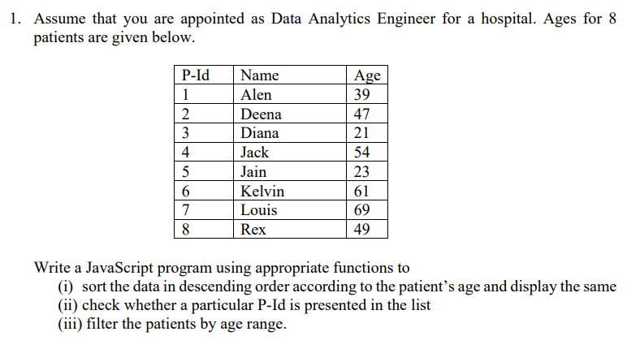

Code:

**HTML**

<!DOCTYPE html>

<html lang="en">

<head>

    <meta charset="UTF-8">

    <meta name="viewport" content="width=device-width, initial-scale=1.0">

    <title>23BCE1728</title>

    <style>

        table{

            border-collapse: collapse;

            border: 2px solid black;

            box-sizing: border-box;

        }

        td,th{

            text-align: left;

            width: 150px;

        }

        #sort-button{

            width: 150px;

        }

        input{

            width: 100px;

        }

        #pid-found-status{

            width: 400px;

            height: 50px;

            margin: 20px 0px 0px 0px;

        }

        .range-value{

            border: 2px solid black;

            border-radius: 5px;

            width: 40px;

            height: 20px;

            display: inline-block;

        }

        .range-container{

            width: 300px;

            display: flex;

            justify-content: space-evenly;

            align-items: center;

        }

    </style>

</head>

<body>

    <h2>Exercise 10.1</h2>

    <table *border*="1" id="table1">

        <tr class="table-header-row">

            <th>P-Id</th>

            <th>Name</th>

            <th>Age</th>

        </tr>

        <tr class="table-row">

            <td>1</td>

            <td>Alen</td>

            <td>39</td>

        </tr>

        <tr class="table-row">

            <td>2</td>

            <td>Deena</td>

            <td>47</td>

        </tr>

        <tr class="table-row">

            <td>3</td>

            <td>Diana</td>

            <td>21</td>

        </tr>

        <tr class="table-row">

            <td>4</td>

            <td>Jack</td>

            <td>54</td>

        </tr>

        <tr class="table-row">

            <td>5</td>

            <td>Jain</td>

            <td>23</td>

        </tr>

        <tr class="table-row">

            <td>6</td>

            <td>Kelvin</td>

            <td>61</td>

        </tr>

        <tr class="table-row">

            <td>7</td>

            <td>Luis</td>

            <td>69</td>

        </tr>

        <tr class="table-row">

            <td>8</td>

            <td>Rex</td>

            <td>49</td>

        </tr>

    </table>

    <button class="sort-button">Sort</button>

    <br>

    <br>

    <div style="border: 2px solid black;width: 450px;padding: 5px;">

        <label for="">Enter PID to find: </label>

        <input type="text" id="pid-input">

        <br>

        <button id="pid-submit">Submit</button>

        <br>

        <div id="pid-found-status">

            <table id="pid-found-status-table"></table>

        </div>

    </div>

    <br>

    <div style="border: 2px solid black;width: 450px;padding: 5px;height: 500px;">

        <h3>Age Range Filter</h3>

        <div class="range-container">

            <label for="">Min Range</label>

            <input type="range" class="range-input" value="20" min="20" max="70">

            <p class="range-value"></p>

        </div>

        <div class="range-container">

            <label for="">Max Range</label>

            <input type="range" class="range-input" value="70" min="20" max="70">

            <p class="range-value"></p>

        </div>

        <table *border*="1" id="table2">

        </table>

    </div>

    <script src="script1.js"></script>

</body>

</html>

**JS**

function sortAge(event){

    event.preventDefault;

    flag=0;

    let table=document.querySelector('#table1');

    let rows=document.querySelectorAll('.table-row');

    let arr=Array.from(rows);

    arr.sort((a,b)=>{

        let age1=parseInt(a.cells[2].textContent);

        let age2=parseInt(b.cells[2].textContent);

        return age1-age2;

    });

    arr.forEach(row=>table.appendChild(row));

}

function findPID(event){

    event.preventDefault;

    let pid=parseInt(document.querySelector("#pid-input").value);

    let table=document.querySelector('table');

    let rows=document.querySelectorAll('.table-row');

    let arr=Array.from(rows);

    let ans=-1;

    let i;

    for(i=0;i<arr.length;i++){

        if(arr[i].cells[0].textContent==pid){

            ans=i;

            break;

        }

    }

    if(ans==-1){

        let element=document.createElement('tr');

        element.innerHTML='<td colspan="3" style="width:450px;text-align:center;">No Patient Found</td>';

        document.querySelector("#pid-found-status-table").innerHTML=element.outerHTML;

    }

    else{

        document.querySelector("#pid-found-status-table").innerHTML=rows[i].outerHTML;

    }

}

document.querySelector(".sort-button").addEventListener('click',sortAge);

document.querySelector("#pid-submit").addEventListener('click',findPID);

const rangeInputs=document.querySelectorAll(".range-input");

const rangeValues=document.querySelectorAll(".range-value");

max=50;

min=20;

function updateRangeValue(index){

    let num=rangeInputs[index].value;

    rangeValues[index].innerHTML=num;

    if(index==0){min=parseInt(num);}

    else{max=parseInt(num);}

    let rows=document.querySelectorAll('.table-row');

    let arr=Array.from(rows);

    let table2=document.querySelector('#table2');

    min=parseInt(min);

    max=parseInt(max);

    table2.innerHTML="";

    for(let i=0;i<arr.length;i++){

        let num=parseInt(arr[i].cells[2].textContent);

        if(num<=max&&num>=min){

            let element=document.createElement('tr');

            element.innerHTML=rows[i].innerHTML;

            table2.append(element);

        }

    }

}

rangeInputs.forEach((i,index)=>{

    updateRangeValue(index);

    i.addEventListener('input',()=>updateRangeValue(index));

})

Output:

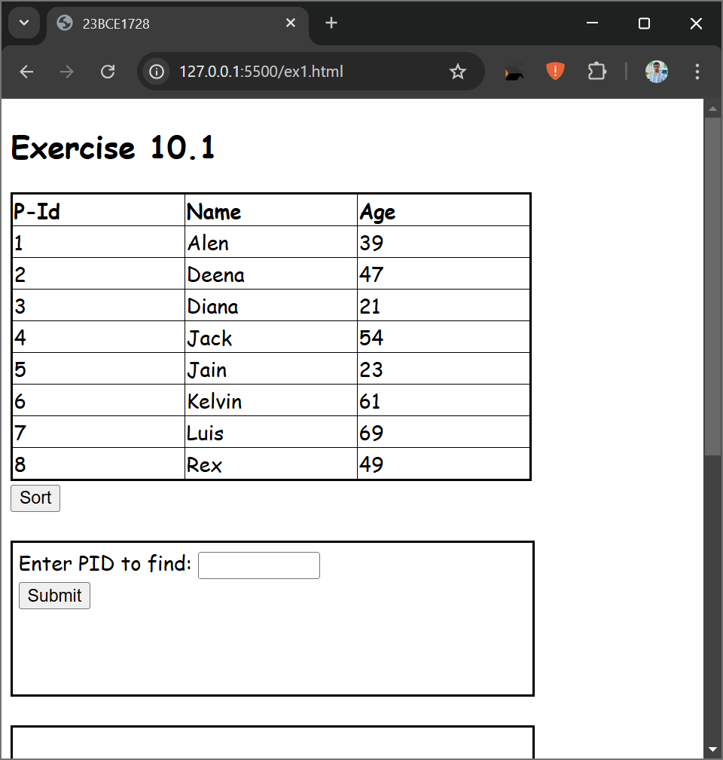

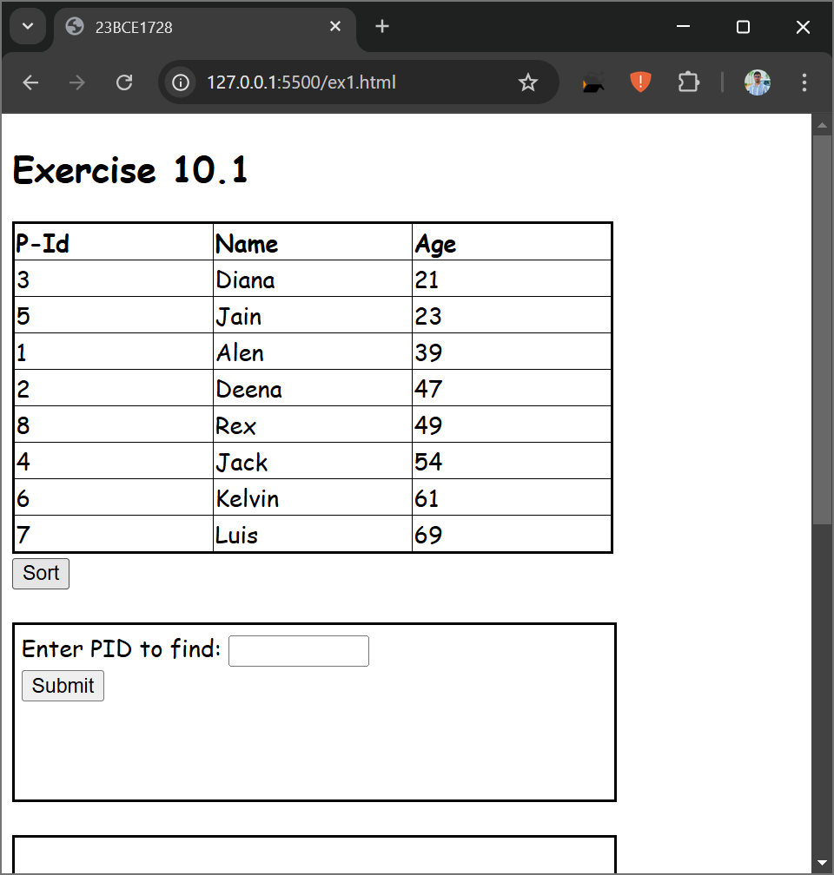

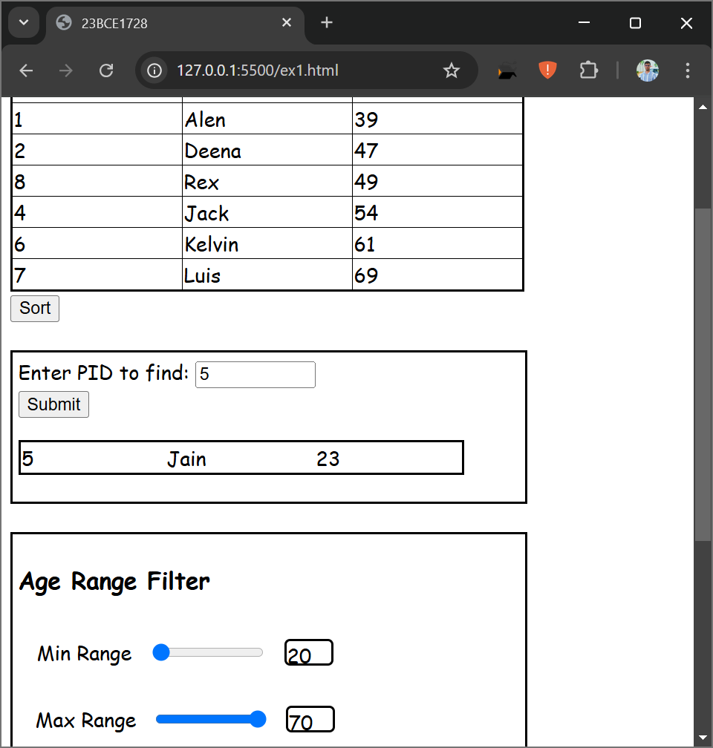

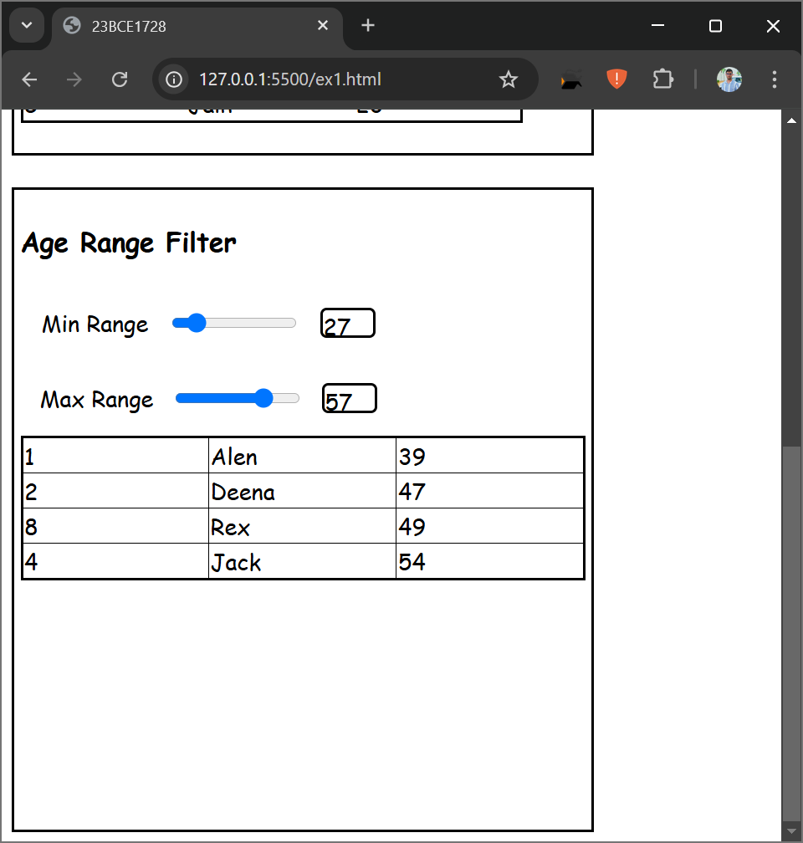

Question 2:

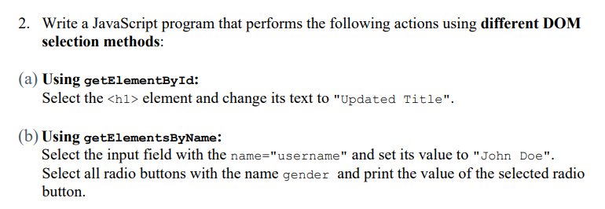

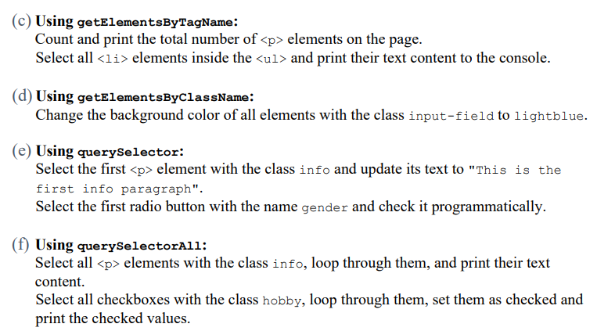

Code:

**HTML**

<!DOCTYPE html>

<html lang="en">

<head>

    <meta charset="UTF-8">

    <meta name="viewport" content="width=device-width, initial-scale=1.0">

    <title>23BCE1728</title>

</head>

<body>

    <h2>Exercise 10.2</h2>

    <h1 id="title">Original Title</h1>

    <input type="text" name="username">

    <br>

    <input type="radio" name="gender" value="Male"> Male

    <input type="radio" name="gender" value="Female"> Female

    <br>

    <p>This is paragraph 1.</p>

    <p>This is paragraph 2.</p>

    <ul>

        <li>Item 1</li>

        <li>Item 2</li>

    </ul>

    <input type="text" class="input-field">

    <input type="text" class="input-field">

    <p class="info">Info paragraph 1</p>

    <p class="info">Info paragraph 2</p>

    <input type="checkbox" class="hobby" value="Reading"> Reading

    <input type="checkbox" class="hobby" value="Gaming"> Gaming

    <input type="checkbox" class="hobby" value="Coding"> Coding

    <script src="script2.js"></script>

</body>

</html>

**JS**

document.getElementById("title").textContent = "Updated Title";

document.getElementsByName("username")[0].value = "John Doe";

const genderRadios = document.getElementsByName("gender");

for (let radio of genderRadios) {

    if (radio.checked) {

        console.log("Selected Gender:", radio.value);

    }

}

const paragraphs = document.getElementsByTagName("p");

console.log("Total <p> elements:", paragraphs.length);

const listItems = document.getElementsByTagName("li");

for (let li of listItems) {

    console.log("List Item:", li.textContent);

}

const inputFields = document.getElementsByClassName("input-field");

for (let field of inputFields) {

    field.style.backgroundColor = "lightblue";

}

const firstInfoParagraph = document.querySelector(".info");

if (firstInfoParagraph) {

    firstInfoParagraph.textContent = "This is the first info paragraph";

}

const firstGenderRadio = document.querySelector('input[name="gender"]');

if (firstGenderRadio) {

    firstGenderRadio.checked = true;

}

const infoParagraphs = document.querySelectorAll(".info");

infoParagraphs.forEach(p => console.log("Info Paragraph:", p.textContent));

const hobbyCheckboxes = document.querySelectorAll(".hobby");

hobbyCheckboxes.forEach(checkbox => {

    checkbox.checked = true;

    console.log("Checked Hobby:", checkbox.value);

});

Output:

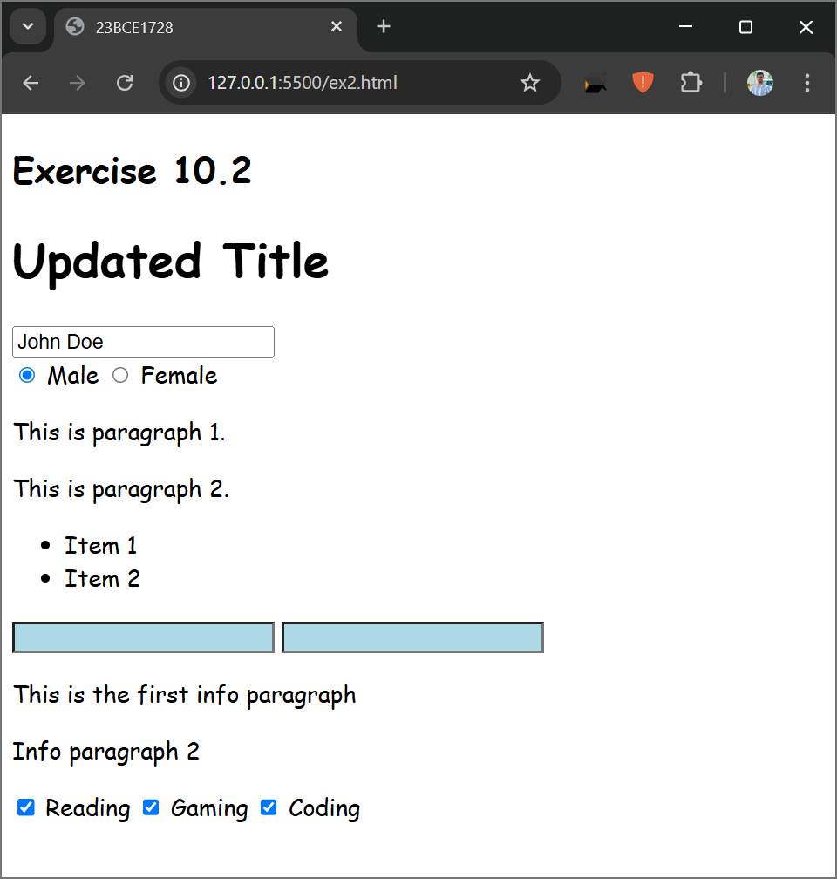

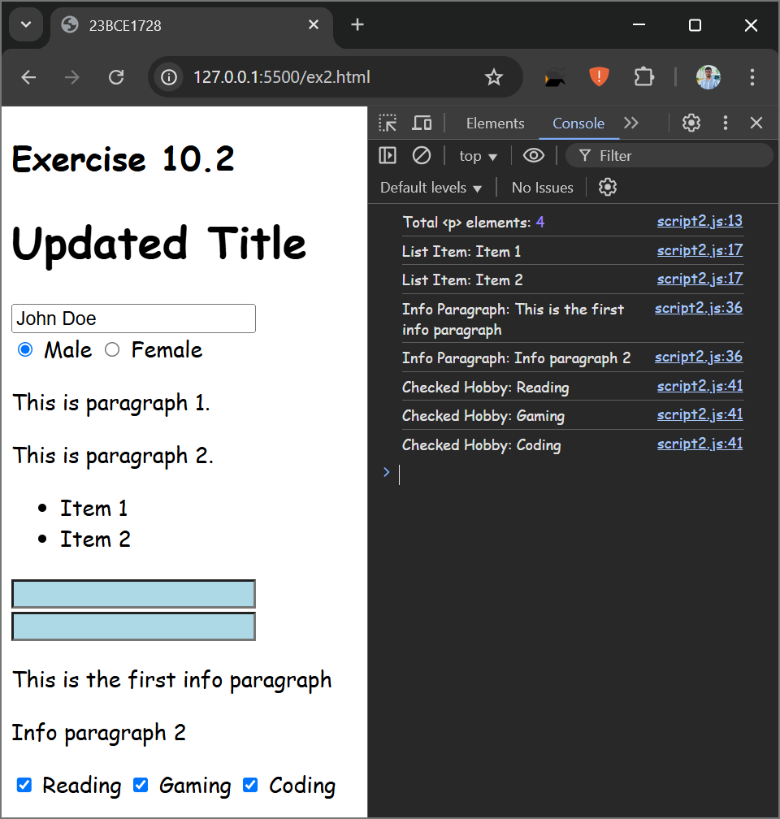

Question 3:

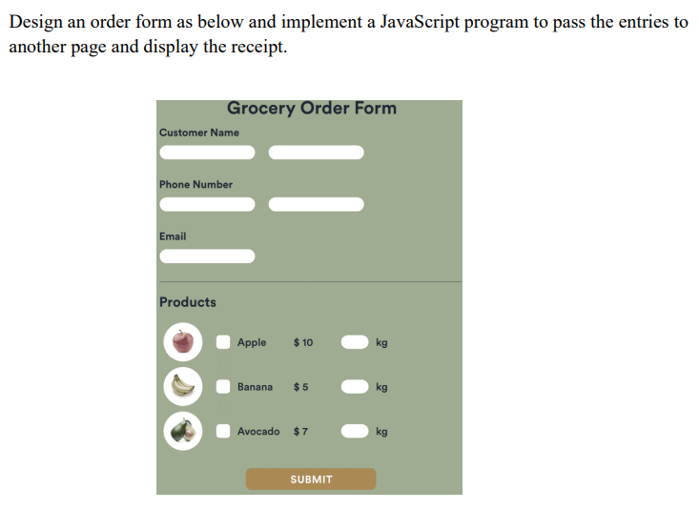

Code:

**HTML**

**ex31.html**

<!DOCTYPE html>

<html lang="en">

<head>

    <meta charset="UTF-8">

    <meta name="viewport" content="width=device-width, initial-scale=1.0">

    <title>23BCE1728</title>

    <link rel="stylesheet" href="style3.css">

</head>

<body>

    <h2>Exercise 10.3</h2>

    <div class="wrapper">

        <h3 class="heading">Grocery Order Form</h3>

        <div class="info-input-div">

            Customer Name

            <br>

            <input type="text" class="customer-name">

        </div>

        <div class="info-input-div">

            Phone Number

            <br>

            <input type="text" class="phone-number">

        </div>

        <div class="info-input-div">

            Email

            <br>

            <input type="text" class="email">

        </div>

        <hr>

        <h4>Products</h4>

        <form action="" name="f1">

            <ul>

                <li>

                    <img src="apple_fruit_powder3.jpg" class="fruit-image" alt="">

                    <input type="checkbox" name="fruit" id="">

                    <div class="fruit-name">Apple</div>

                    <div class="fruit-price">&dollar;10</div>

                    <input type="text" class="fruit-qty">

                    <div class="kg">kg</div>

                </li>

                <li>

                    <img src="download.jpg" class="fruit-image" alt="">

                    <input type="checkbox" name="fruit" id="">

                    <div class="fruit-name">Banana</div>

                    <div class="fruit-price">&dollar;5</div>

                    <input type="text" class="fruit-qty">

                    <div class="kg">kg</div>

                </li>

                <li>

                    <img src="118166873.png" class="fruit-image" alt="">

                    <input type="checkbox" name="fruit" id="">

                    <div class="fruit-name">Avocado</div>

                    <div class="fruit-price">&dollar;7</div>

                    <input type="text" class="fruit-qty">

                    <div class="kg">kg</div>

                </li>

            </ul>

            <button id="submit-button">Submit</button>

        </form>

    </div>

    <script src="script3.js"></script>

</body>

</html>

**receipt.html**

<!DOCTYPE html>

<html lang="en">

<head>

    <meta charset="UTF-8" />

    <meta name="viewport" content="width=device-width, initial-scale=1.0" />

    <title>Receipt</title>

    <link rel="stylesheet" href="style3.css" />

</head>

<body>

    <h2>Order Receipt</h2>

    <div id="receipt"></div>

    <script>

        document.addEventListener("DOMContentLoaded", function () {

            let name = localStorage.getItem("customerName");

            let phone = localStorage.getItem("customerPhone");

            let email = localStorage.getItem("customerEmail");

            let products = JSON.parse(localStorage.getItem("orderedProducts"));

            let totalCost = localStorage.getItem("totalCost");

            let receiptHTML = `<p><strong>Name:</strong> ${name}</p><p><strong>Phone:</strong> ${phone}</p><p><strong>Email:</strong> ${email}</p><h3>Products Ordered:</h3><ul>`;

            products.forEach((product) => {receiptHTML += `<li>${product.name} - ${product.quantity} kg @ $${product.price} per kg</li>`;});

            receiptHTML += `</ul><p><strong>Total Cost:</strong> $${totalCost}</p>`;

            document.getElementById("receipt").innerHTML = receiptHTML;

        });

    </script>

</body>

</html>

**style3.css**

*{

    margin: 0px;

    padding: 0px;

}

body{

    display: flex;

    flex-direction: column;

    align-items: center;

}

.wrapper{

    background-color: #9fac91;

    border: 2px solid black;

    width: 50vw;

    height: 77vh;

    margin: 10px;

    padding: 10px;

    display: flex;

    flex-direction: column;

    justify-content: space-around;

    align-content: space-around;

}

.heading{

    text-align: center;

    padding: 0px;

    margin: 0px;

}

.fruit-image{

    width: 40px;

    height: 40px;

    border-radius: 50%;

}

li{

    margin: 5px 0px 5px 0px;

    display: flex;

    flex-direction: row;

    justify-content: space-around;

}

hr{

    margin: 5px 0px 0px 0px;

    background-color: black;

    height: 1px;

    border: none;

    border-radius: 10px;

}

input{

    height: 25px;

    border: none;

    border-radius: 10px;

}

.fruit-name{

    /* border: 2px solid black; */

    width: 100px;

}

.fruit-qty{

    width:50px;

}

.info-input-div{

    padding: 5px 0px 0px 0px;

}

ul{

    padding: 0px;

    width: 50vw;

}

#submit-button{

    width: 100px;

    border: none;

    border-radius: 10px;

    background-color: rgb(166, 108, 0);

    color: white;

    font-weight: bold;

    height:25px;

}

form[name="f1"]{

    display: flex;

    flex-direction: column;

    justify-content: center;

    align-items: center;

}

**JS**

**script3.js**

document.addEventListener("DOMContentLoaded", function() {

    const form = document.forms["f1"];

    const submitButton = document.getElementById("submit-button");

    submitButton.addEventListener("click", function(event) {

        event.preventDefault();

        let name = document.querySelector(".customer-name").value.trim();

        let phone = document.querySelector(".phone-number").value.trim();

        let email = document.querySelector(".email").value.trim();

        if (!name || !phone || !email) {

            alert("Please fill in all customer details.");

            return;

        }

        let products = [];

        let totalCost = 0;

        const items = [

            { name: "Apple", price: 10 },

            { name: "Banana", price: 5 },

            { name: "Avocado", price: 7 }

        ];

        const checkboxes = document.querySelectorAll("input[name='fruit']");

        const quantities = document.querySelectorAll(".fruit-qty");

        checkboxes.forEach((checkbox, index) => {

            if (checkbox.checked) {

                let quantity = parseFloat(quantities[index].value);

                if (!isNaN(quantity) && quantity > 0) {

                    products.push({ name: items[index].name, quantity, price: items[index].price });

                    totalCost += items[index].price * quantity;

                }

            }

        });

        if (products.length === 0) {

            alert("Please select at least one product and enter a valid quantity.");

            return;

        }

        localStorage.setItem("customerName", name);

        localStorage.setItem("customerPhone", phone);

        localStorage.setItem("customerEmail", email);

        localStorage.setItem("orderedProducts", JSON.stringify(products));

        localStorage.setItem("totalCost", totalCost);

        window.location.href = "receipt.html";

    });

});

Output:

