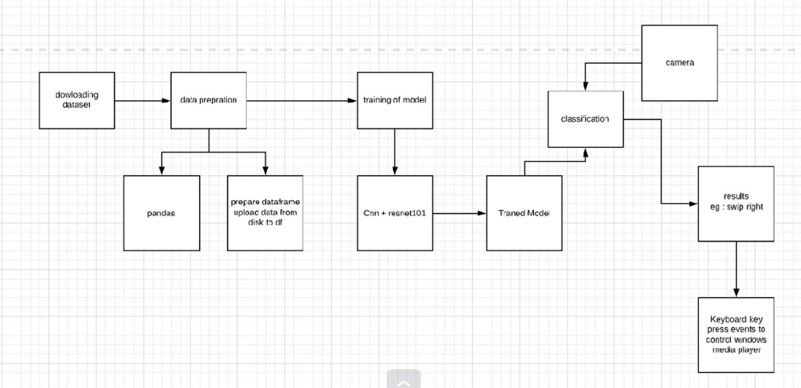

**1. Data Downloading**

* This block refers to acquiring the dataset to be used for training the machine learning model.
* The data source is not specified in the diagram, but common data sources include online repositories, APIs, and internal databases.
* When choosing a dataset, consider the following:
  + **Relevance:** Does the data pertain to the problem you are trying to solve?
  + **Size:** Is there enough data to train the model effectively?
  + **Quality:** Is the data clean and free of errors?
* Data downloading can be done using various methods depending on the source. Here are some common methods:
  + **Web Scraping:** This involves extracting data from websites. You can use libraries like Beautiful Soup or Scrapy in Python for web scraping.
  + **APIs:** Many data providers offer APIs that allow you to programmatically access their data.
  + **Downloading from a URL:** You can simply download the data from a URL if it is available.

**2. Data Preprocessing**

* Data preprocessing is a crucial step in machine learning as it prepares the data for training the model.
* Common data preprocessing techniques include:
  + **Handling missing values:** This involves replacing missing values with a placeholder value (e.g., mean, median) or removing rows/columns with missing values.
  + **Data normalization or standardization:** This involves scaling the data to a common range (e.g., 0-1 or -1, 1) to improve the convergence of the machine learning model.
  + **Feature engineering:** This involves creating new features from existing features that might be more relevant for the machine learning model.
* The data preprocessing techniques used will depend on the specific dataset and machine learning model.

**3. Prepare Dataframe**

* This block likely refers to creating a Pandas dataframe [pandas.pydata.org] out of the downloaded and preprocessed data.
* A Pandas dataframe is a tabular data structure with labeled axes (rows and columns) that allows for efficient data manipulation and analysis.
* To create a Pandas dataframe, you can use the pd.read_csv() function if the data is stored in a CSV file format, or similar functions for other file formats (e.g., pd.read_excel() for Excel files).

**4. Upload Data from Disk to DL Framework**

* This block refers to loading the prepared dataframe into a deep learning framework for model training.
* Common deep learning frameworks include TensorFlow <https://www.tensorflow.org/> and PyTorch [pytorch.org].
* The specific method for loading data into a deep learning framework will depend on the framework being used. However, most frameworks provide functions for loading data from CSV files or other data sources.

**5. Training the Model**

* In this block, the machine learning model is trained on the prepared data.
* The diagram shows that the Conv+ResNet101 model is being used. This is a convolutional neural network (CNN) architecture that is pre-trained on the ImageNet dataset [image-net.org]. The ResNet101 architecture is a variant of the ResNet architecture that is known for its good performance on image classification tasks.
* Training a machine learning model involves feeding the data into the model and adjusting the model's parameters (weights and biases) to minimize a loss function. The loss function measures how well the model's predictions match the true labels of the data.
* The training process typically involves iterating over the data multiple times (epochs) and updating the model's parameters after each iteration.

**CNN + ResNet101 Model**

* **Convolutional Neural Networks (CNNs):**
  + CNNs are a type of deep learning architecture specifically designed for image recognition and classification tasks.
  + They leverage the spatial structure of images by using convolutional filters that extract features from local regions of the image.
  + These features are then processed by additional layers to learn more complex representations of the image.
* **ResNet101 Architecture:**
  + ResNet101 is a specific CNN architecture introduced in the Deep Residual Learning for Image Recognition paper by He et al. (2016) [refer to the paper for detailed explanation].
  + It addresses the vanishing gradient problem that can hinder training in very deep neural networks.
  + ResNet101 achieves this by introducing residual connections, which skip some layers in the network and add the input directly to the output.
  + This allows the network to learn the identity mapping, facilitating gradient flow and enabling deeper architectures to be trained effectively.

**Technical details for implementation paper:**

* **Pre-trained vs. Training from Scratch:**
  + The diagram suggests using a pre-trained ResNet101 model.
  + Pre-trained models like ResNet101, trained on massive datasets like ImageNet, have learned powerful feature representations that can be beneficial for various computer vision tasks.
  + You can fine-tune the pre-trained model on your specific dataset by freezing the earlier layers (which capture generic features) and training the later layers (which are more task-specific) on your data.
  + Alternatively, you can choose to train the entire ResNet101 model from scratch on your data, but this may require a larger dataset and more computational resources.
* **Modifications to ResNet101:**
  + Depending on your specific task, you might need to modify the final layers of the ResNet101 architecture.
  + For example, if your task involves classifying images into 10 different categories, you would likely replace the final fully connected layer of ResNet101 with a new layer that has 10 output neurons (one for each category).
* **Hyperparameter Tuning:**
  + The performance of the model can be sensitive to various hyperparameters such as the learning rate, batch size, and the number of training epochs.
  + Briefly discuss the hyperparameters you used and how you tuned them (e.g., manual tuning, grid search).

**6. Classification**

* This block refers to using the trained model to make predictions on new data.

## When a new data point is presented to the model, the model will process the data and output a classification. For example, an image classification model might classify an image as a cat or a dog.

## Data Augmentation Techniques for Image Classification

Data augmentation is a powerful technique used in image classification to artificially expand the size and diversity of your training dataset. This helps to improve the model's generalization ability and prevent overfitting, which occurs when the model performs well on the training data but poorly on unseen data.

There are two main approaches to data augmentation: online and offline.

**1. Online Data Augmentation:**

* Performed during training on each batch of images.
* More computationally efficient as augmentations are applied on the fly.
* Offers greater flexibility as you can control the randomness of transformations.

**Common Online Augmentations:**

* **Random Flipping:** Horizontally flipping images (mirroring) creates variations in object orientation.
* **Random Rotation:** Rotating images by small random angles helps the model recognize objects from different viewpoints.
* **Random Cropping:** Cropping random patches from the original image forces the model to learn from different parts of the object.

**2. Offline Data Augmentation:**

* Performed before training by creating a new, augmented dataset.
* Requires additional storage space for the augmented data.
* Less flexible as the transformations are predetermined.

**Common Offline Augmentations:**

* **Horizontal and Vertical Flips:** Create mirrored versions of all images in the dataset.
* **Rotations:** Rotate all images by a set of predefined angles.
* **Cropping:** Randomly crop a fixed number of patches from each image.
* **Color Jittering:** Randomly adjust image brightness, contrast, saturation, and hue to simulate different lighting conditions.

Here's a breakdown of some specific augmentation techniques:

* **Flip (Horizontal and Vertical):** Flips the image horizontally (left-right) or vertically (up-down). This increases the model's robustness to mirrored versions of objects.
* **Rotation:** Rotates the image by a random angle within a predefined range. This helps the model recognize objects from different viewpoints.
* **Crop:** Takes a random sub-region of the original image. This forces the model to focus on different parts of the object and reduces the influence of background clutter.
* **Colour Augmentations:** These techniques modify the color channels of the image to simulate variations in lighting conditions. Examples include:
  + **Brightness Jitter:** Randomly adjusts the overall brightness of the image.
  + **Contrast Jitter:** Randomly adjusts the contrast between light and dark regions.
  + **Saturation Jitter:** Randomly adjusts the saturation of colors in the image.
  + **Hue Jitter:** Randomly shifts the hue of colors in the image.

**Choosing Data Augmentation Techniques:**

The choice of data augmentation techniques depends on your specific dataset and task. Consider the following factors:

* **Type of objects:** For objects with strong orientations (e.g., cars), flipping might be more important.
* **Background complexity:** If backgrounds are cluttered, cropping might be beneficial.
* **Lighting variations:** Consider color jittering if lighting variations are a concern.

**Overall, data augmentation is a valuable tool for improving the performance of image classification models. By incorporating a combination of online and offline techniques, you can effectively increase the diversity of your training data and achieve better generalization on unseen images.**

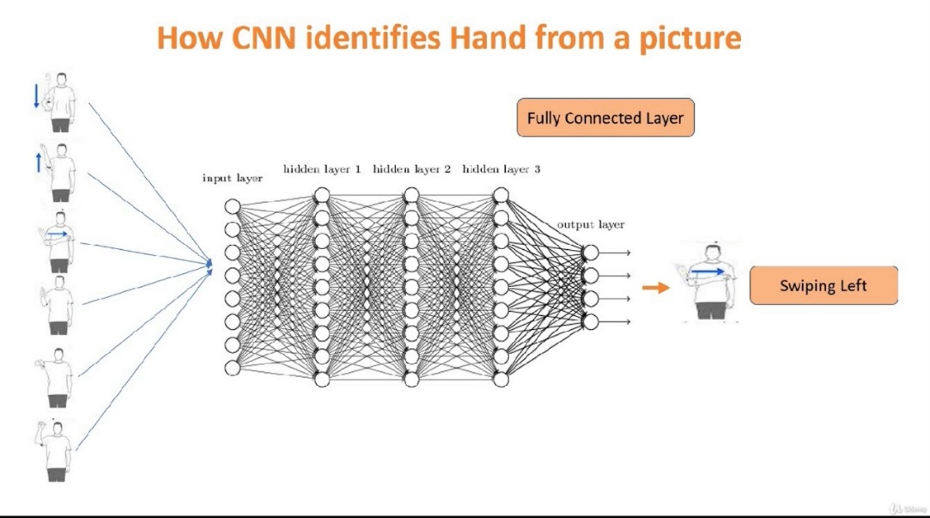

## How a CNN Identifies Hands in Images: A Layer-by-Layer Breakdown

Convolutional Neural Networks (CNNs) excel at image recognition tasks, including hand detection. Here's a breakdown of how a CNN identifies hands in an image, focusing on the key layers and their functionalities,

**1. Input Layer:**

* This layer acts as the entry point for the image data.
* The image is typically preprocessed (resized, normalized) and converted into a 3D tensor representing the pixel values (width, height, color channels).
* For example, a grayscale image might be a 2D tensor (width, height), while an RGB image would be a 3D tensor (width, height, 3 color channels).

**2. Convolutional Layer:**

* The core building block of a CNN.
* It applies a filter (kernel) that slides across the width and height of the input, computing the dot product between the filter and the local image region.
* This process extracts features from the image, such as edges, shapes, and textures.
* The filter moves with a stride (number of pixels) to cover the entire image and generates a feature map.

**Mathematics of Convolution:**

(Refer to previous explanation)

**3. ReLU (Rectified Linear Unit) Layer:**

* This non-linear activation function is often used after the convolution layer.
* It introduces non-linearity into the network, allowing it to learn more complex features.
* ReLU sets all negative values in the feature map to zero, while keeping positive values unchanged.

**Mathematics of ReLU:**

(Refer to previous explanation)

**4. Pooling Layer:**

* Reduces the spatial dimensionality of the feature maps while preserving important features.
* Common pooling techniques include:
  + **Max Pooling:** Takes the maximum value from a rectangular region in the feature map.
  + **Average Pooling:** Takes the average value from a rectangular region in the feature map.
* Pooling helps to:
  + Reduce computational cost by reducing the number of parameters.
  + Make the model more robust to small variations in the input image (e.g., hand position).

**5. Flattening Layer:**

* This layer transforms the outputs of the previous layer (typically multiple feature maps) into a single long vector.
* It essentially reshapes the data from a multi-dimensional tensor (width, height, channels) into a one-dimensional vector.
* Flattening is necessary because fully connected layers require a single-dimensional input.

**6. Fully Connected Layer:**

* Connects all neurons from the previous layer (e.g., flattened pool outputs) to all neurons in the current layer.
* This layer integrates the features extracted from previous layers to form a higher-level representation of the image.
* Multiple fully connected layers can be stacked to create a deep learning architecture.

**7. Output Layer:**

* The final layer has a number of neurons equal to the number of classes you want to predict (e.g., 1 for hand, 0 for not hand).
* This layer typically uses a softmax activation function that outputs a probability distribution for each class.
* The neuron with the highest probability indicates the model's prediction.

**Identifying Hands: Feature Vectors and Training**

* During training, the CNN learns feature vectors that are optimal for hand detection.
* The initial layers learn low-level features like edges and lines.
* Subsequent layers progressively combine these features to form more complex representations that capture hand-like shapes.
* The final layers use these learned features to classify the image as containing a hand or not.

**Overall, CNNs effectively identify hands in images through a combination of feature extraction, non-linear activation, and classification. By learning from a large dataset of hand and non-hand images, the CNN can generalize its knowledge to identify hands in unseen images.**

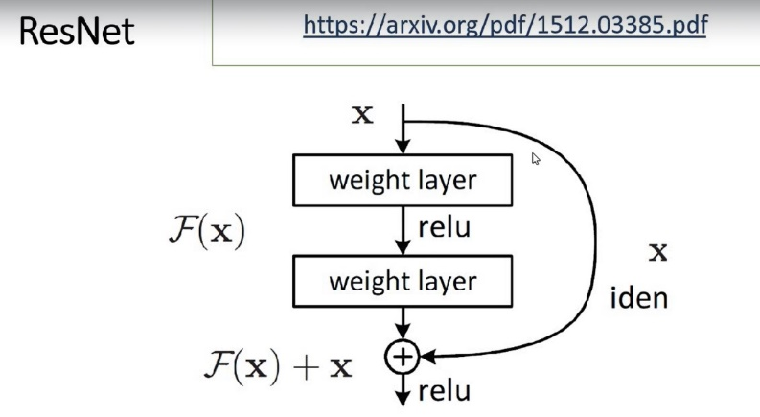

The diagram shows a residual block, which is a common building block in residual networks (ResNets) for deep learning. Residual networks address the vanishing gradient problem, which can occur when training very deep neural networks.

Here’s a breakdown of the terms:

* **ResNet**: A type of convolutional neural network (CNN) architecture that stacks residual blocks together. Residual blocks allow for easier training of very deep neural networks by introducing “skip connections” that bypass some of the layers. Residual networks won the ImageNet Large Scale Visual Recognition Competition (ILSVRC) in 2015 [1].
* **Weight layer**: A layer in a neural network that applies a linear transformation to its input. This transformation is achieved by multiplying the input by a weight matrix and adding a bias vector. The weight matrix and bias vector are parameters of the neural network that are learned during training.
* **relu**: Rectified linear unit (ReLU) activation function. It is a popular activation function in neural networks that sets all negative inputs to zero. It is simple to compute and has been shown to be effective in many applications.
* **iden**: Identity connection. This refers to the skip connection in a residual block that copies the input to the residual block and adds it to the output of the stacked layers.
* **F(x)**: This represents the stacked layers within the residual block.

Here’s how a residual block works:

1. The input data (x) is passed through a weight layer (denoted as F(x) in the diagram).
2. The output of the weight layer is passed through a ReLU activation function.
3. The input data (x) is added, element-wise, to the output of the ReLU activation function.
4. The sum is then passed through another weight layer.

The skip connection ensures that the gradient can flow directly through the residual block during backpropagation, avoiding the vanishing gradient problem. This allows residual networks to train much deeper models than traditional CNNs

**Mathematics involved in ResNet**

**1. Convolution (within Weight Layer):**

The weight layer (F(x)) typically uses a convolution operation. Convolution is a mathematical operation that involves a sliding filter (kernel) that extracts features from the input data. Mathematically, it can be represented as:

* Y = W * X + b
  + Y: Output feature map
  + W: Convolutional kernel (weights)
  + X: Input feature map
  + *: Convolution operation (often implemented with element-wise multiplication and summation)
  + b: Bias vector

**2. ReLU Activation (relu):**

The ReLU (rectified linear unit) activation function is applied element-wise to the output of the convolution. It sets all negative values to zero and keeps positive values unchanged. Mathematically:

* f(x) = max(0, x)
  + f(x): Output after ReLU
  + x: Input to ReLU

**3. Element-wise Addition (iden):**

The identity connection (iden) simply adds the original input (x) to the output of the ReLU activation function (F(x) + relu). This addition happens element-wise, meaning corresponding elements from both tensors are added.

**4. Convolution (potentially within another Weight Layer):**

The final step often involves another convolution operation on the sum obtained from the identity connection. This additional convolution layer can further process the features learned by the residual block. The mathematical form remains the same as the first convolution (Y = W * X + b).

**Overall Function of Residual Block:**

While the specific mathematical functions within F(x) can vary depending on the network architecture, the overall function of the residual block can be represented as:

* H(x) = F(x) + relu(x)
  + H(x): Output of the residual block
  + F(x): Output of the stacked convolutional layers (may include additional activation functions)
  + relu(x): Output of the ReLU activation function applied to the input (x)

This highlights how the residual block learns the difference (residual) between the desired output (H(x)) and the original input (x), making it easier to train deeper networks.