EXPERIMENT-2

Aim
To design and develop basic web pages using HTML5, CSS, and Bootstrap. This includes understanding HTML5 semantic tags, creating a personal profile homepage using section elements, and developing a blog page with multimedia and a contact form.

Theory and Code

1. HTML5 Tags
HTML5 is the latest version of HyperText Markup Language used to structure and present content on the web. One of the most important improvements introduced in HTML5 is the use of semantic tags. Semantic tags clearly describe the meaning and purpose of the content they contain, making web pages easier to understand for both developers and web browsers.
Before HTML5, developers mainly used generic tags such as <div> and <span> to create page layouts. These tags did not indicate the type of content inside them. HTML5 introduced semantic elements that define specific sections of a webpage, improving code readability, maintainability, accessibility, and search engine optimization (SEO).
Some commonly used HTML5 semantic tags include:
- <header> – Represents the introductory content of a webpage or section. It usually contains the website title, logo, or navigation links.
- <nav> – Defines a set of navigation links that help users move between different pages or sections of the website.
- <section> – Represents a thematic grouping of content, typically with a heading.
- <article> – Used for self-contained content such as blog posts, news articles, or forum posts.
- <aside> – Contains content that is indirectly related to the main content, such as sidebars or advertisements.
- <footer> – Represents the footer of a webpage or section and typically contains copyright information, contact details, or additional links.
HTML5 also introduced multimedia elements, which allow developers to embed media without external plugins:
- <video> – Used to embed video files directly into web pages.
- <audio> – Used to embed sound or music files.
Code and output:
<!DOCTYPE html>
<html lang="en">
<head>
<meta charset="UTF-8">
<meta name="viewport" content="width=device-width, initial-scale=1.0">
<base href="" target="_blank"/>
<link rel="stylesheet" href="styles.css" hreflang="en" media="screen" />

<style type="text/css" media="screen" scoped >
body{
font-family: Arial,sans-serif;
background-color: #f5f5f5;
}
</style>

<script charset="UTF-8"
src="scripts/myjs.js"
defer="defer"
async="async">
</script>

<title>Document</title>
</head>
<body>
<h1>Explore various html5 tags</h1>
<main>
<hgroup>
<h1>HTML Elements demo</h1>
<h1>Text,media,lists,tables,graphics</h1>
</hgroup>

<hr>

<p>This is <b>bold</b> text, <i>Italic</i> text, <strong>strong</strong> text, and <em>emphasized</em> text.</p>

<p>
Chemical formula: H<sub>2</sub>O
Mathematical expression: E = mc<sup>2</sup>
</p>

<p>
Line break example:<br>
This is the first line.<wbr>Here
</p>

<hr>

<h2>Lists</h2>

<h3>Unordered List</h3>

<ul>
<li>Item 1</li>
<li>Item 2
<ul>
<li>Subitem 2.1</li>
<li>Subitem 2.2</li>
</ul>
</li>
<li>Item 3</li>
</ul>

<h3>Ordered List</h3>

<ol>
<li>First</li>
<li>Second
<ol>
<li>Second.A</li>
<li>Second.B</li>
</ol>
</li>
<li>Third</li>
</ol>

<h2>Code and output</h2>

<p>Inline code: <code>console.log("hello world")</code></p>

<pre>
function greet(name) {
return "Hello";
}
</pre>

<p>Program output: <output>Hello!</output></p>

<hr>

<h2>Deleted and Inserted Text</h2>

<p>
Old price: <del>$50.00</del><br>
New price: <ins>$35.00</ins>
</p>

<hr>

<h2>Quotes</h2>

<p>Short quote: <q>This is a short inline quote.</q></p>

<blockquote>HTML is a standard markup language for creating web pages.</blockquote>

<table border="1">
<caption>Sample Table</caption>
<thead>
<tr>
<th>Item</th>
<th>Quantity</th>
<th>Price</th>
</tr>
</thead>
<tbody>
<tr>
<td>Apples</td>
<td>10</td>
<td>$5.00</td>
</tr>
<tr>
<td>Bananas</td>
<td>6</td>
<td>$3.00</td>
</tr>
</tbody>
<tfoot>
<tr>
<td colspan="2">Total</td>
<td>$8.00</td>
</tr>
</tfoot>
</table>

<img src="pic.png" alt="Sample Image" width="200" height="150">

<h2>Audio</h2>
<audio controls>
<source src="Recording.m4a" type="audio/mpeg">
Your browser does not support the audio element.
</audio>

<hr>

<h2>Datalist (input list)</h2>

<input list="languages" name="language" />
<datalist id="languages">
<option value="JavaScript">
<option value="Python">
<option value="Java">
<option value="C++">
<option value="Ruby">
</datalist>

<hr>

<h2>Meter</h2>

<p>Task completion:</p>
<meter value="0.6">60%</meter>

<h2>Figure and Figcaption</h2>

<figure>
<img src="pic.png" alt="Sample Image" width="200" height="150">
<figcaption>Figure 1: Sample Image with Caption</figcaption>
</figure>

<h2>SVG</h2>

<svg width="100" height="100">
<circle cx="50" cy="50" r="40" stroke="green" stroke-width="4" fill="yellow" />
</svg>

<hr>
<h2>Canvas</h2>
<canvas id="mycanvas" width="200" height="100" style="border:1px solid #000000;">
Your browser does not support the HTML5 canvas tag.
</canvas>
<script>
const canvas = document.getElementById('mycanvas');
const ctx = canvas.getContext('2d');
ctx.fillStyle = 'blue';
ctx.fillRect(10, 10, 150, 75);
</script>
</main>
</body>
</html>
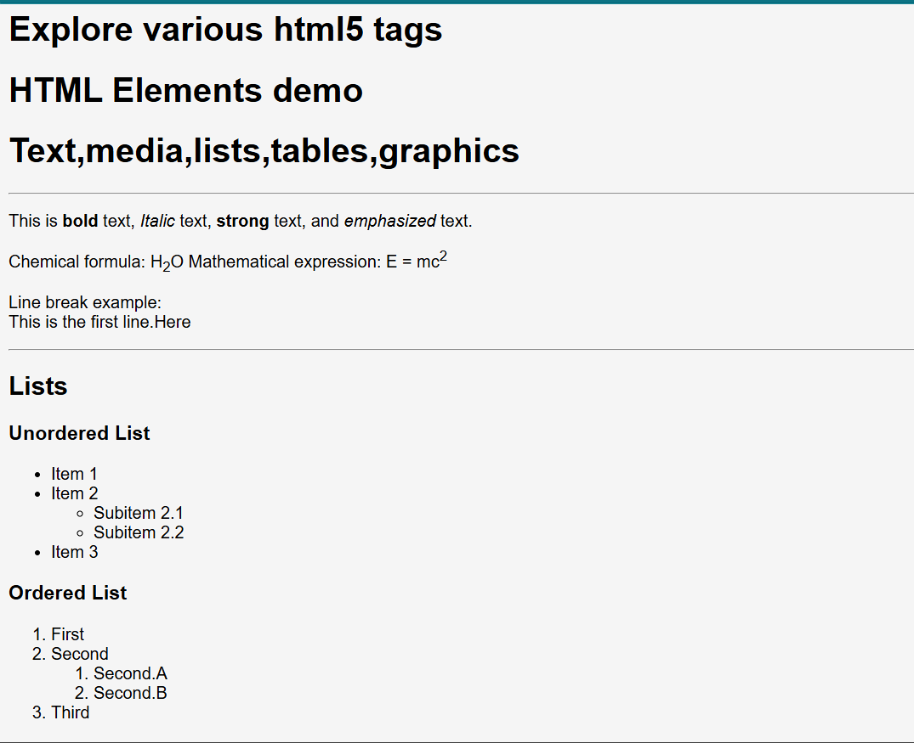
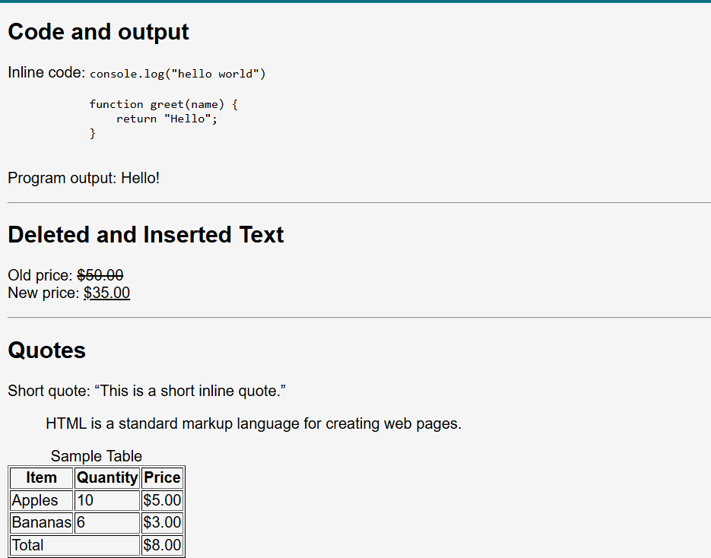
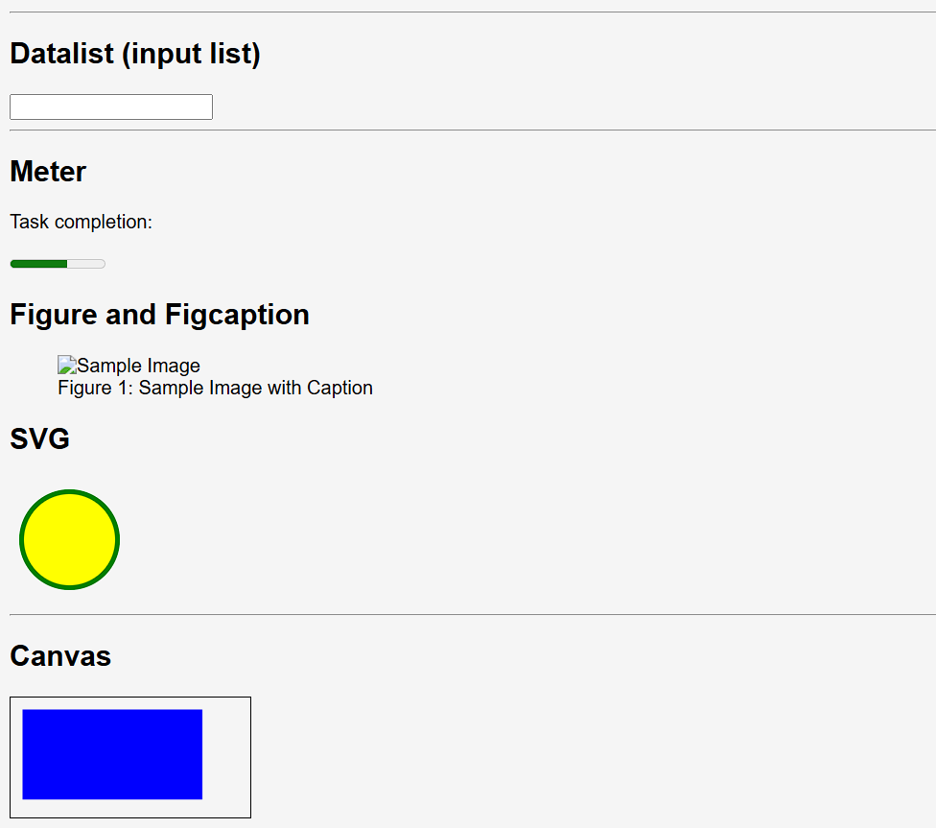

2. CSS Web Home Page using Section Elements
Cascading Style Sheets (CSS) is used to style HTML elements and control layout, colors, fonts, and responsiveness. Section elements such as <header>, <nav>, <section>, <aside>, and <footer> help create a structured homepage. CSS can be used to design a personal profile page with navigation menus, profile details, and styled content.
Code and Output
Index.html
<!DOCTYPE html>
<html lang="en">
<head>
<meta charset="UTF-8">
<meta name="viewport" content="width=device-width, initial-scale=1.0">
<title>Personal Profile</title>
<link rel="stylesheet" href="profile.css">
</head>
<body>
<header class="site-header">
<div class="brand">My Profile</div>
<nav class="site-nav">
<a href="#about">About</a>
<a href="#skills">Skills</a>
<a href="#projects">Projects</a>
<a href="#contact">Contact</a>
</nav>
</header>

<main>
<section class="hero" id="about">
<div class="hero-text">
<p class="eyebrow">Student Portfolio</p>
<h1>Chandrayan Paul</h1>
<p>
I am a web programming student who enjoys building clean,
responsive pages with HTML, CSS, and JavaScript.
</p>
<a href="#contact" class="cta-btn">Get In Touch</a>
</div>
<div class="hero-card">
<h2>Quick Info</h2>
<p><strong>Role:</strong> Student</p>
<p><strong>Focus:</strong> Front-End Development</p>
<p><strong>Location:</strong> India</p>
</div>
</section>

<section class="content-section" id="skills">
<h2>Skills</h2>
<div class="card-grid">
<article class="info-card">
<h3>HTML5</h3>
<p>Creating semantic page structures with accessible content.</p>
</article>
<article class="info-card">
<h3>CSS3</h3>
<p>Designing responsive layouts, forms, and navigation bars.</p>
</article>
<article class="info-card">
<h3>JavaScript</h3>
<p>Adding interactivity through DOM manipulation and events.</p>
</article>
</div>
</section>

<section class="content-section alt-section" id="projects">
<h2>Projects</h2>
<div class="card-grid">
<article class="info-card">
<h3>Portfolio Pages</h3>
<p>Built multiple portfolio layouts using structured HTML and custom CSS.</p>
</article>
<article class="info-card">
<h3>Blog Layout</h3>
<p>Created a styled blog page with media, forms, and modern sections.</p>
</article>
<article class="info-card">
<h3>Navigation Design</h3>
<p>Developed clean navbar components for lab assignments and practice work.</p>
</article>
</div>
</section>

<section class="content-section" id="contact">
<h2>Contact</h2>
<form class="contact-form" action="#">
<label for="name">Name</label>
<input type="text" id="name" name="name" placeholder="Enter your name">

<label for="email">Email</label>
<input type="email" id="email" name="email" placeholder="Enter your email">

<label for="message">Message</label>
<textarea id="message" name="message" rows="5" placeholder="Write your message"></textarea>

<button type="submit">Send Message</button>
</form>
</section>
</main>

<footer class="site-footer">
<p>&copy; 2026 Chandrayan Paul. All rights reserved.</p>
</footer>
</body>
</html>
Profile.css
:root {
--bg-color: #f4f7fb;
--surface-color: #ffffff;
--primary-color: #0f4c81;
--accent-color: #ffb703;
--text-color: #243447;
--muted-color: #5f6c7b;
--shadow: 0 12px 30px rgba(15, 76, 129, 0.12);
}

* {
box-sizing: border-box;
margin: 0;
padding: 0;
}

body {
font-family: "Segoe UI", Tahoma, Geneva, Verdana, sans-serif;
background: linear-gradient(180deg, #eef5ff 0%, var(--bg-color) 100%);
color: var(--text-color);
line-height: 1.6;
}

.site-header {
background-color: var(--surface-color);
box-shadow: 0 2px 12px rgba(0, 0, 0, 0.06);
display: flex;
justify-content: space-between;
align-items: center;
padding: 1.2rem 8%;
position: sticky;
top: 0;
}

.brand {
font-size: 1.5rem;
font-weight: 700;
color: var(--primary-color);
}

.site-nav {
display: flex;
gap: 1.5rem;
}

.site-nav a {
color: var(--text-color);
text-decoration: none;
font-weight: 600;
}

.site-nav a:hover {
color: var(--primary-color);
}

main {
width: min(1100px, calc(100% - 40px));
margin: 0 auto;
}

.hero {
display: grid;
grid-template-columns: 2fr 1fr;
gap: 2rem;
align-items: center;
padding: 4rem 0 3rem;
}

.hero-text h1 {
font-size: 3rem;
margin-bottom: 1rem;
color: var(--primary-color);
}

.eyebrow {
color: var(--accent-color);
font-weight: 700;
letter-spacing: 0.08em;
text-transform: uppercase;
margin-bottom: 0.8rem;
}

.hero-text p {
max-width: 60ch;
color: var(--muted-color);
margin-bottom: 1.5rem;
}

.cta-btn {
display: inline-block;
background-color: var(--primary-color);
color: #ffffff;
text-decoration: none;
padding: 0.9rem 1.5rem;
border-radius: 999px;
font-weight: 600;
}

.hero-card,
.info-card,
.contact-form {
background-color: var(--surface-color);
border-radius: 18px;
box-shadow: var(--shadow);
}

.hero-card {
padding: 2rem;
}

.hero-card h2 {
margin-bottom: 1rem;
color: var(--primary-color);
}
.hero-card p + p {
margin-top: 0.75rem;

.content-section {
padding: 2rem 0 3rem;
}
.content-section h2 {
font-size: 2rem;
margin-bottom: 1.5rem;
color: var(--primary-color);
}

.alt-section {
background-color: rgba(255, 255, 255, 0.55);
padding-inline: 1.5rem;
border-radius: 24px;
}
.card-grid {
display: grid;
grid-template-columns: repeat(3, minmax(0, 1fr));
gap: 1.5rem;

.info-card {
padding: 1.5rem;
}
.info-card h3 {
margin-bottom: 0.75rem;
color: var(--text-color);
}
.info-card p {
color: var(--muted-color);
}
.contact-form {
padding: 2rem;
display: grid;
gap: 0.9rem;
}

.contact-form label {
font-weight: 600;
}

.contact-form input,
.contact-form textarea {
width: 100%;
padding: 0.9rem 1rem;
border: 1px solid #cdd8e4;
border-radius: 12px;
font: inherit;
}

.contact-form button {
width: fit-content;
padding: 0.85rem 1.4rem;
border: 0;
border-radius: 999px;
background-color: var(--accent-color);
color: #1f2933;
font-weight: 700;
cursor: pointer;
}

.site-footer {
text-align: center;
padding: 1.5rem 1rem 2rem;
color: var(--muted-color);
}

@media (max-width: 800px) {
.site-header,
.hero {
grid-template-columns: 1fr;
}

.site-header {
flex-direction: column;
gap: 1rem;
padding: 1rem 5%;
}

.site-nav {
flex-wrap: wrap;
justify-content: center;
} .hero {
padding-top: 2.5rem;
} .card-grid {
grid-template-columns: 1fr;
} .hero-text h1 {
font-size: 2.3rem;
}
}
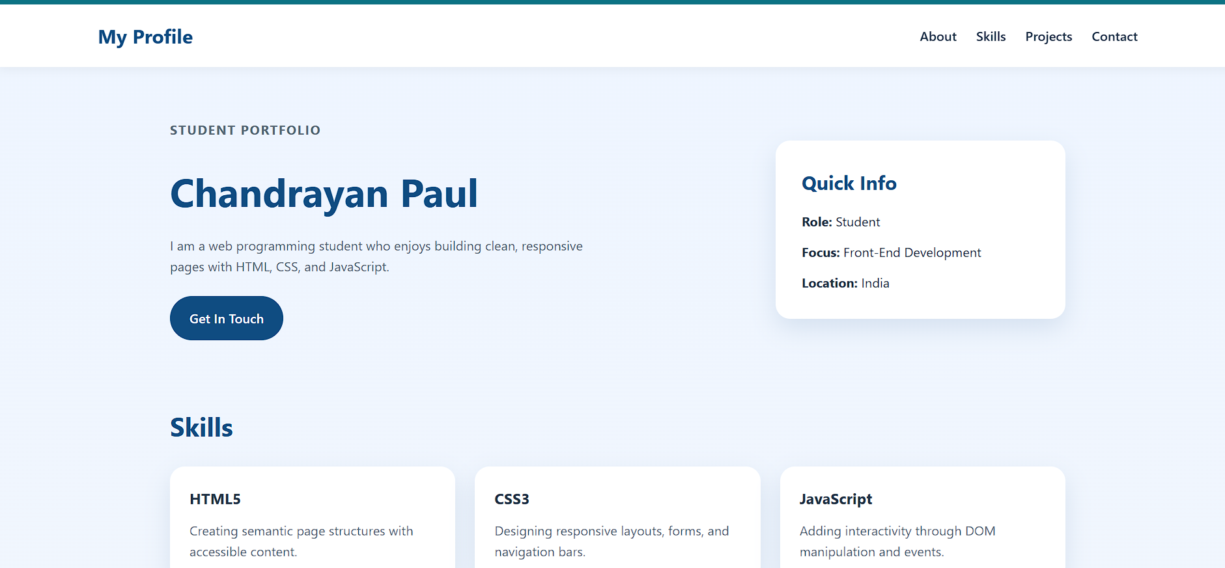

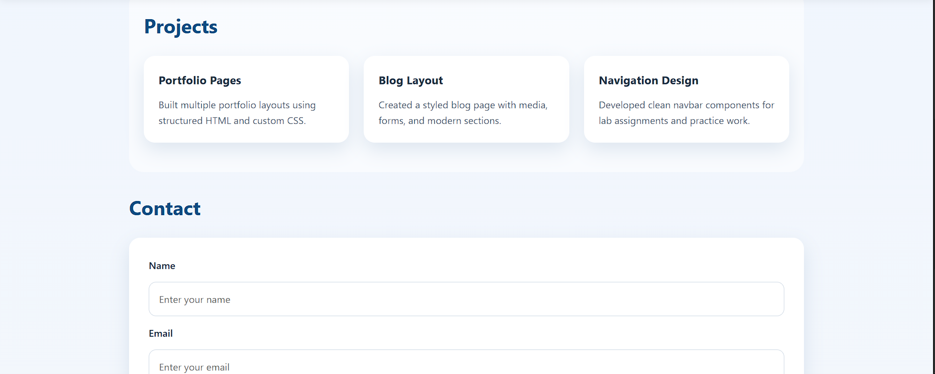
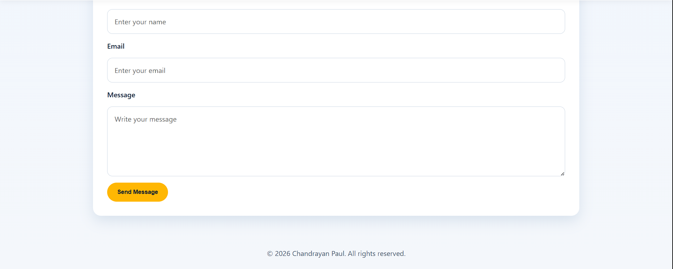

3. Blog Page using HTML, CSS, and Bootstrap
Bootstrap is a popular front-end framework that helps create responsive web pages quickly. A blog page can include text posts, images, embedded videos (such as YouTube), and a contact form. Bootstrap components like cards, grids, and forms make the page visually appealing and mobile-friendly.
Code and Output
Index.html
<!DOCTYPE html>
<html lang="en">
<head>
<meta charset="UTF-8">
<meta name="viewport" content="width=device-width, initial-scale=1.0">
<title>Cricket Chronicles</title>
<link rel="stylesheet" href="blogpage.css">
</head>
<body>

<header class="main-header">
<div class="logo">Cricket Chronicles</div>
<nav>
<a href="#">Matches</a>
<a href="#">Training Tips</a>
<a href="#">Highlights</a>
</nav>
</header>

<main class="blog-container">
<section class="hero-post">
<img src="https://images.unsplash.com/photo-1540747913346-19e32dc3e97e?auto=format&fit=crop&w=1200&q=80" alt="Cricketer playing a shot on the field" class="hero-img">
<div class="hero-content">
<h1>Mastering the Cover Drive: Why Timing Matters More Than Power</h1>
<p>The best cricket shots are not forced. A perfect cover drive comes from balance, footwork, and meeting the ball at exactly the right moment.</p>
</div>
</section>

<section class="article-body">
<div class="text-block">
<h2>The Rhythm of a Great Innings</h2>
<p>Building a strong innings is about reading the field, rotating the strike, and knowing when to accelerate. Top batters stay patient early, punish loose deliveries, and adapt quickly to the bowler's plan.</p>

<div class="video-card">
<h3>Watch: Cricket Skills and Match Moments</h3>
<video controls>
<source src="https://www.w3schools.com/html/mov_bbb.mp4" type="video/mp4">
Your browser does not support the video tag.
</video>
</div>
</div>

<aside class="sidebar">
<section class="form-card">
<h3>Join the Cricket Club</h3>
<p>Get weekly cricket news, tips, and match updates in your inbox.</p>
<form action="#">
<div class="input-group">
<label for="fname">Your Name</label>
<input type="text" id="fname" placeholder="Rahul" required>
</div>
<div class="input-group">
<label for="email">Email Address</label>
<input type="email" id="email" placeholder="cricketfan@example.com" required>
</div>
<div class="input-group">
<label for="message">Which team do you support?</label>
<textarea id="message" rows="3"></textarea>
</div>
<button type="submit" class="submit-btn">Subscribe Now</button>
</form>
</section>
</aside>
</section>
</main>

<footer class="main-footer">
<div class="footer-content">
<p>&copy; 2026 Cricket Chronicles</p>
<div class="footer-links">
<a href="#">Privacy</a>
<a href="#">Terms</a>
<a href="#">Contact</a>
</div>
</div>
</footer>
</body>
</html>
blogpage.css
:root {
--primary: #ff7e67;
--secondary: #2d3436;
--bg-color: #fcf9f2;
--card-bg: #ffffff;
--text: #4a4a4a;
}

* {
margin: 0;
padding: 0;
box-sizing: border-box;
font-family: 'Segoe UI', Roboto, sans-serif;
}

body {
background-color: var(--bg-color);
color: var(--text);
line-height: 1.7;
}

.main-header {
background: var(--card-bg);
padding: 1.5rem 10%;
display: flex;
justify-content: space-between;
align-items: center;
box-shadow: 0 2px 10px rgba(0,0,0,0.05);
position: sticky;
top: 0;
z-index: 100;
}

.logo {
font-size: 1.5rem;
font-weight: bold;
color: var(--secondary);
}

nav a {
text-decoration: none;
color: var(--text);
margin-left: 2rem;
font-weight: 500;
transition: color 0.3s;
}

nav a:hover {
color: var(--primary);
}

.blog-container {
max-width: 1100px;
margin: 3rem auto;
padding: 0 20px;
}

.hero-post {
background: var(--card-bg);
border-radius: 20px;
overflow: hidden;
margin-bottom: 3rem;
}

.hero-img {
width: 100%;
height: 450px;
object-fit: cover;
}

.hero-content {
padding: 2.5rem;
}

.hero-content h1 {
font-size: 2.5rem;
margin: 1rem 0;
color: var(--secondary);
line-height: 1.2;
}

.article-body {
display: grid;
grid-template-columns: 2fr 1fr;
gap: 40px;
}

.video-card {
margin-top: 2rem;
background: var(--secondary);
color: white;
padding: 20px;
border-radius: 15px;
}

.video-card h3 {
margin-bottom: 15px;
}

video {
width: 100%;
border-radius: 10px;
box-shadow: 0 5px 15px rgba(0,0,0,0.3);}
.form-card {
background: var(--card-bg);
padding: 2rem;
border-radius: 20px;
box-shadow: 0 10px 30px rgba(0,0,0,0.05);
position: sticky;
top: 100px;}
.input-group {
margin-bottom: 1.2rem;}
.input-group label {
display: block;
font-weight: 600;
margin-bottom: 5px;
font-size: 0.9rem;}
.input-group input,
.input-group textarea {
width: 100%;
padding: 12px;
border: 2px solid #eee;
border-radius: 10px;
outline: none;
transition: border-color 0.3s;}
.input-group input:focus {
border-color: var(--primary); }
.submit-btn {
width: 100%;
padding: 15px;
background: var(--primary);
color: white;
border: none;
border-radius: 10px;
font-weight: bold;
cursor: pointer;
transition: transform 0.2s, background 0.3s;}
.submit-btn:hover {
background: #ff6b52;
transform: translateY(-2px);}

.main-footer {
background: var(--secondary);
color: rgba(255, 255, 255, 0.7);
padding: 1rem 0;
margin-top: 2rem;
font-size: 0.85rem;
}

.footer-content {
max-width: 1100px;
margin: 0 auto;
padding: 0 20px;
display: flex;
justify-content: space-between;
align-items: center;
}

.footer-links a {
color: rgba(255, 255, 255, 0.7);
text-decoration: none;
margin-left: 1.5rem;
transition: color 0.3s;}.footer-links a:hover {
color: var(--primary);}

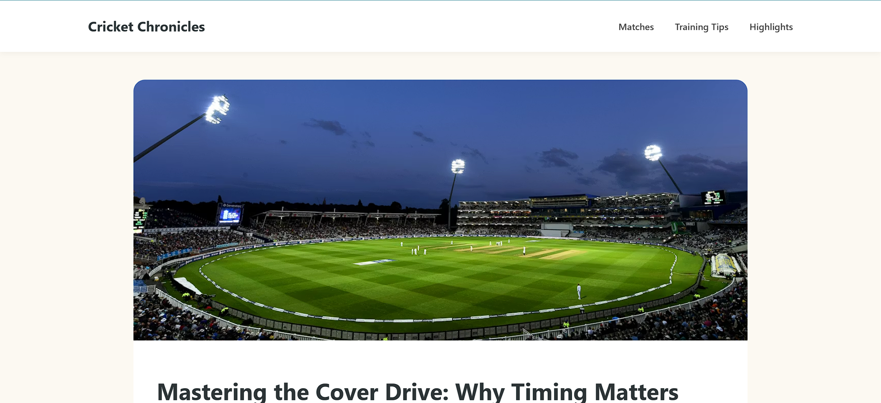
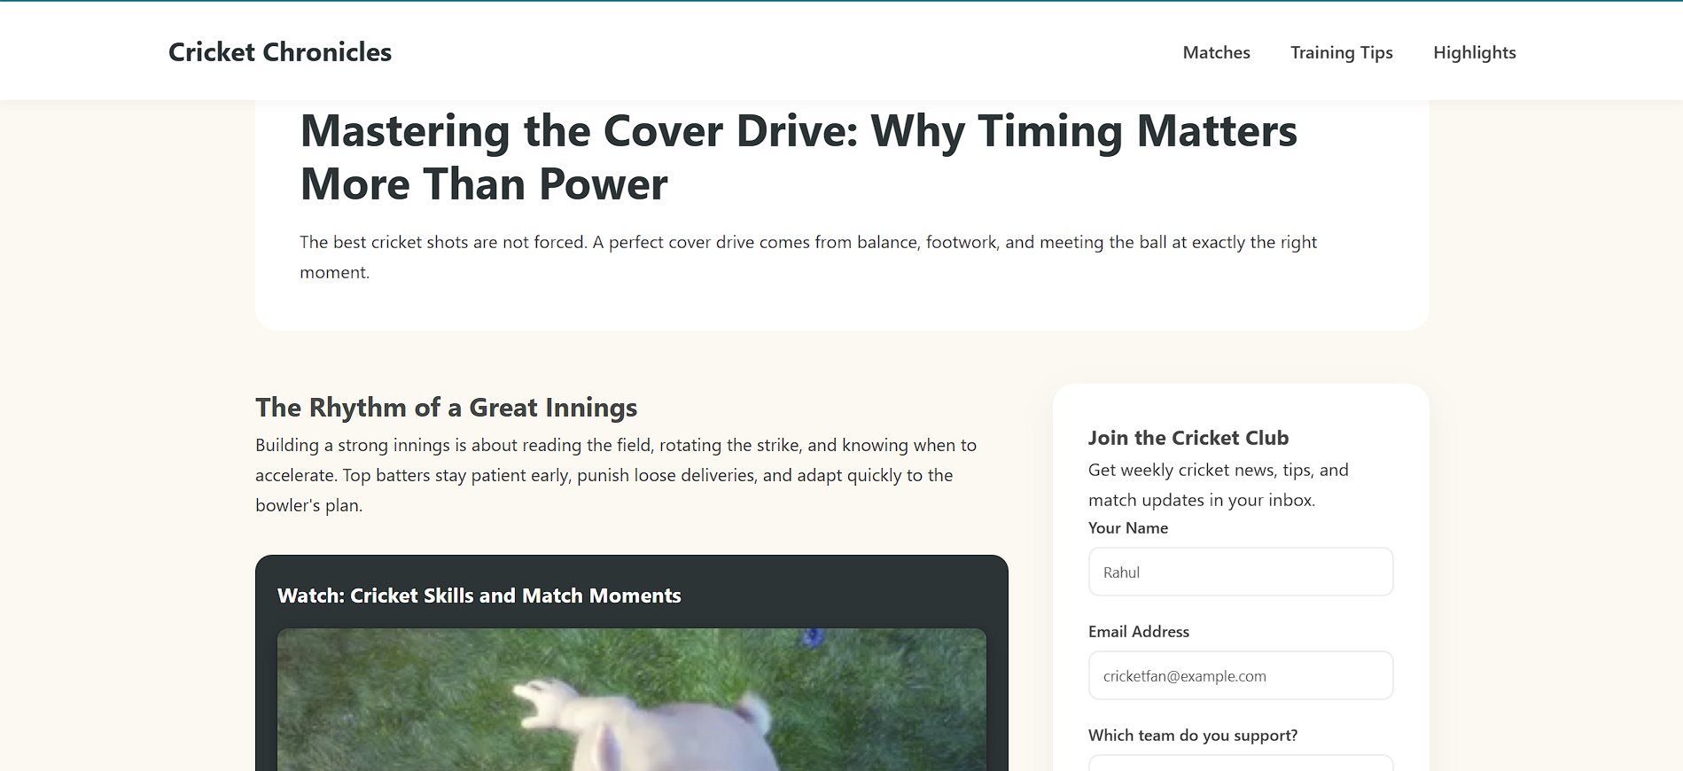
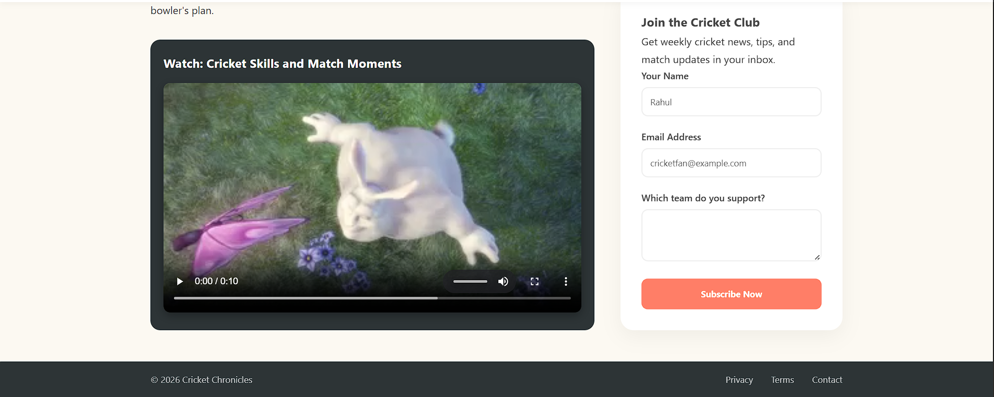

Conclusion
This practical demonstrated the use of HTML5 semantic tags, CSS styling, and Bootstrap framework to design structured and responsive web pages. The experiment helped in understanding modern web development practices and building visually organized web interfaces.

