EXPERIMENT-3

Aim:

To understand and implement JavaScript concepts such as arrays, functions, callback functions, Date and Math objects, and to apply event handling techniques by developing an interactive portfolio landing page with dark mode, light mode, and animations using HTML, CSS, and JavaScript

Theory and Code

1. Arrays, Date & Math Object, and Functions

Arrays in JavaScript
An array in JavaScript is a data structure used to store multiple values in a single variable. Arrays allow developers to manage collections of data efficiently. Elements in an array are accessed using an index number, which starts from 0.
JavaScript provides many built-in methods to manipulate arrays, such as push(), pop(), shift(), unshift(), and sort(). The sort() function is commonly used to arrange array elements in ascending or descending order.
Example:
An array can store numbers, strings, or even objects.
Arrays are widely used in web development for handling lists of data such as user information, product lists, or search results.

Callback Functions
A callback function is a function that is passed as an argument to another function and is executed later. Callback functions allow asynchronous operations and improve code flexibility.
They are commonly used in array methods, event handling, and asynchronous programming.
For example, functions like map(), filter(), and forEach() use callback functions to perform operations on array elements.
Callback functions make programs more modular and reusable.

Date Object in JavaScript
The Date object in JavaScript is used to work with dates and time. It allows developers to create, manipulate, and format date and time values.
Using the Date object, developers can:
- Get the current date and time
- Extract specific parts such as year, month, day, hours, and seconds
- Perform date calculations
Common methods include:
- getDate()
- getMonth()
- getFullYear()
- getHours()
The Date object is useful in applications such as calendar systems, time tracking, and displaying timestamps.

Math Object in JavaScript
The Math object provides mathematical functions and constants for performing calculations.
It includes functions such as:
- Math.random() – generates a random number
- Math.round() – rounds a number
- Math.sqrt() – finds the square root
- Math.pow() – calculates power
These functions are commonly used in applications that require calculations, random number generation, and numerical operations.

Functions – Prime Number and Perfect Number
A function in JavaScript is a reusable block of code designed to perform a specific task. Functions help organize code and improve readability.
Two commonly implemented logical programs are Prime Number and Perfect Number.
A Prime Number is a number greater than 1 that has only two factors: 1 and itself. Examples include 2, 3, 5, and 7.
A Perfect Number is a number that is equal to the sum of its proper divisors (excluding itself). For example, 6 is a perfect number because 1 + 2 + 3 = 6.
Functions can be written to check whether a number is prime or perfect by using loops and conditional statements.
Code and Output
<!DOCTYPE html>
<html lang="en">
<head>
<meta charset="UTF-8">
<meta name="viewport" content="width=device-width, initial-scale=1.0">
<title>JavaScript Practice - Arrays, Date, Math</title>
<style>
body {
font-family: Arial, sans-serif;
margin: 24px;
line-height: 1.6;
}
h1 {
margin-bottom: 8px;
}
pre {
background: #f6f8fa;
border: 1px solid #ddd;
border-radius: 8px;
padding: 14px;
white-space: pre-wrap;
}
</style>
</head>
<body>
<h1>JavaScript Concepts Demo</h1>
<p>Arrays, callback functions, Date and Math objects, prime and perfect numbers.</p>
<pre id="output"></pre>

<script>
const output = document.getElementById("output");
let report = "";

function addLine(text) {
report += text + "\n";
}

addLine("=== ARRAYS AND SORT ===");
const numbers = [45, 12, 88, 9, 31, 50, 3];
addLine("Original array: " + numbers.join(", "));

const ascSorted = [...numbers].sort(function (a, b) {
return a - b;
});
addLine("Sorted ascending: " + ascSorted.join(", "));

const descSorted = [...numbers].sort(function (a, b) {
return b - a;
});

function processArray(arr, callbackFn) {
return arr.map(callbackFn);
}

function square(n) {
return n * n;
}

const squared = processArray(numbers, square);
addLine("Squared values (callback function): " + squared.join(", "));

const doubled = processArray(numbers, function (n) {
return n * 2;
});
addLine("Doubled values (anonymous callback): " + doubled.join(", "));

const evenNumbers = numbers.filter(function (n) {
return n % 2 === 0;
});
addLine("Even numbers (filter callback): " + evenNumbers.join(", "));

addLine("\n=== DATE OBJECT ===");
const now = new Date();
addLine("Current date and time: " + now.toString());
addLine("Year: " + now.getFullYear());
addLine("Month (1-12): " + (now.getMonth() + 1));
addLine("Day of month: " + now.getDate());
addLine("Day of week (0-6): " + now.getDay());

addLine("\n=== MATH OBJECT ===");
addLine("Math.PI: " + Math.PI);
addLine("Math.sqrt(81): " + Math.sqrt(81));
addLine("Math.pow(3, 4): " + Math.pow(3, 4));
addLine("Math.ceil(4.2): " + Math.ceil(4.2));
addLine("Math.floor(4.9): " + Math.floor(4.9));
addLine("Random number (0 to 1): " + Math.random());

addLine("\n=== PRIME NUMBER FUNCTION ===");
function isPrime(num) {
if (num <= 1) {
return false;
}
for (let i = 2; i <= Math.sqrt(num); i++) {
if (num % i === 0) {
return false;
}
}
return true;
}

const primeCheckNumbers = [2, 7, 12, 19, 25, 31];
primeCheckNumbers.forEach(function (n) {
addLine(n + (isPrime(n) ? " is prime" : " is not prime"));
});

addLine("\n=== PERFECT NUMBER FUNCTION ===");
function isPerfect(num) {
if (num <= 1) {
return false;
}

let sum = 1;
for (let i = 2; i <= Math.sqrt(num); i++) {
if (num % i === 0) {
sum += i;
const pair = num / i;
if (pair !== i) {
sum += pair;
}} }
return sum === num;
}
const perfectCheckNumbers = [6, 10, 28, 30, 496];
perfectCheckNumbers.forEach(function (n) {
addLine(n + (isPerfect(n) ? " is a perfect number" : " is not a perfect number"));
});
output.textContent = report;
</script>
</body>
</html>
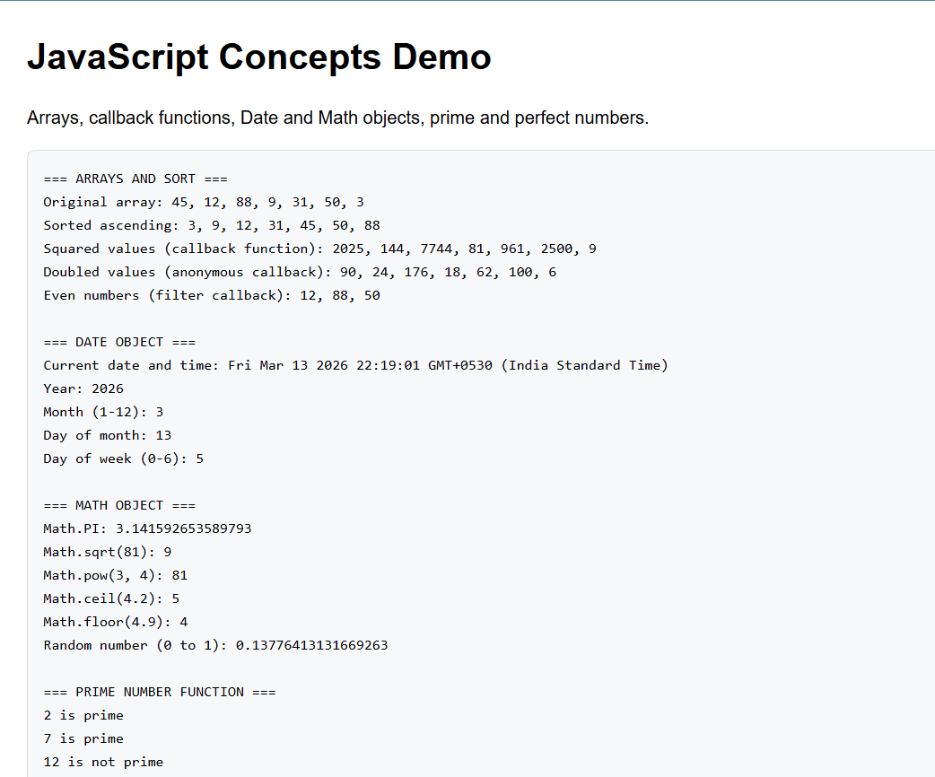
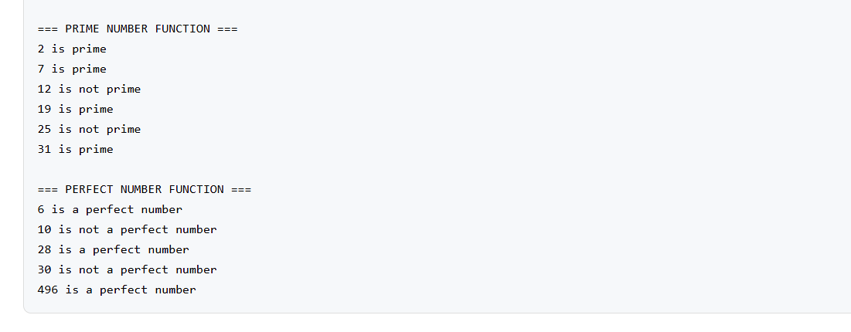

2. Event Handling in JavaScript

Event handling in JavaScript refers to the process of detecting and responding to user actions on a webpage. These actions are known as events, such as clicking a button, hovering over an element, typing in a form field, or loading a page.
JavaScript allows developers to attach event listeners to HTML elements so that specific functions are executed when an event occurs.
Common types of events include:
- Click events
- Mouse events
- Keyboard events
- Form events
- Page load events
Event handling is usually implemented using methods such as addEventListener(), which attaches an event handler to an element.
In modern web development, event handling is widely used to create interactive and dynamic websites.
For example, in a portfolio landing page, event handling can be used to:
- Toggle between dark mode and light mode
- Trigger animations when users interact with elements
- Show or hide sections of the webpage
- Handle form submissions
The dark mode and light mode feature improves user experience by allowing users to switch between themes depending on their visual preference. This is usually implemented by changing CSS classes when a button is clicked.
Animations can also be added using CSS animations or JavaScript to make the website visually appealing and engaging.
Overall, event handling plays a crucial role in creating responsive, interactive, and user-friendly web applications.

Code and Output
Index.html
<!DOCTYPE html>
<html lang="en">
<head>
<meta charset="UTF-8">
<meta name="viewport" content="width=device-width, initial-scale=1.0">
<link rel="stylesheet" href="style.css" />
<title>Document</title>
</head>
<body>
<nav class="navbar" >
<a href="#">Home</a>
<a href="#">About Us</a>
<a href="#">Browse Developers</a>
<a href="#">Contact Us</a>
<button id="theme-toggle" onclick="toggleTheme()">🌙 Dark Mode</button>
</nav>

<script>
function toggleTheme() {
document.body.classList.toggle('dark-mode');
const btn = document.getElementById('theme-toggle');
if (document.body.classList.contains('dark-mode')) {
btn.textContent = '☀️ Light Mode';
} else {
btn.textContent = '🌙 Dark Mode';
}
}
</script>
</body>
</html>
Style.css
*{
padding:0px;
margin:0px;
}

.navbar{
display:flex;
background-color: #333;
padding: 10px;}
a{
color:white;
text-decoration:none;
padding: 10px;
}
#theme-toggle{
margin-left: auto;
padding: 8px 16px;
border: none;
border-radius: 5px;
cursor: pointer;
background-color: #555;
color: white;
font-size: 14px;
}
#theme-toggle:hover{
background-color: #777;
}
body{
background-color: #fff;
color: #000;
transition: background-color 0.3s, color 0.3s;
}
body.dark-mode{
background-color: #1a1a1a;
color: #fff;
}
body.dark-mode .navbar{
background-color: #111;
}
body.dark-mode #theme-toggle{
background-color: #ddd;
color: #000;
}
body.dark-mode #theme-toggle:hover{
background-color: #fff;
}
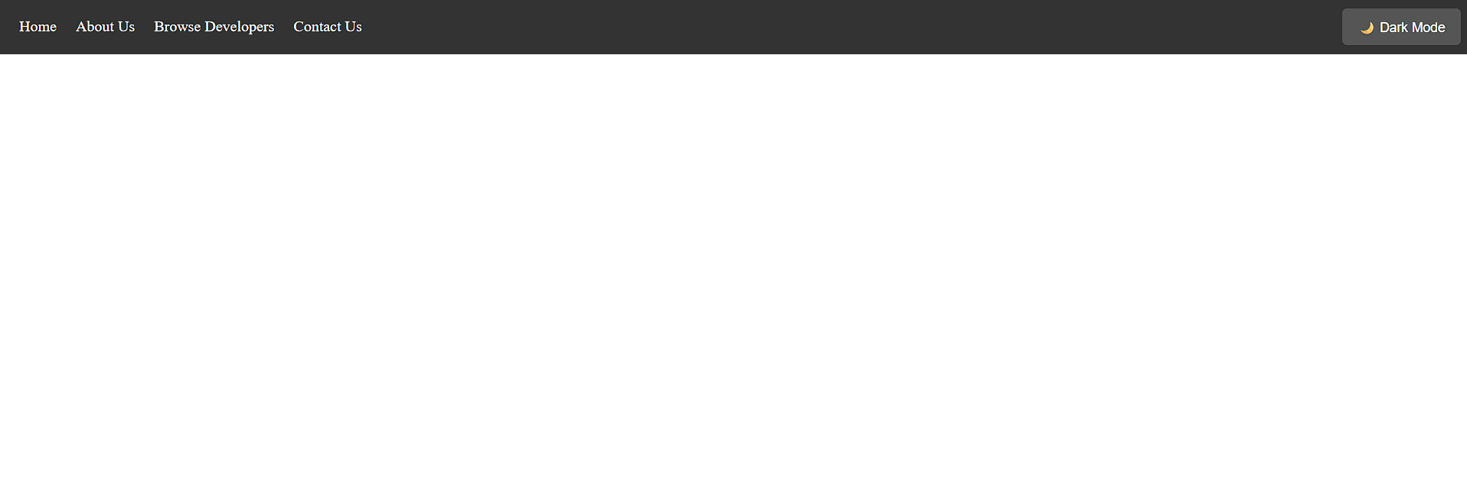
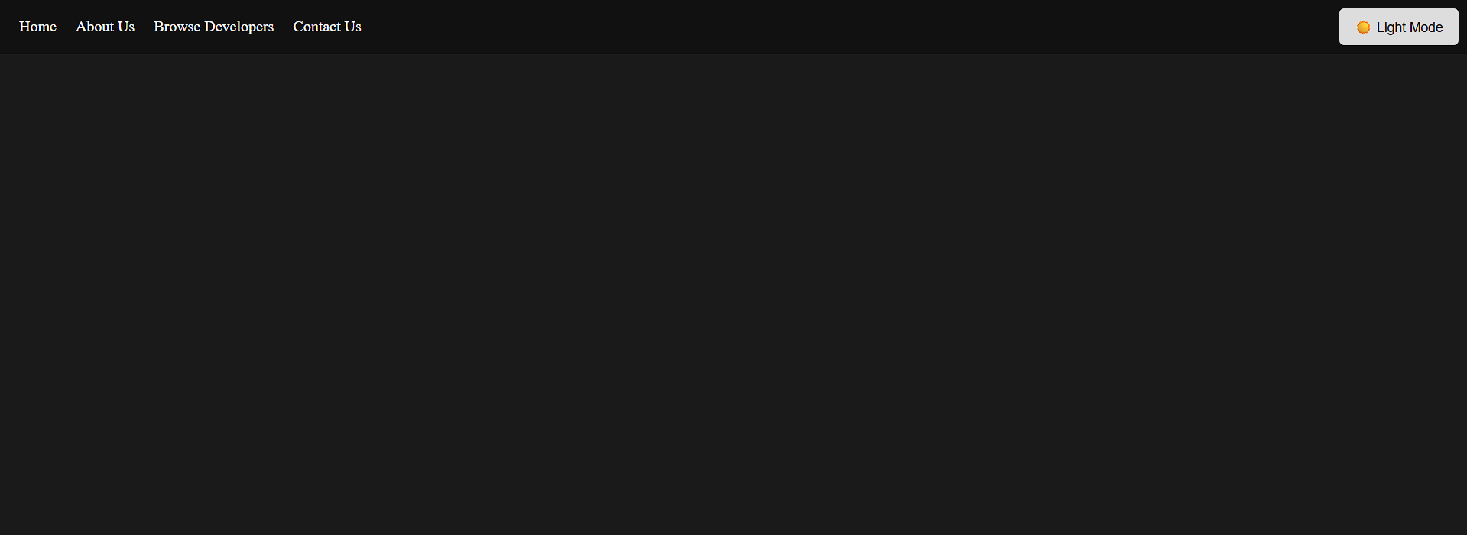

Conclusion
This practical demonstrated the use of HTML5 semantic tags, CSS styling, and Bootstrap framework to design structured and responsive web pages. The experiment helped in understanding modern web development practices and building visually organized web interfaces.

