EXPERIMENT-4

Aim

To design a static HTML webpage that contains a selection box with a list of five countries, and to display the capital city of the selected country dynamically using JavaScript. CSS is used to customize the font properties such as color, font size, and bold style of the displayed capital.

Theory and Code

HTML Selection Box (Dropdown List)
HTML provides the <select> element to create a dropdown list that allows users to choose one option from multiple choices. Each item in the dropdown list is defined using the <option> tag.
The selection box improves user interaction by allowing users to select values easily without typing them manually. It is widely used in web forms for selecting items such as countries, cities, languages, and categories.
In this experiment, a selection box is used to display a list of five countries. When the user selects a country, the corresponding capital city is displayed on the webpage.

JavaScript for Dynamic Content
JavaScript is used to make web pages interactive and dynamic. It allows developers to manipulate HTML elements and update webpage content based on user actions.
In this program, JavaScript detects when the user selects a country from the dropdown list. This is done using an event such as onchange, which triggers a function whenever the selected option changes.
The function then identifies the selected country and displays the corresponding capital city next to the selection box.
This demonstrates how JavaScript can be used to update webpage content dynamically without reloading the page.

CSS for Font Styling
CSS (Cascading Style Sheets) is used to control the appearance and styling of HTML elements.
In this experiment, CSS is used to customize the appearance of the capital city displayed on the webpage. The following properties are applied:
- Color – Changes the color of the capital name.
- Font Weight – Makes the text bold.
- Font Size – Increases the size of the text for better visibility.
Using CSS improves the visual presentation and readability of the webpage.

Code and Output
Index.html
<!DOCTYPE html>
<html lang="en">
<head>
<meta charset="UTF-8">
<meta name="viewport" content="width=device-width, initial-scale=1.0">
<title>Country and Capital Selector</title>
<style>
body {
font-family: Arial, sans-serif;
margin: 30px;
background-color: #f6f8fb;
}

.container {
max-width: 700px;
background: #ffffff;
padding: 24px;
border-radius: 12px;
box-shadow: 0 8px 18px rgba(0, 0, 0, 0.08);
}

h1 {
margin-top: 0;
color: #1f3a5f;
}

.row {
display: flex;
align-items: center;
gap: 14px;
flex-wrap: wrap;
}

select {
padding: 8px 10px;
border: 1px solid #cfd7e3;
border-radius: 6px;
font-size: 16px;
}

#capitalText {
color: #0b63c9;
font-weight: bold;
font-size: 24px;
}
</style>
</head>
<body>
<div class="container">
<h1>Country and Capital</h1>
<div class="row">
<label for="countrySelect">Select Country:</label>
<select id="countrySelect">
<option value="">-- Choose --</option>
<option value="India">India</option>
<option value="Japan">Japan</option>
<option value="France">France</option>
<option value="Brazil">Brazil</option>
<option value="Australia">Australia</option>
</select>
<span id="capitalText">Capital: -</span>
</div>
</div>

<script>
const countrySelect = document.getElementById("countrySelect");
const capitalText = document.getElementById("capitalText");

const capitals = {
India: "New Delhi",
Japan: "Tokyo",
France: "Paris",
Brazil: "Brasilia",
Australia: "Canberra"
};

countrySelect.addEventListener("change", function () {
const selectedCountry = countrySelect.value;
const capital = capitals[selectedCountry] || "-";
capitalText.textContent = "Capital: " + capital;
});
</script>
</body>
</html>
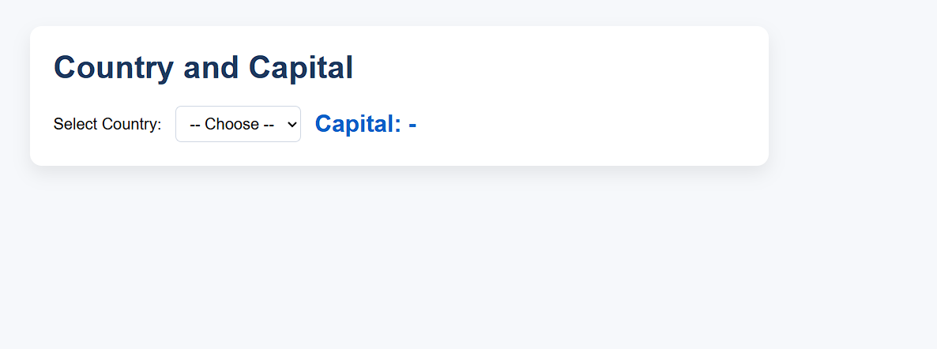

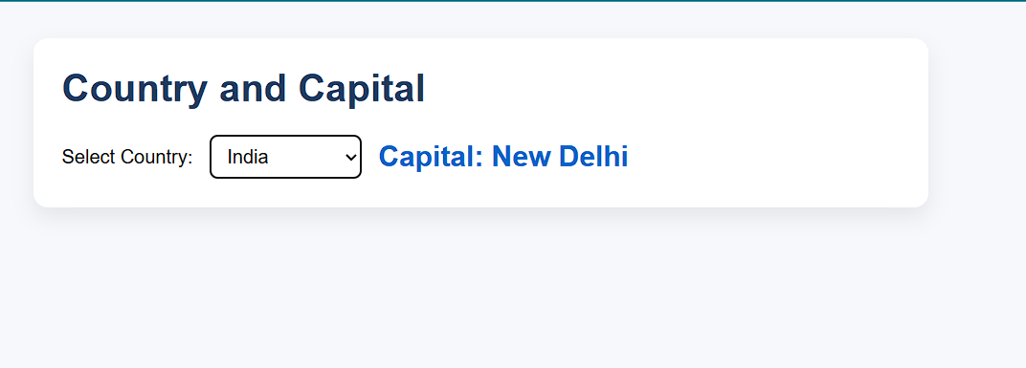
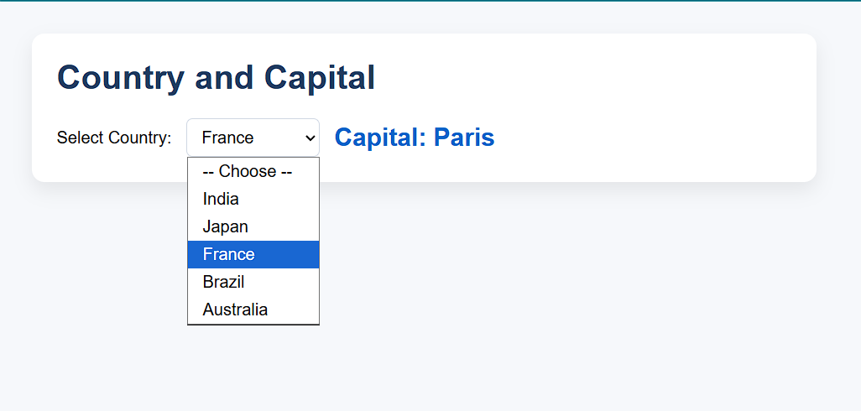

Conclusion
This practical demonstrated the use of HTML5 semantic tags, CSS styling, and Bootstrap framework to design structured and responsive web pages. The experiment helped in understanding modern web development practices and building visually organized web interfaces.

