EXPERIMENT-1

Aim

To install Git, create a Git repository, and understand basic Git operations such as add, commit, modify, and view, along with transferring data between local and remote repositories.

Theory

Git is a distributed version control system used to track changes in files during software development. It helps developers manage different versions of a project, collaborate with others, and maintain a history of modifications made to the code.
A Git repository is a storage location where project files and their complete revision history are maintained. A repository can exist on a developer’s local system or on a remote server such as GitHub.
A local repository is the repository stored on a developer’s computer where files are created, modified, and committed. A remote repository is hosted on a server and allows developers to share their work with others.
Git uses several commands to manage files and track changes:
- git init
This command initializes a new Git repository in a project folder. It creates a hidden .git directory that stores all version control information.
- git add
This command adds files to the staging area, which prepares them to be included in the next commit.
- git commit
The commit command saves the changes made in the staging area to the repository along with a descriptive message. Each commit represents a snapshot of the project at a specific time.
- git status
This command displays the current state of the repository, showing modified files, staged files, and untracked files.
- git log
This command shows the history of commits in the repository, including commit messages, authors, and timestamps.
Git also allows synchronization between local and remote repositories:
- git remote add origin is used to connect a local repository with a remote repository.
- git push uploads local commits to the remote repository.
- git clone copies a remote repository to a local machine.
- git pull downloads the latest updates from the remote repository to the local repository.
Using these commands, developers can efficiently track project changes, manage versions, and collaborate with other team members.
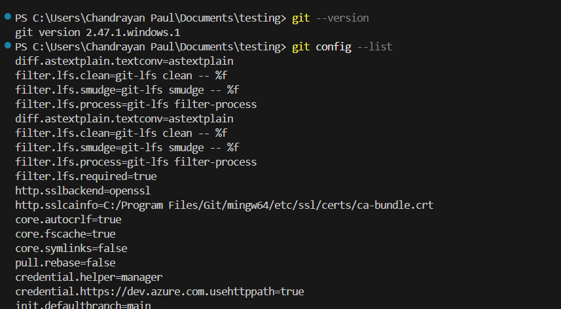
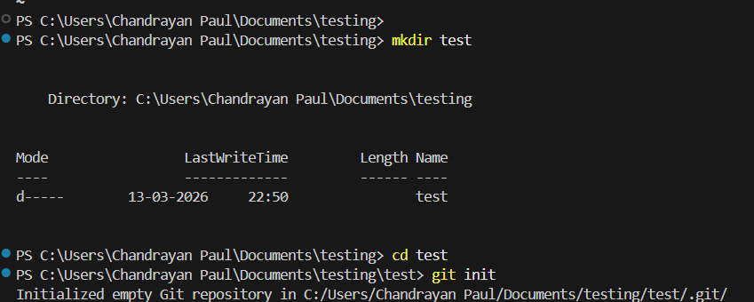
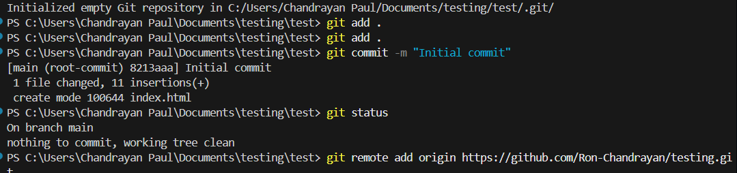
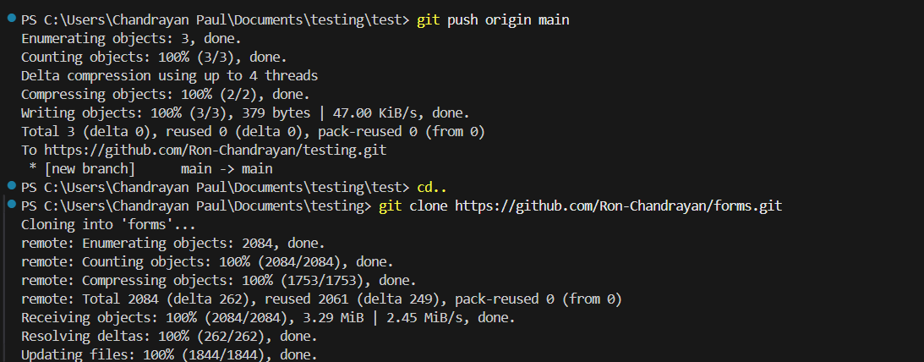
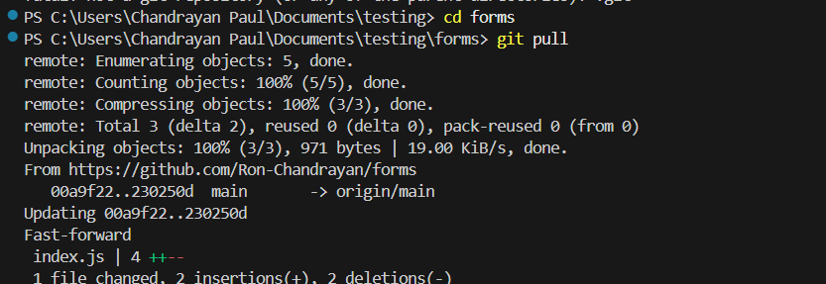
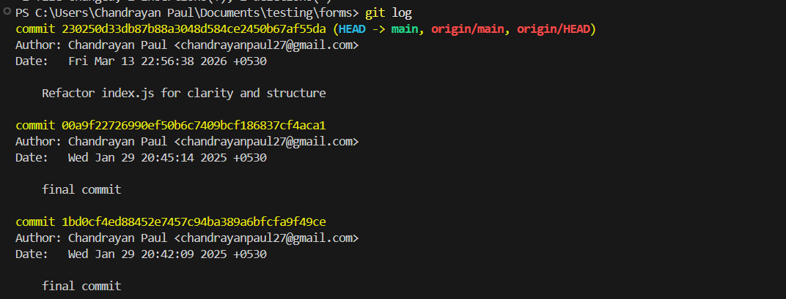

Conclusion
This practical demonstrated the use of HTML5 semantic tags, CSS styling, and Bootstrap framework to design structured and responsive web pages. The experiment helped in understanding modern web development practices and building visually organized web interfaces.

