Which features influence house price the most?
The most important feature affecting house price was area, by a significant margin. Other influential features included number of bathrooms, air conditioning, parking availability, stories, and bedrooms. The correlation heatmap also showed that area (0.54), bathrooms (0.52), and air conditioning (0.45) had strong positive relationships with price

How accurate was your model (in plain terms)?
The model was reasonably accurate at estimating house prices. The Actual vs Predicted scatter plot shows a clear positive trend, meaning the predictions generally followed the real prices. However, the model was less accurate for some higher-priced properties, indicating there is still room for improvement.

What surprised you in the data?
One surprising finding was that air conditioning and bathrooms had a stronger influence on price than bedrooms alone.

One recommendation for a real estate business based on your findings:
Real estate businesses should focus on promoting features that add the most value, particularly larger living area, additional bathrooms, air conditioning, and parking facilities. Highlighting these features in listings and property advertisements can help attract buyers and justify higher selling prices.
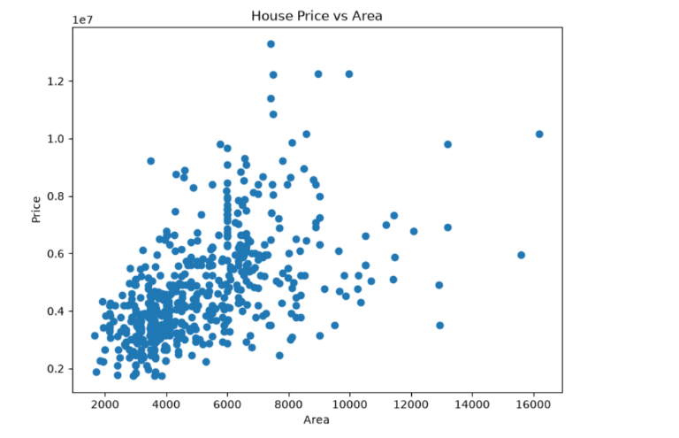
The scatter plot shows a positive relationship between area and house price, indicating that larger houses generally tend to have higher market values.

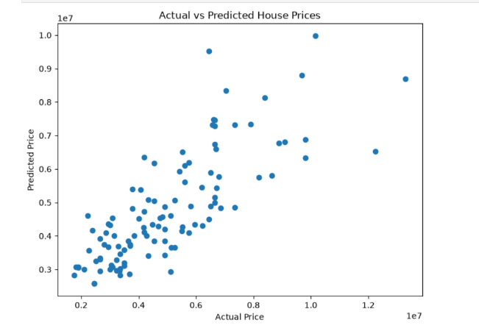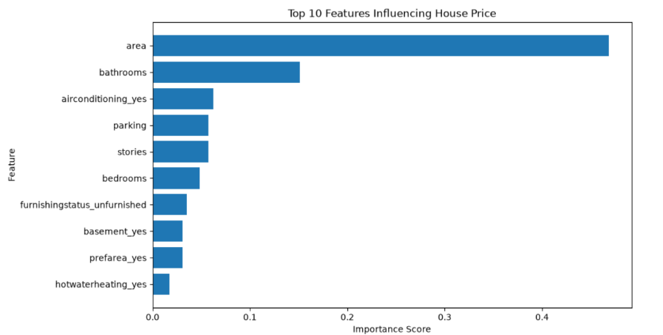
Area is the strongest predictor of house price, followed by bathrooms, air conditioning, parking, and stories.
The model's predictions generally follow the actual house prices, indicating reasonable predictive accuracy.

