CS 170 ch.3 Lab 3

# Task 1

Question:

Write a program that will query whether an employee qualifies for a loan or not based on their annual salary and how many years they have worked at this company. Your program should ask the user to input both the annual salary and the years worked. Analyze the flowchart provided above and convert it to Java code.

Test case1 : income = 42,000  years worked : 3

Test case2 : income = 40,000  years worked : 1

Test case3 : income = 35,000  years worked : 5

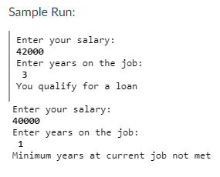

|  |
| --- |
|  |

|  |
| --- |
|  |

# Task 2

Question: **Analyze and trace** the following code. (Do not code it yet):

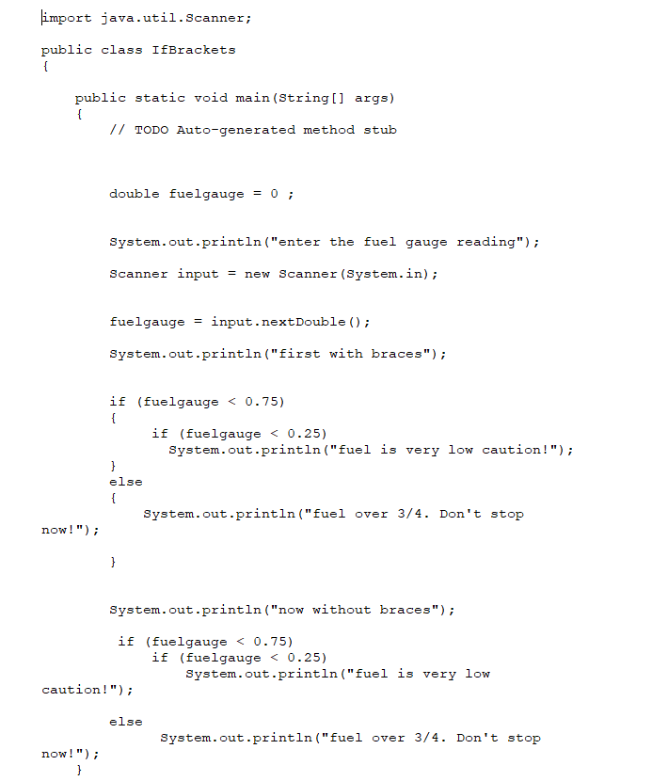

**Part A.** Trace through the following code by hand and record your results in a trace table.

|  |  |
| --- | --- |
| Fuel Gage | Screen Output |
| 0.1 | First with braces  Fuel is very low caution!  Now with braces  Fuel is very low caution! |
| 0.5 | First with braces  Now without braces  Fuel over ¾. Don’t stop now! (logical error) |
| 0.8 | First with braces  Fuel over ¾. Don’t stop now!  Now without braces  (logical error) |

**part B:** Now write the code in your IDE, debug, and execute. Include a snapshot of the code and execution here.

|  |
| --- |
|  |

|  |
| --- |
|  |

**part C:** Compare your results in part A to the results in part B. Even if they differ, please do not change them.

You will still get full credit for this task. Explain the importance of the braces and how their absence affected the results in the second part of the program.

|  |
| --- |
| Braces are very important to ensure that the Boolean logic in your code is correct. While the first and second parts of the program look very similar, the logic behind the second one is incorrect because the else statement is not attached to the right if statement. |

# Task 3

Question: Write a program with a class name **IsDivisible** that reads two integers from the user and determines if one is divisible by the other. Your program should use a method from the Scanner class that validates the input is an integer.

**Test Case 1:**

Enter two integers, I’ll check if one is divisible by the other: **9 4**

9 and 4 are not divisible

**Test Case 2:**

Enter two integers, I’ll check if one is divisible by the other:**15 5**

15 is divisible by 5

**Test Case 3:**

Enter two integers, I’ll check if one is divisible by the other:**5 15**

15 is divisible by 5

**Test Case 4:**

Enter two integers, I’ll check if one is divisible by the other: **2 $**

Input is not an integer

|  |
| --- |
|  |

|  |
| --- |
|  |