CS 170 ch.4 Lab 1

# Task 1

Question: Write a java program that prints the words "I love Java" 10 times on separate lines. Your code should incorporate a counter-controlled while loop to achieve repetition.

Part A:

start your counter at zero.

|  |
| --- |
|  |

|  |
| --- |
|  |

Part B:

start your counter at one.

|  |
| --- |
|  |

|  |
| --- |
|  |

# Task 2

Question: Write a java program that calculates the annual interest rate ( 7%) on a credit card balance of 10,000.

How many years will it take for your balance to reach 20,000 or more?

Use a while loop to continuously calculate the interest rate and add it to the balance until 20,000 is reached.

All the variables should be declared and initialized to the values provided.

Your program MUST use constants where applicable.

**Sample Run (15 is a sample answer, not the correct one):**

  The investment doubled after 15 years.

|  |
| --- |
|  |

|  |
| --- |
|  |

# Task 3

Question: Greetings: Write a Java program that greets the user with "Hello" then asks the user if they want to be greeted again, if ( y or Y) then you need to greet them again, and again, until the user types (n or N).

Upon exiting the loop, print Goodbye*.*You can only use a Do/ While loop in this task.

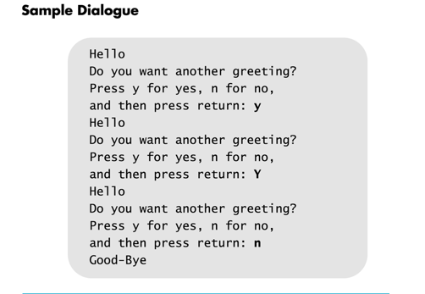

You will need to execute all the different test cases:

YES, Yes, yes, Y, y, YEs, NO, No, no............$, Z.....Yup, Yellow

|  |
| --- |
|  |

|  |
| --- |
|  |