CS 170 ch.4 Lab 3

# Task 1

Question: Students will write a java program that asks the user to input their weekly salary or -1 to terminate.

After totaling up all the salaries, you will calculate the average salary. You will need to maintain a counter for this purpose.

Method of iteration: while loop with a sentinel value of -1

**Test cases:**

                       1.   the user enters -1 from the very beginning

                       2. enter the four salaries for a month and calculate their average:

                              wk1         650

                              wk2         750

                              wk3         810

                              wk4         450

**Sample Run:**

Enter your salaries, or enter -1 to terminate: 10 10 40 -1

Your average salary is $20.00

|  |
| --- |
|  |

|  |
| --- |
|  |

# Task 2

Question: **part A: Using Booleans and sentinels (slide 58)**

Write a program that asks the user to enter a group of positive numbers one at a time and when finished, enter -1 then find the maximum number among these numbers.

Your program must use a Boolean and a sentinel.

Sample run:

**Enter a positive number, -1 to finish: 17**

**Enter a positive number, -1 to finish: 2**

**Enter a positive number, -1 to finish: -1**

**The maximum number is: 17**

|  |
| --- |
|  |

|  |
| --- |
|  |

**part B. (slide 59) : Using sentinels and validation methods from the Scanner class**

Write a program that asks the user to enter a group of positive or negative numbers one at a time and when finished, enter Q, then find the product of all these numbers.

Your program must use  a sentinel and a validation method from the Scanner class.

sample run:

Enter any number(positive or negative), Q to quit: **3**

Enter any number(positive or negative), Q to quit: **2.7**

Enter any number(positive or negative), Q to quit: **-5**

Enter any number(positive or negative), Q to quit: **Q**

**The product of the numbers is: -40.50   (precision, two places behind the decimal)**

|  |
| --- |
|  |

|  |
| --- |
|  |

# Task 3

Question: Students will write code to simulate two dice throws. Print out the random values for each dice,10 times.

|  |
| --- |
|  |

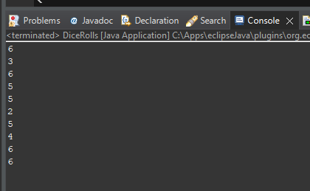

# Task 4

Question: Explain what you did in task 10 by answering the following questions:

1. What does the random method return?
2. Why did you multiply by 6?
3. What was the result after multiplying by 6? Give an example.
4. Why do we add 1 at the end?
5. Why do we use casting?

|  |
| --- |
| 1. **A** 2. **A** 3. **A** 4. **A** 5. **A** |