CS 170 ch.6 Lab 2

# Task 1

Question: **Arrays and Methods**

Write a program that instantiates an array of integers called numbers of size 8.

create 4 methods that manipulate this array:

  1-populateArray: this method is a void method that takes numbers as an argument and populates it with the following values: 5,0,7,2,11,16,0,21;

      when returning to the main method, print out the values of the array (numbers) by invoking the printArray method (step 2).

   2- printArray: this is a void method that prints the array. This method should efficiently use the enhanced for loop.

  3- summing method; that takes numbers as an argument; sums the elements using the enhanced for loop, and returns the sum; print the result in the main method.

  4- doubling: this void method accepts the numbers array as an argument, then doubles all the values in the array.  Print the contents of the array in the main method by invoking the printArray method.

 5- evens: pass in the numbers array as an argument; then instantiate a new int array of size 4 called evenElements,

     populate this array with the contents of the even indices.

     Return this array and print the contents of it in the main method by invoking the printArray method.

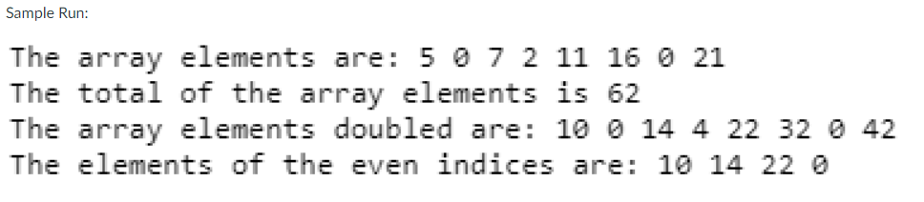

|  |
| --- |
|  |

|  |
| --- |
|  |

# Task 2

Question: **2-D Arrays (this program is in our book/slides)**

 A. Write a program that will display all the medals (gold, silver, bronze) won by the 7 seven countries (Canada, China, Germany, Korea, Japan, Russia, United States) at the Olympics.

B. Have your program tally how many total medals each country won. (Write a method called totalMedals that carries out this function. Your method should take in two parameters, the array and the row.)

Note: You will need a 2-D array called medals of size [7] [3] to represent how many medals were won by each country. You will also need a one-dimensional array of Strings called countries to hold all the names of the seven countries.



  
  
  

  
  
  