CS 170 ch.6 Lab 1

# Task 1

Question: **Array Lists**

Declare an array list of Strings called friends. Populate it with 5 friend names. Add these names using two forms of the add method.

Also, show the use of the remove, get, and set methods. Print your ArrayList with and without a for loop. You may also use an enhanced for loop.

Make use of the size method when printing. Hi-light in yellow your enhanced for loop ( use this loop anywhere in this assignment)

sample case:

**friends: Carrie, Bob, Ali, Sarah, Ellen**

* add each of the names listed above to the end of the list
* add the name Richard After Sarah.
* set the last name in the list to Ellie
* get the last name in the list and print it
* remove the first name on the list
* print the size of the list
* print the friends list with and without a loop

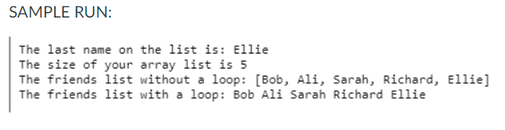

|  |
| --- |
|  |

|  |
| --- |
|  |

# Task 2

Question: **Array Lists**

* Populate a friends ArrayList with the following Strings: Allen, Cindy, Tran, Jose
* write a method reverse that creates a new ArrayList called newFriends and reverses the names of the friends ArrayList. This method should return a reference to the new ArrayList.  (refer to the slides)
* print both the original and new reversed ArrayLists in the main method

Sample run:

original array: [Allen, Cindy, Tran, Jose]

reversed array: [Jose, Tran, Cindy, Allen]

|  |
| --- |
|  |

|  |
| --- |
|  |