CS 170 ch.3? Lab 1?

# Task 1

Question: Solve the 4 test cases in the box. Include your answers in your Word document similar to the format in the box. 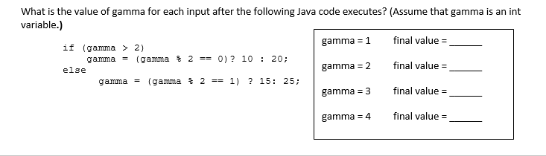

|  |  |  |  |  |  |  |  |  |  |  |  |  |  |  |  |
| --- | --- | --- | --- | --- | --- | --- | --- | --- | --- | --- | --- | --- | --- | --- | --- |
| |  |  |  | | --- | --- | --- | | Initial Gamma | Step by Step Solution | Final Gamma | | Gamma = 1 | False  1 % 2 = 1  1 == 1 : true  Gamma = 15 | 15 | | Gamma = 2 | False  2 % 2 = 0  0 == 1 : false  Gamma = 25 | 25 | | Gamma = 3 | True  3 % 2 == 1  1 == 0 : false  Gamma = 20 | 20 | | Gamma = 4 | True  4 % 2 == 0  0 == 0 : true  Gamma = 10 | 10 | |

# Task 2

Question: Write a program that reports whether a number is even or odd.

**Test Case 1**

Input a number: 7

The number 7 is odd

**Test Case 2**

Input a number: 1020

The number 1020 is even

|  |
| --- |
|  |

|  |
| --- |
|  |

# Task 3

Question: Write a program that asks the user to enter two words and then reports which of the words comes first in the alphabet.

**Test case 1**

Enter your first word using all lowercase:  
hello  
Enter your second word using all lowercase:  
goodbye  
hello comes after goodbye in the alphabet

**Test case 2**

Enter your first word using all lowercase:  
apple  
Enter your second word using all lowercase:  
zebra  
apple comes before zebra in the alphabet

**Test case 3**

Enter your first word using all lowercase:  
zebra  
Enter your second word using all lowercase:  
apple  
zebra comes after apple in the alphabet

**Test case 4**

Enter your first word using all lowercase:  
java  
Enter your second word using all lowercase:  
java  
java and java are equal

|  |
| --- |
| *Copy and paste a screenshot of your source code here.* |

|  |
| --- |
| *Copy and paste a screenshot of your test results here.* |

# Task 4

Question: **Part 1:**

Students will write two classes to represent the reading on a Richter Scale.(refer to section 3.3 pg 98 in your book)

RichterReading1.java and RichterReading2.java.

In the first class, you will use Multi-branching methods. (if -  else if -  else if -  else)

In the second class, you will only use if statements.

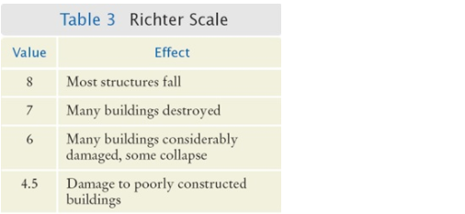

Include snapshots of your code and executions for both programs.

**Part Two:**

Compare the results of both programs and explain the difference.

|  |
| --- |
| *Copy and paste a screenshot of your source code here.* |

|  |
| --- |
| *Copy and paste a screenshot of your test results here.* |