SmartCare v0.3 - Domain Model Workbook
Week 6 student resource

Requirement-to-Concept Trace
Requirement | Concept | State/behaviour | Decision
FR-01: Add patient record | patient | New patient created | Direct mapping:  New data is added
FR-02: Add practitioner record | practitioner | New Practitioner created | Direct mapping:  Data is added
FR-03: Book a new appointment | Appointment created | Clinic links a Patient + Practitioner into a new Appointment | If no conflict and duplication status found then appointment booked
FR-04: Prevent double booking  same practitioner/date/time | Appointment, Practitioner | Appointment conflicts:  checked before save | Business rule modelled as behaviour, not as a new class
FR-05: View all appointment | Clinic | Clinic returns its appointments collection | Clinic owns the collection and they can access it
FR-06: Cancel an existing appointment | Appointment | status changes from 'booked' to 'cancelled' | appointments are recorded, not deleted but status are updated
FR-07: Search appointments by name | Clinic | Clinic search by patient name | Search spans the whole collection,
FR-08: Practitioner views their own shedules | Practitioner, clinic | filter Clinic's appointments where practitioner = themselves | Practitioner requests a view
FR-09: Standardise patient/practitioner names | Patient, Practitioner | name normalised (.strip().title()) on creation | Each class is responsible for formatting its own name attribute

CRC Cards

Patient
Responsibilities | Collaborators
Store patient identifying details (name, patented) | Appointment
Provide a standardized name for matching and display | Clinic

Practitioner
Responsibilities | Collaborators
Store practitioner identifying details (name, practitioner) | Appointment
Determine whether a proposed appointment conflicts with an existing one (has Conflict) | Appointment, Clinic

Appointment
Responsibilities | Collaborators
Hold date, time and status, and reference its Patient and Practitioner | Patient, Practitioner
Change its own status when cancelled; report whether it conflicts with another appointment | Practitioner

Optional class
Responsibilities | Collaborators
Own the collections of patients, practitioners and appointments | Patient, Practitioner, Appointment
Coordinate booking, cancellation, search and count requests from the receptionist | Patient, Practitioner, Appointment

UML Class Diagram
Insert/draw UML here. Include defensible relationships and multiplicities.
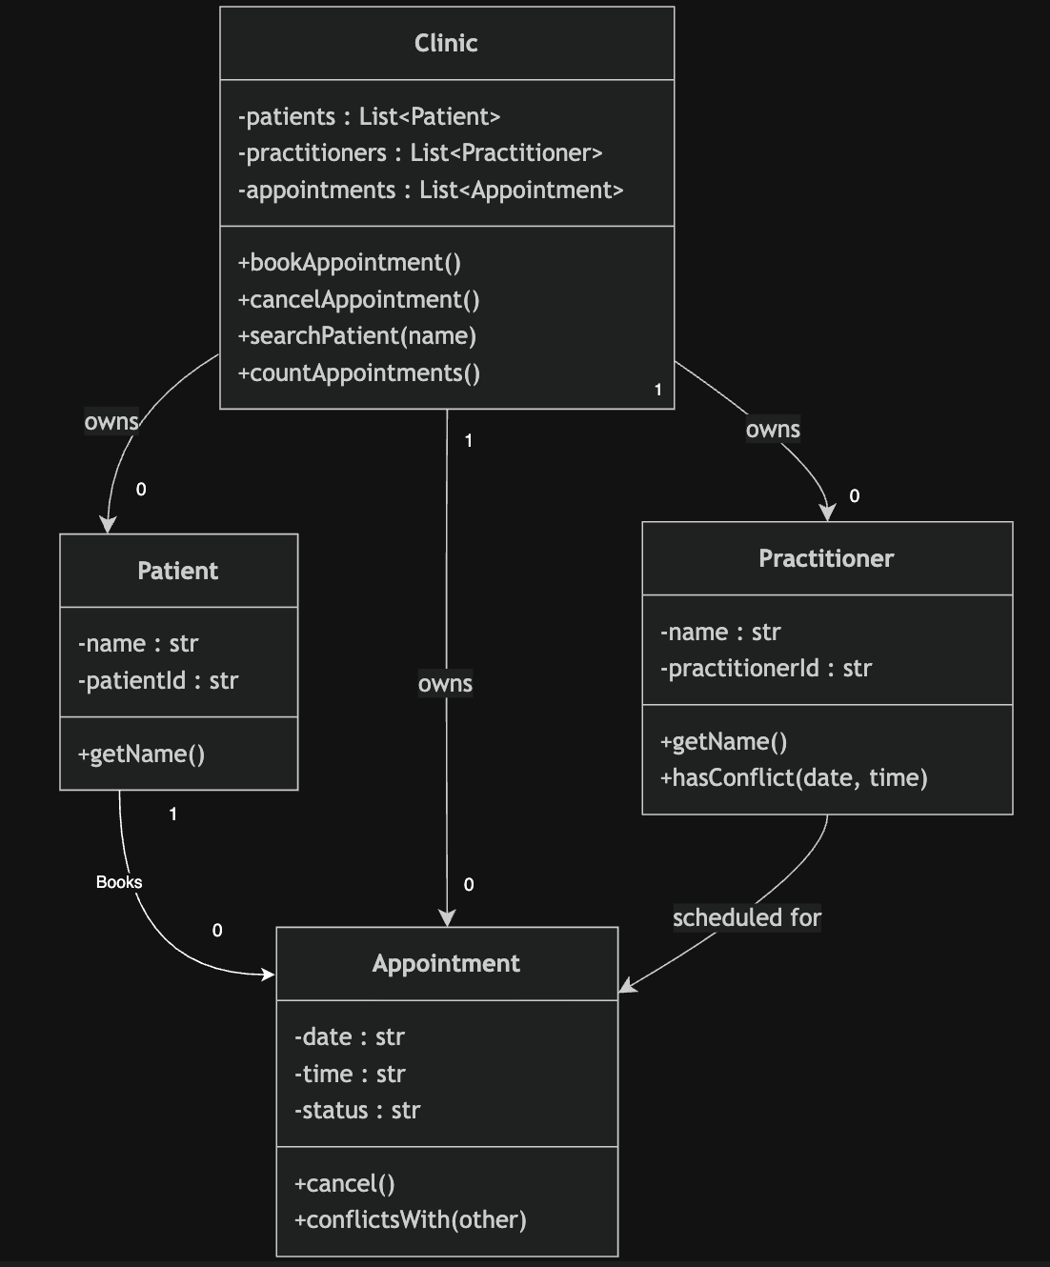

Design Rationale
Explain class selection, responsibility allocation and key relationships.
Design Rationale
Patient, Practitioner and Appointment come straight from the client brief and FR-01–FR-03 — each is a real-world entity with its own identity, so each gets a class. Clinic was added as the optional class to own the three collections and handle whole-collection operations like viewing, searching and counting appointments (FR-05, FR-07), instead of duplicating that logic elsewhere.
Name, Status and Cancellation are not classes. Name and Status are just attributes (Status has a small fixed set of values: booked/cancelled), and Cancellation is really a behavior - Appointment.cancel() - not a thing with its own identity.
Relationships are associations, not inheritance: an Appointment isn't a type of patient, it just links to one (1 Patient: 0* Appointments, same for Practitioner). Clinic "owns" the other three classes through aggregation, since it manages their collections, but they still exist independently. The no-double-booking rule (FR-04, NFR-04) is handled as behavior (conflicts) rather than a multiplicity, because UML multiplicities can't express "not at the same date and time."

AI Design Review Record
AI suggestion | Evidence | Decision | Reason | Model change
PatientManager | FR-01 requires adding patient records and FR-09 requires standardising patient names. | Reject | These responsibilities are already handled by the Clinic class, which manages patient records. Introducing a separate manager class would duplicate existing responsibilities without providing additional domain value. | No change. Patient remains a domain entity and Clinic continues managing patient-related operations.
PractitionerManager | FR-02 requires adding practitioner records and FR-09 requires standardising practitioner names. | Reject | The proposed responsibilities overlap with those already assigned to the Clinic class. A separate manager would increase model complexity without supporting an additional requirement. | No change. Clinic continues managing practitioner records.
AppointmentManager | FR-03 (book appointment), FR-05 (view appointments), FR-06 (cancel appointment), FR-07 (search appointments) | Modify | The suggested functionality is supported by the requirements; however, these responsibilities are already allocated to the Clinic class. Creating a separate manager is unnecessary for the current system scope. | Retain appointment management responsibilities within Clinic. No new class added.
ClinicController | No functional or non-functional requirement refers to user interface control, application flow, or controller behaviour. | Reject | A controller is an implementation or architectural component rather than a domain concept. It does not represent a business entity or requirement identified in the domain model. | No change. Excluded from the domain model.
NotificationManager | No requirement involves notifications, reminders, messaging, emails, or alerts. | Reject | The class is not supported by any stated requirement and therefore falls outside the scope of the system. | No change. Excluded from the domain model.
ScheduleEngine | FR-04/NFR-04 require prevention of practitioner double-booking, and FR-08 requires practitioners to view their schedules. | Modify | Scheduling behaviour is required; however, conflict detection is already assigned to the Practitioner and Appointment classes. A dedicated scheduling class may be appropriate in a larger system but is unnecessary for the current requirements. | Retain scheduling and conflict-checking responsibilities in existing classes. No new class added.

