Table of Contents

Proposed Automation Strategy: 1

Evidence of Additional Research: 2

Screen Shots: 3

Annotate your screen shot to show functionality 9

COMMENTED CODE: 17

The test Plan: 47

# Proposed Automation Strategy:

It is the framework for the database project it shows how the scripts works and what methods are used in it and also through the planning it finalizes the process need to be done to complete the project. Usually the project will start when the schema is finalized using ER diagram. In the schema we can solve the problems using procedure, function and trigger. It outlines the overall plan and during working process when following the process, it is done through PL/SQL and if there comes error then it is solved after a while. This is the clearest process to do work because if the checking process is not use in one by one method then it may harm total done project and can find the problem in easy way also can execute highest number of test case in limited time period. This clarification can be used over multiple projects because it is easy and has complete information regarding testing phase, testing environment and plays vital roles and responsibility of all participants.

This is the core parts of many software systems like database and is the core part of modern days’ software system, management and manipulating data related to specific subject. Sometimes different application may take different code some code most required in some software and some code doesn’t require so to test these kind of application so after coding run the code in the application and testing of the result is much important from there it is known that whether the function and coding is working or not. Thus to avoid these kind of application the automated test application should be made because it would be easy and quick process to solve all the problems.

# Evidence of Additional Research:

Starting to database project group 7 has no specific plan. It is rumoring that from where to start, and how to start. So on Members of the group decided to research about the project relevant website and blogs from there many things were found like easy way of doing database project, codes that are more easy and some blogs from where the database problem were solved easily. The database project always been top class and to solve it research helped most without research may not the project will be fulfilling on time. In the research process there were found good practice material on some of the website and blogs some of them are as follows: -

Using the Harvard referencing standard following website is listed:

1. PL/SQL Triggers. 2017. PL/SQL Triggers. [ONLINE] Available at: <https://docs.oracle.com/cloud/latest/db112/LNPLS/triggers.htm#LNPLS99955>. [Accessed 17 April 2017].
2. PL/SQL Control Structures. 2017. PL/SQL Control Structures. [ONLINE] Available at: <https://docs.oracle.com/cd/A97630_01/appdev.920/a96624/04_struc.htm>. [Accessed 30 April 2017].
3. Oraclecom.2017.Oraclecom.[Online].[17 March 2017]. Available from:

https://docs.oracle.com/cd/A97630_01/appded.920/a96624/04_struc.htm

1. Ss64com.2017.Ss64com.[Online].[19 April 2017]. Available from:

https://ss64.com/oraplsql/cursor_fetch_close.html

# 

# Screen Shots:

Here are some of the screen shot of the sql plus prompt.

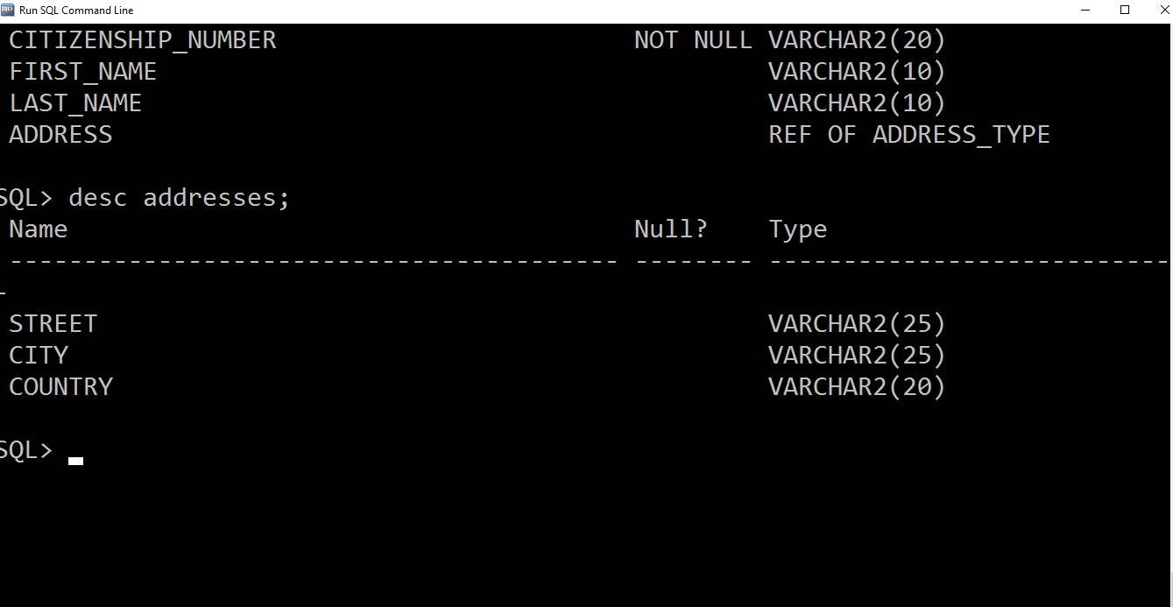

Fig: Addresses table description

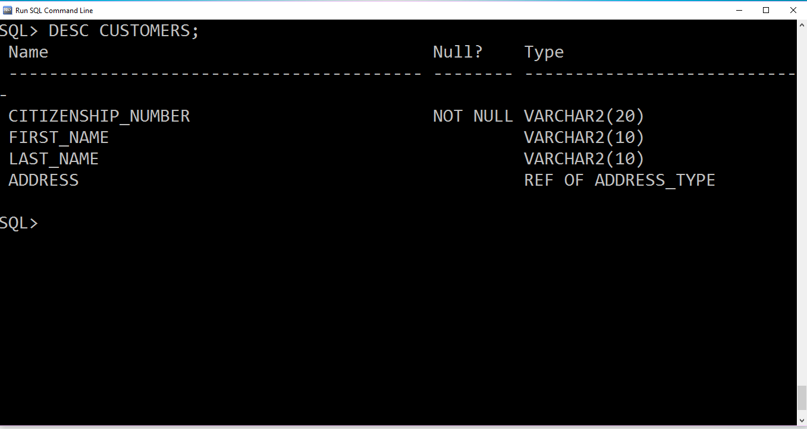

Fig: Customer table description

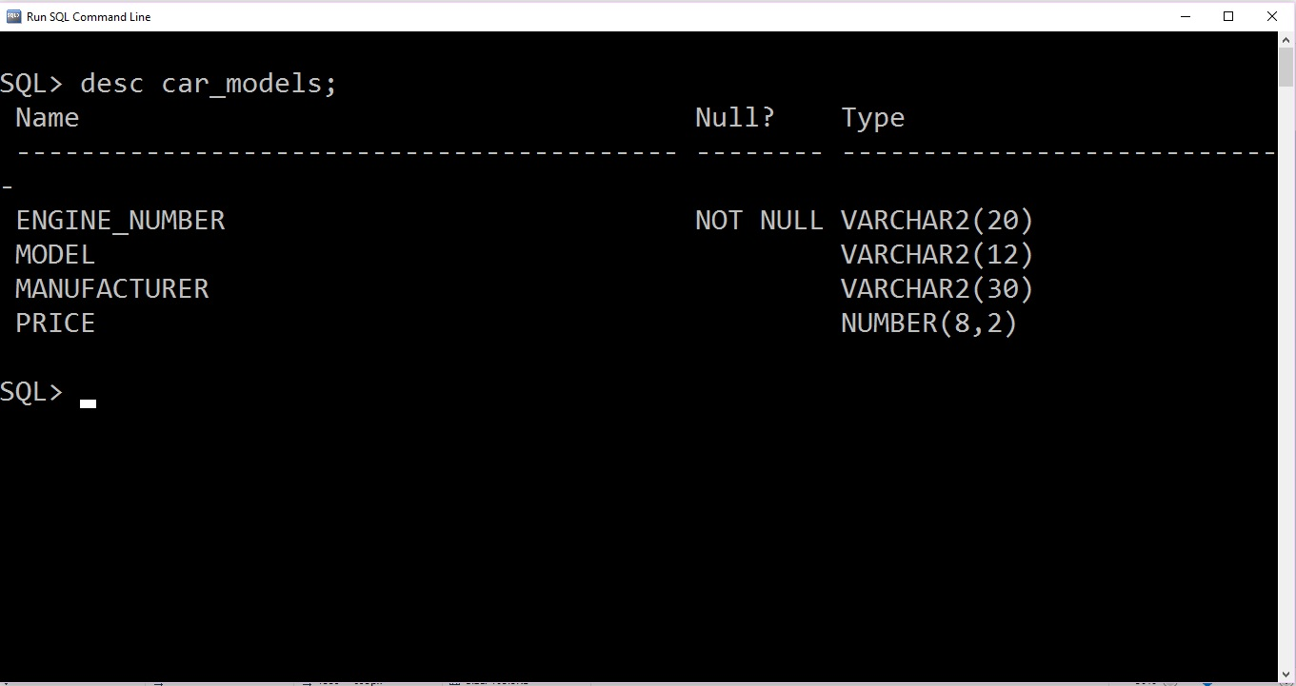

Fig: Car model table description

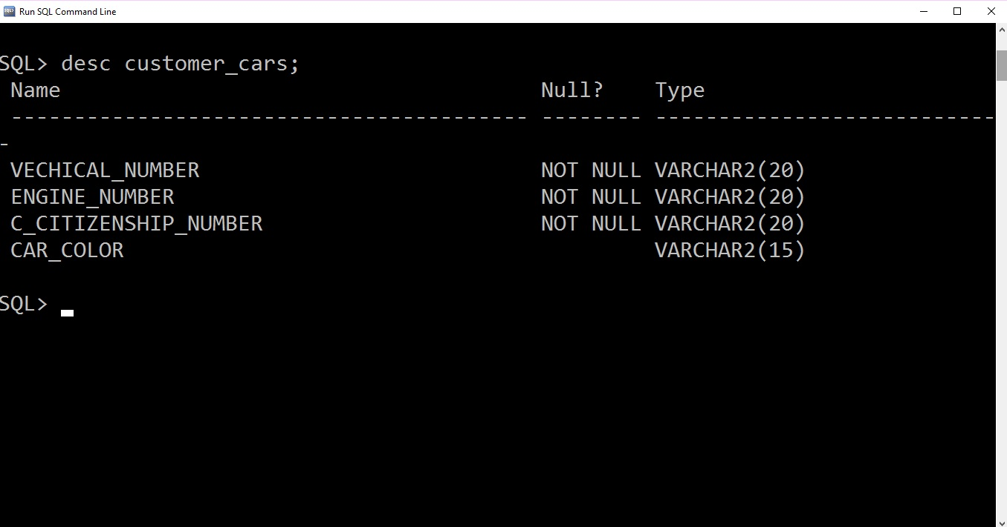

Fig: Customer car description

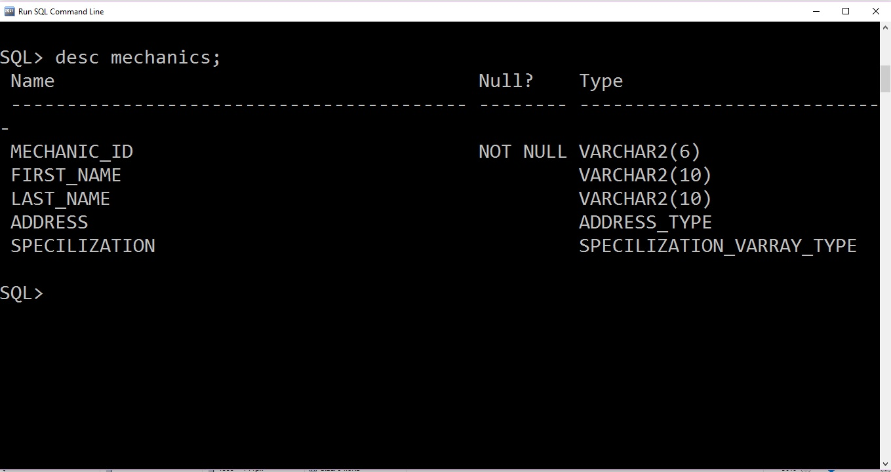

Fig: Mechanic table description

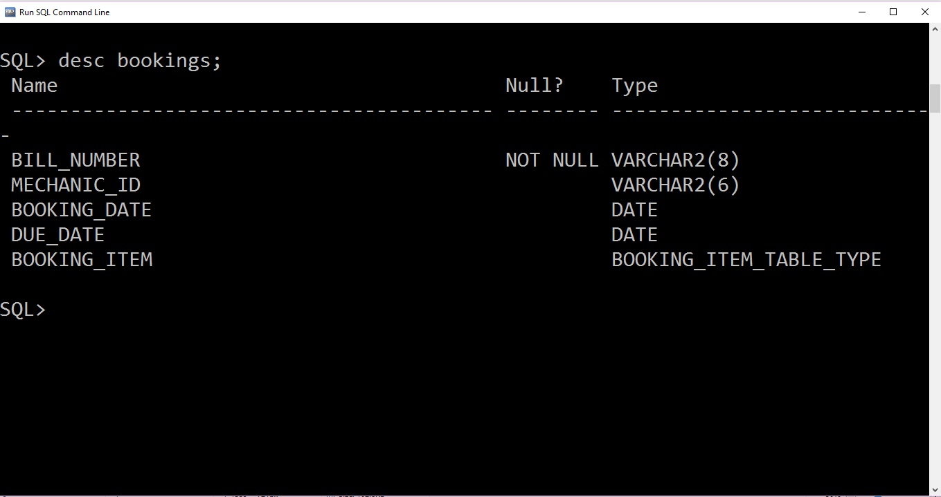

Fig: Booking table description

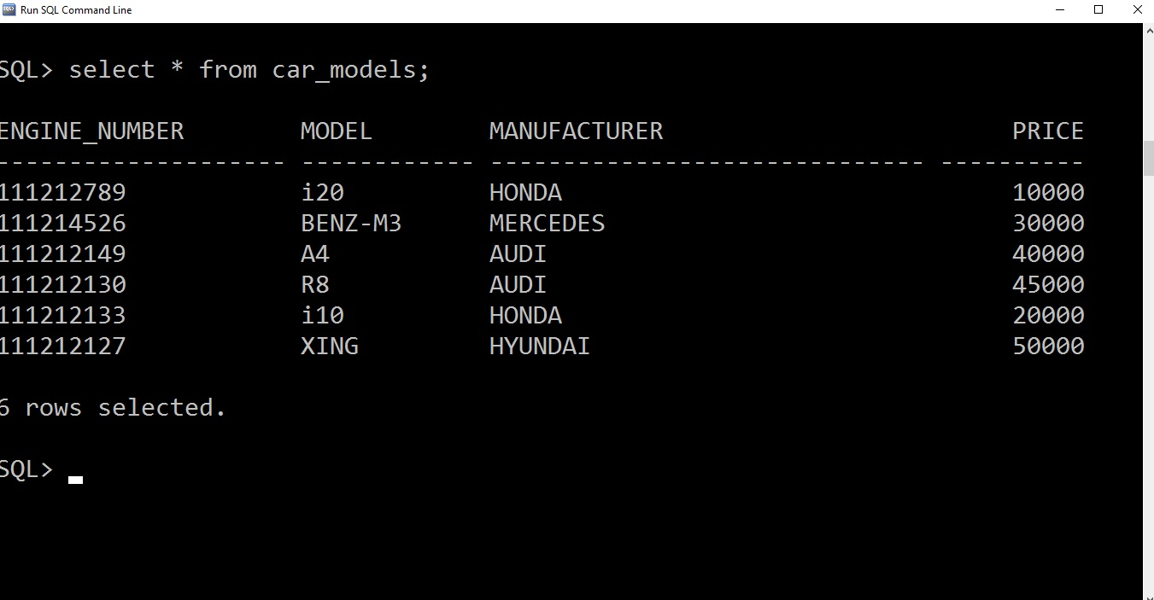

Fig: All car model data

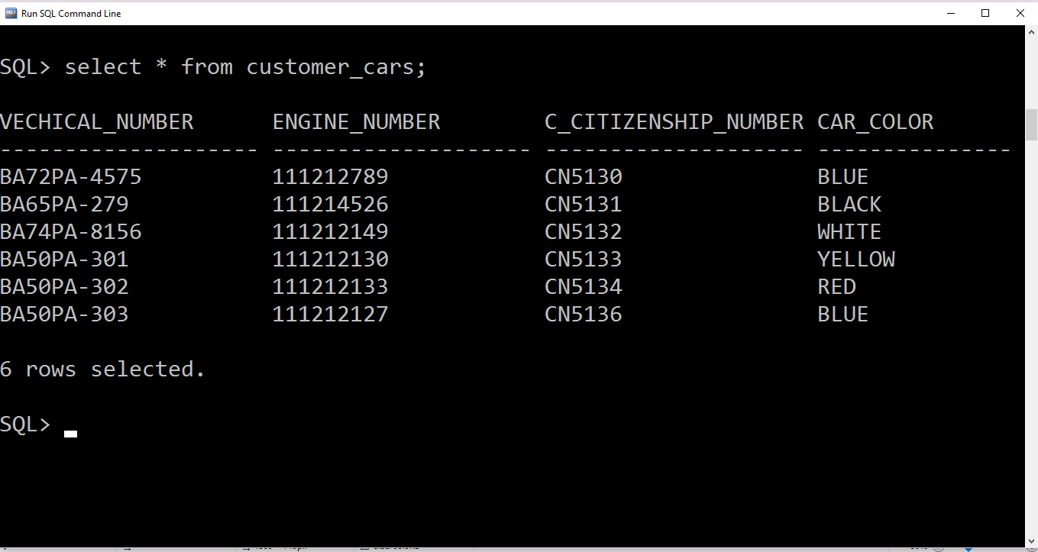

Fig: All customer car data

Listed below is some of the query.

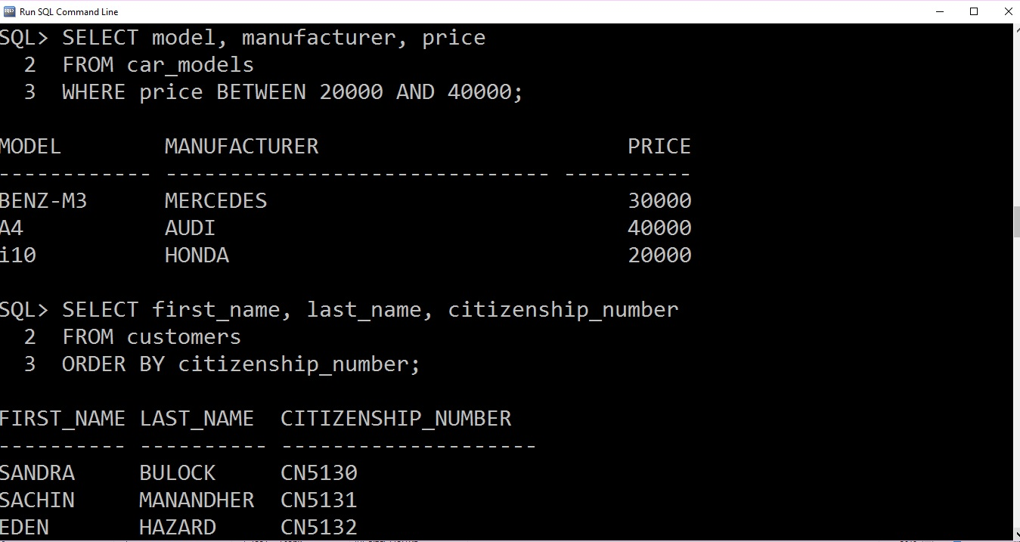

Fig: query 1

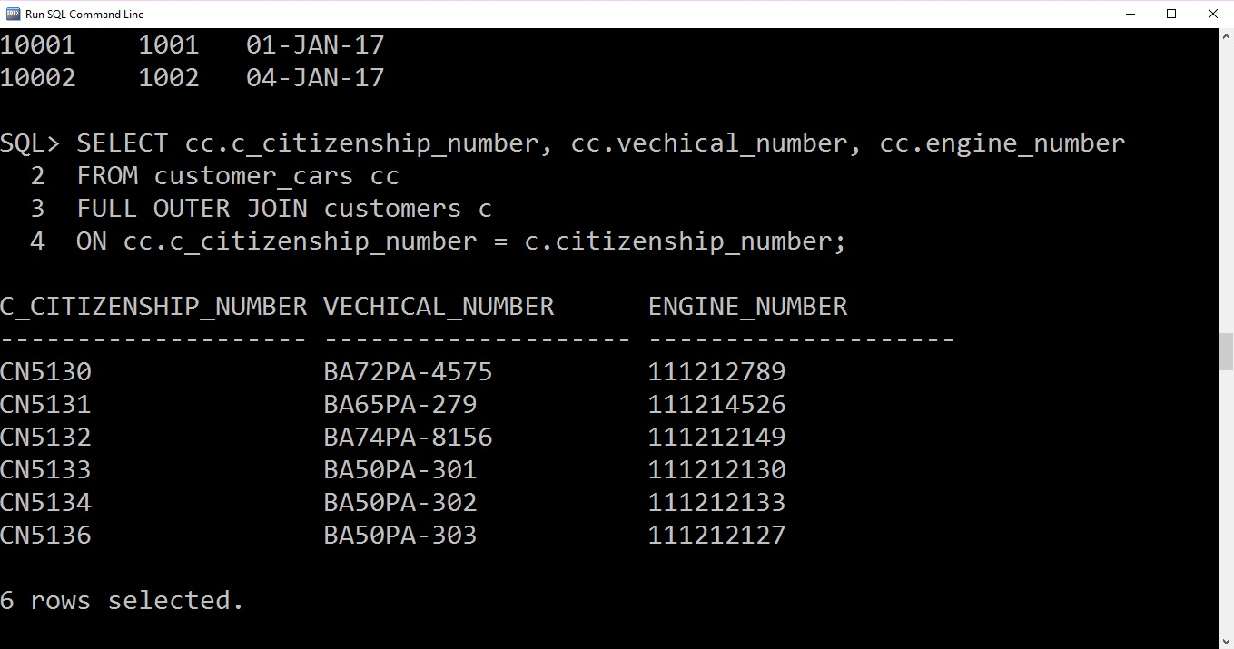

Fig: query2

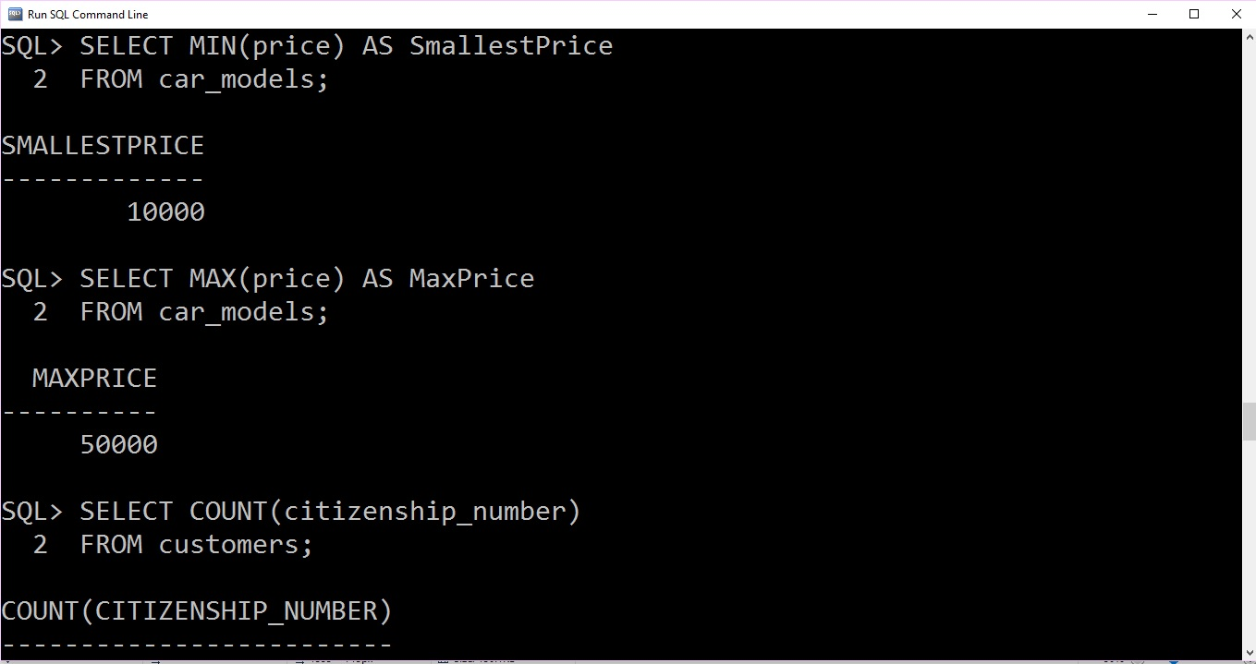

Fig: query3

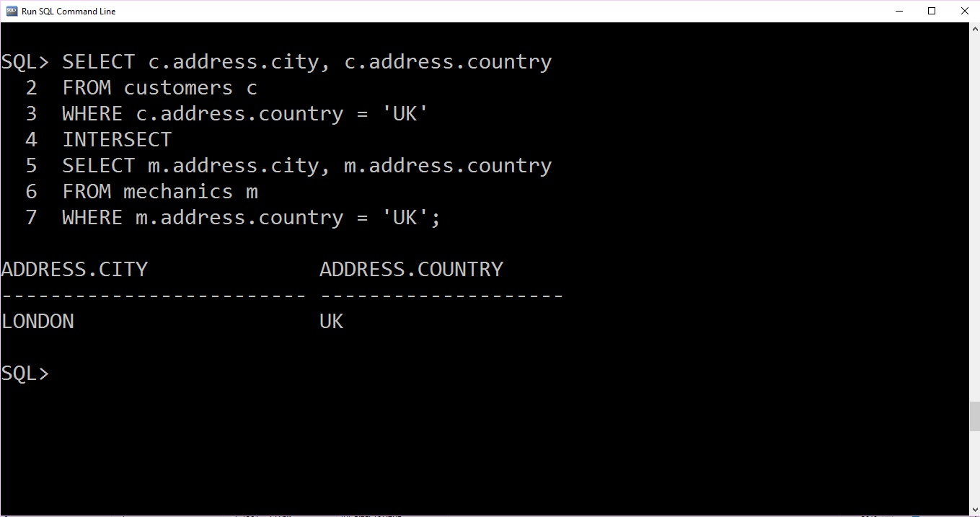

Fig: query4

# Annotate your screen shot to show functionality

1. Testing for bill number

Valid condition query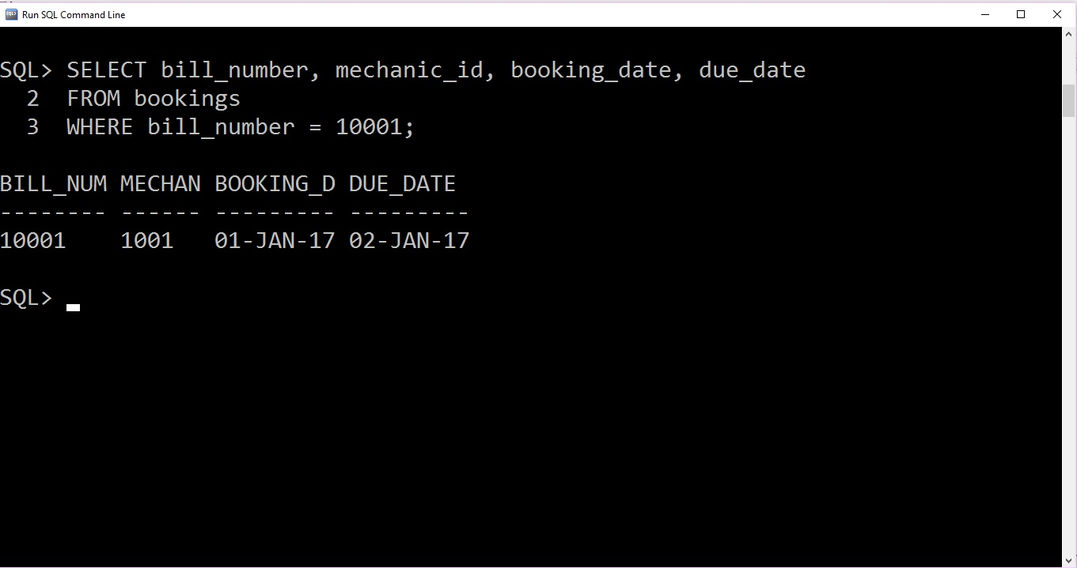

After executing procedure proc_bill_number

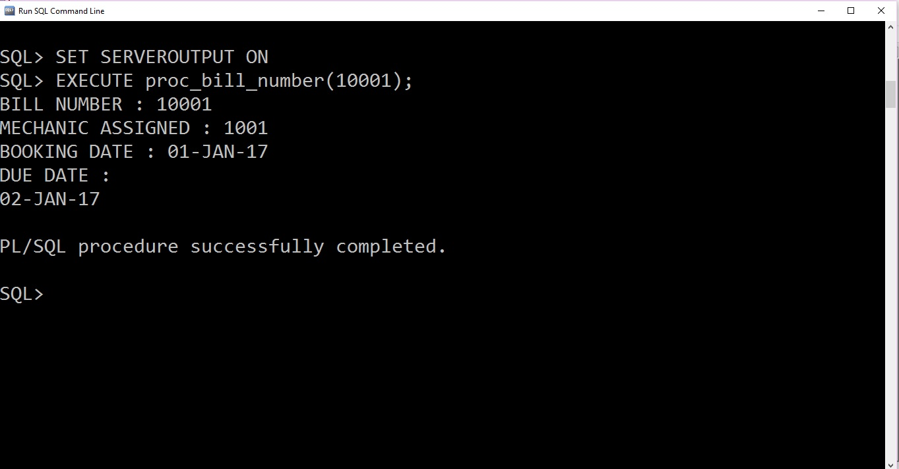

Query with invalid booking id and Procedure proc_bill_number with invalid booking id 10003

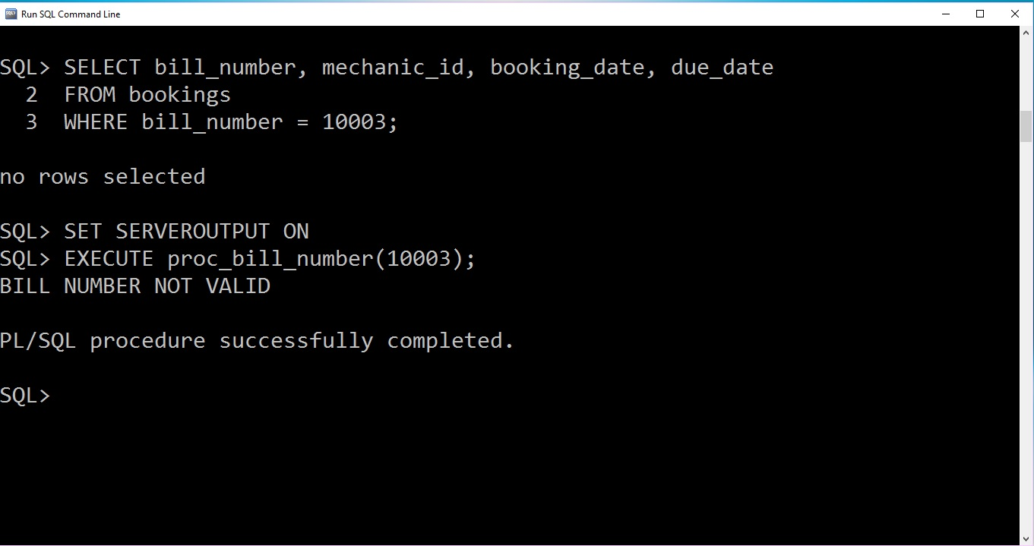

1. TEST CONDITION FOR BOOKING AMOUNT OF BOOKING_ITEM_TABLE

VALID CASE

BEFORE CREATING PROCEDURE proc_booking_item_type

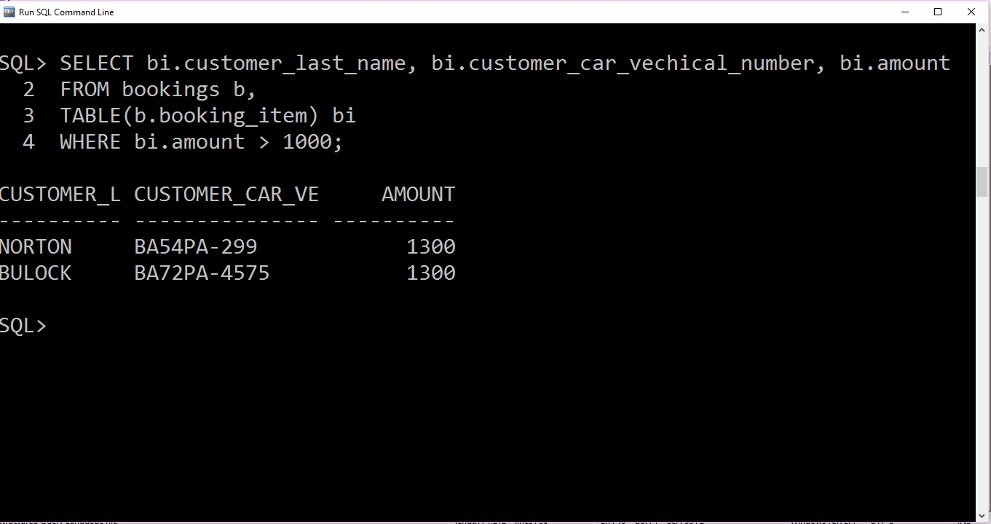

Using procedure proc_booking_item_type

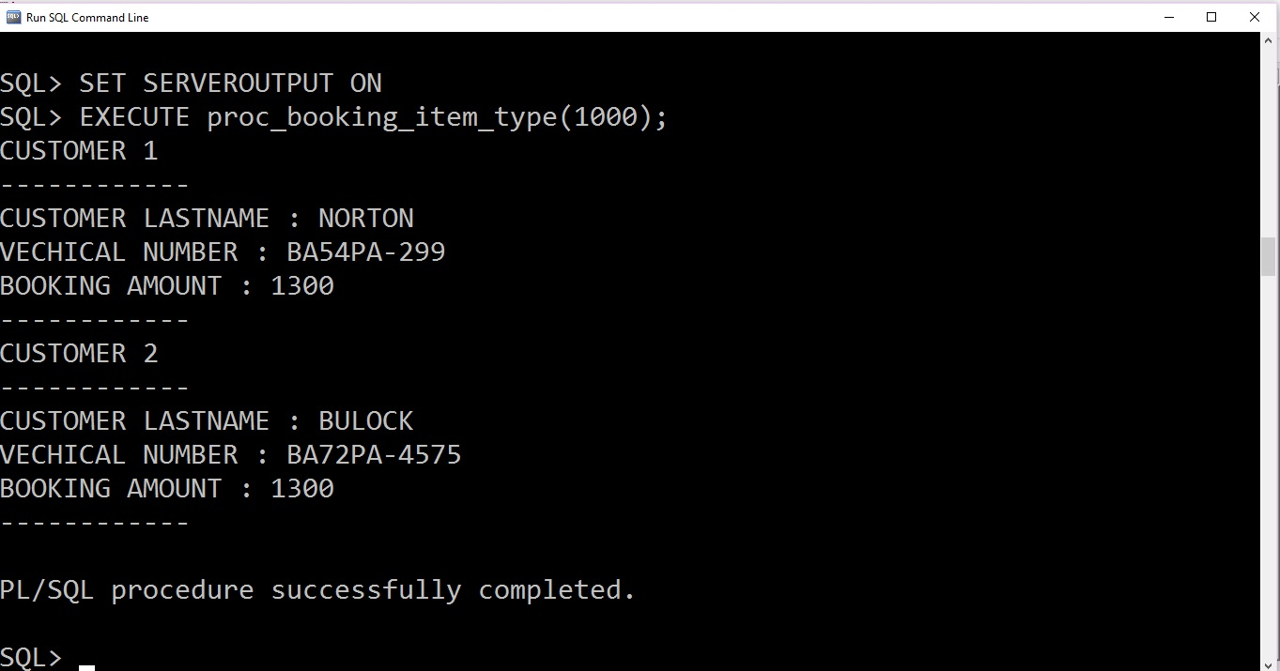

INVALID CASE

Query and procedure with invalid amount

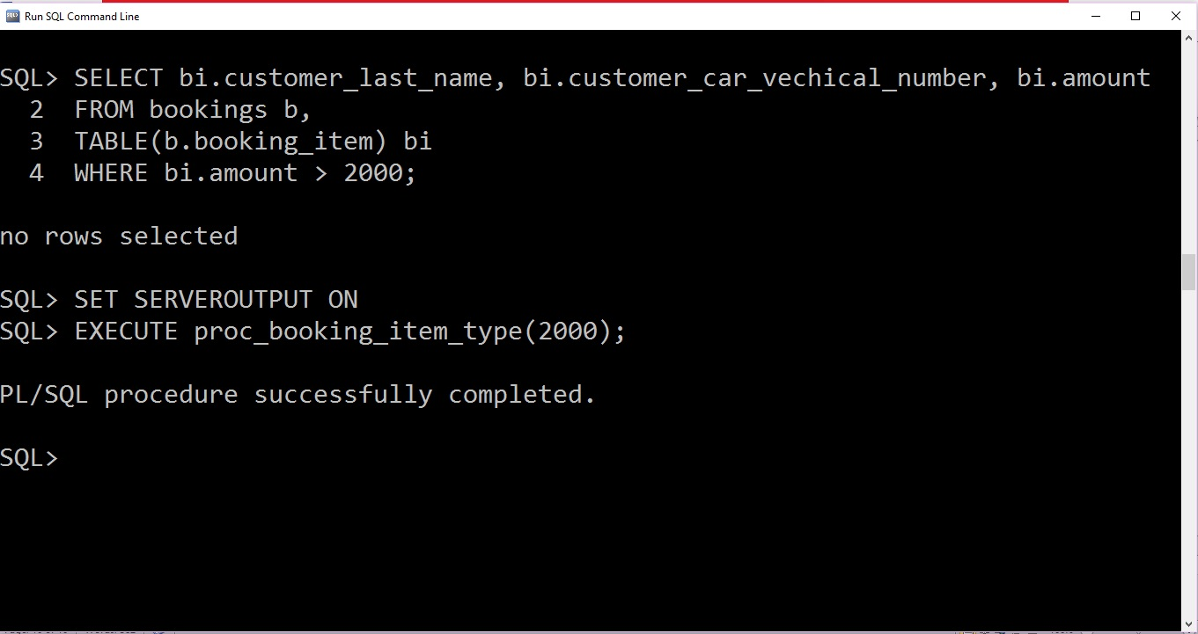

1. TEST CONDITION INSERTING VALUE INTO CUSTOMER CAR TABLE USING PROCEDURE

Before inserting value into customer car using procedure



Inserting using procedure

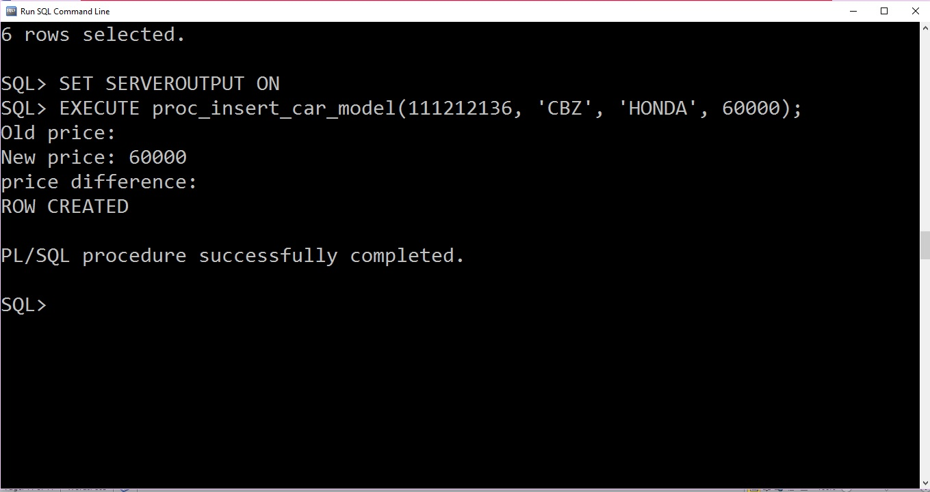

After executing proc_insert_car_model

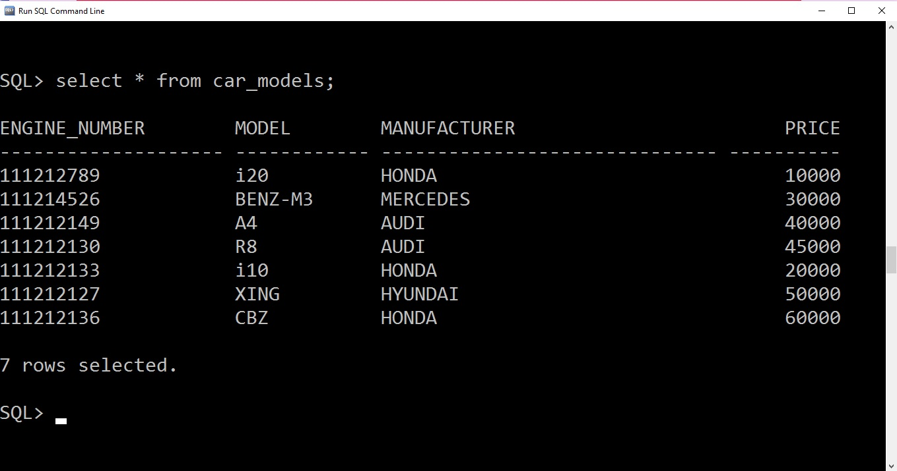

1. TESTING TRIGGER trig_booking_date_ck, DUE DATE MUST NOT BE LESS THAN BOOKING DATE

THIS TRIGGER IS FIRE WHENEVER USER TRY IT INSERT DUE DATE LESS THAN BOOKING DATE

Before creating a trigger

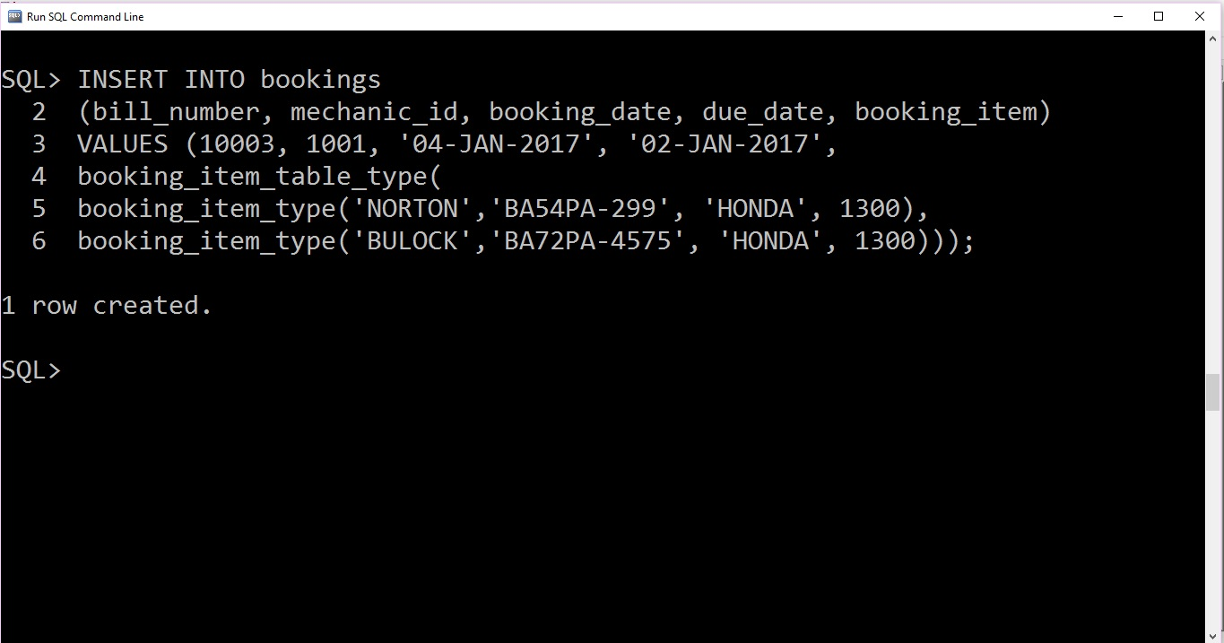

Whatever may be the due it will insert into the table, here due date is less than booking date.

After creating a trigger

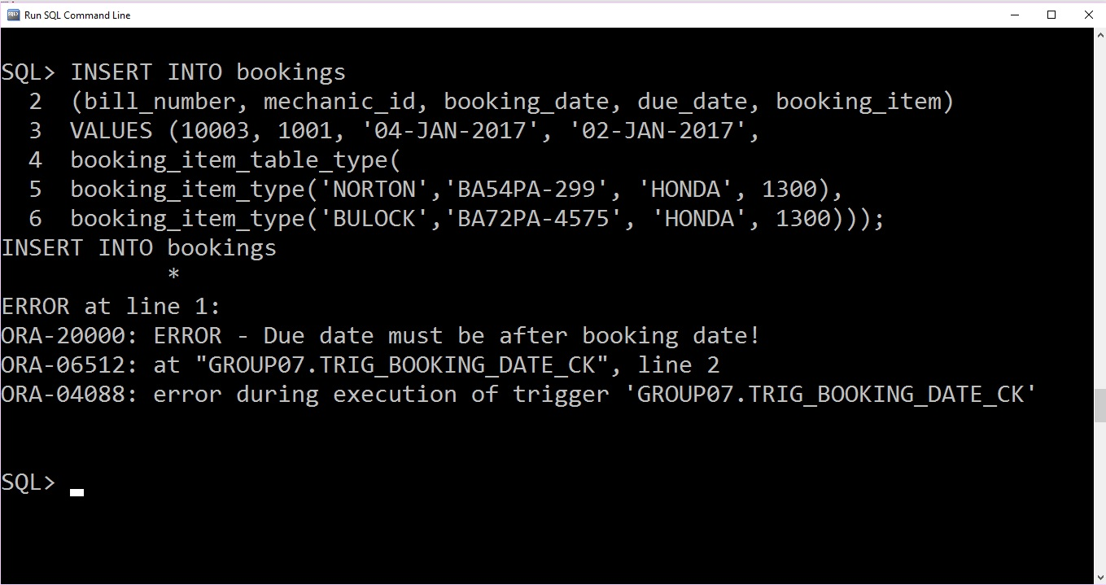

Here prompt won’t let user to put due date less than booking date.

1. Testing Drop script

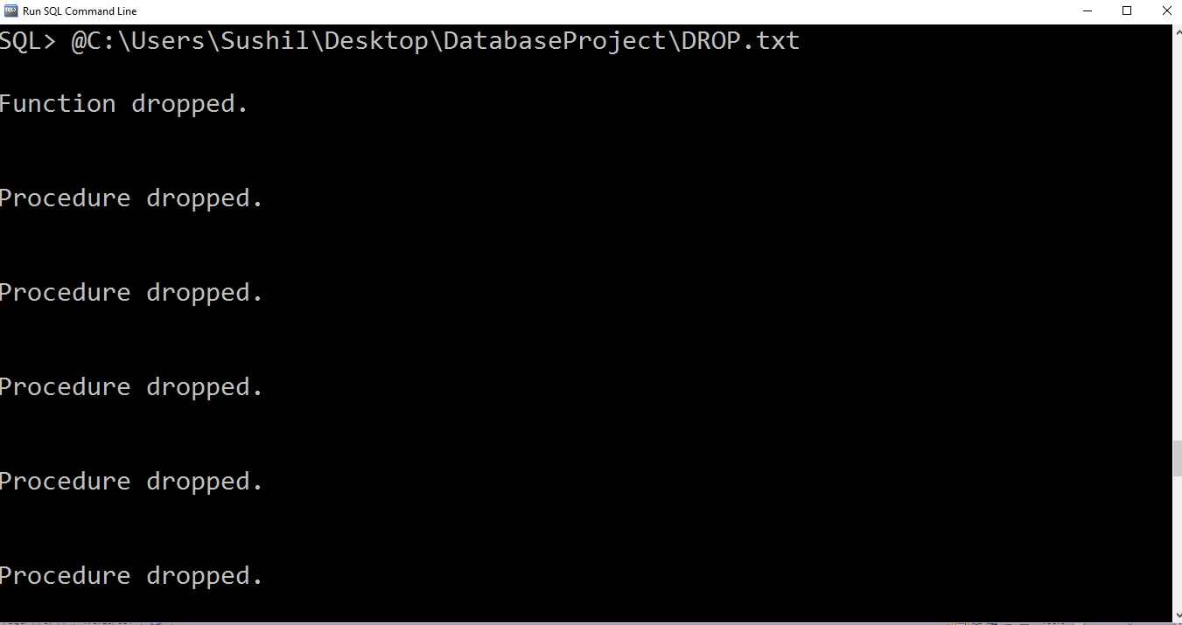

Fig: drop1

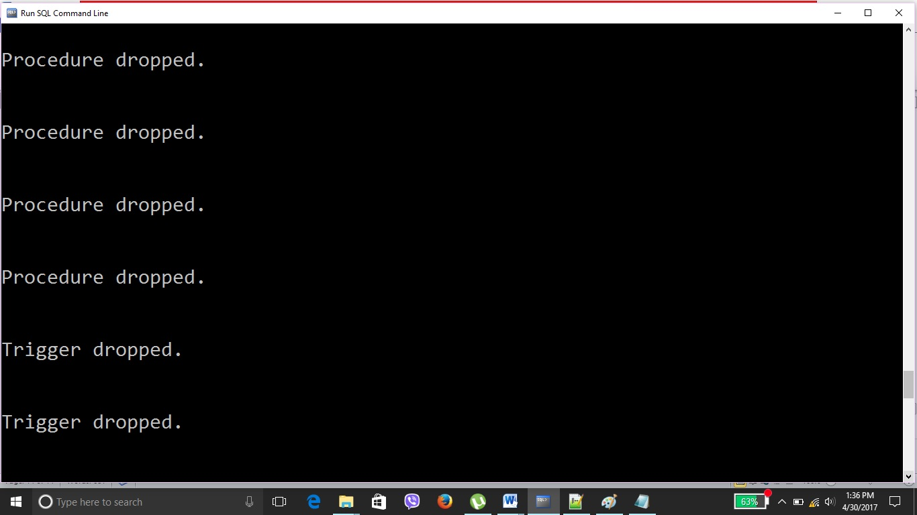

Fig: drop2

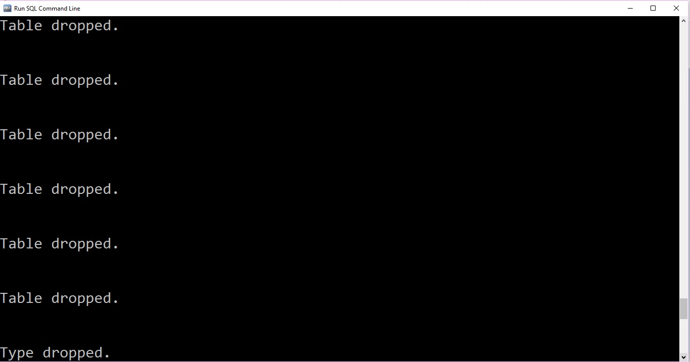

Fig: drop3

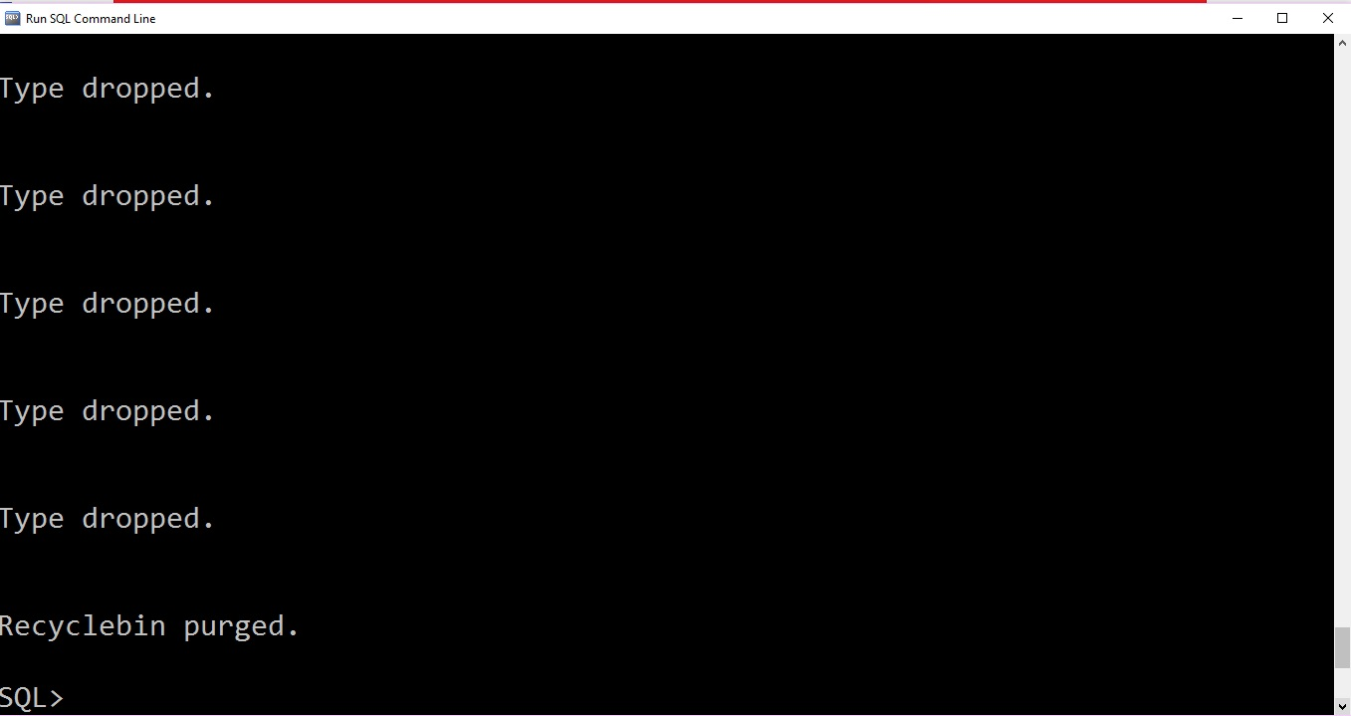

Fig: drop4

# COMMENTED CODE:

1. CREAT TABLE

--@C:\Users\Sushil\Desktop\DatabaseProject\Create_Table.sql

-- Author: Sushil Pun

--15/03/2017

-- CREATING AN OBJECT TYPE NAME ADDRESS TYPE

CREATE OR REPLACE TYPE address_type AS OBJECT (

street VARCHAR2(25),

city VARCHAR2(25),

country VARCHAR2(20) )

/

CREATE TABLE addresses OF address_type;

-- CREATING A CUSTOMER TABLE

CREATE TABLE customers(

citizenship_number VARCHAR2(20),

first_name VARCHAR2(10),

last_name VARCHAR2(10),

address REF address_type SCOPE IS addresses);

-- CREATING A CAR MODEL TABLE

CREATE TABLE car_models(

engine_number VARCHAR2(20),

model VARCHAR2(12),

manufacturer VARCHAR2(30),

price NUMBER(8,2));

-- CREATING A CUSTOMER CAR TABLE

CREATE TABLE customer_cars(

vechical_number VARCHAR2(20),

engine_number VARCHAR2(20),

c_citizenship_number VARCHAR2(20),

car_color VARCHAR2(15));

CREATE TYPE specilization_type AS OBJECT(

-- catagory for example engine, wheels or general

catagory VARCHAR2(10),

-- block coloumn specify mechanic works in which department or block

block NUMBER(6),

-- mechanic wage for doing specific task

charge NUMBER(10, 2));

/

CREATE TYPE specilization_varray_type AS VARRAY(50) OF specilization_type;

/

-- -- CREATING A MECHANIC TABLE

CREATE TABLE mechanics (

mechanic_id VARCHAR2(6),

first_name VARCHAR2(10),

last_name VARCHAR2(10),

address address_type,

specilization specilization_varray_type);

-- CREATING A NESTED TABLE OF TYPE BOOKING_ITEM_TYPE

CREATE OR REPLACE TYPE booking_item_type AS OBJECT(

customer_last_name VARCHAR2(10),

customer_car_vechical_number VARCHAR2(15),

manufacturer VARCHAR2(30),

amount NUMBER(10,2));

/

CREATE TYPE booking_item_table_type AS TABLE OF booking_item_type;

/

-- CREATING A BOOKING TABLE

CREATE TABLE bookings(

bill_number VARCHAR2(8),

mechanic_id VARCHAR2(6),

booking_date DATE,

due_date DATE,

booking_item booking_item_table_type)

NESTED TABLE booking_item STORE AS booking_item_table;

1. ALTER TABLE

--@C:\Users\Sushil\Desktop\DatabaseProject\Alter.sql

-- Author: Sushil Pun

--15/03/2017

--Creating PKs for table

ALTER TABLE customers

ADD CONSTRAINT pk_customers

PRIMARY KEY (citizenship_number);

ALTER TABLE car_models

ADD CONSTRAINT pk_engine_number

PRIMARY KEY (engine_number);

ALTER TABLE customer_cars

ADD CONSTRAINT pk_customer_cars

PRIMARY KEY (vechical_number, engine_number, c_citizenship_number);

ALTER TABLE mechanics

ADD CONSTRAINT pk_mechanics

PRIMARY KEY (mechanic_id);

ALTER TABLE bookings

ADD CONSTRAINT pk_bookings

PRIMARY KEY (bill_number);

--Creating FKs for table

ALTER TABLE customer_cars

ADD CONSTRAINT fk_cc_customers

FOREIGN KEY (C_citizenship_number)

REFERENCES customers(citizenship_number);

ALTER TABLE customer_cars

ADD CONSTRAINT fk_cc_car_models

FOREIGN KEY (engine_number)

REFERENCES car_models(engine_number);

ALTER TABLE bookings

ADD CONSTRAINT fk_b_mechanics

FOREIGN KEY (mechanic_id)

REFERENCES mechanics(mechanic_id);

1. INSERT INTO TABLE

--@C:\Users\Sushil\Desktop\DatabaseProject\INSERT.sql

-- Author: Sushil Pun

--15/03/2017

-- INSERTING VALUE INTO ADDRESSES TABLE

INSERT INTO addresses (street, city, country)

VALUES ('221 BAKER STREET', 'LONDON', 'UK');

INSERT INTO addresses (street, city, country)

VALUES ('641 FULHAM ROAD', 'LONDON', 'UK');

INSERT INTO addresses (street, city, country)

VALUES ('544 42ND STREET', 'NEW YORK', 'USA');

INSERT INTO addresses (street, city, country)

VALUES ('456 AVENUE CHAMPS', 'PARIS', 'FRANCE');

INSERT INTO addresses (street, city, country)

VALUES ('562 HOCKEY STREET', 'TORONTO', 'CANADA');

-- INSERTING VALUE INTO CAR MODELS TABLE

INSERT INTO car_models (engine_number, model, manufacturer, price)

VALUES ('111212789', 'i20', 'HONDA', 10000);

INSERT INTO car_models (engine_number, model, manufacturer, price)

VALUES ('111214526', 'BENZ-M3', 'MERCEDES', 30000);

INSERT INTO car_models (engine_number, model, manufacturer, price)

VALUES ('111212149', 'A4', 'AUDI', 40000);

INSERT INTO car_models (engine_number, model, manufacturer, price)

VALUES ('111212130', 'R8', 'AUDI', 45000);

INSERT INTO car_models (engine_number, model, manufacturer, price)

VALUES ('111212133', 'i10', 'HONDA', 20000);

INSERT INTO car_models (engine_number, model, manufacturer, price)

VALUES ('111212127', 'XING', 'HYUNDAI', 50000);

-- INSERTING VALUE INTO CUSTOMERS TABLE

INSERT INTO customers (citizenship_number, first_name, last_name)

VALUES ('CN5130', 'SANDRA', 'BULOCK');

UPDATE customers SET address =

(select ref(a) FROM addresses a

WHERE a.street='641 FULHAM ROAD')

WHERE citizenship_number = 'CN5130';

INSERT INTO customers (citizenship_number, first_name, last_name)

VALUES ('CN5131', 'SACHIN', 'MANANDHER');

UPDATE customers SET address =

(select ref(a) FROM addresses a

WHERE a.street='544 42ND STREET')

WHERE citizenship_number = 'CN5131';

INSERT INTO customers (citizenship_number, first_name, last_name)

VALUES ('CN5132', 'EDEN', 'HAZARD');

UPDATE customers SET address =

(select ref(a) FROM addresses a

WHERE a.street='221 BAKER STREET')

WHERE citizenship_number = 'CN5132';

INSERT INTO customers (citizenship_number, first_name, last_name)

VALUES ('CN5133', 'FERNANDO', 'SUCRO');

UPDATE customers SET address =

(select ref(a) FROM addresses a

WHERE a.street='456 AVENUE CHAMPS')

WHERE citizenship_number = 'CN5133';

INSERT INTO customers (citizenship_number, first_name, last_name)

VALUES ('CN5134', 'GRAHAM', 'NORTON');

UPDATE customers SET address =

(select ref(a) FROM addresses a

WHERE a.street='221 BAKER STREET')

WHERE citizenship_number = 'CN5134';

INSERT INTO customers (citizenship_number, first_name, last_name)

VALUES ('CN5136', 'FRANK', 'JUNIOR');

UPDATE customers SET address =

(select ref(a) FROM addresses a

WHERE a.street='456 AVENUE CHAMPS')

WHERE citizenship_number = 'CN5136';

-- INSERTING VALUE INTO CUSTOMER CARS TABLE

INSERT INTO customer_cars (vechical_number, engine_number, c_citizenship_number, car_color)

VALUES ('BA72PA-4575', '111212789', 'CN5130', 'BLUE');

INSERT INTO customer_cars (vechical_number, engine_number, c_citizenship_number, car_color)

VALUES ('BA65PA-279', '111214526', 'CN5131', 'BLACK');

INSERT INTO customer_cars (vechical_number, engine_number, c_citizenship_number, car_color)

VALUES ('BA74PA-8156', '111212149', 'CN5132', 'WHITE');

INSERT INTO customer_cars (vechical_number, engine_number, c_citizenship_number, car_color)

VALUES ('BA50PA-301', '111212130', 'CN5133', 'YELLOW');

INSERT INTO customer_cars (vechical_number, engine_number, c_citizenship_number, car_color)

VALUES ('BA50PA-302', '111212133', 'CN5134', 'RED');

INSERT INTO customer_cars (vechical_number, engine_number, c_citizenship_number, car_color)

VALUES ('BA50PA-303', '111212127', 'CN5136', 'BLUE');

-- INSERTING VALUE INTO MECHANICS TABLE

INSERT INTO mechanics (mechanic_id, first_name, last_name, address, specilization)

VALUES ('1001', 'SUJIN', 'MANANDHER', address_type('221 BAKER STREET', 'LONDON', 'UK'),

specilization_varray_type (specilization_type ('ENGINE', 2, 1000)));

INSERT INTO mechanics (mechanic_id, first_name, last_name, address, specilization)

VALUES ('1002', 'DEEPAK', 'BASNET', address_type('562 HOCKEY STREET', 'TORONTO', 'CANADA'),

specilization_varray_type (specilization_type ('WHEEL', 1, 200)));

INSERT INTO mechanics (mechanic_id, first_name, last_name, address, specilization)

VALUES ('1003', 'SURAJ', 'KHANAL', address_type('456 AVENUE CHAMPS', 'PARIS', 'FRANCE'),

specilization_varray_type (specilization_type ('GENERAL', 3, 100)));

-- INSERTING VALUE INTO BOOKING TABLE

INSERT INTO bookings

(bill_number, mechanic_id, booking_date, due_date, booking_item)

VALUES ('10001', '1001', '01-JAN-2017', '02-JAN-2017',

booking_item_table_type(

booking_item_type('NORTON','BA54PA-299', 'HONDA', 1300),

booking_item_type('BULOCK','BA72PA-4575', 'HONDA', 1300)));

INSERT INTO bookings

(bill_number, mechanic_id, booking_date, due_date, booking_item)

VALUES ('10002', '1002', '04-JAN-2017', '06-JAN-2017',

booking_item_table_type(

booking_item_type('MANANDHER','BA65PA-279', 'MERCEDES', 1000),

booking_item_type('HAZARD','BA74PA-8156', 'AUDI', 1000)));

SHOW ERRORS;

1. FUNCTION AND PROCEDURE

--@C:\Users\Sushil\Desktop\DatabaseProject\car_models_price.sql

-- Author: Sushil Pun

--15/03/2017

/* FUNCTION PARAMETER ACCEPT PRICE FROM USER AND COUNT THE CAR WHICH ARE MORE COSTLY THAN THE USER INPUT

AND RETURN THE NUMBER OF CAR TO THE PROCEDURE, WHICH WILL DISPLAY THE MESSAGE

*/

CREATE OR REPLACE FUNCTION func_car_models_price(in_price car_models.price%TYPE)

RETURN NUMBER IS

vn_car_price NUMBER(8);

BEGIN

SELECT COUNT(*)

INTO vn_car_price

FROM car_models

WHERE price > in_price;

-- RETURNS THE NUMBER OF CAR COUNTED TO PROCEDURE

RETURN vn_car_price;

END;

/

SHOW ERRORS;

-- CREATING PROCEDURE WHICH ACCEPT A PRICE OF TYPE (CAR_MODELS TABLE PRICE COLOUMN)

CREATE OR REPLACE PROCEDURE proc_car_models_price(in_price car_models.price%TYPE) IS

vn_no_of_cars NUMBER(5) ;

BEGIN

-- calling function func_car_models_price and storing it in vn_no_of_cars

vn_no_of_cars := func_car_models_price(in_price);

DBMS_OUTPUT.PUT_LINE ('The Number of Car greater than price '|| in_price || ' are : '|| vn_no_of_cars );

END proc_car_models_price;

/

SHOW ERRORS;

/*

SET SERVEROUTPUT ON

EXECUTE proc_car_models_price(20000);

SHOW ERRORS;

*/

-- PROCEDURE TO CHECK WHETHER THE GIVEN PERSON ID IS A VALID CUSTOMER OR NOT

CREATE OR REPLACE PROCEDURE proc_customer_citizenship(in_citizenship_number customers.citizenship_number%TYPE)IS

vc_searched_citizen_number VARCHAR2(20);

vc_citizen_first_name VARCHAR2(20);

vc_citizen_last_name VARCHAR2(20);

BEGIN

SELECT citizenship_number, first_name, last_name

INTO vc_searched_citizen_number, vc_citizen_first_name, vc_citizen_last_name

FROM customers

WHERE citizenship_number = in_citizenship_number;

IF vc_searched_citizen_number = in_citizenship_number THEN

DBMS_OUTPUT.PUT_LINE('CITIZENSHIP NUMBER : '|| in_citizenship_number || CHR(10)||

'FirstName : ' || vc_citizen_first_name || CHR(10) ||

'LastName : ' || vc_citizen_last_name);

END IF;

-- EXCEPTION IS THROWN WHEN THE GIVEN PERSON CITIZENSHIP NUMBER IS NOT FOUND

EXCEPTION

WHEN no_data_found THEN

DBMS_OUTPUT.PUT_LINE('CITIZENSHIP NOT FOUND');

END;

/

SHOW ERRORS;

-- SET SERVEROUTPUT ON

-- EXECUTE proc_customer_citizenship('CN5129');

-- DROP

--DROP PROCEDURE proc_customer_citizenship;

-- PROCEDURE TO CHECK WHETHER THE GIVEN BILL NUMBER IS A VALID OR NOT

CREATE OR REPLACE PROCEDURE proc_bill_number(in_bill_number bookings.bill_number%TYPE)IS

vn_bill_number VARCHAR2(8);

vn_mechanic_id VARCHAR2(6);

vd_booking_date DATE;

vd_due_date DATE;

BEGIN

SELECT bill_number, mechanic_id, booking_date, due_date

INTO vn_bill_number, vn_mechanic_id, vd_booking_date, vd_due_date

FROM bookings

WHERE bill_number = in_bill_number;

IF vn_bill_number = in_bill_number THEN

DBMS_OUTPUT.PUT_LINE('BILL NUMBER : '|| in_bill_number || CHR(10) ||

'MECHANIC ASSIGNED : '|| vn_mechanic_id || CHR(10) ||

'BOOKING DATE : '|| vd_booking_date || CHR(10) ||

'DUE DATE : '|| vd_due_date);

END IF;

-- EXCEPTION IS THROWN WHEN THE GIVEN PERSON CITIZENSHIP NUMBER IS NOT FOUND

EXCEPTION

WHEN no_data_found THEN

DBMS_OUTPUT.PUT_LINE('BILL NUMBER NOT VALID');

END;

/

SHOW ERRORS;

-- SET SERVEROUTPUT ON

-- EXECUTE proc_bill_number('500');

SHOW ERRORS;

-- procedure using cursor to find out the booking item details which is a nested table inside bookings table

CREATE OR REPLACE PROCEDURE proc_booking_item_type(in_amount NUMBER) IS

vc_name VARCHAR2(25);

vc_vechical_number VARCHAR2(15);

vn_booking_cost NUMBER(10,2);

CURSOR C1 IS SELECT bi.customer_last_name, bi.customer_car_vechical_number, bi.amount INTO vc_name, vc_vechical_number, vn_booking_cost

FROM bookings b,

TABLE(b.booking_item) bi

WHERE bi.amount > in_amount;

BEGIN

IF NOT C1%isopen THEN

OPEN C1;

END IF;

LOOP

-- reference https://ss64.com/oraplsql/cursor_fetch_close.html

FETCH C1 INTO vc_name, vc_vechical_number, vn_booking_cost;

EXIT WHEN C1%NOTFOUND;

DBMS_OUTPUT.PUT_LINE('CUSTOMER '|| C1%rowcount);

DBMS_OUTPUT.PUT_LINE('------------');

DBMS_OUTPUT.PUT_LINE('CUSTOMER LASTNAME : '||vc_name|| CHR(10)||

'VECHICAL NUMBER : '|| vc_vechical_number ||CHR(10)||

'BOOKING AMOUNT : '|| vn_booking_cost);

DBMS_OUTPUT.PUT_LINE('------------');

END LOOP;

CLOSE C1;

END;

/

SHOW ERROR;

-- SET SERVEROUTPUT ON

-- EXECUTE proc_booking_item_type(2000);

/* DELETING A ROW FROM A CAR MODEL TABLE USING A PROCEDURE */

SET SERVEROUTPUT ON

CREATE OR REPLACE PROCEDURE proc_delete_car_model(in_model IN car_models.model%TYPE )

IS

BEGIN

DELETE FROM car_models

WHERE model = in_model;

-- IF ABOVE STATEMENT IS TRUE IT WILL DISPLAY ROW DELETED IF NOT IT WILL GO TO ELSE STATEMENT

IF SQL%FOUND THEN

DBMS_OUTPUT.PUT_LINE('ROW DELETED');

ELSE

DBMS_OUTPUT.PUT_LINE('NO SUCH MODEL AVAILABLE');

END IF;

COMMIT;

END;

/

SHOW ERRORS;

SET SERVEROUTPUT ON

--EXECUTE proc_delete_car_model('CBZ');

/* EMPTY PARAMETER PROCEDURE USING FOR LOOP TO DISPLAY ALL THE MECHANICS

FIRSTNAME AVAILABLE IN THE TABLE MECHANICS.

*/

CREATE OR REPLACE PROCEDURE proc_for_loop IS

vn_counter NUMBER := 0;

BEGIN

DBMS_OUTPUT.put_line ('Procedure For Loop Starts....');

FOR rec IN (SELECT * FROM mechanics)

LOOP

vn_counter := vn_counter + 1;

DBMS_OUTPUT.put_line ('Record ' || vn_counter || ' mechanics is- ' || rec.first_name);

END LOOP;

DBMS_OUTPUT.put_line ('Procedure For Loop Completed!');

END;

/

SHOW ERRORS;

-- SET SEVEROUTPUT ON

-- EXECUTE proc_for_loop;

/* INSERTING A DATA USING A PROCEDURE */

CREATE OR REPLACE PROCEDURE proc_insert_car_model(

in_engine_number IN car_models.engine_number%TYPE,

in_model IN car_models.model%TYPE,

in_manufacturer IN car_models.manufacturer%TYPE,

in_price IN car_models.price%TYPE)

IS

BEGIN

INSERT INTO car_models(engine_number, model, manufacturer, price)

VALUES (in_engine_number, in_model, in_manufacturer, in_price);

-- IF ABOVE STATEMENT IS TRUE IT WILL DISPLAY ROW CREATED IF NOT IT WILL GO TO ELSE STATEMENT

IF SQL%FOUND THEN

DBMS_OUTPUT.PUT_LINE('ROW CREATED');

ELSE

DBMS_OUTPUT.PUT_LINE('INPUT VALUE MAY BE WRONG');

END IF;

COMMIT;

END;

/

SHOW ERRORS;

SET SERVEROUTPUT ON

--EXECUTE proc_insert_car_model('111212136', 'CBZ', 'HONDA', 60000);

/* THIS IS A TEST.. INSERTING A DATA USING A PROCEDURE

IN THE TABLE CUSTOMER CAR WHERE

ENGINE NUMBER AND CITIZENSHIP NUMBER ARE FOREIGN KEY, IF TRY IT FAIL'S DUE TO INTEGRITY CONSTRAINTS

SO MUST NOT EXECUTE THE PROCEDURE

*/

CREATE OR REPLACE PROCEDURE proc_insert_customer_car(

in_vechical_number IN customer_cars.vechical_number%TYPE,

in_engine_number IN customer_cars.engine_number%TYPE,

in_citizen_number IN customer_cars.c_citizenship_number%TYPE,

in_car_color IN customer_cars.car_color%TYPE)

IS

BEGIN

INSERT INTO customer_cars (vechical_number, engine_number, c_citizenship_number, car_color)

VALUES (in_vechical_number, in_engine_number, in_citizen_number, in_car_color);

COMMIT;

END;

/

SHOW ERRORS;

--EXECUTE proc_insert_customer_car('BA50PA-299', '111212136', 'CN5129', 'RED');

/* USING THE SWITCH CASE STATEMENT PROCEDURE OUTPUT THE CATEGORY OF CAR

IF CAR IS BELOW 10000 THEN IT'S LOW COST CAR

IF-ELSE CAR IS BELOW 40000 IT'S AVERAGE COST CAR

ELSE THE CAR IS HIGH COST CAR.

*/

-- procedure takes a parameter model and matches it with the model of car_models table

-- evaluates price and show it's catagory

CREATE OR REPLACE PROCEDURE pro_car_category(in_model car_models.model%TYPE) IS

vn_price NUMBER(10, 2);

vc_manufacturer VARCHAR2(20);

vc_model VARCHAR2(12);

BEGIN

SELECT manufacturer, model, price

INTO vc_manufacturer, vc_model, vn_price

FROM car_models

WHERE model = in_model;

CASE

WHEN vn_price < 10000 THEN DBMS_OUTPUT.PUT_LINE('LOW COST CAR');

WHEN vn_price < 40000 THEN DBMS_OUTPUT.PUT_LINE('AVERAGE COST CAR');

ELSE DBMS_OUTPUT.PUT_LINE('HIGH COST CAR');

END CASE;

END;

/

SHOW ERRORS;

SET SERVEROUTPUT ON

EXECUTE pro_car_category('R8');

-- REFERENCE https://docs.oracle.com/cd/A97630_01/appdev.920/a96624/04_struc.htm

/* THIS IS A IMPLICIT CURSOR USING THE WHILE LOOP

FIRST IT WILL SHOW THE RECORD OF EACH ROW OF CAR MODEL TABLE

THEN IT ADDS THE PRICE COLOUMN OF EACH RECORD UNTIL NO RECORD IS FOUND

FINALLY IT SHOW'S THE TOTAL PRICE OF CAR MODEL PRICE COLOUMN

*/

SET SERVEROUTPUT ON

DECLARE

vc_manufacturer VARCHAR2(20);

vc_model VARCHAR2(15);

vn_price NUMBER(10);

vn_total_price NUMBER(10) := 0;

CURSOR cursorValue IS

SELECT manufacturer, model, price

INTO vc_manufacturer, vc_model, vn_price

FROM car_models;

BEGIN

OPEN cursorValue;

FETCH cursorValue INTO vc_manufacturer, vc_model, vn_price;

WHILE (cursorValue%FOUND) LOOP

DBMS_OUTPUT.PUT_LINE('VECHICAL '|| cursorValue%rowcount);

DBMS_OUTPUT.PUT_LINE('====================');

DBMS_OUTPUT.PUT_LINE('MANUFACTURER : '|| vc_manufacturer|| CHR(10)||

'MODEL : '|| vc_model || CHR(10) || 'PRICE : '|| vn_price);

DBMS_OUTPUT.PUT_LINE('====================');

vn_total_price := vn_total_price + vn_price;

FETCH cursorValue INTO vc_manufacturer, vc_model, vn_price;

END LOOP;

CLOSE cursorValue;

DBMS_OUTPUT.PUT_LINE('THE WHOLE TOTAL PRICE OF THE CAR STORE IN DATABASE IS : '|| vn_total_price);

END;

/

SHOW ERRORS;

/* USING THE SWITCH CASE STATEMENT PROCEDURE OUTPUT THE CATEGORY OF CAR

IF CAR IS BELOW 10000 THEN IT'S LOW COST CAR

IF-ELSE CAR IS BELOW 40000 IT'S AVERAGE COST CAR

ELSE THE CAR IS HIGH COST CAR.

*/

SET SERVEROUTPUT ON

CREATE OR REPLACE PROCEDURE pro_car_category(in_model car_models.model%TYPE) IS

vn_price NUMBER(10, 2);

vc_manufacturer VARCHAR2(20);

vc_model VARCHAR2(12);

BEGIN

SELECT manufacturer, model, price

INTO vc_manufacturer, vc_model, vn_price

FROM car_models

WHERE model = in_model;

CASE

WHEN vn_price < 10000 THEN DBMS_OUTPUT.PUT_LINE('LOW COST CAR');

WHEN vn_price < 40000 THEN DBMS_OUTPUT.PUT_LINE('AVERAGE COST CAR');

ELSE DBMS_OUTPUT.PUT_LINE('HIGH COST CAR');

END CASE;

END;

/

SHOW ERRORS;

EXECUTE pro_car_category('R8');

-- REFERENCE https://docs.oracle.com/cd/A97630_01/appdev.920/a96624/04_struc.htm

SET SERVEROUTPUT ON

/* THIS TRIGGER IS FIRED WHENEVER THE BOOKING DATE IS GREATER THAN THE DUE DATE OF BOOKINGS TABLE.

*/

CREATE OR REPLACE TRIGGER trig_booking_date_ck

BEFORE INSERT OR UPDATE OF booking_date, due_date ON bookings

FOR EACH ROW

WHEN

(NEW.booking_date > NEW.due_date)

BEGIN

RAISE_APPLICATION_ERROR(-20000, 'ERROR - Due date must be after booking date!');

END;

/

INSERT INTO bookings

(bill_number, mechanic_id, booking_date, due_date, booking_item)

VALUES ('10003', '1001', '04-JAN-2017', '02-JAN-2017',

booking_item_table_type(

booking_item_type('NORTON','BA54PA-299', 'HONDA', 1300),

booking_item_type('BULOCK','BA72PA-4575', 'HONDA', 1300)));

ROLLBACK;

/* TRIGGER IS FIRE WHEN USER INSERT OR UPDATE VALUE INTO CAR MODEL TABLE

DELETE OPERATION CANNOT BE DONE BECAUSE IT'S PK IS FK IN ANOTHER TABLE

*/

CREATE OR REPLACE TRIGGER trig_car_price

BEFORE DELETE OR INSERT OR UPDATE ON car_models

-- reference https://docs.oracle.com/cloud/latest/db112/LNPLS/triggers.htm#LNPLS99955

FOR EACH ROW

WHEN (NEW.engine_number > 0)

DECLARE

price_difference NUMBER;

BEGIN

price_difference := 0;

price_difference := :NEW.price - :OLD.price;

dbms_output.put_line('Old price: ' || :OLD.price);

dbms_output.put_line('New price: ' || :NEW.price);

dbms_output.put_line('price difference: ' || price_difference);

END;

/

/*

INSERT INTO car_models (engine_number, model, manufacturer, price)

VALUES ('111212146', 'i10', 'HUNDAI', 22000);

UPDATE car_models SET price = 30000

WHERE model = 'i20';

-- DELETE CANNOT BE DONE BECAUSE IT'S DATA IS LINK TO CUSTOMER CAR TABLE

*/

1. DROP

--@C:\Users\Sushil\Desktop\DatabaseProject\DROP.txt

-- Author: Sushil Pun

--15/03/2017

/* Drop */

DROP FUNCTION func_car_models_price;

DROP PROCEDURE proc_car_models_price;

DROP PROCEDURE proc_customer_citizenship;

DROP PROCEDURE proc_bill_number;

DROP PROCEDURE proc_booking_item_type;

DROP PROCEDURE proc_insert_customer_car;

DROP PROCEDURE proc_insert_car_model;

DROP PROCEDURE proc_delete_car_model;

DROP PROCEDURE pro_car_category;

DROP PROCEDURE proc_for_loop;

DROP TRIGGER trig_car_price;

DROP TRIGGER trig_booking_date_ck;

DROP TABLE bookings;

DROP TABLE customer_cars;

DROP TABLE car_models;

DROP TABLE mechanics;

DROP TABLE customers;

DROP TABLE addresses;

DROP TYPE address_type;

DROP TYPE booking_item_table_type;

DROP TYPE booking_item_type;

DROP TYPE specilization_varray_type;

DROP TYPE specilization_type;

PURGE RECYCLEBIN;

# The test Plan:

|  |  |  |
| --- | --- | --- |
| Test | Expected result | Actual result |
| CREATE OR REPLACE TYPE address_type AS OBJECT | Types must be created with three attribute. | Type created with three attribute. |
| CREATE TABLE addresses OF address_type; | Needs to create object table addresses using address_type. | Table created. |
| CREATE TABLE customers referencing addresses | Table customer with its attributes need to be created | Table customer created with attribute |
| CREATE TABLE car_models | Table car model needs to be created with its attribute | Table car_models created. |
| CREATE TABLE customers_car | Table customer _car with its attributes need to be created. | Table customer_car created. |
| CREATE OR REPLACE TYPE specialization_type AS OBJECT | Needs to create specialization type | Specialization type created. |
| CREATE TYPE specialization_varray_type AS VARRAY(50) OF contact_type | Specialization varray type needs to be created | Specialization varray type created. |
| CREATE OR REPLACE TABLE mechanics referencing object type and specialization_varray_type | Mechanics table needs to be created with its attribute | Mechanics table created |
| CREATE OR REPLACE TYPE booking_item_type AS OBJECT | Booking _item_type needs to be created | Booking_item_ type created |
| CREATE TYPE booking_item_table_type AS TABLE OF booking_type | It must create nested table using booking item table type | Nested table created using booking_item_type |
| CREATE TABLE booking referencing the booking_item_table_type | Needs to create a booking table with its attribute | Booking table created |