Implementation

Author implemented code with the logic behind is described in this section. The programming language used to complete this project is:

1. PHP
2. Ajax
3. Javascript
4. Bootstrap
5. CSS
6. HTML

Index.php:

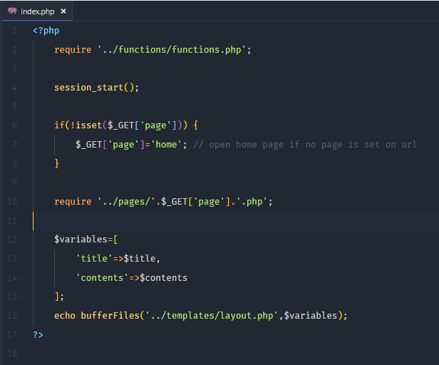

Figure : index page.

Logic:

System starts with index.php page. Here it first get the function.php file where bufferFiles function in placed which takes two parameter one the layout page and another the array. On line number 4 it check if no page is set open home page else get page what is set on url.

Layout.php

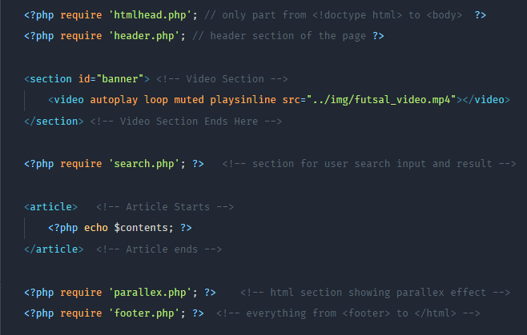

Figure : layout.php

Logic:

Layout.php file get all html element which are placed individually inorder to able to use independently if required and separating and slicing html code can make very flexible and dynamic layout as required. One page can be made of different html element and another page can be made of only some of the html element then it becomes useful.

|  |  |
| --- | --- |
|  |  |

Figure : layout page dynamically selecting html element.

User Login-in Code:

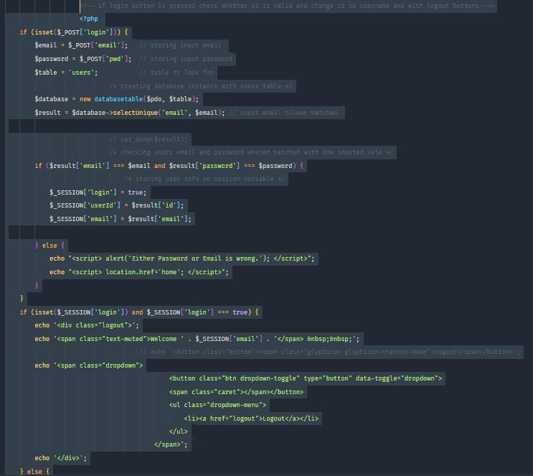

Figure : user login verification code.

Logic:

If user press login without email and password, it will display email required and password required. If user give email address and password then the code will place the user input value to a variable email, password and check that both variable match with the users table in the database or not if match it will display a dropdown link with logout else it will alert with invalid username or password message.



Figure : initial user-login form.

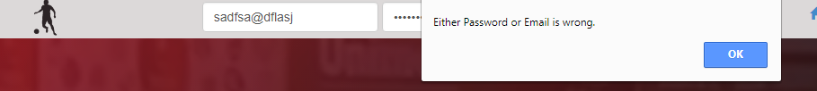

Figure : invalid user login.



Figure : after valid user login.



Figure : user logout link.

Inserting user to database:

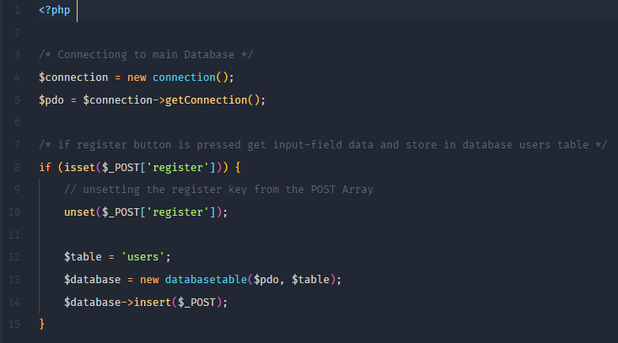

Figure : Inserting user details to database.

Logic:

Here in this code first creating an instance of connection class and calling getConnection method which return pdo object that connects to xampp phpmyadmin. Then on line number 8 it is checking is register button is clicked unset the array index register, and specifying the table name with users and calling databaseTable insert method passing array. databaseTable insert function takes array with key and value and separate key in one string and values in another sting with comma and finally insert them.

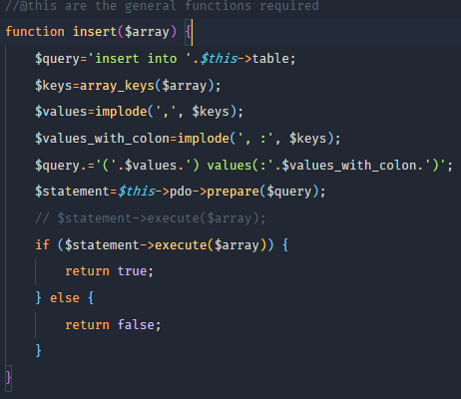

Figure : insert code.

Booking page

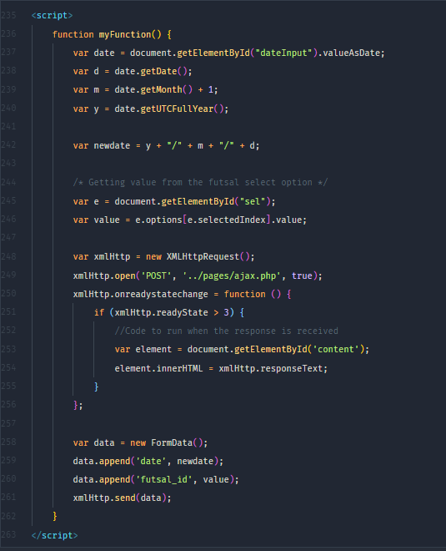

Figure : javascript passing and getting value from ajax.php

Logic:

Javascript get the date and futsal venue id from the booking page and send it to ajax.php page.

Ajax.php

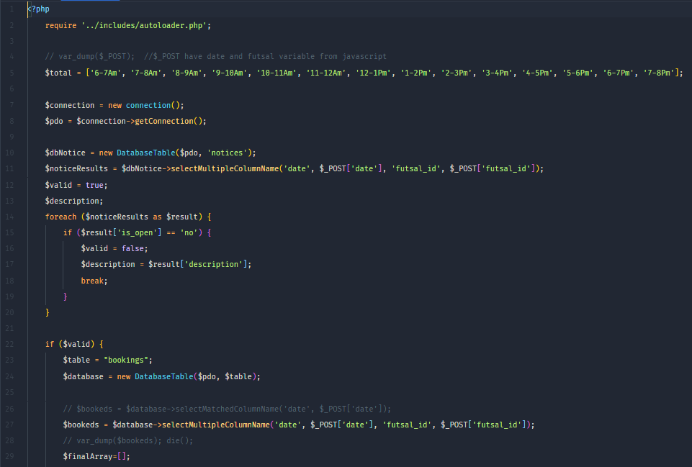

Figure : ajax.php

Logic:

Ajax.php page get the value passed by javascript and search in the database whether the supplied date, futsal by javascript is available to book or not, the information is then send back to the javascript and javascript display the information placing it in one of the element

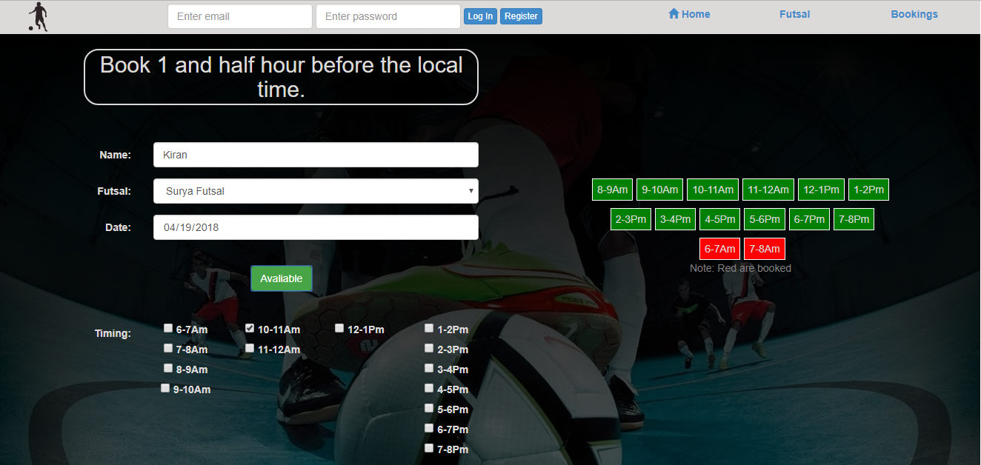

Figure : ajax implemented.

Suppling futsal name, date and clicking on the available button javascript send futsal id and date to ajax page and ajax return information to javascript. In above picture futsal name and date 04/19/2018 is selected and checking available ajax return value with booked with red color and green with available one on the same working page.

.Validating selected time whether it is passed or not:

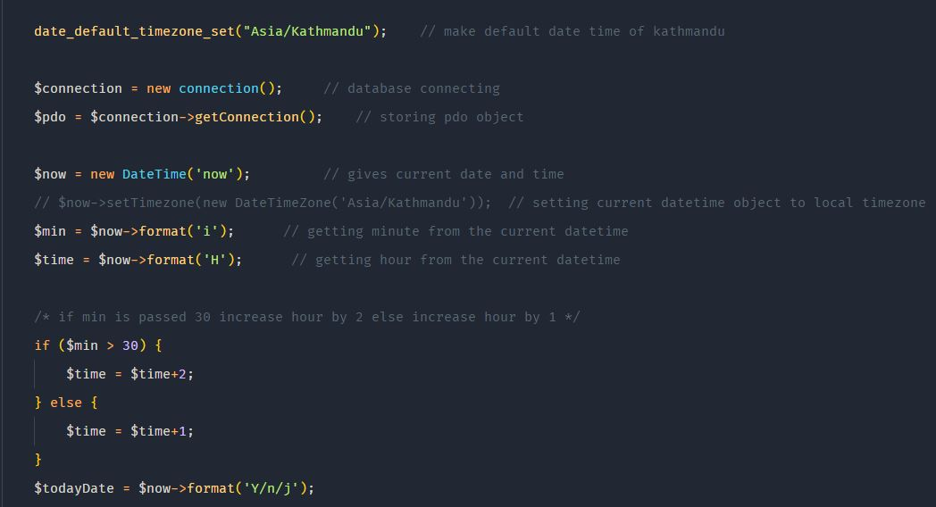

Figure 14: Storing current local date and time.

Logic:

The logic here is user can only book 1 and half hour before the current time.

Get the current local date and time. Separate date, hour and minute store hour in 24 hour format because in 12 – hour format 1 hour will be smaller than 12 so in 24 hour format 1 will be 13 and so on.

If min has not passed 30 then can bookable after 1 hour else if min is already passed 30 increase bookable time by 2.

Checking date:

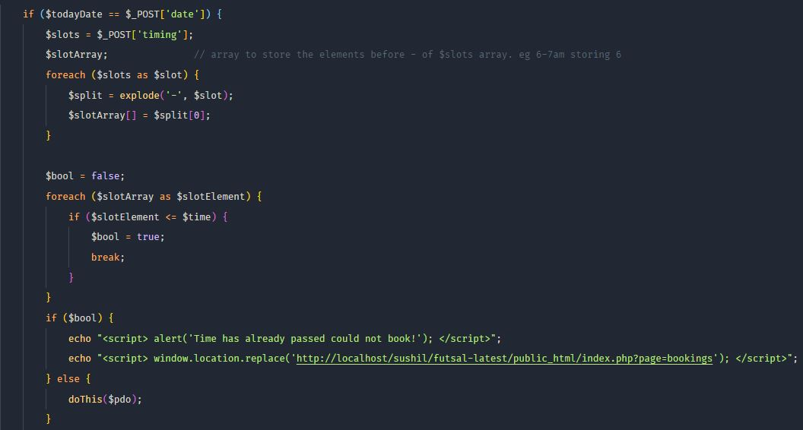

Figure 15: checking date and time.

Logic:

Get the user selected time slot which are stored in $slots array. Splits array element and store only first index of the array. For example if user selected timing are 6-7am, 8-9am and 9-10am then get first element of this array and store in a new array called slotArray. Now slot array will have 6, 8, and 9. We already have current local 24 – hour format time, now compare this time with slot array if time collide make Boolean value true and break from the loop. Finally check Boolean value if result is true display that the time slot is already booked else make them book.

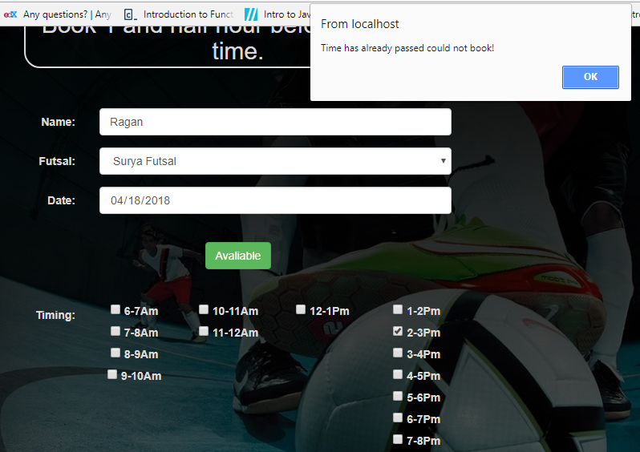

Figure 16: time passed to book.

Sandbox paypal payment code:

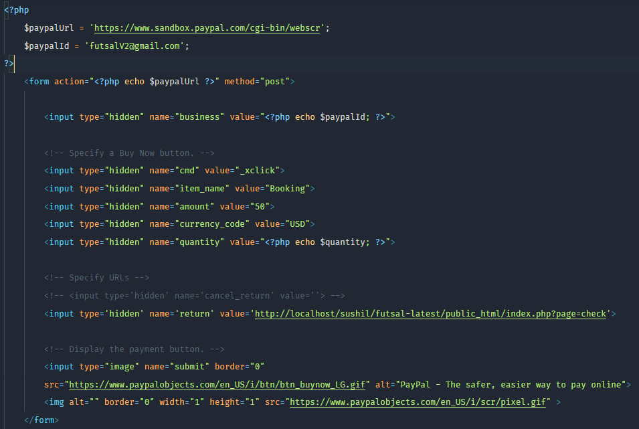

Figure 17: sandbox paypal payment code.

Logic:

Here on the top url is the paypal sandbox developer url. And paypalId is a business organization to whom the money is going to transfer. Basically it is a hidden form which transfer the supplied value to the sandbox developer url. Here in the code author has put a quantity variable that is the number of selected timing from the user, if it is 1 the amount 50 will deduce from the user account if the quantity is 2, 50*2=100 amount will get deduce.