**Testing**

Testing was done for all the pages and functionality listed below are the black box testing and white box testing.

**Black box testing:**

|  |  |  |  |  |
| --- | --- | --- | --- | --- |
| Login/Logout Functionality | | | | |
| S.N | CONDITION | EXPECTATIONS | OUTCOMES | REMARKS |
| 1 | When Admin login button clicked | If username and password matches with the username and password of the admins table in database | Should access to admin page | Verified |
| 2 | When futsal vendor login button clicked | If futsals email matches with email and password matches with their respective password | Should access to their page | Verified |
| 3 | When Admin logout button clicked | Logout from the admin content and display login content. | Session logged out and redirected to login page. | Verified. |
| 4 | When futsal vendor logout button clicked | Logout from the futsal vendor content and display login content. | Session logged out and redirected to login page. | Verified. |

|  |  |  |  |  |
| --- | --- | --- | --- | --- |
| Admin Content View, Add, Edit and Delete Functionality | | | | |
| S.N | CONDITION | EXPECTATIONS | OUTCOMES | REMARKS |
| 1 | When clicked on the admins | Display all the admins that are recorded on the database. | Displayed recorded admins from the database. | Verified |
| 2 | When clicked on the add admin | Form that can store new admin to database | New admin added to database. | Verified |
| 3 | When clicked on the edit admin | Edit current admin information and store to database | Admin information Edited | Verified |
| 4 | When clicked on the delete admin | Delete the selected the admin from the database. | Admin deleted from the database. | Verified |
| 5 | When clicked on the futsals | Display all the futsals that are recorded on the database. | Displayed recorded futsals from the database. | Verified |
| 6 | When clicked on the add futsal | Form that can store new futsal to database | New futsal added to database. | Verified |
| 7 | When clicked on the edit futsal | Edit current futsal information and store to database | futsal information Edited | Verified |
| 8 | When clicked on the delete futsal | Delete the selected the futsal from the database. | futsal deleted from the database. | Verified |

|  |  |  |  |  |
| --- | --- | --- | --- | --- |
| Futsal vendor Content View, Add, Edit and Delete Functionality | | | | |
| S.N | CONDITION | EXPECTATIONS | OUTCOMES | REMARKS |
| 1 | When clicked on the notices | Display all the notices that are recorded on the database. | Displayed recorded notices from the database. | Verified |
| 2 | When clicked on the add notice | Form that can store new notice to database | New notice added to database. | Verified |
| 3 | When clicked on the edit notice | Edit current notice information and store to database | notice information Edited | Verified |
| 4 | When clicked on the delete notice | Delete the selected the notice from the database. | notice deleted from the database. | Verified |
| 5 | When clicked on the bookings | Display all the bookings that are recorded on the database. | Displayed recorded bookings from the database. | Verified |
| 6 | When clicked on the edit bookings | Edit current booking information and store to database | Booking edited to database. | Verified |
| 7 | When clicked on the delete booking | Delete the selected the booking from the database. | booking deleted from the database. | Verified |

|  |  |  |  |  |
| --- | --- | --- | --- | --- |
| User Login/Logout Functionality | | | | |
| S.N | CONDITION | EXPECTATIONS | OUTCOMES | REMARKS |
| 1 | When user login button clicked | If email and password matches with the email and password of the users table in database | Session variable set to user id and user name. | Verified |
| 2 | When user logout button clicked | User logged out with session variable unsetting and redirected to home page. | Session variable unset and redirected to home page. | Verified. |

|  |  |  |  |  |
| --- | --- | --- | --- | --- |
| User Registration Functionality | | | | |
| S.N | CONDITION | EXPECTATIONS | OUTCOMES | REMARKS |
| 1 | When user click register button without specifying the required input form | Input textfield required. | Please fill out this field. | Verified |
| 2 | When user click register button with all required input | User input value get stored in the users table of database at respective coloumn. | New user record added. | Verified. |

|  |  |  |  |  |
| --- | --- | --- | --- | --- |
| Search button Functionality | | | | |
| S.N | CONDITION | EXPECTATIONS | OUTCOMES | REMARKS |
| 1 | When user click search button without specifying the any value | Input text-field required. | Please fill out this field. | Verified |
| 2 | When user click search button with all required input value | Futsal information should be shown according to the supplied value. | Futsal information is shown according to the supplied value. | Verified. |

|  |  |  |  |  |
| --- | --- | --- | --- | --- |
| Available button Functionality | | | | |
| S.N | CONDITION | EXPECTATIONS | OUTCOMES | REMARKS |
| 1 | When user click available button with empty date | When user without selecting date click available show no response. | Have no response. | Verified |
| 2 | When user click available button with specified date | Get the futsal name and date and search for available time on that date. | Show available plus the one which are booked. | Verified. |
| Futsal selected : Surya Futsal  Date: 04/19/2018  Clicked Available button shows 6-7Am and 7-8Am booked other timing is available to book. | | | | |

|  |  |  |  |  |  |  |  |
| --- | --- | --- | --- | --- | --- | --- | --- |
| Submit Button Functionality | | | | | | | |
| S.N | CONDITION | EXPECTATIONS | | OUTCOMES | | REMARKS | |
| 1 | When user click submit button with-out filling the form | Alert message pop up with please fill up the form | | Alert message with fill the form | | Verified | |
| 2 | When user click submit button with-out ticking the timing slot | Show message that the time has not been selected. | | Time slot already selected | | Verified. | |
| User select 6-7Am which is already booked at Surya Futsal on given date so alert message pop up. | | | | | | | |
| 3 | When user click submit button with valid information | | User should be forwarded to online payment procedure. | | User is directed to payment page. | | Verified. |

|  |  |  |  |  |
| --- | --- | --- | --- | --- |
| Buy Now button Functionality | | | | |
| S.N | CONDITION | EXPECTATIONS | OUTCOMES | REMARKS |
| 1 | When user click buy now button | User need to validate his paypal account if validate amount is deducted from user account to destination account. | Amount transferred successfully. | Verified |
| 2 | When user click buy now button | After Amount transferred successfully record are stored in database | Record stored in database | Verified. |

Screen shot of amount transfer from customer to vendor.

Initial customer amount. Initial vendor amount.

|  |  |
| --- | --- |
|  |  |

After transaction amount transfer from customer to vendor.

|  |  |
| --- | --- |
|  |  |

Money deducted from customer and transferred to futsal vendor.

**White box testing:**

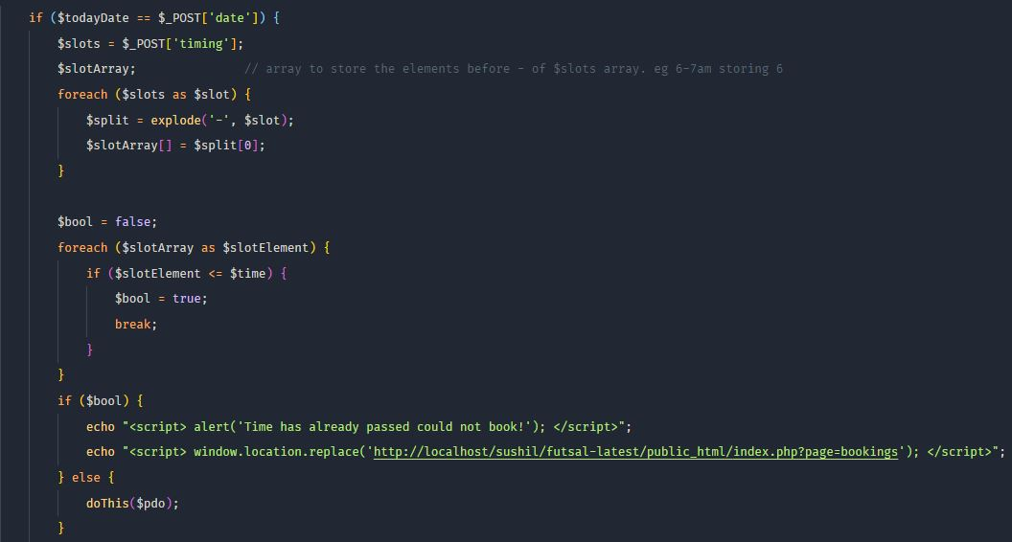

Figure 1: white box testing 1.

Cyclomatic Complexity = 1 + ∑decision points

= 1+4

= 5

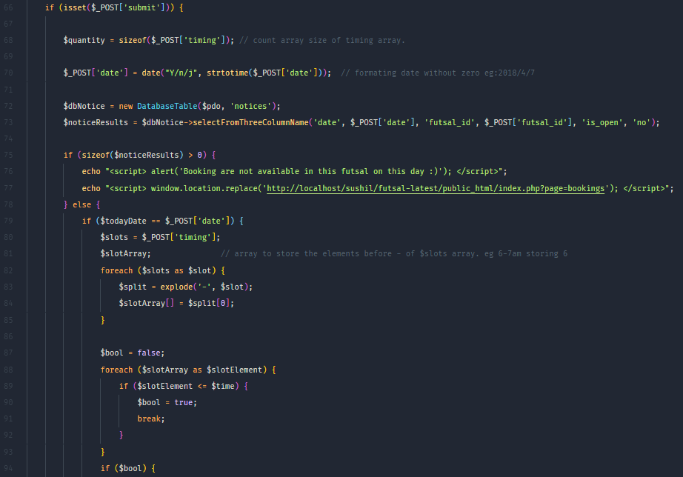

Figure 2: white box testing 2.

Cyclomatic Complexity = 1 + ∑decision points

= 1+7

= 8