# The Design and Development of Object Database

By Sushil Pun

UN UK ID: 16401146

BSc. Computing (Software Engineering)

Table of Contents

1 Introduction: 4

Background Research: 4

Aim: 5

Objective: 5

Project Development Methodology 5

2. Requirement Engineering 5

2.1 Elicitation Activities 5

2.1.1 Interview plans 5

2.1.2 Interview Findings 6

2.2 Other Problem Domain Research 8

2.2.1 Comparable System 8

2.3 Development Relevant Legislation 10

Data Protection Act: 10

Computer Misuse Act 11

2.4 Requirement Specifications 11

2.4.1 Problem Domain Description 11

2.4.2 Existing Business Operation 11

2.4.3 Summary of existing business. 11

2.5 Functional Requirements 11

2.5.1 System Functionality 11

2.6 Performance Requirements 12

2.6.1 Speed: 12

2.6.2 Capacity 12

2.6.3 Reliability 12

2.6.4 Usability 12

2.7 Design Constraint 12

3. System Design and Analysis 12

3.1 Preliminary Design Stages 12

3.1.1 Textual Analysis 12

3.1.2 Significant Event Analysis 13

3.2 Command queries and constraints 14

3.3 System Architecture Design 14

3.4 BON Diagram 15

3.4.1 BON Cluster Chart 15

3.5 Database Schema 17

3.6 ODL Code 18

4 Interface Design: 18

4.1 login page 19

4.2 Home page 19

4.3 Categories page 20

4.4 Advance Search: 23

4.5 Add product: 25

4.6 Edit product: 26

4.7 Delete product: 28

5 Testing 28

5.1 Development testing: 29

5.2 Tabular testing: 29

6 Evaluations: 30

7 Conclusions: 30

8 Limitations: 30

9 Bibliography: 31

10 References: 31

LIST OF TABLE:

Table 1: interview with Mr. Max Forthby. 6

Table 2: interview with Mr. Thomas Black. 7

Table 3: interview with Mr. Mark Jones. 8

Table 4: interview with Mr. Mark Jones. 8

Table 5: system functionality. 11

Table 6: textual analysis. 12

Table 7: significant event analysis. 13

Table 8: command queries and constraints. 14

Table 9: BON cluster chart 1. 16

Table 10: BON cluster chart 2. 16

Table 11: login and logout testing 29

Table 12: product view, add, edit, delete and search. 29

LIST OF FIGURE

Figure 1: hamrobazar.com home page 10

Figure 2: auctionhouse.co.uk 11

Figure 3: BON diagram. 16

Figure 4: database schema. 18

Figure 5: ODL Code. 19

Figure 6: admin-login. 20

Figure 7: forthby home page. 21

Figure 8: drawing products with medium. 21

Figure 9: painting category. 22

Figure 10: photographic-image. 22

Figure 11: sculpture category. 23

Figure 12: carving category with different material used. 24

Figure 13: advance search. 25

Figure 14: database table with attributes and values. 25

Figure 15: search item result. 26

Figure 16: adding product form. 26

Figure 17: product added. 27

Figure 18: editing a currently added product form. 28

Figure 19: product edited. 29

Figure 20: before delete. 29

Figure 21: after delete. 29

# 1 Introduction:

## Background Research:

Forthby is an international auction house that sells fine arts. In this generation of computer, forthby wants its buoyant art inventory to be computerized to provide fast and efficient way of searching mechanism for its customer. Currently forthby is on clerical inventory system. Items that are for sale on each auction are printed and distributed to its client before or on the day of auction.

Auction items are categorized in five sections they are paintings, drawings, photographic images, sculptures and carvings. All auction items irrespective of the category will have the following details in common.

* Item Lot Number
* Artist Name
* Produced year.
* Classification of the item.
* Description of the item.
* Auction Date.
* Estimated Price.
* Dimension in cm of an item.

And there are specific details only for specific category.

For Drawings and Paintings

* Medium Used. E.g. (pencil , ink, oil, watercolor)
* Framed or not.

For Photographic Images

* Image type e.g. ( black and white or color)

For Sculptures and Carvings

* Material used e.g. (Bronze, Marble)
* Approx. weight.

## Aim:

The main goal of the project is to design and implement prototype catalogue with computerized application that make customer search effective. Prototype catalogue must be built with object database Matisse and with java programming language.

## Objective:

In order to achieve the aim author will follow the following listed objectives.

* Background research of existing system.
* Interviewing the stakeholder to get better understanding of current system in and out.
* Comparing similar application.
* Designing OOD (Object Oriented Database)
* Coding using JAVA Language.
* Testing and Evaluation.

## Project Development Methodology

Interviewing stakeholder author will collect all the useful information that must be incorporated in project. After the interview section author will be using Matisse for object database server and java (jsp, servlet and tomcat) for web server.

# 2. Requirement Engineering

## 2.1 Elicitation Activities

### 2.1.1 Interview plans

Interviewing the various stakeholder different opinions, experience and expectation come up. Different stakeholders have different responsibility so author need to gather information related to all the stakeholder responsibility and their working difficulties. Interview to the following stakeholder conducted:

* Mr. Max Fothby
* Mr. Mark Jones
* Mr. Paul Smith
* Mr. Thomas Black

### 2.1.2 Interview Findings

Interview finding are listed below in tabular form.

Table 1: interview with Mr. Max Forthby.

|  |  |
| --- | --- |
| Stakeholder: Mr. Max Fothby | |
| Question | Answer |
| Why forthby is switching to computer base system? | After finding the current clerical limitation and existing problem. |
| Who are going to use the system? | Administrator, buyer and seller. |
| What is the number of employee in the company? | Current approximation in 24 might be up to 26. |
| Can you provide us the month, day that you want system to be ready? | Mid of April, I want system to be ready. |
| How long do you system to store data? | In current system data stay for 3 year but in computerized system we’ll like to have indefinite. |
| How the bidding system work? | We have commission system. Buyer calls and inform maximum and minimum price they are interested to pay. |
| Do auction have max or min value? | Minimum is base price but there are no maximum bid values. |
| If item is not sold they are relisted again? | If customer agrees with relisting then item relist again for auction. |
| How the items are delivered? | Through courier after sold. |
| How is the payment done and the time frame to pay? | Payment must be done after the auction is over and the time frame to pay is as early as possible. |
| Is there an age limit for buyer and seller? | Minimum age for buyer and seller is 18 year. |
| Do you wish to make the sold item public? | No we don’t want information about the sold items. |
| Is there any specific color, logo, design that system must have? | Yes the logo must be in royal colors like purple, red etc. |
| How would you like to deal with user detail data? | As we are bound to data protection act we want information about user to be sensitive. |
| Can a seller withdraw an item? | If it is before auction seller won’t be charged but if seller withdraw after they will be charged 5% of estimated price. |

Table 2: interview with Mr. Thomas Black.

|  |  |
| --- | --- |
| Stakeholder: Mr. Thomas Black | |
| Question | Answer |
| What is your responsibility? | As a senior administrator I have to categorize items and organize items into slots. I also do other administrative work. |
| What are the problems faced in current system? | As it is a clerical system it takes lot of space and frequently losing files. Also issue with data security. |
| What level of access do you have in current system? | I have top level access as I manage most of the auctions like add delete. |
| Who generate and manage the catalogue? | I generate and manage catalogue. |
| How many items go to one catalogue? | Almost 270 items go into one catalogue. |
| How long it takes to prepare a catalogue? | Almost 2 or 3 weeks to prepare catalogue. |
| How catalogue are stored in current system? | Catalogues are prepared in word and document is sent to print. |
| What number of client may use the new system? | Currently we have 500 thousand client so the system must be able to handle 500k clients. |
| How would you like to have an access for individual data for individual person? | I like to have different access for buyer, seller , evaluator and administrator with strong password. |
| What is the particular thing you would like to must have in new system? | We are looking for speed. Should be easy to operate and less errors than human in new system. |

Table 3: interview with Mr. Mark Jones.

|  |  |
| --- | --- |
| Stakeholder: Mr. Mark Jones | |
| Question | Answer |
| How you access auction information? | Currently we on paper base system so we access according to document. |
| Why do you want the system to be upgraded? | Because it make things slow and consumes lot of working time. |
| How is the payment done after you have purchased the items? | The amount is withdrawn from the account. |
| How you collect items you purchased? | We collect it through courier. |
| What feature is foremost according to your point of view? | I am concerned about the data security. I don’t want information to be stolen by other person. |

Table 4: interview with Mr. Mark Jones.

|  |  |
| --- | --- |
| Stakeholder: Mr. Mark Jones | |
| Question | Answer |
| Do you have used any other system and your experience? | Yes used cremasteric and south piece. These systems allow us to live stream of auctions. |
| What searching criteria would you like? | People should be able to search items by different criteria example by price and color. |
| What features would you like to have in new system? | I personally like to have an efficient and speed in new system. |

## 2.2 Other Problem Domain Research

### 2.2.1 Comparable System

Observing and comparing to the already existing system will benefit in building new system. Author tries to compare to other existing system and find out the best and worst user experience on every individual system. Author find out there are couple of system working in market similar to our project which are:

* HamroBazar.com
* auctionhouse.co.uk

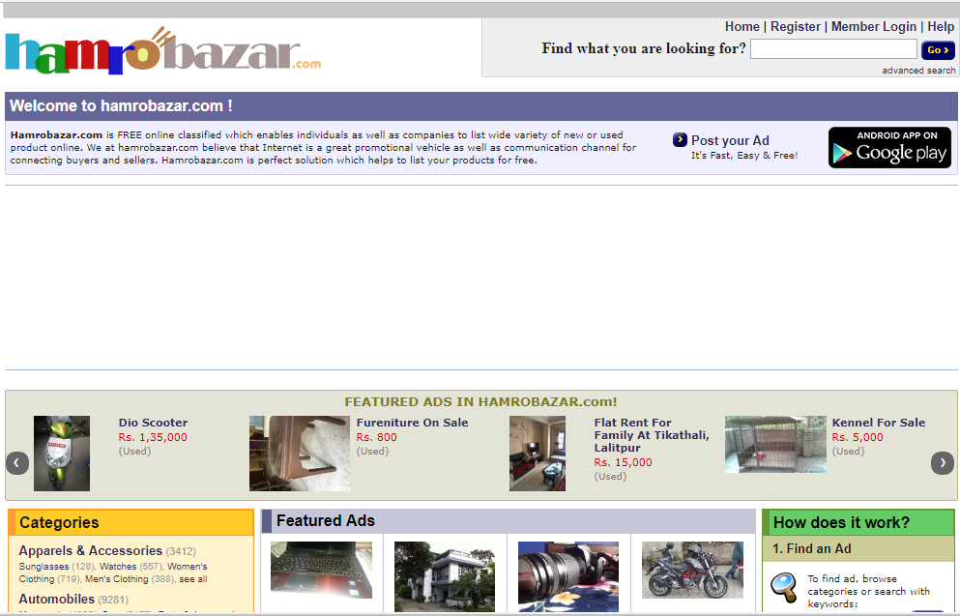

Figure 1: hamrobazar.com home page

**Review on hamrobazar.com**

In hamrobazar.com seller can sell any number of items. The items that the seller is selling are categories in various sections. It is typically not an auction system but work in a way that the client can sell and buy product. The deal is done here in first come first service. To whoever the client deal is finalized item are sold to them. After the item is sold they are on sold list so no other client can buy it.

System webpages are not like professional level they look not so user-friendly. There is no proper validation of what the seller is selling i.e. seller may advertise product in one way but the end product may be very differ.

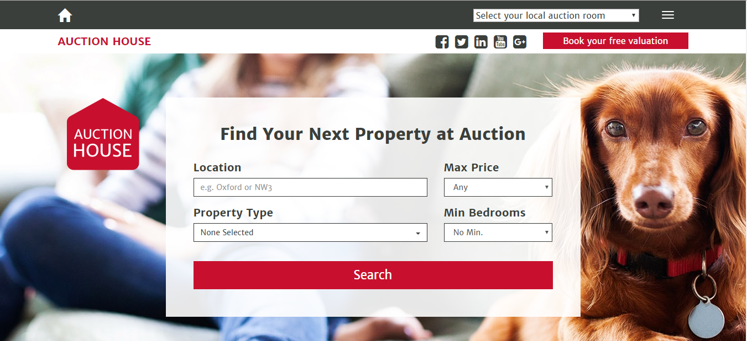

Figure 2: auctionhouse.co.uk

**Review on Auctionhouse.co.uk**

System website looks very aesthetic. The design is very good. Clients feel easy and friendly to use system again and again.

Auctionhouse.co.uk work on selling/buying house property based on United Kingdom UK territory. Client search of appropriate property and the auction detail will display and according to auction detail buyer/seller can proceed further.

## 2.3 Development Relevant Legislation

### Data Protection Act:

Data is everything; if data gets in wrong hand then it can change the balance of existing environment. Data protection act ensure legal control on data that is stored in electronics device. This act was formed to address following issue.

* Data accurate information.
* Who can use data?
* Who can edit data?
* Whether the data can be copied or not.

This act gives legal right of person or organization to store this data. And everyone using this data must accept the data protection act principle. Some of the principles are listed below:

* It must be current and accurate.
* It must be proceed lawfully.
* It must be protected against unauthorized and accidental loss.
* It must be used for only specific purpose. (Gov.uk, 2017)

### Computer Misuse Act

This act protects against the person or organizations will to consciously the hamper other’s original application/software.

Some of the activities that may lead to this act are:

* Hacking
* Unauthorized access.
* Knowingly spreading malicious virus. (Gov.uk, 2017)

## 2.4 Requirement Specifications

### 2.4.1 Problem Domain Description

Fotheby is currently on paper based. In this approach of working they are facing lot of difficulties. One is they stored document that can be easily lost or can have human error. Another issue is in retrieving information as it is document based, they need human effort. To just find one document they have to search many predecessor or successor document. Auction bidding in current system is time consuming and lengthy process, it can be overcome in computerized system.

### 2.4.2 Existing Business Operation

Existing business is clerical based. Auction is perform twice in a week and only 18 plus can bid. Seller and auction house set the initial price of the item and the bidding start, and the client with the highest amount of bid will get the selling item. Looking for the desired item document is a lengthy process.

### 2.4.3 Summary of existing business.

Forthby is an international auction house currently working in clerical way. Client that may be buyer or seller must visit auction house. Seller comes to auction house and both party set item a minum value then buyer client can visit and see the auction details with the minimum price. If a buyer wants to have a further information about the auction item then forthby employee search s the product ( which is time consuming ) and returns it to potential buyer client.

## 2.5 Functional Requirements

### 2.5.1 System Functionality

Table 5: system functionality.

|  |  |  |
| --- | --- | --- |
| Product item | | |
| Functionality | Admin | Users |
| Create | Can create an item | Has no access |
| Read | Can view all the information about the items | Can view auction item that is yet sold. |
| Update | Can update the items details. | Has no access |
| Delete | Can delete the individual auction item | Has no access. |
| Search | Can search items. | Can search items. |

## 2.6 Performance Requirements

Performance of new system must be less time consuming, efficient and easy to use. Performance requirement will be measured in following topic:

### 2.6.1 Speed:

User experiencing the system needs to be fast. System should precede user request in no time i.e. if a client request and system take more time to proceed than user may cancel the working procedure. Auction bidding and auction searching should be fast and efficient.

### 2.6.2 Capacity

It is basically an information storage capacity of the system. System should be built in such a capacity that it can handle and execute information that are continuously storing for no less than 3 year.

### 2.6.3 Reliability

While handling the large number of information and user request system should not get crashed. New system must be a reliable so testing is very important that ensure that system does not crashed once.

### 2.6.4 Usability

System must be simple and user-friendly that it should not require any further brain processing of user. System must be built in mobile first design i.e. responsive.

## 2.7 Design Constraint

Forthby international auction house is currently working clerical based. Due to this they are only limited to many functionality and facing various difficulties that they want to be resolved in new system. According to interview findings, problem domain, requirement specification and performance requirement system will be built as simple but as efficient.

# 3. System Design and Analysis

## 3.1 Preliminary Design Stages

### 3.1.1 Textual Analysis

Table 6: textual analysis.

|  |  |
| --- | --- |
| Classes | Routines |
| Admin | * Login * Logout * Access to all the information. * Able to add new items. * Able to edit existing items. * Able to delete existing item * Able to search for specific item. |
| Client (buyer/seller) | * Only able to see item that admin want to be shown. * Can search for specific item. |

### 3.1.2 Significant Event Analysis

Table 7: significant event analysis.

|  |  |  |
| --- | --- | --- |
| Events | Performer | Attributes |
| Log in | Admin | Username  Password |
| Add product | Admin | Item_name  Artist_name  Lot_number  Produce_year  Classification  Description  Auction_date  Estimated_price  Category  Medium  Framed  Image_type  Material_used  Weight  Dimension |
| Edit/delete | Admin | OID |
| Search | Admin/User | Item_name  Lot_number  Category  Artist_name  Estimated_price |

## 3.2 Command queries and constraints

Table 8: command queries and constraints.

|  |  |  |  |
| --- | --- | --- | --- |
| CLASS | PRODUCT | | PART I/I |
| TYPE OF OBJECT  It represents the product that is for auction. | | Created/Auther:  22-04-2018/ P Sushil | |
| Queries | product_name, artist_name, lot_number, category, classification, description, produce_year, description, auction_date, estimated_price, medium, framed, image_type, material_used, dimension and weight. | | |
| Commands | Add, Edit, Delete, Display, Allocate | | |
| Constraints | Lot_number and estimated_price must be integer.  Auction_date must be a date.  Weight and dimension must be positive integer value. | | |

## 3.3 System Architecture Design

Domain Objects

1. Users

* Admin
* Username
* Password
* Clients
* First_name
* Last_name
* Email
* Address
* Date_of_birth

1. Products

* Item_name
* Artist_name
* Lot_number
* Produced_year
* Classification
* Description
* Auction_date
* Estimated_price
* Category
* Medium
* Framed
* Image_type
* Material_used
* Weight
* Dimension

## 3.4 BON Diagram

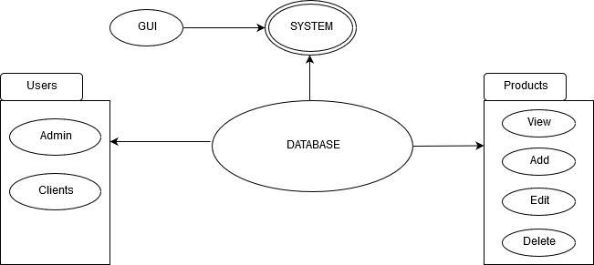

Figure 3: BON diagram.

### 3.4.1 BON Cluster Chart

Table 9: BON cluster chart 1.

|  |  |  |  |  |
| --- | --- | --- | --- | --- |
| Cluster | | Interface | Part:1/1 | |
| Purpose:  Allowing users to register in the system | | | | INDEXING  Author: Sushil Pun  Keyword: interface, database functionality |
| Cluster | Description | | | |
| Interface | This is the basic cluster of the system to interfering with the system and its functionality. | | | |

Table 10: BON cluster chart 2.

|  |  |  |  |  |
| --- | --- | --- | --- | --- |
| Cluster | | Users | Part:1/2 | |
| Purpose:  Create types of users | | | | INDEXING  Author: Sushil Pun  Keyword: interface, database functionality, users |
| Users | There are 2 types of users for this system. They are: admin and clients. | | | |
| Admin | This is the type of user who has control to the entire system. | | | |
| clients | Clients are buyer and seller. They can sell item and view auction item details. | | | |

## 3.5 Database Schema

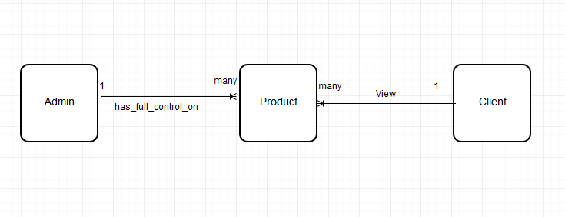

Figure 4: database schema.

## 3.6 ODL Code

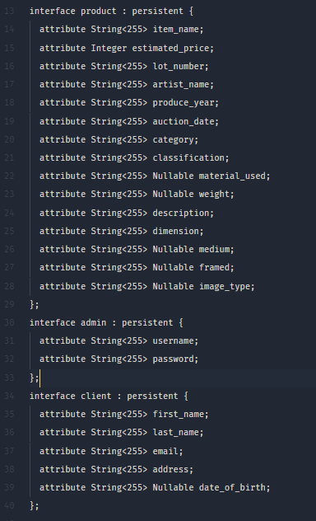

Figure 5: ODL Code.

# 

# 4 Interface Design:

This section deals with the system integrated design.

* Login page
* Home page
* Categories page
* Advance search
* Add product
* Edit, Delete product

## 4.1 login page

Currently system has only admin authentication login page. To get access to admin feature they need to provide correct username and password. After the admin is authenticated they can have admin functionality.

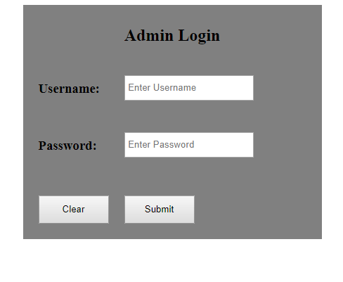

Figure 6: admin-login.

If username and password is not provided or incorrect provided system will through alert message with incorrect username or password.

Clear button is to clear out the input field. If both username and password is correct then the user will be validated as admin and will have full authorization over system data.

## 4.2 Home page

Home page is the basic layout of the system. System start with the home page and user can choose what to do and where to go.

Through home page user can go to admin login page, search or advance search. User can also view different category of auction.

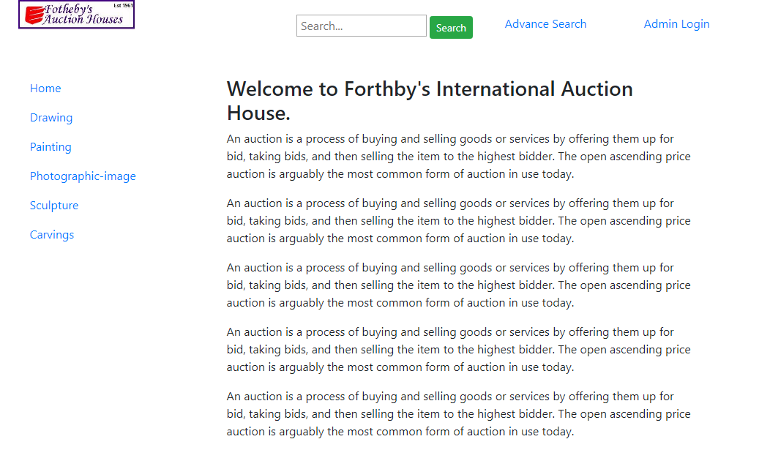

Figure 7: forthby home page.

## 4.3 Categories page

Auction items are basically categories in 5 sections they are drawings, paintings, photographic, sculptures and cravings.

Selecting on individual category will display their product details basically author has displayed static information on this section.

**Drawing category**

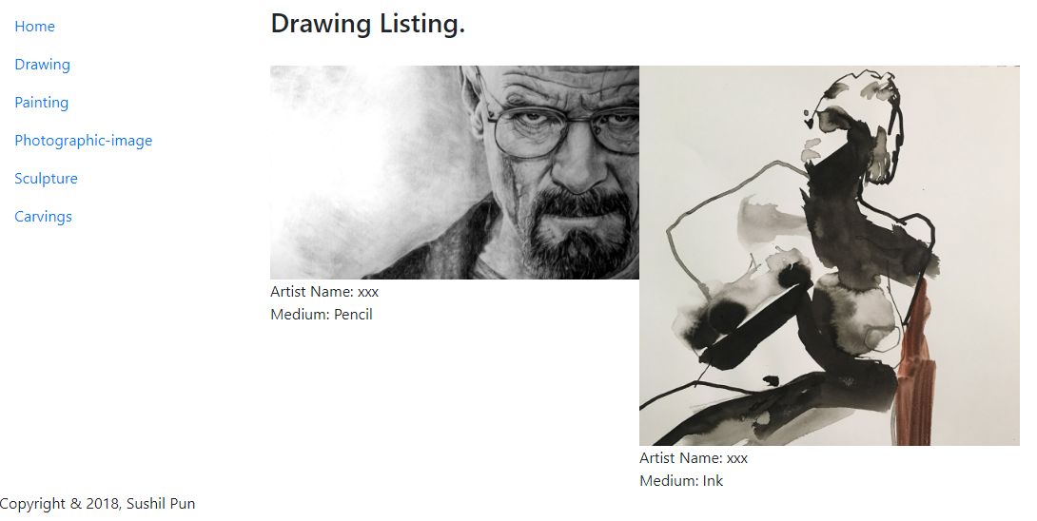

Figure 8: drawing products with medium.

**Painting category**

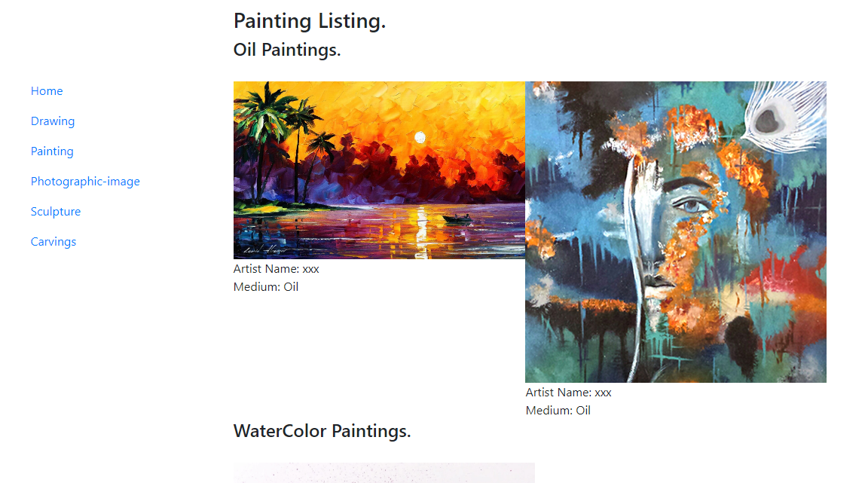

Figure 9: painting category.

**Photographic-image category.**

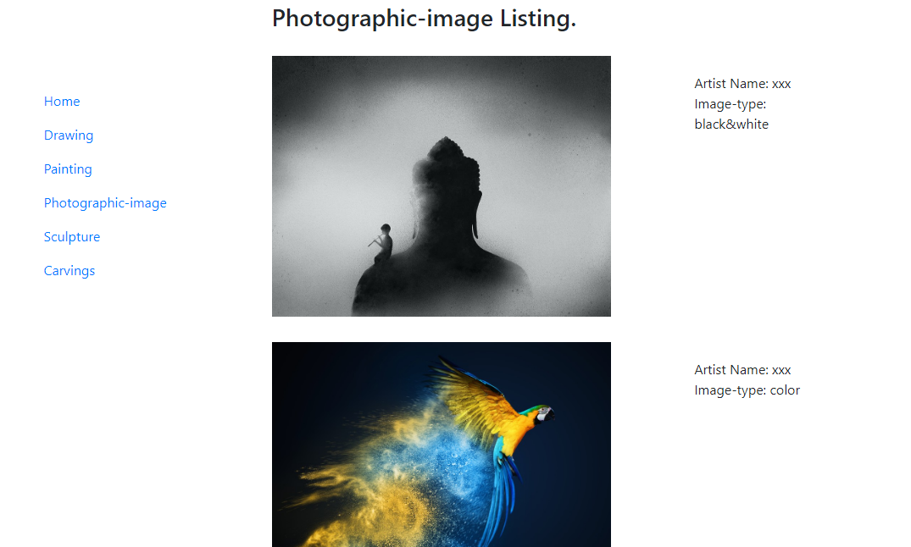

Figure 10: photographic-image.

**Sculpture category.**

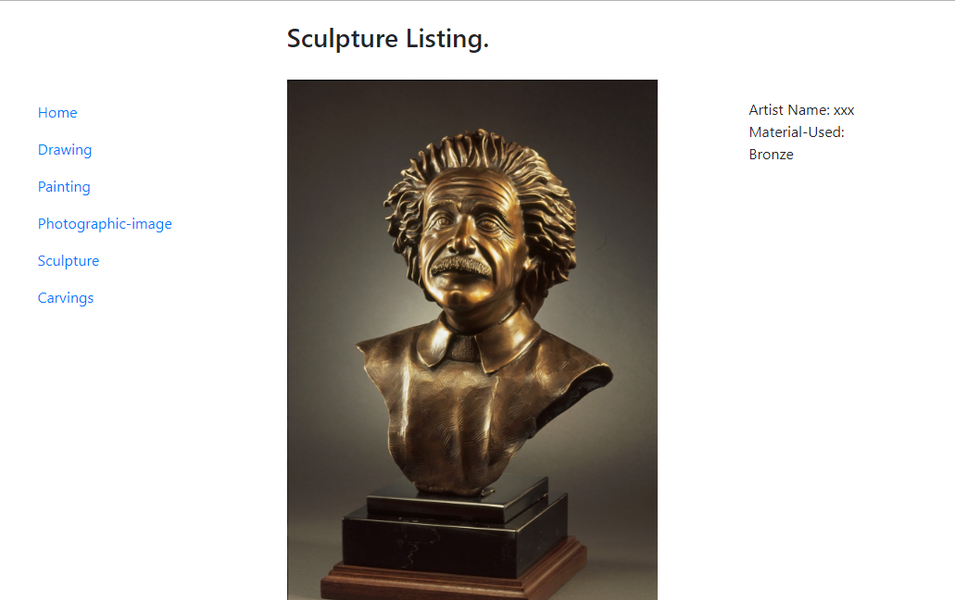

Figure 11: sculpture category.

**Carving category**

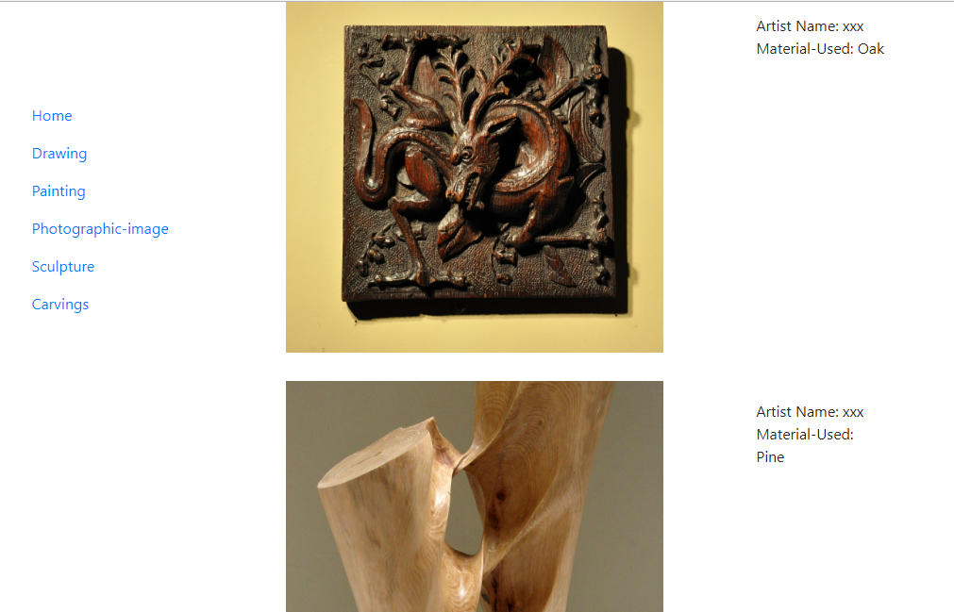

Figure 12: carving category with different material used.

## 4.4 Advance Search:

User can search auction item providing multiple input field and the product with the correct item will be displayed.

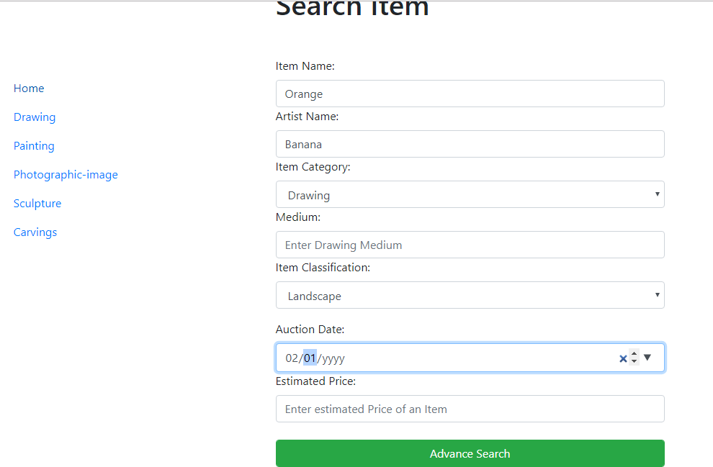

Figure 13: advance search.

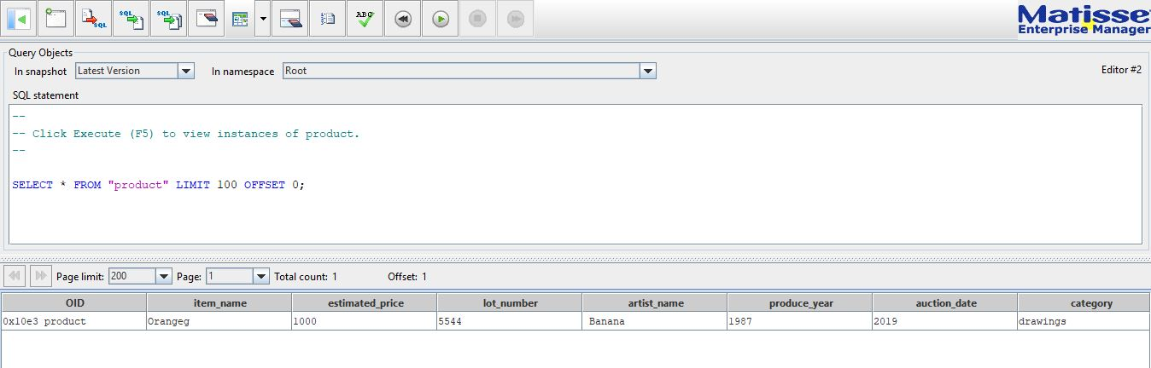

Figure 14: database table with attributes and values.

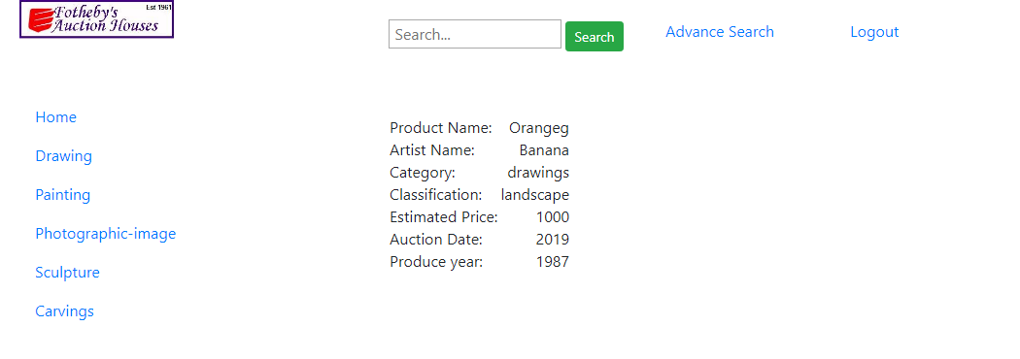

Figure 15: search item result.

## 4.5 Add product:

In order to add a product user must be an admin then only he/ she can add new product to database. Add product is basically a form that gets register to database.

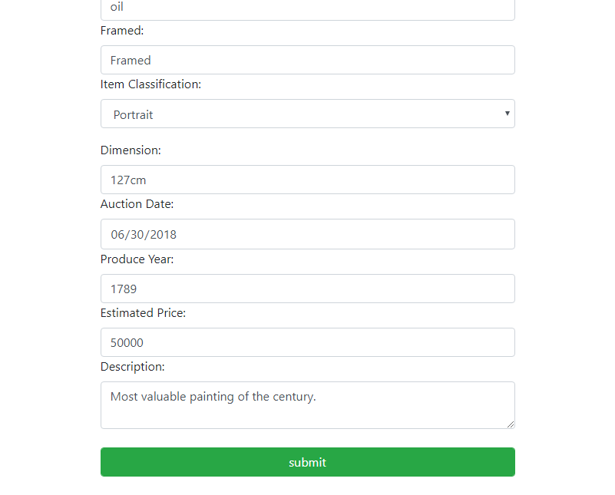

Figure 16: adding product form.

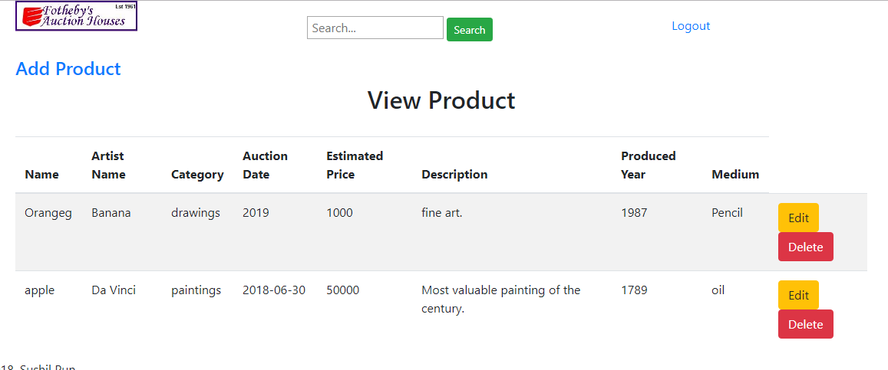

Figure 17: product added.

## 4.6 Edit product:

Admin can edit the current list of product. When admin click edit button form with current product value appears and the admin can change the desired value only.

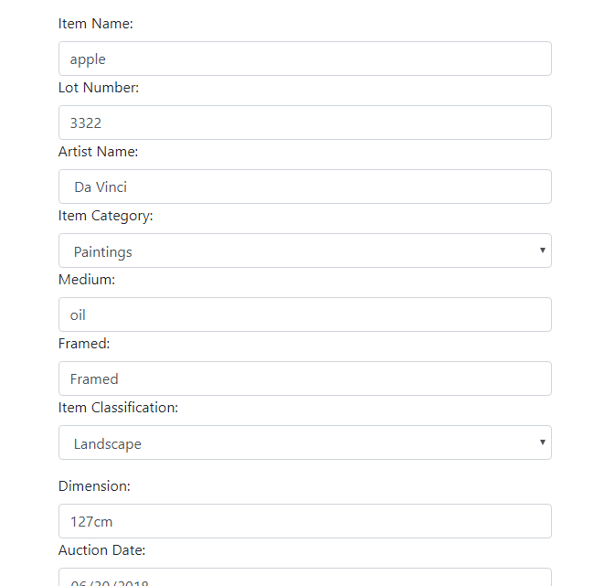

Figure 18: editing a currently added product form.

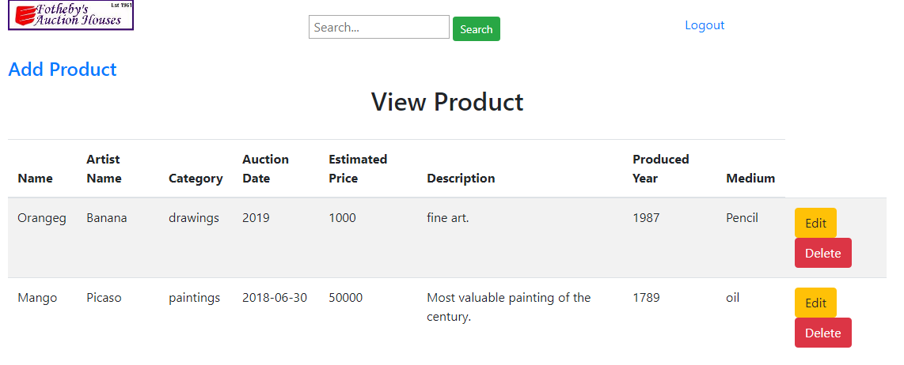

Figure 19: product edited.

Product with name apple and artist da vinci edited to Mango and Picaso.

## 4.7 Delete product:

Admin view the list of product and there in right hand side there is an option delete which deletes the product from the database.



Figure 20: before delete.

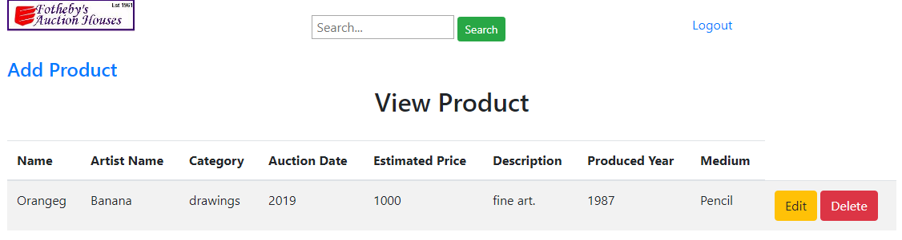

Figure 21: after delete.

# 

# 5 Testing

Testing is the vital part of the software development. No system is a perfect system. Some bug may be remaining so testing must be done in every phase of development. Author has done development testing and tabular testing which is listed below:

## 5.1 Development testing:

While the software is in development phase author tested each and every functionality before moving to implement new functionality to software. While implementing new features previous code get crashed some time so author has to be carefully test previous all features if new functionality is added. Author completed this testing with the help of eclipse build-in debug feature commonly known as debug as server while running eclipse EE edition.

## 5.2 Tabular testing:

Table 11: login and logout testing

|  |  |  |  |  |
| --- | --- | --- | --- | --- |
| Login/Logout Functionality | | | | |
| S.N | CONDITION | EXPECTATIONS | OUTCOMES | REMARKS |
| 1 | Login button clicked with wrong username, password or empty value | Alert message should display saying username and password is in-correct. | Alert message pop-up displaying that username and password is wrong. | Passed. |
| 2 | When Admin login button clicked | If username and password matches with the username and password of the admins table in database | Accessed to admin content. | Passed |
| 3 | When Admin logout button clicked | Logout from the admin content and display login content. | Session logged out and redirected to login page. | Passed. |

Table 12: product view, add, edit, delete and search.

|  |  |  |  |  |
| --- | --- | --- | --- | --- |
| Product View, Add, Edit, Delete and Search Functionality | | | | |
| S.N | CONDITION | EXPECTATIONS | OUTCOMES | REMARKS |
| 1 | When admin validation is correct. | Set a new session with name of current admin and display all products. | Session is set and products are displayed. | Passed |
| 2 | When admin click on edit button. | Get the clicked product OID and search a product matching OID and display its value in form so that admin can edit it. | Input form with value of product that needs to be edited displayed. Now admin can edit desired part. | Passed |
| 3 | When admin click add button | New page open with the form that stores product information as attribute value in product table. | Form displayed and admin added new product to the table in database | Passed |
| 4 | When admin click delete button | When delete is clicked get the OID of the product and search in database table. Then delete that row. | Product deleted from the database table. | Passed |
| 5 | When clicked on simple search button. | Simple search field requires item name if correct provided will display its detail. Anything that does not match item name will show no product found. | If correct item name passed the result was shown. With in-correct item name no product found message displayed. Work fine as wished. | Passed |
| 6 | When click on advance search. | If advance search click new page open with multiple form and if form is submitted it should search in database with column matching the provided values. | Searched in product table with multiple attribute and its value and displayed the result. If found product details are displayed in display.jsp page if not then no product found message displayed. | Passed |

# 6 Evaluations:

The software was built with object database for the forthby international auction house. In this software system user can view different category of auction product and their details. Admin can edit and deleted existing auction item and also add new items. Users can search product either with simple query, item name or with complex query. System some feature is static and is messy somewhere. According to author these are the main evaluation point that author has made.

# 7 Conclusions:

Implementing object database to create computerized auction system was the main task of the project. Author conduction interview section and done his homework on requirement specification to develop a system. Author has completed basic requirement with some complex requirement of project need. After completing project author has learned new skill such as jsp, jstl, servlet, matisse database.

# 8 Limitations:

Though the project has been completed but many features can be added to it. Project has a deadline so author could not finish some of the feature in time. The features that can be added to make system more robust are as follows:

* Client user with selling functionality.
* Buyer client with the functionality to bid online.
* System UI design can be made more attractive.
* Confirmation message is not shown on edit and delete of product.

# 9 Bibliography:

http://www.matisse.com/pdf/developers/java_pg.pdf. (2018).

https://nile.northampton.ac.uk/bbcswebdav/pid-4343962-dt-content-rid-3824160_1/xid-3824160_1

# 10 References:

YouTube. 2018. JSP Tutorial #5 - Installing Tomcat for MS Windows - YouTube. [ONLINE] Available at: https://www.youtube.com/watch?v=w3kbB3JOHMo&index=5&list=PLEAQNNR8IlB588DQvb2wbKFQh2DviPApl. [Accessed 18 April 2018].

YouTube. 2018. JSP and Servlets Tutorial : First Java Web Application In 25 Steps - YouTube. [ONLINE] Available at: https://www.youtube.com/watch?v=Vvnliarkw48. [Accessed 10 April 2018].

YouTube. 2018. Servlet Java Tutorial Part 7 How to use HttpSession Session Management - YouTube. [ONLINE] Available at: https://www.youtube.com/watch?v=CzlZGHAGHbk&t=493s. [Accessed 12 April 2018].