**ASSIGNMENT :- 1.**

1. **.Hello World Program**: Write a Java program that prints "Hello World!!" to the console.

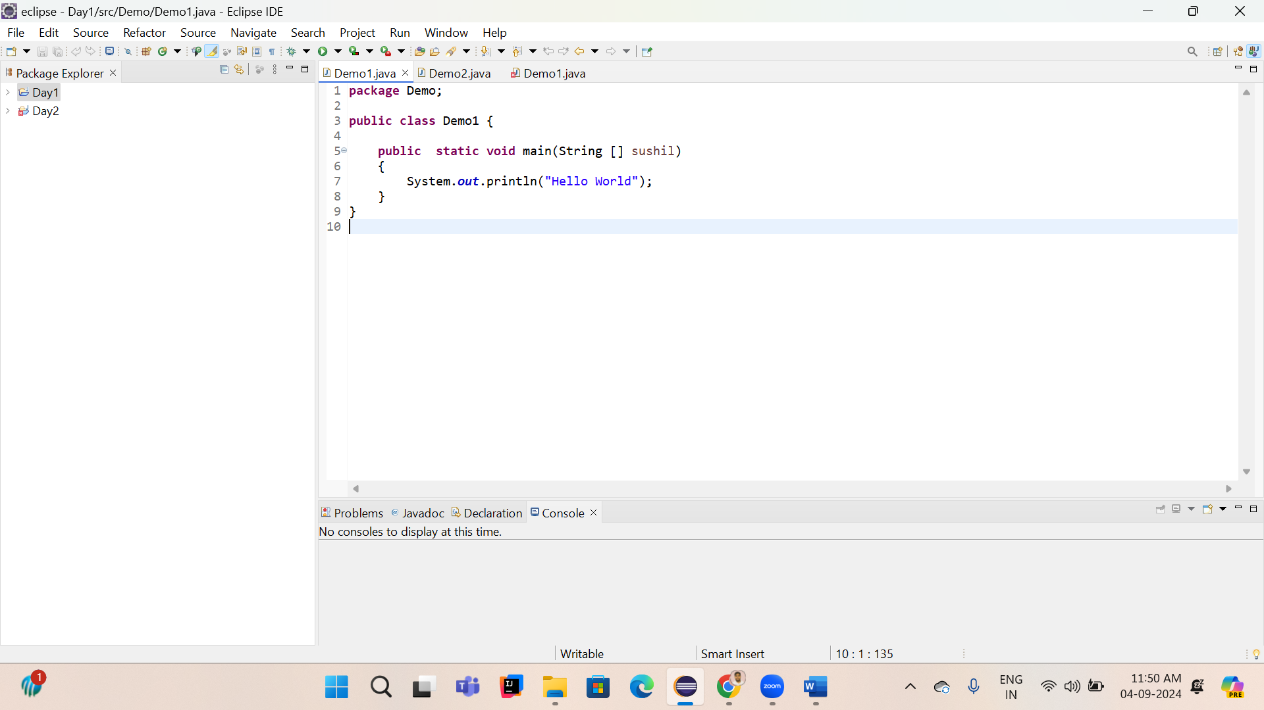

1. **Compile with Verbose Option**: Compile your Java file using the -verbose option with javac. Check the output.

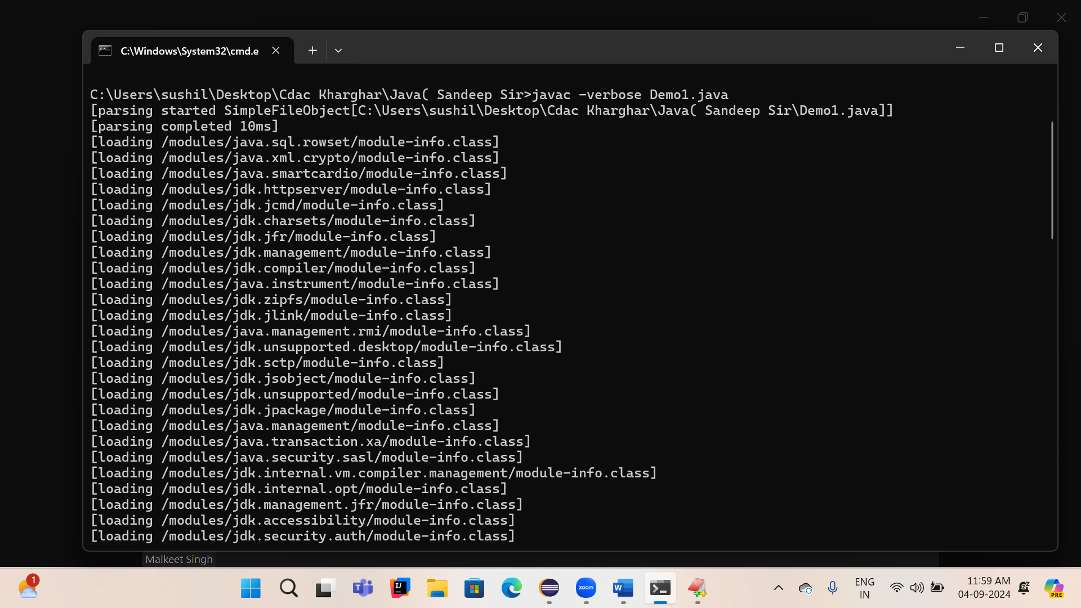

1. **Inspect Bytecode**: Use the javap tool to examine the bytecode of the compiled .class file. Observe the output.

