Assignment –4

Retrieving Information from Tables.

1. Write a select command that produces the order number, amount, and date for all rows in the Orders table.

ANS :🡪 Select the order number, amount, and date for all rows in the Orders table:

SELECT Onum, Amt, Odate

FROM Orders;

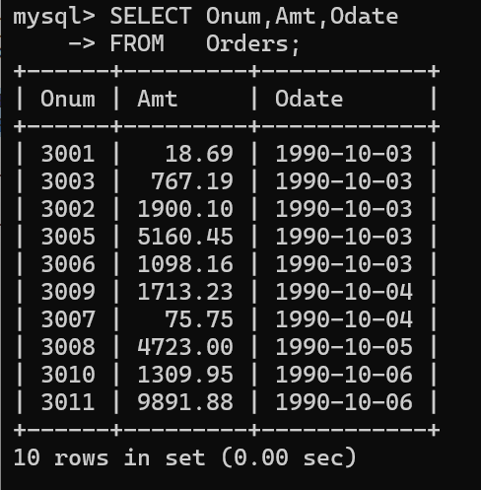

1. Write a query that produces all rows from the Customers table for which the salesperson’s number is 1001.

ANS :🡪 Query to retrieve all rows from the Customers table where the salesperson’s number is 1001:

SELECT \*

FROM Customers

WHERE snum = 1001;

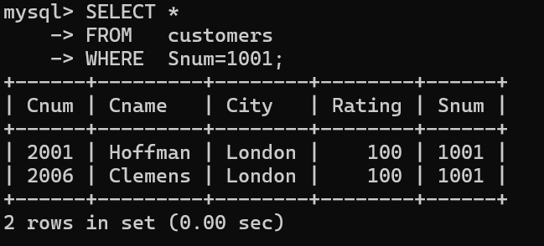

1. Write a query that displays the Salespeople table with the columns in the following order: city, sname, snum, comm.

ANS :🡪 Query to display the Salespeople table with columns in the following order: city, sname, snum, comm:

SELECT city, sname, snum, comm

FROM Salespeople;

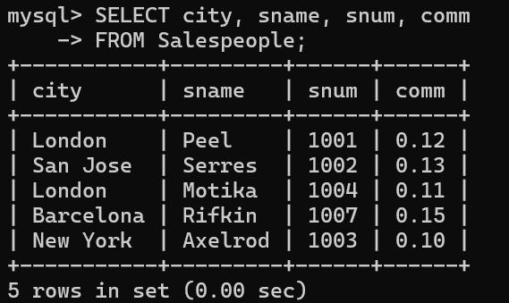

1. Write a select command that produces the rating followed by the name of each customer in San Jose.

ANS :🡪 Select command that produces the rating followed by the name of each customer in San Jose:

SELECT rating, cname

FROM Customers

WHERE city = 'San Jose';

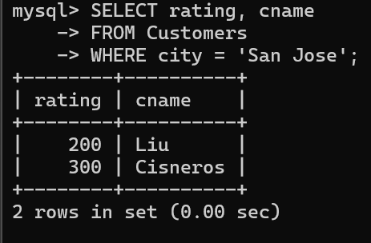

1. Write a query that will produce the snum values of all salespeople (suppress the duplicates) with orders in the Orders table.

Ans :🡪 Query that will produce the snum values of all salespeople (suppressing duplicates) with orders in the Orders table:

SELECT DISTINCT snum

FROM Orders;

