Assignment –5

Relational and Logical Operators.

1. Write a query that will give you all orders for more than Rs. 1,000.

ANS :🡪 Query to get all orders for more than Rs. 1,000:

SELECT \*

FROM Orders

WHERE Amt > 1000;

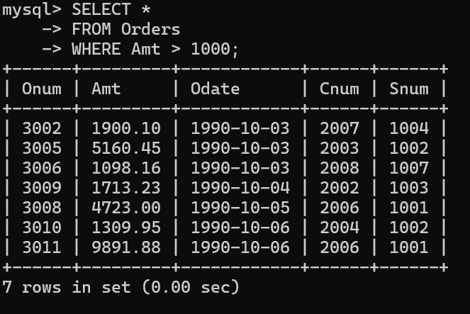

1. Write a query that will give you the names and cities of all salespeople in London with a commission above .10.

ANS :🡪 Query to get the names and cities of all salespeople in London with a commission above 0.10:

SELECT sname, city

FROM Salespeople

WHERE city = 'London' AND comm > 0.10;

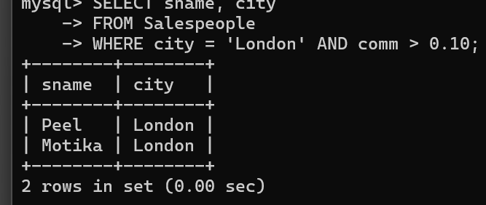

1. Write a query on the Customers table whose output will exclude all customers with a rating <= 100, unless they are located in Rome.

ANS :🡪 customers with a rating ≤ 100 unless they are located in Rome

SELECT \*

FROM Customers

WHERE rating > 100 OR city = 'Rome';

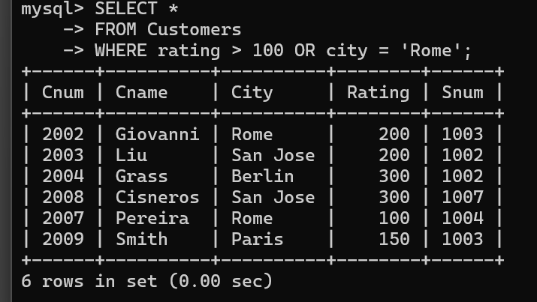

1. What will be the output from the following query? Select \* from Orders where (amt < 1000 OR NOT (odate = ‘1990-10-03’ AND cnum > 2003));

ANS :🡪 Output of the following query:

Select \* from Orders

where (amt < 1000 OR

NOT (odate = '1990-10-03' AND cnum > 2003));

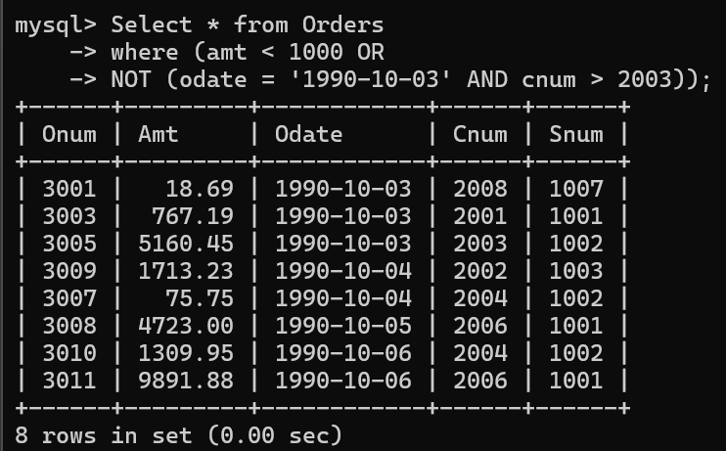

1. What will be the output of the following query? Select \* from Orders where NOT ((odate = ‘1990-10-03’ OR snum >1006) AND amt >= 1500);

ANS :🡪 Select \* from Orders

where NOT ((odate = '1990-10-03' OR snum > 1006) AND amt >= 1500);

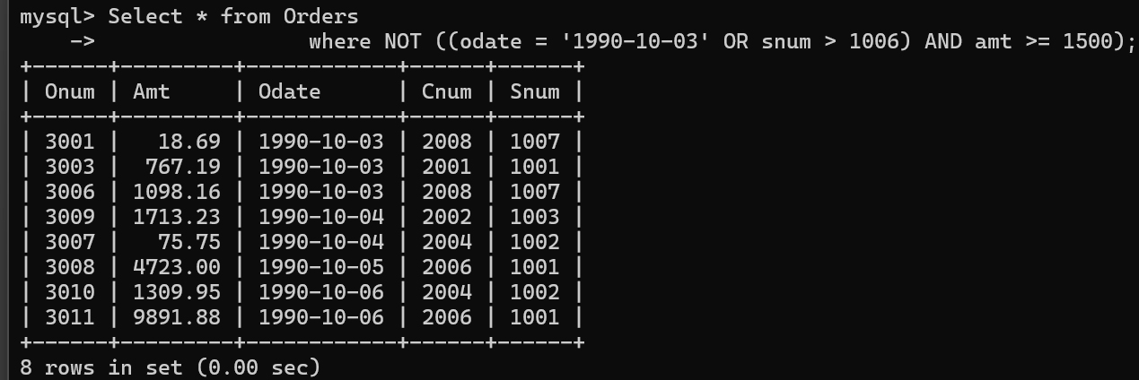

1. What is a simpler way to write this query? Select snum, sname, city, comm From Salespeople where (comm > .12 OR comm

ANS :🡪 Select snum, sname, city, comm

From Salespeople

WHERE comm BETWEEN 0.12 AND 0.14;

