Assignment –6
Using Special Operators in Conditions.
- Write two different queries that would produce all orders taken on October 3rd or 4 th, 1990.
ANS :
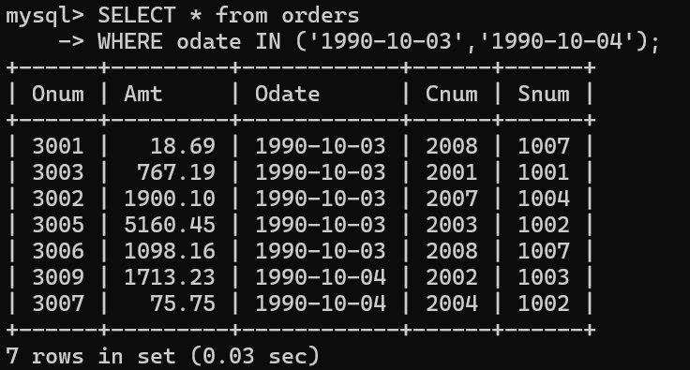
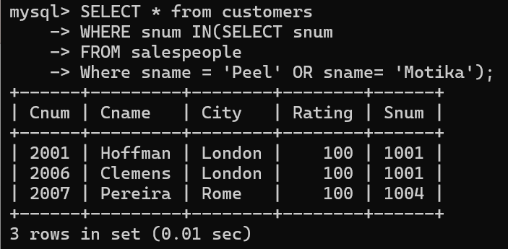

- Write a query that selects all of the customers serviced by Peel or Motika. (Hint: the snum field relates the two tables to one another).
ANS :

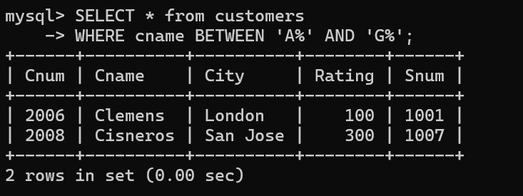

- Write a query that will produce all the customers whose names begin with a letter from ‘A’ to ‘G’.
ANS :

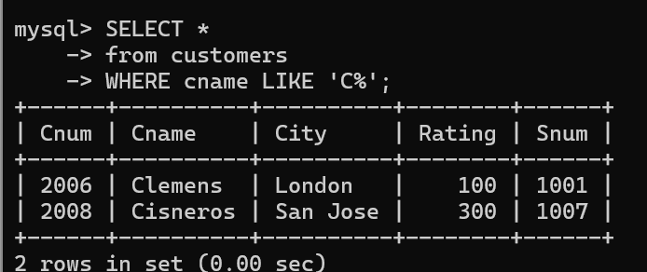

- Write a query that selects all customers whose names begin with the letter ‘C’.

ANS :

- Write a query that selects all orders except those with zeroes or NULLs in the amt field.

ANS :

