Assignment –7
Summarizing Data with Aggregate Functions.
- Write a query that counts all orders for October 3.
ANS :

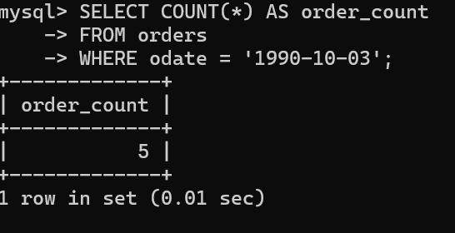

- Write a query that counts the number of different non-NULL city values in the Customers table.
ANS :

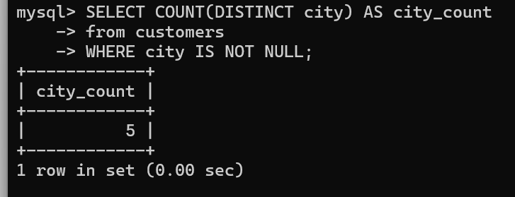

- Write a query that selects each customer’s smallest order.
ANS :

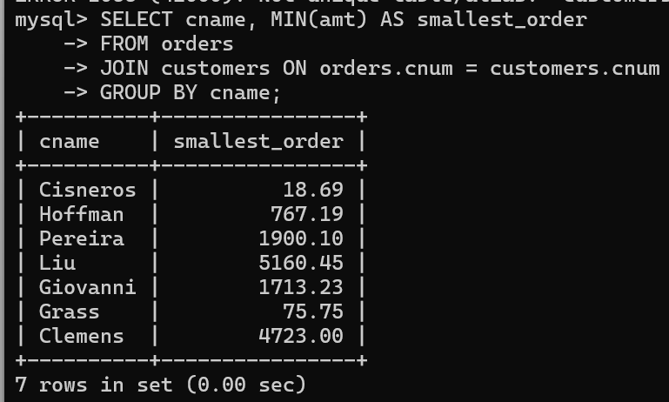

- Write a query that selects the first customer, in alphabetical order, whose name begins with G.
ANS :

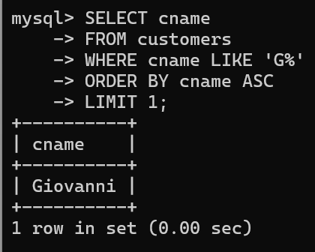

- Write a query that selects the highest rating in each city.
ANS :

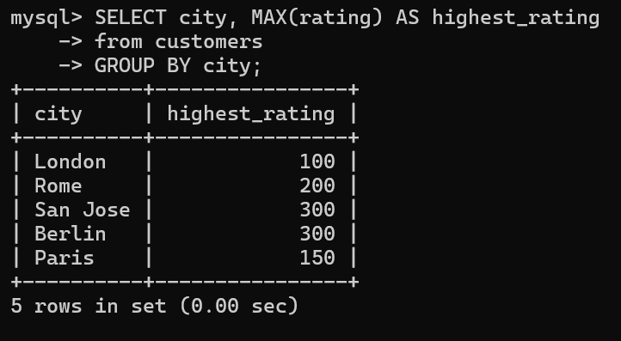

- Write a query that counts the number of salespeople registering orders for each day. (If a salesperson has more than one order on a given day, he or she should be counted only once.).
ANS :

