Table of Contents

0.1 Task 1 - Standardising raw data sets and data modelling. 2

**Source Data Discovery** 2

0.2 Dataset : NSW Property Median Value 5

0.3 Dataset : NSW_Stationentrances_sydney 6

0.4 Dimensional Model 7

Diagram 8

Table Definitions 8

Database creation 8

Create Table Definitions 10

# 0.1 Task 1 - Standardising raw data sets and data modelling.

## **Source Data Discovery**

**Dataset : Aus_SubcityDistrict_State Data**

(a) Observation : Column Names are not Standardized

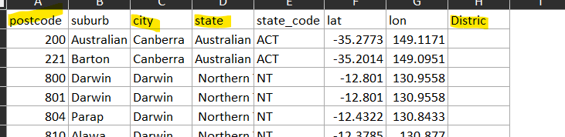

Snippet after Standardization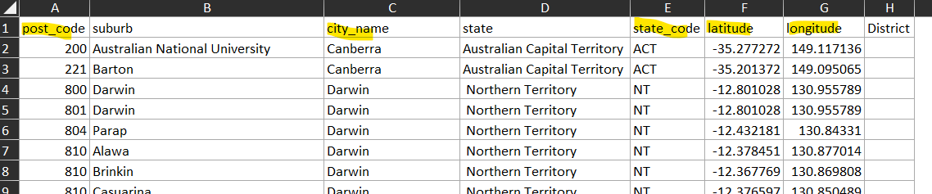

(b) Observation : City Names are having junk values

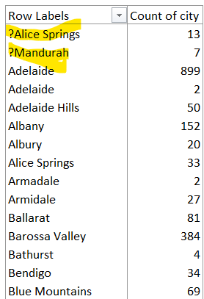

Snippet after standardization

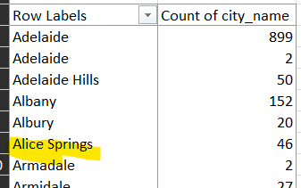

(C) Observation Postcode are having only 3 characters in length

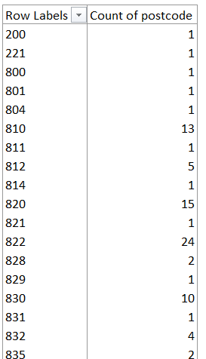

(d) Post Code is standardized to 4 digits using excel formula

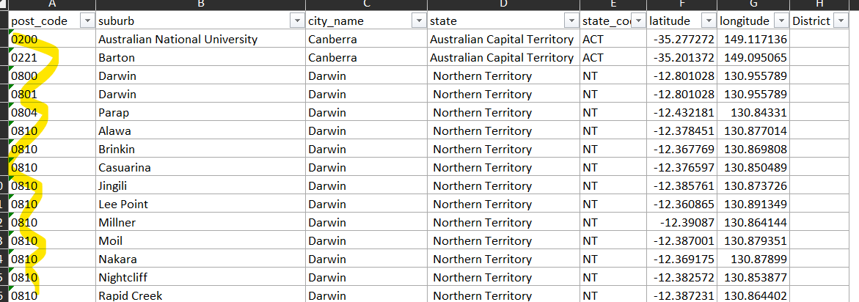

# 0.2 Dataset : NSW Property Median Value

(a) District and location column has Null/Blank (Missing) data.

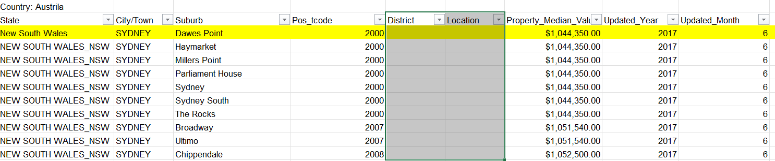

(b) Imputing the missing Data with #N/A.

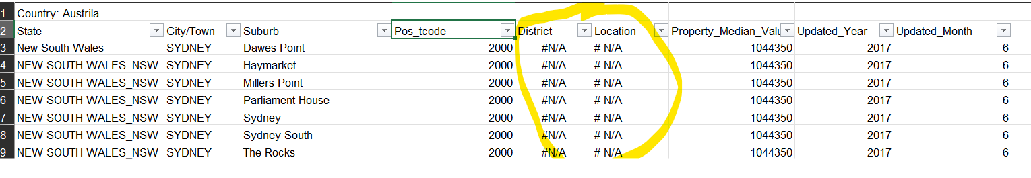

(c) Property Median Values are missing or Nulls

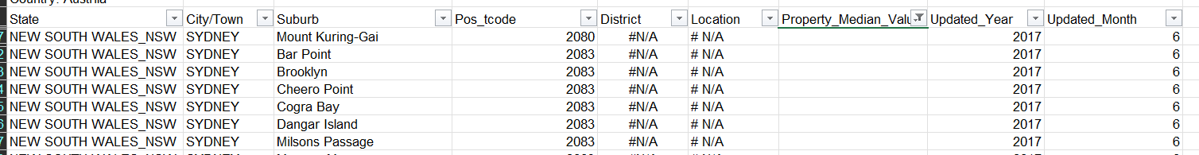

(d) Imputing the missing values to Zero

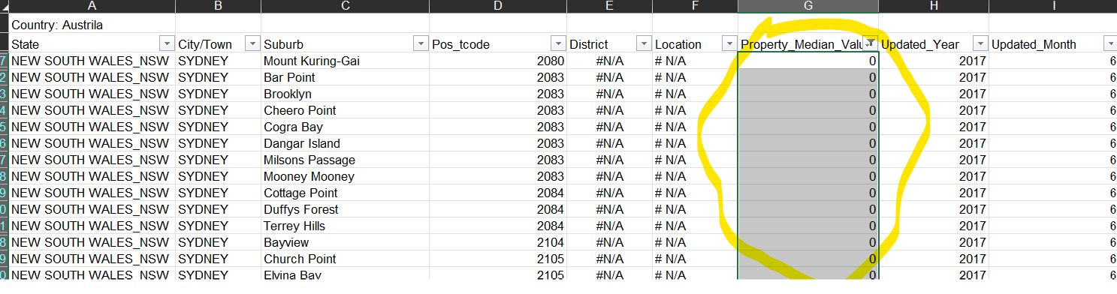

(e) .State Column values not consistent. State Code and State merged into a single column

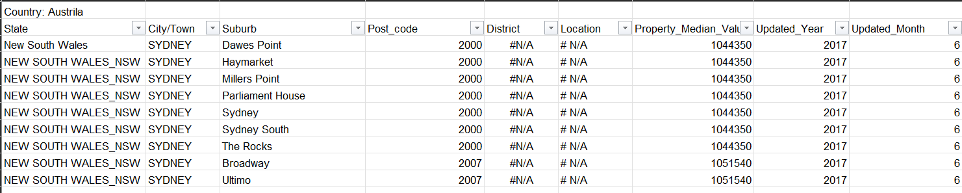

(f) State Code and State Name is split into 2 different columns and data values are standardized

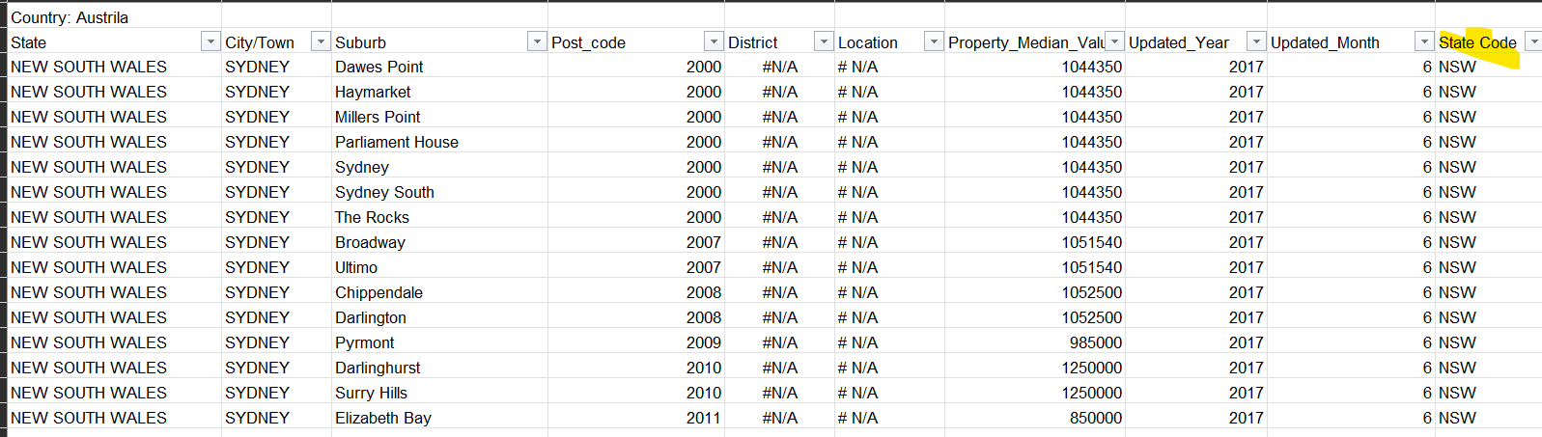

# 0.3 Dataset : NSW_Stationentrances_sydney

**(a) Column Names are not in a standard form for better understanding.**

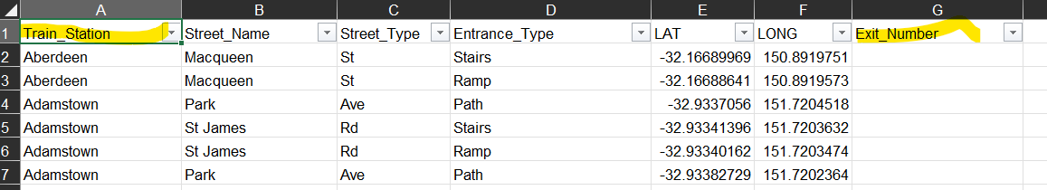

(b) Given more meaningful names for the column.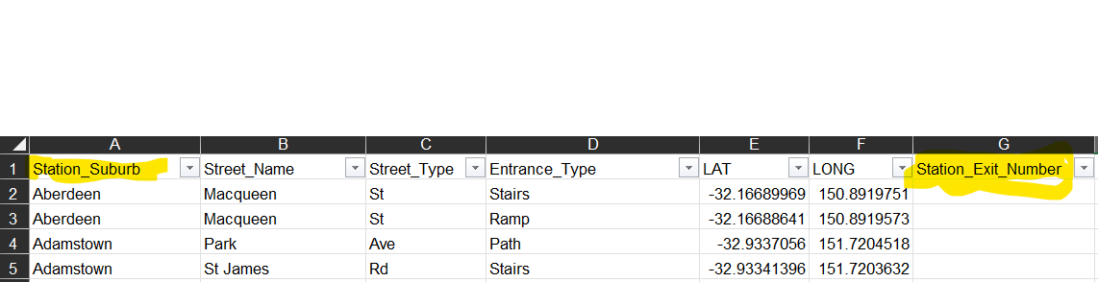

# 0.4 Dimensional Model

## Diagram

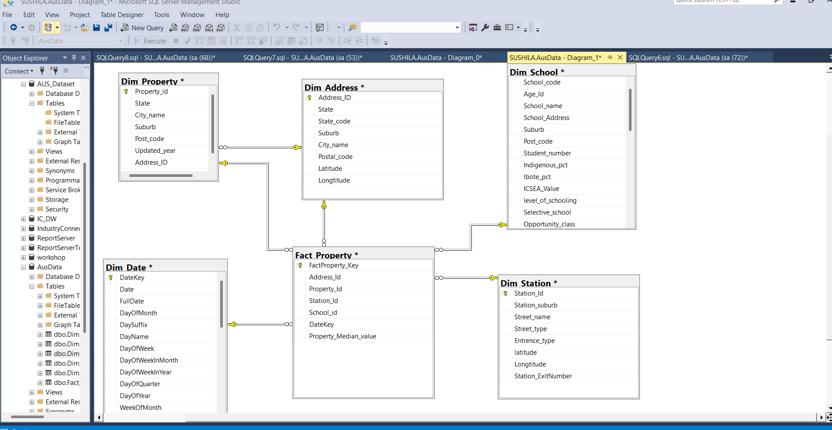

## Table Definitions

## Database creation

USE [master]

GO

/****** Object: Database [AusData] Script Date: 4/10/2022 12:54:41 PM ******/

CREATE DATABASE [AusData]

CONTAINMENT = NONE

ON PRIMARY

( NAME = N'AusData', FILENAME = N'C:\Program Files\Microsoft SQL Server\MSSQL15.MSSQLSERVER\MSSQL\DATA\AusData.mdf' , SIZE = 8192KB , MAXSIZE = UNLIMITED, FILEGROWTH = 65536KB )

LOG ON

( NAME = N'AusData_log', FILENAME = N'C:\Program Files\Microsoft SQL Server\MSSQL15.MSSQLSERVER\MSSQL\DATA\AusData_log.ldf' , SIZE = 8192KB , MAXSIZE = 2048GB , FILEGROWTH = 65536KB )

WITH CATALOG_COLLATION = DATABASE_DEFAULT

GO

IF (1 = FULLTEXTSERVICEPROPERTY('IsFullTextInstalled'))

begin

EXEC [AusData].[dbo].[sp_fulltext_database] @action = 'enable'

end

GO

ALTER DATABASE [AusData] SET ANSI_NULL_DEFAULT OFF

GO

ALTER DATABASE [AusData] SET ANSI_NULLS OFF

GO

ALTER DATABASE [AusData] SET ANSI_PADDING OFF

GO

ALTER DATABASE [AusData] SET ANSI_WARNINGS OFF

GO

ALTER DATABASE [AusData] SET ARITHABORT OFF

GO

ALTER DATABASE [AusData] SET AUTO_CLOSE OFF

GO

ALTER DATABASE [AusData] SET AUTO_SHRINK OFF

GO

ALTER DATABASE [AusData] SET AUTO_UPDATE_STATISTICS ON

GO

ALTER DATABASE [AusData] SET CURSOR_CLOSE_ON_COMMIT OFF

GO

ALTER DATABASE [AusData] SET CURSOR_DEFAULT GLOBAL

GO

ALTER DATABASE [AusData] SET CONCAT_NULL_YIELDS_NULL OFF

GO

ALTER DATABASE [AusData] SET NUMERIC_ROUNDABORT OFF

GO

ALTER DATABASE [AusData] SET QUOTED_IDENTIFIER OFF

GO

ALTER DATABASE [AusData] SET RECURSIVE_TRIGGERS OFF

GO

ALTER DATABASE [AusData] SET DISABLE_BROKER

GO

ALTER DATABASE [AusData] SET AUTO_UPDATE_STATISTICS_ASYNC OFF

GO

ALTER DATABASE [AusData] SET DATE_CORRELATION_OPTIMIZATION OFF

GO

ALTER DATABASE [AusData] SET TRUSTWORTHY OFF

GO

ALTER DATABASE [AusData] SET ALLOW_SNAPSHOT_ISOLATION OFF

GO

ALTER DATABASE [AusData] SET PARAMETERIZATION SIMPLE

GO

ALTER DATABASE [AusData] SET READ_COMMITTED_SNAPSHOT OFF

GO

ALTER DATABASE [AusData] SET HONOR_BROKER_PRIORITY OFF

GO

ALTER DATABASE [AusData] SET RECOVERY FULL

GO

ALTER DATABASE [AusData] SET MULTI_USER

GO

ALTER DATABASE [AusData] SET PAGE_VERIFY CHECKSUM

GO

ALTER DATABASE [AusData] SET DB_CHAINING OFF

GO

ALTER DATABASE [AusData] SET FILESTREAM( NON_TRANSACTED_ACCESS = OFF )

GO

ALTER DATABASE [AusData] SET TARGET_RECOVERY_TIME = 60 SECONDS

GO

ALTER DATABASE [AusData] SET DELAYED_DURABILITY = DISABLED

GO

ALTER DATABASE [AusData] SET ACCELERATED_DATABASE_RECOVERY = OFF

GO

ALTER DATABASE [AusData] SET QUERY_STORE = OFF

GO

ALTER DATABASE [AusData] SET READ_WRITE

GO

## Create Table Definitions

**Dim_Address**

USE [AusData]

GO

/****** Object: Table [dbo].[Dim_Address] Script Date: 4/10/2022 12:56:08 PM ******/

SET ANSI_NULLS ON

GO

SET QUOTED_IDENTIFIER ON

GO

CREATE TABLE [dbo].[Dim_Address](

[Address_ID] [int] NOT NULL,

[State] [nvarchar](10) NULL,

[State_code] [nvarchar](10) NULL,

[Suburb] [nvarchar](50) NULL,

[City_name] [nvarchar](50) NULL,

[Postal_code] [nvarchar](50) NULL,

[Latitude] [nvarchar](50) NULL,

[Longtitude] [nvarchar](50) NULL,

CONSTRAINT [PK_Dim_Address] PRIMARY KEY CLUSTERED

(

[Address_ID] ASC

)WITH (PAD_INDEX = OFF, STATISTICS_NORECOMPUTE = OFF, IGNORE_DUP_KEY = OFF, ALLOW_ROW_LOCKS = ON, ALLOW_PAGE_LOCKS = ON, OPTIMIZE_FOR_SEQUENTIAL_KEY = OFF) ON [PRIMARY]

) ON [PRIMARY]

GO

**Dim_Date**

USE [AusData]

GO

/****** Object: Table [dbo].[Dim_Date] Script Date: 4/10/2022 12:56:45 PM ******/

SET ANSI_NULLS ON

GO

SET QUOTED_IDENTIFIER ON

GO

CREATE TABLE [dbo].[Dim_Date](

[DateKey] [int] NOT NULL,

[Date] [datetime] NULL,

[FullDate] [char](10) NULL,

[DayOfMonth] [varchar](2) NULL,

[DaySuffix] [varchar](4) NULL,

[DayName] [varchar](9) NULL,

[DayOfWeek] [char](1) NULL,

[DayOfWeekInMonth] [varchar](2) NULL,

[DayOfWeekInYear] [varchar](2) NULL,

[DayOfQuarter] [varchar](3) NULL,

[DayOfYear] [varchar](3) NULL,

[WeekOfMonth] [varchar](1) NULL,

[WeekOfQuarter] [varchar](2) NULL,

[WeekOfYear] [varchar](2) NULL,

[Month] [varchar](2) NULL,

[MonthName] [varchar](9) NULL,

[MonthOfQuarter] [varchar](2) NULL,

[Quarter] [char](1) NULL,

[QuarterName] [varchar](9) NULL,

[Year] [char](4) NULL,

[YearName] [char](7) NULL,

[MonthYear] [char](10) NULL,

[MMYYYY] [char](6) NULL,

[FirstDayOfMonth] [date] NULL,

[LastDayOfMonth] [date] NULL,

[FirstDayOfQuarter] [date] NULL,

[LastDayOfQuarter] [date] NULL,

[FirstDayOfYear] [date] NULL,

[LastDayOfYear] [date] NULL,

[IsHoliday] [bit] NULL,

[IsWeekday] [bit] NULL,

[HolidayName] [varchar](50) NULL,

PRIMARY KEY CLUSTERED

(

[DateKey] ASC

)WITH (PAD_INDEX = OFF, STATISTICS_NORECOMPUTE = OFF, IGNORE_DUP_KEY = OFF, ALLOW_ROW_LOCKS = ON, ALLOW_PAGE_LOCKS = ON, OPTIMIZE_FOR_SEQUENTIAL_KEY = OFF) ON [PRIMARY]

) ON [PRIMARY]

GO

**Dim_Property**

USE [AusData]

GO

/****** Object: Table [dbo].[Dim_Property] Script Date: 4/10/2022 12:57:32 PM ******/

SET ANSI_NULLS ON

GO

SET QUOTED_IDENTIFIER ON

GO

CREATE TABLE [dbo].[Dim_Property](

[Property_id] [int] NOT NULL,

[Address_id] [int] NULL,

[State] [nvarchar](50) NULL,

[City_name] [nvarchar](50) NULL,

[Suburb] [nvarchar](50) NULL,

[Post_code] [nvarchar](50) NULL,

[updated_year] [nvarchar](50) NULL,

[updated_month] [nvarchar](50) NULL,

CONSTRAINT [PK_Dim_Property] PRIMARY KEY CLUSTERED

(

[Property_id] ASC

)WITH (PAD_INDEX = OFF, STATISTICS_NORECOMPUTE = OFF, IGNORE_DUP_KEY = OFF, ALLOW_ROW_LOCKS = ON, ALLOW_PAGE_LOCKS = ON, OPTIMIZE_FOR_SEQUENTIAL_KEY = OFF) ON [PRIMARY]

) ON [PRIMARY]

GO

**Dim_School**

USE [AusData]

GO

/****** Object: Table [dbo].[Dim_School] Script Date: 4/10/2022 12:58:19 PM ******/

SET ANSI_NULLS ON

GO

SET QUOTED_IDENTIFIER ON

GO

CREATE TABLE [dbo].[Dim_School](

[School_Id] [int] IDENTITY(1,1) NOT NULL,

[School_code] [nvarchar](50) NULL,

[Age_Id] [nvarchar](50) NULL,

[School_name] [nvarchar](50) NULL,

[School_Address] [nvarchar](50) NULL,

[Suburb] [nvarchar](50) NULL,

[Post_code] [nvarchar](50) NULL,

[Student_number] [nvarchar](50) NULL,

[Indigenous_pct] [nvarchar](50) NULL,

[lbote_pct] [nvarchar](50) NULL,

[ICSEA_Value] [nvarchar](50) NULL,

[level_of_schooling] [nvarchar](50) NULL,

[Selective_school] [nvarchar](50) NULL,

[Opportunity_class] [nvarchar](50) NULL,

[School_specialty_type] [nvarchar](50) NULL,

[School_subtype] [nvarchar](50) NULL,

[Support_classes] [nvarchar](50) NULL,

[Preschool_ind] [nvarchar](50) NULL,

[Distance_education] [nvarchar](50) NULL,

[Intensive_english_centre] [nvarchar](50) NULL,

[School_gender] [nvarchar](10) NULL,

[phone] [nvarchar](10) NULL,

[school_email] [nvarchar](50) NULL,

[fax] [nchar](10) NULL,

[late_opening_school] [nvarchar](50) NULL,

[date_1st_teacher] [nvarchar](50) NULL,

[lga] [nchar](10) NULL,

[electorate] [nvarchar](50) NULL,

[fed_electorate] [nvarchar](50) NULL,

[operational_directorate] [nvarchar](50) NULL,

[principal_network] [nvarchar](50) NULL,

[facs_district] [nvarchar](50) NULL,

[local_health_district] [nvarchar](50) NULL,

[aecg_region] [nvarchar](50) NULL,

[ASGS_remoteness] [nvarchar](50) NULL,

[latitude] [nvarchar](50) NULL,

[longitude] [nvarchar](50) NULL,

[date_extracted] [nvarchar](50) NULL,

CONSTRAINT [PK_Dim_School] PRIMARY KEY CLUSTERED

(

[School_Id] ASC

)WITH (PAD_INDEX = OFF, STATISTICS_NORECOMPUTE = OFF, IGNORE_DUP_KEY = OFF, ALLOW_ROW_LOCKS = ON, ALLOW_PAGE_LOCKS = ON, OPTIMIZE_FOR_SEQUENTIAL_KEY = OFF) ON [PRIMARY]

) ON [PRIMARY]

GO

**Dim_Station**

USE [AusData]

GO

/****** Object: Table [dbo].[Dim_Station] Script Date: 4/10/2022 12:59:07 PM ******/

SET ANSI_NULLS ON

GO

SET QUOTED_IDENTIFIER ON

GO

CREATE TABLE [dbo].[Dim_Station](

[Station_Id] [int] NOT NULL,

[Station_suburb] [nvarchar](50) NULL,

[Street_name] [nvarchar](50) NULL,

[Street_type] [nvarchar](50) NULL,

[Entrence_type] [nvarchar](50) NULL,

[latitude] [nvarchar](50) NULL,

[Longtitude] [nvarchar](50) NULL,

[Station_ExitNumber] [nchar](10) NULL,

CONSTRAINT [PK_Dim_Station] PRIMARY KEY CLUSTERED

(

[Station_Id] ASC

)WITH (PAD_INDEX = OFF, STATISTICS_NORECOMPUTE = OFF, IGNORE_DUP_KEY = OFF, ALLOW_ROW_LOCKS = ON, ALLOW_PAGE_LOCKS = ON, OPTIMIZE_FOR_SEQUENTIAL_KEY = OFF) ON [PRIMARY]

) ON [PRIMARY]

GO

**Fact_Property**

USE [AusData]

GO

/****** Object: Table [dbo].[Fact_Property] Script Date: 4/10/2022 12:59:57 PM ******/

SET ANSI_NULLS ON

GO

SET QUOTED_IDENTIFIER ON

GO

CREATE TABLE [dbo].[Fact_Property](

[FactProperty_Key] [int] NOT NULL,

[Address_Id] [int] NOT NULL,

[Property_Id] [int] NOT NULL,

[Station_Id] [int] NOT NULL,

[School_id] [int] NOT NULL,

[DateKey] [int] NOT NULL,

[MedianvalueID] [int] NOT NULL,

[Property_Median_value] [int] NULL,

CONSTRAINT [PK_Fact_Property] PRIMARY KEY CLUSTERED

(

[FactProperty_Key] ASC

)WITH (PAD_INDEX = OFF, STATISTICS_NORECOMPUTE = OFF, IGNORE_DUP_KEY = OFF, ALLOW_ROW_LOCKS = ON, ALLOW_PAGE_LOCKS = ON, OPTIMIZE_FOR_SEQUENTIAL_KEY = OFF) ON [PRIMARY]

) ON [PRIMARY]

GO