**Add User**

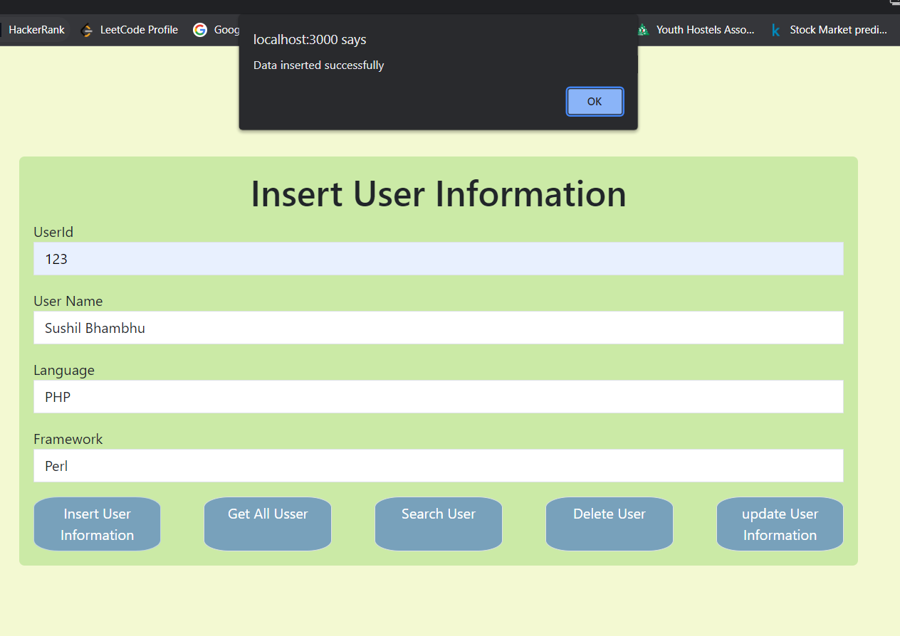

**Show all users**

**Search User by username/Id**

**Delete User**

**Update User**

