COMPUTER GRAPHICS

**CLASS B.C.A.6THSEMESTER**

**PUPIN: 18048685**

**ROLL NO. 8044**

**NAME:SUSHIL**

## TABLE OF CONTENTS

**PROG1: MENU DRIVEN**………………………………………………………………………………………………………………………….1

OUTPUT……………………………………………………………………………………………………………………………………………#

**PROG2: CREATING A HUT**………………………..…………………………………………………………………………………………….#

OUTPUT……………………………………………………………………………………………………………………………………………#

**PROG3:COLOR PALTTE**………………………………………………………………………………………………………………………….#

OUTPUT………………………………………………..…………………………………………………………………………………………#

**PROG4: FOUR EMOJIS**………………………………………………………………………………………………………………………….#

OUTPUT……………………………………………….…………………………………………………………………………………………#

**PROG5: NAVIGATE A OBJECT USING 4 KEYS**………………………………………………………………………………………….#

OUTPUT………………………………………………..…………………………………………………………………………………………#

**PROG6: A 3D BAR GRAPH**…………………………………………………………………………………………………………………….#

OUTPUT…………………….……………………………………………………………………………………………………………………#

**PROG7: A PIR CHART.**………………………………………………………………………………………………………………………….#

OUTPUT…………………………………………………………………………………………………………………………………………#

**PROG8: MOVING CAR WITHOUT MOVING BACKGROUND**……..………………………………………………………….#

OUTPUT…………………………………………………………………..……………………………………………………………………#

**PROG9: MAN WALKING IN RAIN WITH UMBRELLA**…...……………………………………………………………………….#

OUTPUT………………………………………………………….….…………………………………………………………………………#

**PROG10: SUNRISE AND SUNSET**………….…………………………………………………………………………………………….#

OUTPUT………………………………..……….……………………………………………………………………………………………#

**PROG11: MAN SAIING A BOAT**…………………….………………………………………………………………………………….#

OUTPUT………………………………………………….…………………………………………………………………………………#

|  |
| --- |
| PHOTOSHOP ASSIGNMENT |

**1:USE OF LASSO TOOL**………………………………………………………………………………………………………………………….1

OUTPUT…………………………………………………………………………………………………………………………………………#

**2: USE OF MAGIC WAND**………………………………………………………………………………………………………………………….1

OUTPUT…………………………………………………………………………………………………………………………………………#

**3:USE OF CLONE STAMP**………………………………………………………………………………………………………………………….1

OUTPUT…………………………………………………………………………………………………………………………………………#

**4: NIGHT PARTY INVITATION**………………………………………………………………………………………………………………………….1

OUTPUT…………………………………………………………………………………………………………………………………………#

//MenuDriven

#include<stdio.h>

#include<conio.h>

#include<graphics.h>

int main()

{

intgd=DETECT,gm,op,x,y,r,lux,luy,rex,rey,xs,ys,xe,ye,dd;

initgraph(&gd,&gm,"");

do

{

printf("\n1.Circle");

printf("\n2.Line");

printf("\n3.Rectangle");

printf("\n4.Square");

printf("\n5.Exit");

printf("\nEnter your choice");

scanf("%d",&op);

switch(op)

{

case 1:

printf("\nEnter the center and radius of thye circle (x,y)and(r)):");

scanf("%d%d%d",&x,&y,&r);

circle(x,y,r);

break;

case 2:

printf("\nEnter the start and end coordinates for line ((xs,ys)and(xe,ye)):");

scanf("%d%d%d%d",&xs,&ys,&xe,&ye);

line(xs,ys,xe,ye);

break;

case 3:

printf("\nEnter the left upper and right bottom coordinates for rectangle((lux,luy)and(rex,rey)):");

scanf("%d%d%d%d",&lux,&luy,&rex,&rey);

rectangle(lux,luy,rex,rey);

break;

case 4:

printf("\nEnter the start coordintes and length of edge of square(lux,luy,dd):");

scanf("%d%d%d",&lux,&luy,&dd);

rectangle(lux,luy,lux+dd,luy+dd);

break;

case 5:

exit(0);

default:

printf("\n Invalid choice");

break;

}}

while(op!=5);

getch();

closegraph();

}

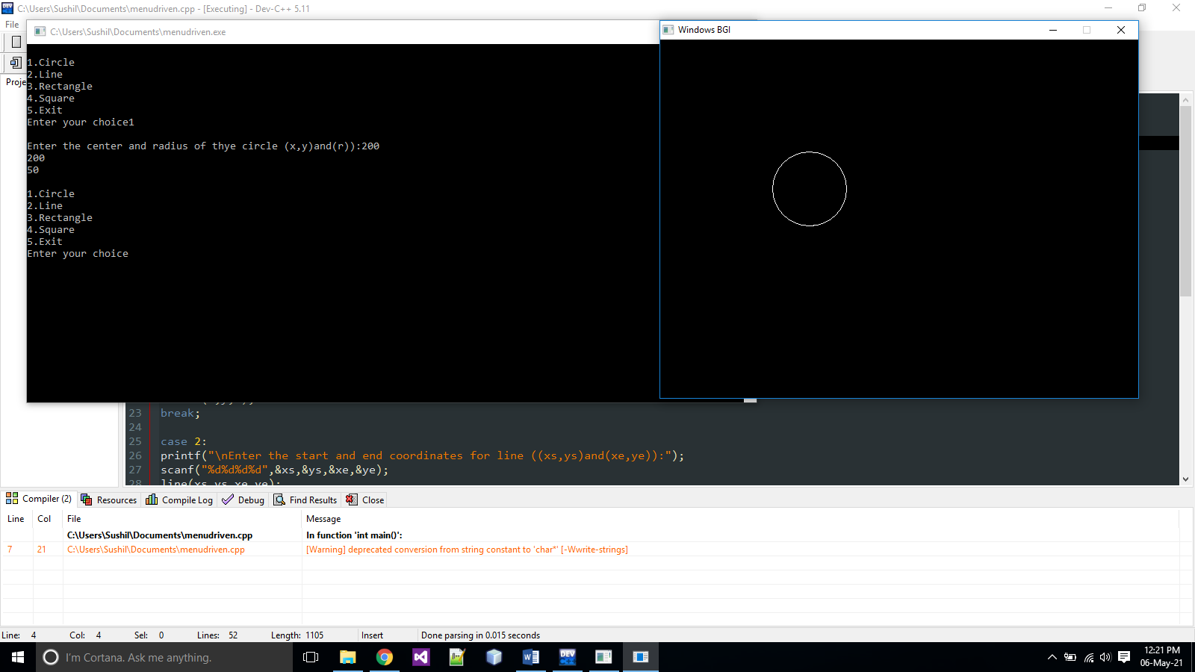

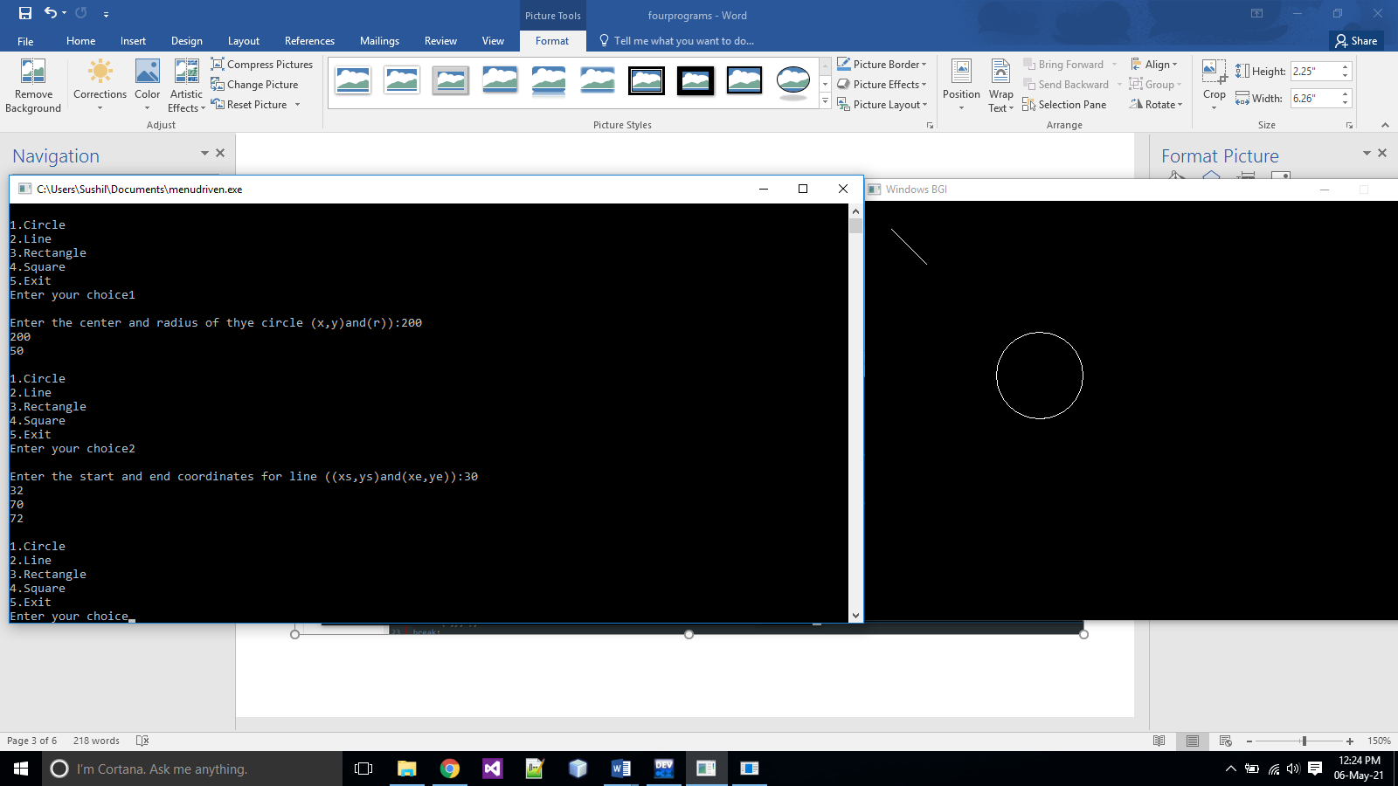

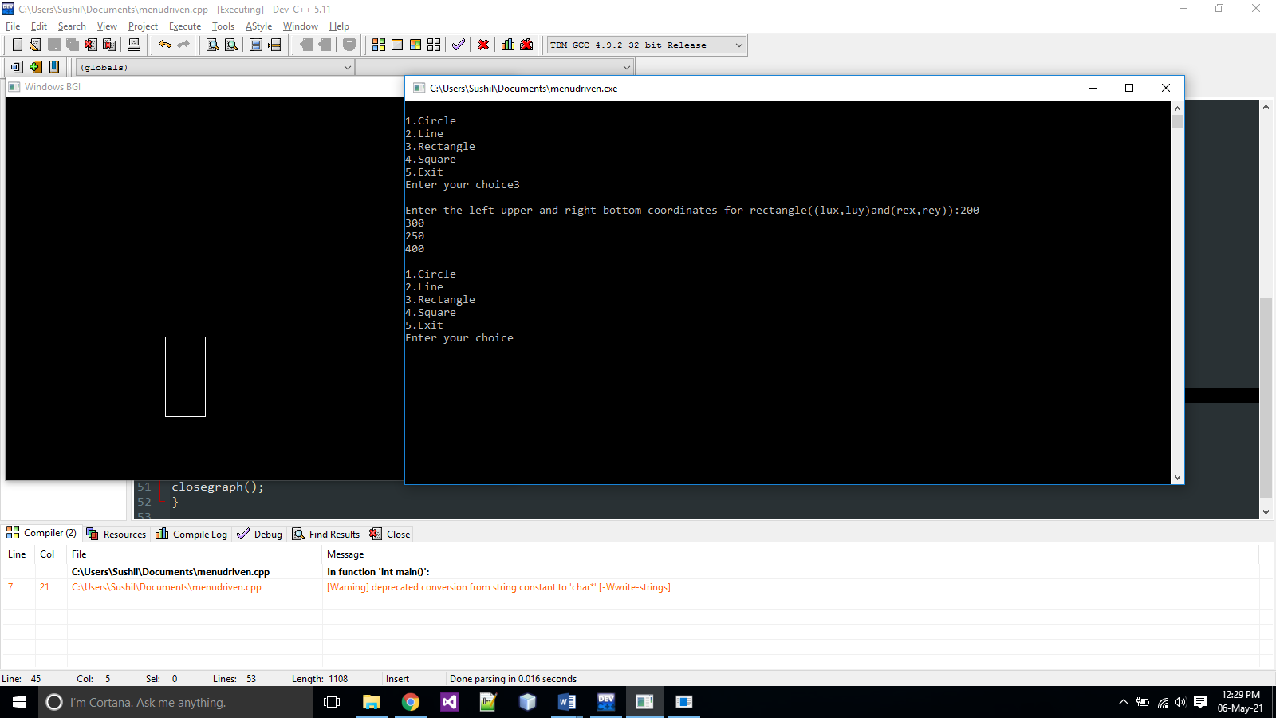

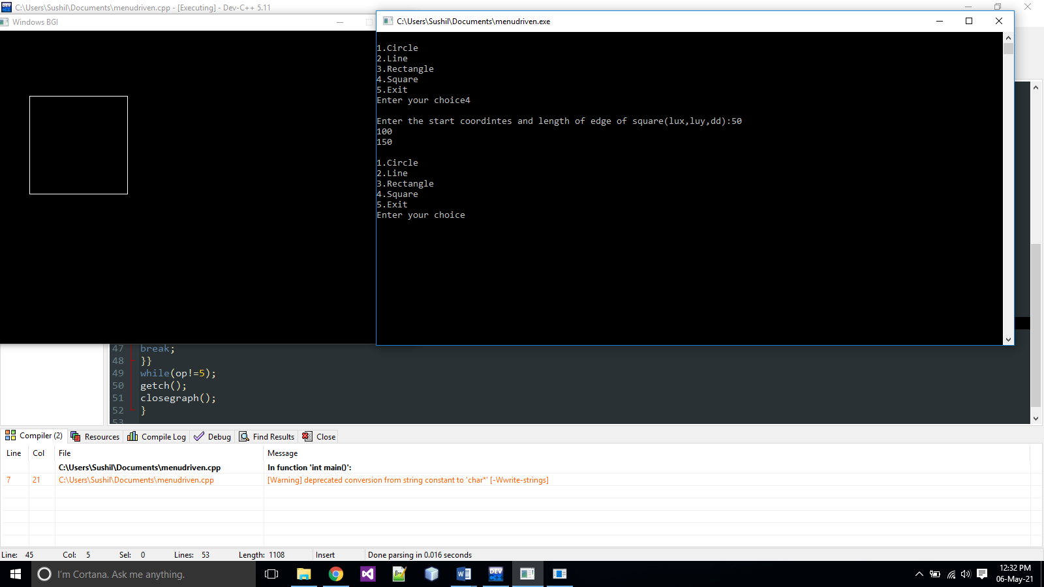

// CREATING A HUT

#include<graphics.h>

#include<conio.h>

int main(){

intgd = DETECT,gm;

initgraph(&gd, &gm, " ");

setcolor(WHITE);

outtextxy(0,0,"hut");

rectangle(150,180,250,300);

rectangle(250,180,420,300);

rectangle(180,250,220,300);

rectangle(280,270,350,200);

line(200,100,150,180);

line(200,100,250,180);

line(200,100,370,100);

line(370,100,420,180);

setfillstyle(SOLID_FILL, BROWN);

floodfill(152, 182, WHITE);

floodfill(252, 182, WHITE);

setfillstyle(SLASH_FILL, BLUE);

floodfill(182, 252, WHITE);

setfillstyle(SOLID_FILL, 3);

floodfill(200, 105, WHITE);

floodfill(210, 105, WHITE);

getch();

closegraph();

return 0;

}

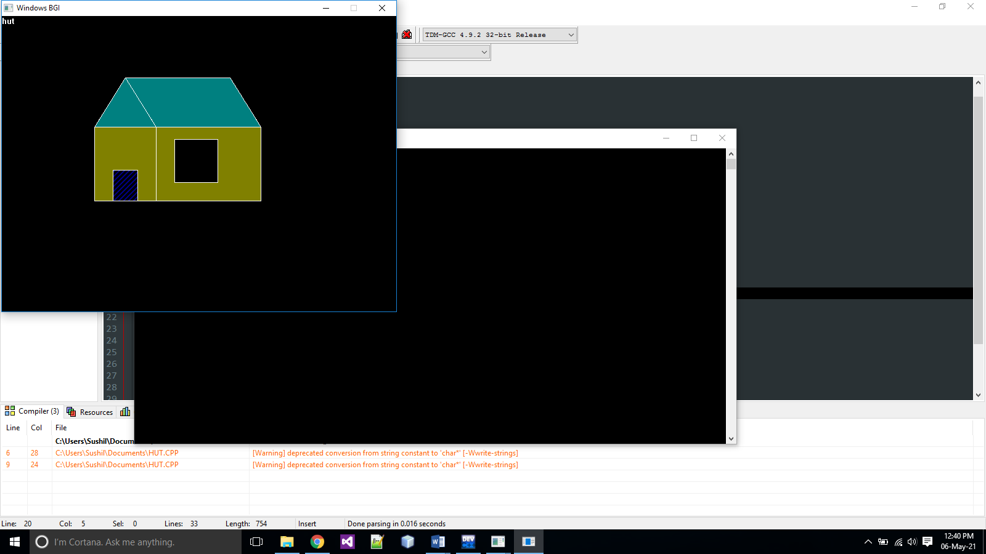

//color platte

#include<conio.h>

#include<graphics.h>

#include<stdio.h>

#include<dos.h>

int main()

{

intgd=DETECT,gm ,i=0;

initgraph(&gd,&gm,"");

while(!kbhit())

{

setfillstyle(SOLID_FILL,i);

circle(310,240,100);

floodfill(250,300,WHITE);

delay(1000);

i++;

}

getch();

closegraph();}

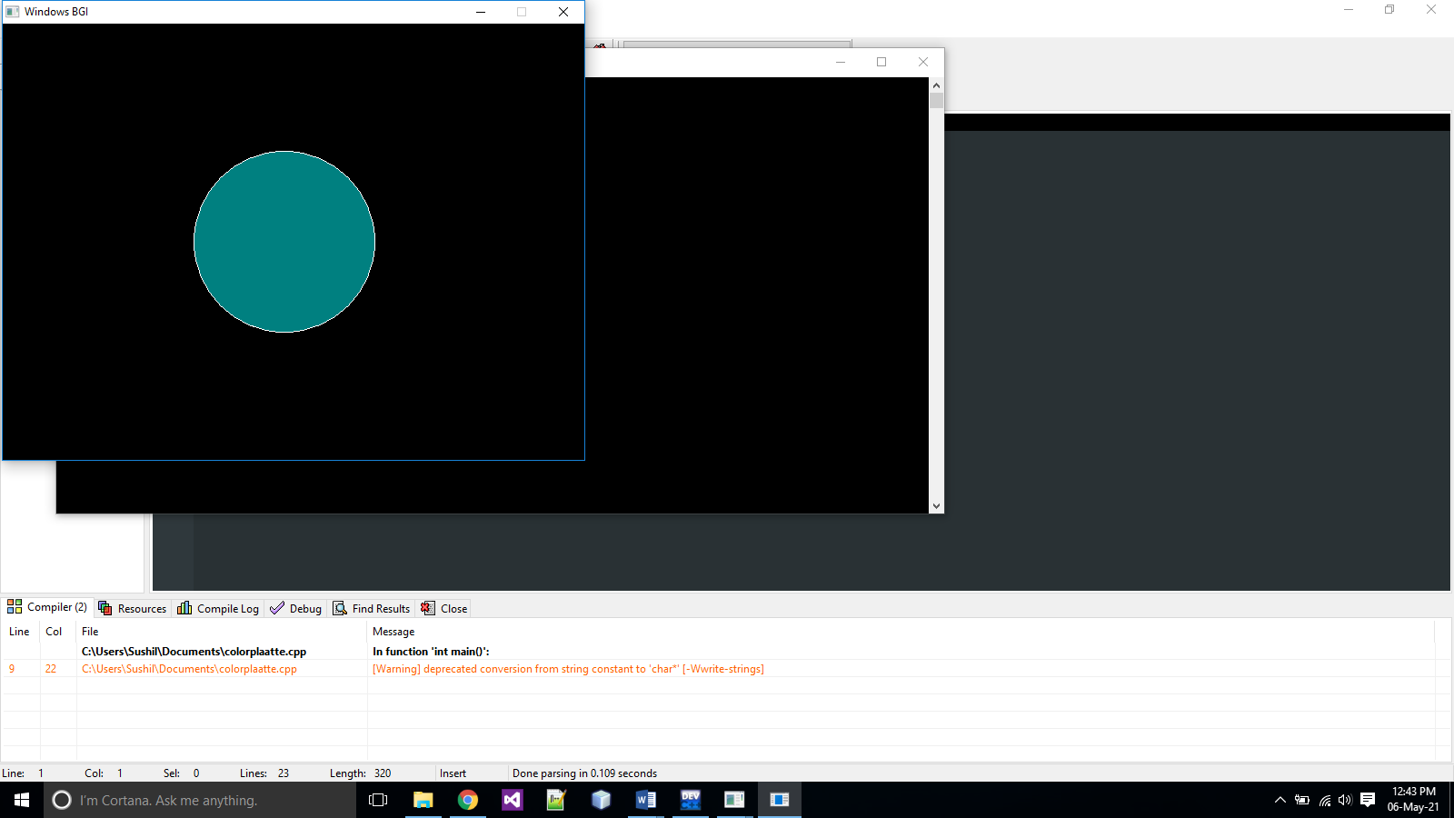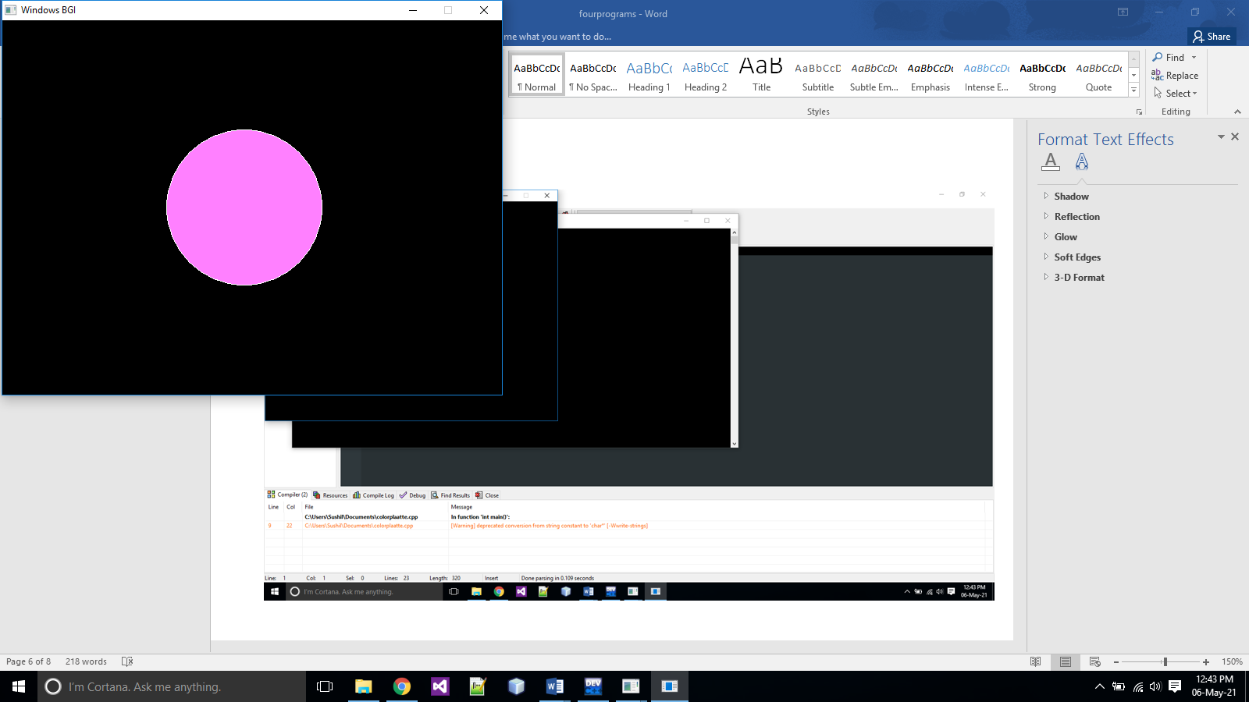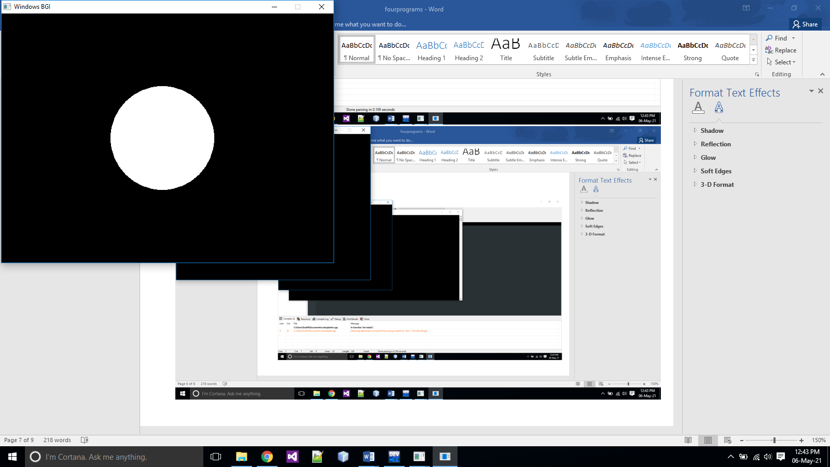

// C program to create a smiley face

#include <conio.h>

#include <graphics.h>

#include <stdio.h>

int main()

{

int gr = DETECT, gm;

initgraph(&gr, &gm, "");

setcolor(WHITE);

//face 1

circle(100,100,50);

circle(75,90,10);circle(125,90,10);circle(100,120,15);

//face 2

circle(300,100,50);

circle(275,90,10);circle(325,90,10);arc(300,110,200,340,25);

//face 3

circle(100,300,50);

circle(75,310,10);circle(125,310,10);arc(100,290,30,160,25);

//face 4

circle(300,300,50);

circle(275,290,10);circle(325,290,10);

rectangle(280,310,320,330);

setfillstyle(HATCH_FILL, GREEN);

floodfill(281,312,15);

getch();

closegraph();

return 0;

}

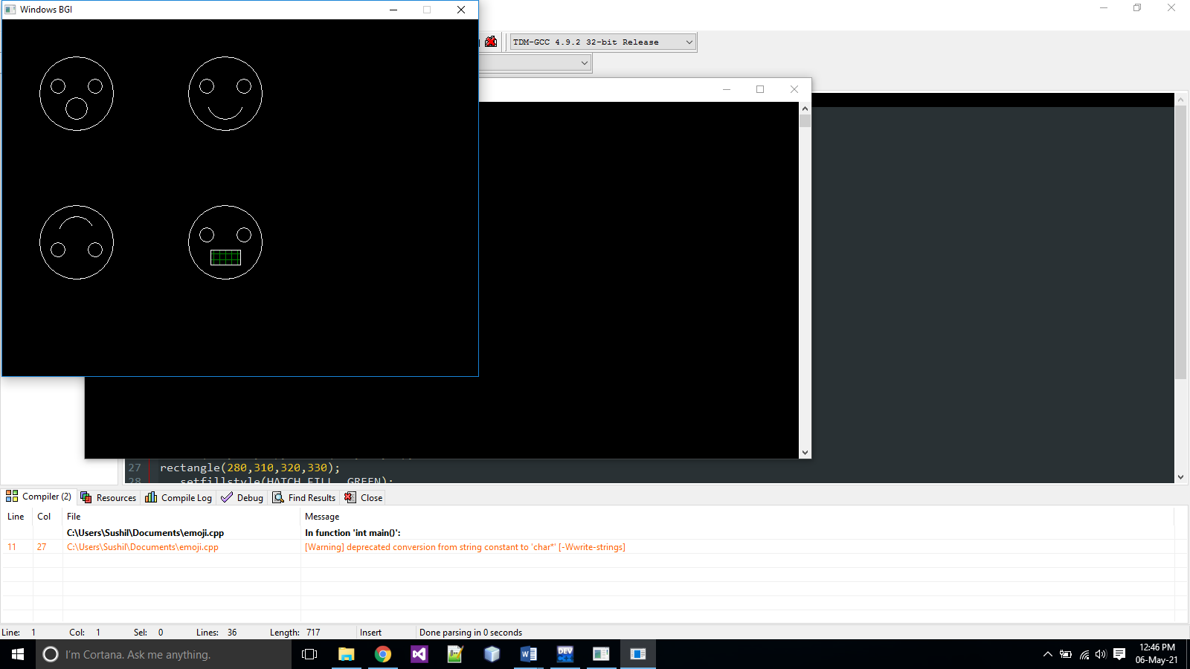

//WAP TO NAVIGATE(TOP,BOTTOM,LEFT,RIGHT)

#include<graphics.h>

#include<process.h>

#include<dos.h>

#include<conio.h>

int main()

{

Int i=200,j=200,x=0,y=-1,ch;

int gd = DETECT, gm;

initgraph(&gd, &gm, "");

while(1)

//infiniteloop

{

circle(i,j,30);

if(kbhit())

//checkif a key is pressed

{

ch=getch();

if(ch=='w')

//move upward

{

x=0;

y=-1;

}

if(ch=='a')

//move left

{

x=-1;

y=0;

}

if(ch=='d')

//move right

{

x=1;

y=0;

}

if(ch=='s') //move downward

{

x=0;

y=1;

}

if(ch=='m') //exit when esc pressed

exit(0);

}

i=i+x;

j=j+y;

delay(50);

cleardevice();

}}

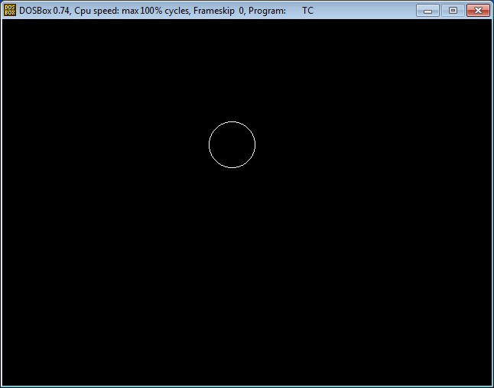

Circle in the screen shown moves with following keys A,S,D, and W for Right, Down, Left and Up respectively.

//CREATE A 3D BAR GRAPH

#include<stdio.h>

#include<conio.h>

#include<graphics.h>

void main()

{

int gd=DETECT,gm;

initgraph(&gd,&gm,"");

//x axis

line(50,350,480,350);

outtextxy(500,350,"MONTHS");

//y axis

line(50,150,50,350);

outtextxy(20,120,"ATTENDENCE");

//bar

bar3d(60,270,80,350,15,1);

outtextxy(75,250,"42");

outtextxy(55,360,"JULY");

bar3d(110,250,130,350,15,1);

outtextxy(125,230,"46");

outtextxy(110,360,"AUG");

bar3d(160,300,180,350,15,1);

outtextxy(175,280,"30");

outtextxy(160,360,"SEPT");

bar3d(210,220,230,350,15,1);

outtextxy(225,200,"50");

outtextxy(213,360,"OCT");

bar3d(260,205,280,350,15,1);

//bar

bar3d(60,270,80,350,15,1);

outtextxy(75,250,"42");

outtextxy(262,360,"NOV");

bar3d(110,250,130,350,15,1);

outtextxy(125,230,"46");

outtextxy(313,360,"DEC");

bar3d(160,300,180,350,15,1);

outtextxy(175,280,"30");

outtextxy(360,360,"JAN");

bar3d(210,220,230,350,15,1);

outtextxy(225,200,"50");

bar3d(260,285,280,350,15,1);

outtextxy(275,185,"38");

bar3d(310,315,330,350,15,1);

outtextxy(325,295,"20");

bar3d(360,299,380,350,15,1);

outtextxy(375,279,"36");

bar3d(410,305,430,350,15,1);

outtextxy(425,285,"32");

outtextxy(425,360,"SEP");

getch();

closegraph();

}

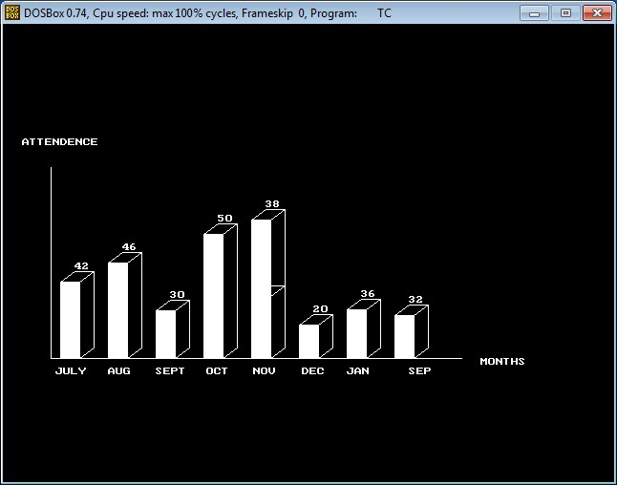

//CREATE A PIE CHART

#include<stdio.h>

#include<conio.h>

#include<graphics.h>

int main()

{

int gd=DETECT,gm;

int x,y;

initgraph(&gd,&gm," ");

settextstyle(BOLD_FONT,HORIZ_DIR,2);

outtextxy(250,50,"PIE CHART");

x=getmaxx()/2;

y=getmaxy()/2;

settextstyle(SANS_SERIF_FONT,HORIZ_DIR,1);

setfillstyle(SOLID_FILL,RED);

pieslice(x,y,0,60,120);

outtextxy(x+140,y-70,"BREAST ANIMALS(150)");

setfillstyle(SOLID_FILL,YELLOW);

pieslice(x,y,60,160,120);

outtextxy(x-120,y-140,"OTHER LAND ANIMALS(400)");

setfillstyle(SOLID_FILL,GREEN);

pieslice(x,y,160,220,120);

outtextxy(x-220,y,"BIRDS(225)");

setfillstyle(SOLID_FILL,BROWN);

pieslice(x,y,220,300,120);

outtextxy(x-90,y+150,"WATER ANIMALS(175)");

setfillstyle(SOLID_FILL,CYAN);

pieslice(x,y,300,360,120);

outtextxy(x+150,y+50,"REPTILE(50)");

getch();

closegraph();

}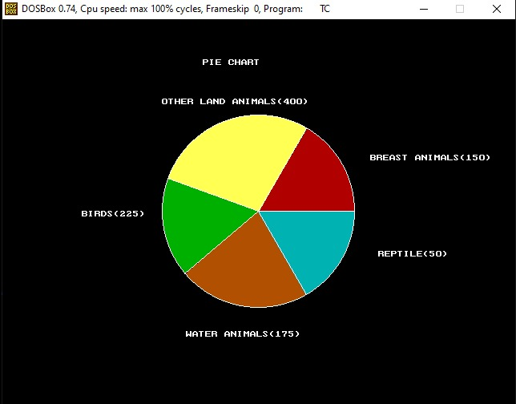

//CREATE A CAR MOVING WITHOUT MOVING ITS BACKGROUND

#include <stdio.h>

#include <graphics.h>

#include <conio.h>

#include <dos.h>

int main() {

int gd = DETECT, gm;

int i, maxx, midy;

initgraph(&gd, &gm, "c:\\turboc3\\bgi");

maxx = getmaxx();

midy = getmaxy()/2;

for (i=0; i < maxx-150; i=i+5) {

cleardevice();

bar(150,100,200,250);

bar(200,200,250,250);

bar(250,250,300,250);

bar(300,50,350,250);

bar(350,90,400,250);

bar(400,70,450,250);

bar(50,50,100,250);

setcolor(GREEN);

line(0, midy + 37, maxx, midy + 37);

setcolor(YELLOW);

setfillstyle(SOLID_FILL, BLUE);

line(i, midy + 23, i, midy);

line(i, midy, 40 + i, midy - 20);

line(40 + i, midy - 20, 80 + i, midy - 20);

line(80 + i, midy - 20, 100 + i, midy);

line(100 + i, midy, 120 + i, midy);

line(120 + i, midy, 120 + i, midy + 23);

line(0 + i, midy + 23, 18 + i, midy + 23);

arc(30 + i, midy + 23, 0, 180, 12);

line(42 + i, midy + 23, 78 + i, midy + 23);

arc(90 + i, midy + 23, 0, 180, 12);

line(102 + i, midy + 23, 120 + i, midy + 23);

line(28 + i, midy, 43 + i, midy - 15);

line(43 + i, midy - 15, 57 + i, midy - 15);

line(57 + i, midy - 15, 57 + i, midy);

line(57 + i, midy, 28 + i, midy);

line(62 + i, midy - 15, 77 + i, midy - 15);

line(77 + i, midy - 15, 92 + i, midy);

line(92 + i, midy, 62 + i, midy);

line(62 + i, midy, 62 + i, midy - 15);

floodfill(5 + i, midy + 22, YELLOW);

setcolor(BLUE);

setfillstyle(SOLID_FILL, GREEN);

circle(30 + i, midy + 25, 9);

circle(90 + i, midy + 25, 9);

floodfill(30 + i, midy + 25, BLUE);

floodfill(90 + i, midy + 25, BLUE);

bar(100,50,100,250);

delay(100);

}

getch();

closegraph();

return 0;

}

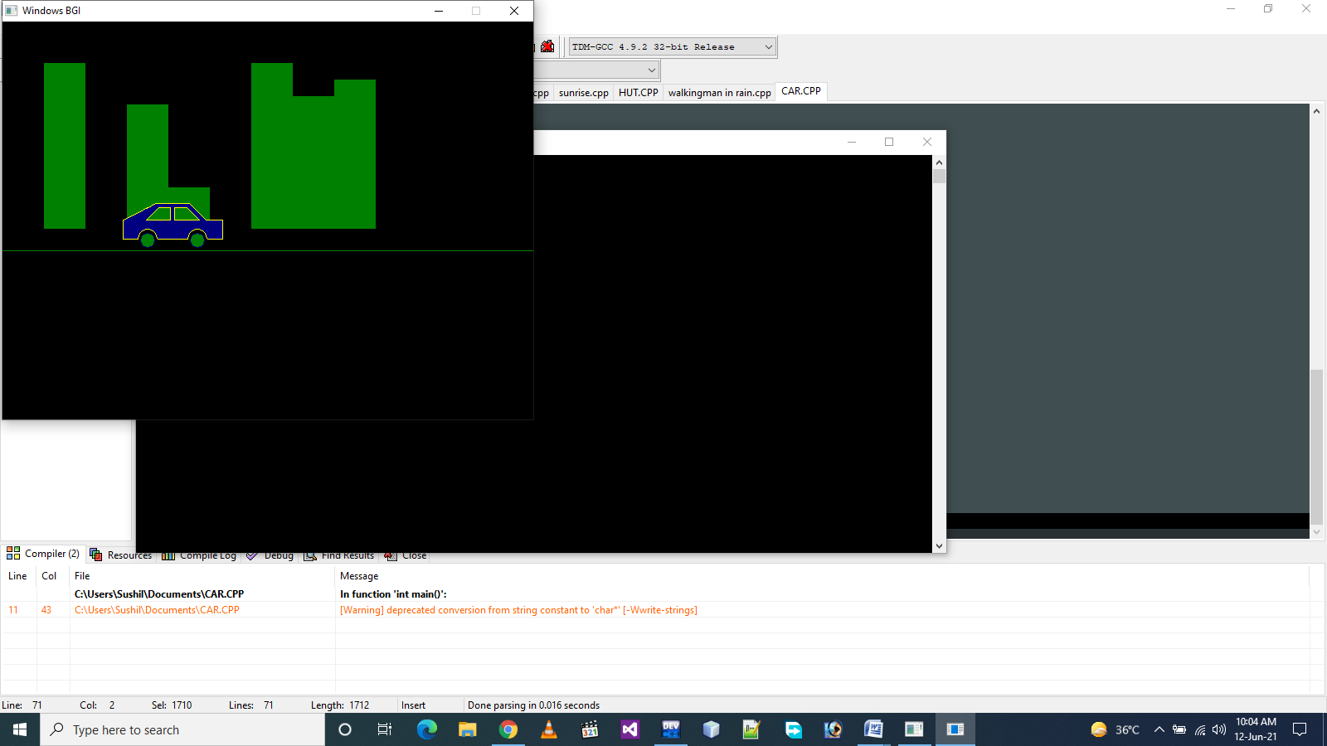

//WAP FOR WALKING MAN WITH UMBRELLA IN RAIN

#include<stdio.h>

#include<graphics.h>

#define ScreenWidth getmaxx()

#define ScreenHeight getmaxy()

#define GroundY ScreenHeight*0.75

int ldisp=0;

void DrawManAndUmbrella(int x,int ldisp)

{

//head

circle(x,GroundY-90,10);

line(x,GroundY-80,x,GroundY-30);

//hand

line(x,GroundY-70,x+10,GroundY-60);

line(x,GroundY-65,x+10,GroundY-55);

line(x+10,GroundY-60,x+20,GroundY-70);

line(x+10,GroundY-55,x+20,GroundY-70);

//legs

line(x,GroundY-30,x+ldisp,GroundY);

line(x,GroundY-30,x-ldisp,GroundY);

//umbrella

pieslice(x+20,GroundY-120,0,180,40);

line(x+20,GroundY-120,x+20,GroundY-70);

}

void Rain(int x)

{

int i,rx,ry;

for(i=0;i<400;i++)

{

rx=rand() % ScreenWidth;

ry=rand() % ScreenHeight;

if(ry<GroundY-4)

{

if(ry<GroundY-120 || (ry>GroundY-120 && (rx<x-20 || rx>x+60)))

line(rx,ry,rx+0.5,ry+4);

}

}

}

int main()

{

int gd=DETECT,gm,x=0;

//Change BGI directory according to yours

initgraph(&gd,&gm,"C:\\TurboC3\\BGI");

while(!kbhit())

{

//Draw Ground

line(0,GroundY,ScreenWidth,GroundY);

Rain(x);

ldisp=(ldisp+2)%20;

DrawManAndUmbrella(x,ldisp);

delay(75);

cleardevice();

x=(x+2)%ScreenWidth;

}

getch();

return 0;}

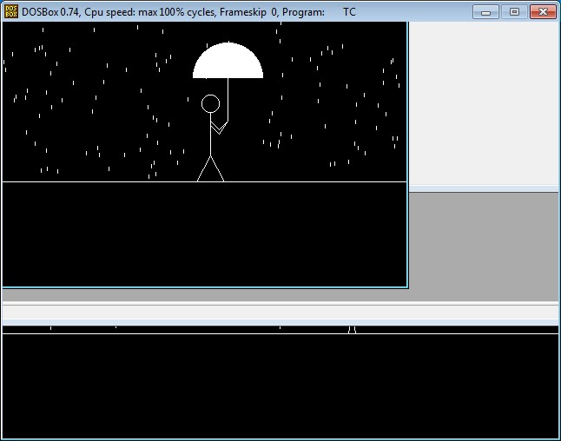

//AN ANIMATED SCENE OF SUNRISE TO SUNSET

#include<iostream>

#include<graphics.h>

#include<cstdlib>

#include<dos.h>

#include<cmath>

using namespace std;

int main()

{

initwindow(800,500);

int x0,y0;

int gdriver = DETECT,gmode,errorcode;

int xmax,ymax;

errorcode=graphresult();

if(errorcode!=0)

{

cout<<"Graphics error:"<<grapherrormsg(errorcode);

cout<<"Press any ket to halt";

exit(1);

}

int i,j;

setbkcolor(BLUE);

setcolor(RED);

rectangle(0,0,getmaxx(),getmaxy());

outtextxy(250,240,"::::PRESS ANY KEY TO CONTINUE:::::");

while(!kbhit());

for(i=50,j=0;i<=250,j<=250;i+=5,j+=5)

{

delay(120);

cleardevice();

if(i<=150)

{

setcolor(YELLOW);

setfillstyle(1,YELLOW);

fillellipse(i,300-j,20,20);

}

else

{

setcolor(GREEN^RED);

setfillstyle(1,GREEN^RED);

fillellipse(i,300-j,20,20);

}

}

delay(1000);

cleardevice();

setcolor(RED);

setfillstyle(1,RED);

fillellipse(300,50,20,20);

delay(150);

int k,l;

for(k=305,l=55;k<=550,l<=300;k+=5,l+=5)

{

delay(120);

cleardevice();

if(k<=450)

{

setcolor(GREEN^RED);

setfillstyle(1,GREEN^RED);

fillellipse(k,l,20,20);

}

else

{

setcolor(YELLOW);

setfillstyle(1,YELLOW);

fillellipse(k,l,20,20);

}

}

return 0;

}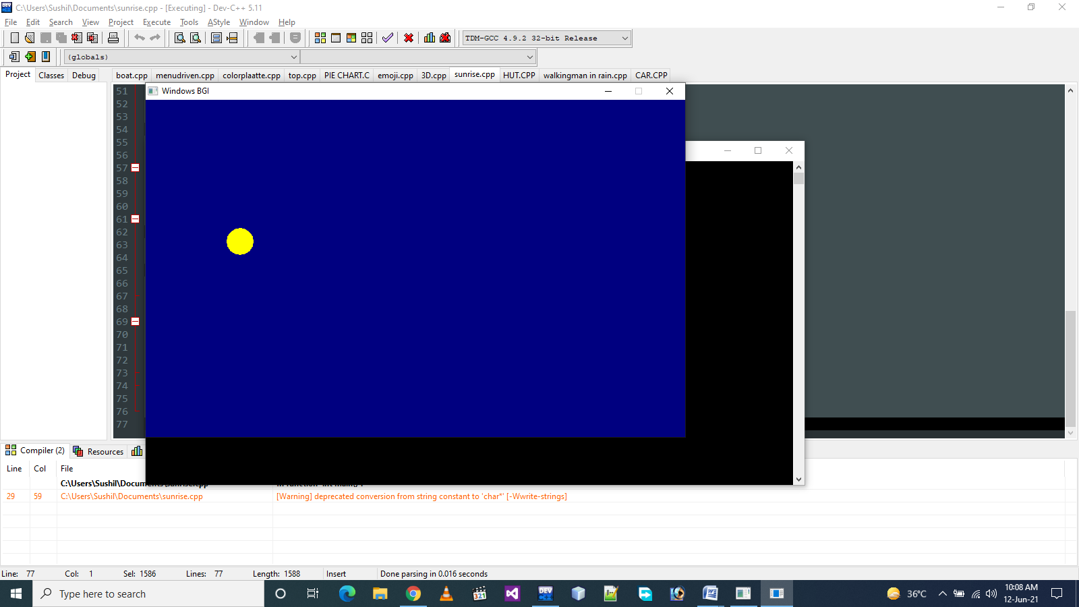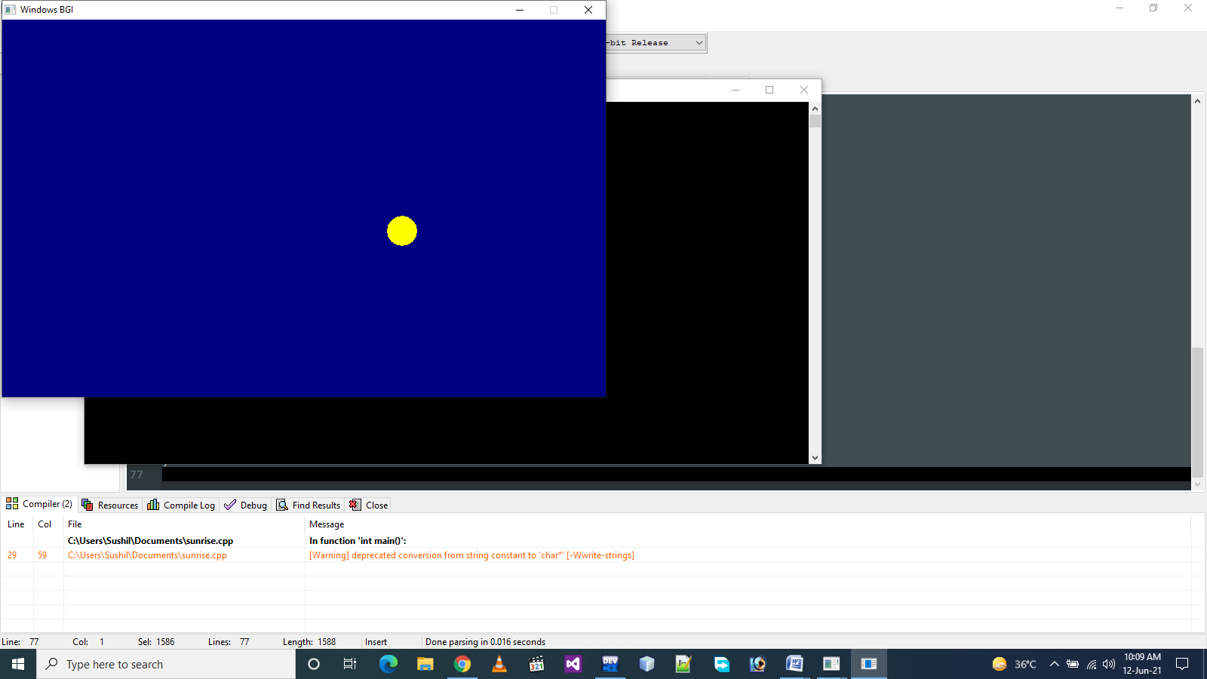

//A SAILING BOAT WITH MAN

#include<stdio.h>

#include<graphics.h>

#include<math.h>

#include<dos.h>

#include<conio.h>

#include<stdlib.h>

int gd=DETECT,gm,xmax,ymax,x,y,tx,ty;

void drawBoat()

{

static int t=0;

line(x,y,x+200,y);

line(x,y,x+20,y+60);

line(x+20,y+60,x+180,y+60);

line(x+180,y+60,x+200,y);

line(x+150,y,x+150,y-35);

setfillstyle(SOLID_FILL,BLACK);

fillellipse(x+150,y-50,15,15);

//circle(x+150,y-50,15);

setfillstyle(SOLID_FILL,WHITE);

//arc(x+150,y-55,0,180,20);

//arc(x+150,y-40,20,160,26);

fillellipse(x+150,y-60,35,3);

fillellipse(x+150,y-65,10,10);

setfillstyle(SOLID_FILL,BROWN);

floodfill(x+40,y+20,WHITE);

if(t<1)

{

line(x+150,y-25,x+130,y-15);

line(x+130,y-15,x+110,y-19);

line(x+150,y-25,x+107,y-25);

//

line(x+107,y-25,x+110,y-10);

line(x+115,y-10,x+108,y-10);

line(x+115,y-10,x+135,y+60);

line(x+108,y-10,x+128,y+60);

line(x+135,y+60,x+128,y+60);

}

else

{

line(x+150,y-25,x+135,y-20);

line(x+140,y-20,x+120,y-10);

line(x+150,y-25,x+120,y-20);

//

line(x+120,y-20,x+130,y-5);

line(x+123,y-5,x+118,y-5);

line(x+118,y-5,x+150,y+60);

line(x+123,y-5,x+158,y+60);

line(x+123,y+60,x+158,y+60);

}

t=(t+1)%4;

}

void drawWave()

{

static int waveh=10,hdiff=0,phasediff=10;

tx=0;

ty=y+40;

for(;tx<xmax*3;tx+=3)

{

putpixel(tx/3,(ty+hdiff)+waveh*sin((tx+phasediff)*3.14f/180),3);

}

//hdiff=(hdiff+2)%4;

//phasediff=(phasediff+20)%70;

setfillstyle(SOLID_FILL,3);

floodfill(xmax-1,ymax-2,3);

}

/*

void rain()

{

int i,rx,ry;

setcolor(WHITE);

for(i=0;i<1000;i++)

{

rx=random(xmax);

ry=random(ymax);

if(ry<y+40)

{

if((ry>y+10||ry<y-77))

line(rx,ry,rx+2,ry+2);

else if((rx<x+90||rx>x+180))

{

line(rx,ry,rx+2,ry+2);

}

}

}

}

*/

int main()

{

initgraph(&gd,&gm,"C:\\TURBOC3\\BGI\\");

cleardevice();

xmax=getmaxx();

ymax=getmaxy();

x=250;

y=ymax-150;

while(!kbhit())

{

x-=8;

drawBoat();

drawWave();

//rain();

delay(300);

cleardevice();

}

getch();

}

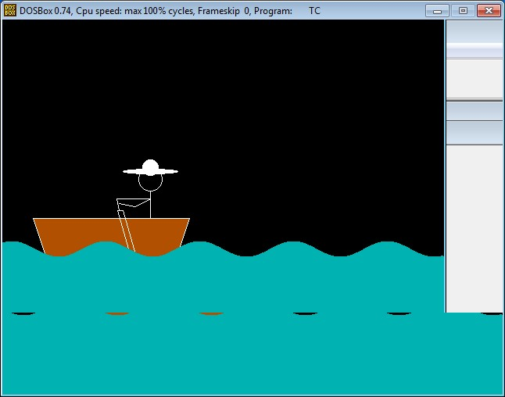

// USE OF LASSO TOOL

|  |
| --- |
| BEFORE:: |



|  |
| --- |
| AFTER:: |

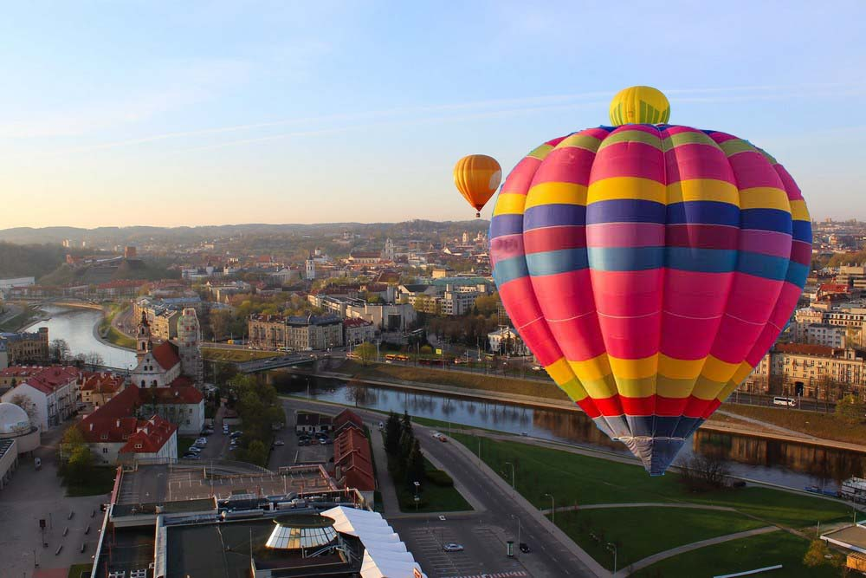

|  |
| --- |
| * Select Lasso Tool from Toolbox. * After selecting lasso tool >> we have to choose magneti from the three of lasso tool * Lasso * Polygonal * Magnetic * Select Image>>Selector tool to move the selected image. * Paste the selected image on the other place where you want. |

//USE OF MAGIC TOOL





|  |
| --- |
| * Select the Magic Wand Tool from the Toolbox kit. * Then select the multiple selection option to select multiple colors. * Now select the colors and the tool made available the colors portion to move it or anywhere we want to move it. |

//USE OF CLONE TOOL



|  |
| --- |
| * To use the Clone Stamp Tool select the Clone tool kit and then select the image. * After selecting the image>> ALT + Left click of mouse . * Then finally use of left click where we want to make clone of the what we have selected. |

//CREATE A INVITATION CARD

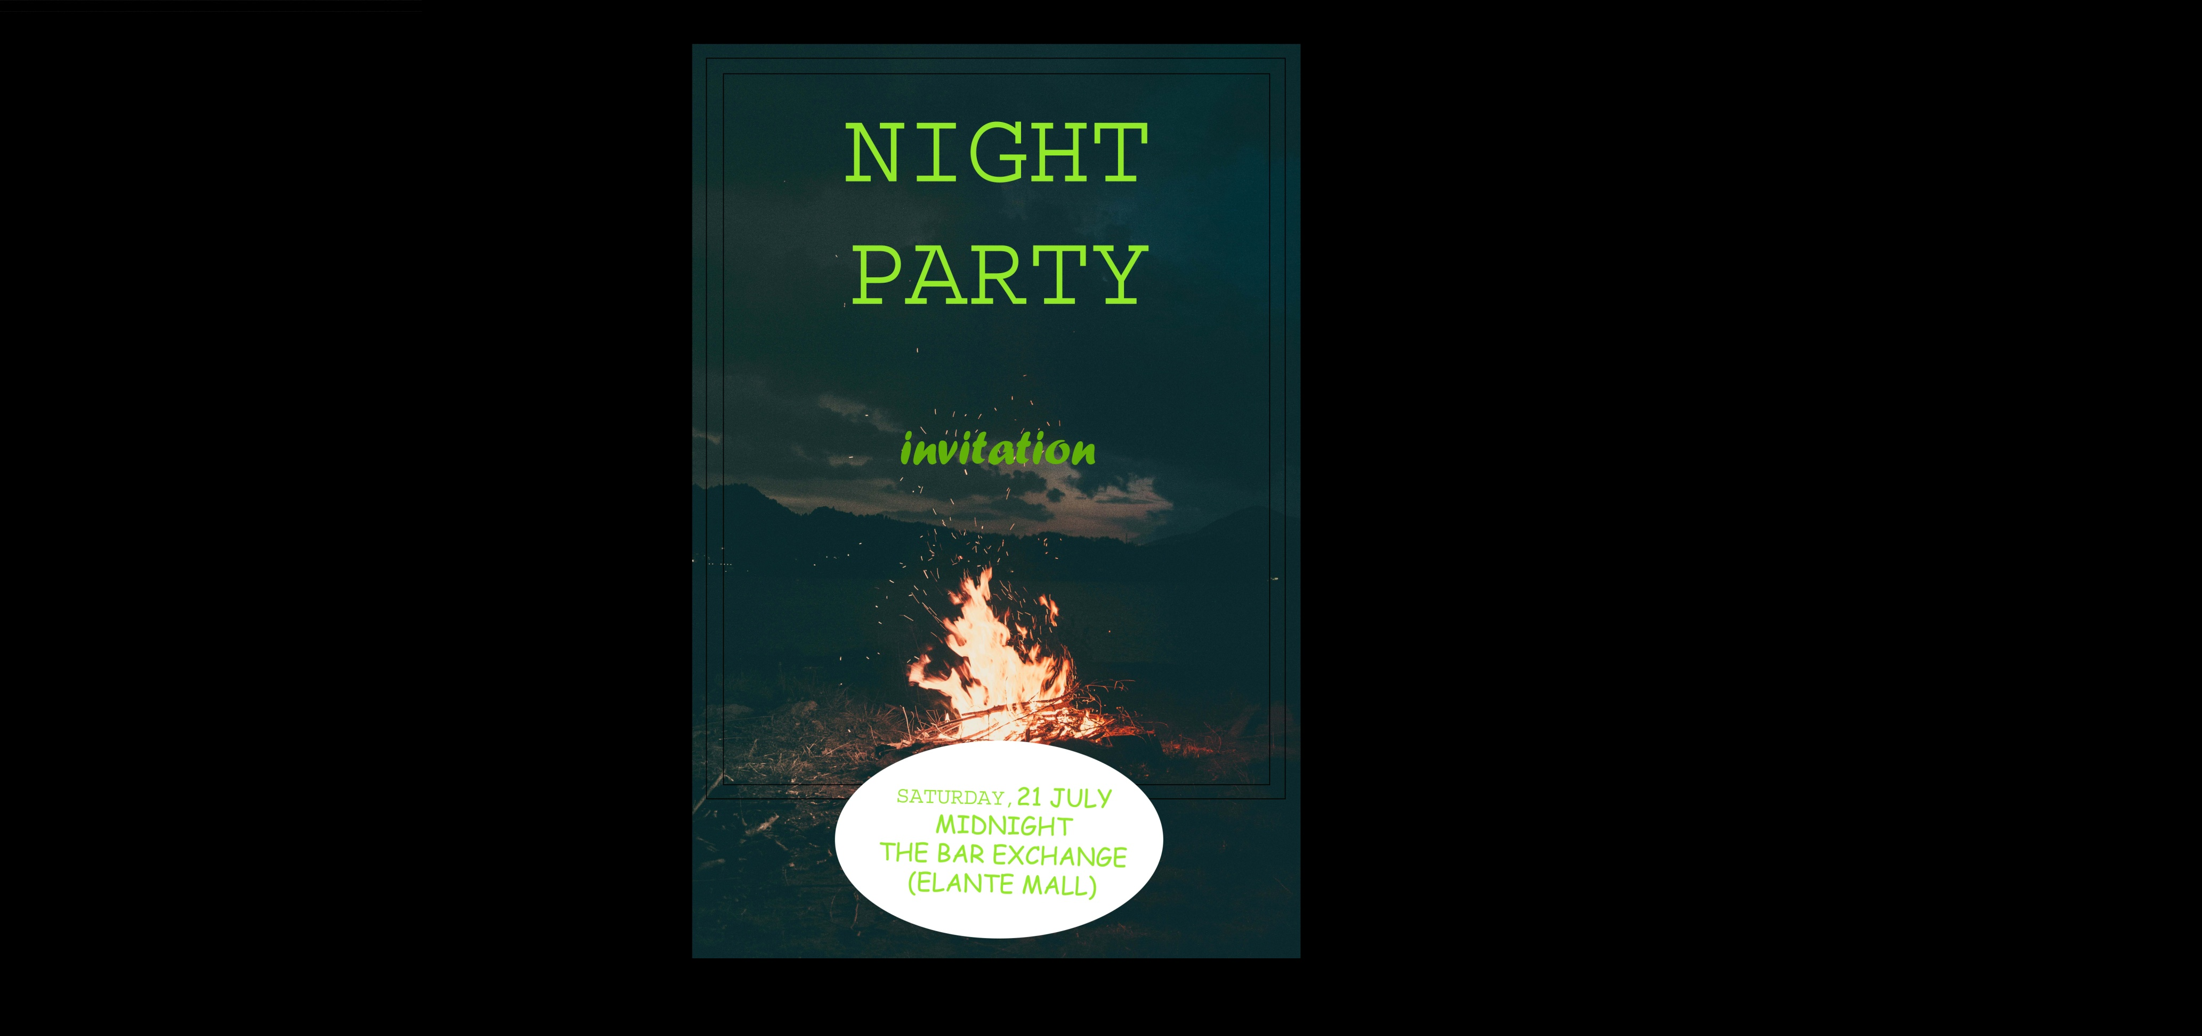

|  |
| --- |
| To CREATE A INVITATION CARD   * Select an image for the background. * Use of Rectangular tool with black border. * Using the same tool make a circle. * Using the text tool to insert text and use the color which you want. * Edit the TEXT FONT, TEXT SIZE,TEXT COLOR . |