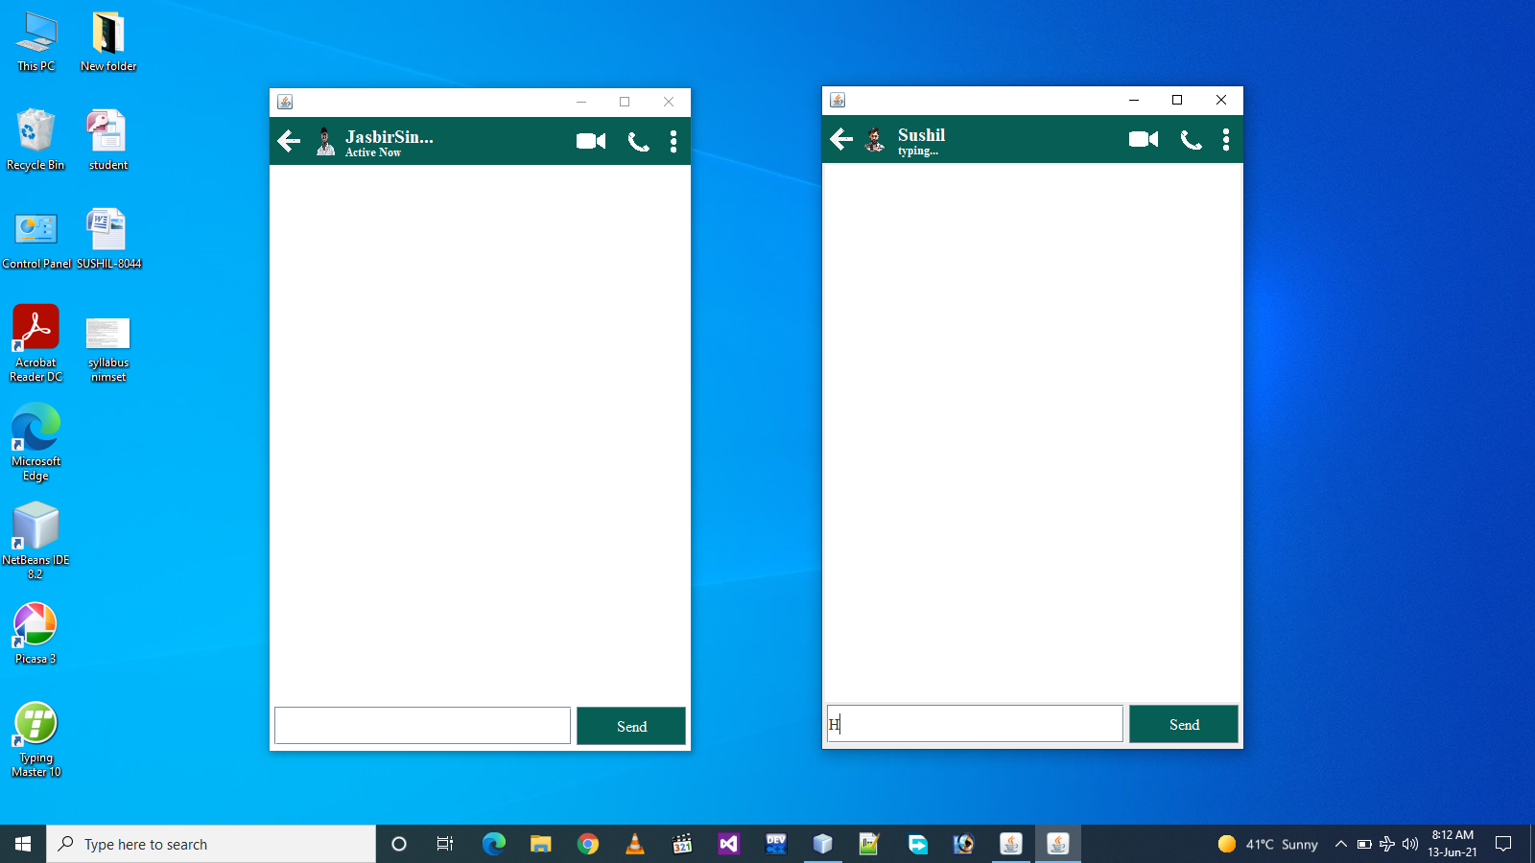

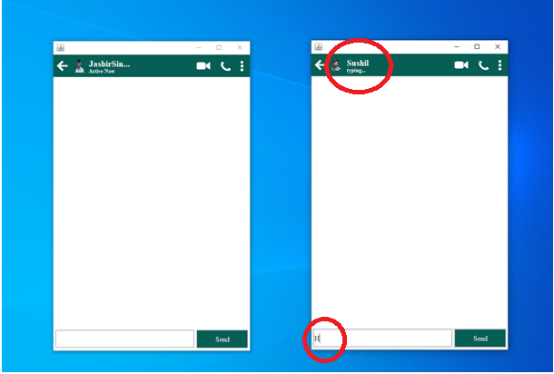

IT WILL SHOW THE TYING TILL AFTER **2 SECONDS** WE STOP THE TYPING IN THE TEXTBOX AREA.

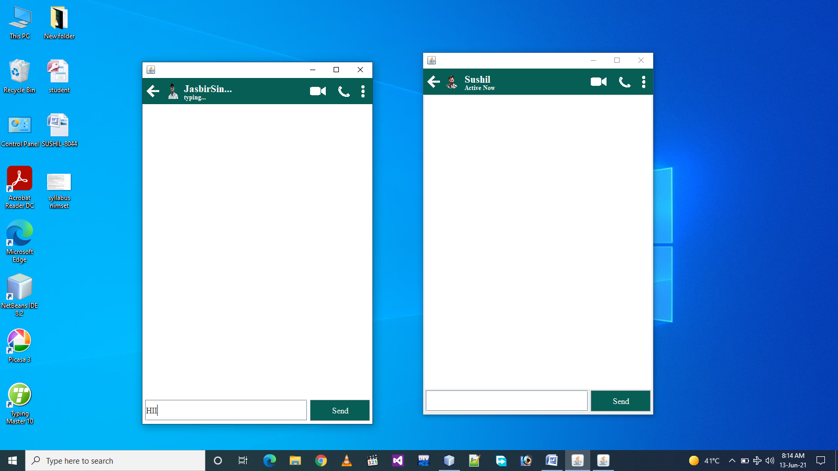

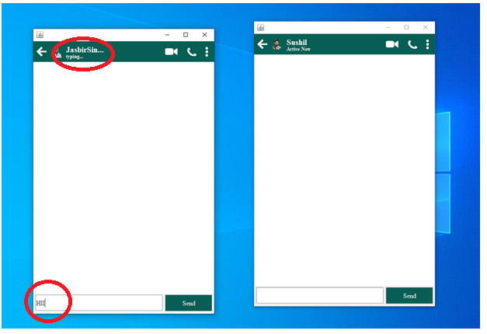

IT WILL SHOW THE TYING TILL AFTER **2 SECONDS** WE STOP THE TYPING IN THE TEXTBOX AREA.