**Post**: localhost:8070/user/

Data in JSON format:

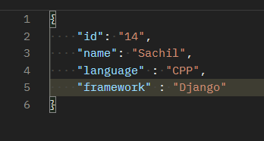

Output:

**Get all Users** -

Get: localhost:8070/user/

Output:

**Get users by Id-**

Get: localhost:8070/user/users/10

Output:

**Get user by name –**

Get: localhost:8070/user/usersName/Sushil

Output:

**Delete**: localhost:8070/user/delete/13

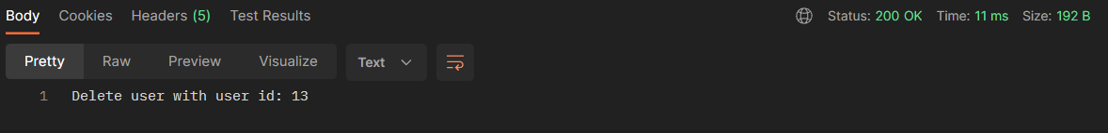

**Update**: localhost:8070/user/update/14

Data in Json format:

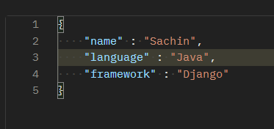

Output:

