Manmohan Technical University
School of Engineering

Department of Electrical & Electronics Engineering

Minor Project Report



AUTOMATIC ROOF CLOSING SYSTEM USING LDR

Submitted by:
Gautam Kumar Gupta (Roll.no 05)
Pabitra Khaptari (Roll.no 06)
Sushil Dulal (Roll.no 15)

Date:-2081/02/09

Table of Contents

Abstract i
Acknowledgment II
Symbols and Abbreviations III
Chapter I : Introduction 1
1.1 Background 2
1.2 Motivation 2
1.3 Problem Description 3
1.4 Objectives 3
1.5 Methodology 3
1.6 Limitations 3
1.7 Organisation of Report 3
1.8 Summary 3
Chapter II: Technology and Literature Survey 5
2.1 Topic 1 (Defining Units) 5
2.2 Topic 2 ( Defining Equations) 5
2.3 Topic 2 ( Write References) 6
2.4 Summary 6
Chapter III: Methodology / Modeling / Experimental Setup ( What ever would be appropriate Topic) 7
3.1 Topic 1 ( Some Common Mistakes) 7
3.2 Topic 2 (Positioning Figures and Tables) 7
3.3 Summary 9
Chapter IV: Study Cases ( or Any relavent Topic such as System analysis or result and analysis) 10
4.1 Topic 1 11
4.2 Summary 11
Chapter V: Conclusion and Future work 12
References 13

ABSTRACT

As we know that the modern electrical automation has made the life more easy and economical . Our minor project is based on the Automatic roof closing system using LDR.

It is designed to provide a smart and efficient solution for protecting spaces from adverse weather conditions,such as rain or excessive sunlight,by automatically closing or opening a roof .

The core component of this system is the LDR,a type of photoresistor whose resistance changes based on the light intensity it receives.During bright condition , the LDR’s resistance decreases basically ,but in our project we have used NOT gate so, during light condition the LDR resistance increase which the control the system interprets as a signal to close the roof and in low light/dark conditions the LDR resistance decreases,signaling the roof to open.
The system aims to provide an automated solution for opening and closing a roof based
on ambient light levels and protecting interior spaces from adverse weather conditions.

Acknowledgment
We would like to thank to department of Electrical and Electronics Engineering Department for providing us with the necessary equipments,lab room and our respected teacher and instructors who helped us in our project.

We are grateful to our respected teacher and supervisor Er.Sagun Paudyal for his co-operation and guidance throughout the project as a project supervisior who helped us with our project by sharing their suggestions and instruction and experiences.

We are heartly thankful to our Head of Department Dr.Ing Deepranjan Dongol who always ready to helped us and for guidance throughout the project.

Also at last we would like to thanks Mr. Pradip Bhattarai who greatlly contributed to the completion of the project.

SYMBOLS AND ABBREVIATIONS

SN | SYMBOLS | COMPONENTS NAME
1. | 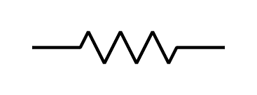 | Resistor
2. | 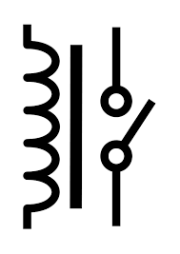 | Relay
3. | 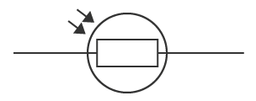 | LDR
4. | 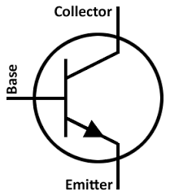 | Transistors
5. |  | Diode
6. |  | Motor
7. | 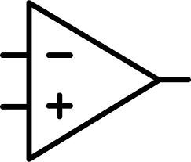 | Op-amp

Chapter I : Introduction

The Automatic Roof Closing System utilizes a Light Dependent Resistor (LDR) to detect changes in light intensity. When the LDR senses a significant decrease in light intensity, indicating the presence of rain or excessive sunlight, it triggers the system to close the roof automatically.

Background

The background discusses the need for an automatic roof closing system,
especially in places prone to sudden weather changes , where manual
operation is inconvenient. It introduces the idea of using an operational
amplifier(op-amp) and a Light Dependent Resistor (LDR) to achieve this
automation.
When the light falls on LDR, the roof automatically opens using DC motor
and at night, the roof closes automatically.

1.2 Motivation

The motivation behind this project is to develop an Automatic Roof Closing System using Light Dependent Resistor (LDR) technology to address the challenges posed by unpredictable weather. This system aims to enhance the usability, comfort, and safety of outdoor spaces by automatically closing the roof when adverse weather conditions are detected.

Problem Description

Some of the Problems to be solved in the Project:

Regulating temperature and Light for plants ( green house):
This will result in better growth of the plants.

Safety and Security : It will Protect the house from thief and other birds
animals during night time.

Convenience: The roof automatically adjusts to sunlight levels, reducing the need for manual operation.

Fading of furniture and fabrics: Prolonged sun exposure can fade the colours of furniture. An Automatic closing roof system can prevent this by providing shade when needed.

Objectives

Some of the objectives of the project are:

Enhanced Comfort : Maintain a comfortable indoor environment by controlling the amount of sunlight entering the space.

Energy Efficiency : Optimize the use of natural light and reduce the need for artificial lighting. When natural light is sufficient, the roof remains open, minimizing energy consumption for lighting.

Methodology:
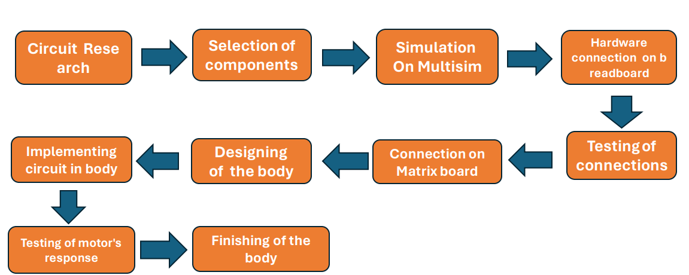

Limitations
1 The accuracy of the LDR sensor in detecting adverse weather conditions may be affected by environmental factors such as dust or debris.
- The motorized mechanism may have limitations in terms of speed and reliability.
- The system may require periodic maintenance to ensure optimal performance.
- The prototype may have limited scalability and may not be suitable for large-scale applications without further development.

Organisation of Report
1-Introduction: Provides an overview of the project, including background, motivation, problem description, and objectives.
- Literature Review: Summarizes existing research and technologies related to automatic roof closing systems and LDR technology.
- Methodology: Describes the approach and steps taken to develop the Automatic Roof Closing System using LDR.
- Results: Presents the findings and performance evaluation of the developed system.

Summary
The Automatic Roof Closing System project aims to develop an innovative solution to protect outdoor spaces from adverse weather conditions. By leveraging LDR technology and a motorized mechanism, the system can automatically detect changes in light intensity and close the roof when rain or excessive sunlight is detected. While the system may have limitations, it offers significant potential to improve the usability, comfort, and safety of outdoor environments.
Chapter II: Technology
An automatic roof closing system using Light Dependent Resistors(LDRs) operates based on changes in light intensity.Here’s a breakdown of the technical background.
Resistor :-
100 kilo-ohm resistor is used in this circuit. It is often used as voltage divider network. This setup helps regulate the voltage reaching the LDR.
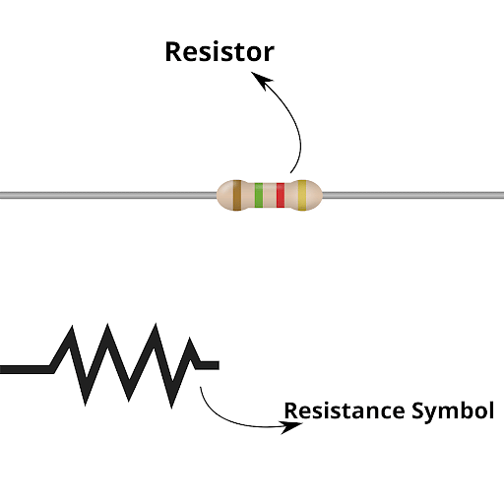
Diode :-
Here IN 4007 diode is used. This diode protects the circuit by allowing a controlled path for the reverse voltage spike when the relay is turned offed.
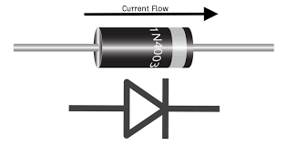

Transistor :-

To complete this circuit we have used transistor BC 457 can switch on and off the relay based on the light condition defected by the LDR. As the light level changes, and this variation is amplified by the transistor to control the relay. It allows a small current variation from the LDR to control a larger current flowing through the relay.
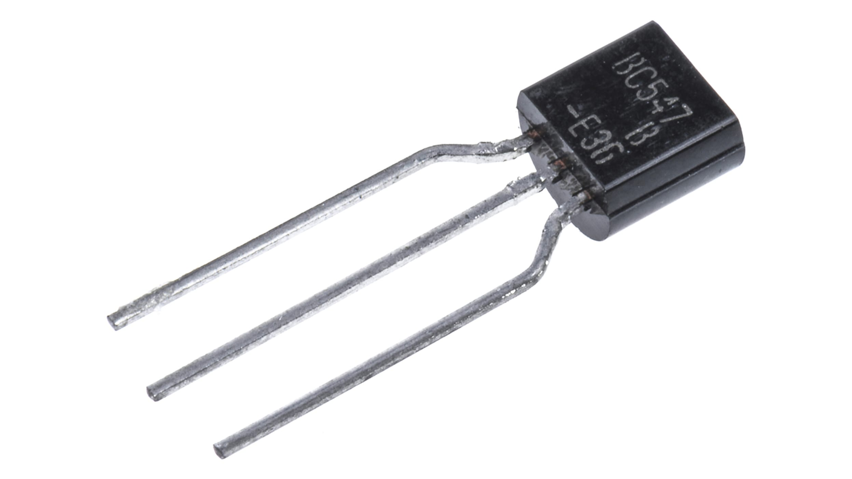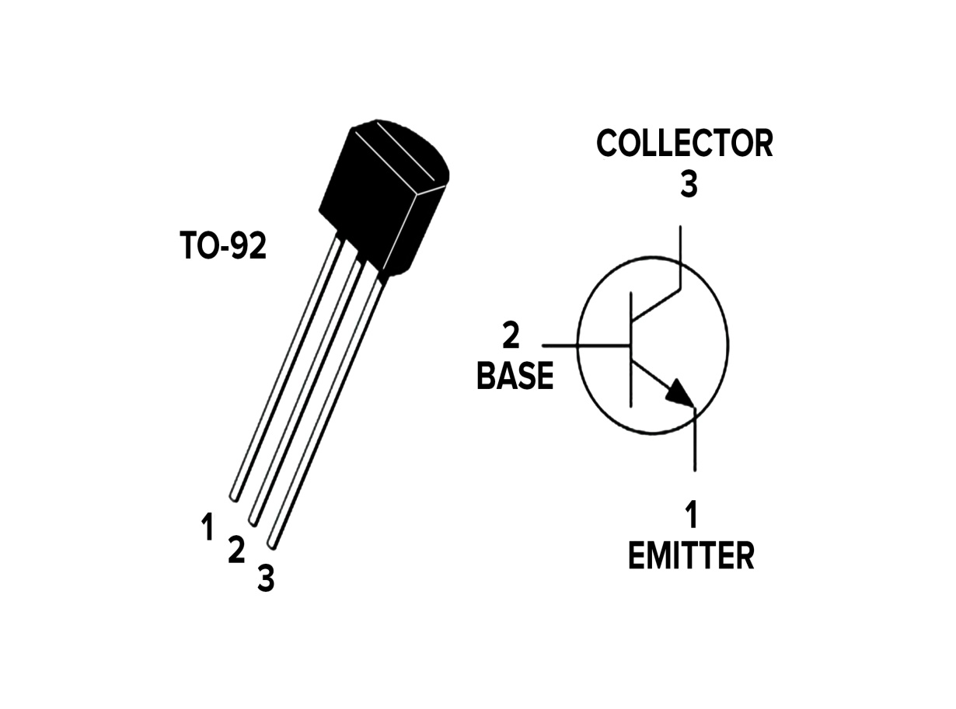

Relay :-
Relay is electromagnetic switch. It is operated using very low voltage like 5v. In the circuit , 12v dc relay is used which provide electrical isolation between low voltage control circuit (usually driven by the LDR and associated components) and the higher voltage motor or load. This isolation helps protect the low voltage components from potential damage due to the higher voltage and current associated with the motor.
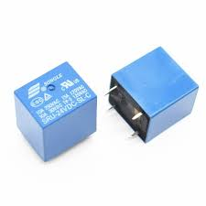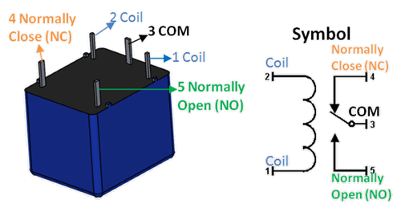

Motor :-
Motor is electrical device which converts electrical into mechanical work. Here 12v dc motor is used in order to automatically close the roof. 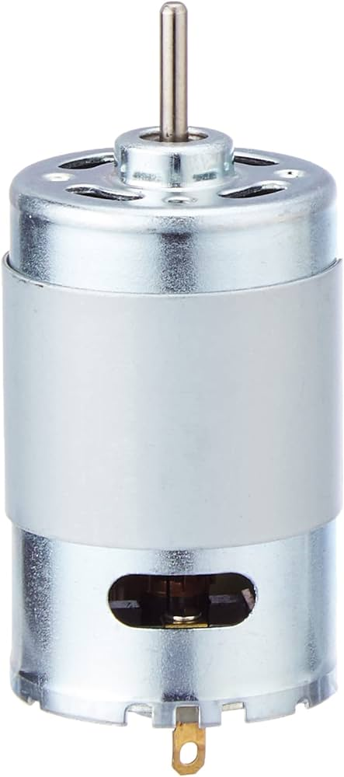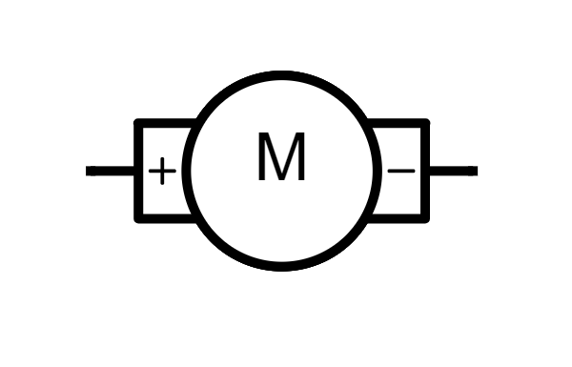

LDR :-
Light Dependent Resistor is a type of resistor whose resistance changes with the amount of light falling on it. It is based on the principle that , it’s resistance decreases when light intensity increases and resistance increases when light intensity decreases.
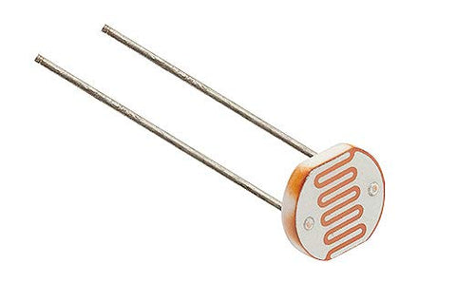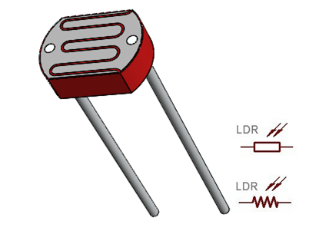

Chapter III: Methodology/system Modelling / Experimental Setup

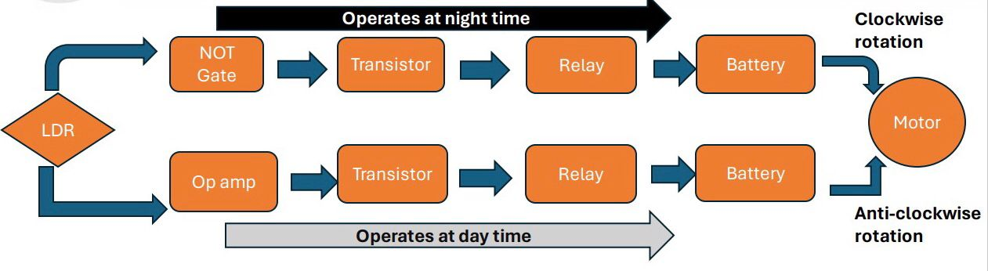
Flowchart showing the operation of automatic roof closing system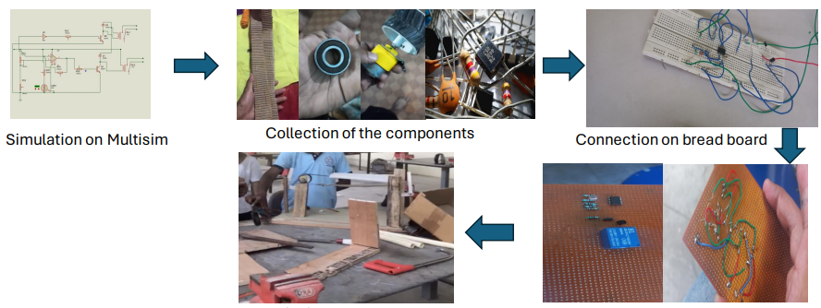
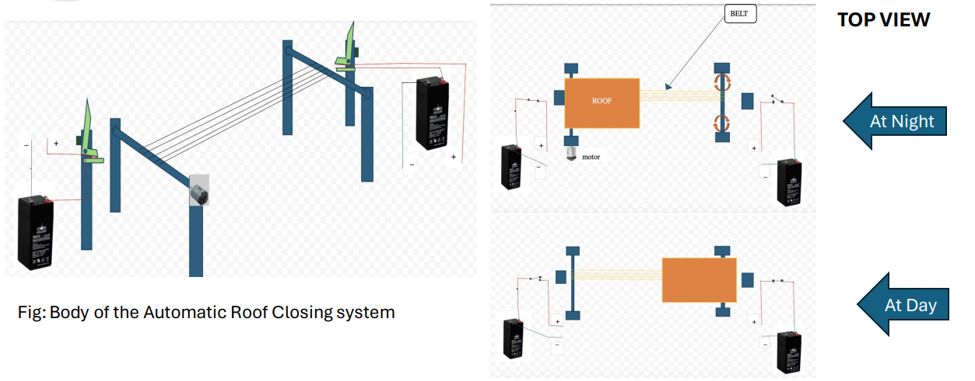
CHAPTER IV:-

result And analysis
During night; • motor will receive 4.07v from the circuit •
Motor will rotates in clockwise direction •
Roof will get closed.
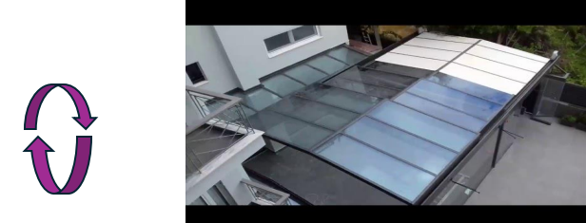
During Daytime; Motor will receive 3.98v from the circuit.
Motor will rotates in anti-clockwise direction
Roof will get opened.
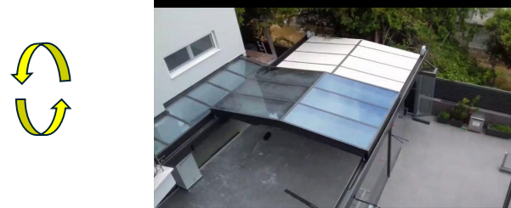

Simulation:
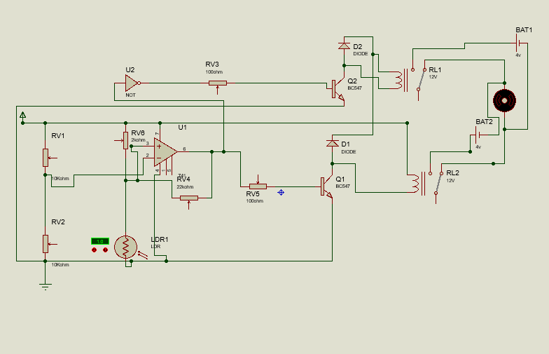

Circuit Analysis:

• LDR Resistance at normal room light = 9.5kΩ
• LDR Resistance at full dark = 19.5kΩ
• LDR Resistance at smart phone flash light = 0.3kΩ ( Distance between the Light sensor and flash light is in between 1cm-3cm )
• Op amp output in smart phone flash light = 0.09v
• Op amp output in dark = 0.78v
• Op-amp and transistor output in smart phone flash light = 0v
• Op-amp and transistor output in dark = 4.07v

• NOT Gate and transistor output in smart phone flash light = 3.98v
• NOT Gate and transistor output in dark = 0v

Expenditure Table:

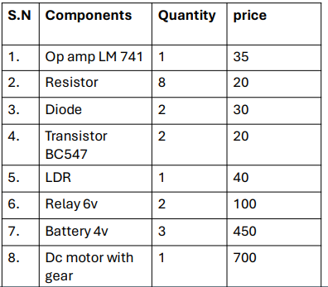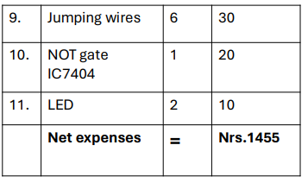

Hence , our overall expenditure is Nrs.1500 including glue stick, soldering aluminum wire, Screw , etc.

Chapter V: Conclusion and Future work
As all of us are searching for conveniences in each and every things. So, the implementation of automatic roof closing system will be great idea to meet the requirements of many people. Hence , we can conclude that, we can simply and automatically open or close the roof as our requirements by utilizing the natural light source.

FUTURE WORK

• Use of rain sensor instead of LDR

• Mobile app control

• Use of wind sensor

• Timer control based on desired schedule
REFERENCE:
R. Gregorian, INTRODUCTION TO CMOS OP-AMP AND COMPARATOR
• Malik Sikandar Hayat Khiyal, Aihab Khan, and Erum Shehzadi. SMS Based wireless Home Appliance control System (HACS) for Automating Appliances And Security, Issues in Informing Science and Information Technology. Vol.9.pp.887-894. 2009.
• Franco, S.(2015). Design with operational amplifiers and Analog integrated circuit(4th ed). McGraw-Hill Education.
• Hughes, A.,& Drury, B.(2019). Electric motors and drives: Fundamentals, types, and appliances (5th ed.). Newnes.
• YouTube : channel names : Slide Canopy , Vetra furniture
• Google Gemini

