Project PyCitySchools(Pandas) – Report

Summary:

The data shows that students score has a direct correlation to the resources available (money spent) within each school irrespective of the school type. For Example: Based on the data table shown below, Student within the lowest spending range (‘<585’ and ‘$585-630’) have managed to have the highest Overall Passing rate (90% and 81%) while the higher ranges ($645-680) have comparatively lower Overall Passing rates (53%).

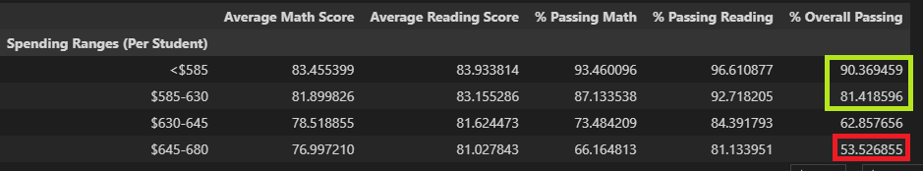

This proves increasing funds is not always the best strategy to improve school performance.

On the contrary, small, and medium sized schools have been clearly delivering better scores, which could be the underlying fact that teachers are probably able to spend more time with their students compared to large sized schools.

So having an optimum teacher to student ratio (class size) is vital to increase overall student scores.

Conclusion 1: Small (89%) and Medium (90%) sized schools have the highest overall passing rates and are highly effective in aiding students succeed with better overall scores compared to Large(58%) sized schools.

Conclusion 2: Students in Charter schools (90%) enjoy a broader strategy and students perform better with highest average overall passing rate compared to District schools (53%).