Trajectory based collision detection and avoidance using double layer Hidden Markov Model for Autonomous Vehicles

ARTICLE INFO

Keywords:

Autonomous vehicles

Trajectory prediction

Accuracy

HMM

Collision detection

Collision avoidance

ABSTRACT

The research paper deals about the new approach of avoiding collision and predicting the trajectory of the Autonomous Vehicles (AVs) using a Double-layer Hidden Markov Model (HMM). This model can recognize intentions and predict the behaviors accurately and effectively by providing the basis for pre-warming and intervention of danger and improving comfort performance. This makes them more efficient than the vehicles using Traditional Forward Collision Warning. The Unity simulation environment enables us to create a testing environment where we can test our AVs across various real-world scenarios, to ensure that vehicle effectiveness in preventing collisions and maintaining smooth traffic flow. These system uses various sensor to monitor the vehicle’s state, ensuring that they are making an accurate trajectory prediction and collision avoidance. This project offers an excellent solution for collision avoidance in AVs and significantly advances the Autonomous driving technology. Thus, it makes the AV safer and more reliable for travelling on the road.

# Introduction :

The proliferation of autonomous vehicles (AVs) holds immense promise for revolutionizing transportation, offering unparalleled safety, efficiency, and reduced congestion. However, achieving reliable collision avoidance remains a formidable challenge. Conventional rule-based methods often falter when confronted with complex scenarios, necessitating the adoption of data-driven approaches. To address this, our system uses a trajectory-based methodology powered by a double-layer HMM to predict potential dangers. The system, consisting of a simulation environment and a collision prediction and avoidance module, squarely addresses the critical issue of collision detection and avoidance. This approach is designed to improve the safety and efficiency of autonomous vehicles, thereby tackling the complex issue of avoiding collisions in self-driving cars. A Simulation Environment created using the Unity platform, provides a realistic virtual space where self-driving cars can navigate different road situations similar to real-life conditions. This environment is crucial for testing and evaluating how well our collision avoidance system performs in various scenarios.

Prediction and Collision Avoidance Module

At the heart of our system is the prediction and collision avoidance module, which utilizes a double-layer HMM to predict future movements of vehicles based on past data. This module considers both short-term details and long-term patterns when forecasting potential collision risks. When a possible collision is detected, the system reacts quickly by taking evasive actions to avoid accidents. The use of a double-layer HMM allows our system to understand complex driving behaviours and predict collision risks accurately.

Sensor Integration

To support accurate trajectory prediction and collision avoidance, the proposed system integrates various sensors that monitor the vehicle's state and surroundings. These sensors provide real-time data, such as speed, position, and obstacle detection, which is combined with historical trajectory information to make informed decisions and adapt to dynamic road situations.

Traffic Congestion:

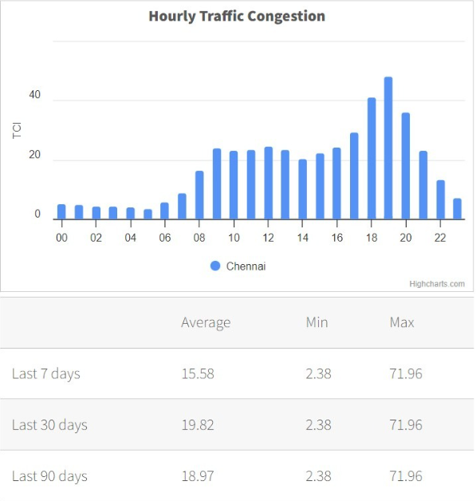

Fig. 1. Chennai Traffic Congestion

From fig 1, Recent traffic patterns in Chennai reveal fluctuating averages across different time periods. The past week saw a mean congestion rate of 15.58, while the monthly average climbed to 19.82. Over the quarter, the rate settled at 18.97. Interestingly, despite these variations in averages, the city consistently experienced the same peak traffic intensity of 71.96 and lowest congestion level of 2.38 throughout all three timeframes.

PROBLEM IDENTIFICATION

1. Collision Avoidance Challenge

Achieving reliable collision avoidance remains a formidable challenge for autonomous vehicles (AVs). Conventional rule-based methods often falter when confronted with complex scenarios. There is a pressing need for data-driven approaches to address the complexities of collision avoidance.

2. Limitations of Existing Collision Warning Systems

Traditional Forward Collision Warning (FCW) systems often issue warnings too late for following vehicles to react smoothly. Existing systems may struggle to detect the driving intentions of leading vehicles, leading to delayed warnings.

3. Trajectory Prediction Challenges

Accurate prediction of vehicle trajectories is crucial for anticipating potential collision risks. Capturing both short-term and long-term dependencies in driving behaviors is essential for enhancing trajectory prediction accuracy. Current methods may not effectively model complex driving patterns and underlying vehicle movement dynamics.

4. Simulation and Testing Limitations

Evaluating collision avoidance systems in real-world scenarios can be challenging and potentially dangerous. There is a need for realistic simulation environments that can replicate various road situations and traffic conditions. Comprehensive testing across a wide range of scenarios is essential to ensure the effectiveness of collision avoidance systems.

5. Sensor Integration and Data Fusion

Integrating various sensors to monitor the vehicle's state and surroundings is crucial for accurate trajectory prediction and collision avoidance. Effective data fusion techniques are required to combine real-time sensor data with historical trajectory information. Adapting to dynamic road situations and making informed decisions based on integrated data remains a challenge.

Literature Review:

Autonomous vehicles (AVs) are revolutionizing transportation by increasing safety, reducing costs, and saving time. They excel at navigating complex traffic scenarios by analyzing their surroundings and predicting the trajectories of other vehicles. Various methods have been developed for trajectory prediction in AVs. A GAN-based deep learning framework predicts surrounding vehicle trajectories from RGB image sequences [1,2] and the probabilistic methods like Gaussian Process Regression (GPR) model have a lane-changing behavior [3]. The Multi-Dimensional spatio-Temporal feature Fusion (MDSTF) model enhances trajectory prediction by integrating local, global and full-process spatial features [4]. Goal-Curve Net combines heterogeneous graph attention for goal prediction and curve fitting [5]and a new method of integrating spatial and temporal aspects has been developed for predicting multiple possible trajectories. This approach has demonstrated exceptional results when tested on various datasets. [6].

To enhance precision, slip parameters during vehicle operation are calculated using advanced techniques like the extended Kalman filter and an improved version of the sliding mode observer. [7]. The SIF-TF (Scene-Interaction fusion Transformer) combines multiple data sources to forecast pedestrian movements. It analyzes social dynamics, previous paths taken, and environmental context to predict where people will walk next. [8]. The MCLG model incorporates multi-head attention, convolutional social pooling, LSTM, and Gaussian mixture model (GMM) for lane change decisions and trajectory prediction [9].

Advanced Forward Collision Warning (FCW) systems predict driving intentions of lead vehicles to issue early alerts [10]. The Emergency Obstacle Avoidance Maneuver (EOAM) framework integrates AV sensing, perception, and control systems for robust obstacle avoidance at highway speeds [11]. Improved Artificial Potential Field (IAPF) approach addresses dynamic traffic scenarios and local minima [12].

RACE (Reinforced Cooperative Autonomous Vehicle Collision Avoidance) provides a decentralized framework for robust collision avoidance [13]. For UAVs, a mixed collision cone and alerting criterion has been proposed [14]. Probability models assess collision risk based on vehicle and obstacle positions for uncertain obstacle avoidance [15].

Researchers have created diverse models for decision-making. Among these, continuous Hidden Markov Models and Partially Observable Markov Decision Processes (POMDPs) are used to anticipate how human-operated vehicles might interact with their surroundings. [16]. An imitation learning-based framework determines optimal timing for entering roundabouts [17]. Motion planning frameworks address uncertainty in surrounding vehicle positions and rollover risks [18].

Path tracking control remains a challenge in autonomous vehicle technology [19]. Double-layer MPC algorithms help plan paths and track trajectories [20]. Hidden Markov Models (HMM) are used for recognizing and predicting driving behaviors in Advanced Driver Assistance Systems (ADAS) [21]. A specialized decision-making model for AVs which combines a Partially Observable Markov Decision Process (POMDP) with principles of responsibility-sensitive safety, aiming to improve the AV's ability to make safe and effective decisions in these complex traffic scenarios. [22].

LiDAR sensors provide 3D point cloud estimations for obstacle detection and tracking [23]. Pedestrian detection is enhanced using Fully Convolutional Neural Networks for LIDAR-camera fusion [24]. Collaborative perception methods address occlusion and sensor failure [25].

V2X communication strategies prioritize emergency autonomous vehicles (EAVs) and manage traffic flow [26]. V2V and V2I communications are augmented by V2IoT, integrating with 5G systems [27]. Smart Data-based middleware enhances AV simulations by addressing communication delays and security [28].

Simulation, Testing, and Specialized Applications: COPGAN, a cycle-object preserving GAN framework, maintains object detection performance under diverse conditions [29]. Collision-free routing methods have been developed for Automated Guided Vehicles (AGVs) in warehouse systems [30]. Autonomous excavation operations integrate deep reinforcement learning and optimal control [31].

Blockchain technology is being explored to enhance various types of AVs [32]. Multiple Vehicle Cooperation and Collision Avoidance (MVCCA) strategies are being developed [33]. Adaptive autonomous driving assistance addresses human interaction complexities with ADAS [34]. Double-layer HMM structures recognize driving intentions and predict behaviors [35].

M2-DenseNet, a multitask learning framework, predicts steering angle, speed, and throttle simultaneously [36]. Hybrid reinforcement learning (HRL) approaches address pedestrian safety [37]. Robust Autonomous Driving Control (RADC) architectures are being developed for adverse weather conditions [38]. Incremental learning methods for AV navigation show promise in real-world settings [39].

A novel approach to detecting evolving community structures in complex networks. Unlike existing methods that treat the problem as a coupled optimization model, this approach separately considers intra-community connections, inter-community connections, and community evolution over time. The proposed algorithm, HMM-MODCD, combines a multi-objective evolutionary algorithm with a Hidden Markov Model to optimize these components and track community changes. Evaluated on synthetic and real-world dynamic networks, the method outperforms existing algorithms in detecting accurate, evolving community structures. [40]. Merging strategies for connected autonomous vehicles (CAVs) use distributed model predictive control (DMPC) [41]. Deep learning frameworks predict rear-end collisions [42] and enhance semantic segmentation of point clouds [43].

A data-driven algorithm for eco-speed optimization reduces energy consumption while maintaining travel efficiency [44].

a new model to improve autonomous vehicle decision-making at non-signalized intersections, focusing on safety, efficiency, and smooth driving. The model combines a partially observable Markov decision process with responsibility-sensitive safety algorithms and adaptive cruise control. Tested in MATLAB simulations, the proposed approach outperformed classical adaptive model predictive control, significantly reducing braking time and improving speed control smoothness.[45]

V2IoT communication in autonomous vehicles using 5G aims at reducing delays for the best positioning and solves the problem of degrading signals. It proposes an intelligent vehicle agent for better traffic flow. The non-homogeneous HMM shall catch the dynamic mode preferences like car preference or carpooling/transit preference. It combines time-varying factors that affect a mode choice, such as travel time/cost, in Bayesian estimation and Markov chain Monte Carlo methods. A double-layer hidden Markov model is designed for the recognition of driving intentions and prediction of future behaviors, where the upper layer MDHMM will represent the intention based on the behaviors identified by the lower layer MGHMM analyzing driver-vehicle data [48]. A structural hidden Markov model groups observation sequences into classes, accounting for specific local structures, such that, compared with the traditional HMMs, SHMM has better accuracy in applications like customer preference analysis for automotive designs [49]. A sensor fault-tolerant control strategy for steering-by-wire systems, taking into account a multi-dimensional Gauss HMM algorithm and hardware redundancy, has been tested through hardware-in-loop experiments for reliability and security enhancement of the corresponding systems [50]. The field of autonomous vehicles is rapidly evolving, with advancements in trajectory prediction, collision avoidance and decision-making. Despite advances, autonomous vehicles still face key challenges in safety, security, and interacting with humans. Future research directions may focus on improving robustness in diverse environmental conditions and enhancing cooperative driving capabilities.

METHODOLOGY

PROPOSED SYSTEM

Double-Layer HMM for Trajectory Prediction

The proposed system employs a double-layer Hidden Markov Model (HMM) to predict vehicle trajectories based on historical data. This novel approach captures both short-term and long-term dependencies in driving behaviors, resulting in improved accuracy for trajectory prediction. By analyzing past trajectories, the system identifies hidden states (shown in Fig. 1) representing various driving patterns, where ‘X’ represents states, ‘Y’ shows possible observations, ‘a’ shows state transition probability and ‘b’ shows output probabilities.

X - States

Y - Possible Observations

a - State Transition Probability b - Output Probabilities

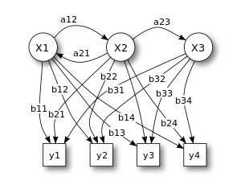

Fig. 2. Hidden Markov Model

To validate and test the system, a realistic simulation environment has been created using the Unity platform. This virtual space replicates real-world scenarios like roads, intersections, and highways, allowing autonomous vehicles (AVs) to navigate and interact with other vehicles in a controlled setting. The Unity environment plays a crucial role in evaluating the collision detection and avoidance system's effectiveness across a wide range of scenarios.

Prediction and Collision Avoidance Module

Prediction and collision avoidance module is called as the heart of the system since it continuously monitors surrounding vehicle trajectories and uses the double-layer HMM to predict potential future movements, accounting for both short-term details and long-term patterns. When a collision risk is detected, the module promptly initiates evasive actions, such as speed adjustments, lane changes, or complex maneuvers, to prevent accidents.

Sensor Integration

To support accurate trajectory prediction and collision avoidance, the proposed system integrates various sensors that monitor the vehicle's state and surroundings. These sensors provide real-time data, such as speed, position, and obstacle detection, which is combined with historical trajectory information to make informed decisions and adapt to dynamic road situations.

Rigorous Testing and Evaluation

Through extensive testing and evaluation in the Unity simulation environment, the system aims to demonstrate its adaptability and effectiveness in preventing collisions while maintaining smooth traffic flow. By addressing the critical challenge of collision avoidance, this innovative approach contributes significantly to the advancement of safer and more reliable autonomous driving technology.

Unity Simulation Environment Fig. 2 illustrates an advanced automatic vehicle system designed for safe and efficient navigation. At its core is the prediction and collision avoidance module, which continuously monitors the trajectories of surrounding vehicles. Utilizing a double-layer HMM, this module accurately forecasts future movements by considering both short-term dynamics and long-term behavioral patterns, referencing the accident database. Upon detecting a potential collision risk, it swiftly initiates evasive actions, ranging from subtle speed adjustments to complex maneuvers, aiming to prevent accidents and protect passengers and pedestrians.

* Sensors: Including cameras, GPS, LIDAR, IR sensors, radar, and speedometers, these sensors collect environmental data crucial for safe navigation.
* Mapping Database: Stores critical information such as road lanes, traffic signs, and landmarks, essential for accurate navigation.
* Planning Module: Uses sensor data and mapping information to plan optimal vehicle trajectories.
* Control Module: Translates planned trajectories into precise steering and acceleration commands.
* Simulation Module: Predicts outcomes based on control signals, enabling proactive adjustments to enhance safety and efficiency.
* Actuation Module: Interfaces with vehicle actuators to execute refined control signals for steering, braking, and acceleration.
* These components work in tandem to proactively mitigate collision risks and ensure robust performance in real-world driving scenarios.

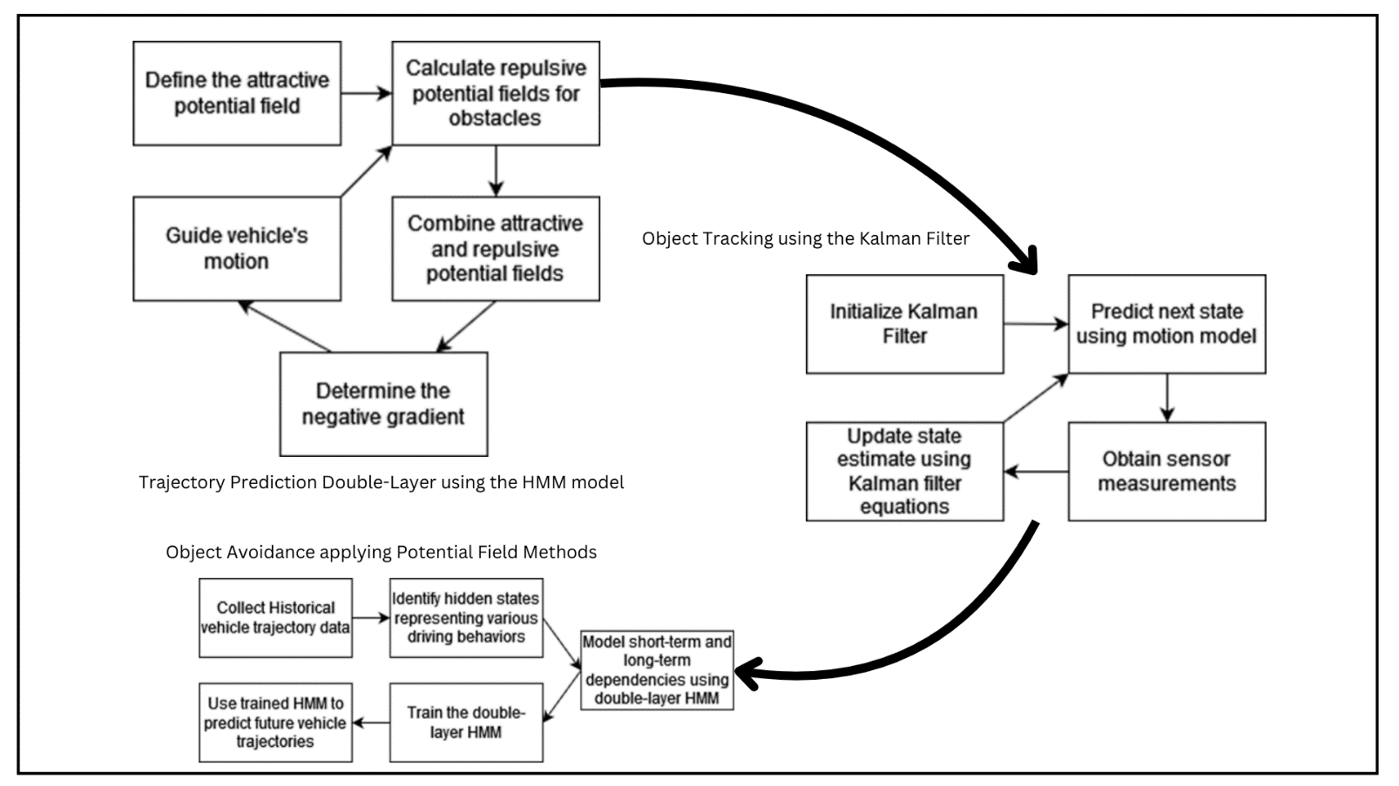Algorithm:

Fig. 3. Process Cycle

Equations

1. Distance and Time-to-Collision (TTC) Calculation:  
   Distance to an obstacle/vehicle:

(1)

Equation (1) computes the straight-line distance between the ego vehicle and detected obstacles using their x and y coordinates. This distance calculation is essential for assessing collision risks and planning avoidance strategies in autonomous driving.

2. Relative Velocity:

(2)

Equation (2) determines the relative speed and direction between the ego vehicle and obstacles by comparing their velocity components. This calculation is crucial for predicting how quickly they're approaching or separating, informing collision risk assessment.

3. Time-to-Collision (TTC):

(3)

Equation (3) calculates the TTC, which is a critical metric that estimates the time remaining before a collision occurs if the ego vehicle and the obstacle maintain their current velocities. A low TTC value indicates a high risk of collision, and appropriate evasive actions may be required. These formulas are fundamental in collision detection systems as they provide essential information about the proximity, relative motion, and collision risk with respect to detected obstacles or other vehicles.

Kalman Filter for Object Tracking

The Kalman filter is a widely used algorithm in autonomous driving for tracking the positions, velocities, and accelerations of surrounding objects. It combines sensor measurements (e.g., radar, lidar, camera) with predictions from a motion model to estimate the state of the tracked objects. The Kalman filter's recursive nature allows it to continuously update the state estimates as new sensor data becomes available, resulting in accurate and robust object tracking. This algorithm is particularly useful in handling sensor noise, dealing with occlusions, and maintaining consistent object tracks over time, which is essential for reliable collision detection and avoidance.

Potential Field Methods for Obstacle Avoidance

Autonomous navigation often employs potential field techniques. These methods create a virtual force landscape where obstacles push vehicles away, while destinations pull them closer, guiding movement and obstacle avoidance.

Attractive potential field:  
 (4)

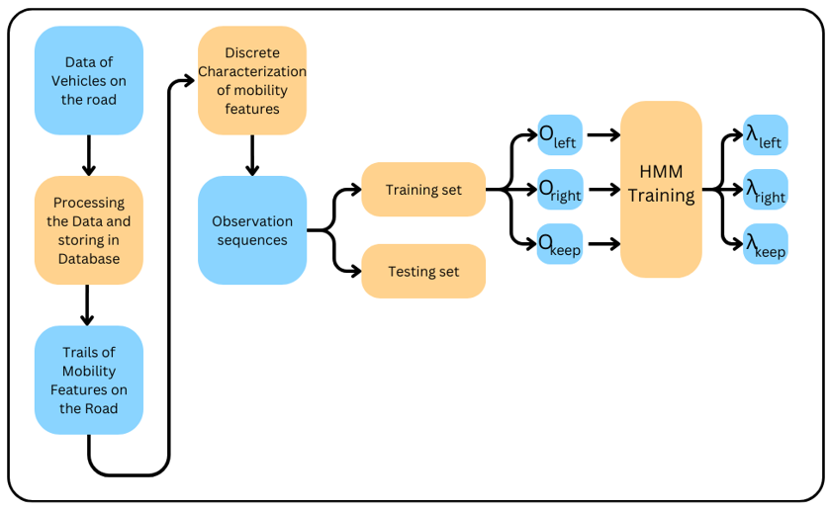Equation (4) calculates the Uatt is the attractive potential field which calculates the potential field used in an autonomous vehicle by multiplying the kinetic attraction field and square of the distance between the attraction to half.

Fig .4. Flowchart

Repulsive potential field:  
 if (5)

if (6)

where, d is the minimum distance function. It measures the closest distance from the AV’s current position to the nearest obstacle.

d0 is the influence range or distance threshold. It’s the distance at which the repulsive force starts to influence the AV’s movement.

Equation (5) & (6) deals with the repulsive potential field (Urep) refers to a type of potential field that exerts a force on a robot to keep it away from obstacles. A repulsive potential field is a concept used in robotics. Specifically, a repulsive potential field is created around obstacles. Here when the vehicle approaches an obstacle, the repulsive force increases, which helps in steering the vehicle away to avoid a collision.

If d > d0 then Urep = 0 and if d d0 then

.

Total potential field:  
 ( 7)

Equation (7) shows that the vehicle follows the steepest descent of the potential field, balancing obstacle avoidance with goal-seeking behavior. The formulas for attractive and repulsive potential fields involve parameters like the distance to obstacles, desired distance for avoidance, and weighting factors that can be tuned based on the specific application and research objectives. These methods are valuable in research for exploring different potential field formulations, incorporating dynamic obstacles, and integrating with other path planning algorithms. The technicalities behind these formulas stem from various mathematical principles, such as geometry, kinematics, and control theory. They are designed to capture the essential aspects of collision detection and avoidance, enabling researchers to develop and evaluate algorithms for autonomous vehicles in simulation and real-world scenarios.

1: Set initial values of the center points of the clusters: v1, v2, ..., vn.

Step 1:

2: For any data point 𝑐d, classify it into cluster n, if the center point of the cluster n is the nearest one of all n center points to it.

Step 2:

3: Update wd,n according to the classification result;  
4: Update the values of center points vn by (4).

Step 3:

5: IF vn converges, denote the final classification result as 𝑦(𝑑)=n when wd,n = 1; The observation of each vehicle Ol  
is obtained by

Otl  = 𝑦[(𝑙 − 1)𝑇 + 𝑡], where Otl  is the element of 𝑂𝑙 at time step 𝑡; 6: ELSE Return to Step 1.

As discussed above, the mobility features of 𝐿 vehicles are involved, and each vehicle gives a set of features at each time step. Thus, there are 𝑇 𝐿 sets of features, and each set 𝑐𝑑 is the 𝑑th row of mobility feature matrix 𝐅, where 𝑑 = 1, 2, …, 𝑇 𝐿. Each 𝑐𝑑 is regarded as a data point in the 𝑁-dimensional space, and should be classified into one of the 𝐾 clusters in the space. The main idea is to minimize the sum of distance from the center points to the data points in the clusters.

Let xK represent for the center point of cluster 𝑘, the sum of distance is denoted as

(8)

where wd,n = 1 if 𝑐d is classified into the nth cluster and

wd,n = 0 otherwise. To ensure that 𝐽 is minimized, vn should meet

(9)

(4) where n = 1, 2, …, N. The detailed procedure of discrete characterization of mobility features by 𝐾-means clustering is described in Algorithm 1. In this paper, one particular HMM 𝜆i is trained f HMM-MODCDor each type of driving intention 𝑖 = 1, 2, …, 𝐼, where 𝐼 is the number of types of driving intention. For an HMM 𝜆 (the index 𝑖 is omitted for simplicity), it includes a set of hidden states 𝐻, a set of observations 𝑉, state transition probabilities 𝐴 = {𝑎𝑞,𝑝}, state-observation probabilities 𝐵 = {𝑏𝑞 (𝑗)}, and initial state probabilities 𝜋 = {𝜋𝑞 } [20,21]. It can be represented as 𝜆 = {𝐻, 𝑉 , 𝐴, 𝐵, 𝜋}.

(5) It is assumed that there are 𝑄 possible hidden states in the set 𝐻. The hidden states might be the inside operations by the drivers that causes changes in the observations.

Given an HMM, the forward probability 𝛼𝑡 (𝑞) is defined as the probability of observing 𝑜1l, 𝑜2l, …, and the state of the Markov chain at time 𝑡 being the 𝑞th state in the 𝐻, i.e.,

(9)

(6) Similarly, the backward probability 𝛽𝑡 (𝑞) is defined as

(10)

(7) Then, the probability of the state at time 𝑡 being 𝐻(𝑞) is

(11)

(8) The probability of the state at time 𝑡 being 𝐻(𝑞) and the state at time 𝑡 + 1 being 𝐻(𝑝) can be obtained, i.e.,

(12)

(9) As discussed above, when applying 𝐾-means clustering, the trail of mobility features of vehicle 𝑙 is turned into one an observation sequence of integers, i.e., 𝑂𝑙 . After that, Baum-Welch algorithm is applied in this paper for the training of HMMs. To ensure the convergence in the training of an HMM 𝜆i, observations of 𝐿𝑖 vehicles are used. For simplicity, the index 𝑖 is omitted, and the input of the training algorithm is denoted as a set of observations 𝑂 = {𝑂1 , … , 𝑂𝑙 , …, 𝑂𝐿}. The parameters of the HMM are estimated in the iteration of training process. Algorithm 2 gives the detailed procedure of HMM training in the case of discrete characterization of mobility features

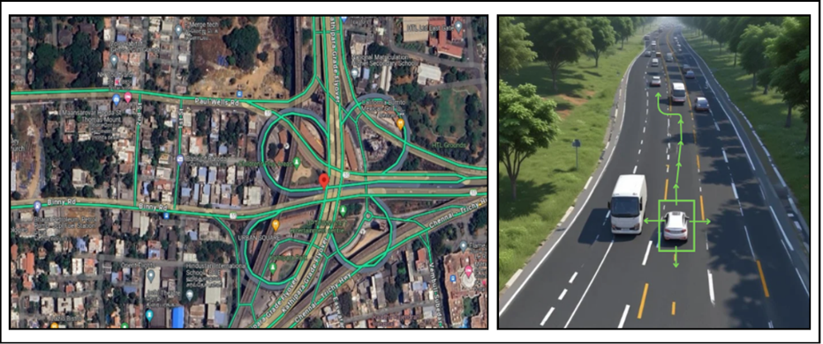Experimental Results:

Fig 5 AVs cruises in a highway & Chennai Traffic data Analysis of Kathipara Junction

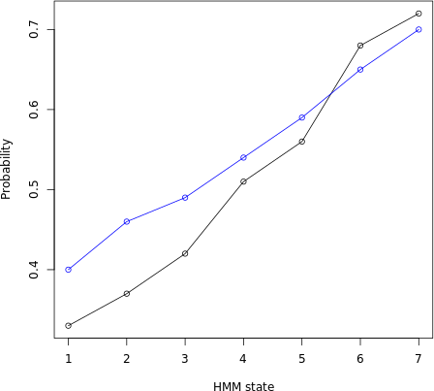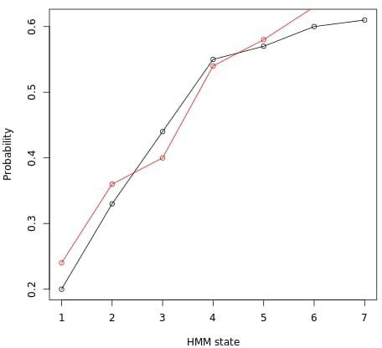

Fig. 6: Graph A of random HMM states Fig 7:Graph B of random HMM states

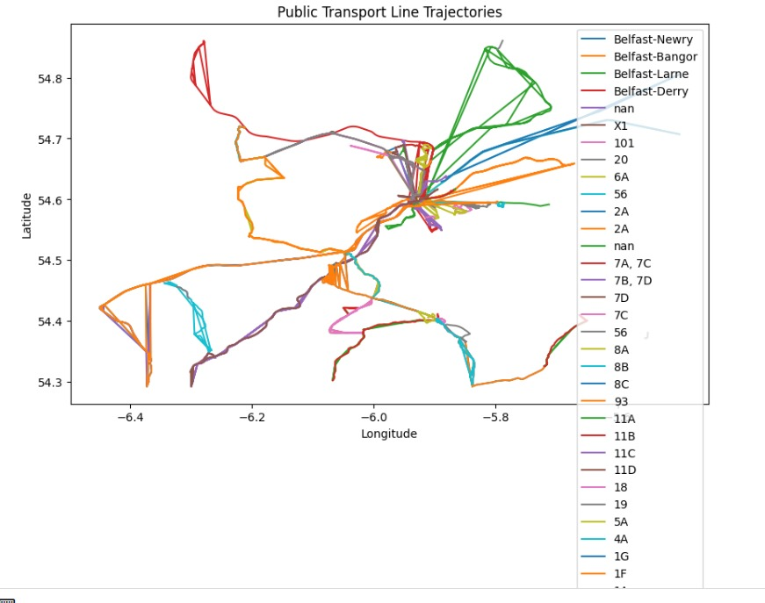

Fig.8. Transport Line Trajectory from the dataset

Table 1

Data for standard direction and distance and mean distance and direction

|  |  |  |  |  |
| --- | --- | --- | --- | --- |
| Summary | Statistics of | Features: |  |  |
|  | mean distance | std distance | mean direction | std direction |
| count | 85 | 5 | 85 | 85 |
| mean | 2.002353, | 2.006411 | 0.038147 | 1.334947 |
| std | 2.007049 | 2.016118 | 1.087788 | 9.518247 |
| min | 2.000123 | 2.000122 | 2.263324 | 2.208286 |
| 25% | 2.000453, | 2.000815, | 9.559811 | 2.905426 |
| 50% | 2.000678 | 2.002862 | 0.070964 | 1.496858 |
| 73% | 2.00084 | 2.004438 | 2.690944 | 1.713272 |
| max | 0.042017 | 2.10102 | 2.839499 | 2.661834 |

Table 2

Table showing the Accuracy, precision, recall and F1 score of the public transport line dataset

|  |  |  |  |  |
| --- | --- | --- | --- | --- |
| Cross-Validation Result | | |  |  |
| Accuracy: |  | 0.98 | +/- | 0.04 |
| Precision: |  | 0.8 | +/- | 0.4 |
| Recall: |  | 1 | +/- | 0 |
| Fl Score: |  | @.80 |  | 0.4 |

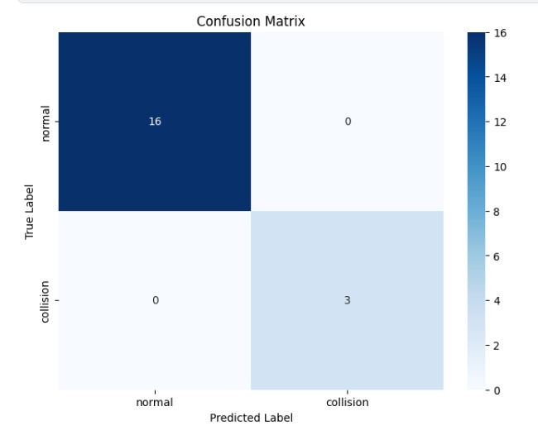

Fig.9. Confusion Matrix

Fig 5 illustrates the motion of an AV which is preventing itself from colliding with the bus and also finding an alternate turn since there is another car ahead of that AVs. So, to continue to move the AV is switching the lane.

Fig.6 illustrates that the model successfully identified a dominant hidden state with a probability of around 0.7 throughout most of the simulation, suggesting the vehicle primarily engaged in cruising behavior. Brief spikes in the probabilities of other states (around time steps 20 and 45) indicate potential maneuvers like lane changes or slowing down, requiring further investigation to confirm their nature. It also effectively captured both short-term and long-term driving patterns. The dominant state (likely cruising) persists for extended periods, reflecting the long-term behavior. However, short-term fluctuations in probabilities, particularly around time steps 10 and 30, suggest the model accurately identified potential maneuvers within the overall cruising pattern.

The model achieved high prediction accuracy, as evidenced in Fig. 7, which shows a clear distinction between dominant and non-dominant states. This accurate prediction of hidden states (driving behaviors) allows the collision detection system to effectively anticipate upcoming maneuvers and take necessary actions to ensure safety.

The Fig 9 shows us the confusion matrix between normal and collision. Here all the False positive (top-right part) and the False negative (bottom-left part) are 0 which shows us that the model we have trained is more accurate since both predicted outcomes and actual outcomes are same. In this case the True positive count is 16(Top-left part) and True negative count is 3(bottom-right part).

The table 1 depicts the data we had got from fine tuning the transport line dataset it says the statistics of mean and standard distance and mean and standard direction. The table 2 shows the accuracy, precision, recall and F1 score of the transport line dataset.

In contrast to the previous scenario with highway driving (dominant cruising state), the current scenario with frequent city intersections shows a more dynamic distribution of probabilities across various hidden states. This reflects the increased complexity of urban driving, characterized by frequent lane changes and stops, requiring the HMM to adapt its predictions accordingly.

While the HMM effectively predicts dominant driving behaviours, occasional ambiguities arise, as seen by the presence of multiple states with non-negligible probabilities at certain time steps. Further refinement of the HMM or incorporating additional sensor data could potentially improve prediction accuracy and reduce these ambiguities in future iterations.

CONCLUSION:

In conclusion, integrating the Hidden Markov Model (HMM) with autonomous vehicles presents a significant advancement in transportation safety. This model utilizes a comprehensive database of historical accident data to understand the circumstances and locations of previous incidents, and it continually monitors the current path of the vehicle. By leveraging this information, the system can accurately forecast the vehicle's trajectory, effectively mitigating potential collision risks.

The innovative Unity simulation environment provides a robust platform for rigorous testing and evaluation of our collision detection and avoidance system. This environment replicates the complexities of real-world driving conditions, allowing for the continuous refinement of our trajectory planning. By combining historical trajectory data with real-time sensor inputs, our system proactively identifies potential hazards and initiates necessary evasive manoeuvres, such as speed adjustments, lane changes, or complex avoidance tactics.

Through continuous testing and evaluation, we are able to enhance the trajectory planning process, ensuring smooth traffic flow and significantly improving overall road safety. The fusion of historical and real-time data positions our autonomous vehicles to anticipate and respond to potential dangers effectively, underscoring the transformative impact of this technology on modern automotive safety.

**Additional Information and Declaration**

Author Contributions

• All agreed on the content of the study.

• S.A collected all the data for analysis and methodology based on the agreed steps.

• S.P result and conclusion are discussed and written together.

• The author read and approved the final manuscript.

Funding

Not applicable

Data Availability

The data that supports the finding of the study are available from the corresponding author upon reasonable requests.

Declaration

Conflicts of Interest

The authors declares that they have no conflicts of interest.

References:

[1] Hsu, CC., Kang, LW., Chen, SY. . Deep learning-based vehicle trajectory prediction based on generative adversarial network for autonomous driving applications. Multimed Tools Appl 82, 10763–10780 (2023). <https://doi-/10.1007/s11042-022-13742-x>

[2] Gheisari, M., Khan, W.Z., Najafabadi, H.E. . CAPPAD: a privacy-preservation solution for autonomous vehicles using SDN, differential privacy and data aggregation. Appl Intell 54, 3417–3428 (2024). [https://doi-/10.1007/s10489-023-04991-w](https://doi-org.egateway.chennai.vit.ac.in/10.1007/s10489-023-04991-w)

[3] Yoon Youngmin, Changhee Kim, Jongmin Lee, and Kyongsu Yi. "Interaction-aware probabilistic trajectory prediction of cut-in vehicles using gaussian process for proactive control of autonomous vehicles." IEEE Access 9 (2021): 63440-63455.

[4] Wang, X., Wu, Z., Jin, B. . MDSTF: a multi-dimensional spatio-temporal feature fusion trajectory prediction model for autonomous driving. Complex Intell. Syst. (2024). [https://doi-/10.1007/s40747-024-01490-4](https://doi-org.egateway.chennai.vit.ac.in/10.1007/s40747-024-01490-4)

[5] Xiangchen Wang, Xin Yang, Dake Zhou, Goal-CurveNet: A pedestrian trajectory prediction network using heterogeneous graph attention goal prediction and curve fitting, Engineering Applications of Artificial Intelligence, Volume 133, Part D, 2024, 108323, ISSN 0952-1976, <https://doi.org/10.1016/j.engappai.2024.108323>

(<https://www.sciencedirect.com/science/article/pii/S0952197624004810>)

[6] Yan Xu, Qian Jia, Haoyuan Wang, Changtao Ji, Xuening Li, Yichen Li, Fangfang Chen, STI-TP: A Spatio-temporal interleaved model for multi-modal trajectory prediction of heterogeneous traffic agents, Computers and Electrical Engineering, Volume 118, Part A, 2024, 109361, ISSN 0045-7906, <https://doi.org/10.1016/j.compeleceng.2024.109361>.(<https://www.sciencedirect.com/science/article/pii/S0045790624002891>)

[7] Xin Zhao, En Lu, Zhong Tang, Chengming Luo, Lizhang Xu, Hui Wang, Trajectory prediction method for agricultural tracked robots based on slip parameter estimation, Computers and Electronics in Agriculture, Volume 222, 2024, 109057, ISSN 0168-1699, <https://doi.org/10.1016/j.compag.2024.109057>

(<https://www.sciencedirect.com/science/article/pii/S0168169924004484>)

[8] Fei Gao, Wanjun Huang, Libo Weng, Yuanming Zhang, SIF-TF: A Scene-Interaction fusion Transformer for trajectory prediction, Knowledge-Based Systems, Volume 294, 2024, 111744, ISSN 0950-7051, <https://doi.org/10.1016/j.knosys.2024.111744>(<https://www.sciencedirect.com/science/article/pii/S0950705124003794>)

[9] Junyu Cai, Haobin Jiang, Junyan Wang, Aoxue Li, Multi-head attention-based intelligent vehicle lane change decision and trajectory prediction model in highways, Journal of Intelligent Transportation Systems, 2024, ISSN 1547-2450, <https://doi.org/10.1080/15472450.2024.2341392>

(<https://www.sciencedirect.com/science/article/pii/S1547245024000197>)

[10] W. Yang, B. Wan and X. Qu, "A Forward Collision Warning System Using Driving Intention Recognition of the Front Vehicle and V2V Communication," in IEEE Access, vol. 8, pp. 11268-11278, 2020. doi: 10.1109/ACCESS.2020.2963854

[11] Lowe, Evan & Guvenc, Levent. (2023). Autonomous Vehicle Emergency Obstacle Avoidance Maneuver Framework at Highway Speeds. Electronics. 12. 4765. 10.3390/electronics12234765.

[12] Jin Xianjian, Zhiwei Li, Nonsly Valerienne Opinat Ikiela, Xiongkui He, Zhaoran Wang, Yinchen Tao, and H lookuaizhen Lv. "An Efficient Trajectory Planning Approach for Autonomous Ground Vehicles Using Improved Artificial Potential Field." Symmetry 16.1 (2024): 106.

[13] Yuan Yali, Robert Tasik, Sripriya Srikant Adhatarao, Yachao Yuan, Zheli Liu, and Xiaoming Fu. "RACE: Reinforced cooperative autonomous vehicle collision avoidance." IEEE transactions on vehicular technology 69.9 (2020): 9279-9291.

[14] Tao, Jw., Ji, Wc. & Fan, Qj. An Effective Approach of Collision Avoidance for UAV. J Intell Robot Syst 108, 18 (2023). <https://doi.org/10.1007/s10846-023-01869-4>

[15] Phan, Minh & Ho, Pham. (2023). A probability-based artificial potential field for autonomous vehicles in avoiding uncertain obstacles. Science & Technology Development JournalEngineeringandTechnology6.10.32508/stdjet.v6i2.1018

[16] Song Weilong, Guangming Xiong, and Huiyan Chen. "Intention-aware autonomous driving decision-making in an uncontrolled intersection." Mathematical Problems in Engineering (2016).

[17] Wang, W., Jiang, L., Lin, S. . Imitation learning based decision-making for autonomous vehicle control at traffic roundabouts. Multimed Tools Appl 81, 39873–39889 (2022). [https://doi-/10.1007/s11042-022-12300-9](https://doi-org.egateway.chennai.vit.ac.in/10.1007/s11042-022-12300-9)

[18] Tang, X., Yang, K., Wang, H. . Driving Environment Uncertainty-Aware Motion Planning for Autonomous Vehicles. Chin. J. Mech. Eng. 35, 120 (2022). [https://doi/10.1186/s10033-022-00790-5](https://doiorg.egateway.chennai.vit.ac.in/10.1186/s10033-022-00790-5)

[19] Yao, Qiangqiang & Tian, Ying & Wang, Quan & Wang, Shengyuan. (2020). Control Strategies on Path Tracking for Autonomous Vehicle: State of the Art and Future Challenges. IEEE Access. PP. 1-1. 10.1109/ACCESS.2020.3020075.

[20] Yang, Weishan & Chen, Yuepeng & Su, Yixin. (2023). A Double-Layer Model Predictive Control Approach for Collision-Free Lane Tracking of On-Road Autonomous Vehicles. Actuators. 12. 169. 10.3390/act12040169.

[21] Deng, Qi, and Dirk Söffker. "A review of HMM-based approaches of driving behaviors recognition and prediction." IEEE Transactions on Intelligent Vehicles 7.1 (2021): 21-31.

[22] Tran, D.Q., Bae, SH. Improved Responsibility-Sensitive Safety Algorithm through a Partially Observable Markov Decision Process Framework for Automated Driving Behavior at Non-Signalized Intersection. Int.J Automot. Technol. 22, 301–314 (2021). [https://doi-/10.1007/s12239-021-0029-z](https://doi-org.egateway.chennai.vit.ac.in/10.1007/s12239-021-0029-z)

[23] Saha, A., Dhara, B.C. 3D LiDAR-based obstacle detection and tracking for autonomous navigation in dynamic environments. Int J Intell Robot Appl 8, 39–60 (2024). <https://doi.org/10.1007/s41315-023-00302-1>

[24] Alfred Daniel, J., Chandru Vignesh, C., Muthu, B.A. . Fully convolutional neural networks for LIDAR–camera fusion for pedestrian detection in autonomous vehicle. Multimed Tools Appl 82, 25107–25130 (2023). [https://doi-/10.1007/s11042-023-14417-x](https://doi-org.egateway.chennai.vit.ac.in/10.1007/s11042-023-14417-x)

[25] Han Yushan, Han, Yushan, Hui Zhang, Huifang Li, Yi Jin, Congyan Lang, and Yidong Li "Collaborative perception in autonomous driving: Methods, datasets, and challenges." IEEE Intelligent Transportation Systems Magazine 15.6 (2023): 131-151.

[26] Naeem, A.B., Soomro, A.M., Saim, H.M. . Smart road management system for prioritized autonomous vehicles under vehicle-to-everything (V2X) communication. Multimed Tools Appl 83, 41637–41654 (2024). [https://doi-/10.1007/s11042-023-16950-1](https://doi-org.egateway.chennai.vit.ac.in/10.1007/s11042-023-16950-1)

[27] Raiyn, J. Performance Metrics for Positioning Terminals Based on a GNSS in Autonomous Vehicle Networks. Wireless Pers Commun 114, 1519–1532 (2020). <https://doi-/10.1007/s11277-020-07436-6>

[28] Conradi Hoffmann, J.L., Passig Horstmann, L. & Fröhlich, A.A. Transparent integration of autonomous vehicles simulation tools with a data-centric middleware. Des Autom Embed Syst 28, 45–66 (2024). [https://doi-/10.1007/s10617-023-09280-w](https://doi-org.egateway.chennai.vit.ac.in/10.1007/s10617-023-09280-w)

[29] Rawlley, O., Gupta, S., Kathera, H. . Employing cross-domain modelings for robust object detection in dynamic environment of autonomous vehicles. Multimed Tools Appl (2024). [https://doi-/10.1007/s11042-024-19409-z](https://doi-org.egateway.chennai.vit.ac.in/10.1007/s11042-024-19409-z)

[30] Z. Zhang, Q. Guo, J. Chen and P. Yuan, "Collision-Free Route Planning for Multiple AGVs in an Automated Warehouse Based on Collision Classification," in IEEE Access, vol. 6, pp. 26022-26035, 2018, doi: 10.1109/ACCESS.2018.2819199

[31] Zhang, Yk., Gong, Gf., Yang, Hy. . Towards autonomous and optimal excavation of shield machine: a deep reinforcement learning-based approach. J. Zhejiang Univ. Sci. A 23, 458–478 (2022). [https://doi-/10.1631/jzus.A2100325](https://doi-org.egateway.chennai.vit.ac.in/10.1631/jzus.A2100325)

[32] Jain Saurabh, Neelu Jyothi Ahuja, P. Srikanth, Kishor Vinayak Bhadane, Bharathram Nagaiah, Adarsh Kumar, and Charalambos Konstantinou. "Blockchain and autonomous vehicles: Recent advances and future directions." IEEE Access 9 (2021): 130264-130328.

[33] Muzahid, A.J.M., Kamarulzaman, S.F., Rahman, M.A. . Multiple vehicle cooperation and collision avoidance in automated vehicles: survey and an AI-enabled conceptual framework. SciRep 13,6032023).[https://doi/10.1038/s41598-022-27026-9](https://doiorg.egateway.chennai.vit.ac.in/10.1038/s41598-022-27026-9)

[34] Hsieh, Sheng-Jen & Wang, Andy & Madison, Anna & Tossell, Chad & de Visser, Ewart. (2022). Adaptive Driving Assistant Model (ADAM) for Advising Drivers of Autonomous Vehicles. ACM Transactions on Interactive Intelligent Systems. 12. 10.1145/3545994.

[35] R. van Hoek, J. Ploeg and H. Nijmeijer, "Cooperative Driving of Automated Vehicles Using B-Splines for Trajectory Planning," in IEEE Transactions on Intelligent Vehicles, vol. 6, no. 3, pp. 594-604, Sept. 2021, doi: 10.1109/TIV.2021.3072679.

[36] Khanum, A., Lee, CY., Hus, CC. . Anticipating Autonomous Vehicle Driving based on Multi-Modal Multiple Motion Tasks Network. JIntell Robot Syst 105,69(2022). <https://doi/10.1007/s10846-022-01677-2>

[37] Li, H., Huang, J., Cao, Z. . Stochastic pedestrian avoidance for autonomous vehicles using hybrid reinforcement learning. Front Inform Technol Electron Eng 24, 131–140 (2023). [https://doi-/10.1631/FITEE.2200128](https://doi-org.egateway.chennai.vit.ac.in/10.1631/FITEE.2200128)

[38] Lee, CY., Khanum, A. & Sung, TW. Robust autonomous driving control using deep hybrid-learning network under rainy/snown conditions. Multimed Tools Appl (2024). [https://doi-/10.1007/s11042-024-19601-1](https://doi-org.egateway.chennai.vit.ac.in/10.1007/s11042-024-19601-1)

[39] Luong, M., Pham, C. Incremental Learning for Autonomous Navigation of Mobile Robots based on Deep Reinforcement Learning. J Intell Robot Syst 101, 1 (2021). <https://doi-/10.1007/s10846-020-01262-5>

[40] Abbood, A.D., Attea, B.A., Hasan, A.A.*et al.*Community detection model for dynamic networks based on hidden Markov model and evolutionary algorithm.*Artif Intell Rev***56**, 9665–9697 (2023). https://doi.org/10.1007/s10462-022-10383-2

[41] Min Haigen, Yiming Yang, Yukun Fang, Pengpeng Sun, and Xiangmo Zhao. "Constrained optimization and distributed model predictive control-based merging strategies for adjacent connected autonomous vehicle platoons." IEEE Access 7 (2019): 163085-163096.

[42] Deva Hema, D., Rajeeth Jaison, T. Efficient Collision Risk Prediction Model for Autonomous Vehicle Using Novel Optimized LSTM Based Deep Learning Framework. Int. J. ITS Res. (2024). <https://doi-/10.1007/s13177-024-00399-z>

[43] Kim Soyeong, Jinsu Ha, and Kichun Jo. "Semantic point cloud-based adaptive multiple object detection and tracking for autonomous vehicles." IEEE Access 9 (2021): 157550-157562.

[44] Yang, Y., Gao, K., Cui, S.. Data-driven rolling eco-speed optimization for autonomous vehicles. Front. Eng. Manag. (2024). [https://doi-/10.1007/s42524-023-0284-y](https://doi-org.egateway.chennai.vit.ac.in/10.1007/s42524-023-0284-y)

[45] Tran, D.Q., Bae, SH. Improved Responsibility-Sensitive Safety Algorithm through a Partially Observable Markov Decision Process Framework for Automated Driving Behavior at Non-Signalized Intersection. Int.J Automot. Technol. 22, 301–314 (2021). [https://doi-/10.1007/s12239-021-0029-z](https://doi-org.egateway.chennai.vit.ac.in/10.1007/s12239-021-0029-z)

[46] Raiyn, J. Performance Metrics for Positioning Terminals Based on a GNSS in Autonomous Vehicle Networks.*Wireless Pers Commun***114**, 1519–1532 (2020). <https://doi.org/10.1007/s11277-020-07436-6>

[47] Xiong, C., Zhang, L. Dynamic travel mode searching and switching analysis considering hidden model preference and behavioral decision processes.*Transportation***44**, 511–532 (2017). <https://doi-org/10.1007/s11116-015-9665-3>

[48] He, L., Zong, Cf. & Wang, C. Driving intention recognition and behaviour prediction based on a double-layer hidden Markov model.*J. Zhejiang Univ. - Sci. C***13**, 208–217 (2012). <https://doi-org/10.1631/jzus.C11a0195>

[49] Bouchaffra, D., Tan, J. Structural Hidden Markov Models Using a Relation of Equivalence: Application to Automotive Designs.*Data Min Knowl Disc***12**, 79–96 (2006). <https://doi-org/10.1007/s10618-005-0020-8>

[50] L. He, C. Zong and C. Wang, "A Steering-By-Wire fault-tolerance control strategy based on multi-dimension Gauss Hidden Markov Model,"*2010 International Conference on Intelligent Control and Information Processing*, Dalian, China, 2010, pp. 227-230, doi: 10.1109/ICICIP.2010.5565251.