
EM4020: MSc. Dissertation

Mapping the Path to Net-Zero: A Bibliometric and Systematic Literature Review of Transition Strategies.

Submitted by:
SUSHMA SHIVAKUMAR BILIDALE
(MSc. Engineering Management)
Name of the Supervisor: MARTINS OBI
Submission date: 07.02.2025

DECLARATION:
I declare that I have personally prepared this assignment. The work is my own, carried out personally by me unless otherwise stated, and has not been generated using paid-for assessment writing services or Artificial Intelligence tools unless specified as a clearly stated
approved component of the assessment brief. All sources of information, including
quotations are acknowledged using the appropriate citations and references. I declare that this work has not gained credit previously for another module at this or another University, save for permitted elements that formed part of an associated proposal linked
directly to this submission.
I understand that plagiarism, collusion, copying another student, and commissioning (which for the avoidance of doubt includes the use of essay mills and other paid-for assessment writing services, as well as unattributed use of work generated by Artificial Intelligence tools)
are regarded as offenses against the University’s Assessment Regulations and may result in
formal disciplinary proceedings.
I understand that by submitting this assessment, I declare myself fit to be able to undertake the assessment and accept the outcome of the assessment as valid.



EPS Ethics Self-Declaration Form for MSc Dissertation Projects
EPS Department: Engineering & Physical Sciences
Degree Programme: MSc. Engineering Management
Project Title: Mapping the Path to Net-Zero: A Bibliometric and Systematic Literature Review of Transition Strategies.
Supervisor Name and e-Mail: Martins Obi (Email – m.obi@aston.ac.uk)
Student Name, Number, and e-Mail: Sushma Shivakumar Bilidale 230427192 (Email- 230427192@aston.ac.uk)

Ethics questions
Please answer Yes or No to each of the following four questions:
1 - Does the project involve participants selected because of their links with the NHS/clinical practice or because of their professional roles within the NHS/clinical practice, or does the research take place within the NHS/clinical practice, or involve the use of video footage or other materials concerning patients involved in any kind of clinical practice? Yes / RNo
2 - Does the project involve any i) clinical procedures or ii) physical intervention or iii) penetration of the participant's body or iv) prescription of compounds additional to normal diet or other dietary manipulation/supplementation or v) collection of bodily secretions or vi) involve human tissue which comes within the Human Tissue Act? (e.g., surgical operations; taking body samples including blood and DNA; exposure to ionizing or other radiation; exposure to sound light or radio waves; psychophysiological procedures such as fMRI, MEG, TMS, EEG, ECG, exercise and stress procedures; administration of any chemical substances)? Yes / RNo

Please briefly justify your answer_____________________________________________________________
________________________________________________________________________________

3 - Having reflected upon the ethical implications of the project and/or its potential findings, do you believe that that the research could be a matter of public controversy or have a negative impact on the reputation/standing of Aston University? Yes / R No
Please briefly justify your answer_____________________________________________________________
________________________________________________________________________________
________________________________________________________________________________
4 - Does the project involve interaction with or the observation of human beings, either directly, indirectly or remotely (e.g., via CCTV or internet), including but not limited to surveys, questionnaires, focus groups, interviews, records relating to humans, use of online datasets (e.g., blogs, social media, etc) or other secondary data, observations, etc.?
Yes / RNo

Student's signature: Sushma Shivakumar Bilidale
Supervisor's signature: Martins Obi
Date: 06-02-2025

Please submit this form as part of your Project Definition Document. If any of the answers are “yes”, you will need to submit an application for ethics approval as per the instructions provided on your MSc dissertation Blackboard site.

FOR OFFICIAL USE ONLY
Version | 1 | Author | Research Integrity Office
Approved date | 26/05/2022 | Approved by | APVC Research Integrity
Effective date | 26/05/2022 | Review date | Annually

ACKNOWLEDGEMENT:
I would like to acknowledge my supervisor Dr.Martins Obi for invaluable guidance, support, and encouragement throughout the course of this research. His expertise, insightful feedback, and patience have been instrumental in shaping this dissertation.
I am truly grateful for the time and effort he dedicated to mentoring me, providing me with helpful criticism, and encouraging me to improve my concepts and approach. Throughout this academic journey, I have been motivated by his unfailing support and belief in my ability.
I want to express my profound gratitude for his commitment to academic success and for establishing an atmosphere that encouraged critical thinking and intellectual development. This dissertation would not have been possible without his guidance and for that, I am immensely thankful.
Sincerely,
Sushma Shivakumar Bilidale

ABSTRACT:
The manufacturing sector's role in the decarbonization agenda to achieve Net Zero by 2050 spans its operations and the wider economy by helping design and manufacture products needed for a low-carbon economy. Countries are trying to develop strategies and roadmaps for Net Zero transitions in the Manufacturing sector. For instance, in partnership with Inspire PLC, Make UK developed the UK’s road map to Net Zero in 2050. However, most of the transition roadmaps are developed in consultation with only manufacturing and sub-manufacturing sectors, thus, neglecting the potential roles and impacts that other sectors could have on the manufacturing sector and vice versa in the transitioning process. Furthermore, research in manufacturing Net Zero transition has focused on core manufacturing activities without viewing the transition strategies from a holistic perspective and gathering insights from other sectors. In this work, we deploy a bibliometric analysis to study the research in Net Zero Transitions in the Manufacturing sector and a Systematic Literature review to scope the links with Manufacturing and other sectors in transitioning to a carbon-neutral economy and finally identify the interventions and impacts from different sectors to Net Zero Transitions in Manufacturing. The outcome of this work provides an opportunity to understand what the manufacturing sector identifies as Net Zero transitions and opens-up conversations on the role of other sectors in achieving Net Zero Manufacturing.

CONTENTS:
DECLARATION: 2
EPS Ethics Self-Declaration Form for MSc Dissertation Projects 3
Ethics questions 3
ACKNOWLEDGEMENT: 5
ABSTRACT: 6
LIST OF TABLES: 9
LIST OF FIGURES: 10
LIST OF ABBREVIATIONS: 11
1.1 Background Study: 13
1.2 Existing Research on Net zero Transition in manufacturing: 14
1.3 Research Problem 15
1.4 Why the research gap needs to be filled? 15
1.5 Research Aim 15
1.6 Objectives of the Study 15
1.7 Research questions: 16
1.8 Significance of the study: 16
1.8.1 The Need for a Holistic Perspective 16
1.9 How does the study attempt to fill the gap? 17
1.9.1 Leveraging Bibliometric Analysis 17
1.9.2 Complementing Bibliometric Analysis with Systematic Literature Review 18
2. LITERATURE REVIEW: 18
2.1 Introduction: 18
2.2 Defining the Research Question using the PICO Framework: 19
2.3 Search strategy: 21
2.4 PRISMA Framework: 21
2.5 Risk of Bias Assessment: 23
2.5.1 Discourse and mitigation strategies: 23
2.6 Synthesis Findings: 24
2.6.1 Landscape-level (Macro level): 25
2.6.2 Regime-level dynamics (Meso Level): 25
2.6.3 Niche Innovations (Micro Level): 26
2.7 Intervention: 27
2.7.1 Transportation: 27
2.7.2 Renewable energy: 27
2.7.3 Governance Policies: 28
2.7.4 Industries: 29
2.7.5 Digital Technologies: 30
2.7.6 Buildings & construction: 30
3. RESEARCH METHODOLOGY & DATA COLLECTION: 31
3.1 Introduction & Research Overview: 31
3.1.1 Research Philosophy: 31
3.1.2 Research Approach: 32
3.1.3 Methodological Choice: 32
3.1.4 Time Horizon – Longitudinal approach: 33
3.1.4 Research Design – Mixed Methodology: 33
3.1.5 Data Collections: 33
3.1.6 Data Analysis: 34
3.1.7 Ethical Considerations: 34
4. DATA ANALYSIS: 35
4.1 Introduction to Analysis and Critique: 35
4.2.1 Citation Analysis: 35
4.2.3 Publication Trends & Temporal Analysis: 40
4.2.4 Geographic Distribution: 41
4.3 Research Analysis Performed on Question 2 – How does the manufacturing sector connect with other sectors in transitioning to a carbon-neutral economy 42
4.3.1 Sectoral Linkage Analysis: 43
5. DISCUSSION AND RECOMMENDATION: 43
5.1 Understanding intersectoral contribution to manufacturing emissions: 44
5.1.1 Energy systems and decarbonization – 50% of manufacturing emissions: 44
5.1.2 Supply chain and logistics -20% of manufacturing emissions: 45
5.1.3 Policy & Economic measures- 10% of manufacturing emissions: 45
5.1.4 Technology & digitalization – 10% of manufacturing emissions: 45
5.1.5 Urban & Industrial Infrastructure – 5% of manufacturing emissions: 46
5.2 A systematic approach to carbon reduction beyond manufacturing – Recommendations: 46
6. CONCLUSION: 47
7. RESULTS: 47
RESEARCH LIMITATIONS: 48
FUTURE WORK: 49
REFERENCES: 49

LIST OF TABLES:
Table 1 – Most cited authors 36
Table 2- Most Influential Journals 37
Table 3- Prominent institutions 37
Table 4- Publication Trend analysis 40
Table 5- Geographical distribution of publications 41

LIST OF FIGURES:
Figure 1: PICO Framework 20
Figure 2: Search Strategy (Nyangchak, 2022) 21
Figure 3: PRISMA Flowchart 22
Figure 4: Visual Representation of RoB Assessment 23
Figure 5: MLP Framework 24
Figure 6: Saunder’s Research Onion Framework (Source: Saunders et al. 2012) 31
Figure 7: Graphical representation of the keywords used in the selected articles. Source: Analysis developed by the authors using information extracted from Scopus & WoS. 39
Figure 8: Sector-wise distribution of research papers 42
Figure 9: Sectoral linkage analysis 43
Figure 10: CO2 contribution & reduction in manufacturing 47

LIST OF ABBREVIATIONS:
1x ABC activity-based costing
2x AI Artificial Intelligence
1x BETs battery-electric trucks
5x CCS carbon capture and storage
4x CCUS carbon capture, utilization, and storage
1x CDR Carbon Dioxide Removal
3x CE circular economy
1x CPOs charge point operators
1x CRFR climate-related financial risk
1x DAC direct air capture
2x EAF Electric Arc Furnaces
4x EE Electrify Everything
2x EH enhanced hydrocarbon recovery
9x EU European Union
13x EV electric vehicle
1x FWCI field-weighted citation impacts
3x GFL grid-following
1x GG Going Green
2x GHG greenhouse gas
1x HPC high-performance computing
1x IBRs inverter-based resources
1x IH Innovation Hotspot
3x IoT Internet of Things
1x ISMP Iron and steel manufacturing process
1x LESER Lean energy-saving and emission-reduction
2x MLP Multi-level Perspective
1x NZCB net-zero carbon building
1x NZT Net Zero Transition
1x ORMs Object-Relational Mappers
1x OSW Organic Solid Waste
1x PGMs platinum metal group
1x PM Place Matters
10x PRISMA Preferred Reporting Items for Systematic Reviews and Meta-analyses
6x PV photovoltaic
1x RoB Risk of Bias
9x SLR systematic literature review
1x SMEs Small Medium enterprises
2x SMRs Small Modular Reactors
1x V2G vehicle-to-grid
1x VPSA vacuum pressure swing adsorption
1x ZEV Zero Emission vehicle

Mapping the Path to Net-Zero: A Bibliometric and Systematic Literature Review of Transition Strategies.
1. INTRODUCTION:

1.1 Background Study:
The Global objective of accomplishing Net Zero emissions by 2050 is an explicit challenge since certain necessitating anomalous changes need to be incorporated across various domains, such as the economic, social, and industrial sectors. Net zero demands urgent, front-loaded emissions reductions. Carbon dioxide removals and offsets must be used cautiously and regulated effectively (Axelesson, fankhauser and Hale, 2023). Among these, the most significant contributor to greenhouse gas emissions is the manufacturing sector. This sector plays a pivotal role in building the economy by serving job creation and always focusing on innovations and technologies. The sector drives economic stability and industrial growth nonetheless a significant contributor to greenhouse gas (GHG) emissions. The manufacturing sector has a dual nature, where it can reduce its emissions and support other sectors through the design and production of low-carbon technologies. Achieving Net Zero emissions by 2050 is accelerated by the combination of strategies such as adopting low and zero-carbon renewable fuels, implementing decarbonization roadmaps, and leveraging innovations in various industrial processes (Anika et al., 2022). The key approach is to enhance energy efficiency, promoting cross-sectoral collaboration to ensure holistic reductions in emissions. Consequently, focusing on core manufacturing activities and intersectoral impacts aims to integrate sustainability into economic systems and perpetuate long-term carbon neutrality. (Anika et al., 2022) These strategies should align with the international climate goals like those of the Paris Agreement to limit global warming to 1.5°C. That essentially requires countries to set and update emission reduction targets while encouraging further global cooperation in climate mitigation. (Liobikienė and Butkus, 2017)
In retaliation to this imperative, most countries across the world are reinforcing new strategies and roadmaps to pilot the manufacturing sector transition towards Net zero. For instance, The United Kingdom’s collaborative initiative with Inspire PLC makes the UK craft a roadmap that combines the sector’s strategies and includes decarbonization plans that aid in achieving net zero by 2050. However, despite the prominence of these efforts, the approaches taken often exhibit significant limitations. Predominantly, these roadmaps are developed with a narrow focus on the manufacturing and sub-manufacturing sectors, neglecting the complex interdependencies with other sectors of the economy. This siloed approach risks overlooking critical insights and contributions that could be derived from a more integrated perspective.

1.2 Existing Research on Net zero Transition in manufacturing:
A study conducted by (Khalifa et al., 2022) explores how transitioning to a circular economy (CE) can help achieve net zero emissions by 2050. By addressing both energy and non-energy-related greenhouse gas emissions. The study reviews CE across various sectors such as technology, finance, ecosystems, and behavior. According (Steiner et al., 2024) manufacturing sectors are responsible for 20% of the EU’s carbon emissions, and using the Delphi methodology the author has only focused on NZCSCs (Net-Zero carbon supply chains). (Okorie et al., 2023) emphasizes digital transformation in the manufacturing industries and using CE and results in the sustainable manufacturing sector. Is about the empirical analysis of EU ETS operational phases. (Vieira, Longo and Mura, 2021) The study demonstrates about few installations that have reduced carbon emissions after thirteen years of carbon emissions regulations. However, the inferior emission reduction performance indicates that EU, ETS phase 3 did not translate. Additional policies are likely necessary to achieve carbon neutrality by 2050. (Glavič et al., 2023) Advocates that net zero emissions can be reduced by optimizing the chemical industries. Study shows that four solutions for fuel switching (green hydrogen, electrification, turquoise hydrogen, and waste heat capture) will be arranged in the next decade, but carbon capture and utilization, industrial bio-based operations, steam cracker electrification, small modular nuclear reactor needs more development to drive longstanding impact. (Nyangchak, 2022) This study has a systematic approach, determining the driving factors behind the emerging green industry. The study researches the questions of when, why, and how, and under what conditions the factors are/are not effective in driving the green industry. Along with other research papers, it either explains the interventions in a particular domain that contributes carbon emissions to the manufacturing sector or revamps the internal process of the manufacturing sector.

1.3 Research Problem
The transition to Net Zero cannot be achieved in isolation by any single sector. The manufacturing sector, for instance, relies heavily on energy systems, transportation networks, waste management practices, and regulatory frameworks, all of which shape its capacity to decarbonize. Similarly, decisions made within manufacturing—such as material selection, process design, and supply chain restructuring—can have far-reaching implications for other sectors, influencing their trajectories toward Net Zero. Yet, current research and policy frameworks often fail to adequately address these interactions, focusing instead on core manufacturing activities such as process optimization, energy efficiency, and emissions control.

1.4 Why the research gap needs to be filled?
Existing research on the manufacturing sector's Net Zero transition has tended to adopt a fragmented approach, emphasizing technical and operational aspects while neglecting the broader systemic and cross-sectoral dimensions. For instance, significant attention has been given to technological advancements, such as energy-efficient machinery, carbon capture and storage (CCS), and digital transformation tools. Or explains that decarbonization can be achieved in different sectors such as resource efficiency, green finance, digitalization, and low-emission transport but likely not explain their interdependencies and connections. However, these studies frequently operate within the confines of the manufacturing sector, paying insufficient attention to how these innovations are influenced by or contribute to other sectors’ decarbonization efforts. This gap underscores the need for a more holistic perspective that situates manufacturing within the broader economic and industrial ecosystem. This study explains the impact that other sectors could have on the manufacturing sectors and vice versa in the transitioning process.

1.5 Research Aim
The research aim is to understand the research landscape in Net Zero transitions and develop the links from other sectors for transitions in the manufacturing sector.

1.6 Objectives of the Study
To seek advanced knowledge and practices related to the Net Zero transition in the manufacturing sector It endorses an interdisciplinary perspective and a holistic approach.
- Conducting a Bibliometric analysis, identifying key themes, trends, and knowledge gaps, and mapping the research landscape on manufacturing and Net Zero transitions.
- Investigating the domains that are interconnected to the manufacturing sectors that are contributing to carbon emissions and exploring their roles in the manufacturing sector.
- Finding and measuring the efficacy and scalability of solutions from other industries that aid in manufacturing’s shift to Net Zero.
- Propose integrated strategies for Net Zero transitions that leverage cross-sectoral synergies and address systemic challenges.

1.7 Research questions:
R1. What is the current research landscape in Net Zero transitions?
R2. What other sectors are linked to Manufacturing in the Net Zero Transitions?
R3. What interventions/links could be drawn from other sectors/domains to aid manufacturing Net Zero Transition?

1.8 Significance of the study:

1.8.1 The Need for a Holistic Perspective
The commencement of the complication requires a fundamental transformation of global production and consumption patterns, particularly in the manufacturing sector, to achieve a net zero transition by 2050. This transformation extends beyond decarbonizing operations and demands a systemic, cross-sectoral approach that integrates energy, waste management, transportation, and policy frameworks. (Qian et al., 2024). To reduce emissions in industrial processes the manufacturing sector’s decarbonization is constitutionally linked to the energy sector’s transition to renewables. It should be operated in low-carbon power sources such as wind, solar, and hydrogen (Tuokko and Silver, 2024) For example, in the Suzhou case study, a deep decarbonization strategy is examined and highlighted how systemic collaboration between different sectors such as urban planning, manufacturing, and energy sectors can significantly lower both carbon dioxide and air pollutant emissions (Qian et al., 2024). This study demonstrates the effectiveness of coordination between industries and municipalities to drive into sustainable approach to achieve net zero. To make manufacturing operations eco-friendly supply chain operations should also be optimized. The transportation and logistics should shift towards electric and hydrogen-powered vehicles (Mete et al., 2021). To reduce reliance on virgin raw materials, and minimize industrial waste circular economy innovations will be functional (Islam & Ali, 2024). Moreover, investments in carbon capture hubs and carbon dioxide transport infrastructure have been identified as key enablers for cross-sectoral decarbonization. (Karlsson, 2024). Current research risks overlooking synergies and co-benefits arising from cross-sectoral collaboration. These are critical for a sustainable net zero transition. Therefore, this study will accomplish in proposing a survey of interconnected domains that contribute to manufacturing’s carbon emissions.

1.9 How does the study attempt to fill the gap?

1.9.1 Leveraging Bibliometric Analysis
Bibliometric analysis is a powerful method that has been used to provide a quantitative analysis. Bibliometric analysis can also be called “Infometrics” (Egghe and Rousseau, 1990). This type of analysis is used is built on a collective of literature studies. The bibliometric analysis mainly overviews the highly cited publications from the selected papers. The overviews are sub-divided into lists of author productions, and national or subject bibliographies. It also includes geographical (Lin, 2012) (Zhuang et al., 2012) and institutional aspects to validate the performance over the period (Huffman et al., 2013). This methodology is usually used for quantitative analysis. But nowadays it's used in qualitative analysis as well. The analysis also shows several author's collaborations and which author has been cited the most. This analysis can narrow down the study to find the desired output for the research (Ellegaard and Wallin, 2015). This method is used to provide the interrelations between different groups in the scientific community (Barth, Haustein, and Scheidt, 2013). Content analysis under bibliometric analysis provides the keyword analysis that again is a quantitative approach together helps identify how the field has evolved and which areas require further exploration (Ellegaard and Wallin, 2015). Bibliometric tools like VOS viewers, the latest version of 1.6.20 was released on October 31, 2023. This tool is used to drive the above-mentioned methods. Furthermore, Bibliometric analysis helps uncover knowledge gaps by identifying underexplored areas within net-zero research. It reveals emerging topics, the impact of policy-driven studies, technological advancements, and guiding future research directions. By leveraging this approach, policymakers, industries, and researchers can make data-driven decisions to accelerate the transition towards carbon carbon-neutral future.

1.9.2 Complementing Bibliometric Analysis with Systematic Literature Review
While bibliometric analysis provides a macro-level view of the research landscape, a systematic literature review (SLR) offers a more detailed and critical evaluation of specific studies. By synthesizing the findings of individual works, an SLR enables researchers to delve into the substantive content of the literature, exploring the methods, theories, and conclusions that underpin current understanding. SLR is known for positive studies since it includes statistically significant findings that either benefit or harm (Nightingale, 2009).
In this study, the SLR focuses on the links between manufacturing and other sectors, examining how cross-sectoral interactions influence the Net Zero transition. It explains the research questions using the PICO framework. This section also includes inclusion and exclusion that should be clearly stated using the PRISMA framework (Nightingale, 2009). Synthesis finding of each sector explains how they release carbon footprint, and the author’s approach to those findings will be stated. Interventions for each sector suggested by authors will be interpreted. By systematically addressing these questions, the SLR complements the bibliometric analysis, providing a richer, qualitative, and more nuanced understanding of the systemic nature of Net Zero transitions.

2. LITERATURE REVIEW:

2.1 Introduction:
This study aims to address this gap by endorsing an interdisciplinary approach to explore the links between manufacturing and other sectors in the transition to a carbon-neutral economy. The objectives of this research study are:
- Conducting a bibliometric analysis to map the research landscape on the Net Zero transition in the manufacturing industry.
- Inspecting the roles and contributions of interconnected sectors in reinforcing manufacturing’s decarbonization efforts.
- Distinguish and evaluate cross-sectoral interventions that accelerate Net zero transition in manufacturing.
- Recommend integrated strategies that leverage synergies across different sectors to address systematic challenges and accelerate the transition to a sustainable low-carbon economy.
The Methodology for this research combines Bibliometric analysis and systematic literature review (SLR) to anticipate a comprehensive study of Net Zero transitions in manufacturing. For Bibliometric analysis, the study employs data from databases such as Scopus, Web of Science, and Google Scholar. The study Predominantly focuses on peer-reviewed papers published between 2020 and 2024. The analysis maps, research trends, and citation patterns identify key themes, and knowledge gaps and are performed using the VOS viewer tool. The analysis distinguishes the quantitative approach that highlights the evolution of research and coloration networks over the years, offering a macro-level view of the field.
The Systematic Literature Review (SLR) Complements by rendering a qualitative, in-depth analysis of cross-sectoral interactions and interventions. Primarily, the research questions were defined using the PICO framework. Besides, explaining the selected studies to explore how other interconnected sectors influence Manufacturing’s decarbonization. It synthesizes findings on interventions, impacts, and interdependencies. Subsequently, the PRISMA framework illustrates the review protocol for study selection.
In conjunction with these two methods, the study enables a dual perspective: a broad, data-driven overview of the existing study is powered by Bibliometric Analysis. Systematic Literature review (SLR) delves into specific insights. Establishing a holistic and interdisciplinary approach to interpret Net Zero transition in Manufacturing.

2.2 Defining the Research Question using the PICO Framework:
In SLR, the PICO framework is essential for structuring and refining the research question. It outlines the Population, intervention, comparison, and outcomes of the study. The trick with a PICO framework is that it searches all the possible combinations of search terms using Boolean operators such as OR & AND, and segregates different groups of terms, and generates the required data. (Sayers, 2008). These elements facilitate search strategy development for a precise answer. In this research, the PICO framework helps define the relationship between the manufacturing sector and other industries in achieving decarbonization goals.

O
Outcomes of Cross-sectoral linkages, Policy recommendations, strategic interventions

C
Comparison of Net Zero roadmaps for different countries, and different developing strategies.

I
Interventions in Policy Frameworks, Technological advancement, circular economy, renewable energy adoptions

P
The targeted population is Manufacturing & Interconnected sectors

Figure 1: PICO Framework
Population (P): The population in this study refers to the manufacturing and other interconnected sectors. (Na et al., 2022) established an assessment to optimize energy consumption, energy efficiency, and carbon dioxide emissions in the Iron and steel manufacturing process (ISMP). Besides (Mikulčić et al., 2016) provided a research study that carbon emissions can be reduced through energy efficiency improvements within the manufacturing sectors. Furthermore, (Cai et al., 2019) being concerned about carbon emissions proposed a new concept entitled Lean energy-saving and emission-reduction (LESER). This approach is an effective method to improve energy efficiency and reduce waste emissions.
Intervention (I): the interventions in this study include policy frameworks, technological advancements, renewable energy adoption, circular economy practices, and industry collaborations. These interventions aim to drive decarbonization within manufacturing and facilitate a holistic transition to net zero.
Comparison (C): The comparison element in this study involves the Net Zero roadmap comparisons of different countries such as the UK, EU, and USA. (Make UK and Inspired PLC,2022) Also differentiating their emerging economies by developing strategies in manufacturing and sub-manufacturing sectors. In the USA, to achieve net zero in 2050; the federal government should engage with various stakeholders to prevent private developers from introducing individual projects. To succeed in this, the effort will need to be simultaneously inclusive and expedient (Jenkins et al., 2021). For the EU, several major European countries have already announced more than two-thirds of newly sold vehicles to be electric by 2030, and for trucks, the manufacturers have announced the target of 100% ZEV (Zero Emission vehicle) trucks in sales by 2040 (Plotz, Wachsmuth and Gnann, 2021).
Outcomes (O): Identifying key research gaps, policy recommendations, and strategic interventions. That is discussed further in the literature review.

2.3 Search strategy:
The study strategy employed a structured approach using Boolean operators and wildcard symbols to ensure comprehensive coverage of relevant literature on net-zero manufacturing transitions. An Iterative search strategy. Begins with the key topic in the research questions. Key terms were created from the topic titles and the results, evaluated the results, and the key terms to search again. The first search string, “Net Zero Manufactur” and “Transition”, gave in three articles, expanding the query to “Net Zero Transition” and “Manufactur” which resulted in seven articles, yielded a broader set of studies that discuss the transition aspect in manufacturing. The most inclusive search, “Net Zero” “Transition” and “Manufactur” retrieved 106 articles. Demonstrating the extensive research interest in the intersection of net-zero goals, transition processes, and the manufacturing sector. (Nyangchak, 2022)

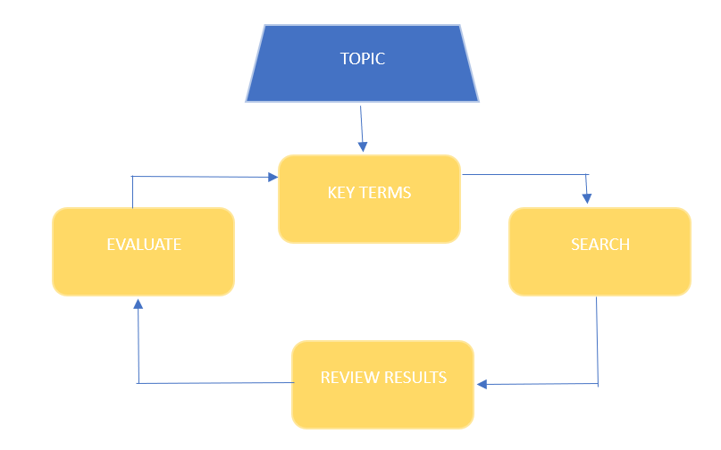
Figure 2: Search Strategy (Nyangchak, 2022)

2.4 PRISMA Framework:
Evolution of PRISMA: The PRISMA (Preferred Reporting Items for Systematic Reviews and Meta-Analyses framework was introduced in 2009 as an advanced framework over the QUOROM (Quality of Reporting of Meta-analyses) which was developed in 1999. To enhance transparency and accuracy in systematic reviews and meta-analyses PRISMA was designed by provisioning a structured approach to reporting research findings (Page et al., 2021).
The below flowchart represents the PRISMA framework of the Systematic Literature review 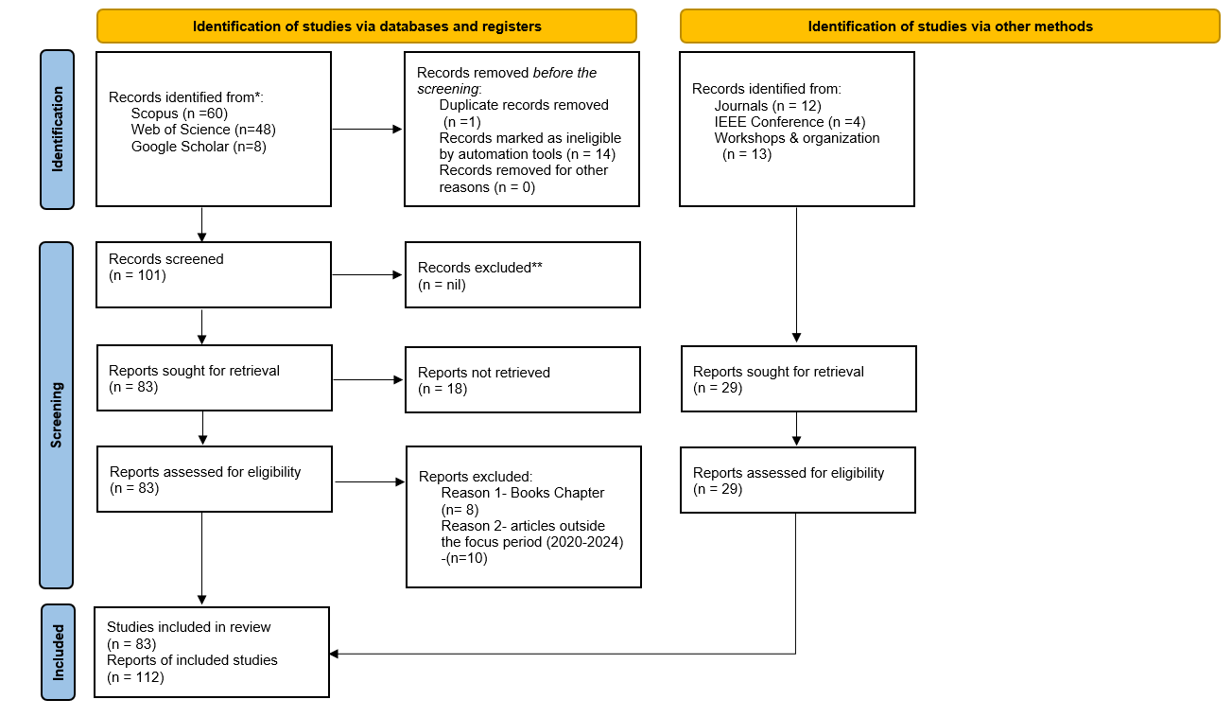
Figure 3: PRISMA Flowchart
Identification: The initial search identified 120 research papers from databases such as Scopus – 60 papers, Web of Science-48 papers, and Google Scholar- 8, along with 29 additional records from journals (12), IEEE conferences (4), and workshops/organizations (13). Before the screening process, 1 paper was removed due to duplication, and the other 16 were removed due to irrelevance records.
Screening: After removing ineligible papers 101 records were screened, from these, 83 reports were sought for retrieval, but 18 were not retrieved due to unavailability or access restrictions.
Eligibility: The 83 retrieved reports were assessed for relevance by applying strict inclusion/exclusion criteria. At this stage, 18 papers were excluded for being book chapters ( 8) or outside the focus period (2020-2024) in 10 papers.
Inclusion: Consequently, 83 studies were included in the review, contributing to 112 reports in total. This Rigorous selection ensures high-quality sources relevant to the research focus. The PRISMA flowchart visually represents this systematic process, enhancing transparency and replicability in this study.

2.5 Risk of Bias Assessment:
The Risk of Bias (RoB) assessment is a crucial step in ensuring the reliability and validity of this systematic literature review and bibliometric analysis on Net Zero Transition (NZT). Since the study has a mixed-method approach; combining bibliometric analysis and qualitative systematic review – this assessment evaluates potential biases in study selection, data sources, methodological transparency, and author interpretations.

2.5.1 Discourse and mitigation strategies:
Definition Bias (High Risk): Studies define “Net Zero Transition” differently leading to inconsistencies. To mitigate this, we categorized definitions into themes for comparative analysis.
Publication Bias (Moderate Risk): The reliance on highly cited journals might incline results. Including Web of Science and Google Scholar helped diversify sources.
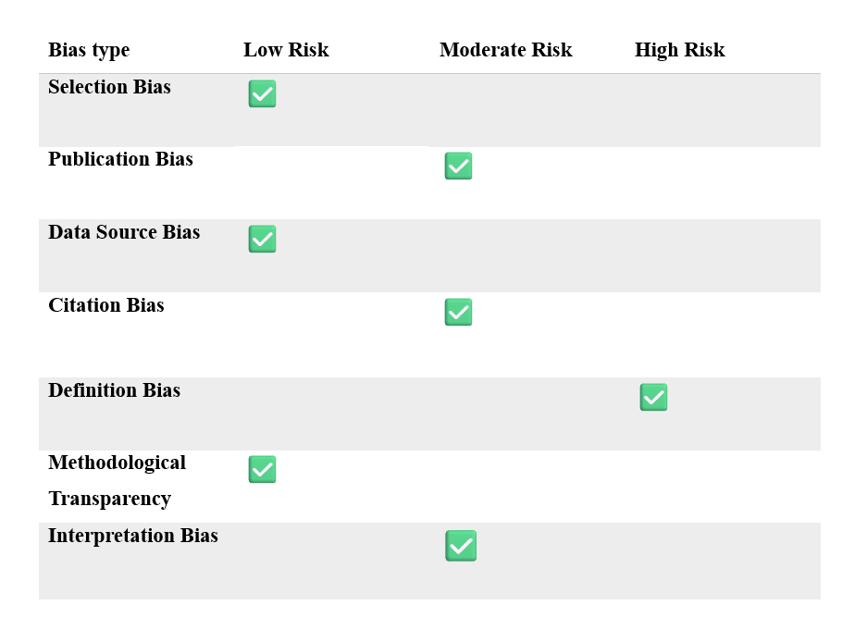
Figure 4: Visual Representation of RoB Assessment
Citation Bias (Moderate Risk): The prominence of specific authors and institutions might influence interpretations. To counter this, the study cross-verified insights with qualitative thematic analysis.
Interpretation Bias (Moderate Risk): some conclusions may reflect dominant narratives rather than empirical bibliometric trends. The study addressed this by incorporating systematic coding of themes.
This systematic review and bibliometric analysis are kept rigorous and reliable by the risk of bias evaluation. Although some biases cannot be eliminated, the study’s robustness is increased by methodological transparency and the use of mitigation techniques. To further minimize biases, future studies should consider broadening their data sources and enhancing their bibliometric methods.

2.6 Synthesis Findings:
The transition to net zero requires a multi-faceted approach to encapsulate the existing findings from the different domains. The Multi-level Perspective (MLP) provides a useful framework for analyzing this transition by categorizing findings. 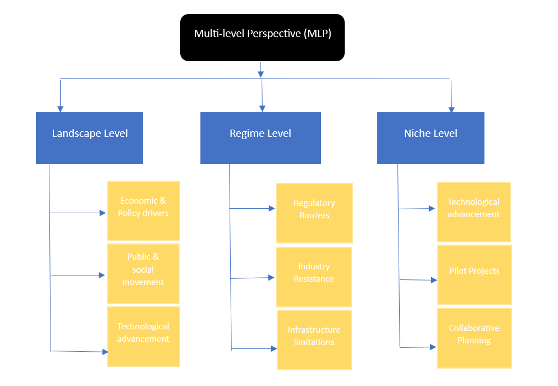
Figure 5: MLP Framework

2.6.1 Landscape-level (Macro level):
Economic and Policy Pressure: This study focuses attention on the role of fiscal policies in driving net-zero transitions. (Lee, 2023) discusses bold EU fiscal policies, promoting electric vehicle (EV) adoption, and expanding green energy generation. 50% of EU carbon emissions are from transportation and energy generation.
Public and social movements: To accelerate the commitment towards decarbonization the public commitment to follow rules, and the global agreement related to the climate plays a vital role. According to (Sharp, Raven, and Farrelly, 2024) there are four distinct net zero frames emerged: Electrify Everything (EE): transitioning all things of importance to renewable energy and electrification. Secondly, Place Matters (PM): this explains the prioritization of liveability, mobility, and inclusivity. Going Green (GG) explains about following a circular economy principle and nature-based solutions. Lastly, Innovation Hotspot (IH): that Precinct is a hub for innovations and entrepreneurship to drive net zero.
Technological Advancements: the technological advancement to indicate shifts in infrastructure priorities by the expansion of hydrogen production. In life with (Maynard and Abdulla, 2023) Bringing up the cost-effectiveness approach in the place that green hydrogen production from Organic Solid Waste (OSW) is expensive compared to grid integration. The costs are projected to be viable only with very aggressive growth, learning rates, and reduced electrolyzer costs (target of $2/kg H₂). To achieve a net zero transition by 2050 adoption of hydrogen production infrastructure is required.

2.6.2 Regime-level dynamics (Meso Level):
Regulatory Barriers: The regime level encompasses entrenched institutions, regulatory frameworks, and industrial practices that can either support Net zero transition or obstruct the process. (Lappin, Scott, and Andrew, 2022) Findings reveal that in regulatory barriers Policy-ins, 35% of disabled drivers may lack access to off-street charging by 2030. Therefore, necessitates innovative on-street solutions.
Incumbent Industry resistance: often, energy and transportation firms resist disruptive changes. For example, a decentralized energy system. As stated in (Zafar et al., 2022) Qatar EV (Electric vehicle) usage is limited due to a lack of EV infrastructure such as charging stations and range anxiety. The Hot weather in the country reduces fuel efficiency in petrol vehicles and can significantly impact EV range due to high air conditioning demand, Thereby, suggesting additional battery capacity is needed for EVs in hot climates. Therefore, the study indirectly addresses net-zero goals by exploring EV adoption as a pathway to decarbonize the transportation sector.
Infrastructure Limitations: Certain challenges are faced due to infrastructure limitations. (Liu and Du, 2023) say, the shift to renewable energy in pursuit of the 2050 net-zero emission target highlights the limitations of intermittent power sources like solar PV. This solution might improve grid integration. The author emphasizes overbuilding PV capacity and controlled curtailment as practical alternatives to expensive energy storage.

2.6.3 Niche Innovations (Micro Level):
Technological advancements: (Earl et al., 2022) Cobalt is indispensable for Lithium-ion batteries used in electric vehicles, renewable energy storage, and other applications. A circular economy for cobalt is underdeveloped with low possibility recycling rates. Bioleaching and Phytomining are new technologies that are promising for sustainable extraction. However, it comes with certain challenges.
Pilot projects: various studies such as (Bellabarba et al., 2023) highlight small-scale pilot programs testing the viability of net zero interventions. In catalyst development research made on earth abundant metals such as Ni & Co are displaced platinum metal group (PGMs) for recent catalytic processes. The main intention behind this is technology adaptation; repurposing refining infrastructure for processing sustainable feedstocks. By engaging stakeholders in energy, catalysis, and material recycling sectors to promote cross-industry collaboration.
Collaborative planning: Multi-sector partnerships are essential for scaling up innovations, as seen in energy-sharing initiatives in local communities. Small Modular Reactors (SMRs); nuclear reactors to generate clean electricity for hard-to-electrify sectors. That being the case, creating “for -the-greater-good” ecosystems. Businesses and countries need to collaborate to share their technologies to reduce emissions and manage geopolitical risks in the supply chain. As per (Copeland, 2023) participatory energy futures allow stakeholders to collaboratively envision pathways toward net-zero emissions.
This could bridge governance gaps by incorporating local perspectives and societal buy-in. consequently, combining exploratory futures with democratic processes like mini-publics enhances long-term decision-making. Additionally (Finstad and Dahl Andersen, 2023) mention promoting cross-sector collaborations will pool resources and share knowledge. This process he calls collaborative industrial clusters.

2.7 Intervention:

2.7.1 Transportation:
Transitioning to a sustainable transportation Electric vehicle (EV) infrastructure development is a crucial aspect. Several authors have suggested interventions to enhance EV adoption and support renewable energy integration. (Zafar et al., 2022) focuses on the need for home and workplace charging stations for fast-charging nodes at high-turnover locations and extended parking. According to the climate, EVs should feature better thermal management and huge batteries. (Lee, 2023) suggests EV subsidies of about €10,000 for lower- middle-income and €5,000 for middle-income households. This will result in doubling the renewable capacity through a €1.58 trillion investment. He suggests that innovations should be encouraged by removing patent barriers and subsidizing R&D. (Lappin, Scott, and Andrew, 2022) and advocates for attainable financial incentives, legislative mandates, and EV charging infrastructure for charge point operators (CPOs) and local authorities (Las). (Sharp, Raven, and Farrelly, 2024) calls for electrification, and improved transport connectivity, to bring in circular economy practices and innovation-driven job opportunities. (Sovacool et al., 2023) recommends solar photovoltaic deployment, heat pumps, and battery storage to optimize renewable energy usage. (McGarry et al., 2024) supports the improvement in technologies such as smart charging with vehicle-to-grid (V2G) systems. Enhancing policy integration and electricity network upgrades.

2.7.2 Renewable energy:
(Maynard and Abdulla, 2023) suggests cost reduction and overbuilt infrastructure by showing the importance of using hydrogen storage, emphasizing underground storage to meet annual rather than monthly demands. Electrolyzer cost reduction is also a priority, aiming to reduce capital costs through technological advancements and economies of scale. (Harvey, Workman and Heap, 2023) proposes the deployment of Carbon Dioxide Removal (CDR) requires a global roadmap with clear targets and safeguards. An international hub would assist in knowledge sharing and policy coordination. Where regional policies would address specific socio-economic and technological contexts. (Veis Karbassi, Trotter and Walther, 2023) highlights deploying renewable infrastructure in underserved regions. The author suggests that encouragement in technology transfer between Europe and Africa would enhance knowledge and innovation exchange. Policy coordination is the most significant task since the development process involves cross-border. Certain regulations standardize and incentivize the renewable energy trade. (Harrison et al., 2023) advocates for advanced grid-forming and grid-following (GFL) configurations, focusing on tuning techniques for weaker grids to improve their applicability. Policy updates should revise grid codes to accommodate GFL converters that meet updated inertial response criteria. Combining GFM and GFL approaches can offer hybrid stabilization solutions, while training programs can educate engineers and policymakers on these technologies.

2.7.3 Governance Policies:
(Lyons and Lee Victoria White, 2023) advocates for innovative financing models by introducing hybrid financial instruments to overcome market barriers. Overall policies should ensure investments target disadvantaged communities, promoting equitable benefits. (Madden, 2022) emphasizes that innovations embrace a systems approach by prioritizing innovation over ESG metrics, stating that ESG relies on linear thinking. Key technological innovations are green hydrogen production, carbon capture and storage (CCS), and small modular reactors (SMRs). By collaborating these technological advancements in ecosystems, can mitigate supply chain risks. By integrating Net Zero strategies into the core operations of the companies, they create a focus on long-term value. (Kuzemko, 2022) highlights Net zero transition can be achieved by government-supported renewable markets, by reducing fossil fuels, and by strengthening climate policy. Technologies like CSS, hydrogen production, and demand-side energy management should be supported with enhanced governmental policies for integrated climate strategies. (Fogg-Rogers et al., 2024) suggests fostering sustainable behavior through education campaigns, community projects, and serious games will help in improving carbon emission reduction. Meanwhile, (Agarwala et al., 2021) suggest implementing carbon pricing mechanisms, public investment in green infrastructure, and regulatory reforms to enforce emission reductions. Similarly, (Chou, Lin, and Walther, 2023) suggest enhancing public engagement in policy-making, and institutional reforms through independent climate governance bodies. Alliance building among academia, NGOs, and civic groups is important for unified policy-making. (Copeland, 2023) proposes democratic engagement through citizen assemblies and participatory workshops, to evaluate multiple net-zero pathways and region-specific energy strategies an exploratory energy futures framework should be introduced. (Klasen et al., 2022) underscores the need for increased technological investments and harmonized international climate finance regulations to reduce carbon emissions in the industry.

2.7.4 Industries:
(Farida Amrouche et al., 2022) advocates that increase in the use of solar and wind energy scale-up renewable-powered enhanced hydrocarbon recovery (EH). Research should focus on upgrading wettability alteration through heat, magnetic fields, and water chemistry to enhance oil recovery. Alongside EH, large-scale carbon capture and storage (CCS) should be deployed to assess net-zero feasibility. (Huo et al., 2023) highlights that developing regional Carbon dioxide transportation infrastructure, prioritizing low-impact feedstocks, and fostering cross-sector collaboration are essential for carbon management. (Bellabarba et al., 2023) emphasize feedstock diversification should include Carbon dioxide conversion biomass utilization and waste plastic upcycling. They also suggest catalyst development using earth-abundant metals for sustainable refining and recycling. Existing infrastructure should be repurposed into circular chemical plants, while metal recycling innovations should improve catalytic material recovery. (Jean-Pierre Birat, 2023) recommends creating collaborative roadmaps for aligning mining, hydrogen production, and steel-making sectors and expanding green hydrogen investments, hydrogen storage, and renewable-powered iron ore reduction methods that can decarbonize steel production. (Turner et al., 2021) suggests reallocating public funds to support CCS projects, introducing tax-based subsidies, and aligning Scottish and UK policies for competitiveness. (Wang et al., 2023) calls for the electrification of oil and gas operations and funding for innovative technologies like nanoparticle-enhanced recovery and hydrogen production. Meanwhile (Deng et al., 2023) advocate for systematic energy optimization, renewable energy expansion, and CCUS integration into daily operations through demonstration projects such as developing model areas to showcase energy-saving and emission-reducing practices.

2.7.5 Digital Technologies:
Authors like (He et al., 2023) and (Fragkos, 2022) propose event adaptation in microgrid control strategies using real-time sensor data. They emphasize the need for interoperable frameworks to ensure compatibility across digital twin systems and advocate for predictive maintenance using machine learning to prevent system failures. (Bergman and Foxon, 2022) suggests policy interventions to enhance data privacy and security while promoting smart digital tools for energy demand reduction. Behavioral interventions should encourage responsible energy consumption through education and incentives, while technological interventions focus on energy-efficient ICT infrastructure and automation for renewable energy integration. (Liao et al., 2023) explains the importance of subsidy allocation for energy storage and photovoltaic (PV) installations. Incentives should encourage businesses to adopt self-sufficient PV systems and energy procurement should be optimized by storing energy during low-demand periods for peak usage. To favor low-carbon sectors and increase penalties for carbon-intensive investments, (Jackson and Bailey, 2023) recommend financial policy adjustments, including expanding bond purchases. Refined climate-related financial risk (CRFR) metrics should be incorporated by enhanced risk assessments.

2.7.6 Buildings & construction:
(Hasan, Lizarralde and Lachapelle, 2023) advocates for a lifecycle approach to reducing emissions across the entire building sector, from manufacturing and transportation to construction. To ensure consistency policy integration is essential in aligning private net-zero carbon building (NZCB) certifications with public regulatory standards. To boot, technological advancements should be prioritized, including the adoption of innovative materials and energy-efficient building designs to minimize environmental impact. (Hammond and Titley, 2022) encourages micro-combined heat and power (micro-CHP) adoption in residential communities to maximize shared benefits while smart grid integration should be improved to optimize energy use and cost efficiency. The economic and policy interventions in this scenario should provide subsidies or tax credits for Micro-CHP adoption and also invest in research and development for cost reduction and improved system performance. (Debnath et al., 2022) highlights behavioral interventions using financial and non-financial incentives to encourage sustainable habits. The adoption of sustainable materials such as mass timber and other low-carbon alternatives is an important aspect of reducing building emissions. Strengthening policy frameworks that incorporate net-zero mandates into global building codes, ensures widespread adoption of sustainable construction practices.

3. RESEARCH METHODOLOGY & DATA COLLECTION:

3.1 Introduction & Research Overview:
This chapter outlines the research methodology focused on the study. It includes a structured framework presented in Saunders' Research Onion. The framework systematically explores the philosophical assumptions, research approaches, methodological choices, strategies, time horizons, and data collection and analysis techniques. It ensures that each aspect of the methodology is considered logically and cohesively.
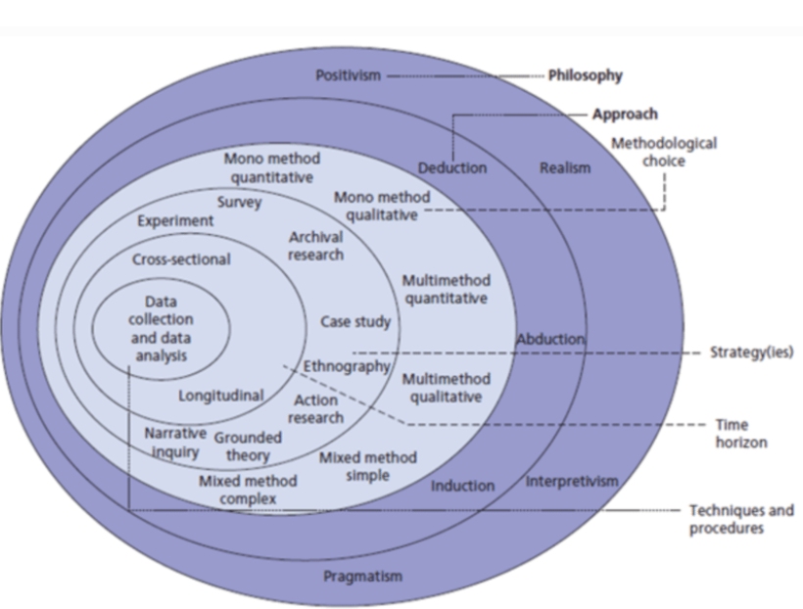
Figure 6: Saunder’s Research Onion Framework (Source: Saunders et al. 2012)

3.1.1 Research Philosophy:
In the research philosophy, the methods that are adopted for this research are Interpretivism approach. The interpretivism approach is suitable because the study seeks to explore how different sectors contribute to the manufacturing sector’s Net Zero transitions. It focuses on understanding the complexities and interrelations within a social and economic context. In the research, Interpretive social analysis connects closely to value-critical policy analysis, where we think about the value choices faced in public action and the value priorities embodied in policy frameworks (e.g., Rein, 1976). This research illustrates the interpretivism approach with the recent research about the net zero transition. The measures taken by different sectors to reduce carbon emissions. Especially on how they are linked to the manufacturing industry. The analysis of discourse and how it structures attention and action can lead to compulsive hypotheses. For instance, the term "carbon," which has been used so frequently in discussions of climate change (carbon markets, carbon capture, carbon sinks, carbon tax, decarbonization, and so forth), has focused too much on carbon dioxide emissions at the expense of other important and perhaps more manageable aspects of the issue. (cf. Prins et al., 2010).

3.1.2 Research Approach:
Identification of information and communication entities is thought to be possible through content analysis, which is methodically carried out by reading and watching texts or objects. It is thought to provide rigorous and repeatable previous research to investigate document distribution (Wimbadi and Djalante 2020). Content analysis is critical in structurally assessing a large amount of information by accurately apprehending pertinent data to determine significant and actual issues, approaches, and arguments. The analysis consists of two types: inductive and deductive reasoning processes (Laibach, Börner, and Bröring 2019). To achieve the goals of this study, the inductive reasoning process involves abstracting, condensing, and organizing the data using concepts, categories, or themes. This study follows an inductive approach since the methodology is a bibliometric analysis of net-zero manufacturing, it involves data-driven investigation into an interconnected multi-disciplinary sector. An Inductive approach helps uncover patterns, trends, and relationships directly from the data (Jebb, Parrigon and Woo, 2017). This approach enables to discovery of an unknown connection between the sectors and facilitates theory-building.

3.1.3 Methodological Choice:
The study adopts a mixed-methods approach the Quantitative Method wherein, Bibliometric analysis quantitatively examines trends, research collaborations, and publication patterns from 115 research papers related to Net Zero Transition. The next approach would be the Qualitative Method Systematic literature review provides qualitative insights into the interactions between manufacturing and other sectors, highlighting interventions and impacts. This methodological choice allows the study to leverage the strengths of both numerical analysis and textual interpretation, providing a well-rounded perspective on the research topic.

3.1.4 Time Horizon – Longitudinal approach:
A longitudinal approach is well-suited for this study because Net-zero transitions are inherently long processes. There will be a constant evolution of policy shifts, technological advancements, and industry-wide transformations. Establishing Net zero transition requires continuous adaptation across multiple sectors. Analyzing these changes over time for a more accurate assessment of trends, challenges, and progress. A longitudinal study helps identify how interventions develop and improve industry innovations and policies. Subsequently, it helps in assessing the effectiveness of interventions, and whether these efforts lead to significant emission reductions and industry shifts. This approach helps in observing relationships over time and reveals patterns of collaboration, bottlenecks, and opportunities. Governments and industries rely on historical data and trend analysis to design effective policies. It also eases in tracking research and innovational growth that helps highlight which areas gain prominence and which need further exploration

3.1.4 Research Design – Mixed Methodology:
The study employs a mixed methods research design since two processes take place, quantitative approach that is bibliometric analysis. This involves citation impact assessment, publication trend evaluations, sectoral linkages, and technological advancement over the years. The second would be a qualitative approach-systematic literature review. That involves thematic analysis, policy critique, and a deeper understanding of the contextual and strategic factors influencing Net Zero Transitions. This mixed method approach ensures a holistic perspective outcome in both statistical trends and nuanced sectoral interactions.

3.1.5 Data Collections:
The data collected in this study is mostly secondary data. That includes research papers, journal articles, and case studies. The secondary data is easily accessible through the data archives in the form of data files or Internet data archives (Hox and Boeije,2005). This study employed the PRISMA framework to ensure a systematic and transparent selection of literature. Initially, 120 research papers were identified from databases such as Scopus (60), Web of Science (48), and Google Scholar (8), along with 29 additional records from journals, IEEE conferences, and workshops. After removing one duplicate and 16 irrelevant records, 101 papers underwent screening. Of these, 83 were retrieved, but 18 could not be accessed. Applying strict inclusion/exclusion criteria, 18 more papers were excluded for being book chapters or outside the focus period (2020-2024). Ultimately, 83 studies were included, contributing to 112 reports in total.

3.1.6 Data Analysis:
This study explains a comprehensive data analysis approach to explore net zero transitions, focusing on the manufacturing sector and its linkages to other industries. Since this research is based on secondary data collection, data analysis for this study is a high-quality approach to explain the research questions by allowing a precise interpretation of data (Windle,2010). To derive the quantitative approach bibliometric method is used that draws citation analysis, keyword mapping using VOS viewer, and publication trends to assess the current research landscape. Citation metrics identify influential authors, journals, and institution's contributions to net zero research. Keyword clustering highlights thematic areas such as sustainability, policy frameworks, technological innovations, and carbon capture. Sectoral linkage analysis reveals the interconnections between manufacturing and other domains. To extract qualitative analysis in the study the systematic literature review begins with the PICO framework that assists in defining the research question, followed by the search strategy, PRISMA framework explains the data extraction process. The study consists of a Risk of Bias assessment that assesses the quality of the literature review conducted. Consequently, to receive a thematic analysis MLP framework is applied to observe the synthesis finding, interventions suggested by each author in different sectors are discussed, and finally, the definition of Net zero by a few authors and construct a robust definition of Net Zero transition.

3.1.7 Ethical Considerations:
The study adheres to ethical guidelines, the data integrity section that consists of Bibliometric and qualitative data are collected and analyzed transparently, ensuring replicability. All the Intellectual Property mentioned with Proper citations and acknowledgments are provided for all sources used. Research Neutrality in the systematic review is conducted without bias, ensuring a balanced representation of perspectives.

4. DATA ANALYSIS:

4.1 Introduction to Analysis and Critique:
We conducted a qualitative analysis in a systematic literature review identified the interventions and acknowledged one research question in this study. This analysis is conducted by bibliometric analysis. This quantitative approach addresses further two critical research questions: understanding the current research landscape in Net Zero transitions and exploring the overall research trends, activity, influential contributions, and intersectoral contribution to the manufacturing industry. These methodologies collectively provide a comprehensive understanding of the topic. Ultimately, the study uncovers key outcomes that enhance our understanding of Net Zero transitions and inform future research directions quantitatively.
4.2 Data Analysis performed on 1st research question – The current landscape in Net Zero Transition
This interrogation focuses on understanding the overall research activity, trends, and influential contributions in the field.

4.2.1 Citation Analysis:
Most cited Authors:
In this phase, the study focuses on estimating the citation metrics of the selected 112 articles within a specific timeframe. Table 1 presents the fifteen most influential research on Net Zero transition in Manufacturing Industries and other sectors that focuses on carbon emission reduction. Published between 2020-2024. This collection provides insightful information about the fundamentals that have shaped our comprehension of this important juncture.

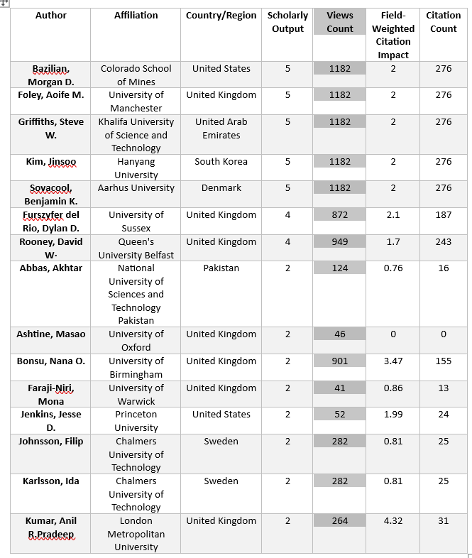
Table 1 – Most cited authors
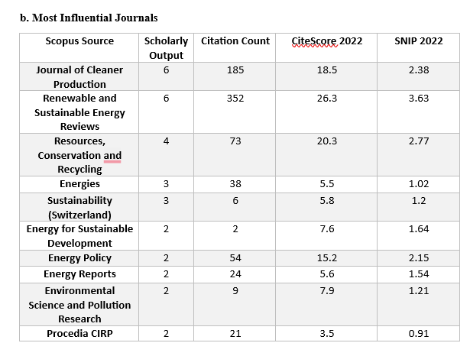
Table 2- Most Influential Journals
In Table 2, The Journal of Cleaner Production, Renewable, and Sustainable Energy reviews are the most influential, reflecting their focus on sustainable practices and innovative energy solutions. Their high citation counts and Cite-Scores indicate their importance as platforms for impactful research. 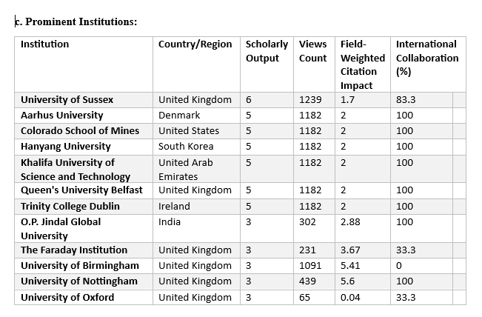
Table 3- Prominent institutions
Table 3 explains the prominent institutions as centers of innovation, cooperation, and information sharing, which are essential to the advancement of research on Net Zero transitions in the industrial sector. The University of Sussex (United Kingdom), Aarhus University (Denmark), and the Colorado School of Mines (United States) are among the major contributors mentioned in the report. High-impact research is regularly produced by these institutions, with a focus on multidisciplinary approaches that combine policy frameworks, technology, and sustainability. Their notable global influence and the value of their contributions to academia and industry are highlighted by their notable field-weighted citation impacts (FWCI).
One characteristic that sets these top universities apart is their collaboration. Aarhus University and Colorado School of Mines, for instance, record 100% international collaboration rates, highlighting the value of international collaborations in tackling the complex issues of reaching Net Zero objectives. With an emphasis on decarbonization technology and the circular economy.
These organizations not only produce cutting-edge research but also foster partnerships with government bodies and industries, translating theoretical insights into actionable solutions. Their prominence in the field reflects their role as key drivers in shaping the discourse and enabling progress toward a carbon-neutral future in manufacturing.
4.2.2 Keyword Analysis:
The study involves analyzing the keywords used in scrutinizing 112 articles and reviews articles. This analysis examines both the keywords provided by the authors and the “keywords plus” automatically extracted from the relevant bibliographic database. Subsequently, these keywords were scrutinized using VOS viewer software. This generated a visual representation of the keyword distribution based on bibliographic data. A database has been established to encompass data related to the 112 chosen articles and reviews. These data include the author’s name, article title, abstract, publication year, keywords, and other pertinent details. The information was sourced from bibliographic records and integrated into VOS viewer software for subsequent analysis.

A total of 2,657 keywords were identified within the papers, articles, and reviews about Net Zero transitions. To refine the focus, we established a minimum occurrence threshold of 10, resulting in 72 keywords meeting the criteria for further analysis. The most relevant keywords were utilized to generate the keyword map illustrated in the attached figure.
The analysis of keywords indicated a significant emphasis on terms related to “climate change,” such as “decarbonization,” “net-zero transition,” “Manufacur” “emission control,” “sustainability,” and “energy policy.” Additional recurring terms included “carbon capture,” “hydrogen production,” “renewable energy,” and “greenhouse gases.” These keywords highlight the thematic diversity of research and the interconnectedness of various subfields.
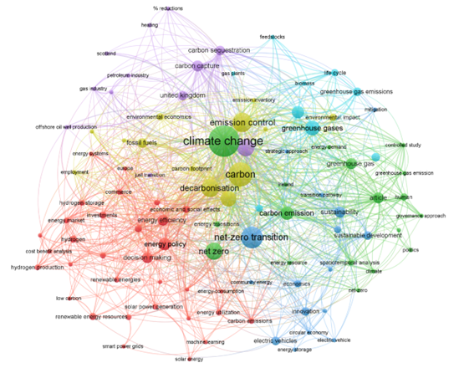
Figure 7: Graphical representation of the keywords used in the selected articles. Source: Analysis developed by the authors using information extracted from Scopus & WoS.
- Green Cluster (climate and sustainability focus): The central green cluster, dominated by terms like “climate change” and “greenhouse gases,” represents a significant area of research focusing on emissions control and sustainability. This cluster has numerous interconnected nodes with “carbon emissions,” “environmental impact,” and “strategic approaches” to decarbonization, demonstrating the research emphasis on achieving global sustainability goals.
- Red Cluster (energy policy and decision-making focus)—The prominent red cluster represents energy policy and decision-making. It also reflects the focus significance of policy implications in the energy transition. Themes that comprise are “renewable energy resources,” “hydrogen production,” and “energy efficiency,”. The cluster underscores research efforts in quantifying the socio-economic trade-offs and benefits of energy transitions.
- Blue Cluster (technology and innovation focus)—This cluster, showcases technological innovations that are linked to “electric vehicles”, “circular economy”, and “machine learning”. this cluster reflects the pivotal role of advanced technologies and data-driven approaches in supporting the energy transition. By exploring these technologies, the research aims to enhance energy utilization and optimize the pathways to net zero.
- Purple Cluster (carbon capture and sequestration focus)—These smaller yet critical Terms such as “gas plants” and “feedstocks” signify research into industrial applications and methods to mitigate carbon emissions effectively. This cluster underscores the technological approaches complementing broader sustainability strategies.

4.2.3 Publication Trends & Temporal Analysis:
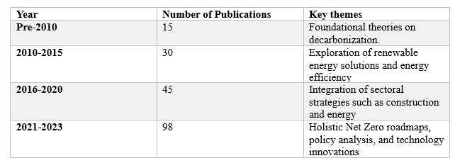
Table 4- Publication Trend analysis

Publication Trends and Temporal Analysis investigates the evolution of Net- Zero Transitions. It mainly focuses on the manufacturing sectors and their interconnected Domains. This analysis combines multiple years of research that took place on this subject and the number of publications published, highlighting significant growth, and active research periods.
- Trend Observations: The study demonstrates that there is a steady growth in scholarly interest, with an increasing number of research on net zero transition bringing a global attention focus on the effect causing to climate change. Publications increased during critical international agreements such as the Paris Agreement and policy. Therefore, the years 2018-2023 saw exponential growth in publication.
- Temporal Growth Patterns: Initial research focused on theories and definitions of Net Zero transition. Between 2010 and 2020 Research diversified into specific areas such as renewable energy, carbon sequestration, and energy efficiency. Post-2020 the government & Industries prioritized the decarbonization strategies for achieving Net Zero goals.
- Key Themes Over Time: Early research themes revolved around defining Net Zero in the manufacturing and energy sector. Recent studies expand to include interdisciplinary approaches, focusing on sectoral linkages (transportation, material science, and policy integration.

4.2.4 Geographic Distribution:
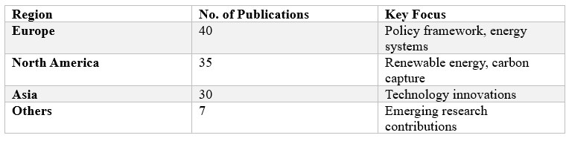
Table 5- Geographical distribution of publications
The study reveals the significant contributions from Europe, North America, and Asia with the UK, USA, and China leading the research landscape. European nations focus on policies and frameworks for net zero while Asian countries focus on technological advancements.

4.3 Research Analysis Performed on Question 2 – How does the manufacturing sector connect with other sectors in transitioning to a carbon-neutral economy
In the research performed, certain domains were discovered that are on the mission of carbon emission reduction. these sectors were found through Databases such as Scopus & Web of Science. With the keywords such as “Net Zero Transition” and “Manufactur” being used. The below figure explains the percentage of research papers found in each sector.
Figure 8: Sector-wise distribution of research papers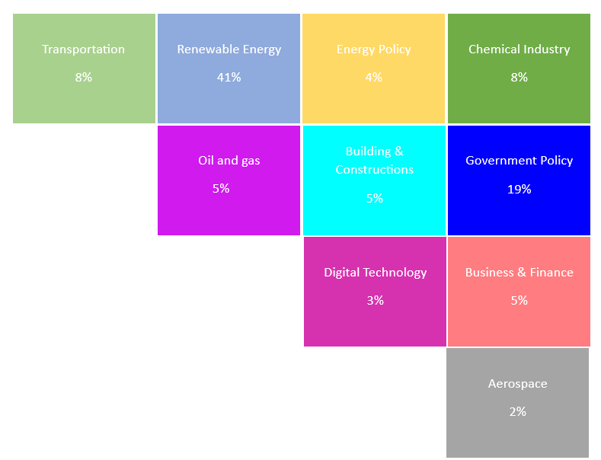

4.3.1 Sectoral Linkage Analysis:
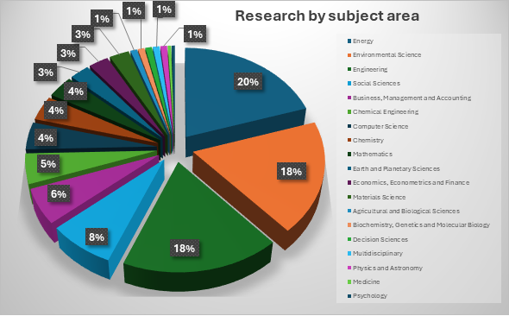
Figure 9: Sectoral linkage analysis
The pie chart above depicts research distribution across various sectors, highlighting their interconnectedness and relevance to Net Zero transitions. The interdependence of these sectors fosters innovations in manufacturing, reducing emissions while promoting circular economies. Effective linkages ensure that industries not only decarbonize but also maintain resilience and competitiveness, enabling a comprehensive transition to Net Zero.

5. DISCUSSION AND RECOMMENDATION:
This study explains that net zero transition can be achieved by decarbonizing the interconnected sectors in the manufacturing industries. (Guan et al., 2021) emphasizes that the manufacturing industry is responsible for 40% of global carbon emissions making it a critical sector for achieving net zero goals. Traditional approaches to reducing emissions have focused primarily on internal manufacturing processes. Such as energy efficiency improvements and process optimizations. However, manufacturing does not operate in isolation- it is deeply interconnected with other sectors, including transportation, energy, supply chain, policy, and digitalization. This study highlights how interventions in these external sectors can contribute significantly to emission reductions in manufacturing, which lead to a system-wide decarbonization strategy.

5.1 Understanding intersectoral contribution to manufacturing emissions:
The carbon emissions from the manufacturing sector extend beyond the internal processes. The emission originates from multiple domains that are interconnected to the manufacturing sector, contributing to the overall 40% share. The estimated breakdown of how various sectors impact manufacturing emissions.

5.1.1 Energy systems and decarbonization – 50% of manufacturing emissions:
The transition to net-zero emissions in manufacturing involves regulating energy systems and adopting decarbonization strategies tailored to various industrial processes. (Tai et al., 2022) highlights that enhanced efficiency in hydrocracking minimizes energy waste and emissions. It’s a significant process optimization in catalytic chemical manufacturing. To reduce reliance on fossil fuels scalable hybrid models, facilitate the transition to renewable feedstocks. (Finstad and Dahl Andersen, 2023) emphasizes the role of carbon footprints in hard-to-abate sectors such as cement and steel. However, challenges arise due to customization needs, technological requirements for specific sectors, and high capital costs. A broader focus on energy efficiency and digitalization is discussed by (Balaji Kalluri et al., 2023) who suggests that by making use of IoT and Data analytics the amount of energy consumption can be tracked and promote behavioral changes in energy use. (Newman, 2023) extends this perspective by underscoring the importance of hydrogen integration and renewable energy particularly in rural and regional industrial settings. Electrification of industrial operations and Zero-carbon logistics contribute to manufacturing’s net-zero transition. (Ni et al., 2020) explains manufacturing with circular economy principles aligning with bio-based materials such as bio-PBS as a sustainable alternative to petroleum-based plastics aids in reducing dependence on fossil fuel. (Ju, Sugiyama and Shiraki, 2023) focuses on renewable energy expansion and its direct impact on manufacturing by increasing clean energy availability, reducing costs, and fostering innovation. However, the study warns that steady energy transitions may force industries to rely on traditional energy sources, raising operational expenses.

5.1.2 Supply chain and logistics -20% of manufacturing emissions:
Author 101 expands the need for regulatory frameworks, A well-structured logistics system, supported by renewable enhances supply chain resilience while lowering emissions from transportation and material sourcing. By prioritizing sustainable energy procurement and optimizing logistics networks, manufacturers can align their operations with net-zero goals while maintaining efficiency and competitiveness electrifying freight transport and optimizing the supply chain can reduce emissions by 5-10%.

5.1.3 Policy & Economic measures- 10% of manufacturing emissions:
Effective policy implementation plays a crucial role in reducing emissions within the manufacturing sectors by integrating regulatory frameworks financial incentives and technological innovations. (Sovacool, Baum and Low, 2023). Policies such as carbon pricing and subsidies for low-carbon technologies encourage industries to adopt sustainable practices (An et al., 2023). Government investments in green finance, workforce training, and energy efficiency initiatives further drive long-term emission reduction (Mayfield et al., 2023). Additionally, monitoring and policy feedback loops enhance the effectiveness of interventions. By aligning manufacturing strategies with net-zero policies, industries can transition toward sustainability while maintaining competitiveness and economic growth (Meadowcroft and Rosenbloom, 2023). Strong policies can drive an additional 5% reduction.

5.1.4 Technology & digitalization – 10% of manufacturing emissions:
AI-driven energy optimization, IoT-enabled predictive maintenance, and digital twins reduce waste and energy consumption (Fragkos, 2022). Advanced computational solutions help manage renewable energy integration, Additionally, digital platforms increase transparency in emissions reporting, aiding in regulatory compliance and sustainable supply chain management. Implementing smart manufacturing could cut emissions by another 5% (Zhang et al., 2018).

5.1.5 Urban & Industrial Infrastructure – 5% of manufacturing emissions:
Building, construction, and infrastructure are closely linked to manufacturing in the pursuit of net-zero emissions. Since both sectors rely on energy-intensive materials like cement & steel. Sustainable industrial zones and changing to smart urban planning can minimize embedded emissions

5.2 A systematic approach to carbon reduction beyond manufacturing – Recommendations:
If Mitigation measures are implemented beyond manufacturing itself, a significant portion of emissions can be eliminated without requiring excessive changes to manufacturing processes. the key concept is that targeting external sectors leads to an indirect yet substantial reduction in manufacturing emissions.
Transitioning to renewable energy cuts 20% of manufacturing emissions. (Ángel, 2024) Policies supporting nuclear flexibility and green hydrogen scaling (Bhattacharya et al., 2024) enhance renewable energy integration with improved grid storage. Using Alternative cement binders and CCUS infrastructure (Griffiths et al., 2023) helps decarbonize material production. (Ankita Singh Gaur et al., 2023) recommends promoting compact urban development that reduces dispersed housing through better spatial planning. Overall, the energy system and decarbonization cause major segment that contributes to manufacturing emissions since significant industries such as steel and iron manufacturers emit large amounts of emissions. If these are mitigated as per the literature review & discussion chapter discussed in this study. The emissions in the manufacturing industry can be reduced drastically. Electrifying logistics and supply chains, the authors provided various recommendations for electrifying logistics and supply chains to reduce carbon footprints in the manufacturing industries. (Schneider et al., 2024) explains Primarily through transportation and energy-intensive operations. Trucks alone account for 25% of transport-related emissions. That represents 8.5% of the European Union’s total emissions. Therefore, as multiple research papers recommended in the study under the literature review and the discussion chapters this domain needs to focus on electrification and battery optimization. Studies indicate that battery-electric trucks (BETs) have lower emissions than diesel trucks powered by renewable energy. This can reduce 5-10% of manufacturing emissions. Policy interventions & Green subsidies that are discussed in this study encourage a 5% reduction in carbon emissions. Consequently, using advanced digital technologies & smart manufacturing can save 5%. This approach ensures a cascading reduction in carbon emissions. Interventions in external sectors simultaneously lower the 40% emissions from manufacturing without requiring drastic process modifications.
6. CONCLUSION:
Decarbonizing manufacturing requires a holistic, cross-sectoral approach rather than isolated interventions. Interconnected sectors such as energy transition, supply chain optimization, digitalization, and strong policies collectively contribute to reducing emissions more effectively than internal improvements alone. A system-wide strategy is essential for achieving sustainability. Net-Zero manufacturing.

Figure 10: CO2 contribution & reduction in manufacturing

7. RESULTS:
In this section, the study reports the results of the Data Analysis conducted on three research questions of the study.
R1: What is the current research landscape in Net-Zero transitions?
From Most cited papers, an influential paper that was conducted by bibliometric analysis concluded that most of the studies are on enhancing sustainable practices in the renewable energy sector. The study showed that interacting and collaborating globally with different organizations can come up with new technologies and policies that can even ultimately reduce the emissions that are contributing to the manufacturing sector. Therefore, the emission reduction will not only in occur the internal operations of manufacturing sectors but also on an external level.
R2: What other sectors are linked to manufacturing in the NZT?
Identifying interdependent sectors in this study emphasizes the importance of collaborating the industries and innovating new technologies and policies will help the countries achieve the global target of achieving net zero by 2050. The study also demonstrated which industry releases more emissions, and how it can be interconnected with another sector to reduce carbon capture. Therefore, sectors identified in the study. Are not just connected to manufacturing but interconnected to each other. Therefore, all industries collaborate to innovate bring in new policies, and reduce emissions.
R3: Interventions
The data analysis conducted by a qualitative approach in SLR, concludes that interventions mentioned in the study will reduce emissions in the manufacturing sector by promoting electrification, hydrogen-based steelmaking, and carbon capture technologies, advanced digital solutions like AI, IoT, and smart grid will optimize energy. By transitioning to cleaner energy sources and sustainable materials manufacturing emissions can be significantly minimized.

RESEARCH LIMITATIONS:
This study primarily relies on bibliometric analysis and systematic literature reviews. Which may acquaint with limitations that are related to selection bias, publication accessibility, and data availability. The exclusion of non-English studies and proprietary industry reports may restrict comprehensive insights into global net zero transitions. Additionally, the study’s cross-sectional nature limits the ability to capture evolving trends in manufacturing decarbonization over time. While interdisciplinary connections are explored, the severity of inter-sectoral dynamics and indirect emissions impacts may not be fully captured, potentially limiting the applicability of the findings to specific industrial contexts.

FUTURE WORK:
Future work should focus on empirical studies incorporating real-world case analyses of cross-sectoral decarbonization strategies that can provide deeper insights into their effectiveness. Additionally integrating quantitative modelling techniques such as life-cycle assessments and emissions reductions across interconnected industries. Exploring the socio-economic impacts of Net Zero policies, particularly in emerging economies, would further enrich the discourse on sustainable industrial transformation. Lastly, incorporating real-time industrial data through digital twin technologies and AI-driven analytics could improve predictive capabilities for net zero planning.

REFERENCES:
Agarwala, M., Burke, M., Klusak, P., Mohaddes, K., Volz, U. and Zenghelis, D. (2021). CLIMATE CHANGE AND FISCAL SUSTAINABILITY: RISKS AND OPPORTUNITIES. National Institute Economic Review, 258, pp.28–46. doi:https://doi.org/10.1017/nie.2021.37.
An, K., Zhang, S., Zhou, J. and Wang, C. (2023). How can computable general equilibrium models serve low-carbon policy? A systematic review. Environmental Research Letters, 18(3), pp.033002–033002. doi:https://doi.org/10.1088/1748-9326/acbbe2.
Ángel, M. (2024). Decarbonizing industry by means of thermochemical conversion of biomass and CO2 capture & transport. [online] doi:https://doi.org/10.14201/gredos.159593.
Anika, O.C., Nnabuife, S.G., Bello, A., Okoroafor, E.R., Kuang, B. and Villa, R. (2022). Prospects of low and zero-carbon renewable fuels in 1.5-degree net zero emission actualisation by 2050: A critical review. Carbon Capture Science & Technology, 5, p.100072. doi:https://doi.org/10.1016/j.ccst.2022.100072.
Ankita Singh Gaur, Jason Mc Guire, O’Riordan, V., Curtis, J. and Daly, H. (2023). Dispersed Settlement Patterns Can Hinder the Net-Zero Transition: Evidence from Ireland. doi:https://doi.org/10.2139/ssrn.4489535.
Axelesson, M., fankhauser, kaya and Hale, S. (2023). The meaning of net zero and how to get it right - Net Zero Climate. [online] Net Zero Climate. Available at: https://netzeroclimate.org/publications/the-meaning-of-net-zero-and-how-to-get-it-right/ [Accessed 7 Feb. 2025].
Balaji Kalluri, Vishnupriya Vishnupriya, Pandarasamy Arjunan and Dhariwal, J. (2023). Net-Zero Energy Campuses in India: Blending Education and Governance for Sustainable and Just Transition. Sustainability, 16(1), pp.87–87. doi:https://doi.org/10.3390/su16010087.
Barth, M., Haustein, S. and Scheidt, B. (2013). The life sciences in German–Chinese cooperation: an institutional-level co-publication analysis. Scientometrics, 98(1), pp.99–117. doi:https://doi.org/10.1007/s11192-013-1147-9.
Bellabarba, R., Johnston, P., Moss, S., Sievers, C., Subramaniam, B., Tway, C., Wang, Z. and Zhu, H. (2023). Net Zero Transition: Possible Implications for Catalysis. ACS Catalysis, 13(12), pp.7917–7928. doi:https://doi.org/10.1021/acscatal.3c01255.
Bhattacharya, S., Banerjee, R., Venkatasailanathan Ramadesigan, Liebman, A. and Dargaville, R. (2024). Bending the emission curve ― The role of renewables and nuclear power in achieving a net-zero power system in India. Renewable & sustainable energy reviews, 189, pp.113954–113954. doi:https://doi.org/10.1016/j.rser.2023.113954.
Chou, K.-T., Lin, M.-X. and Walther, D. (2023). Deadlock in transition to a net-zero socially robust knowledge. Environmental Science & Policy, [online] 147, pp.228–240. doi:https://doi.org/10.1016/j.envsci.2023.04.022.
Copeland, C. (2023). Participatory energy futures as decision support on subnational scales. Environmental Policy and Governance, 34(4), pp.375–386. doi:https://doi.org/10.1002/eet.2087.
Creswell, J. and Piano Clark, V. (2011). Designing and Conducting Mixed Methods Research. Australian and New Zealand Journal of Public Health, 31(4).
Debnath, R., Bardhan, R., Shah, D.U., Mohaddes, K., Ramage, M.H., Alvarez, R.M. and Sovacool, B.K. (2022). Social media enables people-centric climate action in the hard-to-decarbonise building sector. Scientific Reports, [online] 12(1), p.19017. doi:https://doi.org/10.1038/s41598-022-23624-9.
Deng, Q., Shen, F., Wang, K., Gao, J., Li, R., Wen, Z., Wei, Z., Guo, X., Liu, G., Xia, X. and Miao, X. (2023). Practices of Low Carbon Transition of Tarim Oilfield. doi:https://doi.org/10.2118/216847-ms.
Dumas, K. (2024). ORMs and Database Design . [online] digital commons. Available at: https://digitalcommons.unl.edu/honorstheses/734/.
Earl, C., Shah, I.H., Cook, S. and Cheeseman, C.R. (2022). Environmental Sustainability and Supply Resilience of Cobalt. Sustainability, [online] 14(7), p.4124. doi:https://doi.org/10.3390/su14074124.
Easterbrook, S., Singer, J., Storey, M.-A. and Damian, D. (2008). Selecting Empirical Methods for Software Engineering Research. Guide to Advanced Empirical Software Engineering, pp.285–311. doi:https://doi.org/10.1007/978-1-84800-044-5_11.
Egghe, L. and Rousseau, R. (1990). Introduction to Informetrics. Quantitative Methods in Library, Documentation and Information Science. [online] Available at: https://www.researchgate.net/publication/28803158_Introduction_to_Informetrics_Quantitative_Methods_in_Library_Documentation_and_Information_Science.
Ellegaard, O. and Wallin, J.A. (2015). The bibliometric analysis of scholarly production: How great is the impact? Scientometrics, 105(3), pp.1809–1831. doi:https://doi.org/10.1007/s11192-015-1645-z.
Farida Amrouche, Xu, D., Short, M., Iglauer, S., Vinogradov, J. and Blunt, M.J. (2022). Experimental study of electrical heating to enhance oil production from oil-wet carbonate reservoirs. Fuel, 324, pp.124559–124559. doi:https://doi.org/10.1016/j.fuel.2022.124559.
Finstad, J. and Dahl Andersen, A. (2023). Multi-sector technology diffusion in urgent net-zero transitions: Niche splintering in carbon capture technology. Technological Forecasting and Social Change, [online] 194, p.122696. doi:https://doi.org/10.1016/j.techfore.2023.122696.
Fogg-Rogers, L., Sardo, A.M., Csobod, E., Corra Boushel, Laggan, S. and Hayes, E. (2024). Citizen-led emissions reduction: Enhancing enjoyment and understanding for diverse citizen engagement with air pollution and climate change decision making. Environmental Science & Policy, 154, pp.103692–103692. doi:https://doi.org/10.1016/j.envsci.2024.103692.
Fragkos, P. (2022). Decarbonizing the International Shipping and Aviation Sectors. Energies, 15(24), p.9650. doi:https://doi.org/10.3390/en15249650.
Glavič, P., Zorka Novak Pintarič, Levičnik, H., Vesna Dragojlović and Miloš Bogataj (2023). Transitioning towards Net-Zero Emissions in Chemical and Process Industries: A Holistic Perspective. Processes, 11(9), pp.2647–2647. doi:https://doi.org/10.3390/pr11092647.
Goldkuhl, G. (2012). Pragmatism Vs Interpretivism in Qualitative Information Systems Research. European Journal of Information Systems, 21(2), pp.135–146. doi:https://doi.org/10.1057/ejis.2011.54.
Green, D.D. and McCann, J. (2011). Benchmarking a leadership model for the green economy. Benchmarking: An International Journal, 18(3), pp.445–465. doi:https://doi.org/10.1108/14635771111137804.
Griffiths, S., Sovacool, B.K., Furszyfer Del Rio, D.D., Foley, A.M., Bazilian, M.D., Kim, J. and Uratani, J.M. (2023). Decarbonizing the cement and concrete industry: A systematic review of socio-technical systems, technological innovations, and policy options. Renewable and Sustainable Energy Reviews, 180, p.113291. doi:https://doi.org/10.1016/j.rser.2023.113291.
Grubler, A., Wilson, C., Bento, N., Boza-Kiss, B., Krey, V., McCollum, D.L., Rao, N.D., Riahi, K., Rogelj, J., De Stercke, S., Cullen, J., Frank, S., Fricko, O., Guo, F., Gidden, M., Havlík, P., Huppmann, D., Kiesewetter, G., Rafaj, P. and Schoepp, W. (2018). A low energy demand scenario for meeting the 1.5 °C target and sustainable development goals without negative emission technologies. Nature Energy, [online] 3(6), pp.515–527. doi:https://doi.org/10.1038/s41560-018-0172-6.
Guan, Y., Shan, Y., Huang, Q., Chen, H., Wang, D. and Hubacek, K. (2021). Assessment to China’s Recent Emission Pattern Shifts. Earth’s Future, 9(11). doi:https://doi.org/10.1029/2021ef002241.
Hammond, G.P. and Titley, A.A. (2022). Small-Scale Combined Heat and Power Systems: The Prospects for a Distributed Micro-Generator in the ‘Net-Zero’ Transition within the UK. Energies, [online] 15(16), p.6049. doi:https://doi.org/10.3390/en15166049.
Harrison, S., Henderson, C., Papadopoulos, P.N. and Agusti Egea‐Alvarez (2023). Demystifying inertial specifications; supporting the inclusion of grid‐followers. IET Renewable Power Generation, 17(7), pp.1768–1782. doi:https://doi.org/10.1049/rpg2.12711.
Harvey, V., Workman, M. and Heap, R. (2023). Developing carbon dioxide removal policy and anticipatory perspectives in the United Kingdom and United States. Energy Research & Social Science, [online] 102, p.103185. doi:https://doi.org/10.1016/j.erss.2023.103185.
Hasan, L., Lizarralde, G. and Lachapelle, E. (2023). The problem with net zero building policy: reflecting on the making, and future, of a global discourse. IOP conference series, 1196(1), pp.012002–012002. doi:https://doi.org/10.1088/1755-1315/1196/1/012002.
He, X., Zhao, T., Cheng, S. and Gu, C. (2023). Common Information Model Extension for Multi-Energy Microgrids to Enable Digital Twin. 2022 5th International Conference on Energy, Electrical and Power Engineering (CEEPE). [online] doi:https://doi.org/10.1109/ceepe58418.2023.10165910.
Huang, D., Christian Doh Dinga, Tao, Y., Wen, Z., Wang, Y. and Darine Razmadze (2023). Quantitative analysis of net-zero transition pathways and synergies in China’s iron and steel industry. Renewable & sustainable energy reviews, 183, pp.113495–113495. doi:https://doi.org/10.1016/j.rser.2023.113495.
Huffman, M.D., Baldridge, A., Bloomfield, G.S., Colantonio, L.D., Prabhakaran, P., Ajay, V.S., Suh, S., Lewison, G. and Prabhakaran, D. (2013). Global Cardiovascular Research Output, Citations, and Collaborations: A Time-Trend, Bibliometric Analysis (1999–2008). PLoS ONE, 8(12), p.e83440. doi:https://doi.org/10.1371/journal.pone.0083440.
Huo, J., Wang, Z., Oberschelp, C., Guillén-Gosálbez, G. and Hellweg, S. (2023). Net-zero transition of the global chemical industry with CO₂-feedstock by 2050: feasible yet challenging. Green Chemistry, 25(1), pp.415–430. doi:https://doi.org/10.1039/d2gc03047k.
Ibn-Mohammed, T. (2017). Application of mixed-mode research paradigms to the building sector: A review and case study towards decarbonising the built and natural environment. Sustainable Cities and Society, 35, pp.692–714. doi:https://doi.org/10.1016/j.scs.2017.09.027.
Inspired, P. (2025). Manufacturing Net-Zero Roadmap | Make UK & Inspired PLC. [online] Inspired PLC. Available at: https://inspiredplc.co.uk/research-guides/make-uk-manufacturing-net-zero-roadmap/ [Accessed 1 Feb. 2025].
Islam, M.T. and Ali, A. (2024). Sustainable green energy transition in Saudi Arabia: Characterizing policy framework, interrelations and future research directions. Next energy, 5, pp.100161–100161. doi:https://doi.org/10.1016/j.nxener.2024.100161.
Jackson, J.S. and Bailey, D. (2023). ‘Facilitating the transition to net zero’ and institutional change in the Bank of England: Perceptions of the environmental mandate and its policy implications within the British state. The British Journal of Politics and International Relations. doi:https://doi.org/10.1177/13691481231189382.
Jean-Pierre Birat (2023). Net-Zero transition in the steel sector: beyond the simple emphasis on hydrogen, did we miss anything? Matériaux & Techniques, [online] 111(2), pp.201–201. doi:https://doi.org/10.1051/mattech/2023003.
Jebb, A.T., Parrigon, S. and Woo, S.E. (2017). Exploratory data analysis as a foundation of inductive research. Human Resource Management Review, [online] 27(2), pp.265–276. Available at: https://www.sciencedirect.com/science/article/abs/pii/S1053482216300353.
Jenkins, J.D., Mayfield, E.N., Larson, E.D., Pacala, S.W. and Greig, C. (2021). Mission net-zero America: The nation-building path to a prosperous, net-zero emissions economy. Joule. doi:https://doi.org/10.1016/j.joule.2021.10.016.
Jonatan Pinkse, Pelin Demirel and Marino, A. (2023). Unlocking innovation for net zero: constraints, enablers, and firm-level transition strategies. Industry and Innovation, pp.1–26. doi:https://doi.org/10.1080/13662716.2023.2269112.
Ju, Y., Sugiyama, M. and Shiraki, H. (2023). Perceived feasibility and potential barriers of a net-zero system transition among Japanese experts. Communications Earth & Environment, [online] 4(1), pp.1–13. doi:https://doi.org/10.1038/s43247-023-01079-8.
Karlsson, I., Rootzén, J., Johnsson, F. and Erlandsson, M. (2021). Achieving net-zero carbon emissions in construction supply chains – A multidimensional analysis of residential building systems. Developments in the Built Environment, 8, p.100059. doi:https://doi.org/10.1016/j.dibe.2021.100059.
Khalifa, A.A., Ibrahim, A.-J., Amhamed, A.I. and El-Naas, M.H. (2022). Accelerating the Transition to a Circular Economy for Net-Zero Emissions by 2050: A Systematic Review. Sustainability, 14(18), p.11656. doi:https://doi.org/10.3390/su141811656.
Klasen, A., Wanjiru, R., Henderson, J. and Philipps, J. (2022). Export finance and the green transition. Global Policy. doi:https://doi.org/10.1111/1758-5899.13121.
Kuzemko, C. (2022). Business, Government and Policy‐making Capacity: UK Energy and Net Zero Transitions. The Political Quarterly, 93(2). doi:https://doi.org/10.1111/1467-923x.13135.
Lee, K. (2023). Bold fiscal policies for a net-zero EU: Promotion of electric vehicles and expansion of green energy. Energy Reports, 10, pp.2944–2949. doi:https://doi.org/10.1016/j.egyr.2023.09.138.
Liao, T.-Y., Hsu, H.-W., Chen, B.-J., Wang, C.-K. and Fu, J.-Y. (2023). Evaluating the Role of Integrated Photovoltaic and Energy Storage Systems in the Net-Zero Transition: A Case Study in Taiwan. Electronics, [online] 12(16), p.3417. doi:https://doi.org/10.3390/electronics12163417.
Lin, W.-Y.C. (2012). Research status and characteristics of library and information science in Taiwan: a bibliometric analysis. Scientometrics, 92(1), pp.7–21. doi:https://doi.org/10.1007/s11192-012-0725-6.
Liobikienė, G. and Butkus, M. (2017). The European Union possibilities to achieve targets of Europe 2020 and Paris agreement climate policy. Renewable Energy, [online] 106, pp.298–309. doi:https://doi.org/10.1016/j.renene.2017.01.036.
Liu, Z. and Du, Y. (2023). Evolution towards dispatchable PV using forecasting, storage, and curtailment: A review. Electric Power Systems Research, [online] 223, p.109554. doi:https://doi.org/10.1016/j.epsr.2023.109554.
Lyons, M. and Lee Victoria White (2023). How Green Banks can create multiple types of value in the transition to net zero emissions. Australian Journal of Public Administration. doi:https://doi.org/10.1111/1467-8500.12623.
Manolesos, M., Chng, L., Kaufmann, N., Ouro, P., Ntouras, D. and Papadakis, G. (2023). Using vortex generators for flow separation control on tidal turbine profiles and blades. Renewable Energy, [online] 205, pp.1025–1039. doi:https://doi.org/10.1016/j.renene.2023.02.009.
Mayfield, E., Jenkins, J., Larson, E. and Greig, C. (2023). Labor pathways to achieve net-zero emissions in the United States by mid-century. Energy Policy, 177, p.113516. doi:https://doi.org/10.1016/j.enpol.2023.113516.
Maynard, I. and Abdulla, A. (2023). Assessing benefits and costs of expanded green hydrogen production to facilitate fossil fuel exit in a net-zero transition. Renewable Energy Focus, 44, pp.85–97. doi:https://doi.org/10.1016/j.ref.2022.12.002.
McGarry, C., Dixon, J., Flower, J., Bukhsh, W., Brand, C., Bell, K. and Galloway, S. (2024). Electrified heat and transport: Energy demand futures, their impacts on power networks and what it means for system flexibility. Applied Energy, [online] 360, p.122836. doi:https://doi.org/10.1016/j.apenergy.2024.122836.
Mete, G., Hocquet, R. and Sanchez, F. (2021). Reaching Net-Zero Industry through Public-Private Partnerships - Leadership Group for Industry Transition. [online] https://www.industrytransition.org/. Available at: https://www.industrytransition.org/insights/net-zero-industry-public-private-partnerships/.
Mikulčić, H., Klemeš, J.J., Vujanović, M., Urbaniec, K. and Duić, N. (2016). Reducing greenhouse gasses emissions by fostering the deployment of alternative raw materials and energy sources in the cleaner cement manufacturing process. Journal of Cleaner Production, 136, pp.119–132. doi:https://doi.org/10.1016/j.jclepro.2016.04.145.
Mitchell-Larson, E. and Allen, M. (2022). Prosets: a new financing instrument to deliver a durable net zero transition. Climatic Change, 174(1-2). doi:https://doi.org/10.1007/s10584-022-03423-x.
Mwanzu, A., Nguyu, W., Nato, J. and Mwangi, J. (2023). Promoting Sustainable Environments through Urban Green Spaces: Insights from Kenya. Sustainability, [online] 15(15), p.11873. doi:https://doi.org/10.3390/su151511873.
Na, H., Sun, J., Qiu, Z., Yuan, Y. and Du, T. (2022). Optimization of energy efficiency, energy consumption and CO2 emission in typical iron and steel manufacturing process. Energy, 257, p.124822. doi:https://doi.org/10.1016/j.energy.2022.124822.
Newman, P.W.G. (2023). Net Zero in the Maelstrom: Professional Practice for Net Zero in a Time of Turbulent Change. Sustainability, 15(6), p.4810. doi:https://doi.org/10.3390/su15064810.
Ni, Y., Richter, G.M., Mwabonje, O.N., Qi, A., Patel, M.K. and Woods, J. (2020). Novel integrated agricultural land management approach provides sustainable biomass feedstocks for bioplastics and supports the UK’s ‘net-zero’ target. Environmental Research Letters, 16(1), p.014023. doi:https://doi.org/10.1088/1748-9326/abcf79.
Nightingale, A. (2009). A Guide to Systematic Literature Reviews. Surgery (Oxford), 27(9), pp.381–384. doi:https://doi.org/10.1016/j.mpsur.2009.07.005.
Nyangchak, N. (2022). Emerging green industry toward net-zero economy: A systematic review. Journal of Cleaner Production, 378, p.134622. doi:https://doi.org/10.1016/j.jclepro.2022.134622.
Okorie, O., Russell, J., Cherrington, R., Fisher, O. and Charnley, F. (2023). Digital transformation and the circular economy: Creating a competitive advantage from the transition towards Net Zero Manufacturing. Resources, Conservation and Recycling, 189, p.106756. doi:https://doi.org/10.1016/j.resconrec.2022.106756.
Page, M.J., Moher, D., Bossuyt, P.M., Boutron, I., Hoffmann, T.C., Mulrow, C.D., Shamseer, L., Tetzlaff, J.M., Akl, E.A., Brennan, S.E., Chou, R., Glanville, J., Grimshaw, J.M., Hróbjartsson, A., Lalu, M.M., Li, T., Loder, E.W., Mayo-Wilson, E., McDonald, S. and McGuinness, L.A. (2021). PRISMA 2020 Explanation and elaboration: Updated Guidance and Exemplars for Reporting Systematic Reviews. BMJ, [online] 372(160). doi:https://doi.org/10.1136/bmj.n160.
Plotz, P., Wachsmuth, J. and Gnann, T. (2021). Net-zero carbon transport in Europe until 2050-targets, technologies and policies for a long-term EU strategy.
Qian, F., Zhu, Y., Da, C., Zheng, X., Liu, Z., Lu, C., Cheng, Y. and Yang, C. (2024). Deep decarbonization strategy for synergistic reduction of CO2 and air pollutant emissions in metropolises: A case study of Suzhou, China. Energy Sustainable Development/Energy for sustainable development, 83, pp.101575–101575. doi:https://doi.org/10.1016/j.esd.2024.101575.
Sayers, A. (2008). Tips and tricks in performing a systematic review. British Journal of General Practice, 58(547), p.136. doi:https://doi.org/10.3399/bjgp08x277168.
Schneider, J., Wolff, S., Seidenfus, M. and Lienkamp, M. (2024). Sizing up sustainability: Influence of battery size and cell chemistry on battery-electric trucks’ life-cycle carbon emissions. e-Prime - Advances in Electrical Engineering, Electronics and Energy, [online] 9, p.100656. doi:https://doi.org/10.1016/j.prime.2024.100656.
Scott, D. and Gössling, S. (2021). From Djerba to Glasgow: have declarations on tourism and climate change brought us any closer to meaningful climate action? Journal of Sustainable Tourism, pp.1–24. doi:https://doi.org/10.1080/09669582.2021.2009488.
Sharp, D., Raven, R. and Farrelly, M. (2024). Pluralising place frames in urban transition management: Net-zero transitions at precinct scale. Environmental Innovation and Societal Transitions, 50, pp.100803–100803. doi:https://doi.org/10.1016/j.eist.2023.100803.
Sovacool, B.K., Baum, C.M. and Low, S. (2023). Reviewing the sociotechnical dynamics of carbon removal. Joule, 7(1), pp.57–82. doi:https://doi.org/10.1016/j.joule.2022.11.008.
Stefano Schiavon (2023). Climate Change 2022 - Mitigation of Climate Change. doi:https://doi.org/10.1017/9781009157926.
Steiner, B., Münch, C., Beckmann, M. and von (2024). Developing net-zero carbon supply chains in the European manufacturing industry – a multilevel perspective. Supply Chain Management An International Journal. doi:https://doi.org/10.1108/scm-06-2024-0372.
Tai, X.Y., Ocone, R., Christie, S.D.R. and Xuan, J. (2022). Multi-objective optimisation with hybrid machine learning strategy for complex catalytic processes. Energy and AI, 7, p.100134. doi:https://doi.org/10.1016/j.egyai.2021.100134.
Tuokko, K. and silver, A. (2024). Summary of Sectoral Low-Carbon Roadmaps 2024.
Turner, K., Race, J., Alabi, O., Katris, A. and Swales, J.K. (2021). Policy options for funding carbon capture in regional industrial clusters: What are the impacts and trade-offs involved in compensating industry competitiveness loss? Ecological Economics, 184, p.106978. doi:https://doi.org/10.1016/j.ecolecon.2021.106978.
Understanding domestic consumer attitude and behaviour towards energy: A study on the Island of Ireland. (2023). Energy Policy, [online] 181, p.113693. doi:https://doi.org/10.1016/j.enpol.2023.113693.
Veis Karbassi, Trotter, P.A. and Walther, G. (2023). Diversifying the African energy system: Economic versus equitable allocation of renewable electricity and e-fuel production. Applied Energy, 350, pp.121751–121751. doi:https://doi.org/10.1016/j.apenergy.2023.121751.
Vieira, L.C., Longo, M. and Mura, M. (2021). Are the European manufacturing and energy sectors on track for achieving net-zero emissions in 2050? An empirical analysis. Energy Policy, 156, p.112464. doi:https://doi.org/10.1016/j.enpol.2021.112464.
Wang, Z., Li, S., Jin, Z., Li, Z., Liu, Q. and Zhang, K. (2023). Oil and gas pathway to net-zero: Review and outlook. Energy Strategy Reviews, 45(1), p.101048. doi:https://doi.org/10.1016/j.esr.2022.101048.
Ward, H., Burger, M., Chang, Y.-J., Fürstmann, P., Neugebauer, S., Radebach, A., Sproesser, G., Pittner, A., Rethmeier, M., Uhlmann, E. and Steckel, J.C. (2017). Assessing carbon dioxide emission reduction potentials of improved manufacturing processes using multiregional input output frameworks. Journal of Cleaner Production, 163, pp.154–165. doi:https://doi.org/10.1016/j.jclepro.2016.02.062.
Zafar, U., Bayram, I.S., Sertac Bayhan and Jovanovic, R. (2022). Analysis of GPS-based High Resolution Vehicle Mobility Data towards the Electrification of Transportation in Qatar. IECON 2020 The 46th Annual Conference of the IEEE Industrial Electronics Society, pp.1–6. doi:https://doi.org/10.1109/iecon49645.2022.9968586.
Zhang, O., Takaffoli, M., Ertz, M. and Addar, W. (2023). Environmental Impact Assessment of Plastic Waste Management Scenarios in the Canadian Context. Environments, [online] 10(12), p.213. doi:https://doi.org/10.3390/environments10120213.
Zhang, X., Chen, B., Cheng, Y., Sun, S. and Wang, S. (2018). A Multi-microgrids System Model Considering Stochastic Correlations Among Microgrids. Energy Procedia, 145, pp.3–8. doi:https://doi.org/10.1016/j.egypro.2018.04.002.
Zhuang, Y., Liu, X., Nguyen, T., He, Q. and Hong, S. (2012). Global remote sensing research trends during 1991–2010: a bibliometric analysis. Scientometrics, 96(1), pp.203–219. doi:https://doi.org/10.1007/s11192-012-0918-z.

