SIMATS ENGINEERING (SAVEETHA SCHOOL OF ENGINEERING)
Department of Artificial Intelligence and Data Science
ASSESSMENT TOOL 1 – Experiments

Course Code: | DSA03 | Course Title: | Natural Language Processing
CO Assessed: | CO3 – Precision | Assessment: | Assessment Tool 1 – Experiments
Weightage: | 50% of CIA
CO5 Statement: | Apply N-gram models, smoothing techniques, part-of-speech tagging systems and to evaluate effective syntactic analysis. (BL-3)
Student Name: | THONDURU SUSHMA | Reg. No.: | 192325135
Section / Batch: | AIML | Date:

Code of Conduct
I Sushma/192325135 (Name / Reg No) certify that this submission is my original work and that I have adhered to the guidelines specified for this assessment. I understand that any violation of academic integrity rules will result in disciplinary action.
Signature of the Student: Sushma

Instructions
- Perform all experiments using Google Colab.
- Create a separate notebook (.ipynb) for the assessment.
- Ensure all code is executable without errors.
- Include appropriate comments explaining the logic used.
- Complete all three experiments in a single Google Colab notebook.
- Execute all cells and display the outputs for the given test cases.
- Save the notebook with the naming convention: RegNo_Name_CO3-AT1.ipynb
- Upload the notebook to your GitHub repository.
- Ensure the repository is public or accessible to the instructor.
- Submit the following:
- GitHub Repository Link in GCR
- Google Colab Share Link in GCR
- Screenshots of uploaded coding and output files as printout.
- Duration: 30 minutes.

Section / Topic | Focus |  | Experiment Questions
Context-Free Grammars for English Syntax, Context-Free Rules and Trees, Sentence-Level Constructions, Parsing, Top-Down Parsing, Earley Parsing |  | Design a Python program to validate sentences using CFG production rules and construct parse tree representations for valid sentences. | Q1
Agreement, Feature Structures, Sub Categorization |  | Design a Python program to verify subject–verb agreement and validate grammatical constraints using feature structures and subcategorization rules. | Q2
Probabilistic Context-Free Grammars (PCFGs) |  | Design a Python program to parse sentences and compute sentence probabilities using probabilistic grammar production rules. | Q3

Annexure A – Experiments

Experiment 1: Context-Free Grammar Rule Validation and Parse Tree Construction

Experiment Description
Design a Python program to validate whether a sentence follows the given Context-Free Grammar (CFG) rules and generate its parse tree representation.
Grammar:
S → NP VP
NP → Det N
VP → V NP
Det → the | a
N → student | teacher | book
V → reads | likes

Task
- Accept a sentence as input.
- Verify whether it conforms to the CFG.
- Construct and return the parse tree.
- Return "Invalid Sentence" if parsing fails.

Function Prototype
def parse_cfg(sentence):
pass

Test Cases
Input | Expected Output
the student reads a book | Valid Parse Tree
a teacher likes the book | Valid Parse Tree
student reads book | Invalid Sentence
the book likes a teacher | Valid Parse Tree
reads the student book | Invalid Sentence

Experiment 2: Agreement and Feature Structure Checking

Experiment Description
Design a Python program that verifies subject–verb agreement using feature structures containing Number and Person attributes.

Feature Rules
he → singular, third person
she → singular, third person
it → singular, third person
they → plural
runs → singular verb
writes → singular verb
run → plural verb
write → plural verb

Task
- Accept Subject and Verb.
- Compare feature structures.
- Return True if agreement holds.
- Return False otherwise.

Function Prototype
def check_agreement(subject, verb):
pass

Test Cases
Subject | Verb | Expected
he | runs | True
he | run | False
they | run | True
they | writes | False
she | writes | True

Experiment 3: Probabilistic Context-Free Grammar (PCFG) Parsing

Experiment Description
Implement a Python program to compute the probability of a sentence using the given PCFG.

Grammar
S → NP VP [1.0]
NP → John [0.6]
NP → Mary [0.4]
VP → runs [0.5]
VP → walks [0.5]

Probability Formula
P(Sentence)
=
P(S→NP VP)
× P(NP)
× P(VP)

Task
- Accept a two-word sentence.
- Parse using the PCFG.
- Compute sentence probability.
- Return 0 if sentence cannot be generated.

Function Prototype
def sentence_probability(sentence):
pass

Test Cases
Input Sentence | Expected Probability
John runs | 0.30
John walks | 0.30
Mary runs | 0.20
Mary walks | 0.20
Peter runs | 0.00

Rubrics for Calculation

Criteria | Weightage | Level 4 – Exemplary | Level 3 – Proficient | Level 2 – Developing | Level 1 – Beginning
Understanding of Concepts | 25 | Demonstrates thorough understanding and effectively integrates multiple concepts/technologies | Good understanding with proper integration of most concepts | Basic understanding; limited or partial integration | Poor understanding; unable to integrate concepts
Experimental Design | 30 | Well-planned, systematic implementation with optimal solution | Correct implementation with minor issues | Basic implementation with errors or inefficiencies | Incorrect or incomplete implementation
Use of Tools | 20 | Effective and advanced use of tools/technologies with proper configuration | Appropriate use of tools with correct execution | Limited or inconsistent use of tools | Incorrect or minimal use of tools
Analysis of Results | 15 | Insightful analysis with accurate interpretation and validation of results | Good analysis with reasonable interpretation | Basic analysis with limited insights | Poor or incorrect analysis of results
Documentation | 10 | Clear, well-structured documentation with diagrams, code, and results | Organized documentation with necessary details | Basic documentation with missing details | Poor or incomplete documentation

Q. No. / Criteria Level | Understanding of Concepts | Experimental Design | Use of Tools | Analysis of Results | Documentation | Sub. Total | Total %
1
2
3

Faculty In-charge | Course Coordinator | Program Director
Signature: _______________ | Signature: _______________ | Signature: _______________
Date: ___________________ | Date: ___________________ | Date: ___________________

PROGRAMS

Experiment 1: Context-Free Grammar Rule Validation and Parse Tree Construction

def parse_cfg(sentence):
words = sentence.lower().split()
det = ["the", "a"]
noun = ["student", "teacher", "book"]
verb = ["reads", "likes"]
if len(words) != 5:
return "Invalid Sentence"
if (words[0] in det and
words[1] in noun and
words[2] in verb and
words[3] in det and
words[4] in noun):
tree = f"""
S
├── NP
│ ├── Det -> {words[0]}
│ └── N -> {words[1]}
└── VP
├── V -> {words[2]}
└── NP
├── Det -> {words[3]}
└── N -> {words[4]}
"""
return tree
return "Invalid Sentence"
sentence = input("Enter a sentence: ")
print(parse_cfg(sentence))

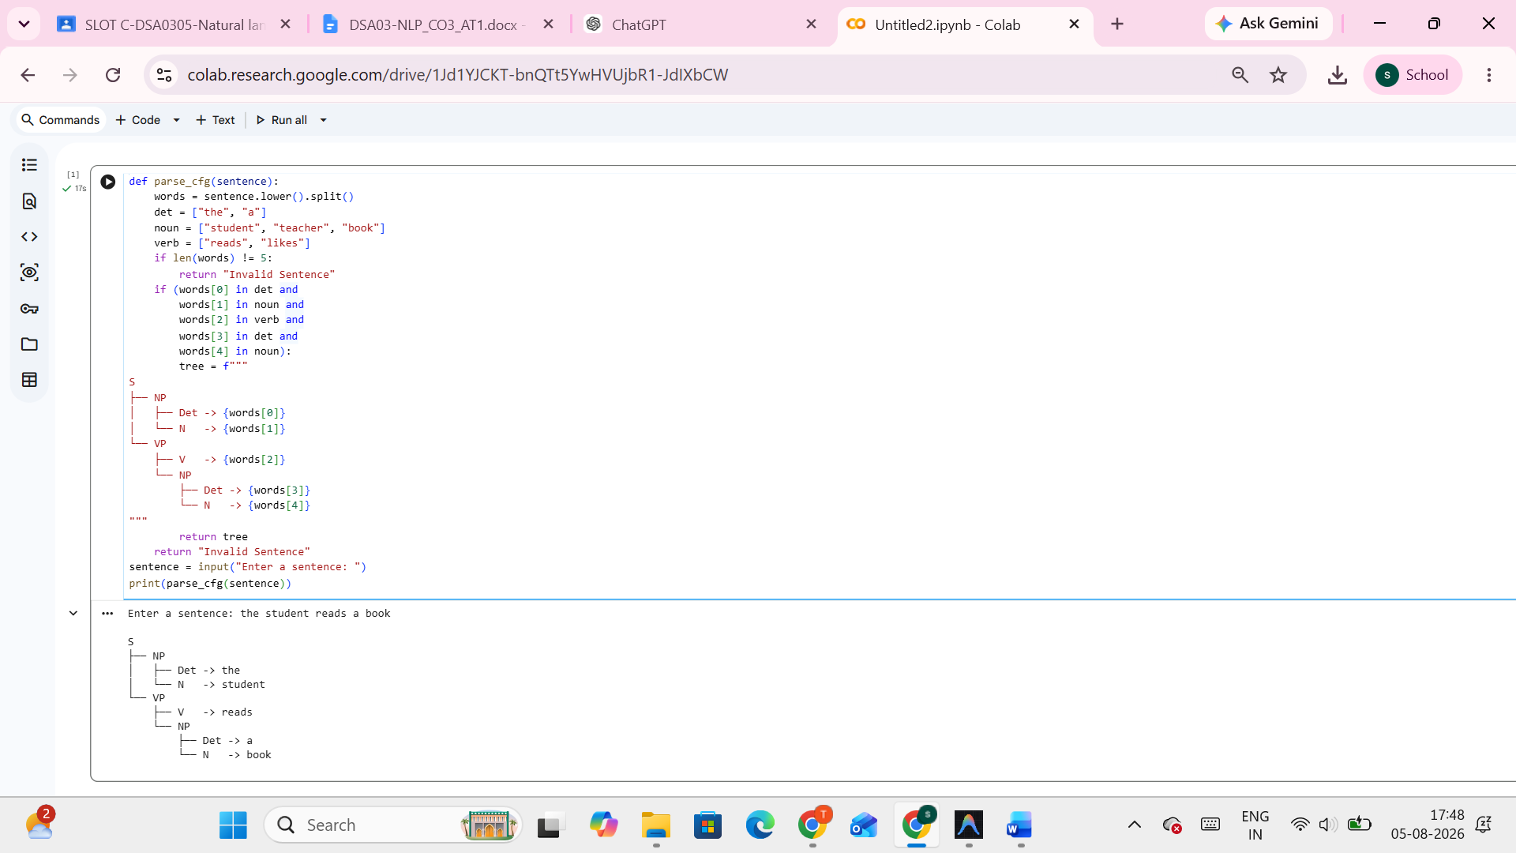

Experiment 2: Agreement and Feature Structure Checking

def check_agreement(subject, verb):
subject_features = {
"he": "singular",
"she": "singular",
"it": "singular",
"they": "plural"
}
verb_features = {
"runs": "singular",
"writes": "singular",
"run": "plural",
"write": "plural"
}
if subject not in subject_features or verb not in verb_features:
return False
return subject_features[subject] == verb_features[verb]
subject = input("Enter Subject: ").lower()
verb = input("Enter Verb: ").lower()
print(check_agreement(subject, verb))

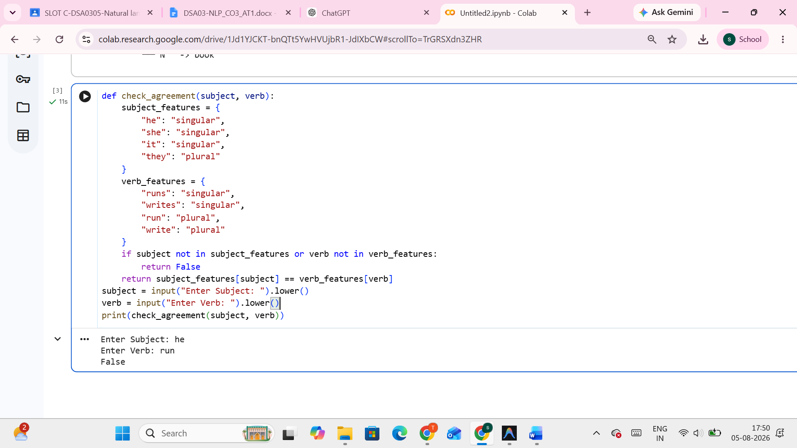

Experiment 3: Probabilistic Context-Free Grammar (PCFG) Parsing

def sentence_probability(sentence):
grammar = {
"John": 0.6,
"Mary": 0.4
}
verbs = {
"runs": 0.5,
"walks": 0.5
}
words = sentence.split()
if len(words) != 2:
return 0.0
np = words[0]
vp = words[1]
if np not in grammar or vp not in verbs:
return 0.0
probability = 1.0 * grammar[np] * verbs[vp]
return probability
sentence = input("Enter a sentence: ")
print("Probability =", sentence_probability(sentence))

