1.Creating Table:

create table HrData(

Emp_no int primary key,

Gender varchar(50) Not Null,

Marital_status varchar(20),

Age_band varchar(50),

Age int,

Department varchar(50),

Education varchar(50),

Education_field varchar(50),

Job_role varchar(50),

Business_travel varchar(50),

Employee_count int,

Attrition varchar(50),

Attrition_label varchar(50),

Job_satisfaction int,

Active_employee int

)

2. View the table:

ViSelect * from HrData

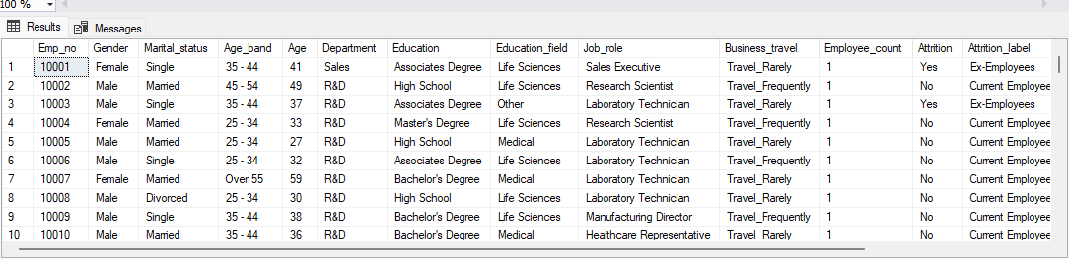

3.KPI’s:

3.1 Employee Count:

select sum(Employee_count) as Employee_count from HrData

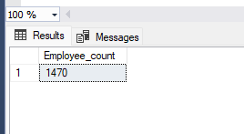

3.2 Attrition :

select count(Attrition) as Attrition from HrData where Attrition = 'yes'

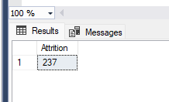

3.3 Attrition Rate:

SELECT FORMAT(((select COUNT(Attrition) from HrData where Attrition='yes')*1.0)/

SUM(Employee_count)*100, '0.00') AS Attrition_Rate

FROM HrData;

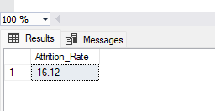

3.4 Active Employees:

select sum(Employee_count) -(select count(Attrition) from HrData where Attrition = 'yes') as Active_Employees from HrData

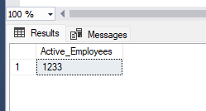

3.5 Average_age:

SELECT Format(AVG(CAST(Age AS decimal(10, 2))),'0') AS Average_age

FROM HrData;

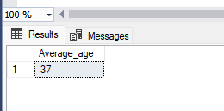

4. Charts:

4.1 Attrition By Gender:

select Gender,count(Attrition) as Gender_Attrition from HrData where Attrition ='yes' group by Gender Order by Gender desc;

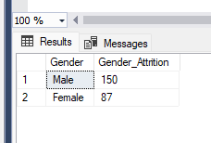

4.2 Attrition By Department:

select Department, count(Attrition) as Department_wise_Attrition , Format((cast (count(Attrition) as numeric) /

(select count(Attrition) from HrData where Attrition= 'Yes')) * 100, '0.00') as pct_departmentattrition from HrData where Attrition='Yes'group by Department

order by count(Attrition) desc;

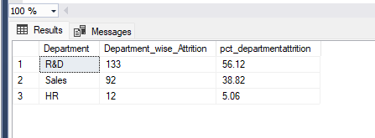

4.3 Employeecount by Age_band and Gender:

select Age_band,Gender,count(Employee_count) from HrData

Group by Age_band,Gender

order by Age_band;

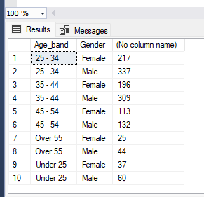

4.3 Job Satisfaction Rate for Different Job roles:

SELECT

Job_role,

COUNT(CASE WHEN Job_satisfaction = '1' THEN 1 END) AS Satisfaction_1,

COUNT(CASE WHEN Job_satisfaction = '2' THEN 1 END) AS Satisfaction_2,

COUNT(CASE WHEN Job_satisfaction = '3' THEN 1 END) AS Satisfaction_3,

COUNT(CASE WHEN Job_satisfaction = '4' THEN 1 END) AS Satisfaction_4

FROM HrData GROUP By Job_role;

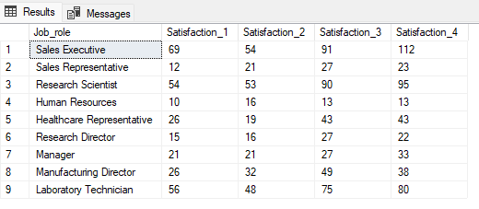

4.3 Attrition count by Education_field:

select Education_field,count(Attrition) as Attritioncount from HrData

where Attrition='yes' group by Education_field order by Attritioncount desc

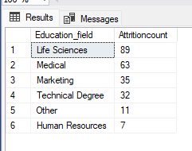

4.4 Attrition Rate by Gender for Different age Group:

select Age_band, Gender, count(Attrition) as attrition_count,

Format((cast(count(Attrition) as numeric) / (select count(Attrition) from HrData where Attrition = 'Yes')) * 100,'0.00') as pct_agewiseattrition

from HrData where Attrition = 'Yes' group by Age_band, Gender order by Age_band, Gender desc;

