**K. Sushma Sree**

**962221106107**

**PROJECT TITLE : Public Health Awareness Campaign with Data Analytics**

**Data Analytics With Congas ( Phase III : Development Part 1 )**

LOADING AND PREPROCESSING THE DATASET

**Given Data:**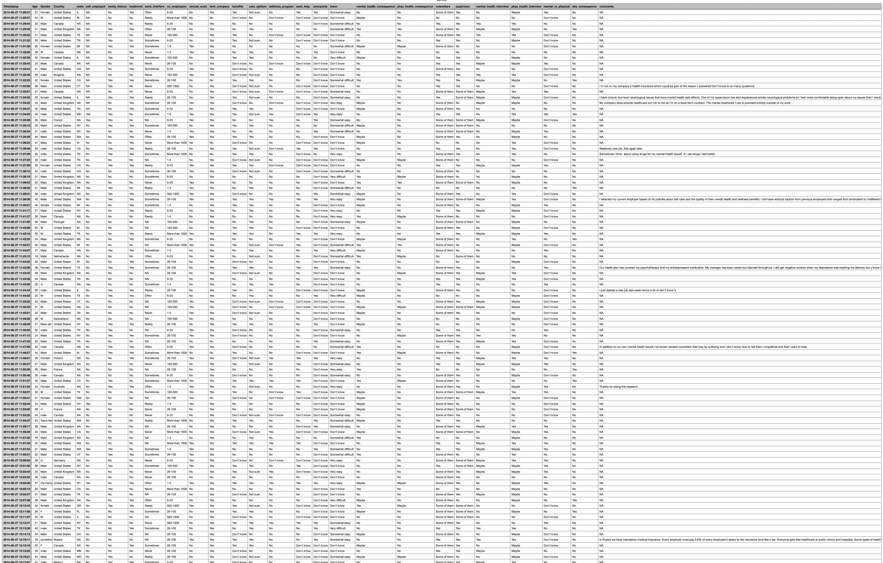

[**https://www.kaggle.com/datasets/osmi/mental-health-in-tech-survey**](https://www.kaggle.com/datasets/osmi/mental-health-in-tech-survey)

**Loading and processing data set in programming:**

To load and process a data set, I will first need to know the format of the data. Is it a CSV file, a JSON file, or something else? Once I know the format, I can use the appropriate libraries to read the data into a Python object.

Once the data is loaded, I will need to process it to make it useful for the task at hand. This may involve cleaning the data, removing outliers, or transforming the data into a different format.

Here is a general overview of the steps involved in loading and processing a data set:

* Load the data. Use the appropriate libraries to read the data into a Python object.
* Clean the data. This may involve removing rows with missing values, correcting typos, or converting data to the correct format.
* Remove outliers. Outliers are data points that are significantly different from the rest of the data. They can skew the results of analysis, so it is important to remove them before proceeding.
* Transform the data. This may involve converting the data to a different format, such as one-hot encoding categorical variables or normalizing numerical variables.
* Save the processed data. Once the data is processed and ready for use, save it to a file so that you can load it again later.

**Here is an example of how to load and process a CSV data set:**

This code will load the CSV data set into a Pandas DataFrame, clean the data, remove outliers, transform the data, and save the processed data to a new CSV file.

Once the data is loaded and processed, you can use it for a variety of tasks, such as machine learning, data analysis, or visualization.

import pandas as pd

# Load the data

df = pd.read_csv('data.csv')

# Clean the data

df.dropna(inplace=True)

df.replace('?', np.nan, inplace=True)

# Remove outliers

df = df[df['price'] < 100000]

# Transform the data

df['city'] = df['city'].astype('category')

df['city'] = pd.get_dummies(df['city'])

# Save the processed data

df.to_csv('processed_data.csv', index=False)

**Data Loading**

Data loading defines the LOAD component of the ETL process. ETL stands for Extraction, Transformation, and Load. Extraction deals with the retrieval and combining of data from multiple sources. Transformation deals with cleaning and formatting of the Extracted Data. Data Loading deals with data getting loaded into a storage system, such as a cloud data warehouse.

ETL aids in the data integration process that standardizes diverse data types to make them available for querying, manipulation, or reporting for many different individuals and teams. Because today’s organizations are increasingly dependent upon their own data to make smarter, faster business decisions, ETL needs to be scalable and streamlined to provide the most benefit.

Data loading is quite simply the process of packing up your data and moving it to a designated data warehouse. It is at the beginning of this transitory phase where you can begin planning a roadmap, outlining where you would like to move forward with your data and how you would like to use it.

**Challenges with Data Loading**

Many ETL solutions are cloud-based, which accounts for their speed and scalability. But large enterprises with traditional, on-premise infrastructure and data management processes often use custom-built scripts to collect and perform data loading on their own data into storage systems through customized configurations. This can:

1.Slow down analysis:Each time a data source is added or changed, the system has to be reconfigured, which takes time and hampers the ability to make quick decisions.

Increase the likelihood of errors. Changes and reconfigurations open up the door for human error, duplicate or missing data, and other problems.

2.Require specialized knowledge:In-house IT teams often lack the skill (and bandwidth) needed to code and monitor ETL functions themselves.

3;Require costly equipment:In addition to investment in the right human resources, organizations have to purchase, house, and maintain hardware and other equipment to run the process on-site.

Unorganized Data: Loading your data can become unorganized very fast. For ETL voyagers, common roadblocks that many encounters early on can be resolved with proper planning and delivery.

Universal formatting: Before you begin loading your data, make sure that you identify where it is coming from and where you want to go.

Loss of data: Tracking the status of all data is critical for a smooth loading process.

Speed: Although it’s exciting to be closer to your final destination, do not rush through this phase. Errors are most likely to occur during this time.

**Methods for Data Loading**

Since data loading is part of the larger ETL process, organizations need a proper understanding of the types of ETL tools and methods available, and which one(s) work best for their needs, budget, and structure.

In the process of Data Loading the data is physically moved to the data warehouse. The Data Loading takes place within a “load window. The tendency is close to real-time updates for data warehouses as warehouses are growing used for operational applications.

1.Cloud-based: ETL tools in the cloud are built for speed and scalability, and often enable real-time data processing. They also include the ready-made infrastructure and expertise of the vendor, who can advise on best practices for each organization’s unique setup and needs.

2.Batch processing: ETL tools that work off batch processing move data at the same scheduled time every day or week. It works best for large volumes of data and for organizations that don’t necessarily need real-time access to their data.

3.Open-source: Many open-source ETL tools are quite cost-effective as their codebase is publicly accessible, modifiable, and shareable. While a good alternative to commercial solutions, these tools can still require some customization or hand-coding.

**Data Loading:** Refresh versus Update

After the initial load, the data warehouse needs to be maintained and updated and this can be done by the following two methods:

Update-application of incremental changes in the data sources.

Refresh-complete reloads at specified intervals.

**Data Preprocessing in Data Analytics:**

Data preprocessing is an important step in the data mining process. It refers to the cleaning, transforming, and integrating of data in order to make it ready for analysis. The goal of data preprocessing is to improve the quality of the data and to make it more suitable for the specific data mining task.

**Some common steps in data preprocessing include:**

Data preprocessing is an important step in the data mining process that involves cleaning and transforming raw data to make it suitable for analysis. Some common steps in data preprocessing include:

**Data Cleaning:** This involves identifying and correcting errors or inconsistencies in the data, such as missing values, outliers, and duplicates. Various techniques can be used for data cleaning, such as imputation, removal, and transformation.

**Data Integration:** This involves combining data from multiple sources to create a unified dataset. Data integration can be challenging as it requires handling data with different formats, structures, and semantics. Techniques such as record linkage and data fusion can be used for data integration.

**Data Transformation:** This involves converting the data into a suitable format for analysis. Common techniques used in data transformation include normalization, standardization, and discretization. Normalization is used to scale the data to a common range, while standardization is used to transform the data to have zero mean and unit variance. Discretization is used to convert continuous data into discrete categories.

**Data Reduction:** This involves reducing the size of the dataset while preserving the important information. Data reduction can be achieved through techniques such as feature selection and feature extraction. Feature selection involves selecting a subset of relevant features from the dataset, while feature extraction involves transforming the data into a lower-dimensional space while preserving the important information.

**Data Discretization:** This involves dividing continuous data into discrete categories or intervals. Discretization is often used in data mining and machine learning algorithms that require categorical data. Discretization can be achieved through techniques such as equal width binning, equal frequency binning, and clustering.

**Data Normalization:** This involves scaling the data to a common range, such as between 0 and 1 or -1 and 1. Normalization is often used to handle data with different units and scales. Common normalization techniques include min-max normalization, z-score normalization, and decimal scaling.

Data preprocessing plays a crucial role in ensuring the quality of data and the accuracy of the analysis results. The specific steps involved in data preprocessing may vary depending on the nature of the data and the analysis goals.

By performing these steps, the data mining process becomes more efficient and the results become more accurate.

**Preprocessing in Data Mining:**

Data preprocessing is a data mining technique which is used to transform the raw data in a useful and efficient format.

**Steps Involved in Data Preprocessing:**

**1. Data Cleaning:**

The data can have many irrelevant and missing parts. To handle this part, data cleaning is done. It involves handling of missing data, noisy data etc.

(a). Missing Data:

This situation arises when some data is missing in the data. It can be handled in various ways.

Some of them are:

1.Ignore the tuples:

This approach is suitable only when the dataset we have is quite large and multiple values are missing within a tuple.

2.Fill the Missing values:

There are various ways to do this task. You can choose to fill the missing values manually, by attribute mean or the most probable value.

(b). Noisy Data:

Noisy data is a meaningless data that can’t be interpreted by machines.It can be generated due to faulty data collection, data entry errors etc. It can be handled in following ways :

1.Binning Method:

This method works on sorted data in order to smooth it. The whole data is divided into segments of equal size and then various methods are performed to complete the task. Each segmented is handled separately. One can replace all data in a segment by its mean or boundary values can be used to complete the task.

2.Regression:

Here data can be made smooth by fitting it to a regression function.The regression used may be linear (having one independent variable) or multiple (having multiple independent variables).

3.Clustering:

This approach groups the similar data in a cluster. The outliers may be undetected or it will fall outside the clusters.

**2. Data Transformation:**

This step is taken in order to transform the data in appropriate forms suitable for mining process. This involves following ways:

1.Normalization:

It is done in order to scale the data values in a specified range (-1.0 to 1.0 or 0.0 to 1.0)

2.Attribute Selection:

In this strategy, new attributes are constructed from the given set of attributes to help the mining process.

3.Discretization:

This is done to replace the raw values of numeric attribute by interval levels or conceptual levels.

4.Concept Hierarchy Generation:

Here attributes are converted from lower level to higher level in hierarchy. For Example-The attribute “city” can be converted to “country”.

**3. Data Reduction:**

Data reduction is a crucial step in the data mining process that involves reducing the size of the dataset while preserving the important information. This is done to improve the efficiency of data analysis and to avoid overfitting of the model. Some common steps involved in data reduction are:

1.Feature Selection: This involves selecting a subset of relevant features from the dataset. Feature selection is often performed to remove irrelevant or redundant features from the dataset. It can be done using various techniques such as correlation analysis, mutual information, and principal component analysis (PCA).

2.Feature Extraction: This involves transforming the data into a lower-dimensional space while preserving the important information. Feature extraction is often used when the original features are high-dimensional and complex. It can be done using techniques such as PCA, linear discriminant analysis (LDA), and non-negative matrix factorization (NMF).

3.Sampling: This involves selecting a subset of data points from the dataset. Sampling is often used to reduce the size of the dataset while preserving the important information. It can be done using techniques such as random sampling, stratified sampling, and systematic sampling.

4.Clustering: This involves grouping similar data points together into clusters. Clustering is often used to reduce the size of the dataset by replacing similar data points with a representative centroid. It can be done using techniques such as k-means, hierarchical clustering, and density-based clustering.

**Conclusion:**

**Here is a summary of data loading and preprocessing:**

* Improved data quality: Data loading and preprocessing can help to identify and correct errors and inconsistencies in the data, such as missing values, typos, and duplicate records. This can improve the overall quality of the data and lead to more accurate and reliable results.
* Reduced data complexity: Data loading and preprocessing can help to simplify and organize the data, making it easier to analyze. This can be especially beneficial for large and complex datasets.
* Increased model performance: Data loading and preprocessing can help to improve the performance of machine learning models. This is because well-prepared data is more likely to be understood and processed accurately by the model.

Overall, data loading and preprocessing are essential steps in any data analytics project. By carefully preparing the data, data analysts can improve the quality and reliability of their results, reduce the complexity of their analysis, improve the performance of their machine learning models, and reduce the training time for their models.