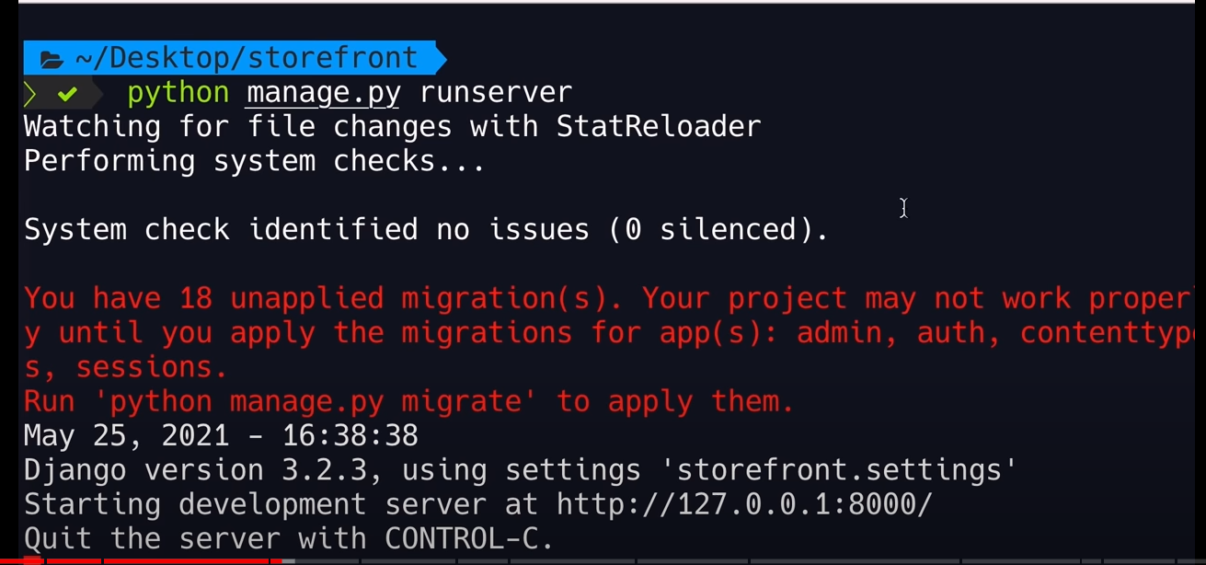

Stop server

Ctrl+C

Search for python interpretor and add path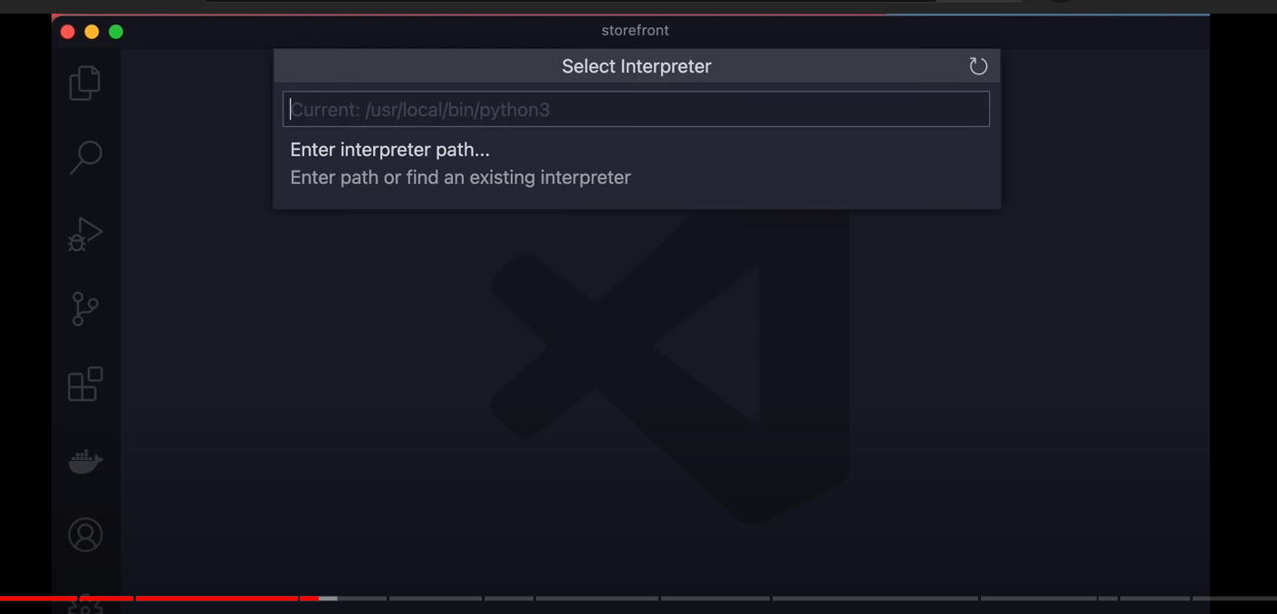

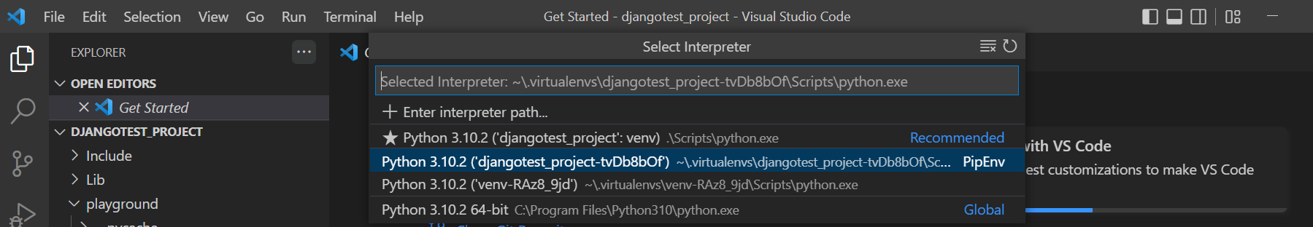

Go to terminal and select bash

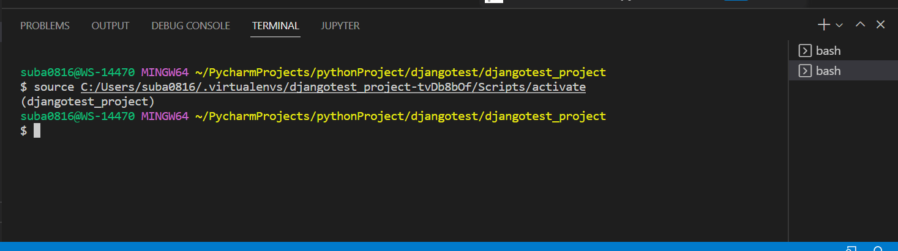

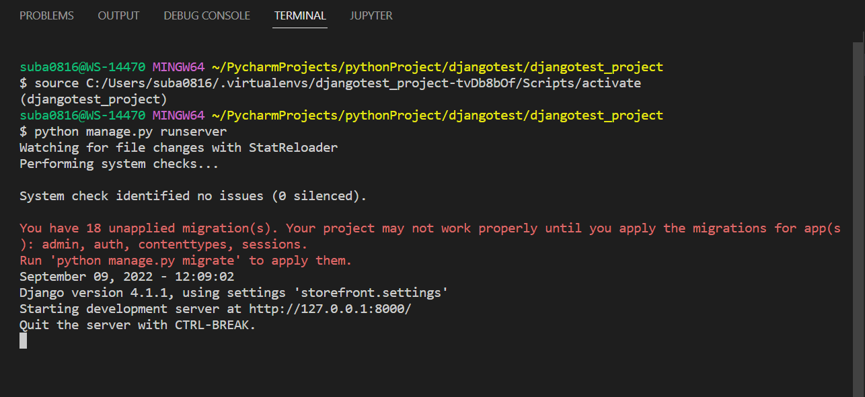

**Creating First App:**

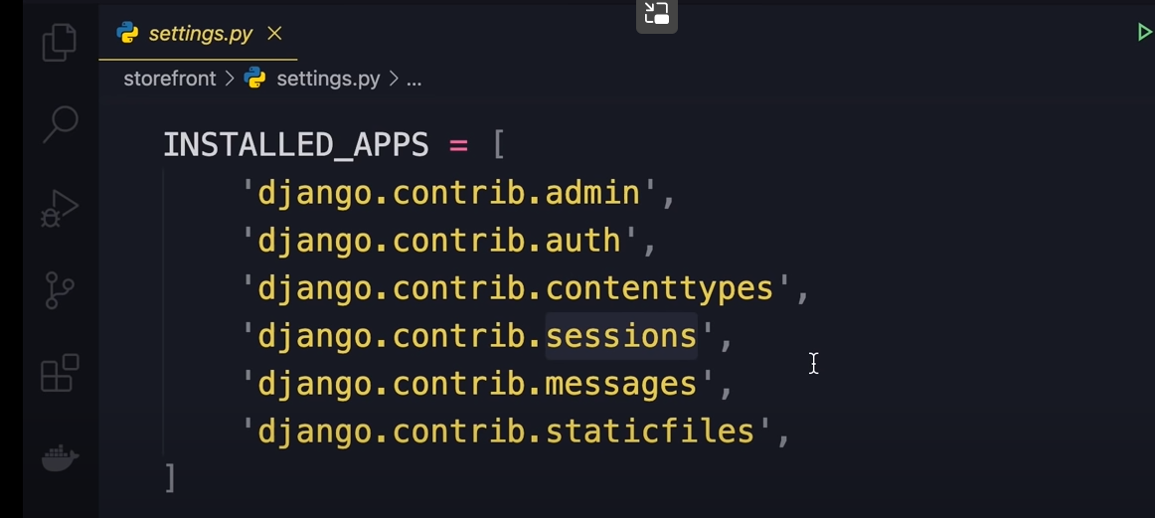

Creating app:

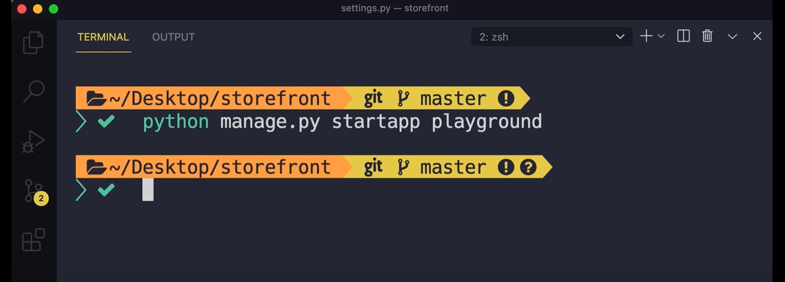 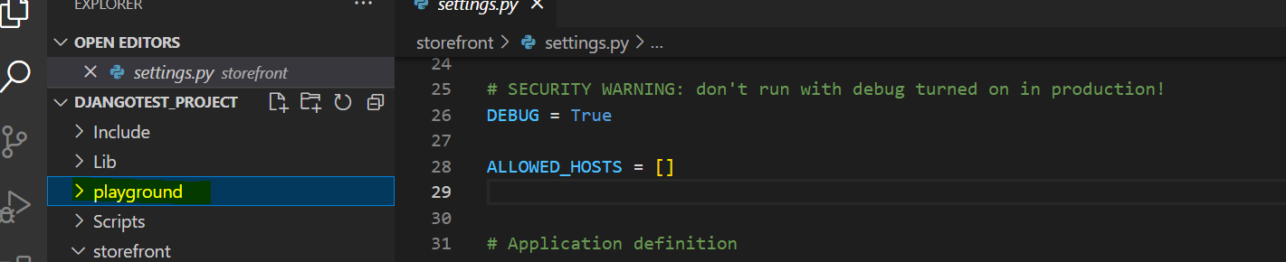

Under playground, we see these:

Migrations for generating database tables

admin is for admin interface

apps.py is like config file

models is for defining model classes

test is for unit tests

views is for requests handling

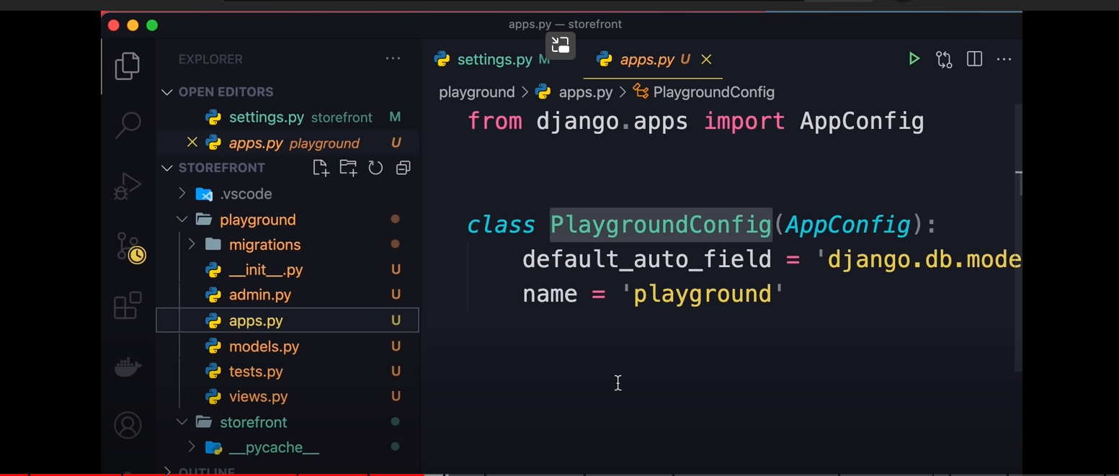

Add playground in storefront/settings.py:

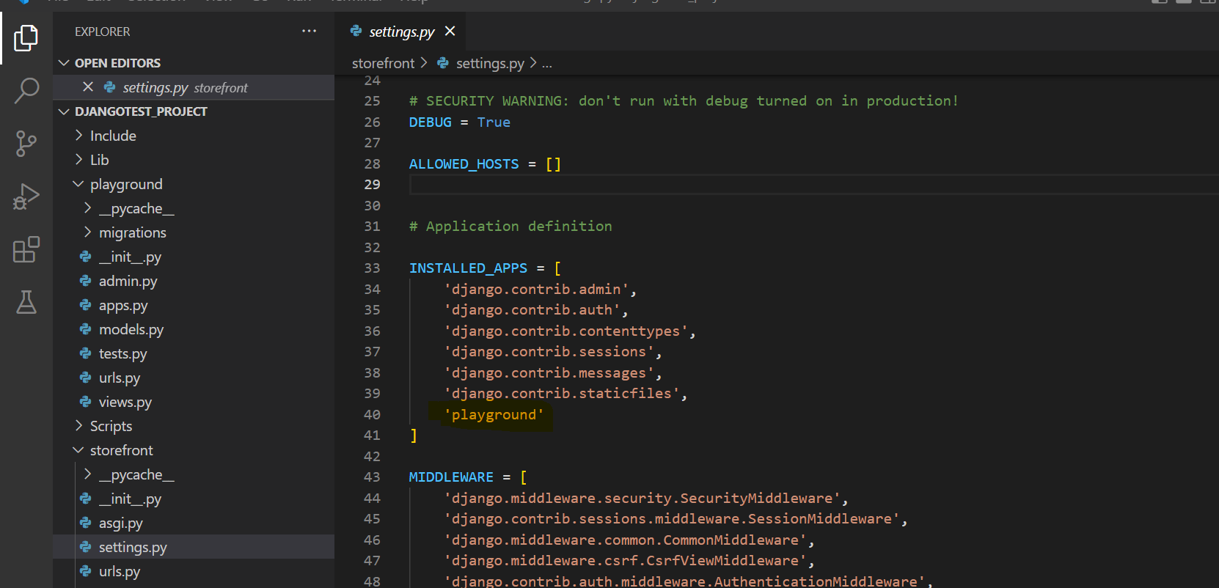

**Views:**

It’s for request response in Django

View function takes a request object and returns response (action in other frameworks)

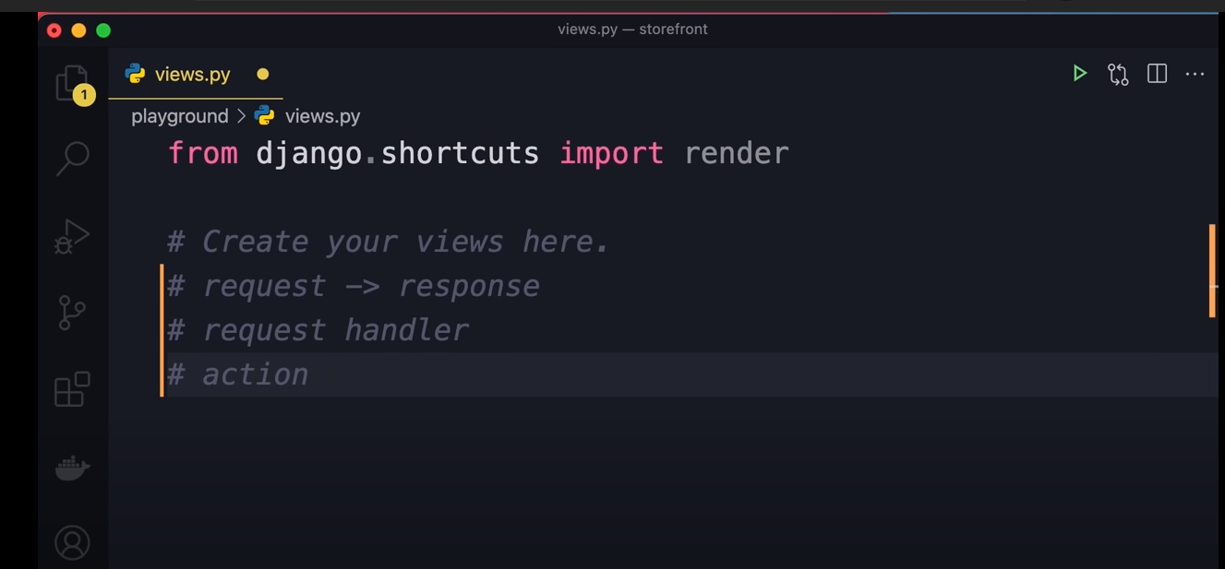

After editing:

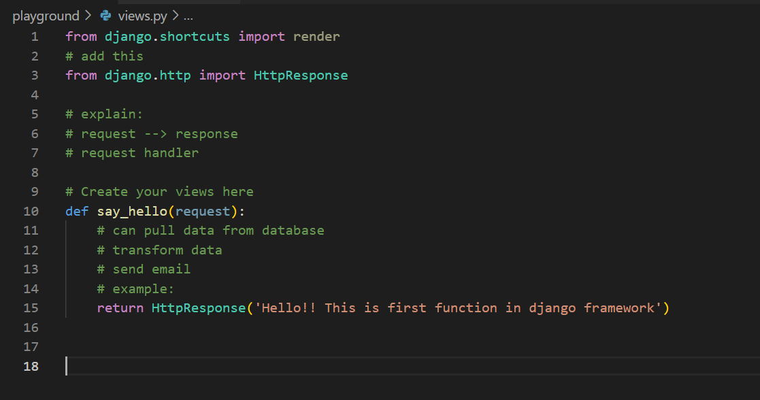

Now, need to map view to a url. So that once we get request on a url, this response will be mapped.

Need to make below happen.

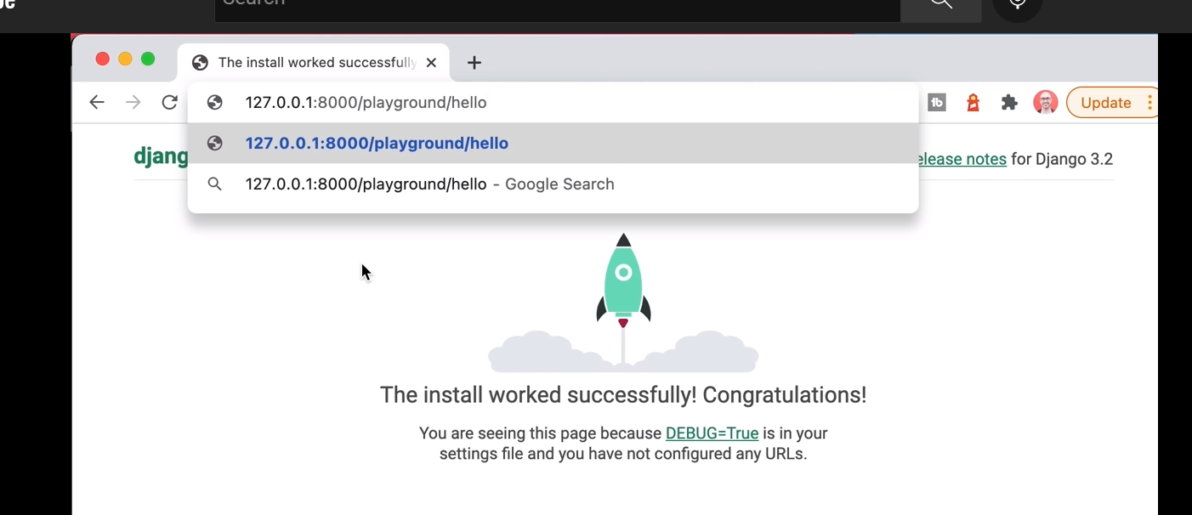

Add urls.py in playground:

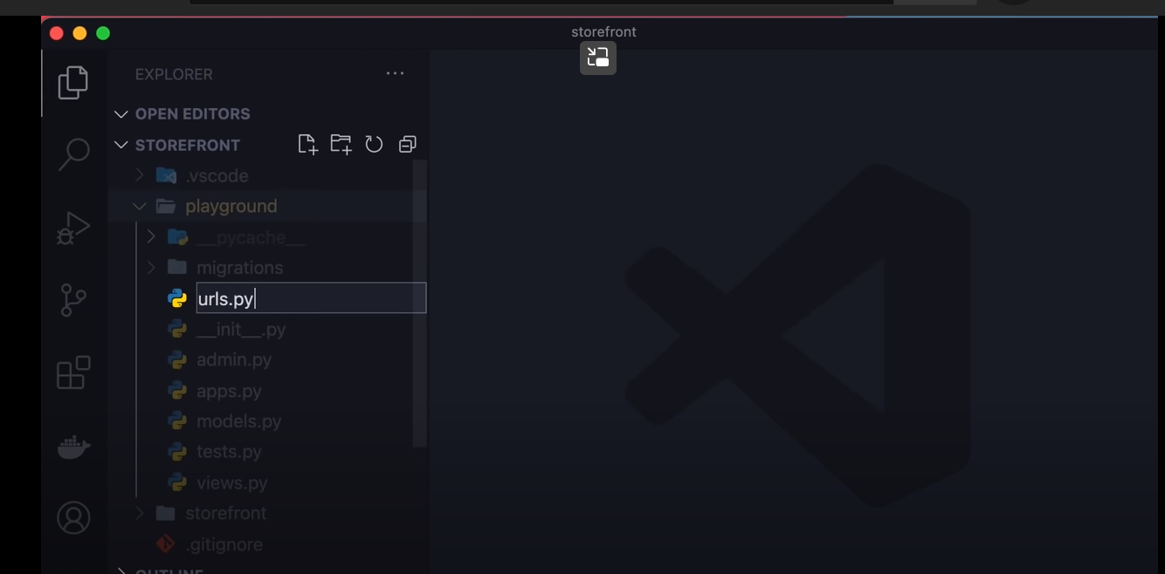

**Mapping URLs to Views:**

Need to map urls to view functions

Path function returns URLPattern object

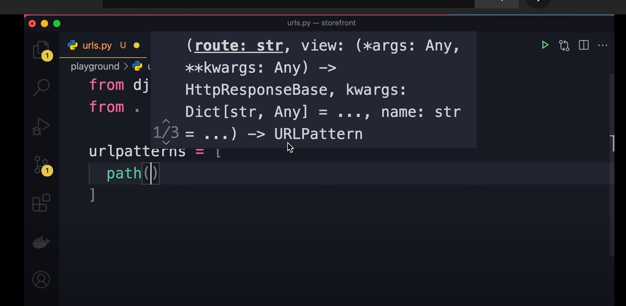

After editing:

Every app should have it’s own URLConf (URL Configuration)

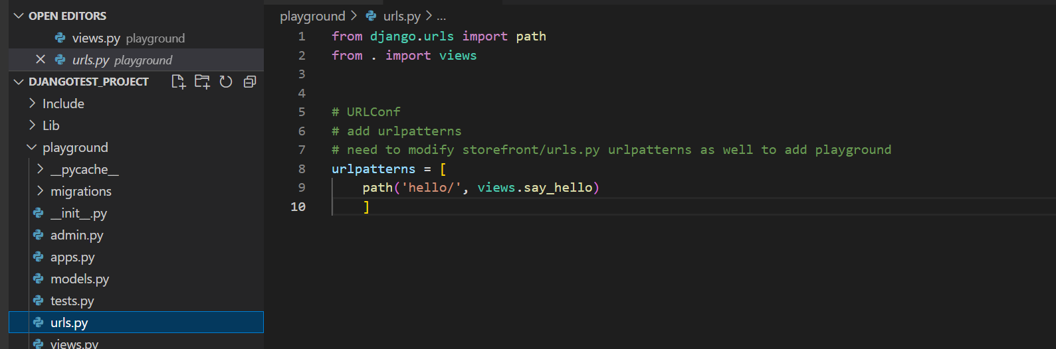

Need to import this URLConf to main URLConf of this project (i.e storefront/urls.py):

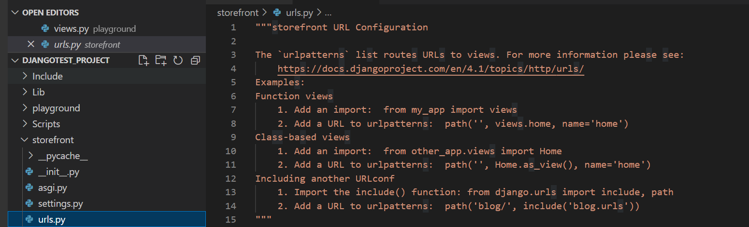

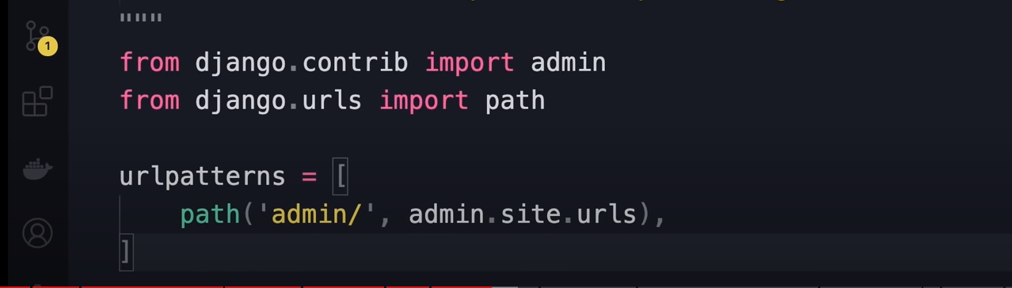

Need to modify this as per comments above, to add another URLConf

i.e, all urls starting with playground will route to playground.urls

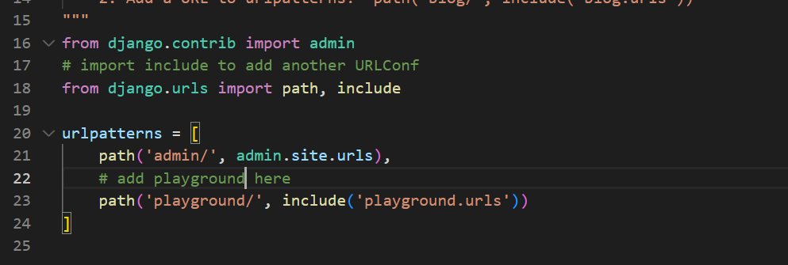

Or

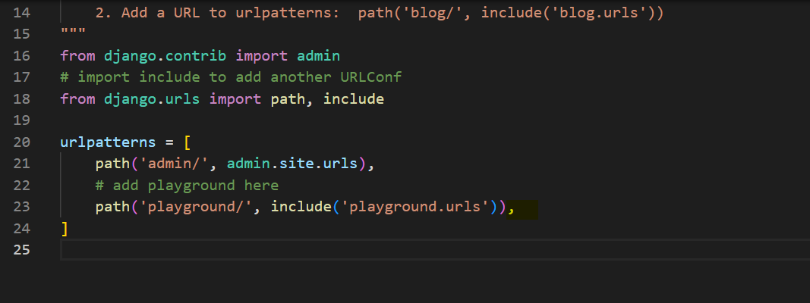

Run server and search with ipaddr/playground/hello/

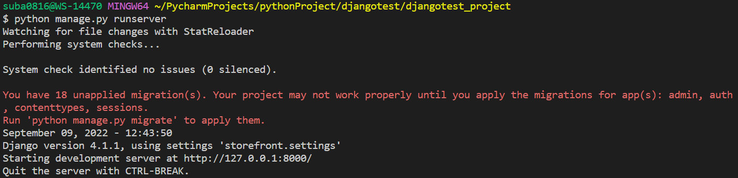

Response:

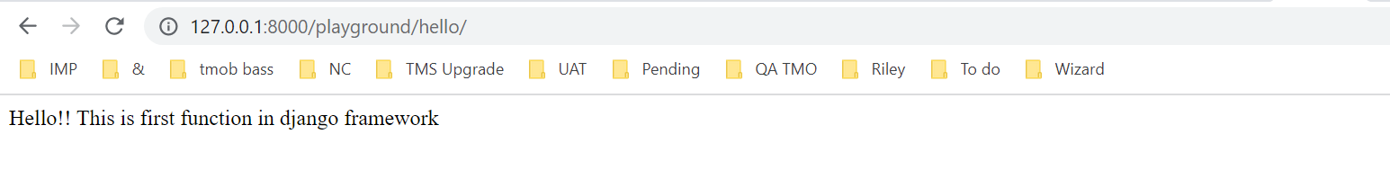

**Templates:**

Views in other frameworks called as template in Django