Version 4 LATEST - Learn Python Programming & Selenium Python Automation from Basics to Advanced level + 5 LIVE Project

Java query executor

Refer: [CSS Selectors Reference (w3schools.com)](https://www.w3schools.com/cssreF/css_selectors.php)

<https://www.w3schools.com/cssreF/css_selectors.php>

Refer: [XPath in Selenium: How to Find & Write Text, Contains, OR, AND (guru99.com)](https://www.guru99.com/xpath-selenium.html)

<https://www.guru99.com/xpath-selenium.html>

[The Internet (the-internet.herokuapp.com)](https://the-internet.herokuapp.com/)

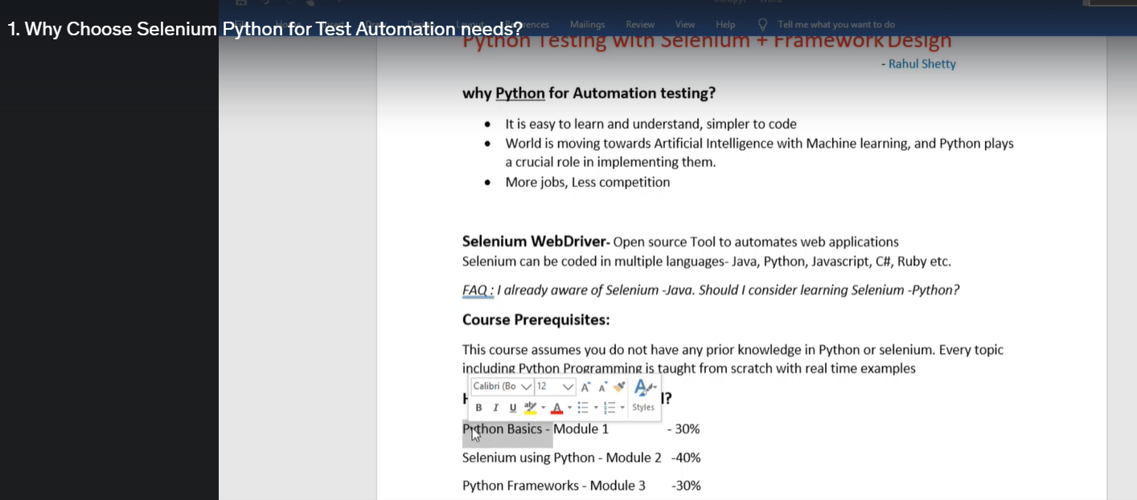

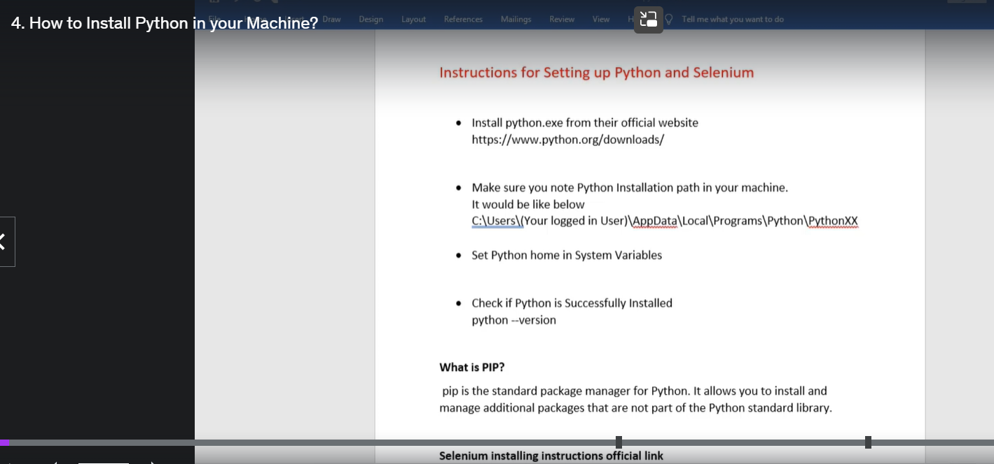

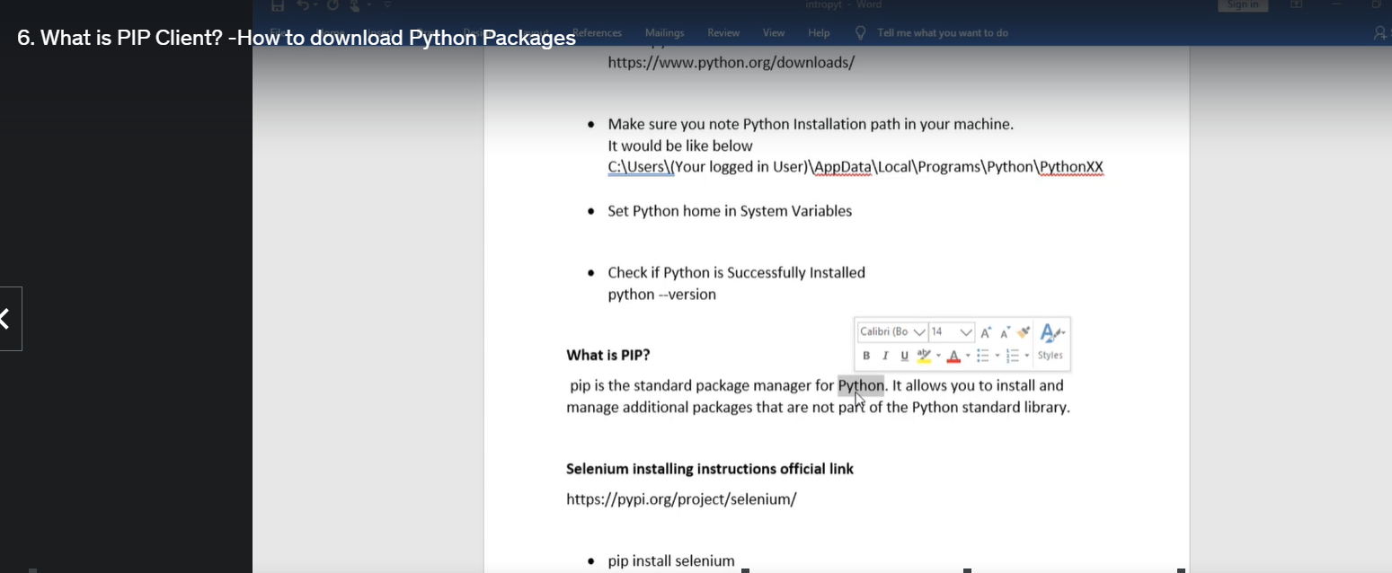

# Setup:

Install Selenium:

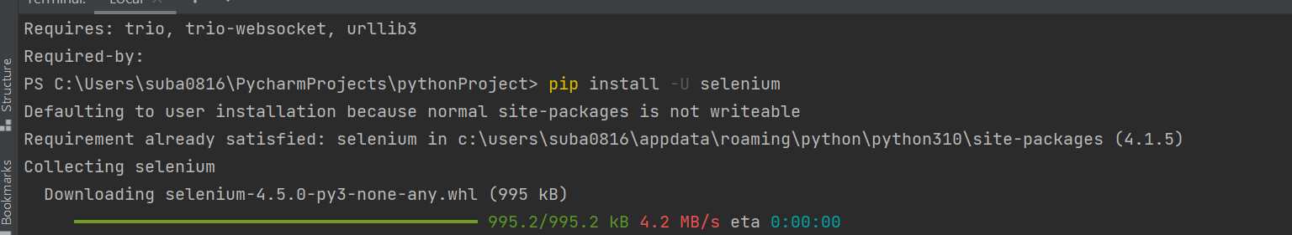

Create selenium project:

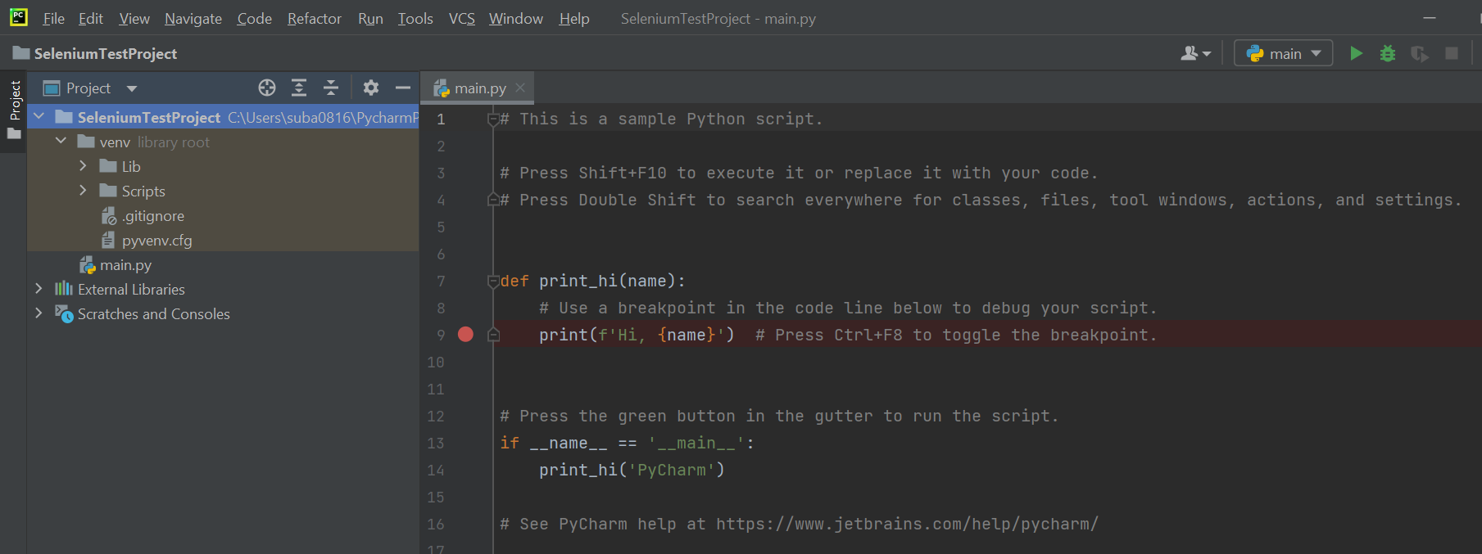

Check for python.exe

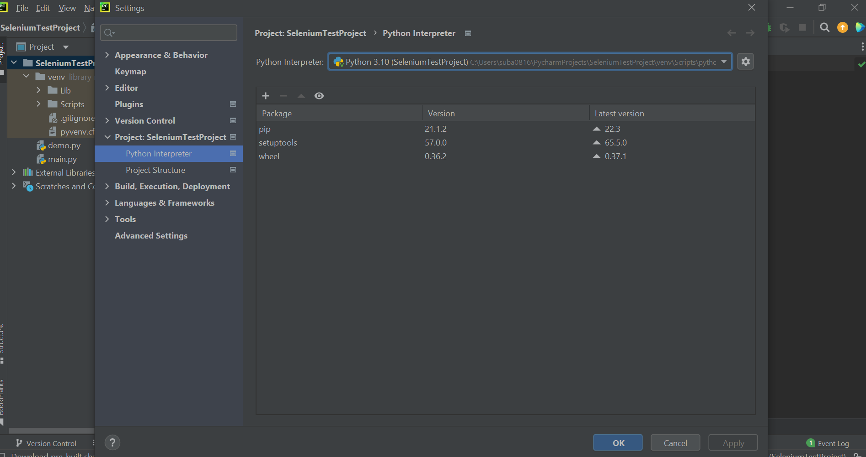

Change to local system one:

As packages already available in system, can be used

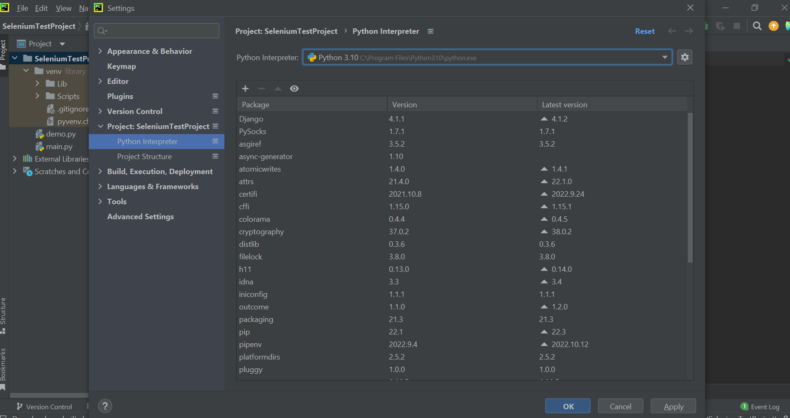

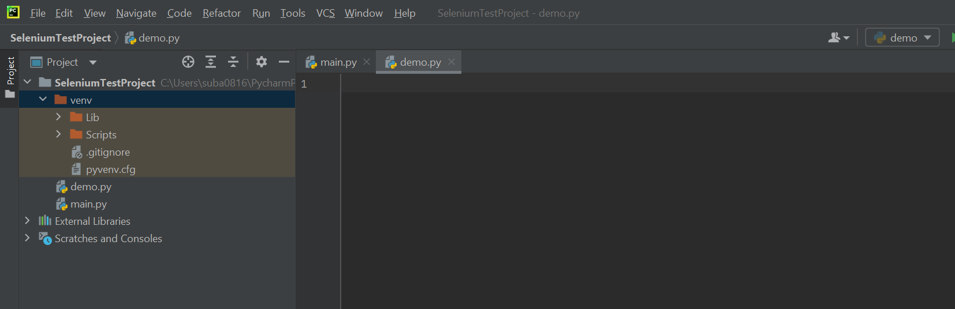

# Python Basics: