**Abstract**

**Table of Contents**

**List of Figures**

**Chapter**

1. **Preamble**
   1. **Introduction**
   2. **Problem Statement**
2. **System Design**
3. **SRS**
4. **Implementation / Methodology**
5. **Software Testing**
6. **Code**
7. **Conclusion**
8. **References**

**Abstract**

The National Center for Atmospheric Research (NCAR) has a long history of applying machine learning to weather forecasting challenges. The Dynamic Integrated forecasting (DICast®) System was one of the first automated weather forecasting engines. It is now in use in quite a few companies with many applications. Some applications being accomplished at NCAR that include DICast and other artificial intelligence technologies include renewable energy, surface transportation, and wildland fire forecasting.

**List of Figures**

**Chapter**

1. **Preamble**

**Introduction**

Weather forecasting has progressed from being a very human-intensive effort to now being highly enabled by computation. The first big advance was in terms of numerical weather prediction (NWP), i.e., integrating the equations of motion forward in time with good initial conditions. But the more recent improvements have come from applying artificial intelligence (AI) techniques to improve forecasting and to enable large quantities of machine-based forecasts.

One of the early successes of the use of AI in weather forecasting was the Dynamical Integrated forecast (DICast®) System. DICast builds on several concepts that mimic the human forecasting decision process [1}. It leverages the NWP model output as well as historical observations at the site for the forecast. It begins by correcting the output of each NWP model according to past performance. DICast then optimizes blending of the various model outputs, again building on the past performance record. DICast has been applied to predict the major variables of interest (such as temperature, dew point, wind speed, irradiance, and probability of precipitation) at sites throughout the world. Fig. 1 illustrates the improvement provided by DICast over the individual NWP models that it is based on. It is typical for DICast to outperform the best individual model by 10-15%, which is considered a large improvement in weather forecasting. One advantage of DICast is that it can be trained on a relatively limited dataset (as little as 30 to 90 days) and updates dynamically to include the most recent forecast information. The gridded version of this system, the Graphical Atmospheric Forecast System (GRAFS) can interpolate forecasts to data-sparse regions.

**Problem Statement**

1. **Weather forecasting** is the application of science and technology [to predict](https://en.wikipedia.org/wiki/Forecasting) the conditions of the [atmosphere](https://en.wikipedia.org/wiki/Earth%27s_atmosphere) for a given location and time. People have attempted to predict the weather informally for [millennia](https://en.wikipedia.org/wiki/Millennia) and formally since the 19th century. Weather forecasts are made by collecting quantitative data about the current state of the atmosphere, land, and ocean and using [meteorology](https://en.wikipedia.org/wiki/Meteorology) to project how the atmosphere will change at a given place.
2. Once calculated manually based mainly upon changes in [barometric pressure](https://en.wikipedia.org/wiki/Atmospheric_pressure), current weather conditions, and sky condition or cloud cover, weather forecasting now relies on [computer-based models](https://en.wikipedia.org/wiki/Numerical_weather_prediction) that take many atmospheric factors into account.[[1]](https://en.wikipedia.org/wiki/Weather_forecasting#cite_note-1) Human input is still required to pick the best possible forecast model to base the forecast upon, which involves pattern recognition skills, [teleconnections](https://en.wikipedia.org/wiki/Teleconnection), knowledge of model performance, and knowledge of model biases. The inaccuracy of forecasting is due to the [chaotic](https://en.wikipedia.org/wiki/Chaos_theory) nature of the atmosphere, the massive computational power required to solve the equations that describe the atmosphere, the land, and the ocean, the error involved in measuring the initial conditions, and an incomplete understanding of atmospheric and related processes. Hence, forecasts become less accurate as the difference between current time and the time for which the forecast is being made (the *range* of the forecast) increases. The use of ensembles and model consensus help narrow the error and provide confidence level in the forecast.
3. There is a vast variety of end uses to weather forecasts. [Weather warnings](https://en.wikipedia.org/wiki/Weather_warning) are important forecasts because they are used to protect life and property. Forecasts based on temperature and [precipitation](https://en.wikipedia.org/wiki/Precipitation_(meteorology)) are important to agriculture, and therefore to traders within commodity markets. Temperature forecasts are used by utility companies to estimate demand over coming days. On an everyday basis, many use weather forecasts to determine what to wear on a given day. Since outdoor activities are severely curtailed by heavy rain, snow and [wind chill](https://en.wikipedia.org/wiki/Wind_chill), forecasts can be used to plan activities around these events, and to plan ahead and survive them.
4. **System Design**

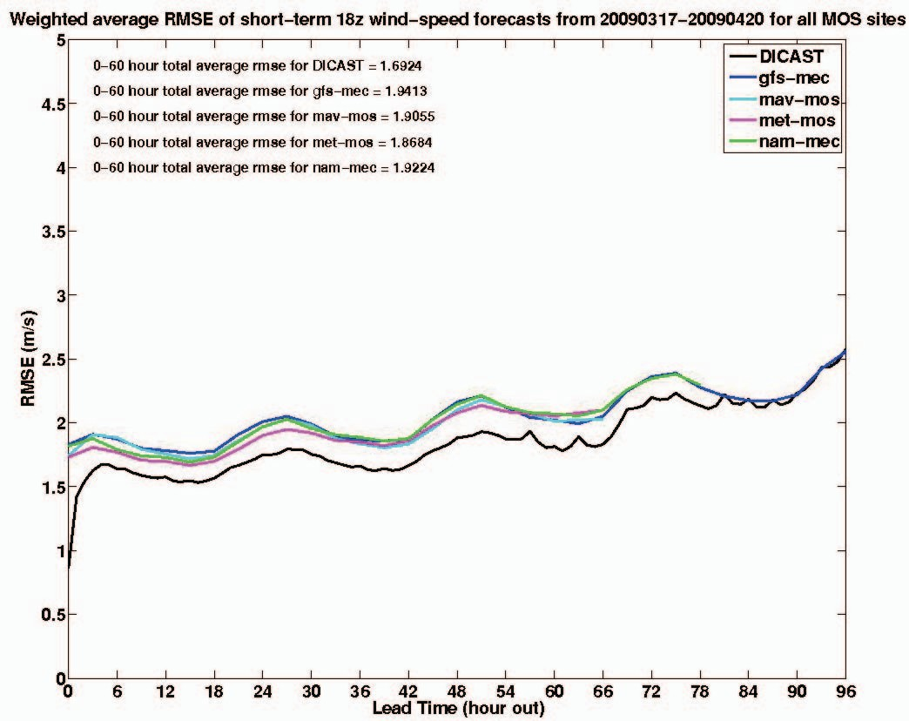

1. **SRS**

**3.1 Functional Requirements:**

Hardware Requirements

* Pentium Processor IV or Higher
* Min 10 GB HDD
* RAM 512 MB or Higher
* 2.4 GHz or faster Processor

Software Requirements

* Windows Vista onwards, Linux, Mac OS
* In the case of building the Project from the source
  + Python Compiler
  + Tensorflow Machine learning library
  + Keras
  + SciKit Learn
  + Pandas
  + Numpy
  + Flask

**3.2 Non Functional Requirements:**

Performance Requirements:

* The formats of the scanned copies should be in the standard format
* Should have a training error of as low as possible

Software Quality Attributes

* Robustness
* Reliability
* Better learning methods
* Acquiring good accuracy results

# **Collecting Weather Data**

The conditions of the atmosphere at a certain time and place are called weather. Is weather important in your life? It affects what clothes you wear and your choices of activities. It may even affect your mood. The weather of an area is due to four factors. They are heat energy, air pressure, winds, and moisture. Changes in these factors determine the kind of weather an area will have. We base decisions on what to wear, where to go, and what to do on the weather forecast.

To make weather maps and forecast weather, weather data must be collected from Earth's surface and atmosphere. Scientists analyze the weather maps and the data in them to forecast the weather. These data are collected in many ways. Data comes from a Latin word meaning "something given." It is the plural form of the word "datum." Today, we often use it as both singular (meaning information) and plural (meaning facts or pieces of information).

Data are collected at weather stations on the ground. More than four hundred national weather stations in the United States measure weather conditions many times every day. Each station measures weather conditions such as temperature, atmospheric pressure, wind speed and direction, amount of cloud cover, and precipitation. The National Weather Service uses the data to make weather maps.

1. **Software Testing**

The research in this thesis focuses on predicting the general sentiment polarity of the reactions to the news on Twitter/Reddit before a news article is published. To answer our research questions regarding the influence of category of product acceptance

SUMMARY

The example discussed here is just one of many emerging applications of applied weather forecasting that blends the best of our knowledge of physics, numerics, and artificial. intelligence using smart Big Data and leveraging the Internet of Things. Applications such as these is the future of improved weather forecasting.

REFERENCES

1. W. Myers, G. Wiener, S. Linden, and S. E. Haupt, “A consensus forecasting approach for improved turbine hub height wind speed predictions,”in Proc. WindPower 2011, Anaheim, CA, May 24, 2011.
2. Myers, W., F. Chen, J. Block, D. T. N. Meteorlogix, and M. N. Burnsville, Application of Atmospheric and land data assimilation systems to an agricultural decision support system. Conference on Agriculture and Forestry, Orlando, FL, American Meteorological Society, 2008.
3. S. D Drobot, and Coauthors, IntelliDrive (SM) road weather research & development—The Vehicle Data Translator. P roc.Intelligent Transportation Society of America Annual Conf., NationalHarbor,MD, ITSA, 13pp. [Available online at <http://www.ral.ucar.edu/projects/intellidrive/publications/ITSA2009_Dr> obot_paper.pdf.] 2009.
4. S. D Drobot, M. Chapman, P. A. Pisano, and B. B. McKeever, Using vehicles as mobile weather platforms. Data and Mobility: Transforming Information into Intelligent Traffic and Transportation Services, Springer, 203–214. 2010.
5. S. D Drobot, M. Chapman, B. Lambi, G. Wiener, and A. Anderson, The Vehicle Data Translator V3.0 System Description. FHWA Tech. Rep. FHWA-JPO-11-127, 45 pp. 2011.
6. W.P. Mahoney, K. Parks, G. Wiener, Y. Liu, B. Myers, J. Sun, L. Delle Monache, D. Johnson, T. Hopson, and S.E. Haupt, “A Wind Power Forecasting System to Optimize Grid Integration,” IEEE Transactions on Sustainable Energy, 3 (4), 2012, pp. 670-682.
7. S.E. Haupt, B. Kosovic, Variable Generation Power Forecasting as a Big Data Problem, IEEE Transactions on Sustainable Energy, **8** (2), pp. 725- 732, 2017.
8. T.C. McCandless, G.S. Young, S.E. Haupt, and L.M Hinkelman, “Regime-Dependent Short-Range Solar Irradiance Forecasting,” Journal of Applied Meteorology and Climatology, **55**, 1599-1613. 2016.
9. S. Alessandrini, L. Delle Monache, S. Sperati, and G. Cervone, “An analog ensemble for short-term probabilistic solar power forecast,” Applied Energy, **157**, 95-110. 2015.