Introduction to Investment
Investment refers to the allocation of money into assets with the expectation of generating future returns. Individuals and institutions invest to grow wealth, achieve financial goals, and secure long-term financial stability.
Common investment options include stocks, bonds, mutual funds, real estate, and commodities. Each investment type carries different levels of risk and potential returns.
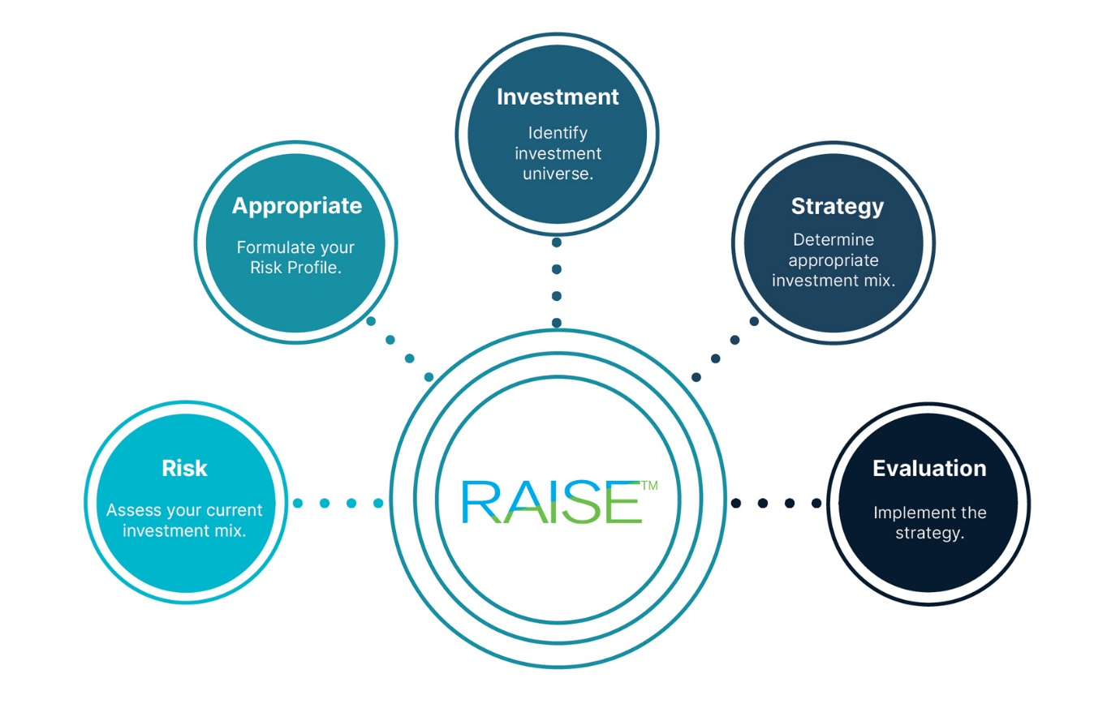
Types of Investments
Stocks represent ownership in a company and offer the potential for capital appreciation and dividends. Bonds are debt securities issued by governments or corporations that provide fixed interest payments.
Real estate investments involve purchasing property to generate rental income or capital gains. Mutual funds and exchange-traded funds allow investors to diversify their portfolios by investing in a collection of assets.
Risk and Diversification
All investments involve some degree of risk. Market fluctuations, inflation, and economic conditions can affect investment returns. Diversification is a strategy used to reduce risk by spreading investments across different asset classes.
A well-diversified portfolio may include a mix of stocks, bonds, and other assets to balance potential risks and rewards.
Long-Term Financial Planning
Successful investing requires patience and long-term planning. Investors often set financial goals such as retirement savings, education funding, or wealth accumulation. Financial advisors may help individuals develop investment strategies based on their risk tolerance and time horizon.
Over time, disciplined investing and careful financial planning can help individuals achieve financial security and independence.

