Introduction to Astronomy
Astronomy is the scientific study of celestial objects such as stars, planets, moons, comets, galaxies, and the universe as a whole. It is one of the oldest sciences known to humanity, dating back thousands of years when ancient civilizations observed the night sky to understand seasons, navigation, and timekeeping. Early astronomers carefully recorded the movement of stars and planets, laying the foundation for modern astronomical research.
Modern astronomy combines physics, mathematics, and advanced technology to explore the universe. Telescopes located on Earth and in space allow scientists to observe distant galaxies billions of light-years away. These observations help researchers understand the origin, structure, and evolution of the universe.

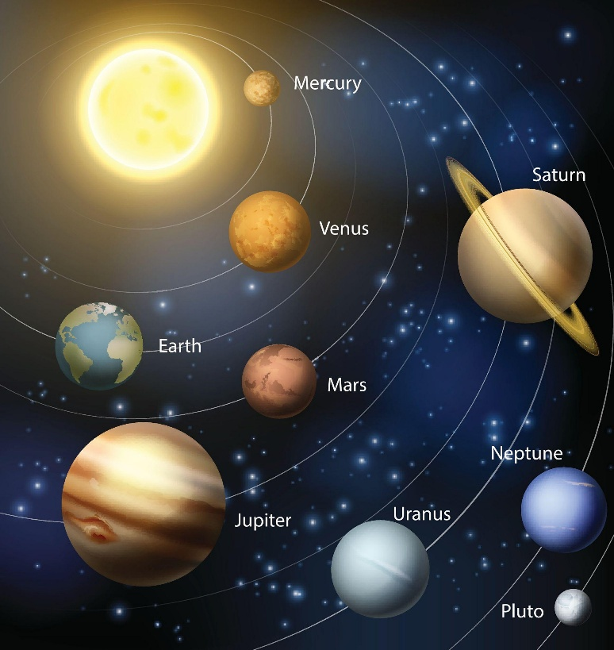
The Solar System
Our solar system consists of the Sun and the objects that orbit it due to its gravitational pull. The eight planets in our solar system are Mercury, Venus, Earth, Mars, Jupiter, Saturn, Uranus, and Neptune. These planets differ greatly in size, composition, and atmosphere. For example, Earth is the only planet known to support life, while Jupiter is the largest planet and is made mostly of gas.
Other objects in the solar system include dwarf planets such as Pluto, asteroids, comets, and meteoroids. Asteroids are rocky objects mainly found in the asteroid belt between Mars and Jupiter, while comets are icy bodies that develop bright tails when they approach the Sun.
Stars and Galaxies
Stars are massive spheres of hot gas that generate energy through nuclear fusion in their cores. The Sun is the closest star to Earth and provides the light and heat necessary for life. However, the universe contains billions of stars, many of which are much larger and brighter than our Sun.
Stars are grouped together in galaxies. Our galaxy is called the Milky Way, which contains hundreds of billions of stars. Astronomers estimate that there are billions of galaxies in the observable universe. Each galaxy can contain planetary systems, nebulae, and other cosmic structures.
Telescopes and Space Exploration
Telescopes are essential tools for astronomers. Optical telescopes collect visible light, while radio telescopes detect radio waves from space. Modern space telescopes such as the Hubble Space Telescope allow astronomers to observe distant galaxies and nebulae with incredible clarity.
Space missions and probes have also played an important role in expanding our knowledge of the universe. Spacecraft have explored planets such as Mars, Jupiter, and Saturn, sending back valuable data and images. Mars rovers, for example, study the surface of Mars to search for signs of past or present life.
The Future of Astronomy
Astronomy continues to evolve with the development of new technologies and scientific discoveries. Scientists are currently studying exoplanets, which are planets orbiting stars outside our solar system. Some of these planets may have conditions suitable for life.
Future missions and advanced telescopes will allow astronomers to explore deeper into space and further back in time, helping humanity better understand the origins and fate of the universe.

