**1.Develop a program to display grayscale image using read and write operation.**

import cv2

import numpy as np

image = cv2.imread('cat.jpg')

image = cv2.resize(image, (0, 0), None, 1.00, 1.00)

grey = cv2.cvtColor(image, cv2.COLOR_RGB2GRAY)

grey_3_channel = cv2.cvtColor(grey, cv2.COLOR_GRAY2BGR)

numpy_horizontal = np.hstack((image, grey_3_channel))

numpy_horizontal_concat = np.concatenate((image, grey_3_channel), axis=1)

cv2.imshow('cat', numpy_horizontal_concat)

cv2.waitKey()

**Output:**

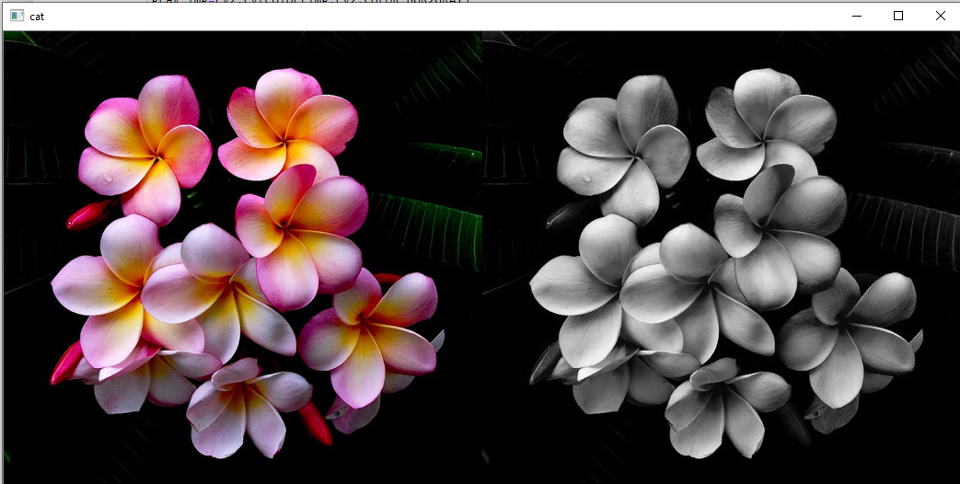

**2.Develop a program to perform linear transformation on image.**

import cv2

import numpy as np

FILE_NAME = 'cat.jpg'

try:

img = cv2.imread(FILE_NAME)

(height, width) = img.shape[:2]

res = cv2.resize(img, (int(width / 2), int(height / 2)), interpolation = cv2.INTER_CUBIC)

cv2.imwrite('result.jpg', res)

cv2.imshow('image',img)

cv2.imshow('result',res)

cv2.waitKey(0)

except IOError:

print ('Error while reading files !!!')

cv2.waitKey(0)

cv2.destroyAllWindows(0)

**Output:**

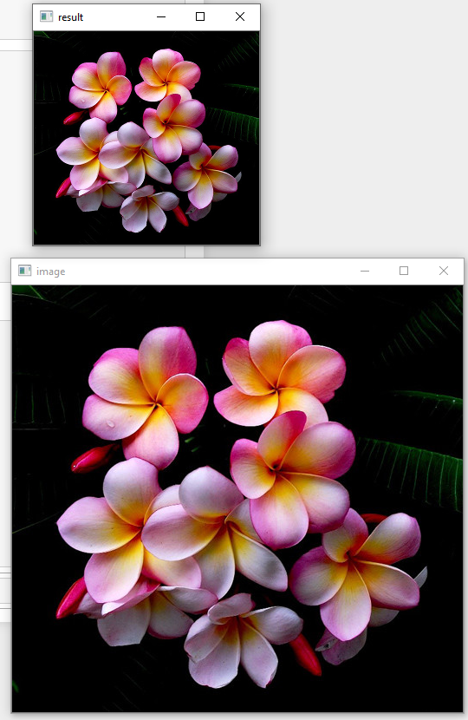

**3.Develop a program to find sum and mean of a set of images.**

**Create n number of images and read the directory and perform operation.**

import cv2

import os

path = "E:\ip"

imgs=[]

dirs=os.listdir(path)

for file in dirs:

fpat=path+"\\"+file

imgs.append(cv2.imread(fpat))

i=0

for im in imgs:

cv2.imshow(dirs[i],imgs[i])

i=i+1

print(i)

cv2.imshow('sum',len(im))

cv2.imshow('mean',len(im)/im)

cv2.waitKey(0)

**Output:**

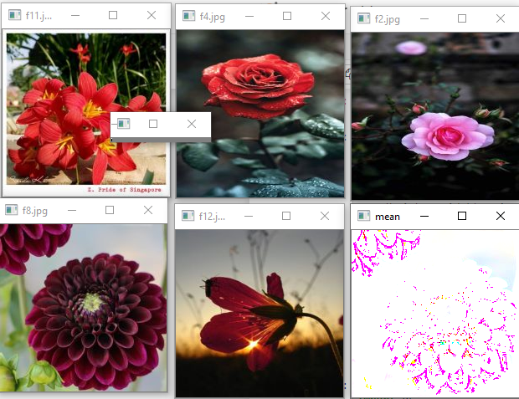

**4.Write a program to convert color image into gray scale and binary image.**

import cv2

img=cv2.imread("cat.jpg",0)

cv2.imshow("cat",img)

ret, bw_img = cv2.threshold(img, 127, 255, cv2.THRESH_BINARY)

bw = cv2.threshold(img, 127, 255, cv2.THRESH_BINARY)

cv2.imshow("Binary", bw_img)

cv2.waitKey()

cv2.destroyAllWindows()

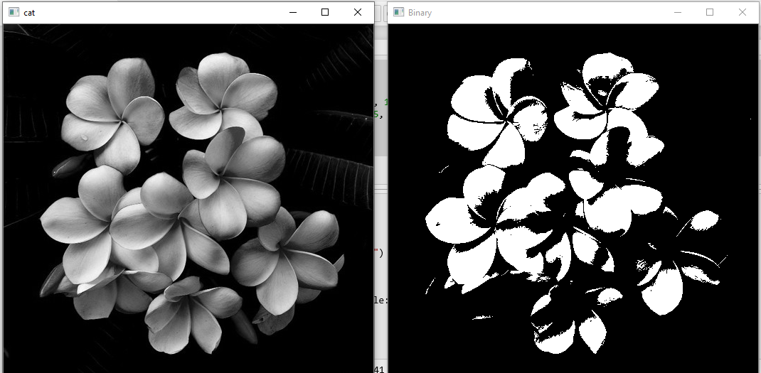

**5.Write a program to convert color image into different color space.**

import cv2

img=cv2.imread("cat.jpg")

gray_img=cv2.cvtColor(img,cv2.COLOR_BGR2GRAY)

cv2.imshow('gray scale image',gray_img)

cv2.waitKey()

yuv_img=cv2.cvtColor(img,cv2.COLOR_BGR2YUV)

cv2.imshow('yuv',yuv_img)

cv2.waitKey()

hsv_img=cv2.cvtColor(img,cv2.COLOR_BGR2HSV)

cv2.imshow('HSV',hsv_img)

cv2.waitKey()

hls_img=cv2.cvtColor(img,cv2.COLOR_BGR2HLS)

cv2.imshow('HLS',hls_img)

cv2.waitKey()

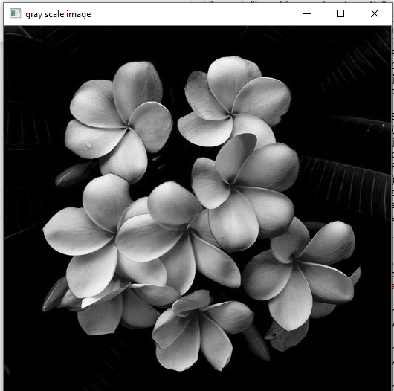 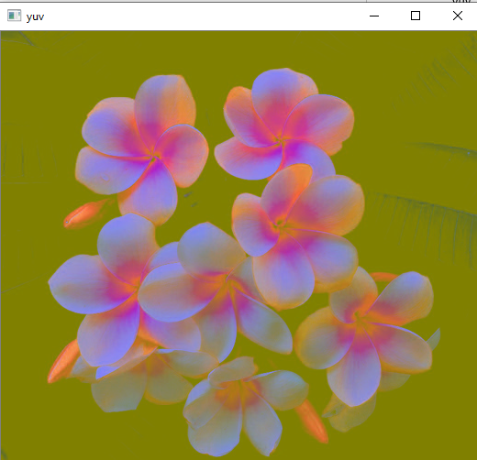

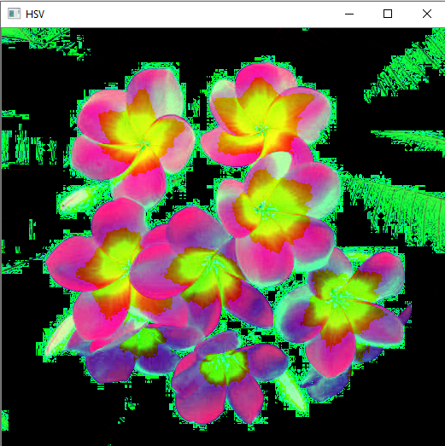 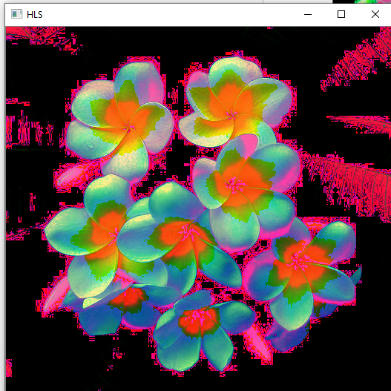

**6.Develop a program to create an image from 2D array.**

from PIL import Image

import numpy as np

w, h =512,213

data= np.zeros((h,w,3),dtype=np.uint8)

data[0:256,0:256]=[255,0,0]

img=Image.fromarray(data,'RGB')

img.save('my.png')

img.show() 